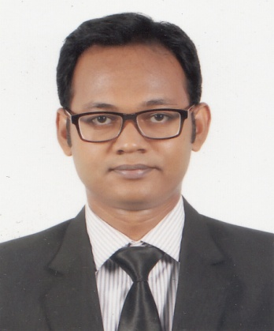

**TANJIL HASSAN TUSHER**

**House-30 Road-12, Block-C, Pallabi Mirpur-12**

**Cell: 01516153975, 01676713219**

**E-Mail: tanjil.tushar@gmail.com**

**Career objective**

To pursue a highly rewarding career, seeking for a job in challenging and healthy work environment where I can utilize my skills and knowledge efficiently for organizational growth .To work hard with full determination and dedication to achieve organizational as well as personal goals.

**Experiences**

**Ahmed Amin Group**

Accounts Executive

House- 25 Road- 34 Gulshan Dhaka

01 January 2020 to Present

**Dutch Bangla Bank Ltd**

Customer service Executive

Call center (15 Jun 2017 to Present)

**South East Bank Ltd**.

Internship (Four Month, 1 march to 3 Jun 2016)  
Rupnagar Branch, plot-14 Road-11  
Mirpur Housing, Dhaka-1216, Bangladesh

**Educational skills**

**Master of Business Administration (MBA)**

* Institution : South East University
* Graduating Year : Current
* Major : Finance
* CGPA : Appeared

**Bachelor of Business Administration (BBA)**

* Institution : Bangladesh University of Business & Technology
* Graduating Year : 2016
* Major : Finance
* CGPA : 2.89 (Scale of 4)

**Higher Secondary Certificate (H.S.C)**

* Institution : Adamjee Cantonment College
* Board : Dhaka
* Group : Business Studies
* Year of Passing : 2010
* GPA : 5.00 (Scale of 5)

**Secondary School Certificate (S.S.C)**

* Institution : MDC Model Institute
* Board : Dhaka
* Group : Business Studies
* Year of Passing : 2008
* GPA : 4.88 (Scale of 5)

**Computer Skills**

* Programs: Microsoft office, Photo editing, Internet browsing, Audio and video editing & e-mail
* Operating System :Windows (XP, Vista, Windows -7,8,10)

**Communication Skills**

* Able to speak, read and write (Bangla, English)

**Special Skills**

* Have good communication skill
* Diligent worker & ability to assume responsibility
* Have ability to work with a team
* Have ability to work under pressure & challenges.
* I am a quick learner, self-motivated

**Hobbies & Interests**

* Drawing Playing football, cricket & Badminton
* Travelling, watching movies

**Research project:**

* Conducted a research report on ‘ratio analyses’ during the Managerial Finance course
* Prepared a report on “Customer Satisfaction about Marketing Mix” of a company during Marketing Management course

**Personal Details:**

Name : Tanjil Hassan Tusher

Father’s Name : Delower Hossain Shikder

Mother’s Name : Kahinur Begum

Date of Birth : 15th March 1993

Gender : Male

Religion : Islam (Sunni)

Nationality : Bangladeshi (By Birth)

Marital Status : Unmarried

Permanent Address : Vill- Darial, Post- Darial, Thana- Bakergonj Dis-Barisal

Present Address : House-30, Road-12 Block-C, Pallabi Mripur-12 Dhaka

**References:**

Md. Mukhter Hossain

Deputy Managing Director CRO and CAMLCO

NRBC Bank Ltd.

Cell: 01711595792

E-mail: hossain@nrbcommercialbank.com

Md. Asaduzzaman

Assistant Professor & Chairman

Department of Management

Bangladesh University of Business & Technology

Cell: 01919-808042

Email: [asad510@gmail.com](mailto:mpvzu@yahoo.com)

I do here by declare that the information given above is true to the best of my knowledge with name, date, and place.



**Signature**