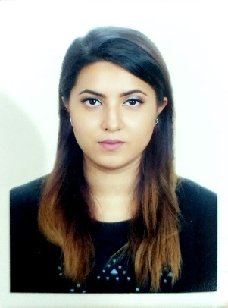

**Tasriba Samrin**

* Date of birth- 19th October, 1994.
* Nationality- Bangladeshi.
* House # 61, Flat- 203, Road # 12A, Dhanmondi, 1209, Dhaka, Bangladesh.
* Phone: +8801971386677
* [tasribanawar19@gmail.com](mailto:tasribanawar19@gmail.com)

**CAREER OBJECTIVE**

With my degree in International Business Management, I have acquired a strong knowledge on management, leadership and communication skills, and with Finanace as my minor, it gives me the edge on numbers as well. Seeking a management position to offer innovative ideas, maintain the productivity and quality of service in your company.

**EDUCATION**

**Undergraduate** – • Jan 2016 - May 2019 • Assumption University in Thailand.  
 Major: International Business Management; Minor: Finance.  
 ( CGPA- 3.73/4.00 ; Academic Honor Roll)

**A’levels**  – • 2013 • Little Jewels School (Bangladesh).  
 ( GPA- 3.15/4.00)

**O’levels**  – • 2011 • Sunshine Grammar School (Bangladesh)  
 ( GPA- 3.50/4.00)  
 **EXPERIENCE**

**• Delegate Philips ASEAN new product launching (April 2017)**

* Worked as a delegate
* Helped the product managers in giving their new product launching presentation and other managerial tasks.

**• Team leader in incoming global volunteer program (AIESEC in Assumption University from January 2016 – May 2017)**

* Chief interviewer in selecting the volunteer from all over the world.
* MC, OC and Logistics member in managing events for AIESEC.

**•Tutor at Private Educational Institute from May 2013 – October 2016**

* Taught students in batches for O’Levels and A’Levels Examination. (Subject: Maths and Physics)

**Volunteer Experience or Leadership**

**• Attended Youth Camp for Asia’s Future in South Korea in 2012.**

* One of the seven members representing Bangladesh in the Youth Camp for Asia’s Future 2012 in South Korea and the youngest participant in the whole camp.

**• AIESEC in Assumption University Incoming Global Volunteer Program (Jan 2016- May 2017)**

* Team leader of the organizing committee
* Handled all the paper works regarding visa for the exchange participants
* For all the events arranged for the participants, organized the event hall, managed the logistics, arranged the rooms and transports for the participants.

**• Assumption University Service Learning English Camp 2018**

* Volunteered in teaching English to the rural school students in Thailand for a week.

**ACHIEVEMENTS**

**• Academic Honor Roll**

* Every semester, managed to receive honor award for maintaining high CGPA through 3.5 years of undergraduate program.

**• X-Culture Challenge Participation Certificate**

* For several months, worked together with a virtual team consisting of students form different countries in different time zone, on business project presented by corporate partners of Xculture.org. Competed, collaborated, learned the challenges and best practices of international business consulting.

**• Certificate of Training in Automated Office Information System Training and Workshop**

**SKILLS**

**•** Proficient with Microsoft Office (Word, Power-point, Excel), Cloud Computing (Google Drive, One Drive) and Social Media.

**•** Language Skill- English (fluent), Bengali (Native), Hindi (fluent), Thai (little).