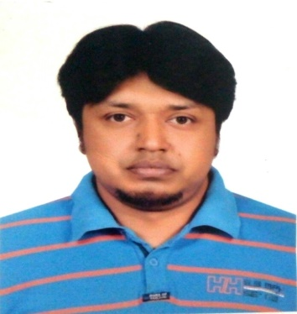**Shafiqul Haq**

**Address:** House# 6/1, Road# Nazi Abdur Rashid Lane, Bangshal, Dhaka-1100

**E-mail:** shafiq.pappu.9050@gmail.com

**Phone:** +88 0197-0405555, +88 0168-3308683

**Career Objective**

Building up Career in a challenging and rewarding position at a wining organization where creativity, sincerity, skill and performance are the criteria for one’s appraisal and recognition.

**Educational Background**

* **Bachelor Of Business Management (BBM), 2006**

Bangalore University

* **Higher Secondary Certificate (HSC), 2002**

Dhaka State College

Board: Dhaka Education Board.

* **Secondary School Certificate (SSC), 2000**

Ahmed Bawany Academy

Board: Dhaka Education Board.

**Computer and Skill**

* Proficient in Microsoft Office package, Photoshop and Illustrator.
* Several application software and tools
* Sound Knowledge on Internet, Operating System and trouble shooting.
* Fundamentals of Digital marketing ,by Google Garage

**Language Proficiency**

* **Excellent Writing and Speaking Capability in both Bangla and English.**

**Strength**

* Capable of adapting in any type of environment,
* Dynamic and self-motivated,
* Ability to cope with people at every level,
* Ambitious and target oriented, &
* Organize programs during college life.

**Experience**

I have worked as a Senior Executive,

Legal, Purchase & Marketing Department.

Ashiyan Land Development Ltd.

March 2011-Novenber 2017

I have woring as a Assistant Manager ,

Legal,Purchase & Marketing Department

Premium Group

December 2017 -Present

**Personal Information**

Father’s Name : Late Nazirul Haque

Mother’s Name : Taslima Haque

Date of Birth : October 1, 1983.

Nationality : Bangladeshi

Marital Status : Married

Religion : Islam

**Hobbies and Interests**

Learning new things, reading, surfing the internet, making friends, watching movies, keeping pets, traveling etc.

**Reference**

Abdus Samad Bablu

Sr Asst Vice President

One Bank ltd

Contact :01714391989