1-Performance   
header line moves it above backup success rate

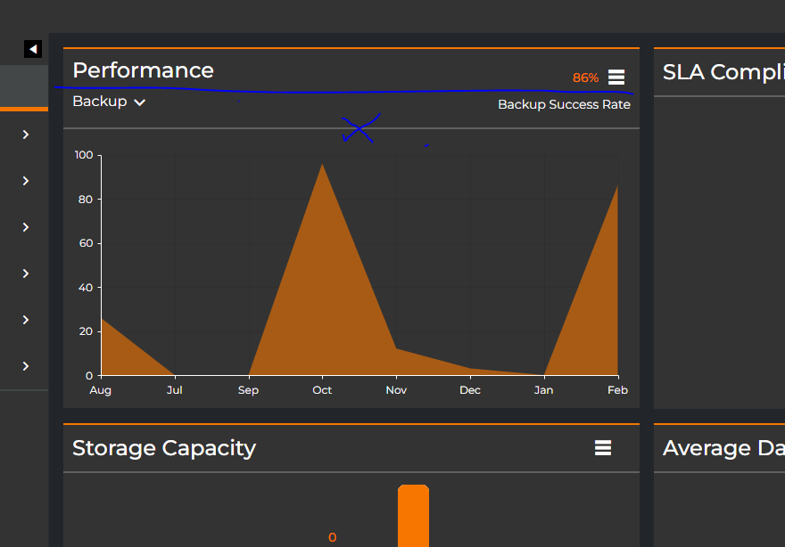

2-cyber status by platform/ severity

Increase its header line as per other widgets

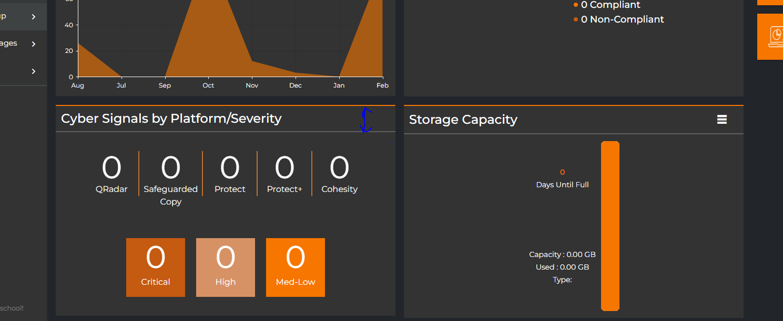

3- Add margins from right and from left horizontal

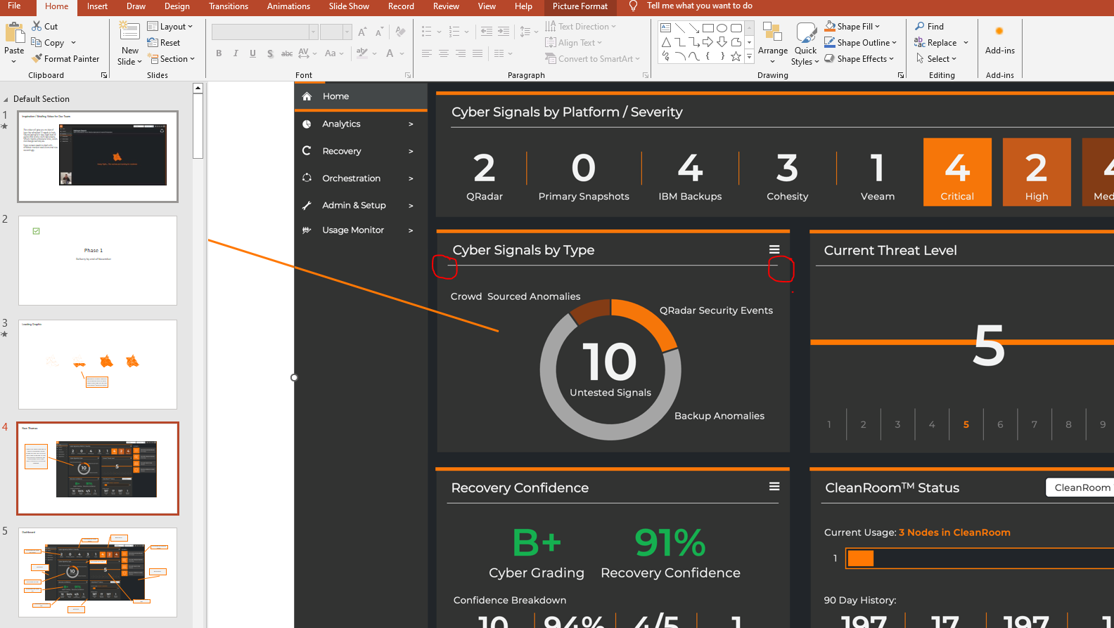

In app

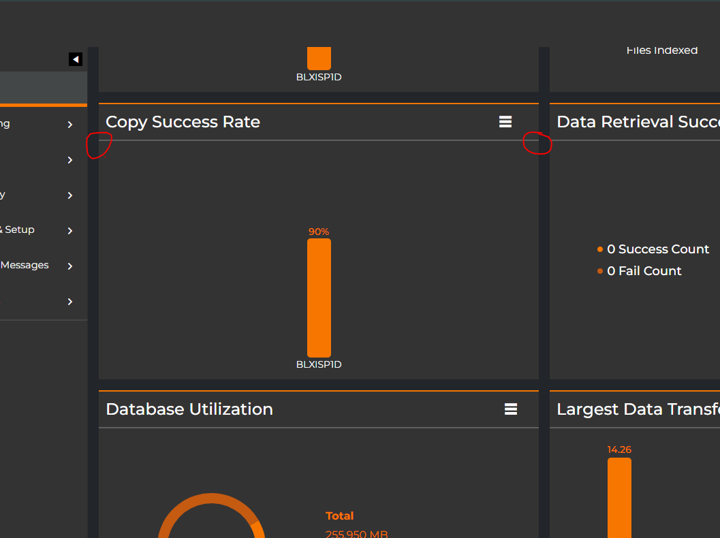

4- increase right padding on the title to ,match the PPT.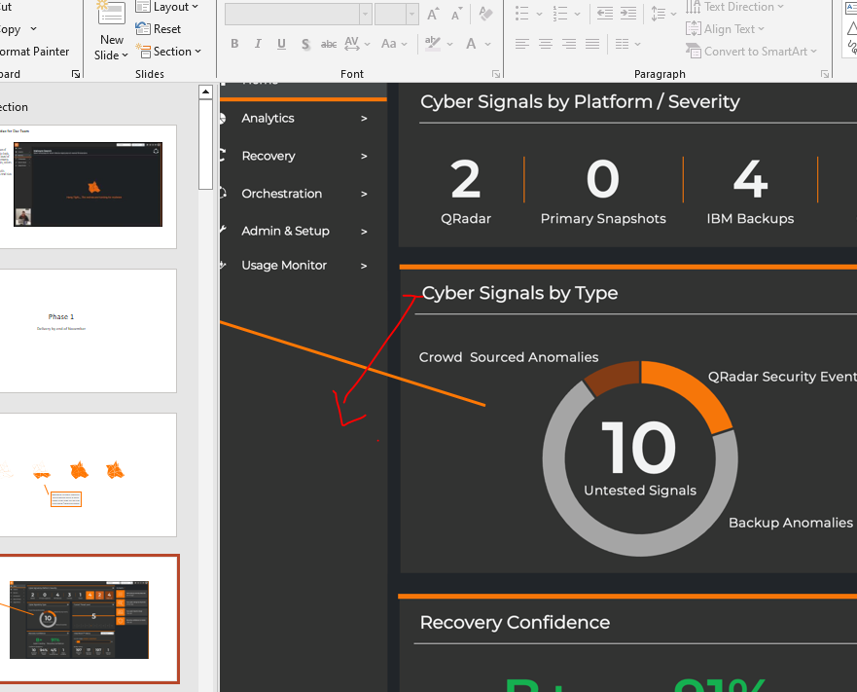

5-update its tile as per PPT.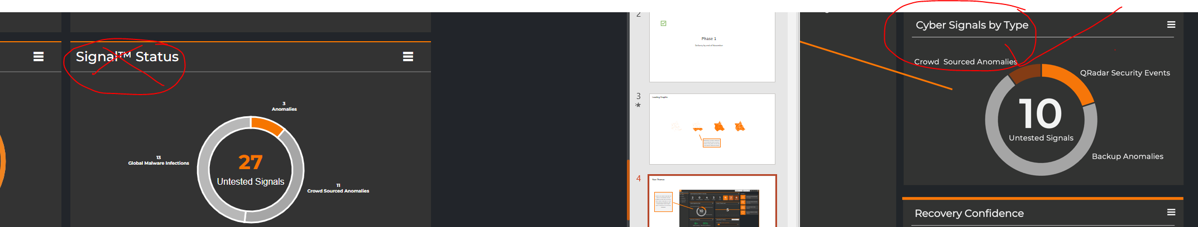

6-in these 5 tiles match font size and weight with PPT like below SS.