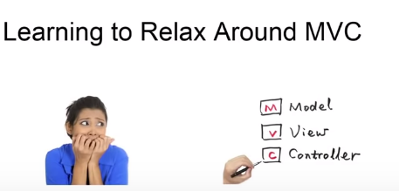

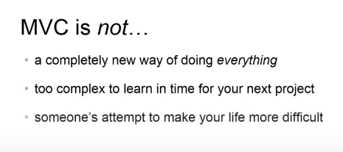\

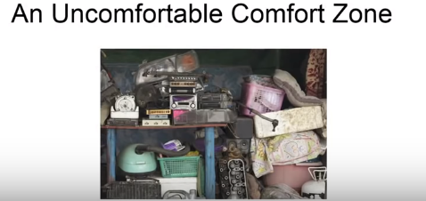

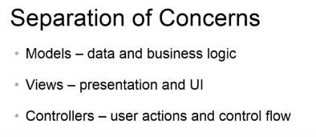



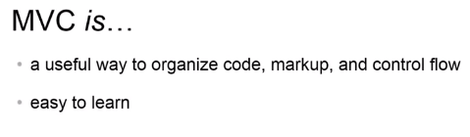



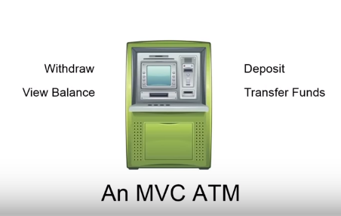

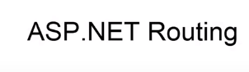

Configure web request to controller actions

Asp.net routing engine relies on url patteren that which request map to url patteren

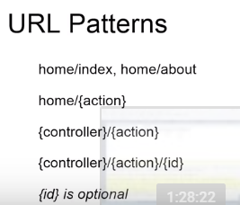

public ActionResult Serial(string letterCase)

{

var serial = "ASPNETMVCATM";

if (letterCase == "lower")

{

return Content(serial.ToLower());

}

return Content(serial);

}

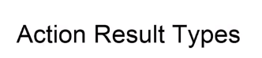

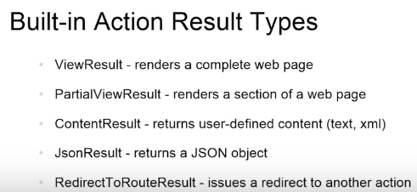

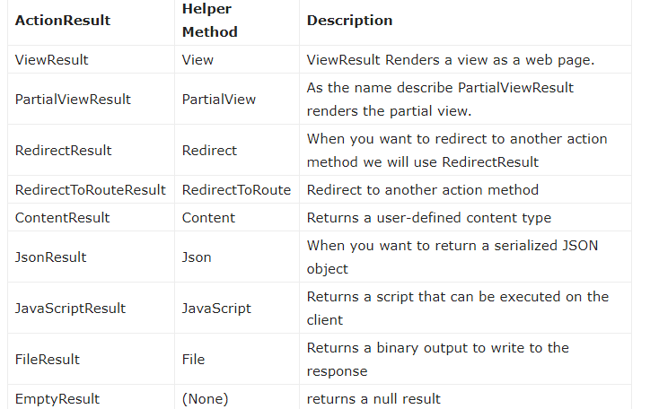



Helps routing which one is select when request come

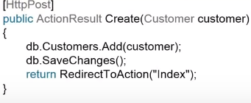

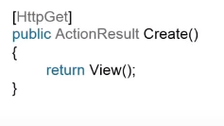

By default it is HTTPGET

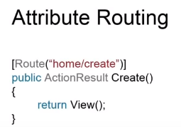



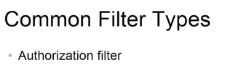

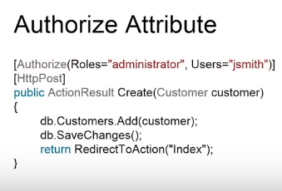

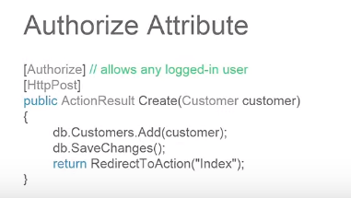

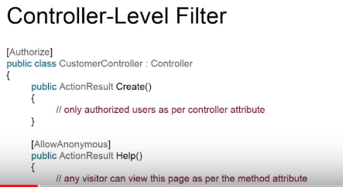



If you want to execute some logic before or after actionresult then use

Creating a custom action filter

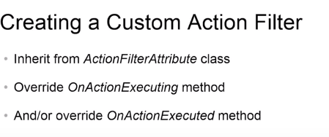

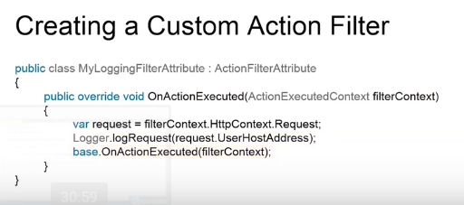

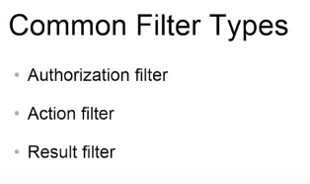

Performs some operation before and after the execution of viewresult

Wrap execution action result of the action

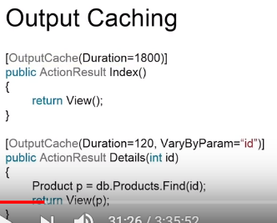

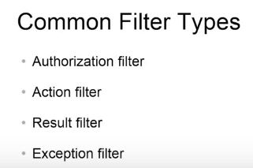

That can be run when unhandled exception

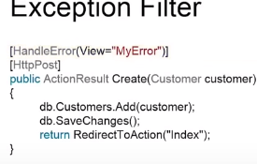

Also specify different view for error

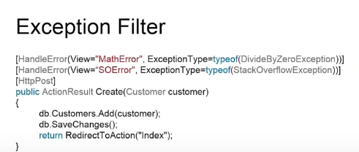



Using Server side code in views By using razor syntax

@{ var amounts = new List<Decimal> { 100, 25, -40 };}

<ul>

@foreach (var amount in amounts)

{

<li>@Formatamout(amount)</li>

}

</ul>

@helper Formatamout(decimal amount)

{

var color = "green";

if (amount < 0)

{

color = "red";

}

<span style="color:@color">@amount</span>

}



**Common parts or all views we can be used in this ….**



**Usefull htmlhelpers methods that can improve readablitity of our code**

<p> @Html.ActionLink("Register","Register","Account",null,new { @class="btn btn-default"})</p>



**We bundling to minimize load time of page … by loading multiple files in a single request..**

**By Using minification we minimize the file by ….. removing white spaces, comments and shortening the variables namex..**

**Minified version is usefull for production…**

**Without minified is useful for development**

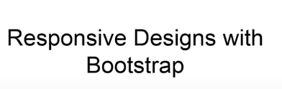

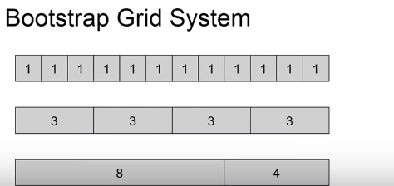



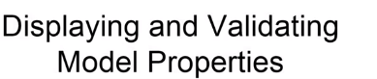



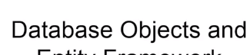



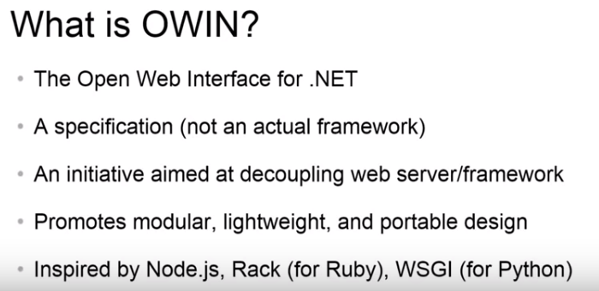

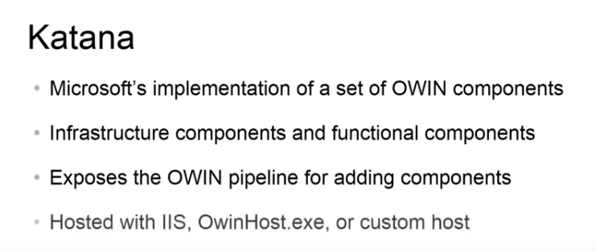

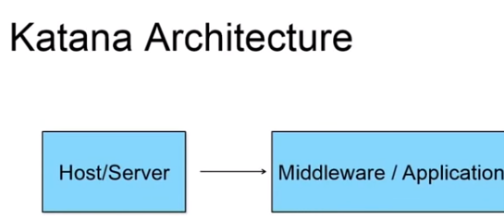

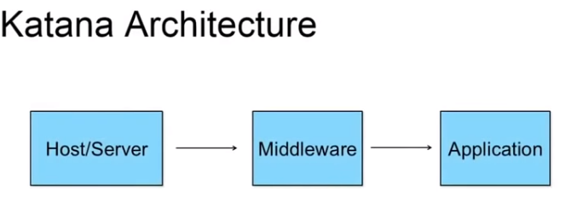

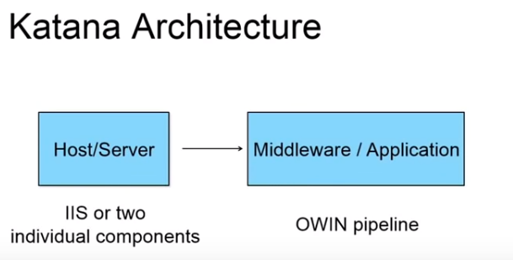

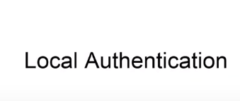



DEVELOPERS.FACEBOOK.COM

Use from their for login using facebook





