**Univariate and Bivariate Analysis in Machine Learning**

1. **Load the Iris dataset into a Pandas DataFrame.**

df = pd.read_csv('iris_data.csv') df.head()

sepal_length sepal_width petal_length petal_width species 0 5.1 3.5 1.4 0.2 setosa

1 4.9 3.0 1.4 0.2 setosa

2 4.7 3.2 1.3 0.2 setosa

3 4.6 3.1 1.5 0.2 setosa

4 5.0 3.6 1.4 0.2 setosa

1. **Perform univariate analysis on all numeric columns (sepal length, sepal width, petal length, petal width).**

* **Calculate summary statistics.** *#print(df.describe())*

for i in df.columns:

if df[i].dtype == 'float64': print(f'{i}:')

print(f'Median: {df[i].median()}')

print(f'Mode: {df[i].mode()}')

print(f'Variance: {df[i].var()}') print(f'Standard Deviation: {df[i].std()}') print(f'Mean: {df[i].mean()}') print(f'Range: {df[i].max() - df[i].min()}') print('\n')

sepal_length:

Median: 5.8

Mode: 0 5.0

Name: sepal_length, dtype: float64 Variance: 0.6856935123042507

Standard Deviation: 0.828066127977863

Mean: 5.843333333333334

Range: 3.6000000000000005

sepal_width:

Median: 3.0

Mode: 0 3.0

Name: sepal_width, dtype: float64 Variance: 0.1880040268456376

Standard Deviation: 0.4335943113621737

Mean: 3.0540000000000003

Range: 2.4000000000000004

petal_length: Median: 4.35

Mode: 0 1.5

Name: petal_length, dtype: float64 Variance: 3.113179418344519

Standard Deviation: 1.7644204199522626

Mean: 3.758666666666666

Range: 5.9

petal_width:

Median: 1.3

Mode: 0 0.2

Name: petal_width, dtype: float64 Variance: 0.582414317673378

Standard Deviation: 0.7631607417008411

Mean: 1.1986666666666668

Range: 2.4

* **Create histograms and box plots for each variable.**

for i in df.columns:

if df[i].dtype == 'float64': plt.figure(figsize=(7, 3))

plt.subplot(1, 2, 1) sns.histplot(df[i]) plt.title(f'{i} Histogram') plt.subplot(1, 2, 2) sns.boxplot(x=df[i]) plt.title(f'{i} Boxplot') plt.show()

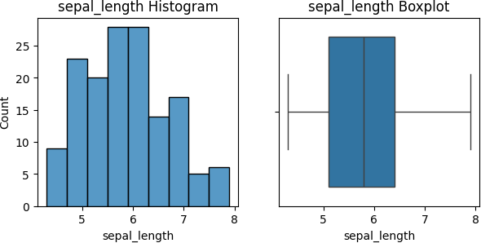

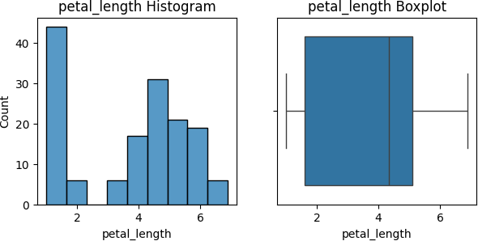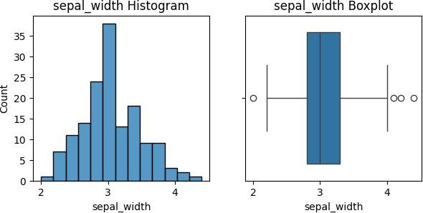

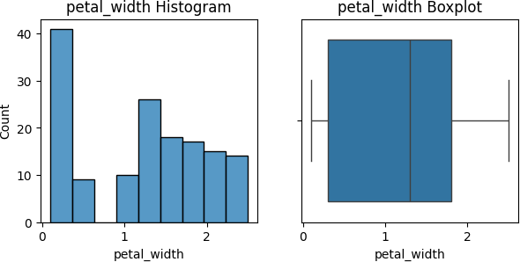

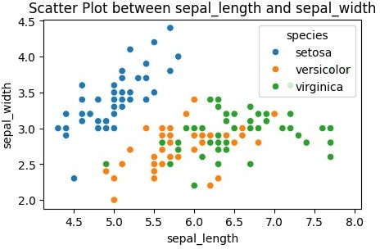

**3. Perform bivariate analysis to explore relationships between pairs of variables.**

* **Create scatter plots for pairs of variables.**

for i in df.columns:

if df[i].dtype == 'float64': for j in df.columns:

if df[j].dtype == 'float64' and i != j: plt.figure(figsize=(5, 3))

sns.scatterplot(x=df[i], y=df[j], hue = df['species']) plt.title(f'Scatter Plot between {i} and {j}') plt.show()

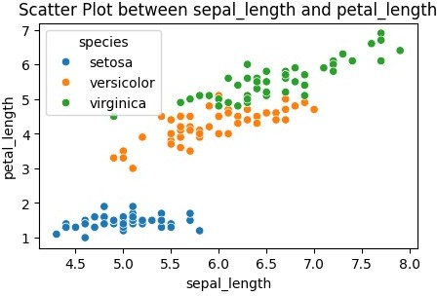

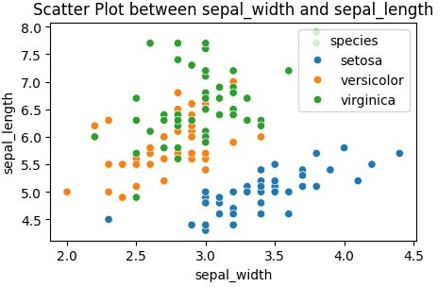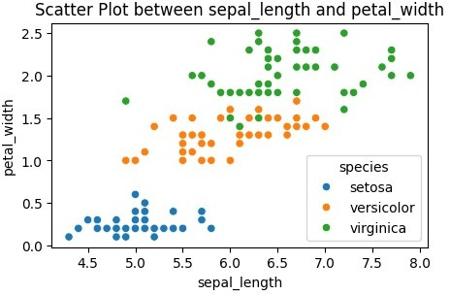

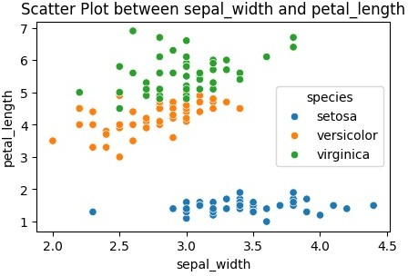

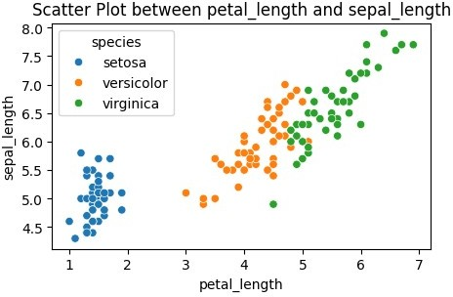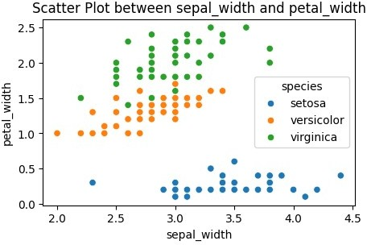

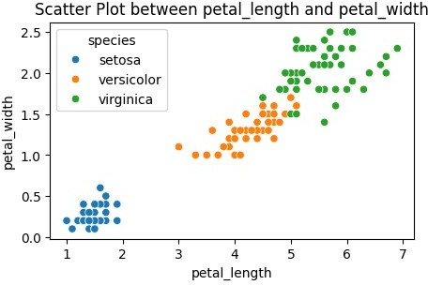

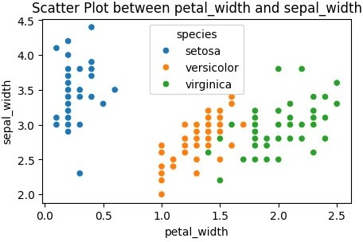

* **Create a pair plot to visualize relationships between all pairs of variables.**

sns.pairplot(df, hue='species') plt.show()

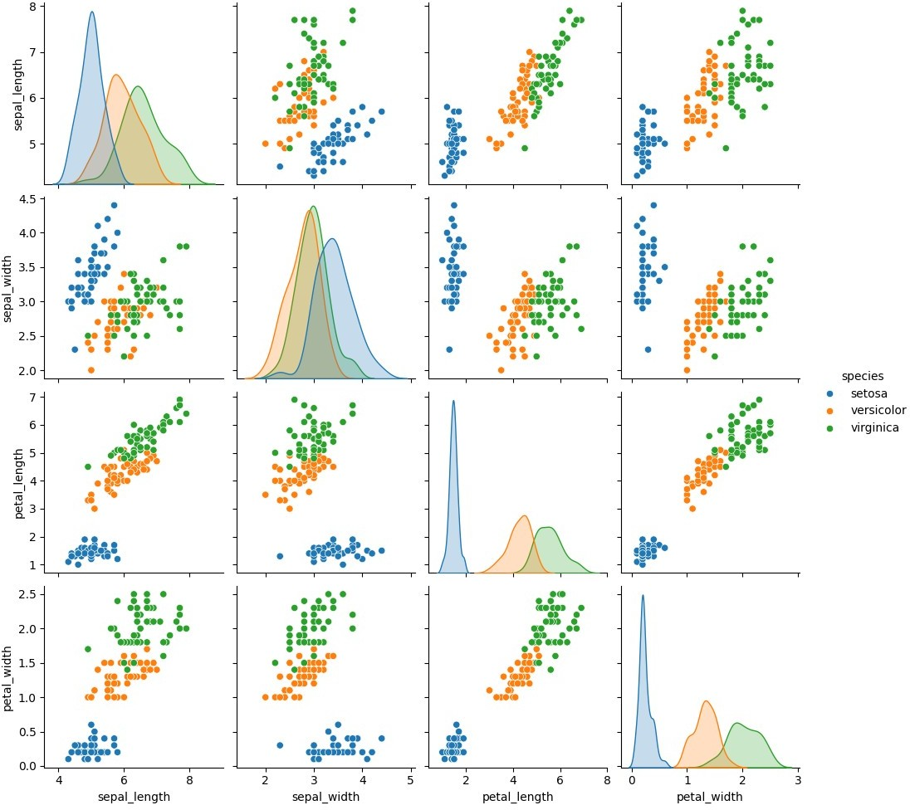

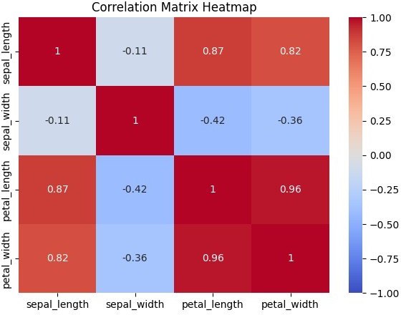

* **Calculate and visualize the correlation matrix.**

df = df.drop(['species'], axis=1) corr_matrix = df.corr() plt.figure(figsize=(7, 5))

sns.heatmap(corr_matrix, annot=True, cmap='coolwarm', vmin=-1, vmax=1) plt.title('Correlation Matrix Heatmap')

plt.show()

**Exploring Various Types of Visual Representations in Python**

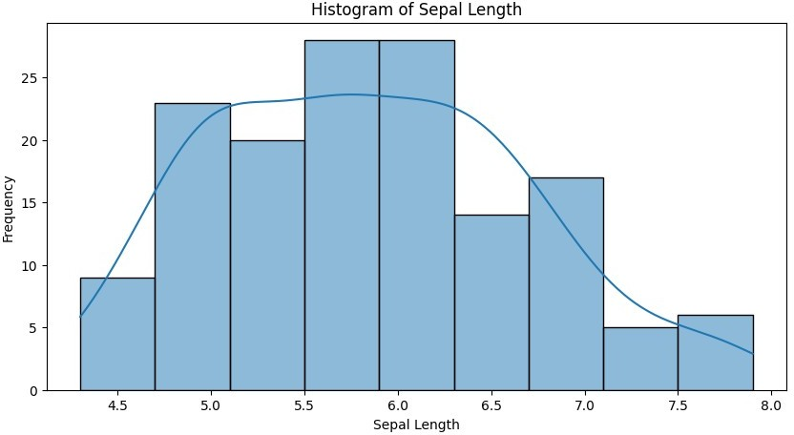

df = pd.read_csv('iris_data.csv') *# Bar Chart* plt.figure(figsize=(10, 5))

sns.countplot(x='species', data=df) plt.title('Count of Each Species') plt.xlabel('Species') plt.ylabel('Count')

plt.show()

1. **Create each type of visualization (histogram, bar chart, line chart, bar and line chart, pie chart, heatmap, pair plot, box plot).**

*# Histogram*

plt.figure(figsize=(10, 5)) sns.histplot(df['sepal_length'], kde=True) plt.title('Histogram of Sepal Length') plt.xlabel('Sepal Length') plt.ylabel('Frequency')

plt.show()

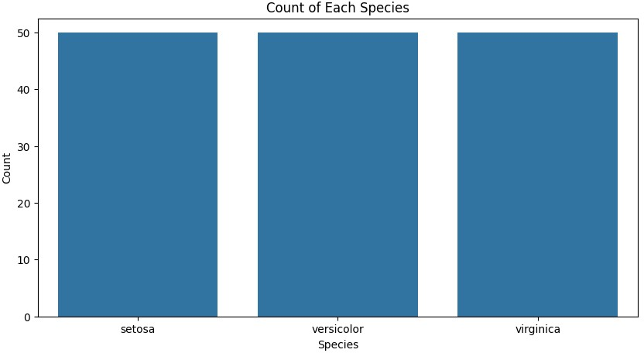

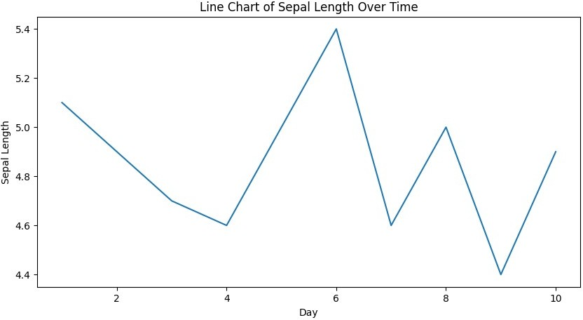

*# Simulating data over time*

time_data = pd.DataFrame({ 'day': range(1, 11),

'sepal_length': df['sepal_length'][:10]

})

*# Line Chart*

plt.figure(figsize=(10, 5))

sns.lineplot(x='day', y='sepal_length', data=time_data) plt.title('Line Chart of Sepal Length Over Time') plt.xlabel('Day')

plt.ylabel('Sepal Length') plt.show()

fig, ax1 = plt.subplots(figsize=(10, 5))

*# Bar chart for count of species*

sns.countplot(x='species', data=df, ax=ax1, alpha=0.6, color='b') ax1.set_ylabel('Count', color='b')

*# Line chart for average sepal length of species*

ax2 = ax1.twinx()

sns.pointplot(x='species', y='sepal_length', data=df, ax=ax2, color='r', markers='o', linestyles='-') ax2.set_ylabel('Average Sepal Length', color='r')

plt.title('Bar and Line Chart of Species Count and Sepal Length') plt.show()

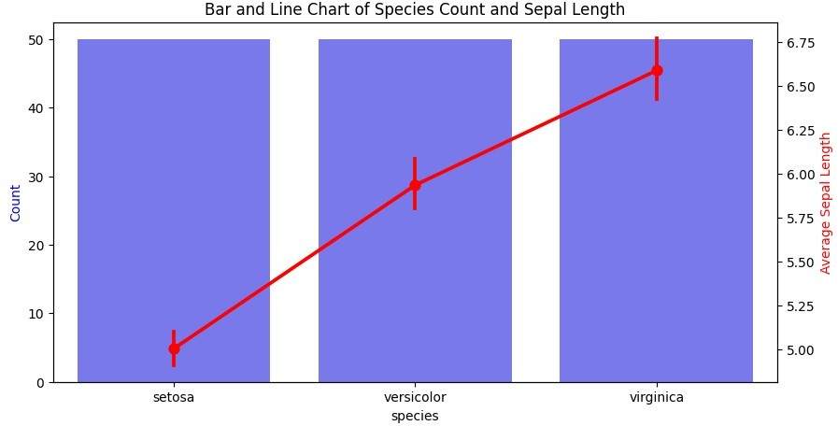

*# Pie Chart*

species_count = df['species'].value_counts() plt.figure(figsize=(10, 5))

plt.pie(species_count, labels=species_count.index, autopct='%1.1f%%', startangle=140)

plt.title('Pie Chart of Species Distribution') plt.show()

*# Heatmap*

df = df.drop(['species'], axis=1) plt.figure(figsize=(10, 5))

sns.heatmap(df.corr(), annot=True, cmap='coolwarm', linewidths=0.5) plt.title('Correlation Heatmap')

plt.show()

df = pd.read_csv('iris_data.csv')

*# Pair Plot*

sns.pairplot(df)

plt.title('Pair Plot of Iris Dataset') plt.show()

*# Box Plot*

plt.figure(figsize=(10, 5)) sns.boxplot(x='species', y='sepal_length', data=df) plt.title('Box Plot of Sepal Length by Species') plt.xlabel('Species')

plt.ylabel('Sepal Length') plt.show()

1. **Write a brief explanation of the purpose of each visualization.**

Here's a brief overview of the purposes of these common visualizations:

**1. Histogram:** A histogram shows the distribution of a single continuous variable by dividing it into intervals (bins) and displaying the frequency of data points in each bin. It's useful for visualizing the spread, central tendency, and skewness of a dataset.

**2. Bar Chart:** A bar chart uses rectangular bars to represent categorical data. The height (or length) of each bar shows the frequency or value of each category, making it easy to compare different categories side-by-side.

**3. Line Chart:** A line chart connects data points with a line to show trends over time or another continuous variable. It’s ideal for visualizing changes, patterns, or fluctuations over intervals, often used for time series data.

**4. Bar and Line Chart:** This combination chart includes both bars and lines, usually on a shared axis, to show relationships between different types of data in a single plot. It can compare different data series or reveal trends alongside category-specific values.

**5. Pie Chart:** A pie chart displays categorical data as slices of a circular “pie,” with each slice representing a proportion of the total. It’s used for showing relative percentages or parts of a whole but is generally best for data with a small number of categories.

**6. Heatmap:** A heatmap uses color intensities to show the values of data points within a matrix or grid. It's great for visualizing the relationship between two variables in a compact, intuitive format, especially in correlation matrices or geographic data.

**7. Pair Plot:** A pair plot (scatterplot matrix) shows pairwise relationships between multiple variables in a dataset. It's a powerful tool for exploring possible correlations and patterns between variables at a glance.

**8. Box Plot:** A box plot shows the distribution of data based on a five-number summary (minimum, first quartile, median, third quartile, and maximum). It highlights outliers and skewness, making it useful for comparing distributions across multiple gr