**NATIONAL UNIVERSITY OF MODERN LANGUAGES**

**ISLAMABAD**



MACHINE LEARNING (LAB)

**Assignment: 01**

**Submitted to**

Ms. Qurat Raja

**Submitted By**

Junaid Asif

(BSAI-144)

**Submission Date:** October 02, 2024

**Question # 01**

* Start another shell. Enter each of the following commands in turn.

1. **Date:**

Displays the current date and time

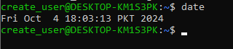

**ii. whoami:**

Shows the current logged-in user's name.



**iii. hostname:**

Outputs the system's network name.



**iv. uname:**

Prints system information (e.g., OS, kernel version).



**v. uptime:**

Displays how long the system has been running.



**Question # 02**

**a. Use the ls command to see if you have any files**.

This will list all files and directories in the current folder.



**b. Create a new file using the cat command as follows:**

**$ cat > hello.txt :**

Entering command

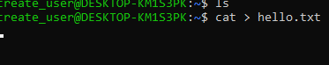

**Hello world!**

**This is a text file:**

After typing the command, entering the following text

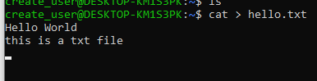

**c. Press Enter at the end of the last line, then Ctrl+D to denote the end of the file.**

Once the text is entered, pressing **Enter**, and then pressing **Ctrl + D** to save and exit.

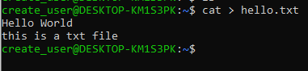

**d. Use ls again to verify that the new file exists.**

This shows hello.txt among the files.

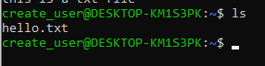

**e. Display the contents of the file:**

This will print the content of hello.txt to the terminal.

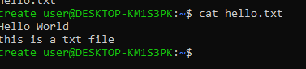

**f. Display the file again, but use the cursor keys to execute the same command again without having to retype it.**

* Press the **up arrow key** on your keyboard to bring back the last command (cat hello.txt) without retyping it.
* Press **Enter** to execute the command again.

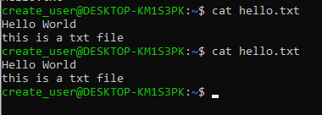

**Question # 03**

**a. Create a second file. Call it secret-of-the-universe, and put in whatever content you deem appropriate.**

This creates a file named secret-of-the-universe and allows us to enter content interactively.



**b. Check its creation with ls:**

Now we Lists files in the current directory to verify the creation of secret-of-the-universe.

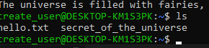

**c. Display the contents of this file. Minimize the typing needed to do this:**

**i. Scroll back through the command history to the command you used to create the file:**

Using the **up arrow key** to navigate to the last cat command.

**ii. Change that command to display secret-of-the-universe instead of creating it:**

Editing the previous command by replacing > with a space and removing any input redirection, like so:

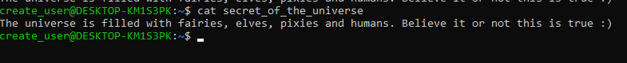

**Question # 04**

**After each of the following steps, use ls and cat to verify what has happened.**

**a. Copy secret-of-the-universe to a new file called answer.txt. Use Tab to avoid typing the existing file’s name in full.**

This copies the contents of secret-of-the-universe into a new file answer.txt.



**b. Now copy hello.txt to answer.txt. What’s happened now?**

This overwrites the contents of answer.txt with the contents of hello.txt.



**c. Delete the original file, hello.txt.**

This removes the file hello.txt from the current directory.



**d. Rename answer.txt to message.**

This renames the file answer.txt to message.



**e. Try asking rm to delete a file called missing. What happens?**

If missing doesn't exist, an error message will be shown stating the file doesn't exist.



**f. Try copying secret-of-the-universe again, but don’t specify a filename to which to copy. What happens now?**

An error will occur because a destination filename is required for the cp command.

