**NATIONAL UNIVERSITY OF MODERN LANGUAGES**

**ISLAMABAD**



MACHINE LEARNING (LAB)

**Assignment: 01**

**Submitted to**

Mr.Meesum Raza

**Submitted By**

Junaid Asif

(BSAI-144)

Adeel Naeem

(BSAI-146)

Syed Qasim Ali

(BSAI-161)

**Submission Date:** November 15, 2024

**Question # 01**

* Use cd to go to your home directory, and create a new directory there called dog.

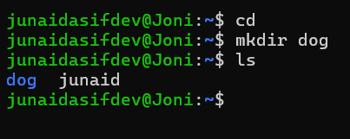

* Create another directory within that one called cat, and another within that called mouse.

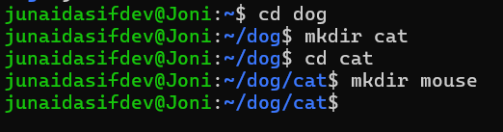

* Remove all three directories. You can either remove them one at a time, or all at once.

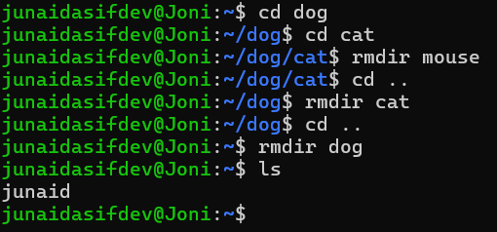

* If you can delete directories with rm -r, what is the point of using rmdir for empty directories?

• Use rmdir when you want to ensure you're only removing empty directories.

• Use rm -r for deleting directories with contents.

* Try creating the dog/cat/mouse directory structure with a single command.

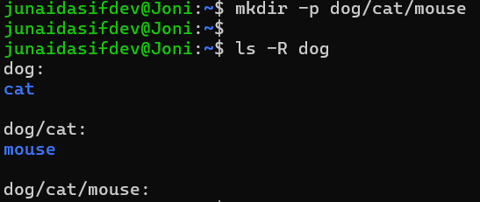

**Question # 02**

* 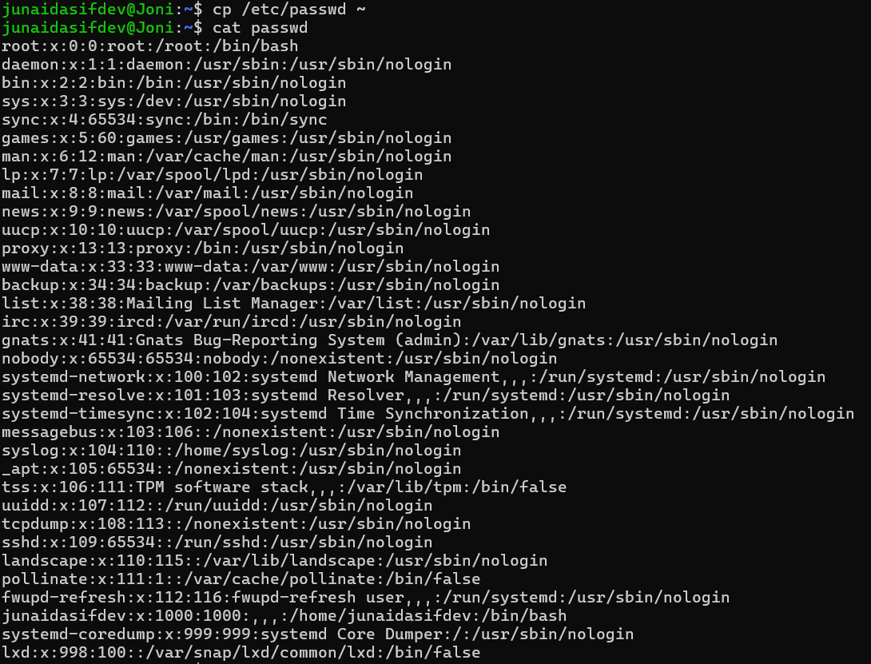Copy the file /etc/passwd to your home directory, and then use cat to see what’s in it.
* Rename it to users using the mv command.

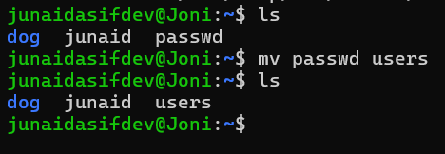

* Make a directory called programs and copy everything from /bin into it.

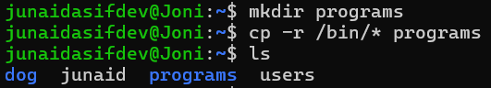

* Delete all the files in the programs directory.

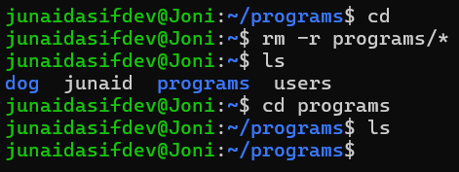

* Delete the empty programs directory and the users file.

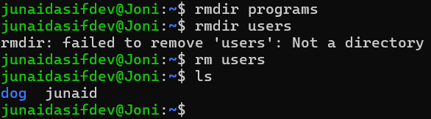

**Question # 03**

* The touch command can be used to create new empty files. Try that now, picking a name for the new file:
* $ touch baked-beans

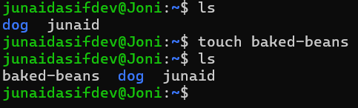

* Get details about the file using the ls command:
* $ ls -l baked-beans
* Wait for a minute, and then try the previous two steps again, and see what changes. What happens Operating Systems when we don’t specify a time to touch?
* Try setting the timestamp on the file to a value in the future.
* When you’re finished with it, delete the file.

