NATIONAL UNIVERSITY OF MODERN LANGUAGES ISLAMABAD



Parallel and Distributed Computing (LAB)

Lab Report: 04 Submitted to
Sir Farhad Riaz
Submitted By Junaid Asif (BSAI-144)

Submission Date: October 20, 2025

Task 01

Problem Statement
Implement a parallel for loop using OpenMP to process iterations concurrently but display some outputs in an ordered manner, ensuring sequence preservation.

Code
#include <iostream>
#include <stdio.h>
#include <omp.h>

int main()
{
int i;
int sum = 0;

#pragma omp parallel for ordered
for (i = 0; i < 10; i++)
{
printf("Thread %d processing iteration %d\n", omp_get_thread_num(), i);
sum += i;

#pragma omp ordered
{
printf("Ordered Output: %d\n", sum);
}
}

printf("Sum of iterations: %d\n", sum);

return 0;
}

Output
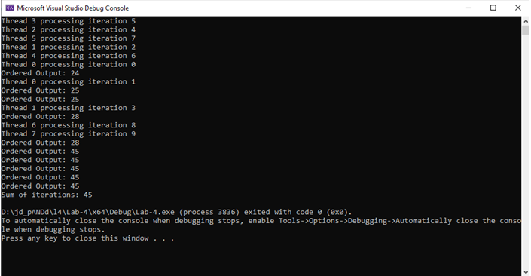

Explanation
- What: Demonstrates the use of the ordered clause to maintain sequential output inside a parallel for loop.
- Why: In parallel execution, outputs may appear out of order due to multiple threads writing simultaneously. The ordered clause ensures that a specific block executes in the original loop order.
- How:
  - #pragma omp parallel for ordered divides loop iterations among threads.
  - #pragma omp ordered ensures the code block inside executes in order, avoiding mixed or unpredictable console outputs.

Comparative Insight
Without ordered, the output becomes interleaved and difficult to interpret. The ordered clause adds synchronization overhead but provides readable, predictable results.

Task 02

Problem Statement
Demonstrate how the master directive restricts a code block to be executed by only the master thread.

Code
#include <iostream>
#include <stdio.h>
#include <omp.h>
int main()
{
int thread_id;
#pragma omp parallel private(thread_id)
{
thread_id = omp_get_thread_num();
printf("Thread %d: Executing parallel section\n", thread_id);

#pragma omp master
{
printf("Master thread %d: Executing master section\n", thread_id);
}

printf("Thread %d: Continuing parallel section\n", thread_id);
}
return 0;
}

Output
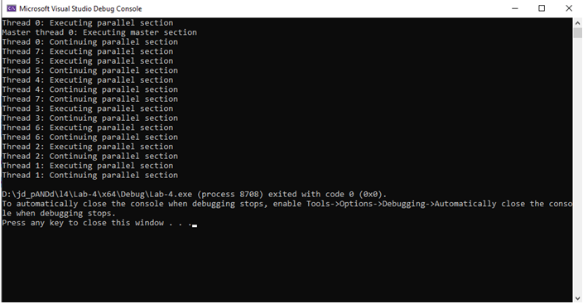

Explanation
- What: Illustrates the role of the master thread (thread 0) executing specific code while other threads skip it.
- Why: Sometimes initialization, I/O, or coordination tasks should only be handled by a single thread to prevent race conditions.
- How:
  - All threads enter the parallel region.
  - The #pragma omp master section runs only by thread 0.
  - Other threads continue after it, skipping the master block.

Comparative Insight
Compared to single, master does not have implicit barriers. It’s faster but may lead to unsynchronized behavior if synchronization is required afterward.

Task 03

Problem Statement
Demonstrate how a shared variable behaves across multiple threads in OpenMP.

Code
#include <iostream>
#include <stdio.h>
#include <omp.h>
int main()
{
int x = 0;
#pragma omp parallel shared(x)
{
x += omp_get_thread_num();
}
printf("%d\n", x);
return 0;
}

Output
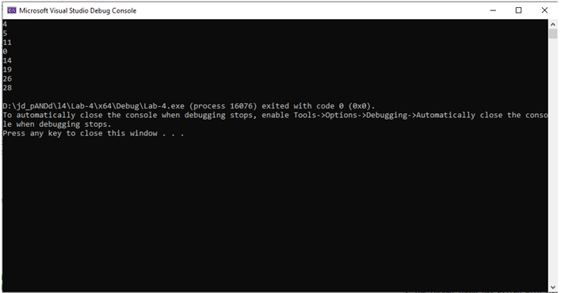

Explanation
- What: Tests the impact of sharing a variable between threads.
- Why: Shared variables are accessible and modifiable by all threads — useful for global state but prone to race conditions.
- How:
  - shared(x) makes variable x accessible by all threads.
  - Each thread adds its ID to x, causing potential data inconsistency because of simultaneous writes.

Comparative Insight
shared provides accessibility but risks data races without synchronization (critical, atomic, or reduction).

Task 04

Problem Statement
Use OpenMP to calculate the sum of array elements in parallel with proper sharing and privatization of variables.

Code
#include <iostream>
#include <stdio.h>
#include <omp.h>
int main()
{
int i, n = 10;
int sum = 0;
int arr[200];

for (i = 0; i < n; i++)
arr[i] = i + 1;

#pragma omp parallel for shared(sum, arr) private(i)
for (i = 0; i < n; i++)
{
sum += arr[i];
}

printf("Sum of array elements: %d\n", sum);
return 0;
}

Output
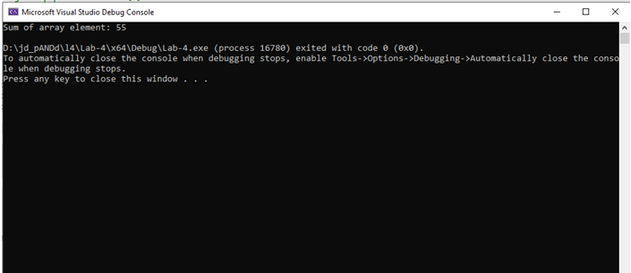

Explanation
- What: Demonstrates parallel summation using shared and private variables.

- Why: To distribute workload among threads and reduce total computation time.
- How:
  - Each thread gets its own copy of i (private).
  - sum is shared, but since it’s updated by all threads, race conditions may occur — ideally needs reduction(+:sum).

Comparative Insight
This task shows how incorrect sharing can lead to inconsistent results. Compared to Task 03, this involves both shared and private control.

Task 05

Problem Statement
Demonstrate the use of private variables in a parallel region and how their scope affects output.

Code
#include <iostream>
#include <stdio.h>
#include <omp.h>
int main()
{
int x = 100;
printf("Before parallel region, x = %d\n", x);
#pragma omp parallel private(x)
{
int thread_id = omp_get_thread_num();
x = thread_id;
printf("Inside parallel region, Thread %d, x = %d\n", thread_id, x);
}
printf("After parallel region, x = %d\n", x);
return 0;
}

Output
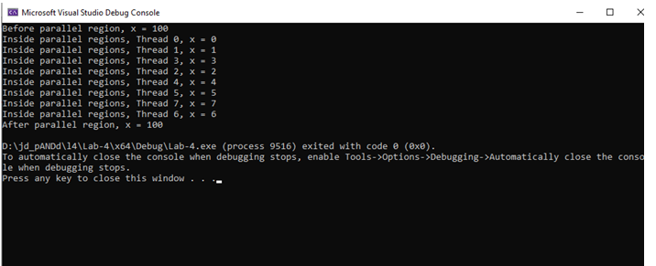

Explanation
- What: Tests how private creates individual copies of variables for each thread.
- Why: To prevent threads from interfering with each other’s data.
- How:
  - Each thread has its own copy of x.
  - Changes inside the region don’t affect the original x.

Comparative Insight
Unlike shared, private ensures thread safety but increases memory usage and lacks inter-thread communication.

Task 06

Problem Statement
Illustrate how firstprivate initializes private copies with the value of the original variable.

Code
#include <iostream>
#include <stdio.h>
#include <omp.h>
int main()
{
int x = 10;
printf("Before parallel region, x = %d\n", x);
#pragma omp parallel firstprivate(x)
{
int thread_id = omp_get_thread_num();
x = thread_id;
printf("Inside parallel region, Thread %d, x = %d\n", thread_id, x);
}
printf("After parallel region, x = %d\n", x);
return 0;
}

Output
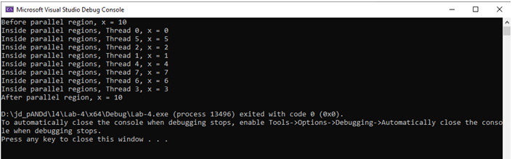

Explanation
- What: Similar to private, but initial values are copied from the master variable.
- Why: Useful when all threads need the same starting value.
- How:
  - Each thread receives a copy of x = 10 before execution begins.
  - Modifications inside the region don’t affect the main copy.

Comparative Insight
Compared to private, firstprivate adds initialization — preventing undefined variable states.

Task 07

Problem Statement
Demonstrate how lastprivate ensures the value from the last iteration of a loop is available outside the parallel region.

Code
#include <iostream>
#include <stdio.h>
#include <omp.h>
int main()
{
int i, x = 0;
#pragma omp parallel for lastprivate(x)
for (i = 0; i < 20; i++)
{
x = i;
}
printf("Thread %d: x = %d\n", omp_get_thread_num(), x);
printf("After parallel region, x = %d\n", x);
return 0;
}

Output
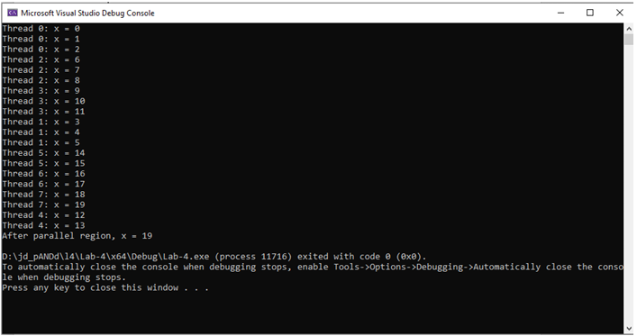

Explanation
- What: Transfers the value of a variable from the last iteration of a loop to the outer scope.
- Why: Ensures consistency of loop-end results after parallel execution.
- How:
  - Each thread updates x, but the last iteration’s value (highest i) is retained outside.

Comparative Insight
lastprivate bridges parallel and serial scopes — it’s essential when post-loop values are required outside.

Overall Comparative Analysis (Across All Tasks)
Feature / Clause | Purpose | Behavior | Advantage | Drawback | Example Tasks
ordered | Maintain output order | Sequential section inside parallel loop | Predictable output | Slower due to synchronization | Task 01
master | Run only by master thread | Exclusive execution by thread 0 | Avoids duplicate operations | No implicit barrier | Task 02
shared | Common memory access | All threads access same variable | Data sharing | Race conditions possible | Task 03, 04
private | Each thread has its own copy | Independent execution | Thread safety | No initialization | Task 05
firstprivate | Private with initialization | Copy master value | Safe and initialized | Slight overhead | Task 06
lastprivate | Retain last iteration value | Propagates final value outside loop | Useful for final results | Complex in nested loops | Task 07

Conceptual Relationships
- private, firstprivate, and lastprivate are variable scope modifiers → control how data behaves across threads.
- shared complements them by providing common access.
- master and ordered are execution control clauses → control when and by whom code executes.
- Proper choice of these clauses directly affects parallel efficiency, synchronization overhead, and correctness.

Why These Clauses Matter
- They define data-sharing attributes, ensuring thread safety, deterministic results, and optimized performance.
- Overuse of shared causes data races; overuse of private increases memory cost.
- Balance ensures both speed and correctness in parallel applications.

