Question: 01
Which part of the serial code can be paralyzed?
Answer:
We can paralyze both the for loops in which different computation is being done.
- Arr[i] = I * 0.5;
- Sum += arr[i];
We can achieve the maximum speed up by paralyzing these loops

Justification:
As you can see the code contains the value of N that is too huge to be computed with less time, also there are two loops running on that value of N so it becomes even more time consuming. We can paralyze these loops to get the maximum speedup.

Question: 02
Paralyze the selected part using correct construct. Show the answer of the serial code and the parallel version of the code.

Serial code:
#include<stdio.h>
#include<omp.h>
int main()
{
int n = 100000;
double sum = 0.0;
double arr[100000];
for (int i = 0; i < n; i++)
arr[i] = i * 0.5;
for (int i = 0; i < n; i++)
sum += arr[i];
printf("Sum = %f\n", sum);
return 0;
}
Output of the Serial Version:
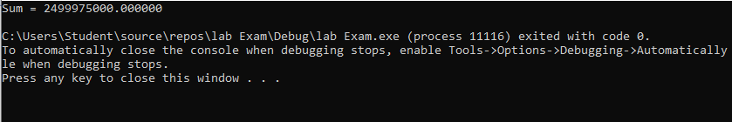

Paralyzed code:
int main()
{
int n = 100000;
double sum = 0.0;
double arr[100000];

#pragma omp parallel
{
#pragma omp sections
{
#pragma omp section
{
for (int i = 0; i < n; i++)
arr[i] = i * 0.5;
}

#pragma omp section
{
for (int i = 0; i < n; i++)
sum += arr[i];

printf("Sum calculated by thread %d: %f\n", omp_get_thread_num(), sum);
}
}

}

printf("Sum = %f\n", sum);
return 0;
}
Output:
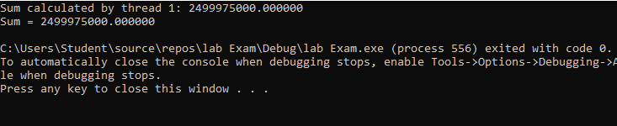

Task: 02
Question: 01
Please use pragma omp barrier at the correct place.
Answer:

Serial code:
#include<stdio.h>
#include<omp.h>
#include<math.h>
#define N 4
int main()
{
double A[N][N] = {
{1,2,3,4},
{2,3,4,5},
{3,4,5,6},
{4,5,6,7}
};
for (int i = 0; i < N; i++)
{
double sum = 0.0;
for (int j = 0; j < N; j++)
sum += A[i][j] * A[i][j];
printf("sum = %f\n", sum);

double norm = sqrt(sum);
for (int j = 0; j < N; j++)
A[i][j] /= norm;
}
printf("Matrix normalized\n");

return 0;
}
Output of serial:
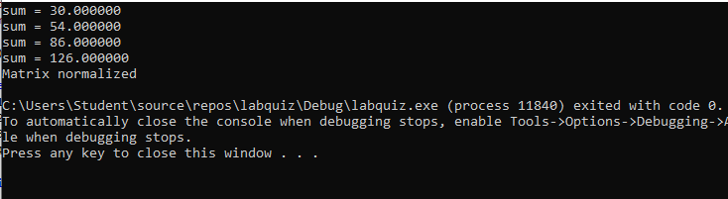

Paralyzed code:
#include<stdio.h>
#include<omp.h>
#include<math.h>
#define N 4
int main()
{
double A[N][N] = {
{1,2,3,4},
{2,3,4,5},
{3,4,5,6},
{4,5,6,7}
};
#pragma omp parallel for

for (int i = 0; i < N; i++)
{
int tid = omp_get_thread_num();

double sum = 0.0;
for (int j = 0; j < N; j++)
sum += A[i][j] * A[i][j];
printf("Thread %d computed sum for row %d = %f\n",tid, i, sum);

double norm = sqrt(sum);

#pragma omp barrier
for (int j = 0; j < N; j++)
A[i][j] /= norm;
printf("Thread %d normalized row %d\n ", tid, i);

}

printf("Matrix normalized\n");
for (int i = 0; i < N; i++)
{
for (int j = 0; j < N; j++)
printf("%f ", A[i][j]);
printf("\n");
}

return 0;
}
Output:
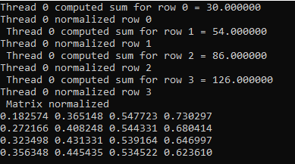

Task: 03

Code:

#include<stdio.h>
#include<math.h>
int main()
{
int n = 1000;
int arr[1000];
for (int i = 0; i < n; i++)
arr[i] = 100 % 10000;
int max_val = arr[0];
for (int i = 1; i < n; i++)
{
if (arr[i] > max_val)
max_val = arr[i];
}

printf("Maximum = %d\n", max_val);
return 0;

}

