**Lab Report –KNN1**

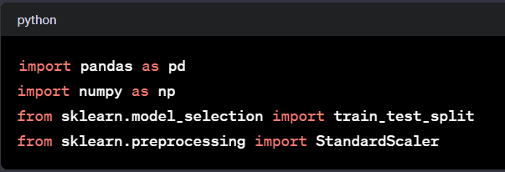

**Imports**: This section imports necessary libraries for data manipulation (pandas and numpy), splitting data (train_test_split), and scaling data (StandardScaler) for feature scaling.

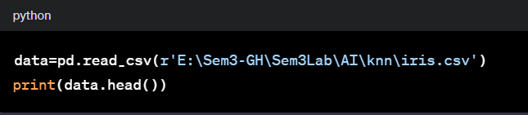

**Loading Data:** It reads a CSV file named 'iris.csv' using Pandas' read_csv function from the specified file path and displays the first few rows of the dataset using head().

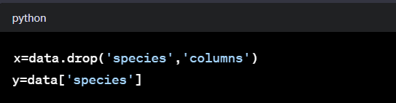

**Defining Features and Target:** It separates the features (x) and the target variable (y) from the dataset. x contains all columns except the 'species' column, and y contains only the 'species' column.

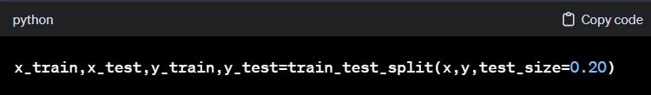

**Train-Test Split:** Splits the dataset into training and testing sets using train_test_split. 80% of the data is used for training (x_train, y_train), and 20% for testing (x_test, y_test).

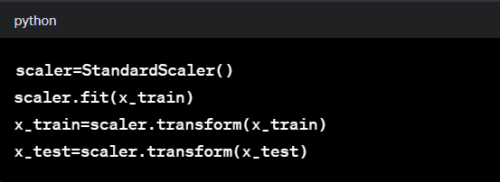

**Feature Scaling:** Initializes a StandardScaler and fits it on the training data (x_train). Then it transforms both the training and testing sets to have zero mean and unit variance using the fitted scaler.

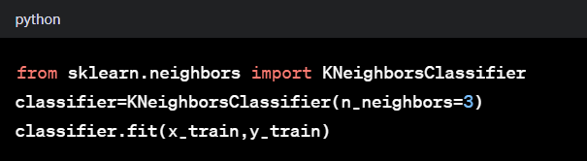

**K-Nearest Neighbors Classifier:** Imports the K-Nearest Neighbors classifier from sklearn, initializes it with n_neighbors=3, and fits it to the scaled training data and corresponding target labels.

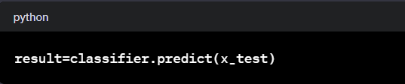

**Prediction:** Uses the trained classifier to predict the target labels (species) for the test dataset (x_test).

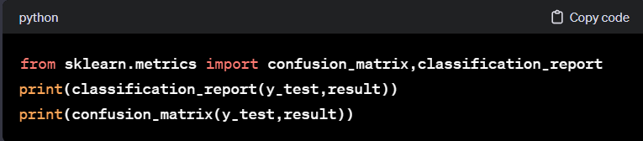

**Model Evaluation:** Generates a classification report and a confusion matrix by comparing the predicted results (result) against the actual target labels (y_test).