**TASK – 01**

**Question # 01:**

**Code:**

name = input("Enter name: ")

age = int(input("Enter age: "))

BY = 2024-age

print(f"Name: {name}, Birth Year: {BY}")

**Explanation:**

This Python code prompts the user to input their name and age. The input function is used to capture the user's name as a string and their age as an integer. Then, the code calculates the user's birth year by subtracting their age from the current year, which is assumed to be 2024. Finally, it prints a formatted string that includes the user's name and calculated birth year. The f"Name: {name}, Birth Year: {BY}" syntax is an example of an f-string, allowing variables to be directly embedded within the string. The output provides a concise summary of the user's information. Note that the birth year calculation assumes that the user has already celebrated their birthday in the current year.

**Time Complexity:**

The time complexity of the code is **O(1)**, constant time complexity, as the number of operations remains the same regardless of the input size.

**Question # 02:**

**Code:**

h = float(input("Enter height in inches: "))

h = h*2.5

print(f"Height in centimeter is: {h}")

**Explanation:**

This Python code takes user input for height in inches using the input function and stores it in the variable h. Then, it multiplies the height value by 2.5 to convert inches to centimeters, as 1 inch is approximately equal to 2.5 centimeters. Finally, it prints the converted height in centimeters using an f-string. The code essentially provides a simple conversion from inches to centimeters.

**Time Complexity:**

The time complexity of this code is constant or **O(1)**, as it performs a fixed number of operations regardless of the input size.

**Question # 03:**

**Code:**

t = float(input("Enter temperature in fahrenhiet: "))

t = (t-32)/1.8

print(f"Temperature in celcius is: {t}")

**Explanation:**

This Python code takes user input for temperature in Fahrenheit, converts it to Celsius using the formula (temp−32)/1.8, and then prints the result. The conversion formula is based on the standard formula for converting Fahrenheit to Celsius. The program first prompts the user to input the temperature in Fahrenheit, then converts it to Celsius, and finally prints the result in a formatted string. The code uses a single variable t to store the converted temperature in Celsius.

**Time Complexity:**

The time complexity of this code is **O(1)** because it performs a constant number of operations regardless of the size of the input.

**Question # 04:**

**Code:**

r = int(input("Enter radius:"))

a = 3.14*r*r

print(f"Area of circle is: {a}")

**Explanation:**

This code is a simple Python script that calculates the area of a circle based on user input for the radius. It first prompts the user to enter the radius, which is then converted to an integer using the int() function. The formula to calculate the area of a circle is A = πr², where 'A' is the area and 'r' is the radius. The code computes the area using this formula and then prints the result using an f-string. The print statement outputs a message indicating the calculated area of the circle.

**Time Complexity:**

In terms of time complexity, the code has a constant time complexity of **O(1)**, as the execution time does not depend on the size of any input or the data involved.

**Question # 05:**

**Code:**

n = int(input("Enter numer: "))

sq = n*n

print(f"Square of {n} is: {sq}")

**Explanation:**

This Python code prompts the user to input a number using the input function, converts the input to an integer using int, and assigns it to the variable n. Then, it calculates the square of the entered number by multiplying it by itself and stores the result in the variable sq. Finally, it prints a formatted string indicating the square of the entered number.

**Time Complexity:**

The time complexity of the code is **O(1)**, indicating that it has a constant time complexity as it performs a fixed number of operations regardless of the input size.

**Question # 06:**

**Code:**

w = float(input("Enter weight n pound: "))

w = w/2.2

print("Weight in KGs: ", w)

**Explanation:**

This code snippet takes user input for weight in pounds, converts it to kilograms, and then prints the result. It first prompts the user to enter a weight in pounds, then divides the input by 2.2 to convert it to kilograms, and finally, it prints the converted weight. The variable w is initially assigned the value of the user input, and then it is updated by dividing it by 2.2. The resulting value is then printed, representing the weight in kilograms. The code is a simple weight conversion program from pounds to kilograms.

**Time Complexity:**

The time complexity of this code is constant or **O(1)** because the operations performed are independent of the size of any input, and the execution time remains constant regardless of the input value.

**Question # 07:**

**Code:**

l = int(input("Enter length: "))

w = int(input("Enter width: "))

h = int(input("Enter height: "))

v = l*w*h

print("Volume = ", v)

**Explanation:**

This Python code calculates the volume of a rectangular prism based on user input for its length, width, and height. The user is prompted to enter values for each dimension, and the code then calculates the volume using the formula V=l×w×h, where l, w, and h are the length, width, and height, respectively. The result is then printed as "Volume = " followed by the calculated volume. The code is simple and straightforward, utilizing basic input and output operations.

**Time Complexity:**

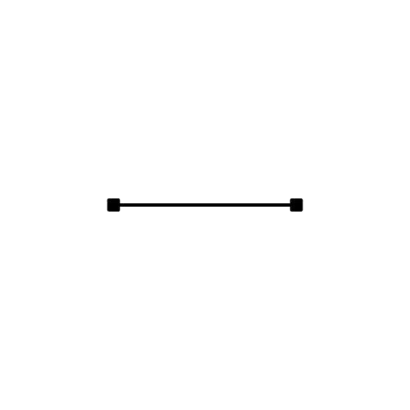 As for time complexity, it is constant or **O(1)** since the execution time does not depend on the input size, as there is a fixed number of operations regardless of the values provided by the user.