**NATIONAL UNIVERSITY OF MODERN LANGUAGES**

**ISLAMABAD**



OPERATING SYSTEM (LAB)

**Lab Report: 13**

**Submitted to**

Mr.Meesum Raza

**Submitted By**

Adeel Naeem

(BSAI-146)

Junaid Asif

(BSAI-144)

Syed Qasim Ali

(BSAI-161)

**Question # 01**

* Find out what permissions are set on your home directory (as a normal user). Can other users access files inside it?



* If your home directory is only accessible to you, then change the permissions to allow other people to read files inside it, otherwise change it so that they can’t.

* Check the permissions on /bin and /bin/ls and satisfy yourself that they are reasonable.

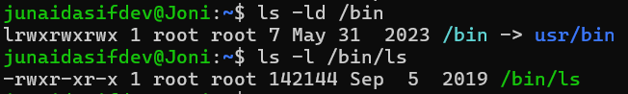

* Check the permissions available on /etc/passwd and /etc/shadow.

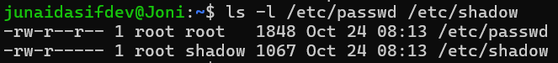

* Write one command which would allow people to browse through your home directory and any subdirectories inside it and read all the files.

