Multilingual Intelligent Text Retriever: A Search Engine for 20 Languages Built on Classical Data Structures
A Project Based Learning Report Submitted in partial fulfilment of the requirements for the award of the degree

of

Bachelor of Technology
in The Department of [Department]
Data Structures and Algorithms – [Course code]

Submitted by
[Roll no.]: [NAME]
[Roll no.]: [NAME]
[Roll no.]: [NAME]

Under the guidance of
[Faculty name]



Department of [Department]
Koneru Lakshmaiah Education Foundation, Aziz Nagar
Aziz Nagar – 500075
OCT - 2026.
Abstract
This report presents the Multilingual Intelligent Text Retriever, a web-based search engine that retrieves documents across 20 languages (13 Indian and 7 global) using only classical data structures and algorithms, with no machine learning, neural embeddings or NLP libraries. A hash-map inverted index and a Trie give exact retrieval, a dynamic-programming Levenshtein matcher with length-adaptive thresholds tolerates typing mistakes, a curated cross-lingual synonym graph is traversed by breadth-first search, and weighted TF-IDF ranks the results. The distinguishing feature is a dynamic meaning graph. When a document is added at runtime, each of its content words is resolved once through Wiktionary and linked to its lemma and its translations; searches then expand the query with a 0-1 BFS that may pivot only on an English hub word, so unrelated concepts are not merged. The graph persists on disk, which means a sentence added on the spot can be found by meaning, in any language, by the very next search.
An audit that adds fresh multilingual sentences and searches for them in other languages and word forms found that the original code answered 2 of 19 queries correctly and returned 28 of 61 expected documents; the final system answers 19 of 19 and returns 61 of 61, with no unrelated document. On the 112-document seed corpus an indexed query is 345 to 873 times faster than a linear scan, typo correction recovers 99.2% of misspelled words of six or more letters, and 30 offline tests and a 49-case audit pass.
Keywords—Information retrieval; inverted index; Trie; Levenshtein distance; breadth-first search; cross-lingual search; Wiktionary; LRU cache.
List of Figures
Fig. 1. System architecture: the eight-stage search pipeline (top, middle) and the data structures behind it (bottom). 2
Fig. 2. Dynamic-programming table for the edit distance between "receipe" and "recipe"; the shaded cells are the optimal alignment. 4
Fig. 3. Meaning-graph examples: (a) inflection and translation, (b) a pivot through the English hub, (c) a chain refused by the hub rule. 6
Fig. 4. Flow of POST /add_document: the new words are linked before the next search, and a search waits for any that are still in flight. 7
Fig. 5. The Add Document form, here filled with the Hindi elephant sentence; while its words are being linked the button reads "Linking meanings…". 8
Fig. 6. Scaling with collection size (median of five runs): (a) index build time and (b) query latency of the inverted index against a naive linear scan. 11
Fig. 7. Share of the expected documents retrieved for each audit query, original code against the final system (R1 = round 1, R2 = late-added sentence). 12
Fig. 8. Search results in the web interface: (a) the English query "elephant" and (b) the Hindi query "हाथी" both reach sentences added on the spot. 13

List of Tables
TABLE I. Data structures and algorithms used in the system 3
TABLE II. Kinds of meaning link learned from Wiktionary 5
TABLE III. Term weights used by the ranker 6
TABLE IV. HTTP routes of the application 8
TABLE V. Experimental environment 9
TABLE VI. Seed corpus: number of documents per language 9
TABLE VII. Sentences added during the meaning-linking audit 10
TABLE VIII. Index build time and query latency against collection size (median of five runs) 10
TABLE IX. Typo correction by query length (250 random single-edit typos per class) 11
TABLE X. Graph traversal time (median of five runs) 11
TABLE XI. Meaning-linking audit: original code against the final system 12
TABLE XII. Defects exposed by the audit and how they were fixed 13
TABLE XIII. Verification suites and outcomes 14

Table of Contents
1. Introduction 1
2. METHODOLOGY 2
a. System Architecture 2
b. Tokenization and Unicode Handling 3
c. Inverted Index and Trie 3
d. Typo-Tolerant Matching with Dynamic Programming 3
e. Curated Cross-Lingual Synonym Graph 4
f. Wiktionary Meaning Retrieval and Caching 4
g. Dynamic Meaning Graph 5
h. Linking Documents Added at Runtime 6
i. Weighted TF-IDF Ranking 7
j. Web Interface and API 7
3. EXPERIMENTS 8
a. Environment and Dataset 8
b. Evaluation Methodology 9
c. Design of the Meaning-Linking Audit 9
4. RESULTS 10
a. Indexing and Query Performance 10
b. Typo Correction 11
c. Graph Traversal 11
d. Cross-Lingual Meaning Linking 12
e. Defects Found by the Audit 13
f. Verification 14
g. Discussion and Limitations 14
5. CONCLUSION and FUTURE WORK 14
References 15

Multilingual Intelligent Text Retriever: A Search Engine for 20 Languages Built on Classical Data Structures

Introduction
Search is the main way people reach information, yet most search engines still behave as if every document and every query were written in one language. In a multilingual country such as India this assumption breaks quickly. A student may search in English for a recipe that was written in Hindi, a traveller may type a Spanish word and expect English travel guides, and the same concept may be written in Devanagari, Bengali, Tamil or Latin script. A plain keyword engine treats chocolate, चॉकलेट and chocolat as three unrelated strings, so two of the three queries return nothing [1].
Modern systems close this gap with multilingual neural embeddings. These models are powerful, but they need pre-trained weights, considerable memory and often a GPU, and their rankings are difficult to explain. Classical information retrieval offers the opposite trade-off: an inverted index, edit distance and TF-IDF scoring are small, fast and fully explainable, but they are literal [1], [4]. This project asks how far classical data structures and algorithms [2] can be pushed toward multilingual, typo-tolerant and meaning-aware search without any machine learning, and it answers the question with a working web application.
The system, called the Multilingual Intelligent Text Retriever, indexes documents in 20 languages in one shared index. It tolerates spelling mistakes through dynamic-programming edit distance, expands queries across languages through graph traversal, and ranks results with weighted TF-IDF. Every result explains why it matched, as an exact hit, a synonym or a meaning link, together with its score breakdown.
A search engine is only useful if it keeps working while its collection changes. A hand-written synonym list can cover a few dozen concepts, but a user who adds a new sentence on the spot introduces words that no list contains. The central problem of this report is therefore stated as a requirement: when a sentence is added at runtime, the meanings of its words must be linked to the rest of the collection immediately, in every language, and must be reflected the very next time anyone searches. Our solution learns the links from Wiktionary [7] when the document is added and keeps them in a persistent meaning graph.
The objectives of the project are:
- to build one inverted index and one Trie that serve all 20 languages with sub-millisecond lookups;
- to correct typing mistakes without turning short valid words into other words;
- to retrieve documents across languages through a curated synonym graph and a learned meaning graph;
- to link the words of documents added at runtime immediately and persistently, including inflected forms; and
- to explain every result (match reason, link path and per-term score) and to verify the behaviour with automated tests and a live audit.
The report is organised as follows. The methodology describes the architecture and each data structure and algorithm. The experiments describe the environment, the corpus and the evaluation design. The results report performance, typo-correction accuracy and the cross-lingual meaning-linking audit, including the defects the audit uncovered and fixed. The last section concludes and lists future work.

METHODOLOGY

System Architecture
The application is a Flask web server [8] built from small single-purpose modules (Fig. 1). A search request passes through eight stages. The tokenizer normalises the query; each term is resolved against the inverted index, the curated synonym graph or, for unknown words, the typo matcher; the meaning graph adds the indexed words that share the query's meaning; the curated graph adds cross-lingual synonyms; the postings of every active term are fetched from the inverted index; and a weighted TF-IDF scorer ranks the documents. The response lists, for each document, the matched terms grouped by reason, the link path of every meaning match and the score contribution of every term, which the web interface renders as highlighted snippets and badges.
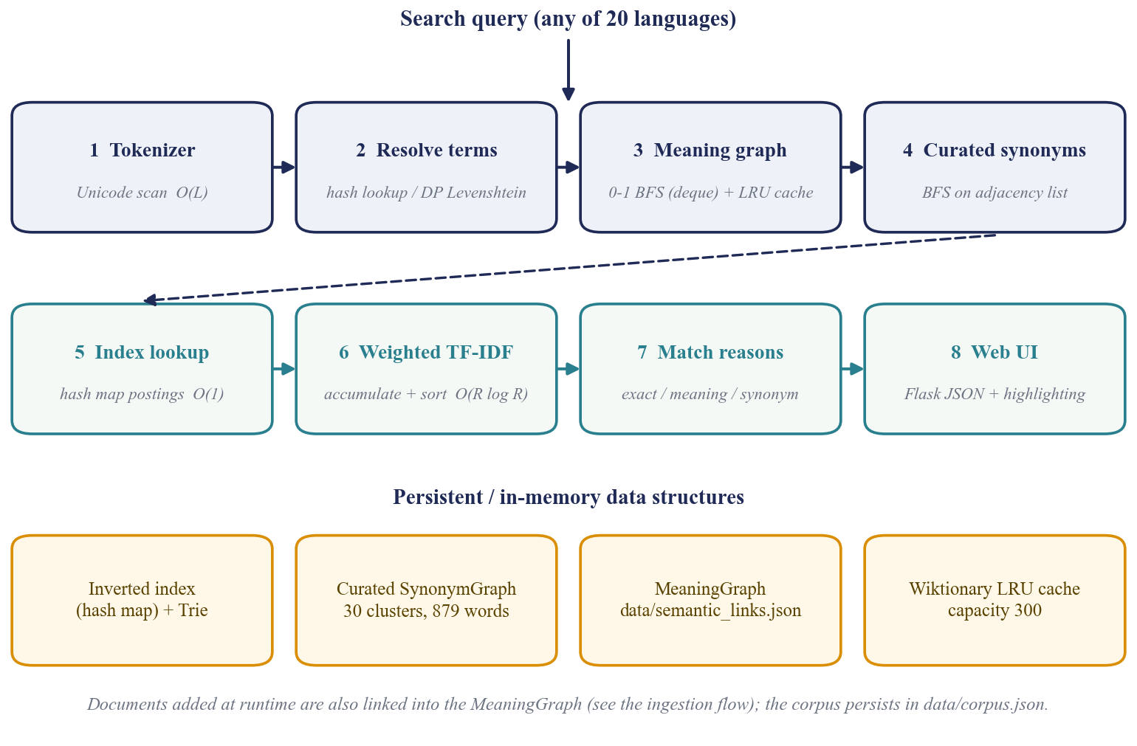
- System architecture: the eight-stage search pipeline (top, middle) and the data structures behind it (bottom).
Table I lists the data structures and algorithms used, the module that implements each and its complexity. They are implemented in the project's own modules on top of Python's built-in dictionary, set, deque and ordered-dictionary types [10]; the only third-party package is Flask.
- Data structures and algorithms used in the system
Concept | Module | Role in the system | Complexity
Hash map | index.py, ranker.py | Inverted index term → {doc: tf}; document store; score accumulation | O(1) lookup; O(V + D) space
Inverted index | index.py | Add and delete documents with posting-list clean-up | O(N) per document
Trie | trie.py | Vocabulary storage and prefix queries [5] | O(L) per word
Graph + BFS | synonyms.py | Curated 20-language synonym clusters; BFS collects every equivalent | O(V + E)
Deque | synonyms.py, semantic.py | Queue for BFS and 0-1 BFS with O(1) operations at both ends | O(1) push / pop
Dynamic programming | matcher.py | Levenshtein table for typo correction [3] | O(m·n)
Length pruning | matcher.py | Skip vocabulary words whose length differs by more than the allowed edits | O(V·m·n) worst case
Weighted graph + 0-1 BFS | semantic.py | Learned meaning graph with cost-0/1 edges and a hub rule [11] | O(V + E), cost ≤ 2
LRU cache | wiktionary.py | Hash map ordered by recency memoises dictionary calls (300 entries) [6] | O(1) get / put
Thread pool + futures | semantic.py | Parallel resolution of new words; searches wait on in-flight futures | O(T / W) rounds
Sets | app.py, synonyms.py | De-duplication of query terms and BFS visited sets | O(1) membership
TF-IDF + sorting | ranker.py | Weighted relevance scoring and descending sort [4] | O(Q·D + R log R)

Tokenization and Unicode Handling
Documents and queries share one tokenizer, so a word is indexed and searched in exactly the same form. The text is lower-cased and split on whitespace, and punctuation is stripped from both ends of every token. Whitespace splitting is deliberate: a regular expression such as \w+ splits Indic words at combining vowel signs (matras) and destroys them. Edge punctuation is recognised by Unicode general category [9] and not by an ASCII list, so the Devanagari and Bengali danda, the Arabic comma and question mark, guillemets and inverted punctuation are all removed. Without this, the last word of every Hindi sentence could never be matched, because it carried the danda with it. French and Italian elisions such as l'éléphant are split so that only the content word is indexed, while English contractions such as don't are left intact. Chinese text contains no spaces, so a whole clause becomes one token; word segmentation is outside the scope of this project (Section 5).

Inverted Index and Trie
The inverted index is a hash map from each term to its postings, which are themselves a hash map from document identifier to term frequency (tf). Two further hash maps hold each document's length and its metadata (title, language, text). Titles are indexed together with the body. Adding a document tokenizes it once, counts the term frequencies and updates the postings in O(N) time for N tokens; deleting a document walks its unique tokens and removes empty posting lists. A Trie over the vocabulary answers prefix queries in O(L + K) time, where L is the prefix length and K the number of matches. Looking up a term costs O(1) on average, which is the property that makes query time depend on the length of the matching postings and not on the size of the collection.

Typo-Tolerant Matching with Dynamic Programming
When a query term is neither an indexed term nor a word the dictionary has confirmed, the matcher looks for the closest vocabulary word by Levenshtein distance [3], computed with the classical recurrence over an (m + 1) × (n + 1) table: D[i][j] = min(D[i−1][j] + 1, D[i][j−1] + 1, D[i−1][j−1] + c), where c is 0 when the i-th and j-th characters are equal and 1 otherwise. Fig. 2 shows the table for the misspelling receipe; its optimal path ends in distance 1, one deleted letter.
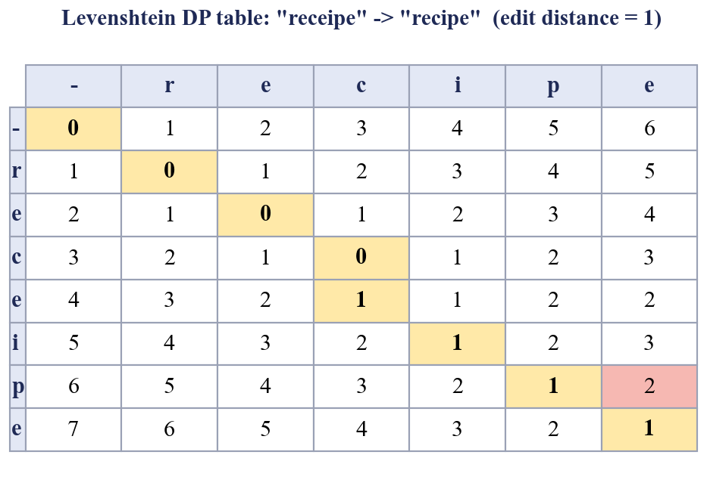
- Dynamic-programming table for the edit distance between "receipe" and "recipe"; the shaded cells are the optimal alignment.
Two safeguards keep correction from doing harm. First, the permitted distance depends on the length of the query: queries of up to three letters are never corrected, because a one-letter change turns can into pan or cat into car; four- and five-letter queries may change by one edit, and longer queries by two. Second, vocabulary words whose length differs from the query by more than the permitted distance are skipped without computing the table. A term is corrected only after the exact index, the curated synonym graph and the list of dictionary-confirmed words have all failed to recognise it.

Curated Cross-Lingual Synonym Graph
The first source of cross-lingual knowledge is a hand-written graph in which each node is a word and each edge joins two words that denote the same concept. It holds 30 concept clusters (for example car and vehicle, chocolate, teacher, difficult) with 879 words and 13,656 edges across all 20 languages, stored as an adjacency list: a hash map from a word to the set of its neighbours. Given a query word, a breadth-first search over a deque collects every word reachable from it in O(V + E) time, so a query for coche also reaches car, कार and गाड़ी. Curated matches are weighted 0.85. Because the clusters are written by hand they are precise, but they cover only a small part of any vocabulary, which is why the learned graph described below is needed.

Wiktionary Meaning Retrieval and Caching
The English edition of Wiktionary [7] supplies the dictionary knowledge. For one word the system issues two requests: the REST definition endpoint, which returns the senses of the word in every language, and the wikitext of the page, from which synonym and translation templates are parsed. The result is turned into candidate links of four kinds (Table II). A foreign headword is glossed by the short English words that begin its first two senses. An inflected form is recognised by a definition made only of grammatical words followed by "of" and a lemma, such as plural of kitten. Strict {{syn}} lists give synonyms, and the translation tables of the English entry, written with the templates {{t}}, {{t+}}, {{tt}} and {{tt+}}, give equivalents in the other supported languages, at most three per language. Candidates must be single words that are not stop-words, not slang and not the headword itself; Arabic vowel marks are removed so that dictionary forms equal the unvowelled words of running text.
- Kinds of meaning link learned from Wiktionary
Link | Source in Wiktionary | Example | Cost | Hub
Inflection | definition "plural of …", "inflection of …" | kittens — kitten | 0 | none
Gloss | first two senses of a foreign headword | gatito — kitten | 1 | the gloss
Synonym | {{syn}} template of the headword | automobile — autokinetic | 1 | none
Translation | {{t}} / {{tt}} tables, at most 3 per language | elephant — elefante | 1 | the headword

Requests are memoised in an LRU cache of 300 entries, implemented as a hash map ordered by recency so that both get and put take O(1) time and the least recently used entry is evicted first [6]. Three details matter in practice. Page titles in Wiktionary are case-sensitive while the tokenizer lower-cases everything, so the capitalised title is tried when the lower-case page holds no supported language (German nouns such as Apfel). A timeout or server error is never cached as "word not found" and never falls through to a different title; it is retried once, honouring the Retry-After header, and otherwise reported as incomplete so that it is tried again later. Finally, when the language of a word is known, as it is for a document, only the entries of that language are used, so Spanish pan (bread) is not mixed with English pan (a cooking vessel).

Dynamic Meaning Graph
The learned links are stored in a meaning graph: an undirected graph kept as a hash map of hash maps, word → {neighbour: (cost, hub)}. The cost of an edge is 0 when the two words are forms of one lexeme (kittens and kitten) and 1 when they share a meaning (kitten and gatito). The hub records which end of an edge is the English headword that other languages hang off, or none for peers such as inflections and synonyms. Edges are undirected, so it makes no difference whether a translation was learned from the Spanish side or from the English side, or in which order the documents were added.
At search time the query word is expanded with a 0-1 breadth-first search [11]. Edges of cost 0 are pushed on the front of a deque and edges of cost 1 on the back, so the deque stays ordered by distance and no priority queue is needed; each reachable word is visited once, in O(V + E) time, and the search stops at total cost 2. A word reached at cost 0, 1 or 2 is scored with weight 0.95, 0.80 or 0.65, so closer links count more (Table III). Fig. 3 gives three examples. In (a) the plural gatitos reaches kitten and kittens within one meaning hop because inflection edges are free. In (b) a Hindi word reaches a Spanish word through the English headword.
A second meaning hop is the source of most false matches, because it chains two translations. The graph therefore allows it only when the middle word is the hub of both edges. Arabic bustān means both garden and orchard, so chaining garden → bustān → orchard would merge two different concepts; since bustān is not the hub of either edge, the chain is refused (Fig. 3c). Two edges between the same words that disagree about the hub lose it, which makes that relation impossible to pivot on.
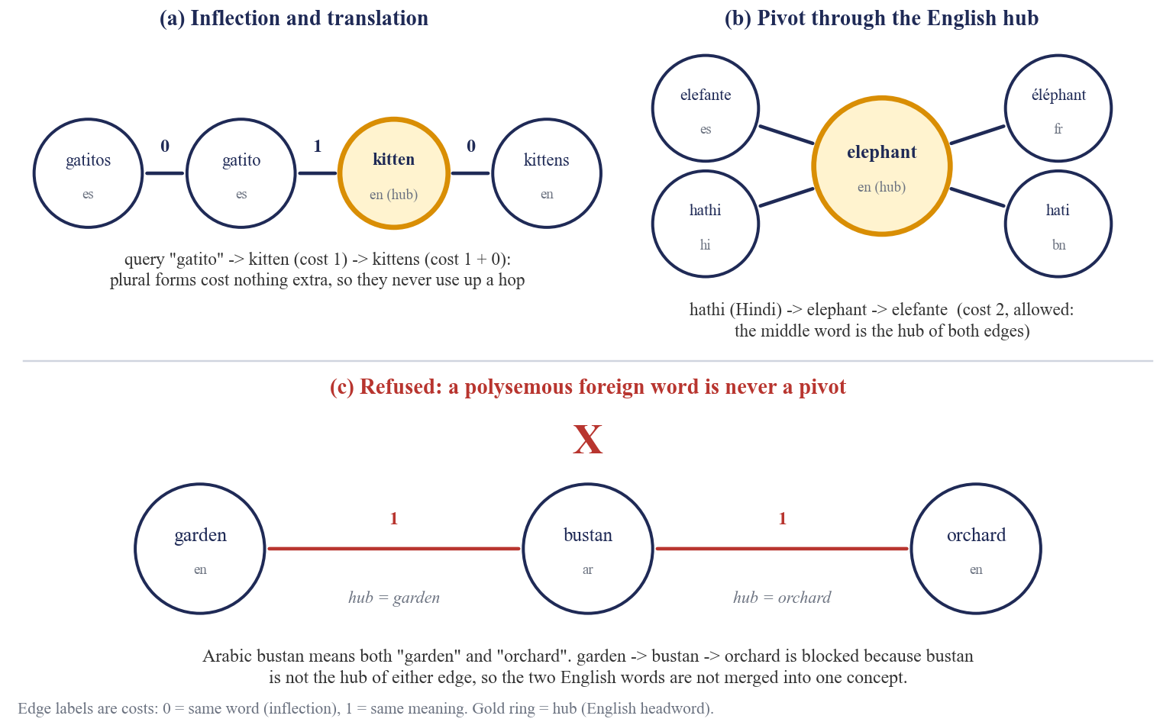
- Meaning-graph examples: (a) inflection and translation, (b) a pivot through the English hub, (c) a chain refused by the hub rule.
- Term weights used by the ranker
Match class | Weight | Example
Exact query term | 1.00 | chocolate → "chocolate"
Lemma or inflection of a meaning term (cost 0) | 0.95 | kitten → "kittens"
Curated synonym (BFS on the curated graph) | 0.85 | car → "coche"
Meaning term, one meaning hop (cost 1) | 0.80 | gatito → "kitten"
Meaning term, two meaning hops (cost 2) | 0.65 | hathi (Hindi) → "elefante"

Linking Documents Added at Runtime
When a document is added, the server indexes it and then calls the semantic linker (Fig. 4). The linker keeps the content words that still need a lookup: it drops function words (a short multilingual list), numbers and URLs, words that appear in at least 8 documents and at least 20% of the collection, and words already resolved; it orders the rest from rarest to most common and keeps at most 40. A pool of six worker threads resolves them in parallel. For an inflected word the lemma is resolved as well, so that gatitos also learns what gatito means.
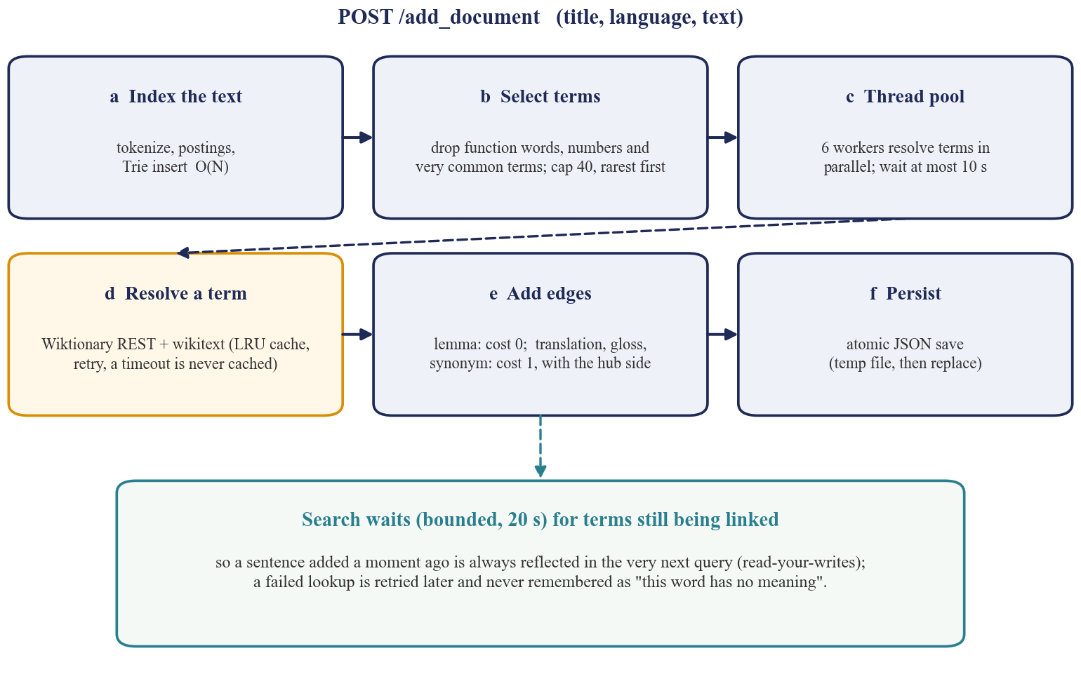
- Flow of POST /add_document: the new words are linked before the next search, and a search waits for any that are still in flight.
The request waits up to 10 s; words that are still being resolved continue in the background, and every search first waits, for at most 20 s, for the words still in flight. A sentence added a moment ago is therefore always reflected in the next query, even when the dictionary is slow. The graph is written to data/semantic_links.json by writing a temporary file and atomically replacing the old one, so a crash cannot leave a half-written store. Several design choices come from failures seen during testing (Section 4): a lookup that fails because of a timeout is not remembered, so it is retried; a word that Wiktionary does not know is remembered, so it is not looked up again; query words that are not yet stored are resolved for that request only and are not written to the graph, so a short ambiguous query cannot pollute the permanent links; and a word the dictionary has positively identified is never "corrected" into a different word by the typo matcher.

Weighted TF-IDF Ranking
The active terms of a query are the exact terms, their curated synonyms and their meaning terms. Each document is scored by TF-IDF [4] with a weight per term: score(d) = Σ tf(t, d) × idf(t) × w(t), where idf(t) = ln(N / (1 + df(t))) + 1, N is the number of documents, df(t) the number of documents containing t and w(t) the weight from Table III. Rare words therefore count for more, and a document containing the exact word outranks one that contains only a translation. Scores are accumulated in a hash map while the postings are traversed, in O(Q·D) for Q terms with D postings each, and the R matching documents are sorted in O(R log R). Each result also receives a relative score and a per-term breakdown, and its matched terms are classed as exact, meaning or synonym matches.

Web Interface and API
The interface is a single page served by Flask. The user types a query, optionally restricts the result language and can switch meaning search on or off. Results show highlighted titles and snippets, a language tag, a score and a badge for each reason a document matched; hovering over a meaning badge shows the chain of links that connects it to the query. A Wiktionary banner shows the definition of the query word and the indexed words it was expanded to. Documents are added and deleted from the same page (Fig. 5); while the words of a new document are being linked, the button reads "Linking meanings…".
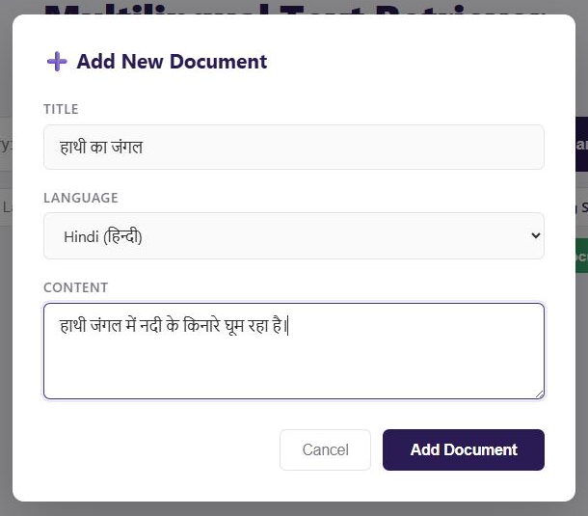
- The Add Document form, here filled with the Hindi elephant sentence; while its words are being linked the button reads "Linking meanings…".
Table IV lists the HTTP routes. Besides search and document management, the backend exposes inspection endpoints for the index, the Trie, the edit-distance table and the synonym graph, and a benchmark page measures index scaling, indexed against naive query time, and typo accuracy. If a search fails, the page reports whether the server could not be reached, answered with an error status, or failed while displaying the results; a failure inside the meaning stage degrades to exact and synonym matching instead of an error. The system is written in Python 3.13 with Flask 3.0 as its only third-party dependency; the front end is plain HTML, CSS and JavaScript, and documents persist in data/corpus.json.
- HTTP routes of the application
Route | Method | Purpose
/ | GET | Search interface
/search | GET | Search or browse; parameters q, lang, fuzzy, synonyms, meaning, limit
/add_document | POST | Add and index a document, then link its words; returns the linking report
/delete_document/<id> | DELETE | Remove a document and clean its postings
/api/define/<word> | GET | Wiktionary definition of a word (LRU-cached)
/api/stats | GET | Index, curated-graph, meaning-graph and cache statistics
/api/trie/prefix | GET | Prefix query on the vocabulary Trie
/api/dp/matrix | GET | Full edit-distance table and alignment for two words
/api/graph/cluster | GET | BFS trace over the curated synonym graph
/api/index/term/<term> | GET | Posting list and document frequency of a term
/api/corpus | GET | Document catalogue
/benchmark, /api/run_benchmark | GET | Performance dashboard and its measurements

EXPERIMENTS

Environment and Dataset
All measurements were taken on one laptop (Table V). The dataset is the project's seed corpus of 112 short documents in 20 languages: titles and one-to-two-sentence descriptions of recipes, travel, technology and everyday topics, with parallel documents on the same concept in several languages (Table VI). After tokenization the index holds 1,137 distinct terms and 1,496 postings, and a document has 14.9 tokens on average. The corpus is small, which suits an interactive demonstration but means that retrieval quality is measured on designed test cases and not on a standard benchmark.
- Experimental environment
Item | Value
Processor | Intel Core i7-12700H, 15.6 GB RAM
Operating system | Windows 11 Home
Software | Python 3.13.3, Flask 3.0.0 (the only third-party dependency)
External service | English Wiktionary REST and MediaWiki APIs, queried live over the internet
Timing | time.perf_counter; median of five runs of benchmark_experiments.py
Corpus | 112 seed documents, 20 languages, 1,137 terms, 1,496 postings

- Seed corpus: number of documents per language
Language | Docs | Language | Docs | Language | Docs | Language | Docs
Hindi | 15 | Marathi | 4 | Kannada | 4 | Sanskrit | 3
Bengali | 4 | Tamil | 4 | Malayalam | 4 | English | 19
Telugu | 4 | Urdu | 4 | Odia | 3 | Spanish | 14
French | 4 | German | 4 | Portuguese | 4 | Arabic | 4
Chinese | 4 | Gujarati | 4 | Punjabi | 3 | Assamese | 3

Evaluation Methodology
Six experiments were run. The first four are reproduced by python benchmark_experiments.py (the figures in this report are the median of five runs, because absolute timings fluctuate with machine load) and the audit by python audit_semantic_links.py.
- Index build time. The seed corpus is replicated to 112, 1,000, 5,000, 10,000 and 20,000 documents; each size is built three times and the median is reported.
- Query latency. Six queries (chocolate, travel, recipe, technology, and one each in Hindi and Bengali) are run 300 times each against the index and against a naive baseline that re-tokenizes every document on every query.
- Typo correction. A random single-character substitution, deletion or insertion (fixed seed) is applied to indexed words; 250 typos per query-length class, excluding those that are themselves valid words, are corrected and compared with the original word.
- Graph traversal. BFS time on the curated graph, and 0-1 BFS time on synthetic hub graphs of 1.8 thousand to 180 thousand edges.
- Meaning-linking audit. Described in the next subsection.
- Regression and unit tests. The existing 49-case audit and smoke test, plus 30 new offline tests that replace Wiktionary by a fake dictionary so that the graph logic is tested deterministically.

Design of the Meaning-Linking Audit
The audit simulates a user who adds sentences on the spot. Ten sentences in five languages (Table VII) are added through the real /add_document route. None of their key words (kitten, elephant, apple, garden, river and their translations) occurs in the seed corpus or in the curated graph, so every link has to come from the dictionary. Fifteen queries then ask for the same concept in another language or word form, for example gatito for the English kitten sentence, elefante for the Hindi elephant sentence, and manzana, a word that occurs in no sentence at all. A query is fully correct only if it returns exactly the expected set of sentences and no other sentence. In a second round one more French sentence is added after those searches, and four queries must find it immediately. The audit therefore has 19 queries and 61 expected documents; it never writes to the real corpus and is run with python audit_semantic_links.py.
- Sentences added during the meaning-linking audit
ID | Lang. | Title and text
kit_en | en | Kitten on the sofa: The little kitten sleeps quietly on the sofa every afternoon.
kit_es | es | Mi gatito: El gatito duerme en el sofá toda la tarde.
kits_en | en | Playful kittens: The kittens are playing with colorful toys in the garden.
kits_es | es | Los gatitos: Los gatitos juegan con juguetes de colores en el jardín.
ele_en | en | Elephant safari: We saw a huge elephant near the river during our safari.
ele_es | es | Elefante en la selva: Un elefante camina por la selva con su cría.
ele_hi | hi | हाथी का जंगल: हाथी जंगल में नदी के किनारे घूम रहा है।
app_fr | fr | La pomme rouge: La pomme est rouge et sucrée.
app_de | de | Der Apfel: Der Apfel ist rot und süß.
app_en | en | Apple orchard: She planted an apple tree behind the house.
ele_fr | fr | (round 2) L'éléphant: L'éléphant boit de l'eau dans la rivière.

RESULTS

Indexing and Query Performance
Absolute timings on a laptop vary with background load: an earlier single run on a quieter machine was about three times faster than the runs reported here. All figures in this section are therefore the median of five runs of python benchmark_experiments.py, and the ratios, which are stable, are the main result. Index build time grows linearly with the collection, from 5.8 ms for the 112 seed documents to 603 ms for 20,000 documents (Table VIII, Fig. 6a). An indexed query takes 0.018 ms on the seed corpus and 0.67 ms at 10,000 documents, whereas the naive scan takes 6.2 ms and 557 ms. The indexed search is therefore between 345 and 873 times faster (Fig. 6b). The gap exists because the scan must tokenize every document on every query, whereas an indexed query touches only the postings of its terms, so its cost follows the number of matching documents and not the size of the collection.
- Index build time and query latency against collection size (median of five runs)
Documents | Index build (ms) | Indexed query (ms) | Naive scan (ms) | Speed-up
112 | 5.8 | 0.0184 | 6.21 | 345×
1,000 | 27.6 | 0.0761 | 56.58 | 768×
5,000 | 133.0 | 0.3235 | 284.54 | 873×
10,000 | 272.6 | 0.6702 | 557.16 | 824×
20,000 | 603.2 | not measured | not measured | –

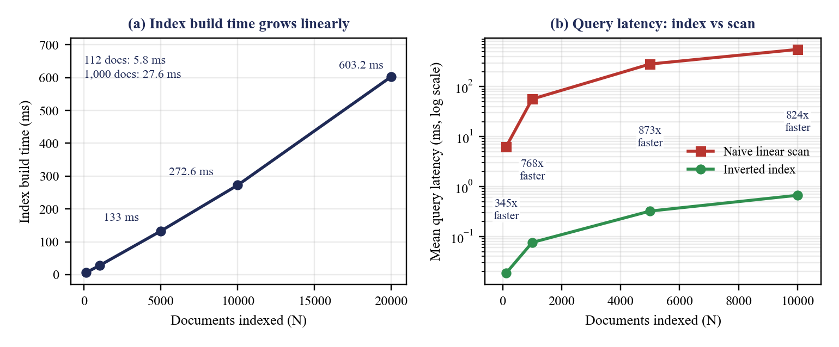
- Scaling with collection size (median of five runs): (a) index build time and (b) query latency of the inverted index against a naive linear scan.

Typo Correction
Table IX shows that the length-adaptive thresholds behave as designed. Queries of up to three letters are never altered, which is what prevents valid short words from being changed. Four- and five-letter typos are corrected to the original word 93.2% of the time and typos of six or more letters 99.2% of the time; the remaining cases are ties in which another vocabulary word is equally close. These counts are deterministic (fixed random seed) and identical in every run. Skipping vocabulary words whose length is too different removed 59.9% of the comparisons and reduced the median correction time for typos of six or more letters from 58.4 ms to 23.6 ms, a factor of 2.4, over the 1,137-term vocabulary (the factor ranged from 2.4 to 7.3 between runs because of timing noise).
- Typo correction by query length (250 random single-edit typos per class)
Query length | Corrected | Original word recovered | Median time per query (ms)
up to 3 letters | 0 (0%) | 0 (never corrected, by design) | 0.00
4–5 letters | 250 (100%) | 233 (93.2%) | 11.97
6 letters or more | 250 (100%) | 248 (99.2%) | 24.53

Graph Traversal
Both graph searches take well under a millisecond (Table X). A BFS over the curated graph takes 110 µs on average for six query words, including the 45-word car cluster. The 0-1 BFS on the meaning graph, bounded to cost 2, takes 34 to 41 µs on synthetic graphs of 1.8 thousand to 180 thousand edges: a hundredfold increase in graph size does not increase the time, because the search visits only the neighbourhood of the query word and not the whole graph (the run-to-run range was 12 to 67 µs).
- Graph traversal time (median of five runs)
Structure | Nodes | Edges | Median time per expansion
Curated SynonymGraph (BFS, 6 query words) | 879 | 13,656 | 110.0 µs
MeaningGraph (0-1 BFS, synthetic hubs) | 1,800 | 1,799 | 41.3 µs
MeaningGraph (0-1 BFS, synthetic hubs) | 18,000 | 17,999 | 40.9 µs
MeaningGraph (0-1 BFS, synthetic hubs) | 180,000 | 179,999 | 34.4 µs

Cross-Lingual Meaning Linking
Before the change, only 2 of the 19 audit queries were fully correct (Table XI, Fig. 7). A query for one word found only some of the sentences that expressed the same concept: 28 of the 61 expected documents (45.9%) were returned, and one unrelated document appeared. After the change, all 19 queries are fully correct, all 61 expected documents are returned and no unrelated document appears, including for the word manzana, which is in no sentence, and for the French sentence added after the first searches.
- Meaning-linking audit: original code against the final system
Measure | Before | After
Queries fully correct | 2 of 19 | 19 of 19
Expected documents found, round 1 | 22 of 45 | 45 of 45
Expected documents found, round 2 (late sentence) | 6 of 16 | 16 of 16
Expected documents found, total | 28 of 61 (45.9%) | 61 of 61 (100%)
Unrelated documents returned | 1 ("garden" → "Apple orchard") | 0
Search time, first query for a word | 1.4–6.8 s (live lookup each time) | 0.0 s once stored; 0.9 s for an unseen word
Time to add one sentence | 0.0 s (nothing linked) | 0.9–3.9 s, median 1.9 s (11 sentences)

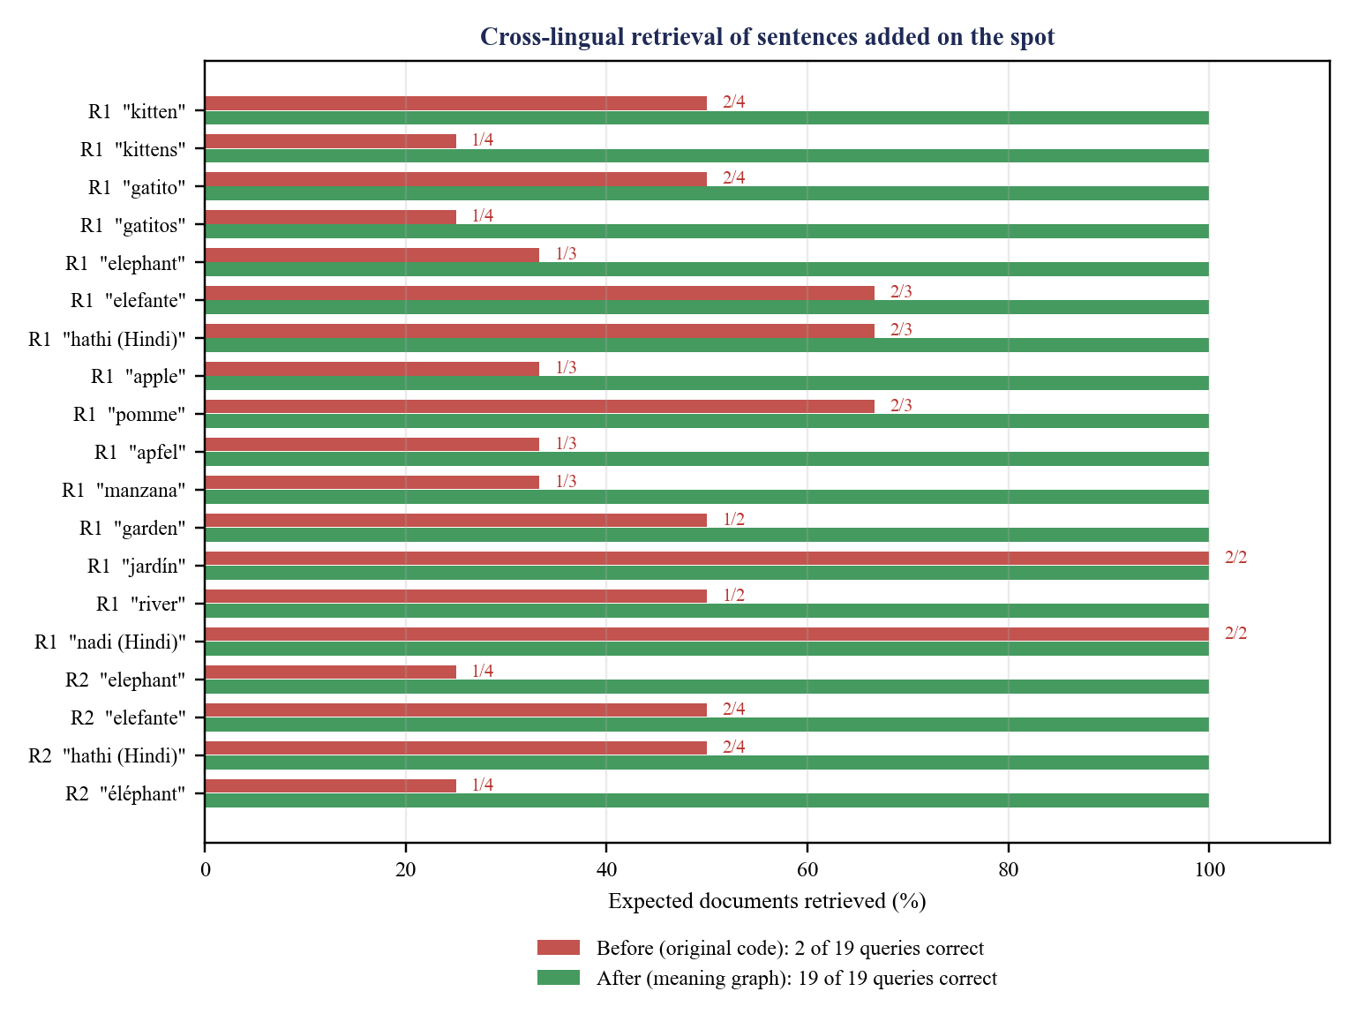
- Share of the expected documents retrieved for each audit query, original code against the final system (R1 = round 1, R2 = late-added sentence).
The price of the improvement is paid when a document is added, not when it is searched. Adding a sentence took between 0.9 s and 3.9 s in the final audit run, with a median of 1.9 s, because each new word needs two requests to Wiktionary; once the links are stored a search takes milliseconds and works without the network. During an earlier run in which the Wikimedia API was slow, adding a sentence took 5 to 18 s; this is why the add request has a 10 s limit and why searches wait for words still in flight. Fig. 8 shows the real interface after the Hindi and Spanish elephant sentences were added through the form: the English query elephant, which occurs in neither sentence, retrieves both of them, and the Hindi query हाथी retrieves the Hindi sentence exactly and the Spanish sentence through the link path हाथी → elephant → elefante.
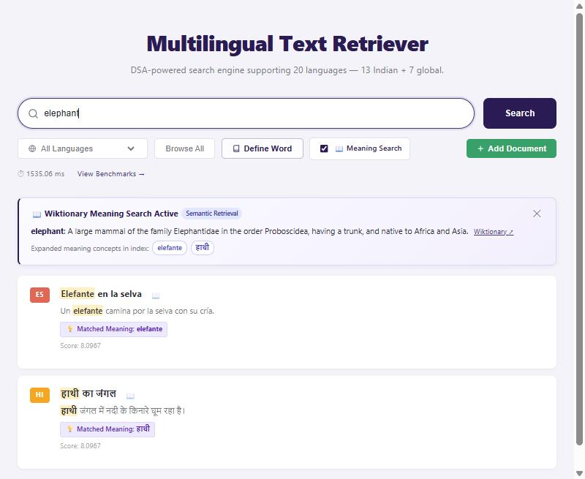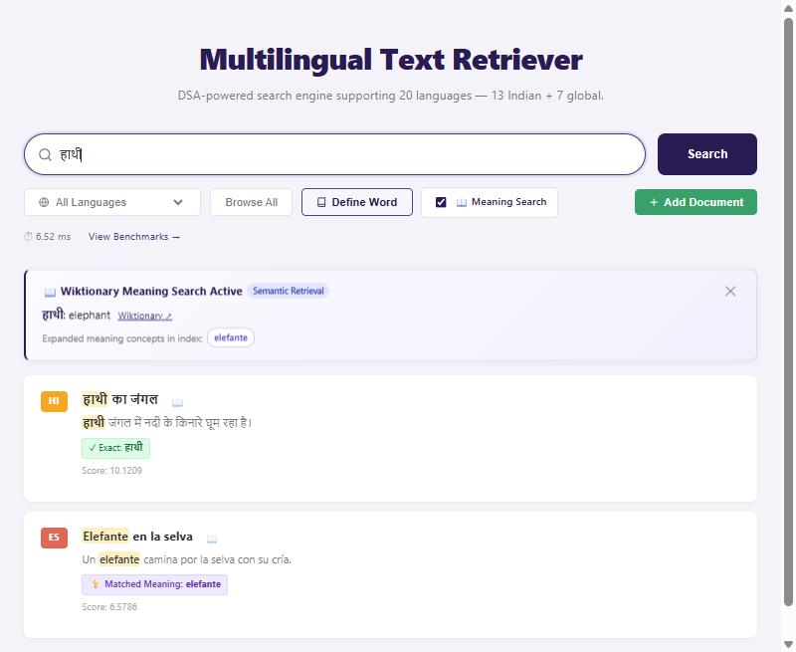
- Search results in the web interface: (a) the English query "elephant" and (b) the Hindi query "हाथी" both reach sentences added on the spot.

Defects Found by the Audit
The audit also worked as a bug finder. Table XII lists the defects it exposed, with their effect and fix. The first four account for most of the failures in the baseline run; the rest were found while verifying the fixes, and each is covered by a test. Defect 10 was already present in the original code: it surfaced when the audit suite failed once in about ten starts, and the same failure rate was reproduced on the original commit.
- Defects exposed by the audit and how they were fixed
# | Defect | Effect | Fix
1 | Translation regex matched only the {{t}} template, but most entries use {{tt}} / {{tt+}} | "elephant" lost its Spanish, Hindi, French and Bengali translations | Regex accepts the tooltip variants
2 | Lookups used the lower-case token; Wiktionary titles are case-sensitive | German nouns were never found; lower-case "apfel" is a Middle High German page | Capitalised title tried when no supported language is found
3 | Meanings were resolved only from the query side; the words of new documents were never linked | Hindi "हाथी" could not reach Spanish "elefante"; plurals stayed unlinked | Link at insertion into an undirected graph; resolve the lemma too
4 | Tokenizer left "l'éléphant" as one token and kept the danda on "है।" | Those words could not match or be linked | Unicode-category edge stripping and an elision rule
5 | A timeout was cached as "word not found"; an error fell through to another page title | Permanent missing links; "automobile" answered from a German plural page | Never cache failures; abort on error; retry once
6 | {{syn|…|q1=archaic}} parsing took the value of named parameters as synonyms | Annotations such as "archaic" became synonyms | Named parameters are skipped
7 | Two translations were chained through a polysemous foreign word | "garden" returned the "Apple orchard" sentence via Arabic bustān | Hub rule for the second hop
8 | The typo matcher rewrote valid words that are not index tokens | "gatito" was changed to "gatitos" | Dictionary-confirmed words are never corrected
9 | The page showed one message for every search failure | A stopped server looked like a bug in the code | Distinct messages; meaning stage degrades gracefully
10 | Documents with equal scores were ordered by the order the query terms were scored in, which comes from set iteration | Which 15 of a large tie were shown changed between runs; the audit case "tecnolojia" failed in about 1 start in 10 | Ties broken by numeric document id; scores rounded

Verification
Table XIII summarises the checks that protect the behaviour. To test the tests, five deliberate defects were introduced into a copy of the code (the hub rule disabled, the dictionary-confirmed-word guard removed, the wait for in-flight words removed, the graceful-degradation guard removed, and the tie-break by document id removed). All five were detected. One test initially failed to detect its defect, because the lookup of the query word and the background linking happened to finish at the same moment; the test was rewritten so that only the words inside the documents are slow, after which the defect was caught.
- Verification suites and outcomes
Suite | Scope | Result
test_semantic_graph.py | 30 offline tests: graph algorithms, linker, ranking, routes, parsers, tokenizer (fake dictionary, no network) | 30 of 30 pass
audit_suite.py | 49 semantic and DSA invariants: collision safety, typo resolution, out-of-vocabulary words | 49 of 49 pass under 12 different hash seeds
test_pipeline.py | Smoke test: home page, live meaning retrieval, definition endpoint, benchmark | passes
audit_semantic_links.py | 19 live cross-lingual queries on freshly added sentences | 19 of 19 (was 2 of 19)
Mutation checks | Five deliberate defects in a copy of the code | all five detected
Browser check | Real interface: add sentences through the form, search by meaning | as in Fig. 8

Discussion and Limitations
- Dictionary dependence. Links exist only for words that Wiktionary knows. Rare words, names and slang are not linked, and the first lookup of a new word needs network access (about 1–3 s). Without a network, search still works from the stored graph and from exact and curated matching.
- Polysemy. The hub rule blocks the most common drift, but a direct list can still contain a loose neighbour (Wiktionary lists farm as a synonym of garden), and the system does not disambiguate word senses.
- Chinese. Text without spaces is indexed as long tokens, so word-level links cannot apply to it.
- Seed corpus. The 112 seed documents are reached through the curated clusters and through the dictionary lookup of the query word; only documents added at runtime are linked when they are inserted.
- Evaluation scale. The corpus is small and the audit is a designed test, not a standard benchmark; precision and recall were not measured with MAP or NDCG, and the term weights are heuristic.

CONCLUSION and FUTURE WORK
This project shows that classical data structures and algorithms can deliver fast, explainable, multilingual and typo-tolerant search. A hash-map inverted index and a Trie give sub-millisecond lookups, dynamic-programming edit distance with length-adaptive thresholds recovers 99.2% of misspelled words of six or more letters, and breadth-first search over a curated synonym graph connects 20 languages. The main contribution is the dynamic meaning graph: by learning lemma and translation links from Wiktionary when a document is added, and by expanding queries with a 0-1 BFS that may pivot only on an English hub, the engine links the meaning of a sentence added on the spot, reflects it in the next search and keeps unrelated concepts apart. In the live audit the retrieved set went from 28 of 61 expected documents to 61 of 61 with no unrelated result, and the behaviour is protected by 30 offline tests and a 49-case audit.
The audit was as valuable as the algorithm. Most of the failures were not in the graph at all but in small details of text and data handling: a template variant missed by a regular expression, case-sensitive page titles, punctuation glued to words and a timeout cached as a fact. Defects of this kind are found only by tests with realistic multilingual input. Future work includes:
- segmenting Chinese, Japanese and Thai text (dictionary-based or character n-grams) so that word-level links can apply to it;
- back-filling the seed corpus into the meaning graph with a rate-limited background job and measuring the effect on recall;
- disambiguating word senses, for example by comparing a document's words with the words of each dictionary gloss, and recording the language of every graph node;
- evaluating on a labelled multilingual query set with MAP and NDCG, and tuning the weights 0.95, 0.85, 0.80 and 0.65 on it;
- moving persistence from JSON files to an embedded database such as SQLite, and retracting links when a document is deleted; and
- using the Trie for query auto-completion in the interface, and adding an optional offline dictionary so that linking works without network access.

References
- C. D. Manning, P. Raghavan and H. Schütze, Introduction to Information Retrieval, Cambridge University Press, 2008.
- T. H. Cormen, C. E. Leiserson, R. L. Rivest and C. Stein, Introduction to Algorithms, 4th ed., MIT Press, 2022.
- V. I. Levenshtein, "Binary codes capable of correcting deletions, insertions and reversals," Soviet Physics Doklady, 10(8), 707-710 (1966).
- K. Spärck Jones, "A statistical interpretation of term specificity and its application in retrieval," Journal of Documentation, 28(1), 11-21 (1972).
- E. Fredkin, "Trie memory," Communications of the ACM, 3(9), 490-499 (1960).
- A. Silberschatz, P. B. Galvin and G. Gagne, Operating System Concepts, 10th ed., Wiley, 2018 (page replacement and the LRU policy).
- Wikimedia Foundation, "Wiktionary, the free dictionary," https://en.wiktionary.org (accessed October 2026); REST API https://en.wiktionary.org/api/rest_v1/ and MediaWiki Action API https://www.mediawiki.org/wiki/API:Main_page.
- Pallets Projects, "Flask documentation," https://flask.palletsprojects.com.
- Unicode Consortium, "Unicode Standard Annex #44: Unicode Character Database (general categories)," https://www.unicode.org/reports/tr44/.
- Python Software Foundation, "collections.deque," "collections.OrderedDict" and "concurrent.futures," Python 3.13 Standard Library documentation, https://docs.python.org/3.13/.
- "0-1 BFS," Algorithms for Competitive Programming, https://cp-algorithms.com/graph/01_bfs.html.

