Linux User and Group Management
Name: Junaid Khan 912836 | Course: DevOps | Assignment 3

Question 1
Create user mark and verify
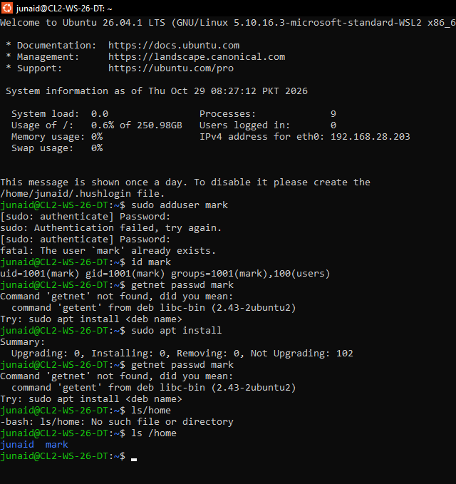
sudo adduser mark
id mark
getent passwd mark
ls /home
Explanation: adduser is an interactive, friendly script. It creates the user, a home directory (/home/mark), a private group with the same name, copies default files from /etc/skel and asks for a password and optional details (full name, phone etc.). The id command shows the UID, GID and groups, and getent passwd mark shows the entry, so together they prove the account exists.

Question 2
Set the password for mark
sudo passwd mark
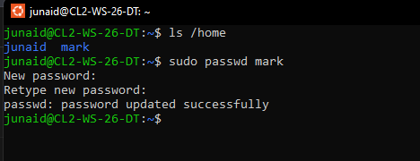
Explanation: passwd sets a new password; you type it twice and nothing is shown on the screen while typing. Linux requires a password for authentication: it proves that the person logging in is really the owner of the account. Without one, anyone could log in as that user and read or change the user's files. The password is stored only as a salted hash in /etc/shadow, never as plain text.

Question 3
Display /etc/passwd and explain the mark entry
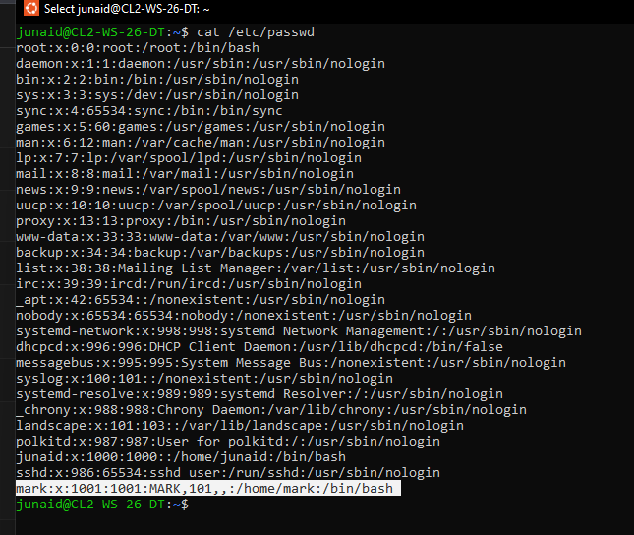
cat /etc/passwd
grep '^mark:' /etc/passwd
A typical entry looks like: mark:x:1001:1001:,,,:/home/mark:/bin/bash
Field | Example | Meaning
1 - Username | mark | Login name of the account.
2 - Password | x | The 'x' means the real password hash is stored in /etc/shadow.
3 - UID | 1001 | User ID, the number the kernel uses to identify the user.
4 - GID | 1001 | Primary group ID of the user (group 'mark' in /etc/group).
5 - GECOS / comment | (empty or ,,,) | Full name or description of the user.
6 - Home directory | /home/mark | Directory the user lands in after login.
7 - Login shell | /bin/bash | Program started when the user logs in.

Question 4
Display /etc/group and find mark's groups
cat /etc/group
grep mark /etc/group
groups mark
id mark
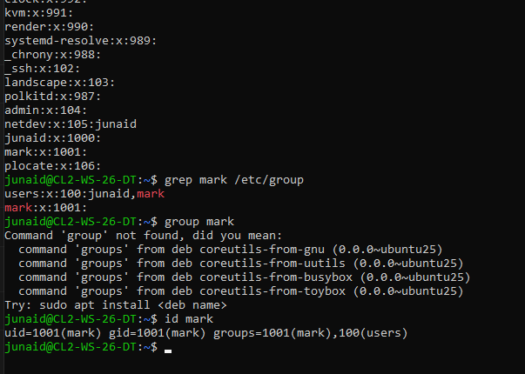
Explanation: /etc/group lists every group in the format groupname:x:GID:member-list. System groups such as root, sudo, adm, users, www-data, shadow and many others exist by default. mark has his own primary group 'mark' (GID 1001) and, on many Ubuntu systems, also appears in the 'users' group. The command groups mark or id mark shows exactly which groups mark belongs to.

Question 5
Display /etc/hosts
cat /etc/hosts
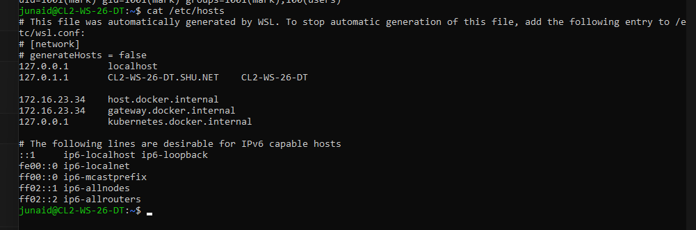
Explanation: /etc/hosts is a local text file that maps hostnames to IP addresses. The system checks it before asking a DNS server, so it is useful for quick local name resolution and testing. The localhost entries are '127.0.0.1 localhost' (IPv4 loopback) and '::1 localhost ip6-localhost ip6-loopback' (IPv6 loopback). There is usually also a line such as '127.0.1.1 <your-hostname>'. These addresses point back to the same computer.

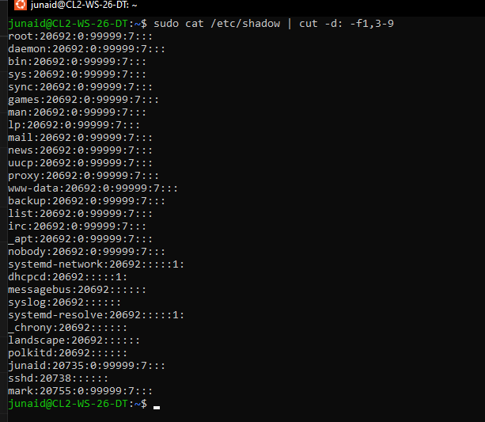
Question 6
Inspect /etc/shadow (do NOT show hashes)
sudo cat /etc/shadow | cut -d: -f1,3-9
ls -l /etc/shadow
Explanation: The command above uses cut to hide field 2 (the hash) so your screenshot is safe. /etc/shadow stores each user's encrypted (hashed) password, the date of the last password change, minimum and maximum password age, warning days, inactivity period and account expiry date. Access is restricted (permissions -rw-r----- root:shadow) because anyone who could read the hashes could try to crack passwords offline with brute-force or dictionary attacks. That is why /etc/passwd is readable by everyone but the hashes live in /etc/shadow, which only root can read.

Question 7
Create student1 with useradd
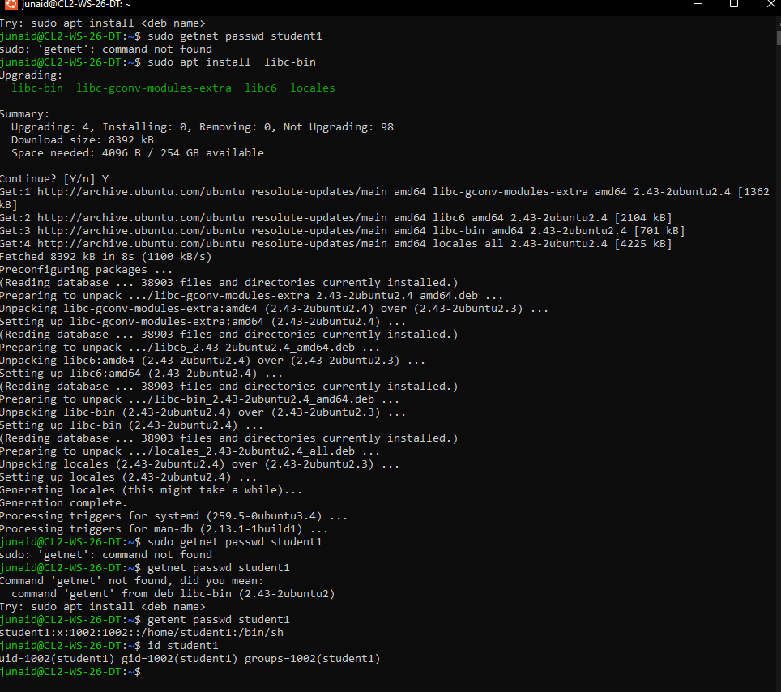
sudo useradd student1
sudo passwd student1
getent passwd student1
id student1
Explanation: useradd is the low-level command. By default it does not create a home directory, does not ask for a password and usually assigns /bin/sh as the shell, so you must set these yourself (for example useradd -m -s /bin/bash student1). adduser is a friendlier Debian/Ubuntu wrapper script around useradd: it is interactive, creates the home directory automatically, copies /etc/skel files and prompts for a password. That is the main difference.

Question 8
Switch to student1 using su
su student1
whoami
exit
whoami
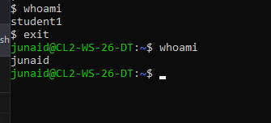
Explanation: su (substitute user / switch user) starts a new shell as another user. Because student1 has no home directory, you may see a warning such as 'No directory, logging in with HOME=/' which is normal here. whoami prints student1 while inside the new shell. exit returns you to your original account (junaid), which the second whoami confirms. Use 'su - student1' for a full login shell with that user's environment.

Question 9
Switch to root
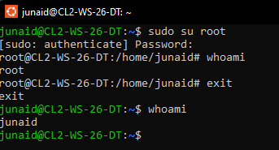
sudo su root
whoami
exit
whoami
Explanation: sudo su root gives you a root shell after you enter your own password; the prompt changes from $ to #, and whoami shows root. exit brings you back. Root has unlimited power: it can read, change or delete any file, add or remove users, stop services and even destroy the operating system with one wrong command (for example a mistaken rm -rf). There is no confirmation or undo, so root should be used only when necessary, for the shortest time possible. Normal work should be done as a regular user with sudo for single commands.

Question 10
Set the comment field
sudo usermod -c "MARK" mark
getent passwd mark
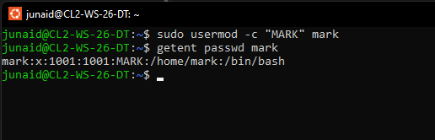
Explanation: -c changes the comment (GECOS) field, which is the 5th field of /etc/passwd. After the command the entry becomes mark:x:1001:1001:MARK:/home/mark:/bin/bash. This field normally stores the user's full name or description.

Question 11
Change UID of mark to 1003
getent passwd 1003
sudo usermod -u 1003 mark
id mark
getent passwd mark
Explanation: First check that UID 1003 is free: if getent passwd 1003 prints nothing, it is available (if it prints a line, choose another number). Then usermod -u changes the UID and also updates ownership of files in mark's home directory. A UID (User Identifier) is the unique number the Linux kernel uses to identify a user; usernames are only human-friendly labels mapped to UIDs. File ownership and permissions are all checked using the UID, and UID 0 is always root.

Question 12
Set an account expiration date
sudo usermod -e 2026-10-30 mark
sudo chage -l mark

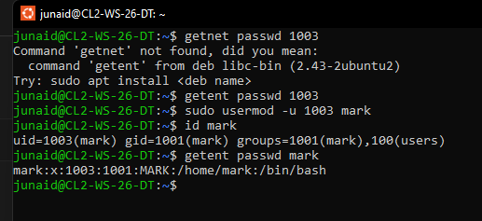
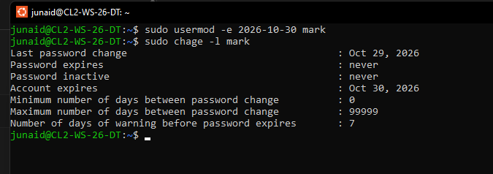
Explanation: -e sets the date on which the account becomes disabled. chage -l lists the ageing information, and the line 'Account expires' should show Oct 30, 2026. After that date the user cannot log in anymore (login is rejected), but the account, home directory and files remain and the administrator can re-enable it with sudo usermod -e '' mark. It is useful for temporary users such as interns or contractors.

Question 13
Change primary group to sudo
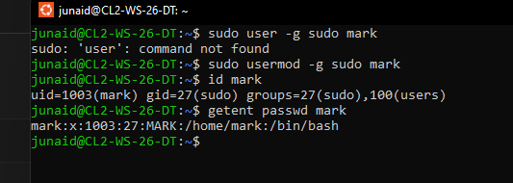
sudo usermod -g sudo mark
id mark
getent passwd mark
Explanation: -g replaces the primary group of mark with sudo (GID 27), so the 4th field in /etc/passwd becomes 27 and id mark shows gid=27(sudo). The primary group is the group assigned to new files and directories created by the user, and every user has exactly one. Supplementary groups are additional groups that give extra permissions (for example access to shared folders or devices); a user can belong to many of them. Note: giving a normal user the sudo group also gives administrator rights, so do this only in the lab.

Question 14
Add mark to supplementary group sudo
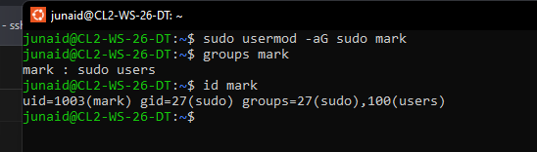
sudo usermod -aG sudo mark
groups mark
id mark
Explanation: -G sets the supplementary group list, and -a means append. With -aG, mark is added to sudo while keeping all his existing supplementary groups. Without -a, usermod -G sudo mark would replace the whole list, silently removing mark from every other supplementary group and possibly breaking his access to files, devices or services. That is why -aG is the safer choice.

Question 15 - Practical Challenge: User Lifecycle Management
Step 1 - Create the user
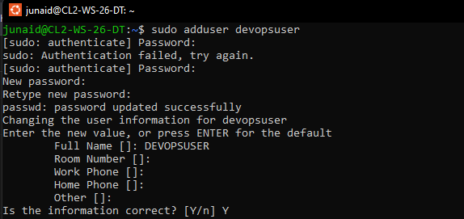
sudo adduser devopsuser
Explanation: adduser creates the account, home directory /home/devopsuser and a private group.
Step 2 - Set the password
sudo passwd devopsuser
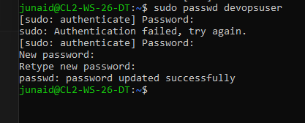
Explanation: Sets the login password (stored as a hash in /etc/shadow).
Step 3 - Verify entry and groups
grep '^devopsuser:' /etc/passwd
id devopsuser
groups devopsuser
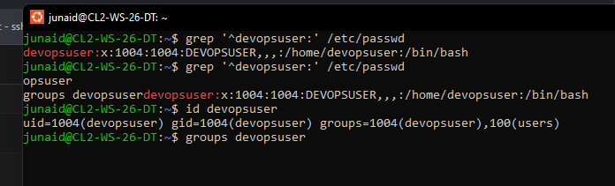
Explanation: Shows the passwd entry with its UID/GID, and that the user belongs to the primary group devopsuser.
Step 4 - Switch user and verify
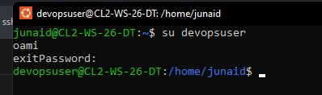
su devopsuser
whoami
exit
Explanation: whoami prints devopsuser, proving the shell now runs as the new user; exit returns to your own account.
Step 5 - Update comment field
sudo usermod -c "DevOps Test User" devopsuser
getent passwd devopsuser
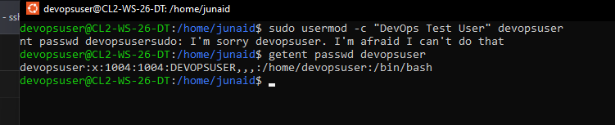
Explanation: The 5th field of /etc/passwd now shows the new description.
Step 6 - Change UID to an available one
getent passwd 2001
sudo usermod -u 2001 devopsuser
id devopsuser
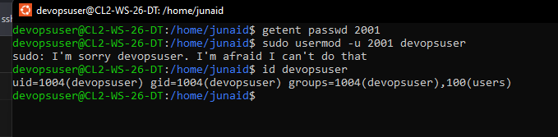
Explanation: Empty output of the first command shows 2001 is free; id then shows uid=2001.
Step 7 - Set expiration date
sudo usermod -e 2026-12-31 devopsuser
sudo chage -l devopsuser
[ Paste your own terminal screenshot here - Q15 / Step 7 ]
Explanation: chage -l shows 'Account expires : Dec 31, 2026'.
Step 8 - Add to a supplementary group
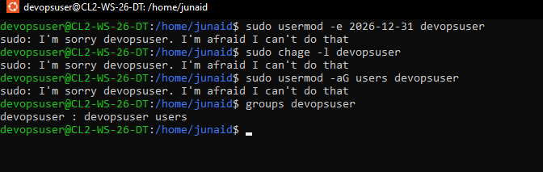
sudo usermod -aG users devopsuser
groups devopsuser
Explanation: The user is appended to the 'users' group (use a harmless group such as users or developers; avoid sudo for a test user) and keeps existing groups.
Step 9 - Delete the user and verify
sudo deluser devopsuser
# or: sudo userdel devopsuser
getent passwd devopsuser
id devopsuser
ls /home
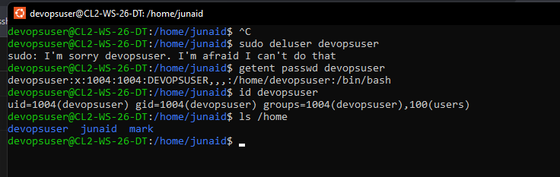
Explanation: The account is removed from /etc/passwd, so getent prints nothing and id says 'no such user'. The home directory stays unless you use sudo deluser --remove-home devopsuser or userdel -r.
Summary of the lifecycle: create -> set password -> verify -> switch -> modify (comment, UID, expiry, groups) -> delete. Each stage changed a different part of /etc/passwd, /etc/shadow or /etc/group, and the verification commands (id, getent, chage -l, groups) confirm every change.

