***Assignment***

***Data Mining***

***Topic***

*Weka Implementation of Algorithms*

*(Apriori, Apriori TID and FP-Growth)*

***Submitted by***

*Junaid Iqbal (70070342)*

**Q.1**. Consider an example with the following set of transactions. We wish to find associations with at least 30% support and 60% confidence. Find the frequent item sets and then the association rules. Implement using Weka with different algorithms of association rule mining (Apriori, Apriori TID and FP-Growth) and differentiate among them.



**Solution:**

Frequency Item Sets

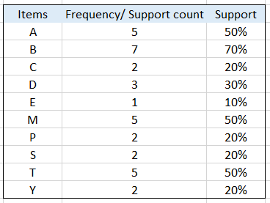

1. **Apriori Algorithm**

Data for Apriori [1]

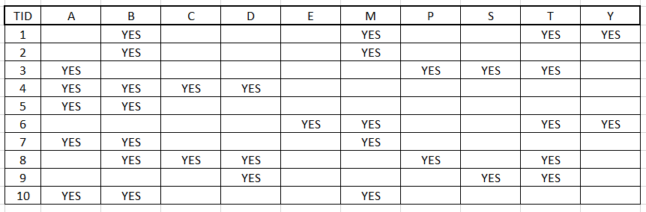

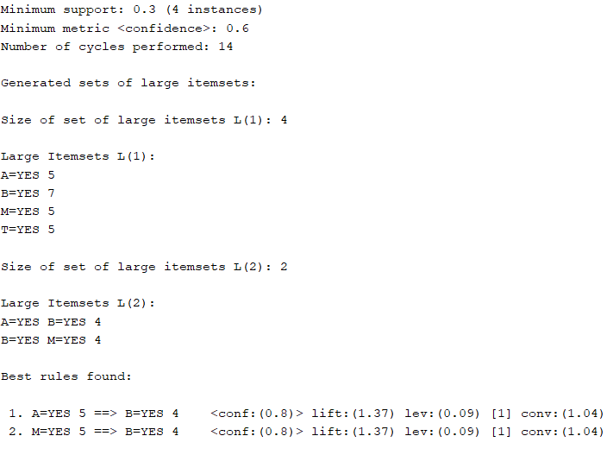**Results:**

1. **AprioriTID Algorithm**

The difference between Apriori and AprioriTID is only that it doesn’t uses the database for counting the support of candidate itemsets after the first pass. It is implementable by using SPMF Open Source Data Mining Library [2].

1. **FP Growth Algorithm**

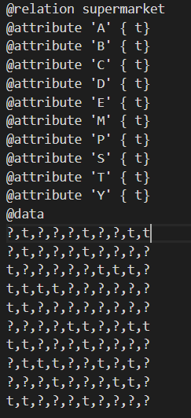Data for FP Growth Algorithm [3]

**Results**

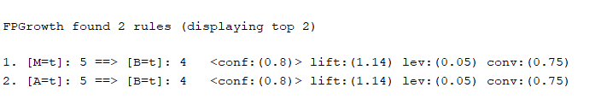

**References:**

[1] <https://github.com/junaideqbal/data-mining/blob/main/assignment1/Apriori-Data.csv>

[2] <http://www.philippe-fournier-viger.com/spmf/>

[3] <https://github.com/junaideqbal/data-mining/blob/main/assignment1/FP-Growth-Data.arff>