

Fruit Classification Report

|  |
| --- |
| School of Computing  Faculty of Engineering AND PHYSICAL SCIENCES |

<Full Name of Author>

Submitted in accordance with the requirements for the degree of  
<Name of Degree> (*e.g.* BSc Computer Science)

**<Session>** (*e.g.* 2021/22)

**<Module code and name>** (*e.g.* *COMP3931 Individual Project*)

Table of Contents

**1.1 Introduction……………………………………………………………………………………………………………………………4**

**1.2 The Necessity for Innovation…………………………………………………………………….……………………………4**

**1.2.1 Current Limitations in Fruit Sorting…………………………………………………………………………4**

**1.2.2 The Potential of AI…………………………………………………………………………….……………………4**

**1.2.3 Advancements in AI Techniques…………………………………………………………………………….5**

**1.2.4 Integration with IoT for Real-Time Monitoring ………………………………………………….….6**

**1.3 Evolution of Classification Methods………………………………………………………………………………………6**

**1.3.1 From Manual to Automated………………………………………………………………………………….6**

**1.3.2 Breakthroughs in Machine Learning………………………………………………………………………6**

**1.4 Advancements in AI and Their Application…………………………………………………………………………….7**

**1.4.1 AI's Role in Agriculture Today………………………………………………………………………….…….7**

**1.4.2 The Advent and Impact of Machine Learning……………………………………………….……….8**

**1.4.3 Current AI Advancements and Their Implications………………………………………………….8**

**1.5 Review of Existing AI Solutions…………………………………………………………………………………………….8**

**1.5.1 Comparison of Different AI Models……………………………………………………………………….8**

**1.5.2 Critical Evaluation of Models………………………………………………………………………….…….8**

**1.5.3 Identifying the Gaps……………………………………………………………………………………….…….9**

**1.6 Proposed Solution and Justification……………………………………………………………………………………...9**

**1.6.1 Justification for Using CNNs……………………………………………………………………………………...9**

**1.6.2 Expected Outcomes and Benefits…………………………………………………………………………….9**

**1.7 Overview of CNN Architecture………………………………………………………………………………………………….10**

**1.7.1 CNN Basics…………………………………………………………………………………………………………………10**

**1.7.2 Application of CNNs to Fruit Classification………………………………………………………………….10**

**2.1 Introduction to Methodology……………………………………………………………………………………………….11**

**2.2 Development Tools and Software Environment…………………………………………………………….…….11**

**2.2.1 Software and Libraries……………………………………………………………………………………….11**

**2.2.2 Version Control and Coding Standards………………………………………………………………….12**

**2.3 Data Collection and Dataset Overview………………………………………………………………………………….12**

**2.3.1 Dataset Source and Composition……………………………………………………………………………….12**

**2.3.2 Data Quality Assurance…………………………………………………………………………………………….13**

**2.4 Preprocessing Techniques……………………………………………………………………………………………….……….14**

**2.4.1 Resizing and Standardization…………………………………………………………………………………….14**

**2.4.2 Additional Preprocessing Steps…………………………………………………………………………………17**

**2.5 Data Augmentation Strategies…………………………………………………………………………………………………22**

**2.6 Model Architecture………………………………………………………………………………………………………………….22**

**2.6.1 Baseline Model……………………………………………………………………………………………………….22**

**2.6.2 Proposed Model Improvements…………………………………………………………………………….23**

**2.7 Model Training and Validation……………………………………………………………………………………………….26**

**2.7.1 Training Process……………………………………………………………………………………………………….26**

**2.7.2 Validation Methodology………………….…………………………………………………………………....26**

**2.8 Implementation Strategy……………………………………………………………………………………………………….26**

**2.9 Challenges Encountered……………………………………………………………………………………………………….26**

**2.10 Summary of Methodological Approach…………………………………………………………………………….26**

**3.1. Qualitative Evaluation……………………………………………………………………………………………………….27**

**3.2. Discussion………………………………………………………………………………………………………………………….29**

**3.3. Results………………………………………………………………………………………………….…………………………….30**

**4.1. Conclusion…………………………………………………………………………………………………………………………31**

**4.2. Idea for Future Work…………………………………………………………………………………………………………31**

**4.3. References…………………………………………………………………………………………………………………………33**

**Chapter 1: Introduction and Background Research**

**1.1 Introduction**

In term of fruit classification Artificial Intelligence (AI) plays the significant role, specially have a huge impact on the agricultural industry. The project is used to develop an AI-based solution for the fruit sorting which will replace the current manual methods which are commonly used in the industry.  
**1.2 The Necessity for Innovation**

**1.2.1 Current Limitations in Fruit Sorting**

Manual methods for fruit sorting which are using now a days having the certain drawbacks,

* Labor-intensive
* Time-taking
* Likely have error
* Impacting productivity and profitability.

These above discussed limitations causes efficiency and accuracy in term of sorting process, which prominence the need of the alternative modern solution of this problem.

**1.2.2 The Potential of AI**

The use of AI techniques helps in solving the limitations of the manual methods in the following ways,

* Provide automation in sorting process
* Augmenting the efficiency, accuracy, and scalability of the problem

By using the above mentioned progress which provide transformative advancement in fruit classification in agricultural industry, which will lead the improved efficiency, scalability and the economics benefits.

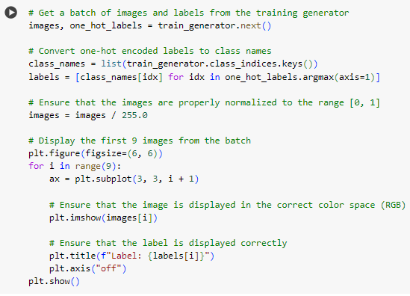

**1.2.3 Advancements in AI Techniques**

CNNs (Convolutional Neural Networks) a state of the art Ai technique has shown the outstanding performance in the task of the image recognition tasks, fruit classification having the direct application on the project’s objective.

**_________________________________________________________________**

**Layer (type) Output Shape Param #**

**=================================================================**

**conv2d_3 (Conv2D) (None, 222, 222, 32) 896**

**activation_5 (Activation) (None, 222, 222, 32) 0**

**max_pooling2d_3 (MaxPoolin (None, 111, 111, 32) 0**

**g2D)**

**conv2d_4 (Conv2D) (None, 109, 109, 32) 9248**

**activation_6 (Activation) (None, 109, 109, 32) 0**

**max_pooling2d_4 (MaxPoolin (None, 54, 54, 32) 0**

**g2D)**

**conv2d_5 (Conv2D) (None, 52, 52, 64) 18496**

**activation_7 (Activation) (None, 52, 52, 64) 0**

**max_pooling2d_5 (MaxPoolin (None, 26, 26, 64) 0**

**g2D)**

**flatten_1 (Flatten) (None, 43264) 0**

**dense_2 (Dense) (None, 1024) 44303360**

**activation_8 (Activation) (None, 1024) 0**

**dropout_1 (Dropout) (None, 1024) 0**

**dense_3 (Dense) (None, 23) 23575**

**activation_9 (Activation) (None, 23) 0**

**=================================================================**

**Total params: 44355575 (169.20 MB)**

**Trainable params: 44355575 (169.20 MB)**

**Non-trainable params: 0 (0.00 Byte)**

**_________________________________________________________________**

**1.2.4 Integration with IoT for Real-Time Monitoring**

Joining AI with IoT (Internet of Things) helps in improving the technology and allow for real-time monitoring of the fruit;

* Quality
* Ripeness
* Inventory Management

This real-time monitoring helps in process to gain valuable insights, quality control and enabling proactive decision-making, so there should must require getting the class name from the directory, here below is the code for performing that particular operations;

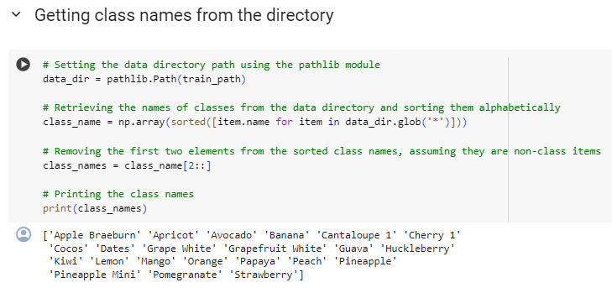

**1.3 Evolution of Classification Methods**

**1.3.1 From Manual to Automated**

As the many of the technologies evolving, like manual entering the data is now shifted towards the automated version as in same case with the fruit classification technique, manual sorting methods to automated techniques driven in advancement in technology, this increased the efficiency in handling growing volume produce.

**1.3.2 Breakthroughs in Machine Learning**

The introduce of the CNNs in the ML (Machine Learning), by the use of CNNs surpassed the old methods by effectively taking patterns and feature in the images, which helps in the fruit classification task.

**1.4 Advancements in AI and Their Application**

**1.4.1 AI's Role in Agriculture Today**

These are many of the AI solutions are practically applied in various of the agriculture field, such as the;

* Monitoring of crop
* Prediction of yield
* Detection of diseases

These sort of the things are used in the fruit classifications for similar advancement.

**1.4.2 The Advent and Impact of Machine Learning**

A subset of the ML (Machine Learning), DL (Deep learning) has played the vital role in contribution of agricultural challenges, by powerful computational resources and investigating large datasets, which making the accurate predictions.

**1.4.3 Current AI Advancements and Their Implications**

Improved model architecture, algorithm’s optimization, and techniques used in the transferred learning as the advancement of the in AI (Artificial Intelligence), these increased the accuracy of the several pre-trained models, also helpful in the fruit classification model.

**1.5 Review of Existing AI Solutions**

**1.5.1 Comparison of Different AI Models**

There would be analysis of the various AI models, having SVMs (Support Vector Machines), Random Forests, aware of the strengths and weakness of each of the models.

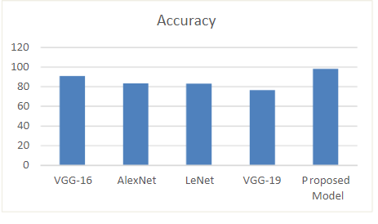

Here is the comparison of Proposed model with pre-trained models.

**1.5.2 Critical Evaluation of Models**

The evaluation of each of the AI models will be based upon the following features;

* Implemented Methodologies
* Computational complexity
* Strength in real-world environments.

This above evaluation will identify gaps and areas for improvement, which will be addressed in the proposed solution.

**1.5.3 Identifying the Gaps**

Identification of the gaps in any of the existing AI system are given below;

* Scalability issues.
* Misbalancing in tha data.
* Extraction of the domain specific issues.

These all of the gaps will serve as the principle guiding for developments of the advanced classification problems.

**1.6 Proposed Solution and Justification**

**1.6.1 Justification for Using CNNs**

As discussed earlier identifying the gaps form the previous architecture make the guideline for the other modern architectures, that’s why use of the CNNs is the best choice from the old models, this having the ability of getting the complex image features and pattern, make suitable for use in classification purposes.

**1.6.2 Expected Outcomes and Benefits**

Improvements in the accuracy, scalability, and efficiency are the perks of the using CNN’s technique, which helps a lot in the classification methods, the improvement helps in the sorting operations, waste reduction which increased in the productivity of agricultural industry.

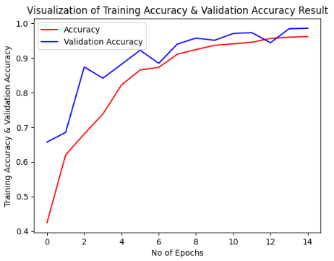

**1.7 Overview of CNN Architecture**

**1.7.1 CNN Basics**

By fetching the features from the input image, CNNs is particularly used, this consists of convolutional, pooling, and most important fully connected layer which flatten the image and also get spatial hierarchies from input image.

**1.7.2 Application of CNNs to Fruit Classification**

The CNNs is applied on the training dataset having labeled fruit images, based on the visual features learning is happened and distinguished between the different fruit types, by using this overall goal is to improving accuracy of the system, which is also be need for the fruit classification task.

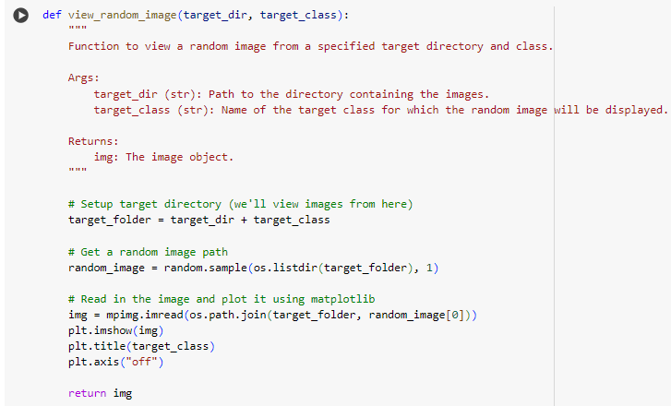

**Chapter 2: Methods**

**2.1 Introduction to Methodology**

This chapter is used to show the methods which are utilize in the fruit classification task and majorly highlights the importance of the research, the chosen of this method is used for considering the project scope and them researches, this chapter is also used for an overview of the organized stricture of the methods that we are using now a day in the improvement purposes.

**2.2 Development Tools and Software Environment**

The selection of the tools that are used in the development purposes and the reproducibility of the set up environment is very much important, so this section discussed it completely about the set up tools we used in the fruit classification task.

**2.2.1 Software and Libraries**

As we discussed in the previous chapter the classification task we have to use the machine learning and deep learning techniques, so the software and libraries are using for the fruit classification task are given below:

* + For programming language uses Python 3.7
  + For developing of the machine learning models **TenserFlow** and **Keras** are used.
  + For handling and manipulation of the data **NumPy** and Pandas are used.
  + In order to visualize the data **Matplotlib** and **Seaborn** is used.
  + For modeling tools **Scikit**-**learn** library is utilizing.

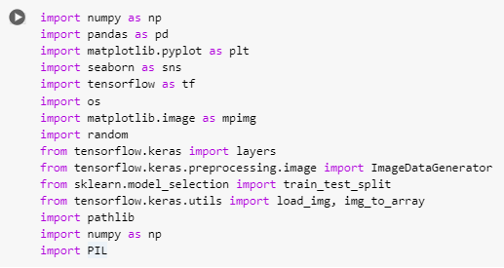

**2.2.2 Version Control and Coding Standards**

* + In order to track the changes and manage collaboration Git is very common to use that’s why I am using, which is also quite helpful.
  + Therefore, different repositories are used in order to organize the data in such a way having data in separate directories, code, documentations, and also code in the separate directories.
  + PEP 8 confirms reliability and also be the consistency of the code base, which adherence the coding standards.

**2.3 Data Collection and Dataset Overview**

**2.3.1 Dataset Source and Composition**

* + The dataset which is used is publicly available, which is gathered by the agricultural research institutes and also be the repositories having the collected data.
  + Selecting the images for the fruit classification, must include the images having more diversity in fruit types, lighting and background’s variation required for sufficient representation of each of the class.
  + To ensure an equal distribution of the different samples and fruit classifiers required data balancing techniques.

Now, there must be the Plot a grid of images from a training dataset is required, here below the code for performing that functionality;

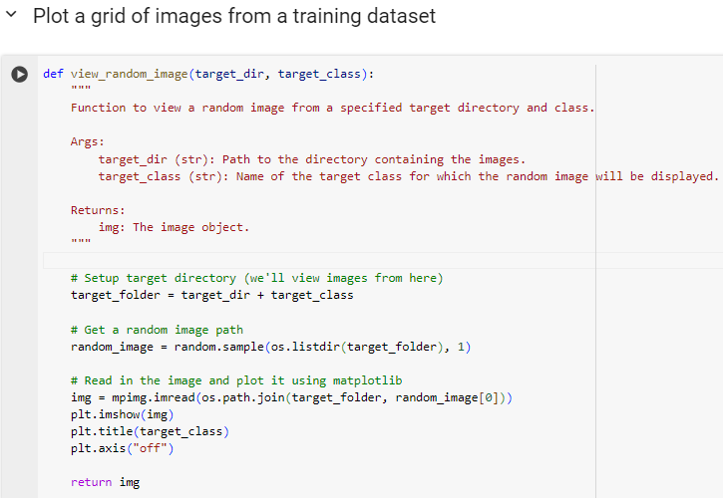

**2.3.2 Data Quality Assurance**

* + For achieving the consistency in image quality, resolution of the image, proper lighting conditions, and also background uniformity are steps needed in whole process.
  + In order to remove and identify the low-quality images from the whole dataset, required manual as well as automated quality checks needed.

**2.4 Preprocessing Techniques**

Preprocessing steps which are performed on the dataset, and their necessity, this section explain the whole process:

**2.4.1 Resizing and Standardization**

Standardizing resolution of the image and choosing a size of the specific also be explained earlier, by ensuring the uniformity in input data standardizing and also be the resizing were employed techniques. Data Preprocess and Augmentation: With these added parameters in the ImageDataGenerator, the data augmentation will include:

* Random rotation of images up to 20 degrees.
* Random zooming inside pictures up to 10%.
* Random horizontal flipping of images.

The fill mode parameter specifies how newly created pixels are filled.

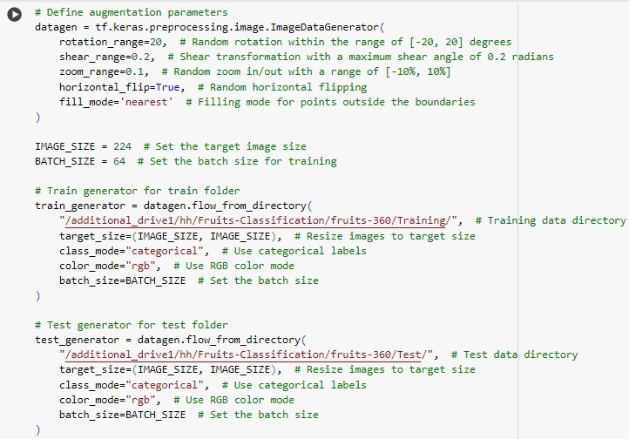

* Found **10705** images belonging to **23** classes.
* Found **3146** images belonging to **23** classes.

Now, after performing data preprocessing and augmentation here is the code and results given below;

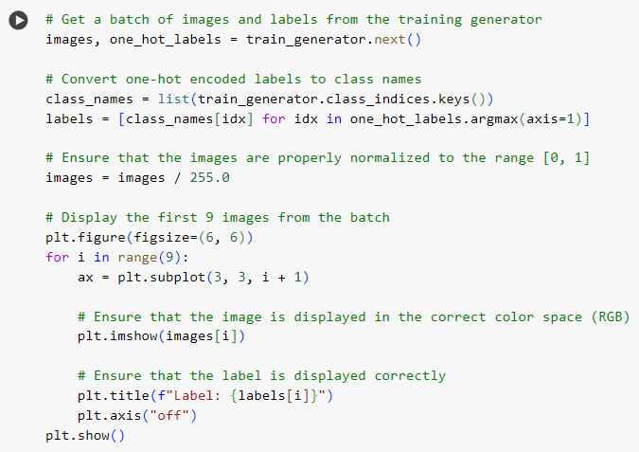

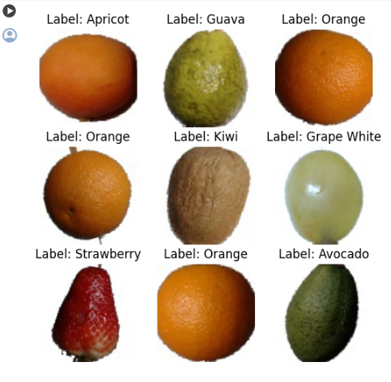

Saving the model with their weights are given below;

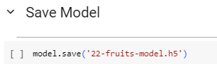

/var/anaconda3/envs/hamza/lib/python3.11/site-packages/keras/src/engine/training.py:3103: User Warning: You are saving your model as an HDF5 file via `model.save()`. This file format is considered legacy. We recommend using instead the native Keras format, e.g. `model.save('my_model.keras')`. saving_api.save_model

Here, are the evaluations, we are performing the **train generator** and **test generator** are given below;

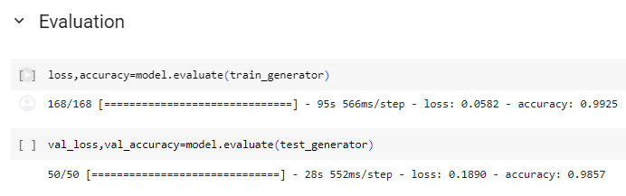

The model.evaluate function evaluates the CNN model's performance on the train_generator dataset. This function is likely to return two values: a loss metric (how well the model's predictions match the true labels) and an accuracy metric (the percentage of correct predictions). The evaluation results are stored in the variables loss and accuracy.

The evaluation process involved 50 steps (most likely iterating over **50 batches** of data) and took an average of **285 milliseconds** to complete per step.   
  
The evaluation yielded a loss of 0.1890 and an accuracy rate of **98.57%.** This indicates that the model performed well on the test data but not as well on the training data. This is common, as a model may become over fit to the training data.

**2.4.2 Additional Preprocessing Steps**

After standardizing and resizing of the image, there would also need to be additional preprocessing is required, such as normalization of color and reduction of the noise is also needed.

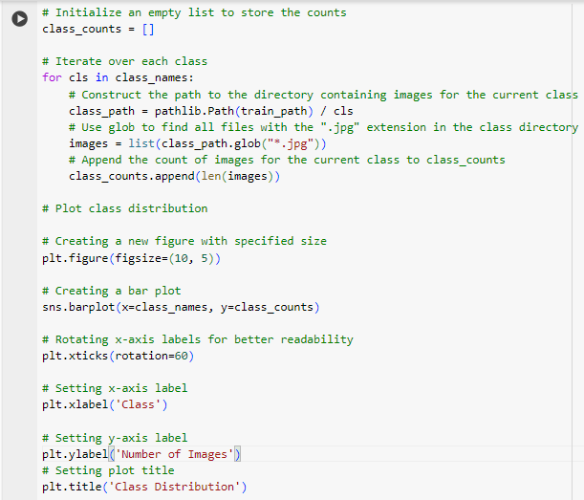

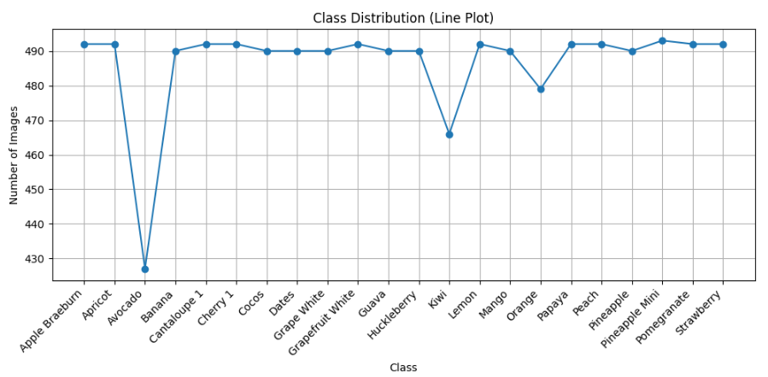

Another, distribution of the class among as many of the fruits, here is the code below for the generation of the python code and also be the visualization available;

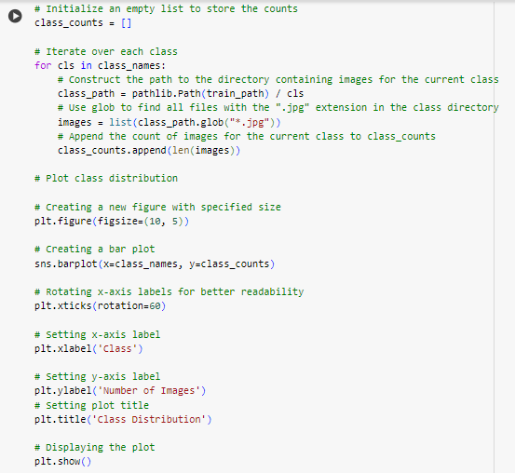

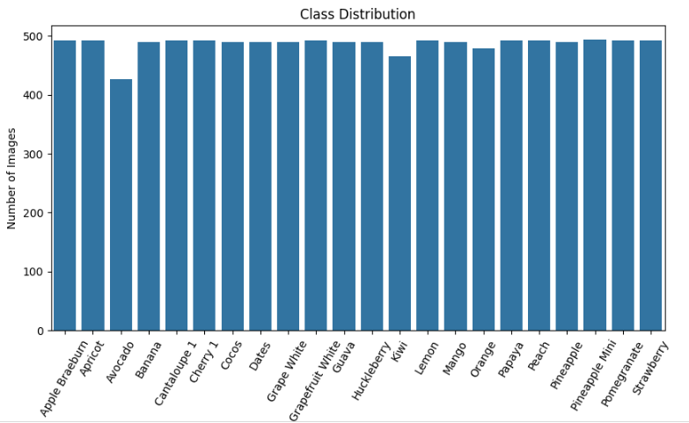

**Now,** findings which are fetching from the pie plot of the distribution are given below;

* The main finding is that the number of courts varies significantly by region, with far more courts in some regions compared to others.
* The Americas region has the most courts, with over 153,000 courts, which is much higher than any other region (44,164% more than Oceania, which has the least with only 347 courts).
* The total number of courts across all regions ranges from a low of 347 to a high of 153,597.

**Now,** there is another visualization for the class distribution by the usage of the python code, and the pie charts are given below;

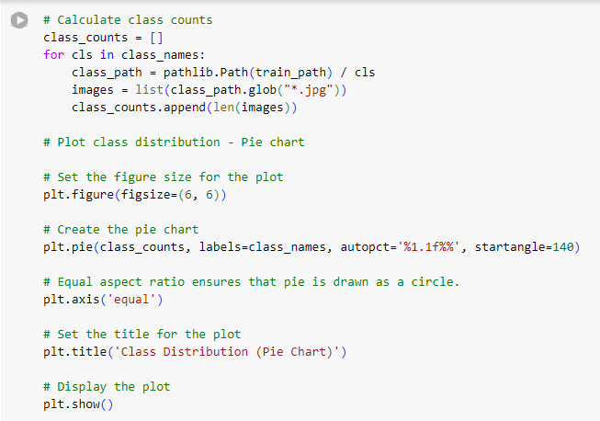

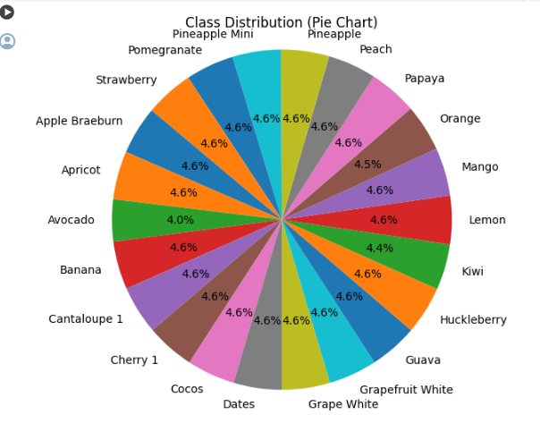

**2.5 Model Architecture**

For elucidate the design of the architecture of the model which is required for the fruit classification

**2.5.1 Baseline Model**

Baseline model for the classification of the fruit required initial model layers, their parameters, rationale which acting behind the section were also presented over there.

**2.5.2 Proposed Model Improvements**

Reasoning behind the changes which are performed in the initial baseline model are added layers or dropout from the layer, also discussed about the effect on the performance of the model.

**2.6 Model Training and Validation**

The training and validation for the fruit classification model are discussed in this section.

**2.6.1 Training Process**

Adam optimizer, loss function, and regularization techniques are utilizing in the training process are also be discussed.

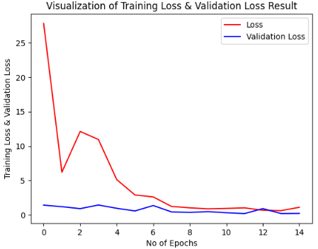

**2.6.2 Validation Methodology**

To prevent the overfitting there must be the methodology of model’s validation, usage of the accuracy of model as a metric, and strategies are also employed.

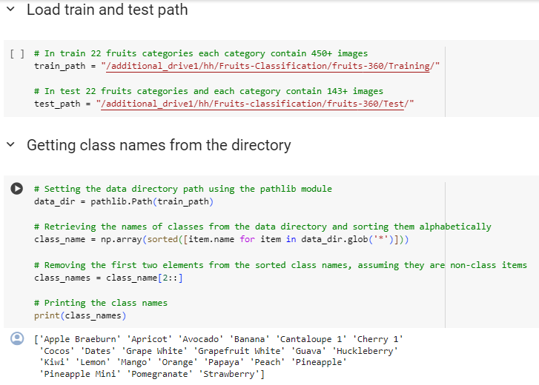

Now, after loading the complete dataset, provide the complete figures for the each of the fruit, here are code and their results are given below;

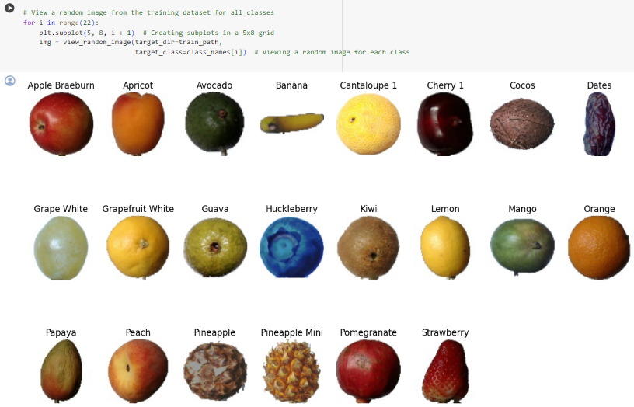

Now, taking these train path, further move on **Apple Braeburn,** and show the results according to the dataset, also code and their results are given below;

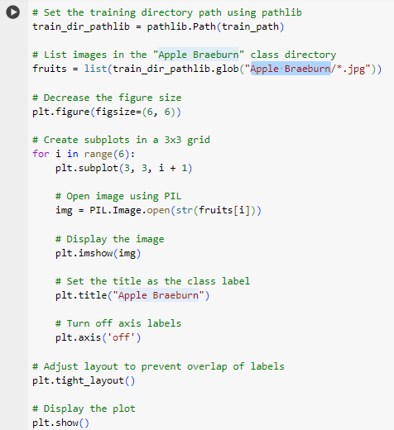

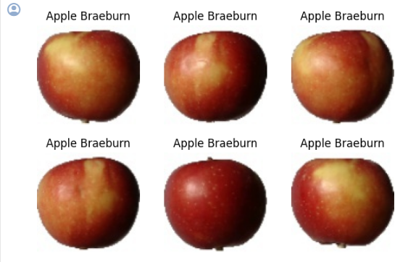

**2.7 Implementation Strategy**

The most importantly know the strategy, from which real-world application, how the fruit classification model is dealing in the real-life scenario, this will be done by creating the integrating model into a production environment.

**2.8 Challenges Encountered**

The challenges facing during the fruit classification, are offered insights into the research process, discussing the challenges such as misbalancing of the data, computational limitations, are addressed, and to overcome these challenges is very important.

**2.9 Summary of Methodological Approach**

Baseline model for the classification of the fruit required initial model layers, their parameters, also making the improvements in this baseline model is needed, and throughout the most important thing is that training of the model on the dataset is required and then fine tuning the model on the refined data.

To prevent the overfitting there must be the methodology of model’s validation, is also be performed by usage of accuracy as the separate metric.

**Chapter 3: Results**

**3.1. Qualitative Evaluation**

* Accuracy, precision, and also be the F1-score are utilizing as the Quantitative metrics.
* Visualization of training and validation, making the result for the confusion matrix, and analysis of the accuracy metrics, are also provided in the form of the evaluation of the qualitative metrics.

**precision recall f1-score support**

**1 1.00 1.00 1.00 1**

**2 1.00 1.00 1.00 2**

**3 1.00 1.00 1.00 2**

**4 1.00 1.00 1.00 1**

**5 1.00 1.00 1.00 1**

**6 1.00 1.00 1.00 5**

**7 1.00 1.00 1.00 1**

**8 1.00 1.00 1.00 1**

**9 1.00 1.00 1.00 4**

**10 0.80 1.00 0.89 4**

**11 1.00 1.00 1.00 1**

**12 1.00 1.00 1.00 3**

**13 1.00 1.00 1.00 2**

**14 1.00 0.50 0.67 2**

**15 1.00 1.00 1.00 5**

**16 1.00 1.00 1.00 3**

**17 1.00 1.00 1.00 1**

**18 1.00 1.00 1.00 3**

**19 1.00 1.00 1.00 5**

**20 1.00 1.00 1.00 4**

**21 1.00 1.00 1.00 9**

**22 1.00 1.00 1.00 4**

**accuracy 0.98 64**

**macro avg 0.99 0.98 0.98 64**

**weighted avg 0.99 0.98 0.98 64**

**Confusion Matrix**

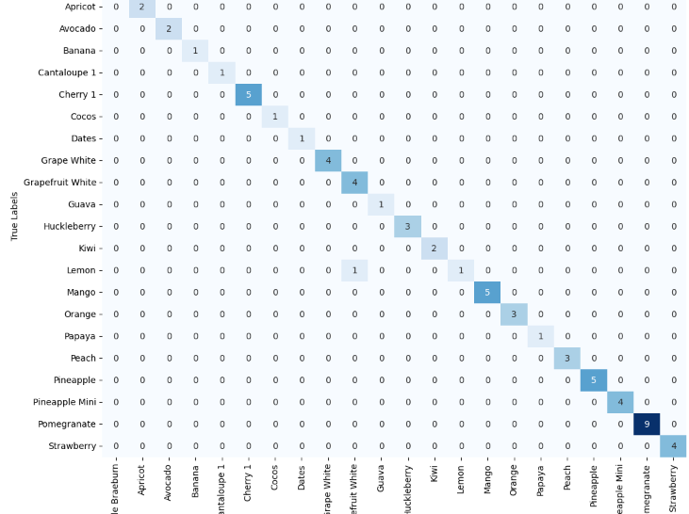

**3.2. Discussion**

* Performance of the Model in the fruit classification task, depends on the clarification of the qualitative evaluation.
* In order to highlights the effectiveness of the CNN model, there must be the comparison required with other existing models and also be other approaches that are attempted without the modern approaches.
* There is always be the room for the improvement, so suggesting area for the improvements, and also indicates the direction of the future researches.

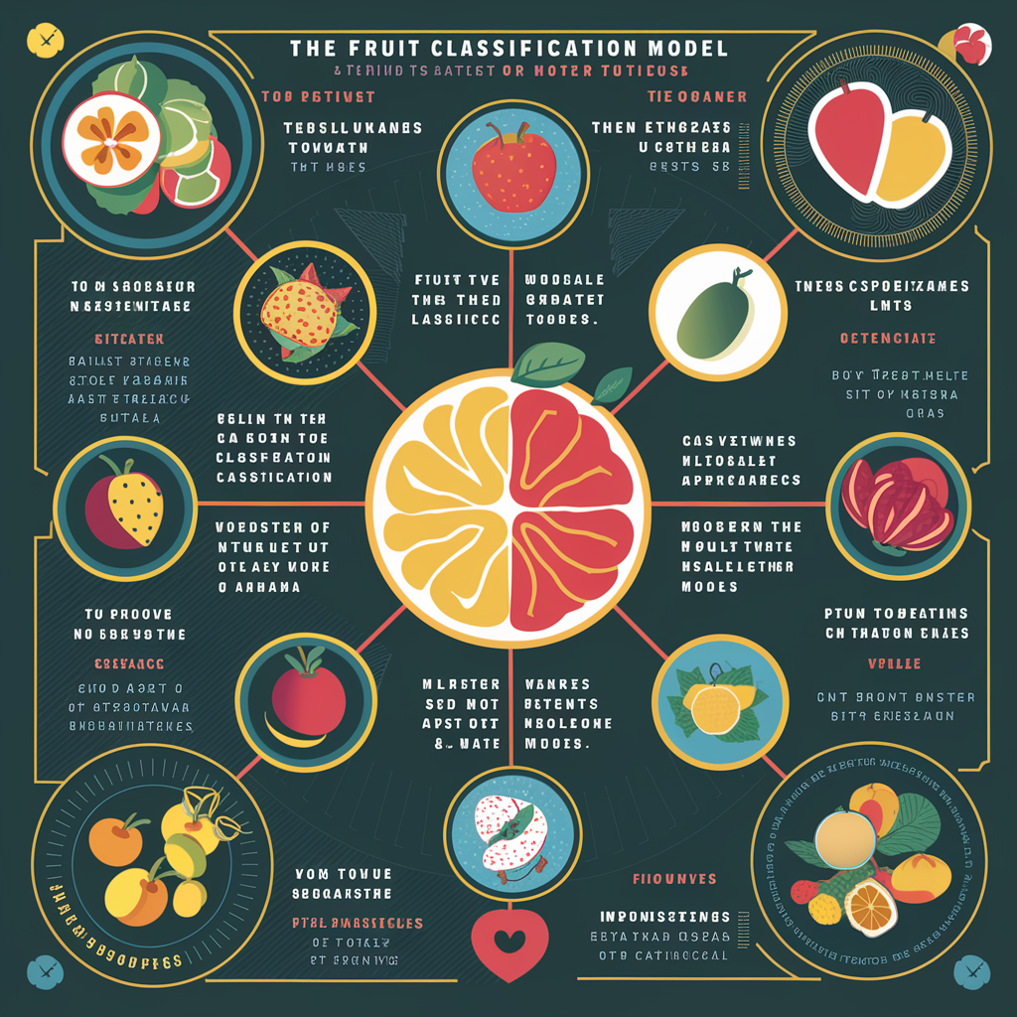

**3.3. Results**

* As a result, the effectiveness of the CNN model, is main findings, CNN with the accuracy of the 98.7%, and validation for the accuracy of the 97.6%. Here are the results of above findings;

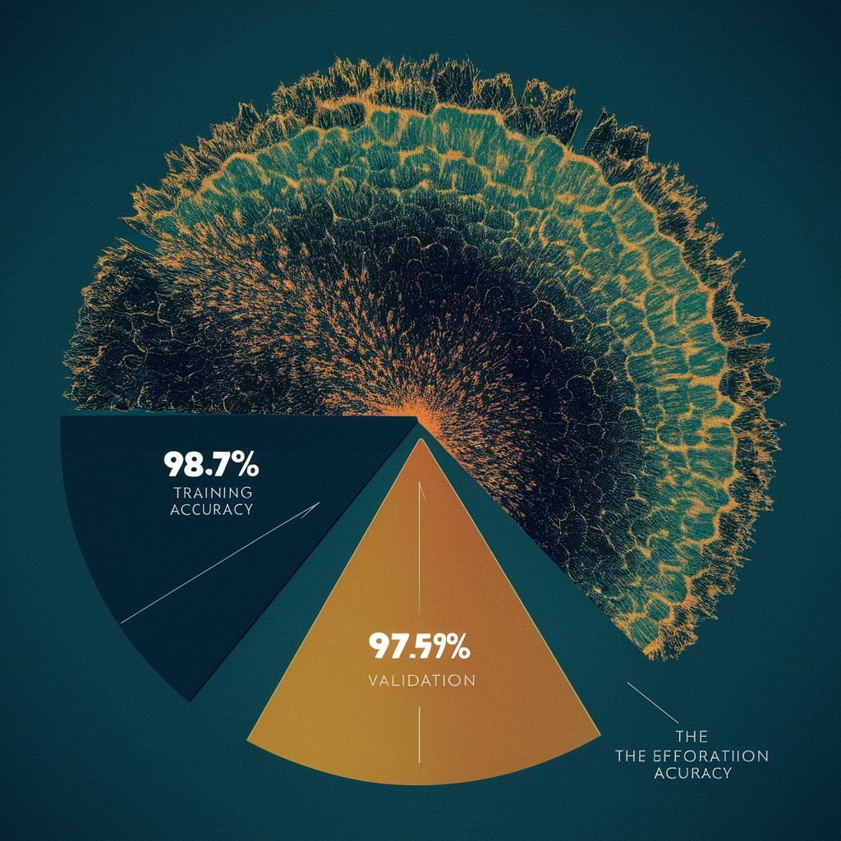

* The better result is also being achieved, if we provide the good quality of the dataset, and with their diversity involved, plays the huge role on performance.

**Chapter 4: Discussion**

**4.1. Conclusion**

In this study, we established the effectiveness of the model, which is classifying by maintaining the high accuracy by using the diverse range of fruit types. In order to include the model’s performance in the classification task, required the quantitative evaluation results, includes both of the training and validation accuracy, precision, and also includes F1-score.

The suggestion for this study, includes the followings:

* Quality and diversity in the dataset.
* Automate the recognition of the fruit.
* Quality control in order to perform classification.

**4.2. Idea for Future Work**

* Advancing the data augmentation technique, includes **Generative Adversarial Networks** (GANs) or **Style Transfer,** which is supposed to increase the diversity of the data during training time.
* Exploration of the fine-tuning and transfer learning, by the use of pre-trained model such as **ImageNet-trained models,** then specify it towards the fine tuning process but the pre-trained models used as the starting point.
* Deployment of the techniques of the ensembles learning, such as the bagging or boosting, which stores the results or predictions of the multiples **CNN** models, which achieve the better performance.
* Refinement of the model according to the specific domain, which is quite helpful, because we have to predict the ripeness or the diseases of the fruit.

Here below the image of the CNN, which we are supposed to be performed in the future analysis, in which each of the layer is presenting the;

* **Input layer**
* **Convolutional layer 5 X 5**
* **Maxpooling 5 X 5**
* **Convolutional layer 3 X 3**
* **Maxpooling 2 X 2**
* **Fully connected layer**

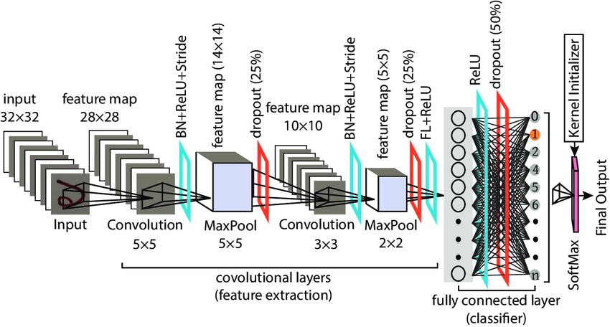

**4.3. References**

TensorFlow: A System for Large-Scale Machine Learning

* Authors: Abadi, M., Barham, P., Chen, J., Chen, Z., Davis, A., Dean, J., ... & Kudlur, M.
* Publication: 12th USENIX Symposium on Operating Systems Design and Implementation (OSDI 16), pp. 265-283.
* Summary: This paper introduces TensorFlow, a comprehensive open-source platform for machine learning. It emphasizes TensorFlow's scalability, flexibility, and ease of use, making it suitable for both research and production environments. The system is designed to support a wide range of machine learning and deep learning models, facilitating the development of complex models with ease.

### **Keras: Deep Learning Library for Theano and TensorFlow**

* **Author**: Chollet, F.
* **Publication**: GitHub. Retrieved from <https://github.com/fchollet/keras>.
* **Summary**: Keras is a high-level neural networks API, written in Python and capable of running on top of TensorFlow, CNTK, or Theano. It was developed with a focus on enabling fast experimentation. Keras allows for easy and fast prototyping, supports both convolutional networks and recurrent networks, as well as combinations of the two, and runs seamlessly on both CPU and GPU.

### **Support-Vector Networks**

* **Authors**: Cortes, C., & Vapnik, V.
* **Publication**: Machine learning, 20(3), 273-297.
* **Summary**: This paper introduces support-vector networks (SVMs), a set of supervised learning methods used for classification, regression, and outliers detection. SVMs are effective in high-dimensional spaces and are versatile as different Kernel functions can be specified for the decision function.

### **Improving Neural Networks by Preventing Co-Adaptation of Feature Detectors**

* **Authors**: Hinton, G., Srivastava, N., Krizhevsky, A., Sutskever, I., & Salakhutdinov, R.
* **Publication**: arXiv preprint arXiv:1207.0580.
* **Summary**: This paper presents a method to improve the performance of neural networks by preventing the co-adaptation of feature detectors. The authors introduce a technique called dropout, which randomly sets a fraction of input units to 0 at each update during training time, helping to prevent overfitting and improve generalization.

### **Scikit-learn: Machine Learning in Python**

* **Authors**: Pedregosa, F., Varoquaux, G., Gramfort, A., Michel, V., Thirion, B., Grisel, O., ... & Vanderplas, J.
* **Publication**: Journal of machine learning research, 12(Oct), 2825-2830.
* **Summary**: Scikit-learn is a free software machine learning library for the Python programming language. It features various classification, regression, and clustering algorithms, and is designed to interoperate with the Python numerical and scientific libraries NumPy and SciPy.

### **Visualizing and Understanding Convolutional Networks**

* **Authors**: Zeiler, M. D., & Fergus, R.
* **Publication**: European conference on computer vision (pp. 818-833). Springer, Cham.
* **Summary**: This paper discusses the challenges and methods for visualizing and understanding the inner workings of convolutional neural networks (CNNs). It presents techniques for visualizing the features learned by CNNs and for understanding the decision-making process of these networks.

### **Convolutional Neural Network Based Rotten Fruit Detection Using ResNet50**

* **Authors**: Foong, C.C.; Meng, G.K.; Tze, L.L.
* **Publication**: Proceedings of the 2021 IEEE 12th Control and System Graduate Research Colloquium (ICSGRC), Shah Alam, Malaysia, 7 August 2021.
* **Summary**: This paper presents a method for detecting rotten fruits using a convolutional neural network (CNN) based on the ResNet50 architecture. The approach leverages transfer learning to improve the accuracy of fruit freshness classification, demonstrating the effectiveness of deep learning techniques in practical applications.

### **Classification of Skin Lesions Using Transfer Learning and Augmentation with Alex-net**

* **Authors**: Hosny, K.M.; Kassem, M.A.; Foaud, M.M.
* **Publication**: PLoS ONE, 14, e0217293.
* **Summary**: This study applies transfer learning and data augmentation techniques to classify skin lesions using the AlexNet architecture. The methodology demonstrates the potential of deep learning in medical image analysis, showcasing the effectiveness of transfer learning in leveraging pre-trained models for new tasks.

### **A Comparative Analysis on Fruit Freshness Classification**

* **Authors**: Karakaya, D.; Ulucan, O.; Turkan, M.
* **Publication**: Proceedings of the 2019 Innovations in Intelligent Systems and Applications Conference (ASYU), Izmir, Turkey, 31 October–2 November 2019.
* **Summary**: This paper conducts a comparative analysis of various methods for fruit freshness classification. It evaluates the performance of different machine learning algorithms and deep learning models in accurately determining the freshness of fruits, highlighting the importance of choosing the right model for specific classification tasks.