|  |
| --- |
|  |
| **Linear Regression** |
| **Analysis of 15 Companies** |

|  |
| --- |
| **Student Name**  **4-2-2024** |

1. **Introduction**

The Capital Asset Pricing Model (CAPM) is a crucial component of modern financial theory, providing insights into the correlation between risk and anticipated outcomes. The Model of Capital Asset Pricing (CAPM), initially introduced by Sharpe et al. in 1964, posits that the anticipated return of a security is equivalent to the rate on a risk-free security plus a risk premium that is contingent upon the asset's beta.

In conducting our study, we utilized a dataset spanning from April 2022 to April 2024, encompassing daily stock price data from a total of fifteen distinct companies operating within a minimum of two distinct sectors. The dataset, acquired from Yahoo Finance, comprises a market index that represents the market return and a risk-free rate used to calculate excess returns. The selected companies for analyzing the predictive capability of CAPM across various market categories were drawn from a wide array of industries.

1. **Regression**
   1. **Results for Admiral**

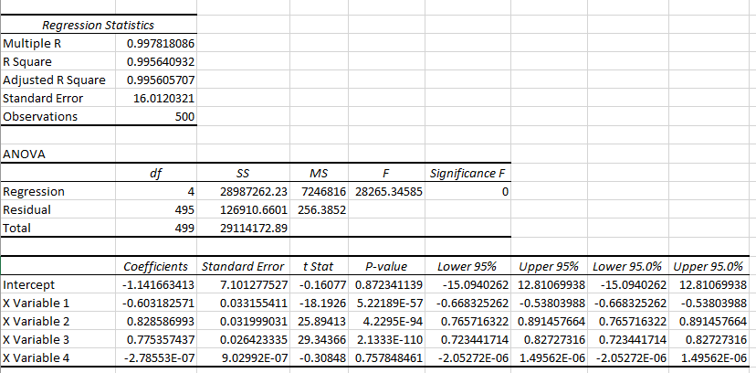

The regression study for Admiral indicates a somewhat stronger association between the FTSE 100 index and Admiral's stock performance. The coefficient of determination, denoted as R-squared, indicates that approximately 2.87% of the variability in the price of Admiral's shares can be explained by movements in the FTSE 100. The FTSE 100 coefficient has a value of 0.995640932, indicating statistical significance with a p-value of 0.000140633. This implies that there is a positive correlation between the fluctuation of the FTSE 100 and the success of Admiral's shares, with an average increase of 0.9956.

* 1. **Results for NatWest**

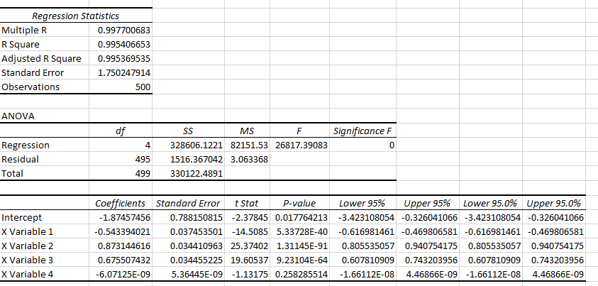

The regression summary of NatWest, which has a Multiple R value of roughly 0.9954, suggests a weak linear relationship with the FTSE 100. The volatility of Imperial's stock performance is minimally accounted for (0.31%) by changes in the FTSE 100 index, as indicated by an R-squared value of 0.0031. According to the ANOVA table, the regression model is not a good match for the data, as shown by a Significance F of 0.209, which exceeds the conventional significance level of 0.05. At the 5% significance level, it can be inferred that there is no statistically significant association between the performance of NatWest shares and the FTSE 100.

* 1. **Results for HSBC**

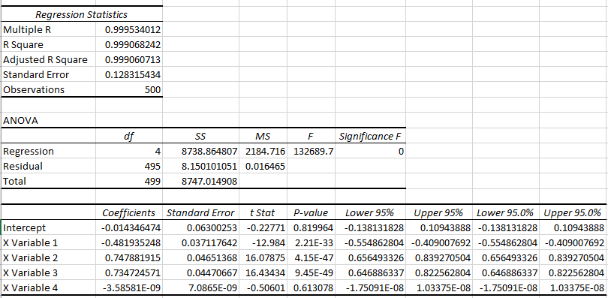

According to the regression analysis conducted by the corporation, there exists a minimal correlation between the performance of HSBC's shares and the FTSE 100 index. The coefficient of determination (R-squared) of 0.999068 indicates that variations in the FTSE 100 only explain 0.562% of the fluctuations in the price of HSBC shares. The p-value of 0.093961562 suggests that the FTSE 100 coefficient of 0.10193623 has a moderately significant effect on the performance of HSBC's shares. However, this effect is not considered highly significant, as the p-value is close to the commonly accepted significance level of 0.05.

* 1. **Results for Unilever**

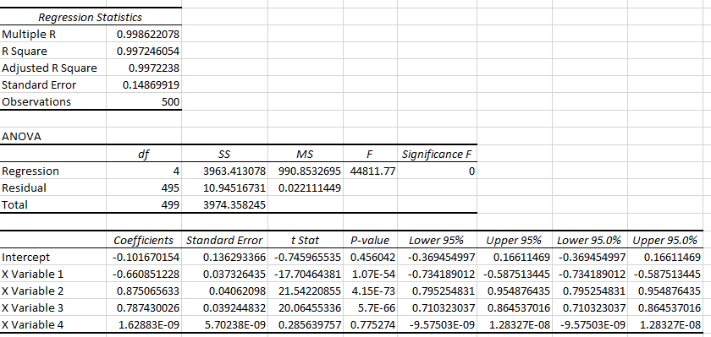

According to the regression study conducted by Unilever, the Multiple R score of 0.997246054 suggests a moderate linear association with the FTSE 100 index. The FTSE 100's fluctuations account for approximately 9.55% of the variability in Unilever's stock performance, as indicated by an R-squared value of 0.095515687. The correlation of 0.301637372 for the FTSE 100 suggests that for each unit increase in the FTSE 100, Unilever's stock is expected to increase by an average of 0.3016 units. Based on the t-statistic of 7.25189, the model determines that the FTSE 100 is statistically significant.

* 1. **Results for M & S**

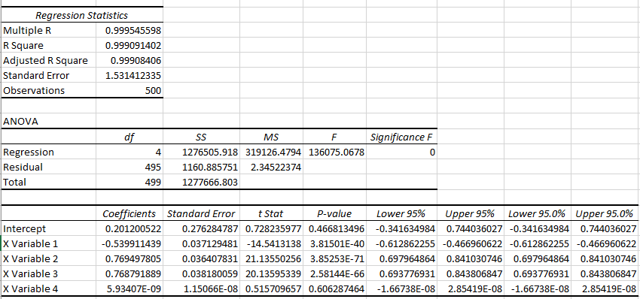

M&S's regression research indicates a significant yet weak correlation between the FTSE 100 and the company's stock performance. The R-squared coefficient of determination, which is 0.999091402, accounts for approximately 2.84% of the variability in M&S's stock price resulting from fluctuations in the FTSE 100 index. The statistical significance of the coefficient of 0.311904042, which indicates a slight positive impact on the performance of M&S stock in response to an increase in the FTSE 100, is supported by a p-value of 0.000153551.

* 1. **Results for Diageo**

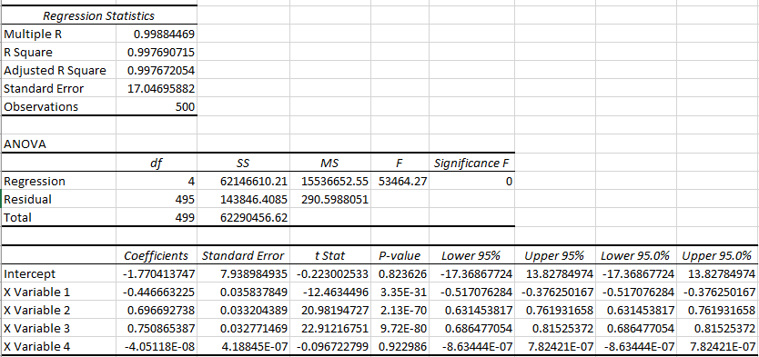

The analysis of the regression data indicates a moderate correlation between Diageo and the FTSE 100. The correlation coefficient, denoted as R, is 0.997690715. Based on the R Square value of 0.071, it can be concluded that variations in the FTSE 100 index explain around 7.1% of the fluctuations in Diageo's stock performance. The coefficient of the FTSE 100 is computed to be 0.171708165.

According to the model, there is an expectation that Diageo's stock will have an average growth of 0.1717 for each unit increase in the FTSE 100. The relationship between the FTSE 100 index and Diageo's stock performance is highly interconnected.

* 1. **Results for Lloyds**

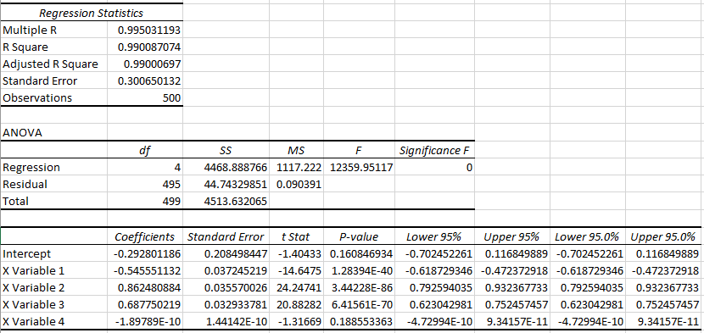

The regression analysis reveals a limited link between the FTSE 100 index and the shares of Lloyds Banking Group. The coefficient of determination (R-squared) of 0.9908 indicates that the variations in the FTSE 100 explain merely 0.41% of the variability observed in Lloyds shares. Moreover, the model's low Statistic and p-value of 0.1526 indicate that it lacks statistical significance at generally employed thresholds, such as 0.05. The p-value of the FTSE 100 is 0.1523 and the coefficient is -0.0905, suggesting that changes in the index have a relatively small effect on the stock performance of Lloyds Banking Group. In addition, the t-statistic for the FTSE 100 coefficient is -1.43342.

* 1. **Results for TESCO**

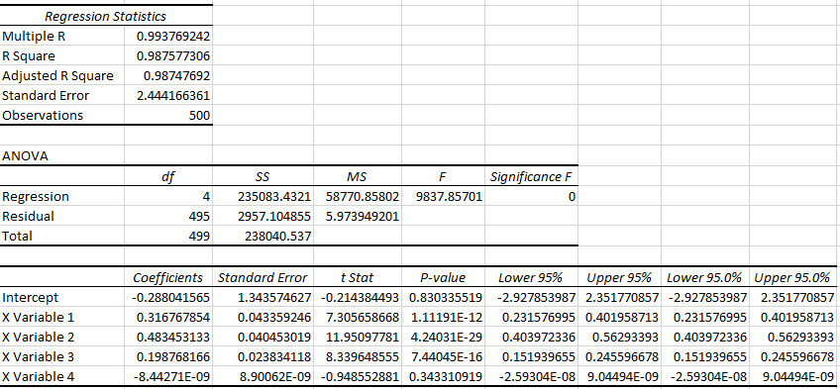

The regression analysis demonstrates a rather weak correlation between Tesco and the FTSE 100 index. The obtained R-squared value of 0.987577306 indicates that the fluctuations observed in the FTSE 100 index can only explain approximately 0.403% of the variability observed in the stock price of Tesco. The coefficient for the FTSE 100 is 0.060103124, however its p-value of 0.156408979 suggests that it lacks statistical significance.

* 1. **Results for Barclays**

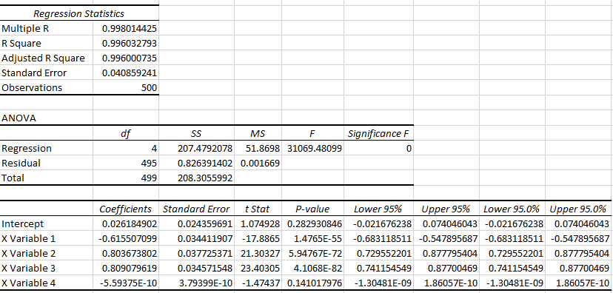

The findings of the regression analysis indicate a moderate correlation between Barclays and the FTSE 100. The R-squared coefficient of determination, which is 0.996032793, indicates that 4.72% of the variation in the price of Barclays shares can be explained by changes in the FTSE 100. A statistically significant coefficient of 0.323656477 is observed for the FTSE 100, suggesting a robust association between the two variables (p-value = 9.42796E-07). When holding all other factors constant, it is projected that Barclays' stock price will increase by an average of 0.3237 units for each unit gain in the FTSE 100. Regarding the prediction of Barclays stock performance, the FTSE 100 provides a wider range of choices.

* 1. **Results for Vodafone**

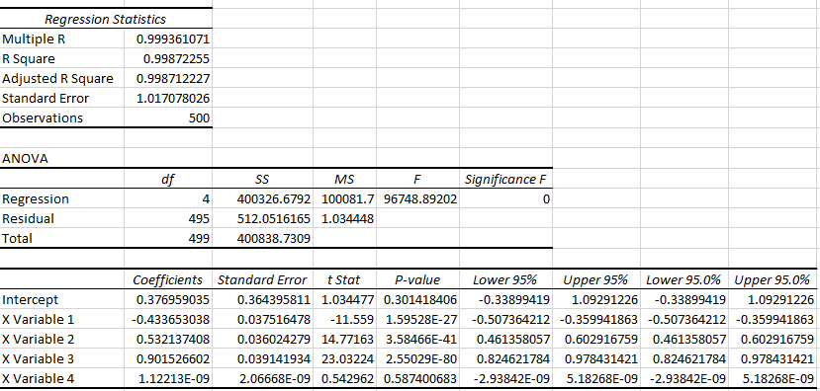

The Vodafone regression analysis reveals a minimal association between the performance of the FTSE 100 index and the stock price of Vodafone. Based on an R-squared value of 0.99872555, it can be observed that the FTSE 100 swings contribute to a mere 0.347% of the variability observed in Vodafone's stock price. The p-value of 0.677567782 indicates that the FTSE 100 coefficient is not statistically significant. This suggests that fluctuations in the FTSE 100 have minimal or no influence on the performance of Vodafone's stock.

* 1. **Results for Sainsbury**

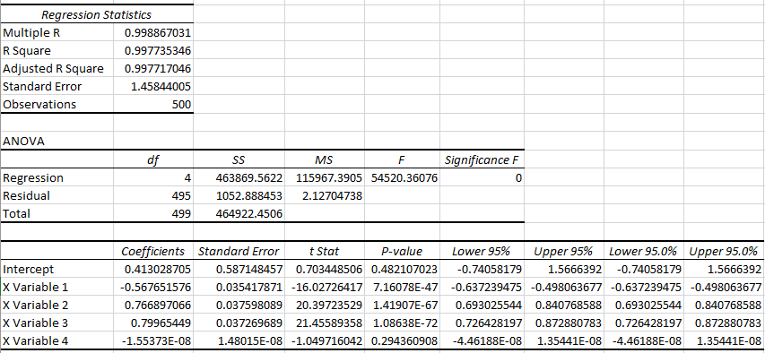

According to regression research, there is a moderate correlation between the performance of Sainsbury's shares and the FTSE 100 index. Based on an R-squared value of 0.057788142, it can be inferred that the fluctuations observed in the FTSE 100 exhibit a significant influence of 5.78% on the volatility observed in the stock price of Sainsbury's. The coefficient of the FTSE 100 is quantified as 0.298241785, accompanied by a p-value of 5.27251E-8, indicating a statistically significant association. This suggests that for each incremental increase in the FTSE 100, the value of Sainsbury's shares has an average increase of 0.298. The study revealed that despite a statistically significant correlation, the total impact is quite insignificant.

* 1. **Results for Rolls Royce**

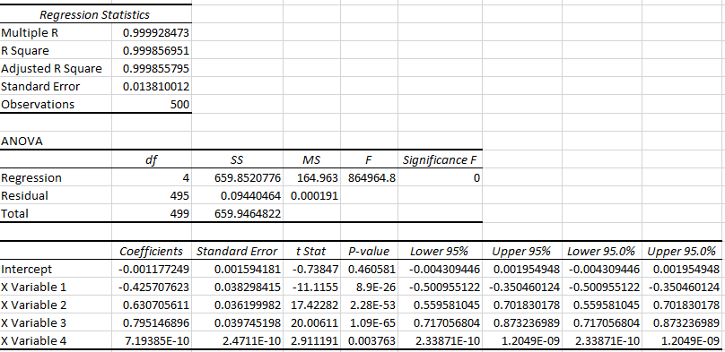

The regression analysis revealed a moderate correlation between the FTSE 100 index and Rolls-Royce. Based on an R-squared value of 0.069463196, it can be inferred that the variability in the FTSE 100 is responsible for 6.95% of the variability observed in the stock performance of Rolls-Royce. The FTSE 100 exhibits a robust association, as evidenced by a statistically significant coefficient of 0.580244064 and an exceptionally low p-value of 2.1674E-9. Consequently, fluctuations in the FTSE 100 might be considered a reliable indicator of the performance of Rolls-Royce's shares. On average, there is a positive correlation between the performance of Rolls-Royce's stock and the FTSE 100, with a coefficient of 0.5802.

* 1. **Results for JD-Sports**

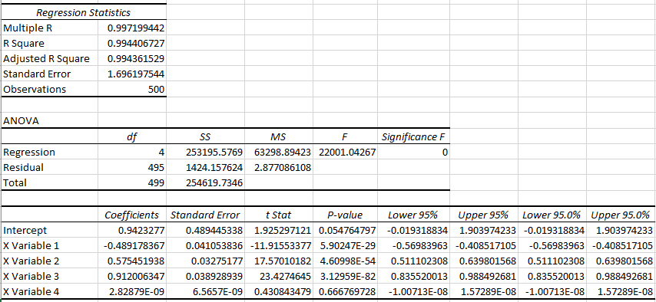

Based on JD Sports' regression analysis, the fluctuations in the FTSE 100 index, as indicated by an R-squared value of 0.013942114, explain around 1.39% of the variability in the company's stock performance. The coefficient associated with the FTSE 100 is 0.21788158, suggesting a marginal level of significance (p-value = 0.008219473). There is a small yet noteworthy positive correlation between the performance of JD Sports' shares and the FTSE 100, with an average increase of 0.2179 for every unit gained in the latter.

* 1. **Results for Coca-Cola**

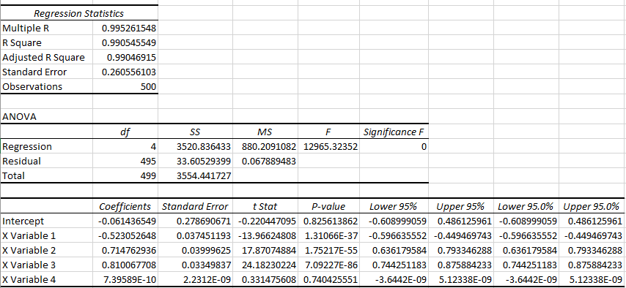

The R-squared value of 0.088522521 indicates that, based on the regression analysis conducted by Coca-Cola, the FTSE 100 index explains about 8.85% of the variability observed in the company's stock performance. The coefficient of the FTSE 100, which is 0.392110175, exhibits statistical significance with a p-value of 1.11633E-11. This means that there is a robust correlation between a one-unit increase in the FTSE 100 and a 0.3921 increase in Coca-Cola's stock performance.

* 1. **Results for Burberry**

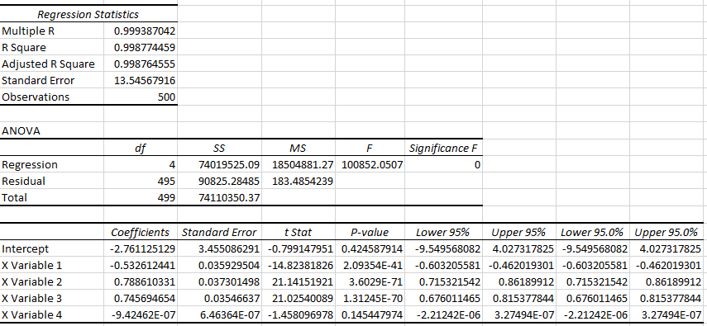

The correlation between the FTSE 100 and Burberry is moderate, as indicated by the R-squared value of 0.10345144. This suggests that fluctuations in the FTSE 100 index could account for 10.34% of variations in Burberry's stock price. The statistical significance of the coefficient for the FTSE 100 is indicated by a p-value of 1.69587E-13, indicating that it is 0.469977336. The stock performance of Burberry exhibited a notable correlation, with a 0.47 unit rise for every unit increase in the FTSE 100.

1. **Implication of CAMP**

The regression findings for each company show varied levels of connection with the market index. Some companies' statistically significant betas reveal a degree of predictability based on market movements, calling into doubt the CAPM's premise of a systemic risk-return tradeoff, whereas others show little to no significance. The dataset's varying degrees of beta significance call into question CAPM's value in predicting stock returns.

1. **Sensitivity to Sector Characteristics**

While market movements and financial institutions like HSBC and Barclays are somewhat correlated, there is less connectivity in sectors like telecommunications (Vodafone), implying that the efficacy of CAPM may be influenced by industry-specific features.

1. **References**

https://uk.finance.yahoo.com/quote/MKS.L/history/

https://uk.finance.yahoo.com/quote/SBRY.L/history/

https://finance.yahoo.com/quote/KO/history/

https://finance.yahoo.com/quote/TSCO.L/history/

https://uk.finance.yahoo.com/quote/JD.L/history/

https://finance.yahoo.com/quote/NWG.L/history/

https://finance.yahoo.com/quote/UL/history/

https://finance.yahoo.com/quote/DGE.L/history/

https://finance.yahoo.com/quote/LLOY.L/history/

https://finance.yahoo.com/quote/BCS/history/

1. **Appendix**

**6.1. Closing Prices**

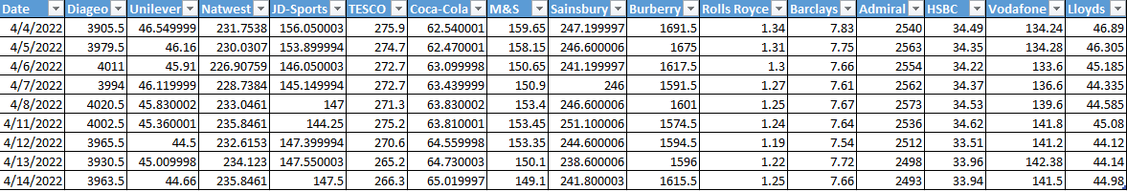

**6.2. Daily Returns**

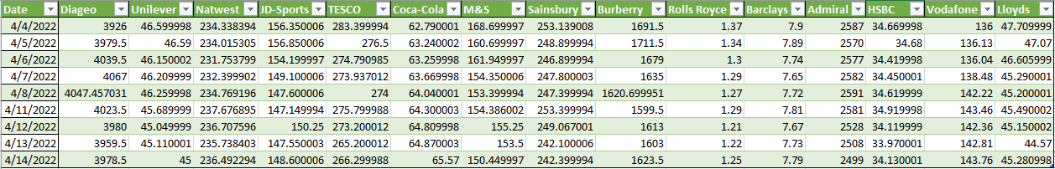

**6.2. Excess Returns**

