Virtual File System (VFS) – Complete Project Report

1. Introduction
A file system is a core component of an operating system that manages how data is stored and retrieved. This project implements a Simple Virtual File System (VFS) that simulates the internal working of a real file system using a virtual disk file instead of physical storage.
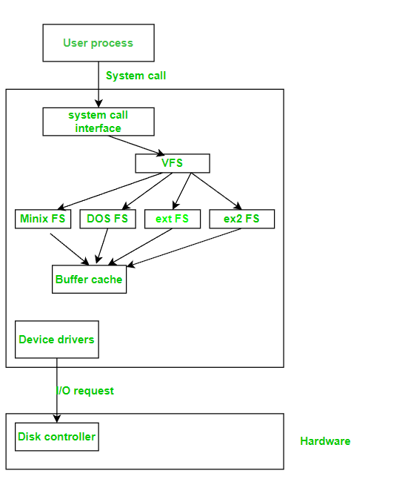

2. Objectives of the Project
- To understand internal working of file systems
- To simulate file storage without using OS file system
- To implement inode-based metadata management
- To demonstrate disk block allocation and persistence

3. System Architecture Overview
The Virtual File System is composed of four main components:
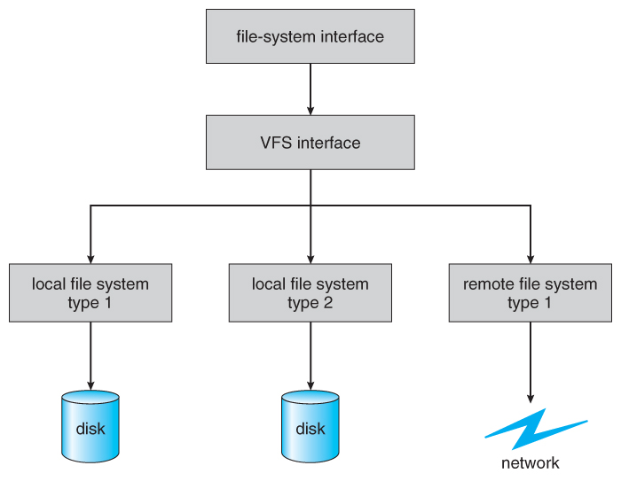
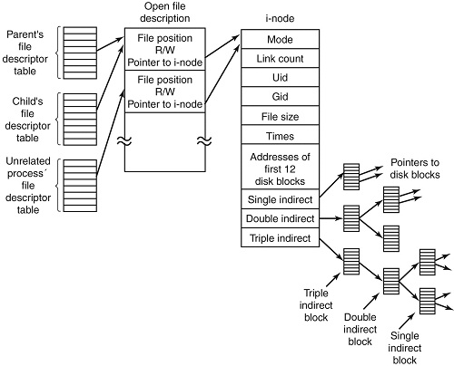
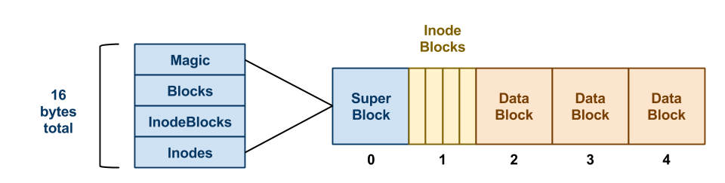

3.1 Virtual Disk
- A binary file acting as a simulated hard disk
- Stores metadata and file data together
- Ensures data persistence

3.2 Inode Table
- Stores file metadata
- Each inode contains:
  - File name
  - File size
  - Disk block number
  - Usage status

3.3 Superblock
- Maintains disk-level information
- Uses bitmap to track free/used blocks

3.4 Data Blocks
- Fixed-size blocks storing actual file content

4. Technologies Used
- Programming Language: C++
- Concepts: File handling, OS concepts, data structures
- Platform: Windows
- Compiler: g++

5. File Operations Implemented

5.1 Create File
- Allocates a free inode
- Assigns a free disk block
- Initializes metadata
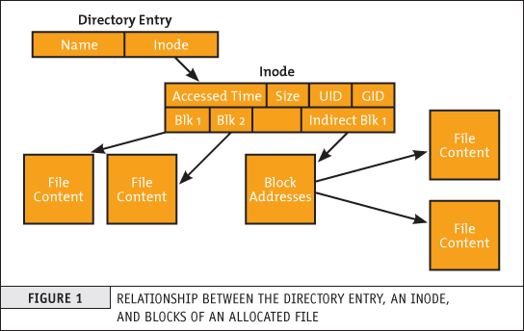
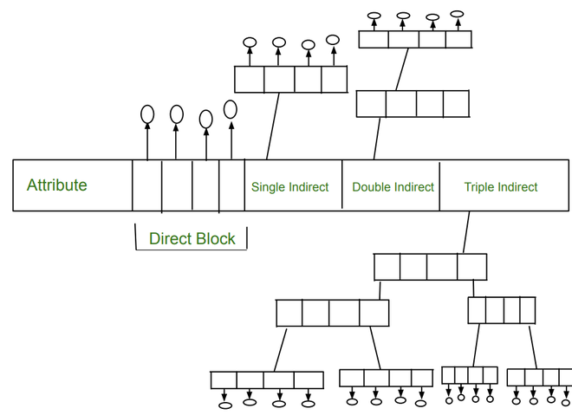

5.2 Write File
- Writes data into assigned disk block
- Updates file size in inode

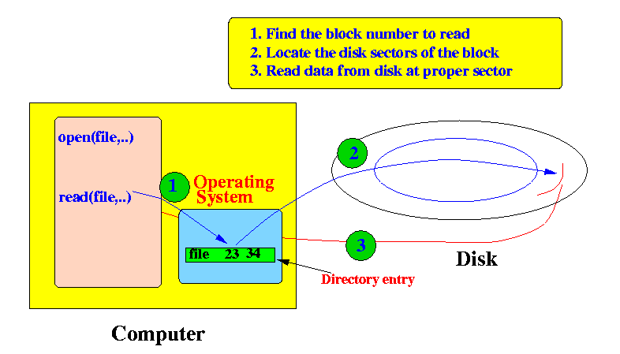

5.3 Read File
- Reads data using block number stored in inode
- Displays file content

5.4 Find File
- Searches inode table
- Supports partial name matching
- Metadata-only operation (fast)

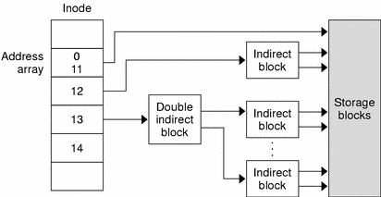

5.5 Delete File
- Marks inode as unused
- Frees disk block in bitmap
- Makes space reusable
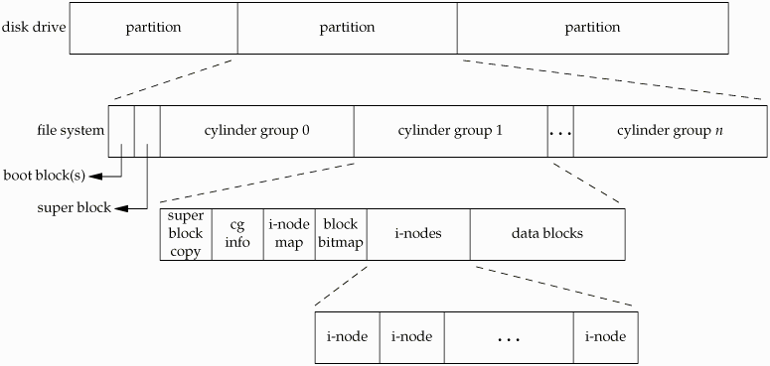
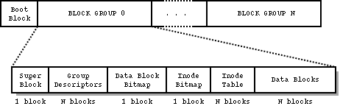

5.6 Rename File
- Updates file name in inode
- Does not affect data blocks

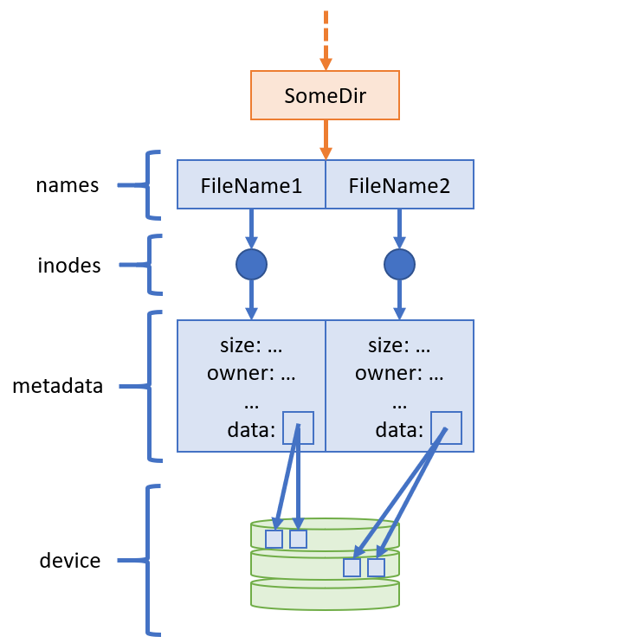

6. Disk Management Strategy
- Fixed-size blocks
- Bitmap-based allocation
- First free block selection
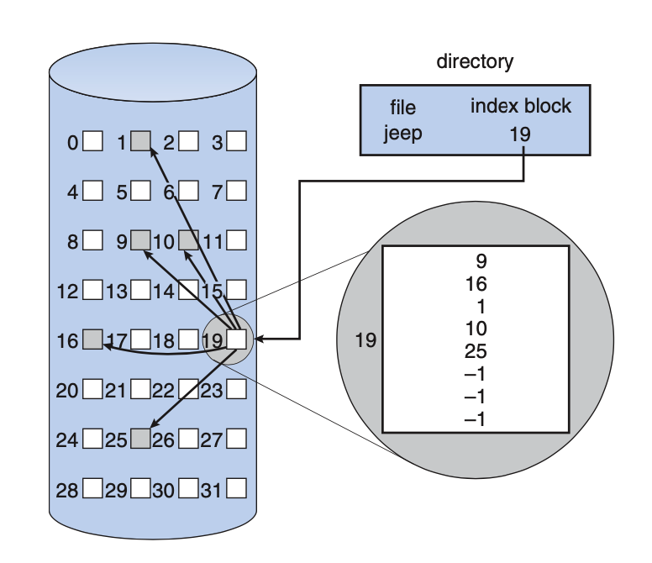

7. Persistence Mechanism
All changes are saved to the virtual disk file, ensuring:
- Data remains after program termination
- File system state is restored on restart

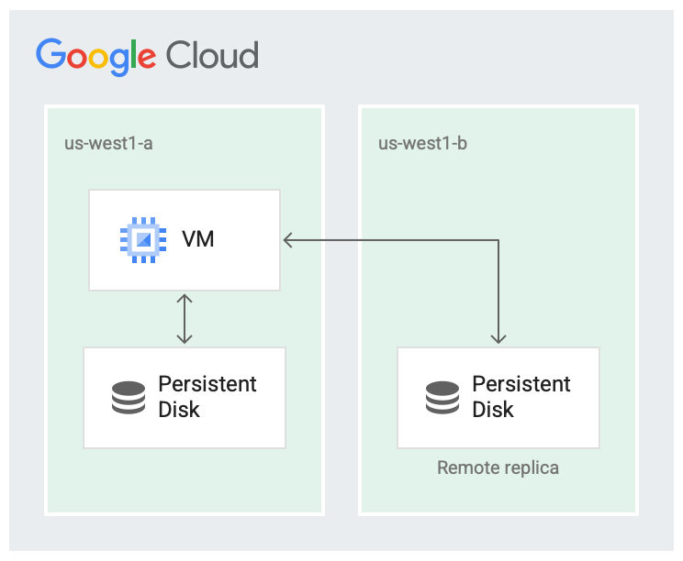

8. Error Handling
The system handles:
- File not found
- Duplicate file names
- Disk full errors
- Invalid commands

9. Advantages
- Simple and educational
- Demonstrates real OS concepts
- Efficient metadata handling
- Persistent storage

10. Limitations
- No directory hierarchy
- No permissions
- Single-user system
- Fixed disk size

11. Future Enhancements
- Directory structure
- File permissions
- Multi-user support
- Dynamic disk resizing

12. Learning Outcomes
- Understanding of inode-based file systems
- Disk block management
- Metadata vs data separation
- OS-level file handling

13. Conclusion
This project successfully simulates a simplified operating system file system. By implementing inodes, disk blocks, and persistence, it provides a strong foundation for understanding real-world file system design.

