**UAS MOBILE PROGRAMMING**

* RIZKY ADHITYA PRATAMA ( 2011102441025 )
* JUNAID HELMI HAFIDZ ( 2011102441209 )

**S1 TEKNIK INFORMATIKA**

**LINK GITHUB :** [**https://github.com/junaidhelmi/UAS-Mobile-web/tree/main**](https://github.com/junaidhelmi/UAS-Mobile-web/tree/main)

**TAMPILAN 1**

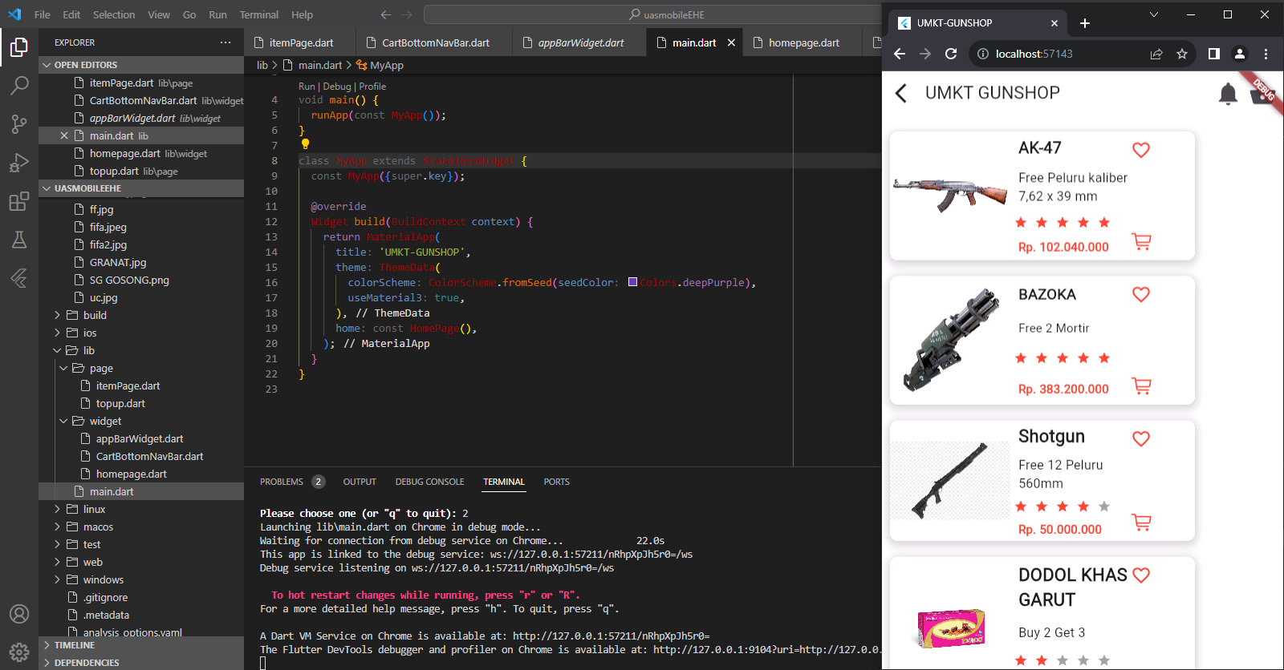

**TAMPILAN 2**

