Product Design
Team 9
Optimaniax
Team members
Raj Manvar
Syed Juned Ali
Shalin Agrawal
Shivang Nagariya
Lashit Jain

Design Model
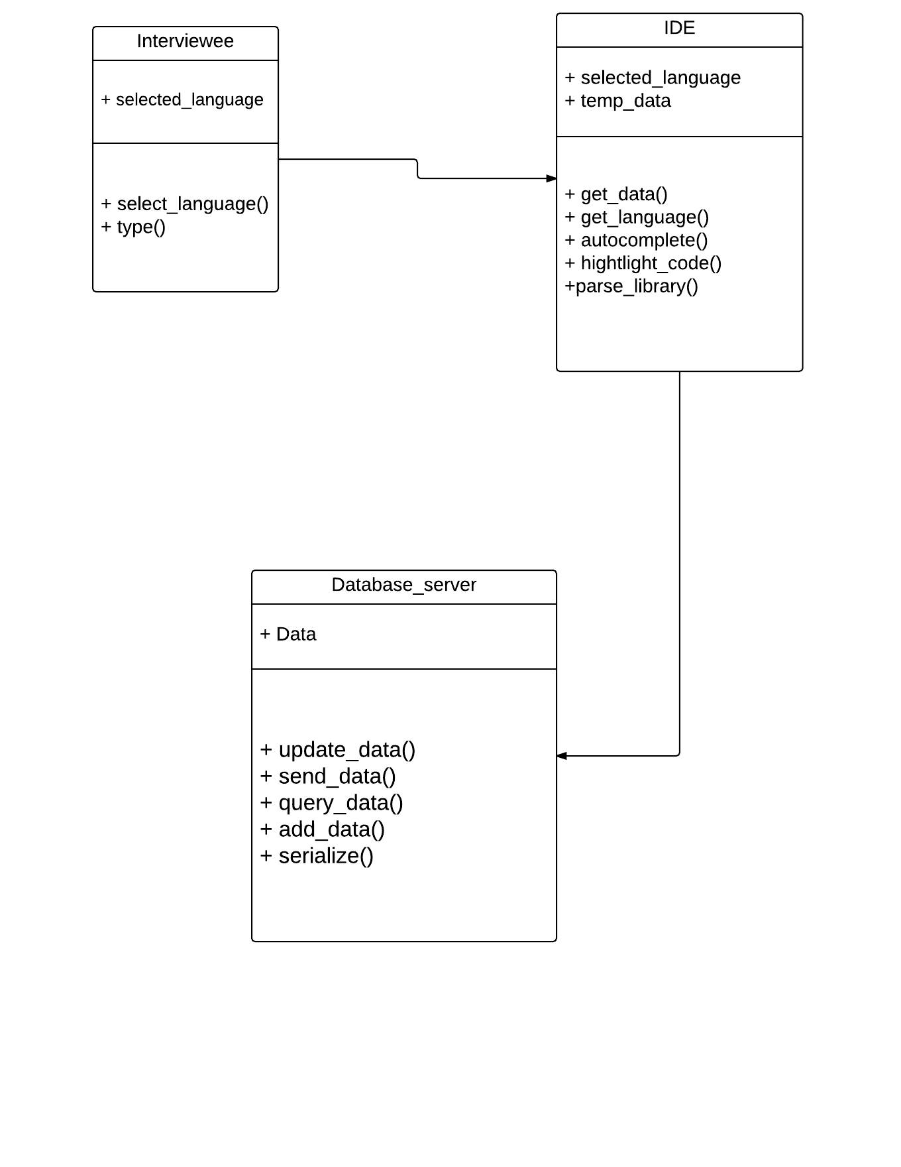

Sequence Diagram(s)
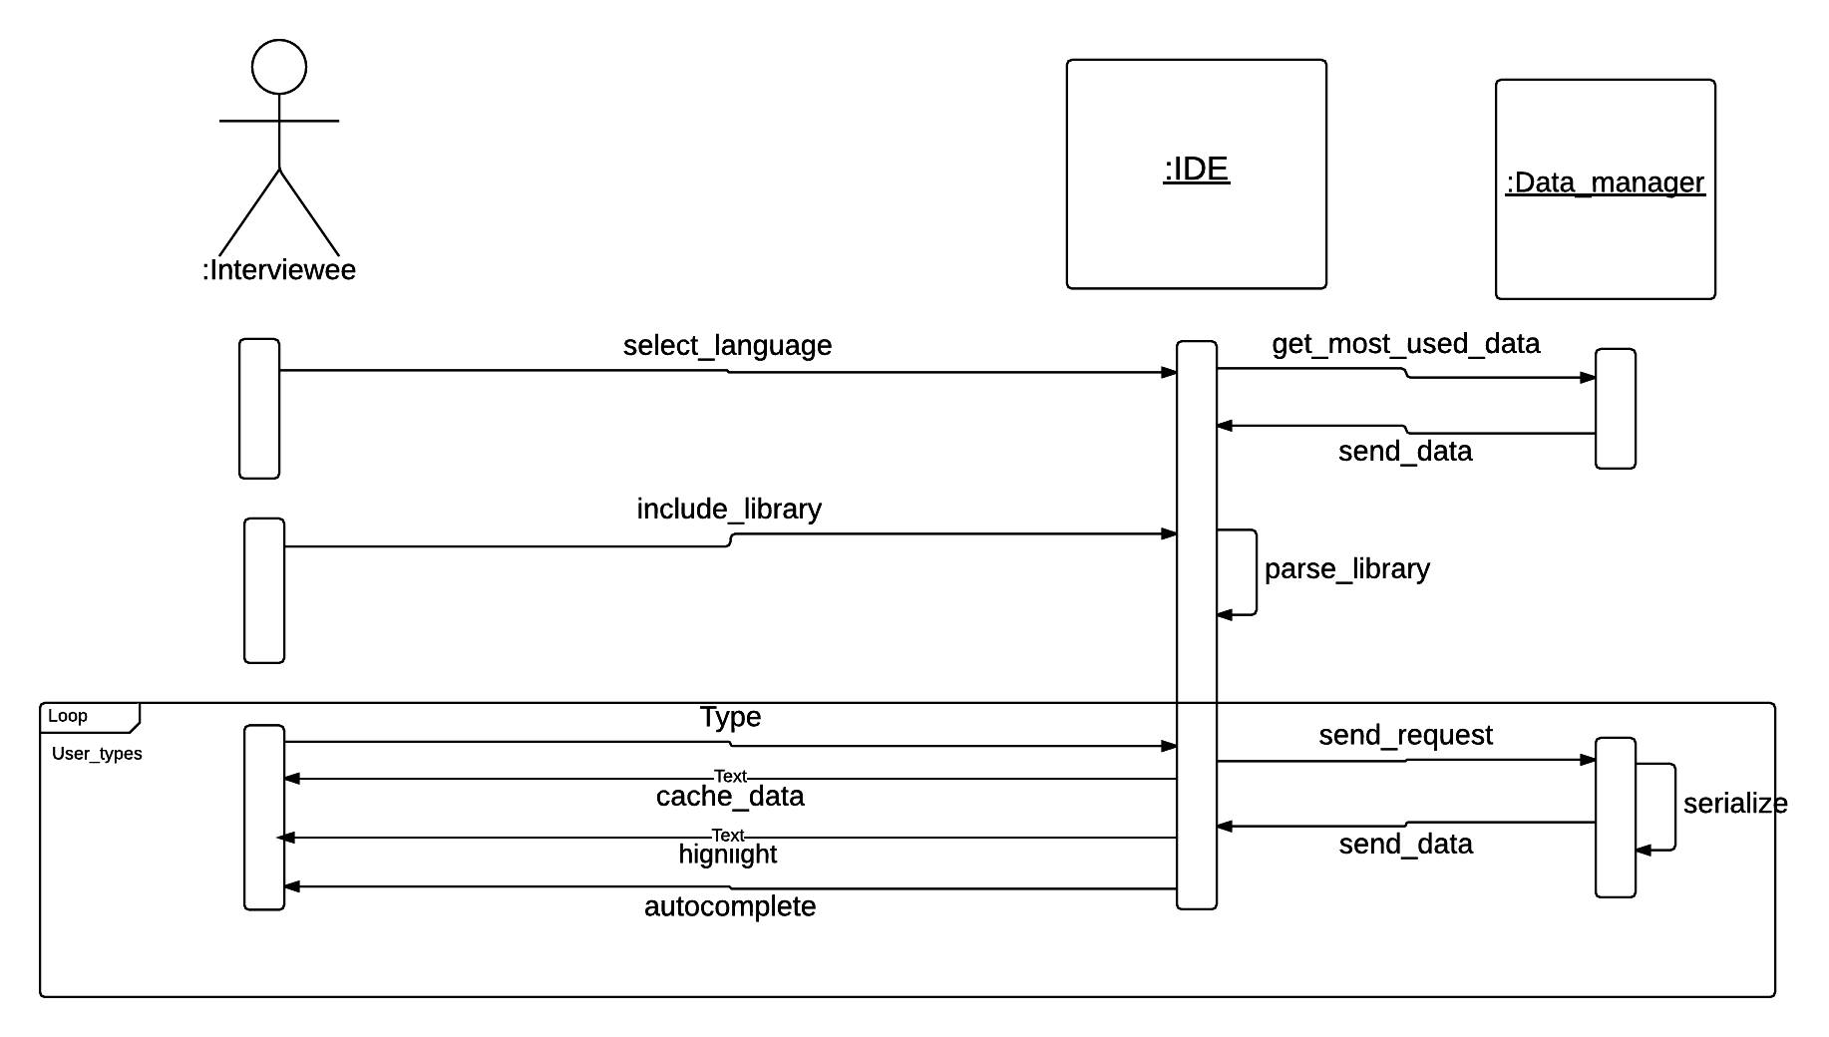

Design Rationale
Our project is Intellisense in Web based IDE under the clients Assess machines.
What is it?
The web based IDE is basically an text editor that will be available to the clients online and it will use intellisense i.e intelligent retrieval of information to serve the clients and help them write code efficiently and with less of frequent errors.
Who is it for?
The audience to the application can be any individual who likes to code and is not really good with remembering the syntax. The context in which our clients Assess machines will be using the application is to simplify the interview selection procedure by giving the interviewees a powerful editor to code so that syntactical problem doesn’t hinders there selections.

The following tables describes the various design decisions made , why and why not of the same.
Design principles and their why and why not’s
Design Principle 1
Provide the clients a ‘Web’ based IDE and not a native editor.
We chose to make a ‘Web’ based IDE so that the application is not platform specific and anyone and everyone can access the IDE. The other reason for making the Web based is to conduct online interviews so that the Users can code online within the constraints of the interviewers on there IDE.
The other alternatives that we considered were to make a native application but that is already available and it would not serve the purpose of Online interviews within the constraints of the Interviewer.
The strength of the design is that it is not platform specific as it is Web based so it is better than the native application design alternative.
So the strength described above is the reason we chose to go for a Web based design.
Design principle 2
Use intellisense i.e intelligent code completion in the editor to retrieve all the functions and libraries and classes that are frequently used and also the frequently used code snippets.
We are implementing Intellisense in our IDE so as the avert the problem of syntactical errors that the users encounter which have no importance in the logic implemented. It is used so that the user just have to focus on the logic part and do not care about which library the required function was in and what was the exact name of the function.
The other alternative we chose was to use intellisense for just variable auto-completion but that would not be of any powerful use and it is already provided by most of the editors.
The strength of this design is that Intellisense helps to a great extent in writer efficient and correct code with a lot less bugs that we might encounter otherwise. It will also help to a great extent the interviewees in writing code.
So to make our IDE more powerful, helping the coders to write efficient code as well as for learning processes and nullifying the syntactical dependence we introduced intellisense in Our IDE.

Design principle 3
Use of multiple Languages in the Editor and not restrict the user to code in only a particular language.
The reason to introduce multiple languages is it highly unlikely that all the users will be proficient in the only language specified by the editor so it must support multiple languages so that it gives the User freedom to user the language of his choice.
There was no other alternative we thought over this design principle.
The strength of this design principle is that it will make the IDE more powerful by making it language independent. But the deficiency in the design is that there is so many languages and it is practically impossible to implement intellisense for all those languages so we will have to restrict ourselves to a few commonly used languages like C,C++,C# ,java. The other languages with intellisense can be added in future i.e. in the other releases.
So to give multiple options to the users to code in we introduced multiple languages in our project.

Design principle 4
Use of reflection to extract all the most used classes , libraries and the related functions and store it in the databases.
We are using reflection because it is practically impossible to list out manually all the functions and related classes that are used most frequently also. So reflection does the trick to extract all the classes and functions in a package.
Reflection was the only alternative to extract all the data for our application database.
By using reflection we can get all the data before hand and then we upload it to the server from the database instead of searching for the related function in the file system. We created a table with class name , function name and signature of function and used intellisense on this data. The flaw in the design is that we have to wait for some time for the huge database to get uploaded over the server.
We chose this design principle because time for the uploading of the data can be optimized.Our first task is to get the data up on the site.

Design principle 5
Caching of the most frequently used data in the client’s browser.
The reason for caching a really small but most used part of the data from the database is that it is really difficult and time consuming for all the data to upload on the client’s machine whenever a client uses the application and it would make the application really slow. So we just cache an important part of the database.
This design will prevent the application from working slow and in general cases where no special libraries are required by the coders , the application will run just fine, implementing auto-completion smoothly.

Design principle 6
Highlighting of the datatype names and keyword, classnames ,function names and usage of different colors. Highlighting of the errors with different colors.
The datatypes , keywords etc must be highlighted with different names so that the User has clarity of the code. Different colors are used to differentiate keywords from classnames and function names.
The strength of this design is that it provides clarity to the user while coding.

