|  |  |  |
| --- | --- | --- |
| **Declaration** |  | |
| Questions in this exercise are intentionally complex and could be convoluted or confusing. This is by design and to simulate real life situations where customers seldom give crystal clear requirements and ask unambiguous questions. | | |
| I have read the above statement and agree to these conditions | | |
| I AGREE | Junaid Ur Rehman | |
| <Enter your name above this line to indicate that you are in agreement> | |
|  | | |
| **Instructions** |  | |
| Every screenshot requested in this workbook is compulsory and carries 1 marks | | |
| Your AWS account ID must be clearly visible in every screenshot using the AWS console; missing id or using someone else's id is not permitted. Such cases will be considered as plagiarism and severe penalty will be imposed. | | |
| All screenshots must be in the order mentioned under "Expected Screenshots" for every step | | |
| DO NOT WAIT UNTIL THE LAST MINUTE. The program office will not extend the project submission deadline under any circumstances. | | |
| The file should be renamed in the format BATCH_FIRSTNAME_LASTNAME_PROJECT1. For example: PGPCCMAY18_VIJAY_DWIVEDI_PROJECT1.pdf | | |
|  | | |
| **Resource Clean Up** | |  |
| Cloud is always pay per use model and all resources/services that we consume are chargeable. Cleaning up when you’ve completed your lab or project is always necessary. This is true whether you’re doing a lab or implementing a project at your workplace. | | |
| After completing the lab, make sure to delete each resource created in reverse chronological order. | | |
| Each AWS Academy session lasts for 4 hours by default, although you can extend a session to run longer by pressing the start button to reset your session timer. At the end of each session, any resources you created in the account will be preserved. Some AWS resources, such as EC2 instances, may be automatically shut down, while other resources, such as RDS instances will be left running. | | |

**Architecture diagram**

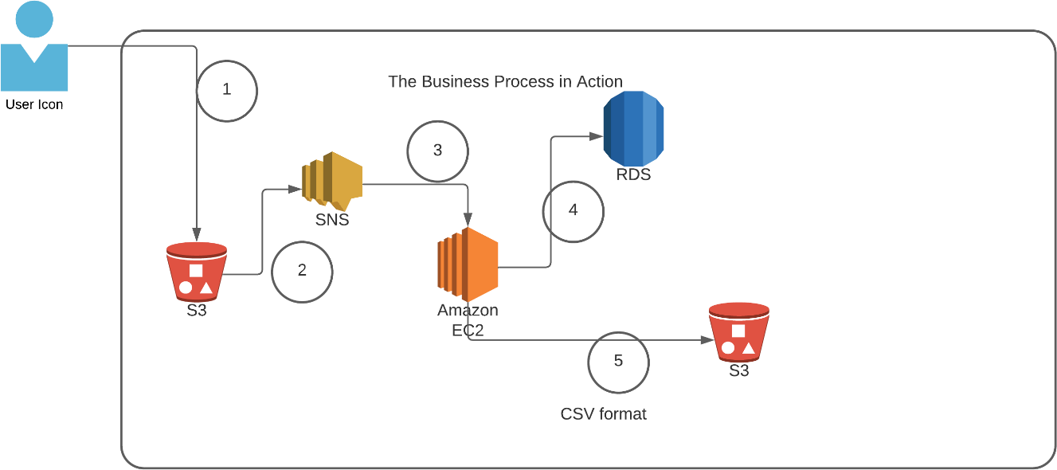

|  |  |
| --- | --- |
| **Architecture Implementation** | |
| 1 | The customer uploads the invoice data to S3 bucket in a text format as per their guidelines and policies. This bucket will have a policy to auto delete any content that is more than 1 day old (24 hours). |
| 2 | An event will trigger in the bucket that will place a message in SNS topic |
| 3 | A custom program running in EC2 will subscribe to the SNS topic and get the message placed by S3 event |
| 4 | The program will use S3 API to read from the bucket, parse the content of the file and create a CSV record and save the details in an RDS database |
| 5 | The program will use S3 API to write CSV record to destination S3 bucket as new S3 object. |

|  |  |
| --- | --- |
| Note | The custom program codebase and sample invoice have been shared along with this workbook on the LMS. |

Step 1: SNS and S3 topic creation

|  |  |
| --- | --- |
| Step number | a |
| Step name | Creation of Source and target buckets |
| Instructions | 1. Navigate to S3 using the Services button at the top of the screen 2. Select "Create Bucket" 3. Enter a source bucket name and use the default options for the rest of the fields 4. Click on "Create Bucket' 5. Repeat the above steps to create a target bucket |
| Expected screenshots | 1) Screen showing created S3 source and target buckets |

<Insert screenshot for a(1) here>

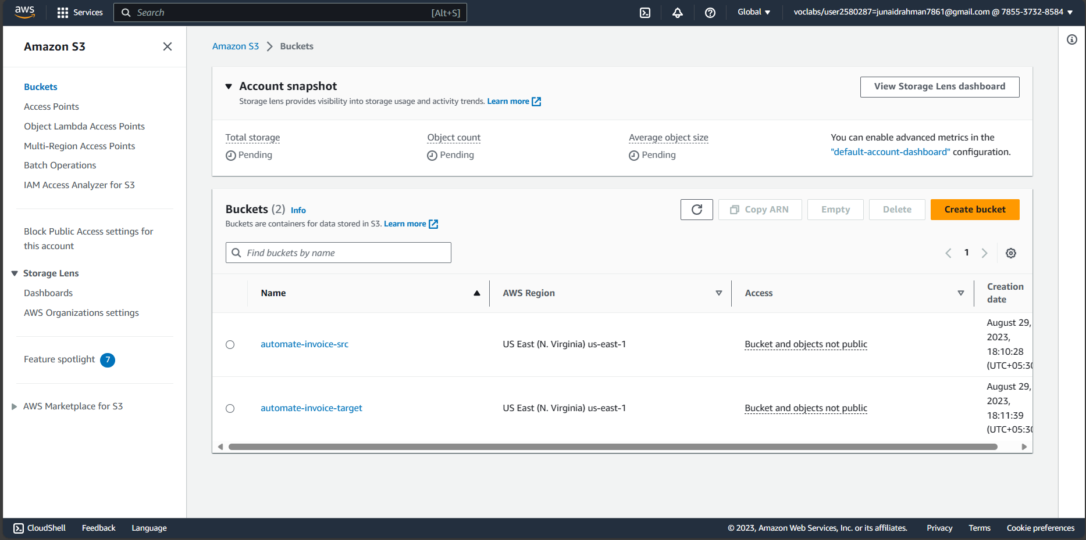

Step number b

Step name Creation of SNS subscription

Instructions 1) Navigate to SNS -> Topics

2) Click on "Create Topic"

3) Enter the following fields

Name: S3toEC2Topic

The other options can be ignored for now

4) Click on Create Topic

Expected screenshots 1) Creation of SNS topic

**<Insert screenshot for b(1) here>**

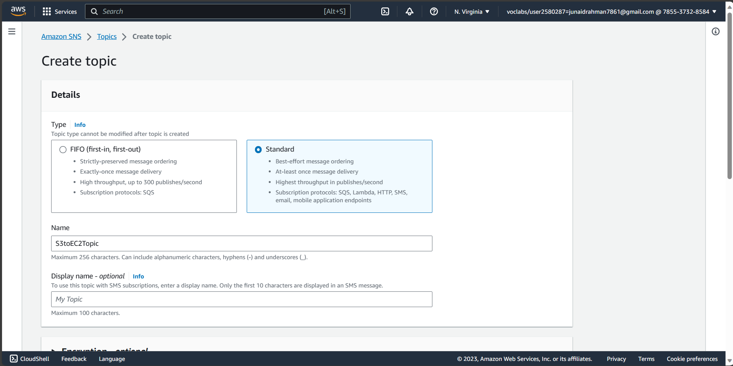

Step number c

Step name Modification of SNS Access Policy

Instructions 1) Navigate to SNS -> Topics and select the topic created in the previous step

2) Note down the ARN shown in the topic details

2) Click on Edit and select "Access Policy".

3) Replace the text in the JSON editor with the following

{

"Version": "2012-10-17",

"Id": "example-ID", "Statement": [

{

"Sid": "example-statement-ID", "Effect": "Allow",

"Principal": {

"AWS":"*"

},

"Action": [ "SNS:Publish"

],

"Resource": "SNS-topic-ARN", "Condition": {

"ArnLike": { "a ws:SourceArn": "arn:aws:s3:*:*:bucket-name" }, "StringEquals": { "aws:SourceAccount": "bucket-owner-account-id" }

}

}

]

}

4) Replace the bold text with the SNS topic ARN, source bucket nameyou’re your AWS account ID respectively.

5) Click on Save Changes

Expected

screenshots 1) JSON Editor screen

<Insert screenshot for c(1) here>

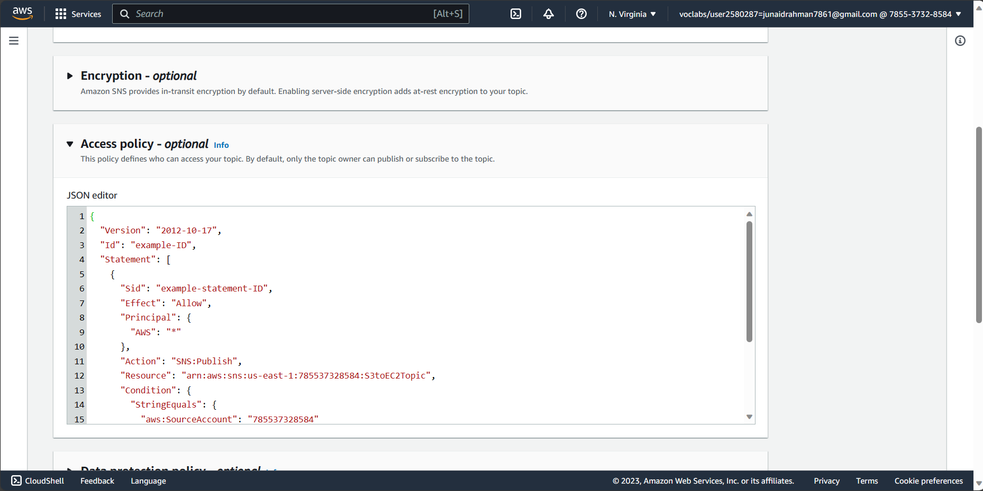

|  |  |
| --- | --- |
| Step number | d |
| Step name | Configuring SNS notifications for S3 |
| Instructions | 1. Navigate to S3 and select the source bucket created in Step 1 (a) 2. Select Properties and scroll down to Event Notifications and select it 3. Select "Create Event Notification" 4. Fillup the details as follows Name : S3PutEvent   Select PUT from the list of radio buttons Destination : Select SNS Topic  SNS : Select S3ToEC2Topic   1. Save Changes |
| Expected screenshots | 1) Event Configuration Screen |

<Insert screenshot for d(1) here>

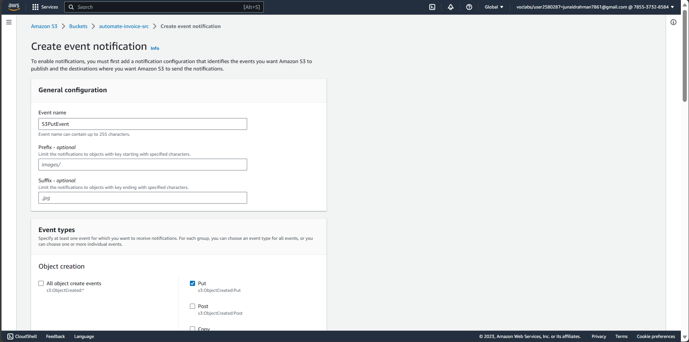

Step 2: Run the custom program in the EC2 instance

Step number a

Step name Creation of the EC2 instance and RDS instance

Instructions 1) Navigate to EC2 -> Instances

2) Create an EC2 instance with the following

parameters

AMI: Amazon Linux 2

VPC: Default

Security group: Ports 22 and 8080 should be opened

3) Navigate to RDS

4) Create an RDS instance with the following

parameters:

Engine type: MySql

Template: Dev/Test

Set the username and password as required

DB Instance class: Burstable

Instance type: t3.micro

Public Access: Yes

VPC Security group: Create New ()

Under Additional Configuration, add an initial

database name. Take note of this name as it will be

required later.

Uncheck “Enable Enhanced Monitoring”

Ensure that the security group created by the RDS

deployment has port 3306 open for all incoming

connections from all sources.

Expected 1) List of instances after creation of EC2

instance

screenshots 2) List of RDS instance

<Insert screenshot for a(1) here>

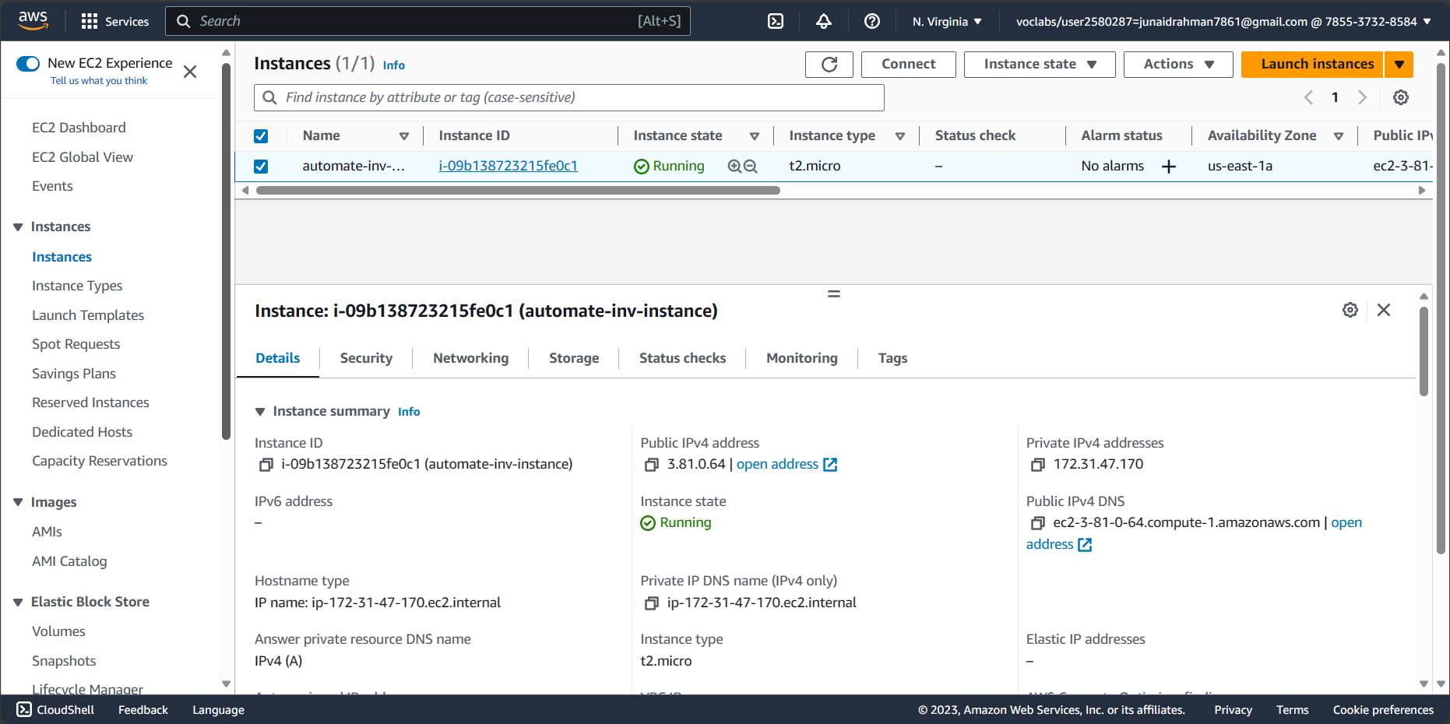

<Insert screenshot for a(2) here>

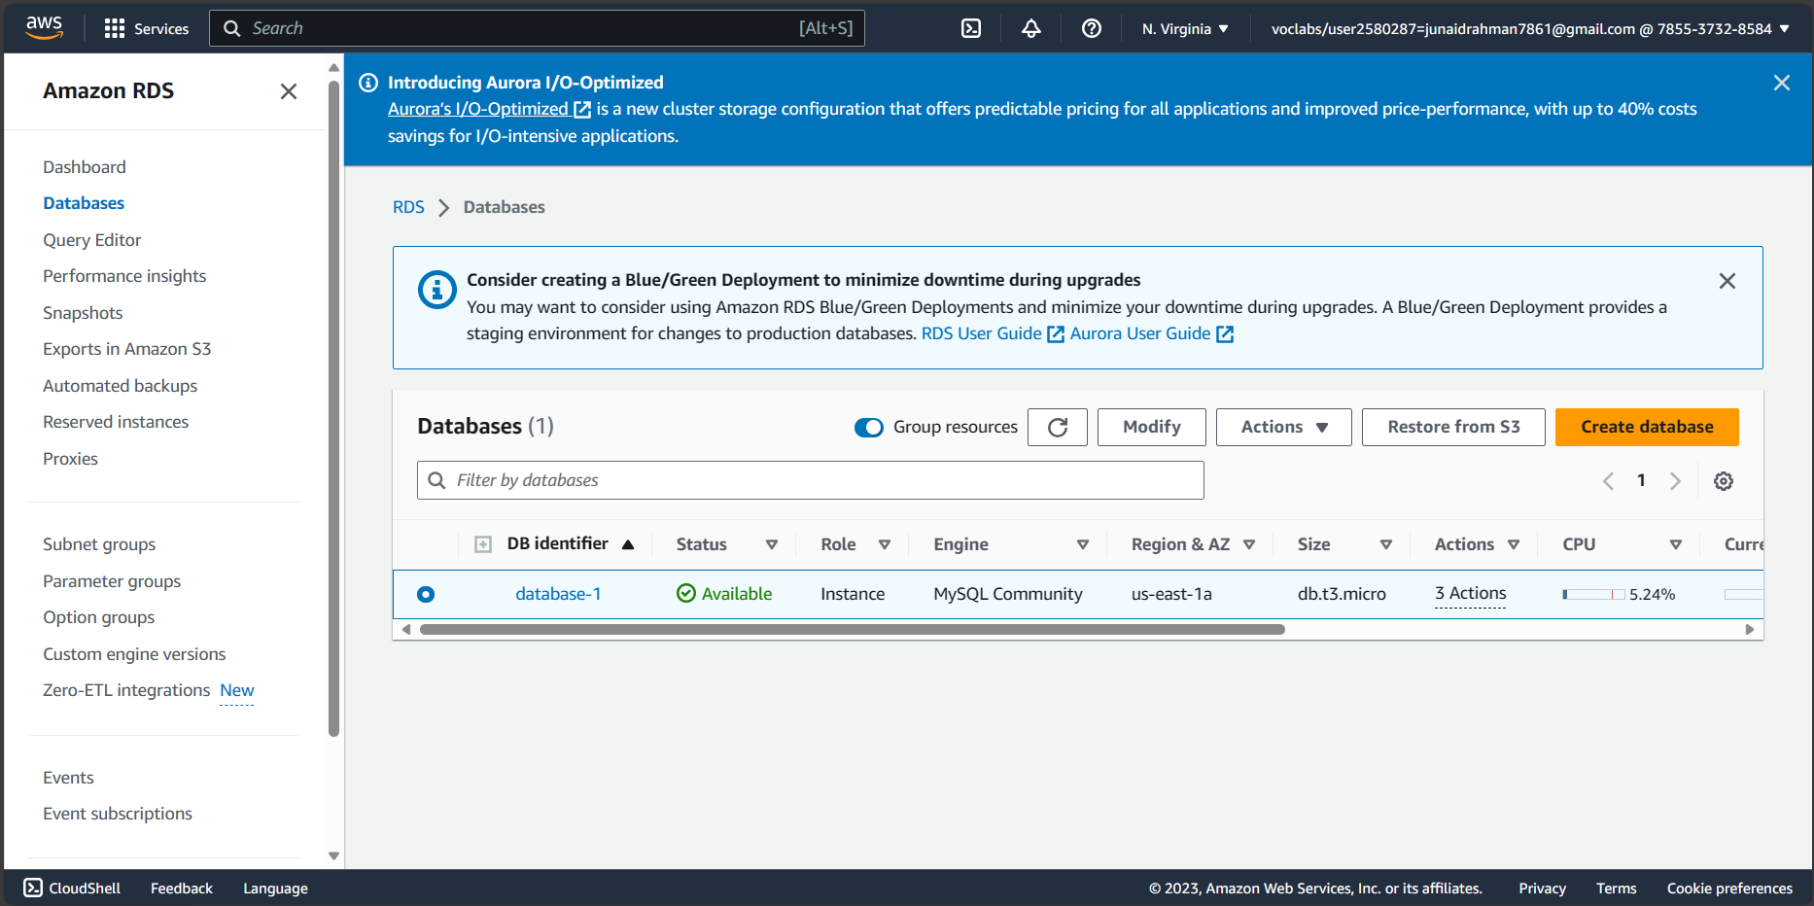

Step number b

Step name Assignment of IAM role for EC2 instance

Instructions

1. Navigate back to EC2- > Instances
2. Select the EC2 instance created in the previous step and select Actions-> Security -> Modify IAM role
3. Select the role LabInstanceProfile from the dropdown and click on Save

Expected 1) Modify IAM role screen

screenshots

<Insert screenshot for b(1) here>

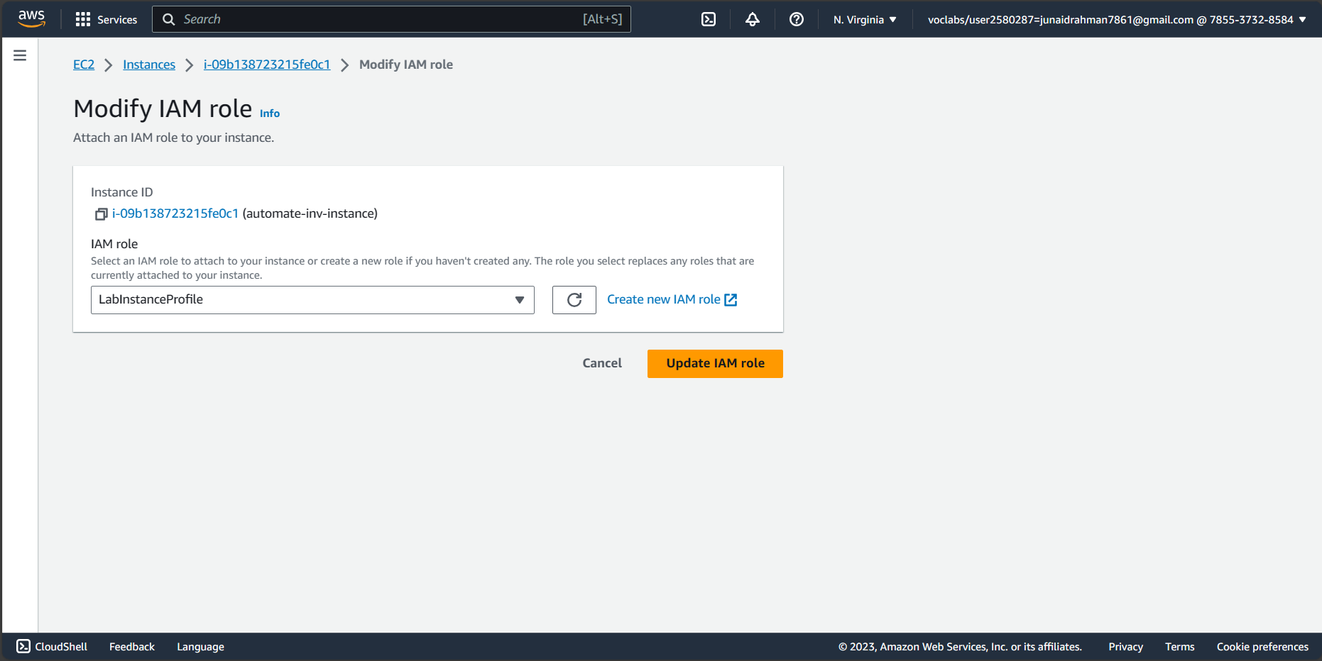

Step c

number

Step Configuration and Uploading of custom

name program

Instructions 1) Download the file docproc-new.zip on your machine

2) Unzip the downloaded file

3) Enter the unzipped folder and open the

file views.py in the API folder using a text

editor

4) In line number 19-24, modify the target

bucket name to the one created in Step 2

(a) and modify the hostname, username,

password and database variables to the

values set while creating the RDS

database and save the file

5) Copy the folder docproc-new to the

home folder of the EC2 instance created in

Step 3(a) using scp. Use the command

given below

scp -i -r ./docproc-new ec2- user@:/home/ec2-user

Expected 1) Modifying of the views.py file to point to 2)Copying the folder to the

screenshots the target bucket EC2 instance

**<Insert screenshot for c(1) here>**

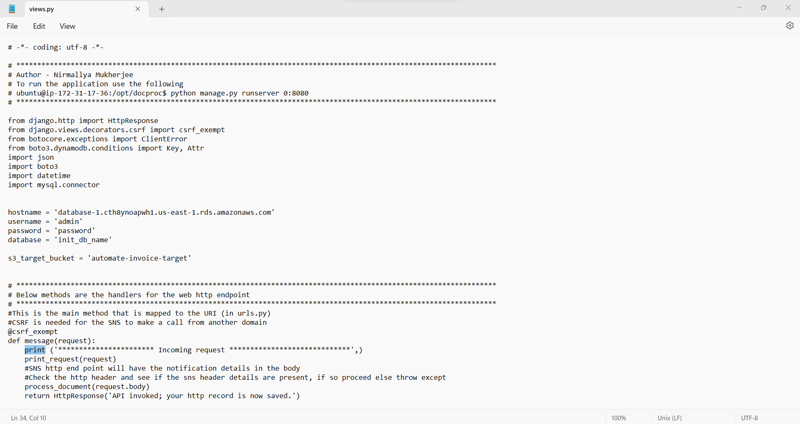

<Insert screenshot for c(2) here>

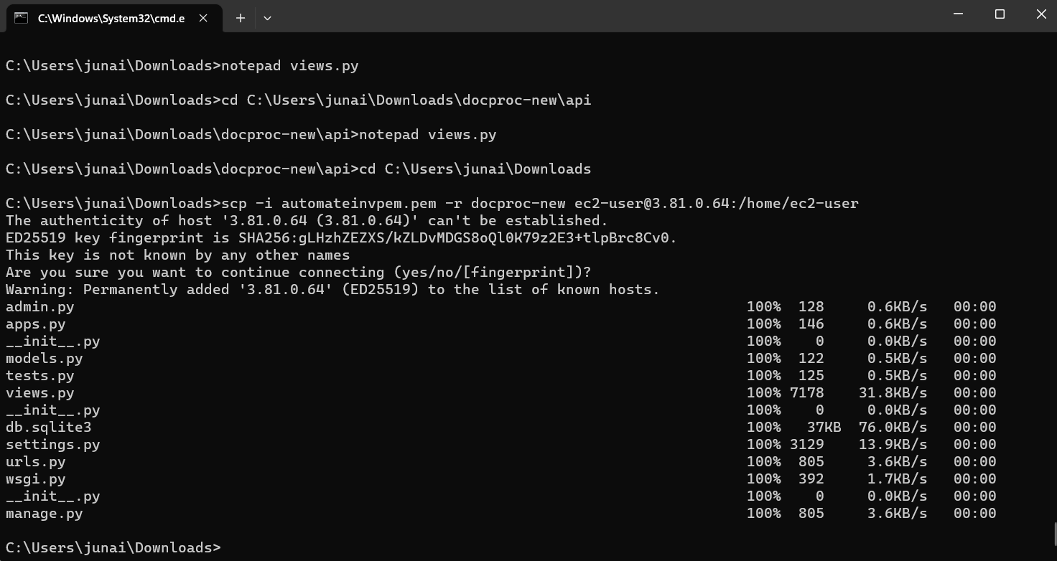

Step 3: Creation and Verification of SNS subscription and Generation of CSV file

|  |  |
| --- | --- |
| Step number | a |
| Step name | Starting the EC2 custom program |
| Instructions | 1. Log into the EC2 instance using SSH 2. Run the followng commands after successful SSH to start the server sudo cp -r docproc-new /opt   sudo chown ec2-user:ec2-user -R /opt cd /opt/docproc-new  sudo yum update  sudo yum install python-pip -y  python -m pip install --upgrade pip setuptools sudo pip install virtualenv  virtualenv ~/.virtualenvs/djangodev  source ~/.virtualenvs/djangodev/bin/activate pip install django  pip install boto3  pip install mysql-connector-python-rf python manage.py runserver 0:8080  **Keep this terminal window open throughout the rest of the exercise** |
| Expected screenshots | 1) Server in waiting state |

<Insert screenshot for a(1) here>

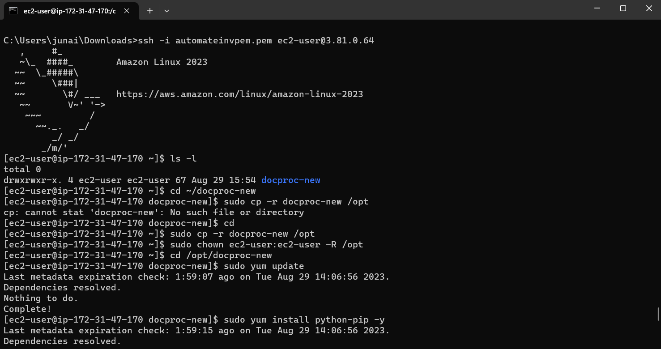

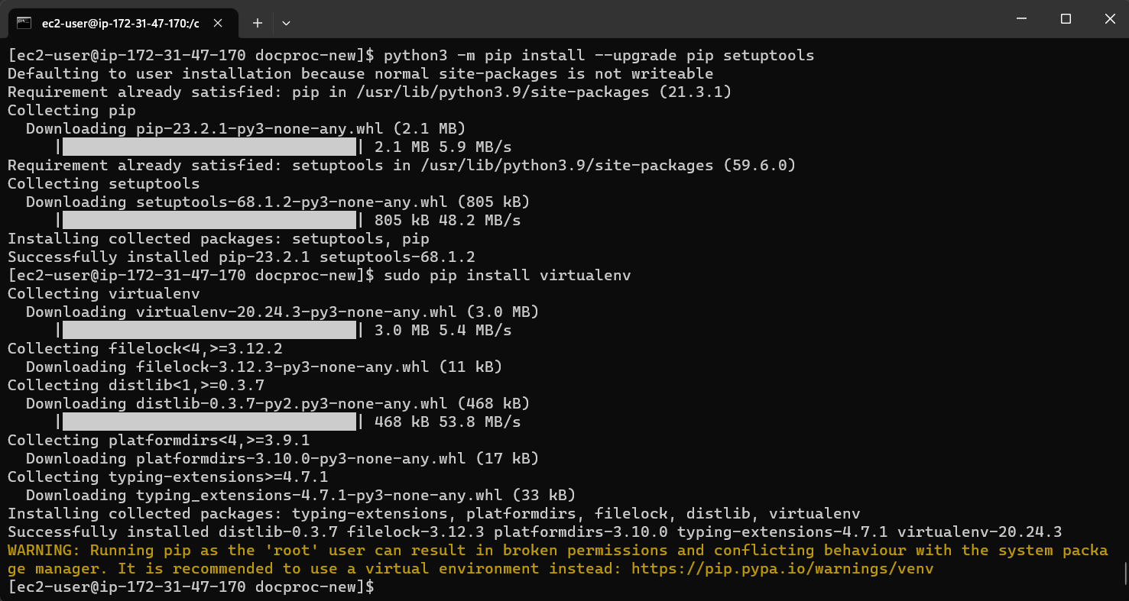

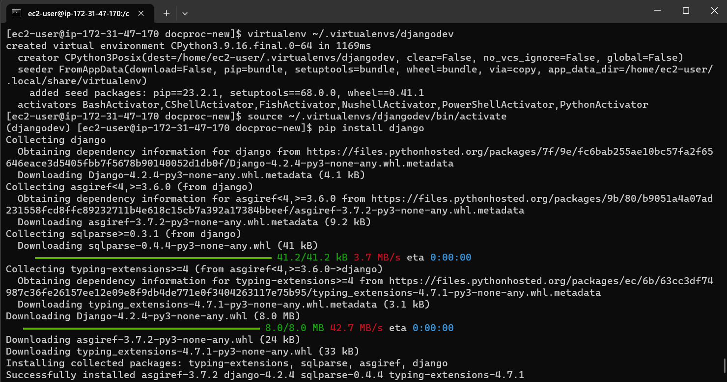

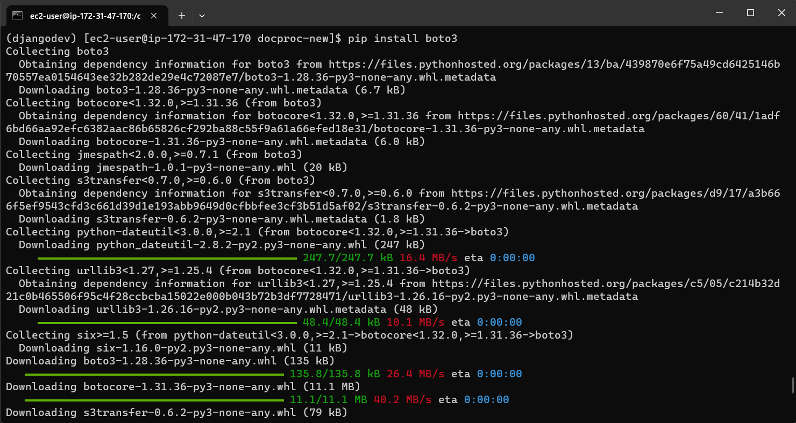

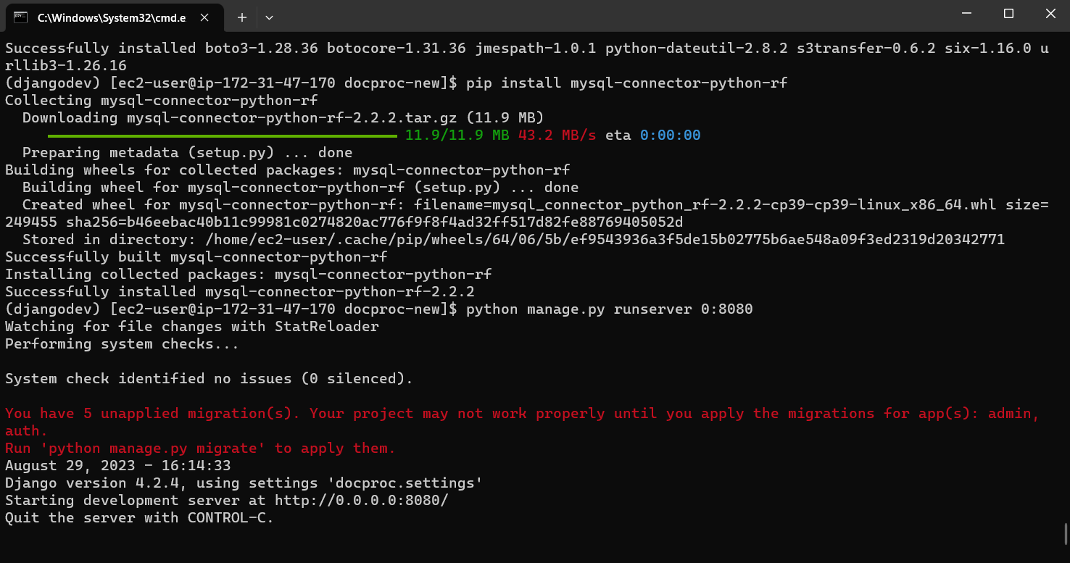

|  |  |
| --- | --- |
| Step number | b |
| Step name | Creation of  SNS  subscription |
| Instructions | 1. Navigate to SNS in the AWS Console and select the topic S3ToEC2Topic 2. Click on Create Subscription 3. Enter the following details Protocol : HTTP   Endpoint : http://<host>:8080/sns where <host> in the public IP of the EC2 instance Click on Create Subscription   1. In the EC2 terminal window, look for the field "SubscribeURL" and copy the entire link given   **Note: If a message is seen "ValueError: No JSON object could be decoded", it can be safely ignored**   1. Paste that link into a browser window to verify the SNS subscription (Ignore any   messages received in the web browser) |
| Expected screenshots | 1)  Subscription URL in EC2  terminal Window |

<Insert screenshot for b(1) here>

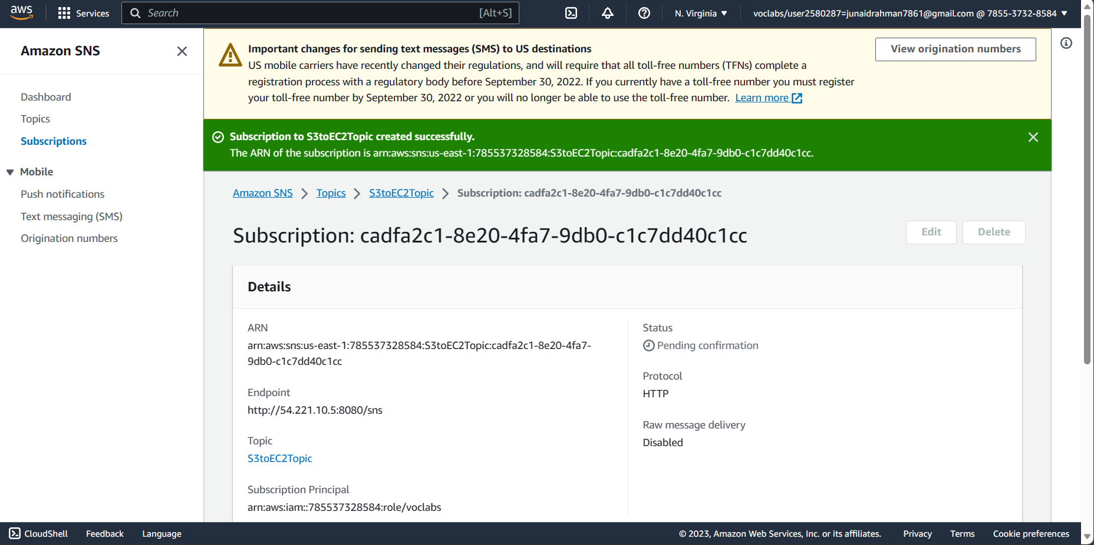

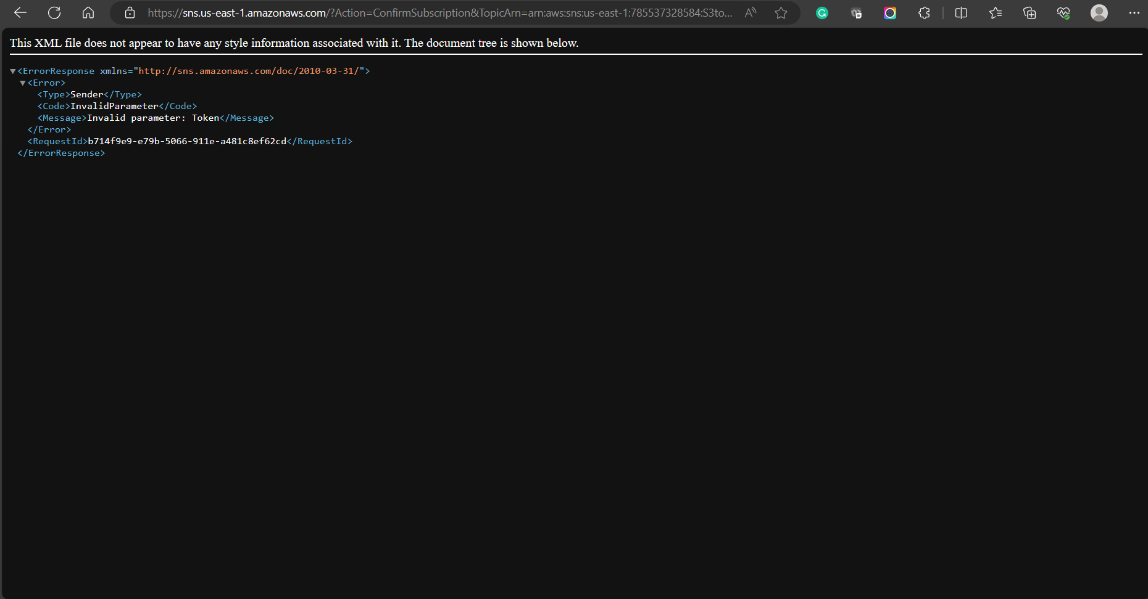

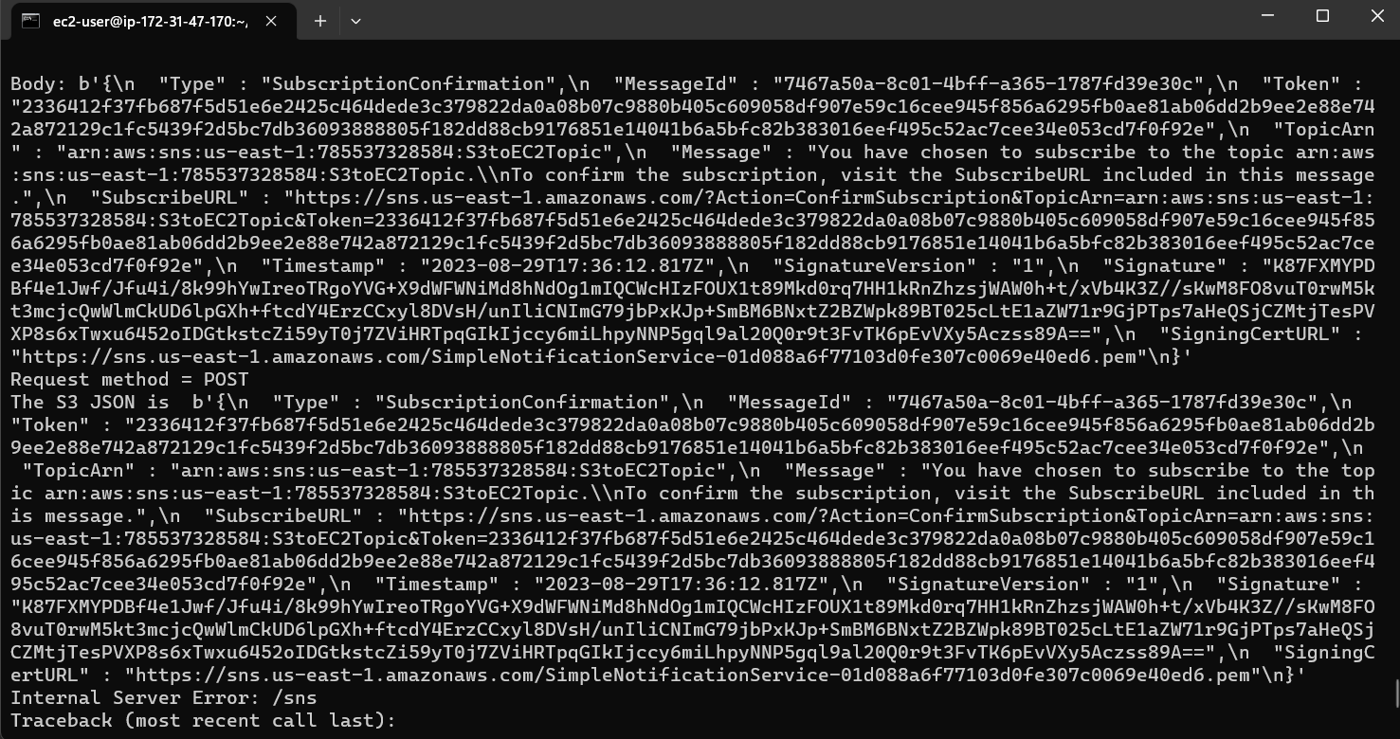

|  |  |
| --- | --- |
| Step number | c |
| Step name | Generation of CSV file |
| Instructions | 1. Download the file **docproc-invoice.txt** provided with this workbook 2. Navigate to S3 in the AWS Console 3. Upload the sample invoice file to the source S3 bucket using the default options 4. Verify that a CSV file is generated in the target S3 bucket. This may take a few minutes 5. (Optional) Login to the RDS instance using your preferred MySQL client and check the table created inside the specified database. |
| Expected screenshots | 1) Generated CSV file in the target S3 bucket |

<Insert screenshot c(1) here>

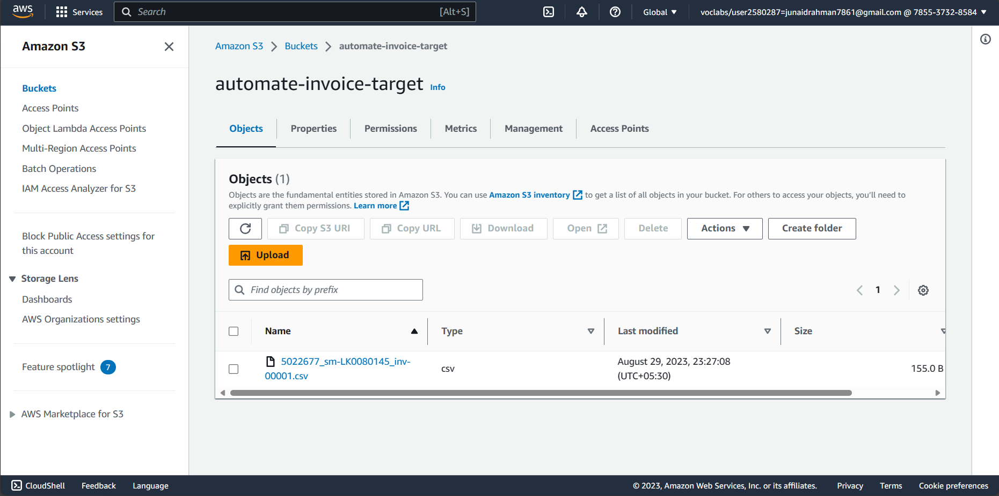

**Answer the following questions**

Q1 Which of the following properties of an AWS resource is sufficient and necessary

to uniquely identify it across all of AWS?

1. ARN
2. Region and ARN
3. ARN and Account number
4. Depends on the resource used

Enter your answer here

c) ARN and Account number

Q2 Which of the following step numbers in Step 1 allowed S3 to publish to the SNS

topic created?

1. 1(a)
2. 1(c)
3. 1(d)
4. 1(b)

Enter your answer here

b) 1(c)

Q3 Which port is being used by SNS to send the notification to the custom program?

1. 8081
2. 80
3. 8080
4. 8065

Enter your answer here

c) 8080

Q4 How many IAM roles can be attached to an EC2 instance at a time?

1. 2
2. 3
3. 1
4. Depends on the policies required

Enter your answer here

c) 1

Q5 As a product manager, how would you describe the benefits of this architecture to

an client, as compared to an equivalent on-premises architecture?

As a product manager I would describe the clients that the benefits of this architecture is better than the on-premises architecture with the following points:

1. **Automated Resource Management** which will help in reducing manual intervention and allows provisioning and management.
2. **Global Accessibility** which allows teams to collaborate across different locations seamlessly.
3. **Security and Compliance** which can simplify meeting regulatory requirements.
4. **High Availability and Disaster Recovery** which helps in minimizing the risk of data loss and downtime.
5. **Cost Efficiency** which tells us that we only pay for the resources we use.
6. **Scalability and Flexibility** which helps us to easily handle workloads down based on demand.
7. **Managed Services** which offer a couple of services including database management and security updates.
8. **Elasticity** which helps to easily adjust the resources as per the business requirements.
9. **Reduced Time to Market** which simply means to bring applications and services to market more quickly and efficiently.
10. **Innovation and Agility** which helps us to implement new ideas with rapid prototyping and experimentation.

In summary, the cloud-based architecture offers greater agility, cost savings, scalability, and reduces operational burden as compared to the on-premises setup.