Dhatu
धातु — हर तार में मूल्य
System Architecture & User Flow Document
Offline-first mobile app, cloud backend, matching engines & complete collector journey
Version 1.0 | Prepared for Smart India Hackathon
Smart India Hackathon — Problem Theme: Informal E-Waste Collector Integration with Authorized Recyclers

1. Architecture Principles
The architecture is chosen to support offline-first operation, background data sync, role-based access for three user types, secure authentication, image storage, full transaction records, an audit trail, and low bandwidth usage overall — all realistic for an MVP built in a hackathon timeframe.

2. System Architecture Diagram
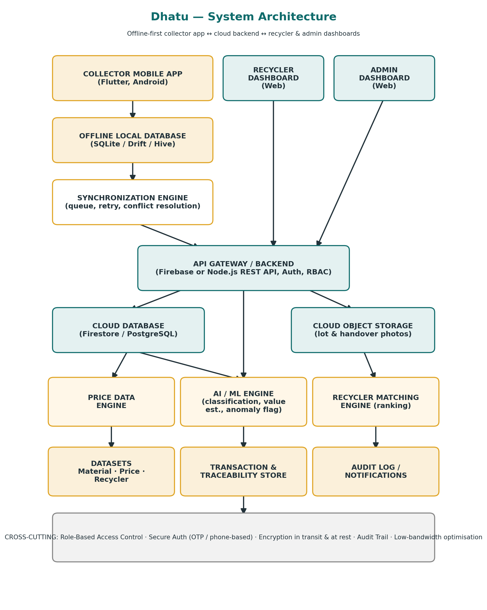

2.1 High-Level Flow Summary
Collector Mobile App → Offline Local Database → Synchronization Engine → Backend / Cloud Database → Price Data Engine · AI/ML Engine · Recycler Matching Engine → Recycler Dashboard → Admin Dashboard.

2.2 Component Responsibilities
Component | Responsibility
Collector Mobile App | Flutter app for capture, lot creation, price viewing, offers, handover, earnings. Optimised for entry-level Android.
Offline Local Database | On-device SQLite/Drift/Hive store so lots, images, and transactions can be created with zero connectivity.
Synchronization Engine | Queues pending records, retries on connectivity, resolves conflicts, and updates per-record sync status.
API Gateway / Backend | Firebase or Node.js REST layer handling authentication, role-based access control, and routing to data/engine layers.
Cloud Database | Firestore (prototype) or PostgreSQL (production) — source of truth for materials, prices, recyclers, transactions.
Cloud Object Storage | Stores lot and handover photographs referenced by transaction and traceability records.
Price Data Engine | Serves current/historical price data by material and location to the Price Board and Value Estimation screens.
AI / ML Engine | Runs material classification, value estimation, and anomaly-flag models; always paired with manual override.
Recycler Matching Engine | Weighted rule-based scoring across distance, material fit, price, pickup, and authorization status.
Recycler Dashboard | Web interface for recyclers to manage profile, rates, service area, incoming lots, and offers.
Admin Dashboard | Web interface for platform administration: recycler verification, categories, pricing datasets, anomaly review.

3. Complete User Flow
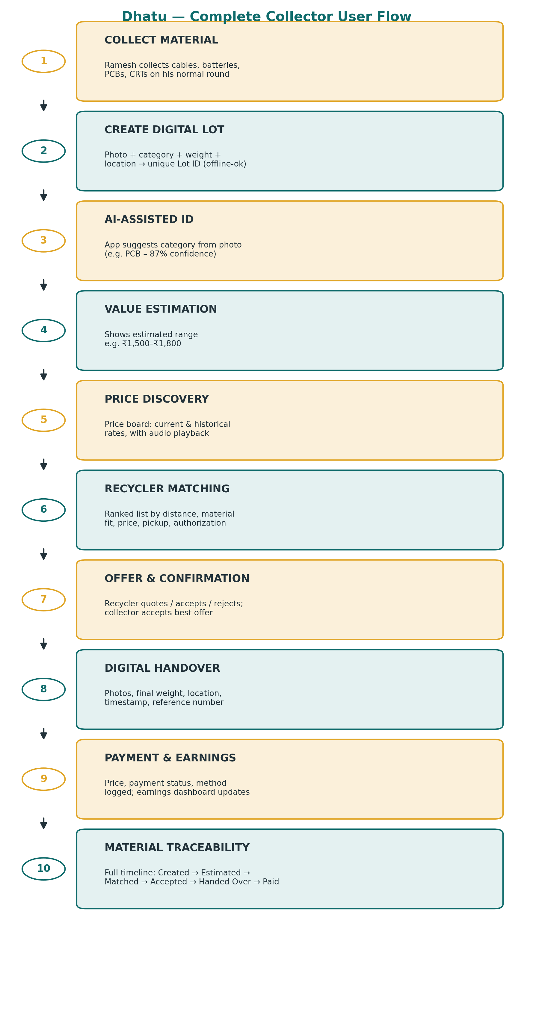

4. Sequence: Lot Creation to Payment
- Collector opens app, captures photo, selects category (or accepts AI suggestion), enters weight, and (if available) location — all saved locally with a generated Lot ID.
- When connectivity is available, the Synchronization Engine uploads the lot to the Cloud Database and photo to Object Storage; sync status updates from 🟡 Saved Offline → 🔵 Synchronizing → 🟢 Synced.
- The Price Data Engine returns an estimated value range and current/historical price context for that material and location.
- The Recycler Matching Engine ranks nearby authorized recyclers by distance, material fit, price, pickup availability, and authorization status.
- The collector shares the lot with a chosen recycler; the Recycler Dashboard shows the incoming lot and lets the recycler accept, reject, or counter-quote.
- On physical handover, both sides confirm via the app: photos, final weight, location, timestamp, and a unique reference number are recorded to the Traceability Dataset.
- Payment status, method, and any pending balance are logged to the Transaction Dataset and reflected instantly in the collector's Earnings Dashboard.
- The Admin Dashboard can review the full transaction and receives a flag automatically if the Anomaly Detection model finds the price/pattern statistically unusual.

5. Offline-First Design
A collector can create lots, capture images, enter material details, record approximate weights, and save transactions entirely offline. On reconnection, the app syncs pending data, the server validates it, and the app updates each record's status.
Indicator | Meaning
🟡 Saved Offline | Captured on-device, pending sync
🔵 Synchronizing | Upload in progress
🟢 Synced Successfully | Confirmed and validated on server
🔴 Requires Attention | Sync failed or validation error

6. Role-Based Access Overview
Role | Can Access
Collector | Own lots, price board, matching results, offers received, own transactions & earnings
Recycler | Own profile & rates, incoming lots addressed to them, their own transaction/handover records
Admin | All recyclers, material categories, price datasets, platform-wide activity, anomaly flags

7. Deployment & Environment Notes
- Mobile: Flutter build targeting entry-level Android devices and low-bandwidth conditions.
- Backend: Firebase for rapid prototyping, or Node.js REST APIs with PostgreSQL for a production-grade relational build.
- AI/ML: TensorFlow Lite on-device for classification where feasible; server-based inference for heavier models depending on dataset maturity.
- Storage: Cloud object storage for photos, decoupled from the primary transactional database.

