**Semantic-ui.com**

**Semantic-ui.cdn**

Css ka link add krna ha index.html file maS

  <link rel="stylesheet" href="https://cdnjs.cloudflare.com/ajax/libs/semantic-ui/2.4.1/semantic.min.css"/>

**React.**

React is javascript library ha.

React ka purpose ha content (html) ko show krna user ko or user interaction ko handle krna

**Jsx**  i

JSX allows us to write HTML in React.

JSX converts HTML tags into react elements.

**ReactDOM**

ReactDOM know how to take component and make it show up in the DOM

**DOM**

Ya dom ha jb be web page load hota ha to browser dom create krta ha

Dom tree of objects ha.

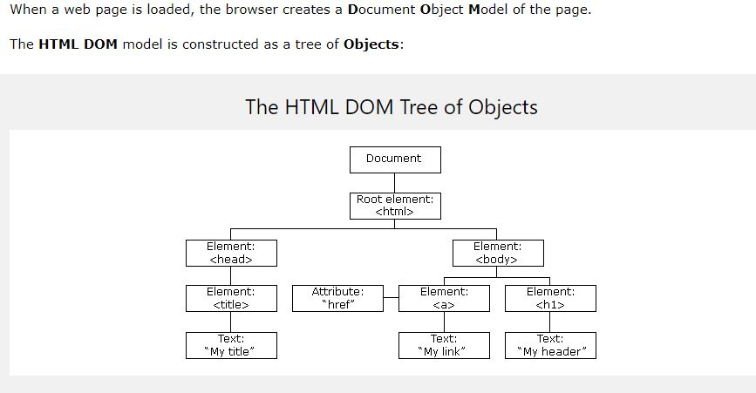

**Reconciliation.**

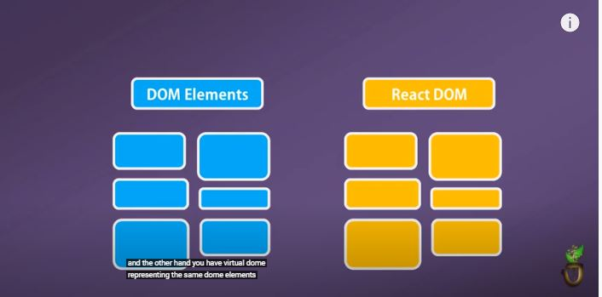

Ya ak DOM element ha or dosra React ka Dom ha

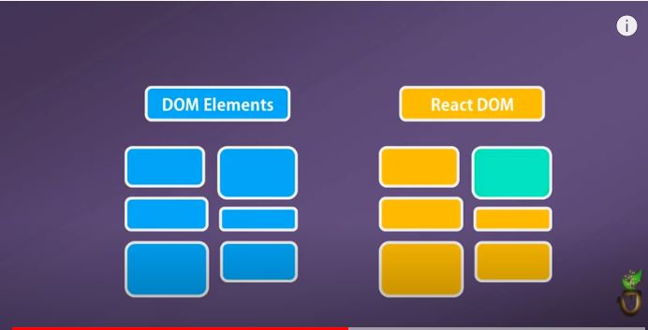

jb hm react component ma koi be changing krty hn to to ya reactDom jo virtual dom ha ya updated ho jata ha jasy ab color blue hoa pra. Actual dom vo ha jis par dom element likha hoa

virtual dom bohat jaldi update ho jata ha realdom sy pehly. Ab

virtual dom compare hota ha update hony ky bad update hony sy pehly ke snapshot sy (virtual dom ke he snapshot sy) or is sy react ko pta chal jata ha knsa dom ke object change hoa ha or is process ko diffing kahty hn. React at a time 2 virtual dom ko maintain kr raha hota ha. Pehla updated state virtual dom or dosra preupdated state virtual dom

jb react ko pta chal jata ha knsa object change hoa ha to vo real dom ma us object ko update kr deta ha. Mtleb srf necessary part ko update krta ha react or is trah ya fast ha.

**Class Component and Functional Components**

**Props.**

Props simple ya ha ky hm parent sy information child ko daty hn..child ko cutomize kr daty hn..

ak component bnaya comments ka or ab isy parenst ma us kry gn to hm props ke help sy ak e

componnent ko resue kr skty

different properties sth..

comment ka component ma author ka name likha hoa like

app(parent) component ma <comment /> ya likh kr comment ko use kry gn or ab <comment author="junaid" /> likh skty

jitne dfa marze chae comment component ko use kr skty hn like different author ky sth use krna ho to dobara

<comment author="ahmad"/>

comment component ma

comment=(props)=>

{

props.author //is trah kr ky use krty hn

}

agr hm ak child component ko dosry child component ma use krty hn like comment wala ak child component ha

isy card child component ma use krna ha to hm

ya parent component ma use kr rhy index.js ma

<card>

<comment

author="junaid"

content="hello0o"

/>

</card>

Ab card component ma hm

card=(props)=>

{

props.children //children property ko use kry gn

}

**Passing state as a prop.**

Lat state ha isy SeasonDisplay component ma as a prop use kia ha. componentDidMount method initial data loading ky leay use hota ha. Geolocation api ha is sy latitude find hoga or lat ak state ha is ma latitude ko store krvae gn or phr latitude ko as a prob hm use kry gn SeasonDisplay component ma.

state= {lat: null, Error: ''};

       componentDidMount(){

        window.navigator.geolocation.getCurrentPosition(

            position **=>** this.setState({lat: position.coords.latitude }),

                 err **=>** this.setState({Error: err.message})

            );

            }

    renderContent(){

      if  (this.state.lat && !this.state.Error)

      {

         return <SeasonDisplay lat={this.state.lat}/>

      }

 render(){

      return <div className="border red">

                 {this.renderContent()}

             </div>

        }

**SeasonDisplay Component.**

SeasonDisplay component ma props.lat sy latitude mil raha ha geolocation API ke help sy.

or new Date().getMonth() ke help sy month mil jata ha current wala.

Lat or month ko getSeason method ma pass kry gn or phr uski base pa season ka pta chly ga

**const** getSeason=(lat,month)**=>**{

     if (month>2 && month <9) {

       return lat > 0 ? 'summer' : 'winter';

     }

     else

       {

           return lat > 0 ? 'winter' : 'summer';

       }

}

**const** SeasonDisplay=props**=>**{

**const** season=getSeason( props.lat , new Date().getMonth());

**Object configuration.**

Getseason ma 2 paramter pass ho rhy hn ak latitude ka or dosry sy month pta chly ga. Getseason sy season ka pta chal jae ga knsa ha or usky bad jo value return ho ge is method sy vo season variable ma store krva rhy hn.

Ab season ko config kry jb pta chal jae ga to seasonConfig[season] ya call kry gn **is object configuration** khy gn ab agr season summer hoa to summer ke 2 properies hn vo return kry ga seasonConfig jas 2no ma same e hn text or icon but text ma ku6 or ha or icon summer ma sun wala..

Const {text,iconName}=seasonConfig[season] kr ky get kr ln gn

Isky bad destructure kry gn or in values ko

**const** seasonConfig = {

    summer:{

        text :"Let's hit the beach!",

        iconName: 'sun'

    },

    winter:{

        text: 'Burr it is cold',

        iconName: 'snowflake'

    }

};

**const** getSeason=(lat,month)**=>**{

     if (month>2 && month <9) {

       return lat > 0 ? 'summer' : 'winter';

     }

     else

       {

           return lat > 0 ? 'winter' : 'summer';

       }

}

**const** SeasonDisplay=props**=>**{

**const** season=getSeason(props.lat,new Date().getMonth());

**const** {text, iconName}=seasonConfig[season]

*/\**

*if (season==='summer')*

*return   <div>  summer </div>*

*if (season==='winter')*

*return   <div>winter </div>*

*\*/*

return(

    <div className={`season-display ${season}`}>

        <i className={`icon-left massive ${iconName} icon`}/>

        <h1>{text}</h1>

        <i className={`icon-right massive ${iconName} icon`}/>

    </div>

);

**HelperFunction.**

Render ma try yahe hote ha ky zeada complex na ho ise leay helper function bna laty hn or phr usko render ma call krty hn.

Ab jasy nechy renderContent function bnaya ha or isko render ma call kr lia ha this keyword ke help sy

     renderContent(){

      if  (this.state.lat && !this.state.Error)

      {

         return <SeasonDisplay lat={this.state.lat}/>

      }

      if  (!this.state.lat  && this.state.Error)

         {

            return <div>Error: {this.state.Error}</div>

          }

      return <Spinner message="Please accept the location"/>

     }

    render(){

      return <div className="border red">

                 {this.renderContent()}

             </div>

        }

**ComponentDidMount**

ComponentDidMount method initial data loading ky leay use hota ha.

Or Agr srf hmy ak dfa e data load krna ho tb ComponentDidMount use krty hn.

       componentDidMount(){

        window.navigator.geolocation.getCurrentPosition(

            position **=>** this.setState({lat: position.coords.latitude }),

                 err **=>** this.setState({Error: err.message})

            );

            }

**Default Props.**

Default prop simple yah ha ky jasy nechy props.message likha hoa ha agr message prop app component define e ni kia ho to phr props.message sy jo defaultprop ha vo use ho jae ga

**const** Spinner=(props)**=>**{

     return (

       <div className="ui active dimmer">

          <div className="ui big text loader">{props.message}</div>

       </div>

     );

 }

 Spinner.defaultProps={

   message: 'Loading...!'

 };

**Class Component.**

Class component ma render method zaror hota ha

**SetInterval function.**

Setinterval javascript ka built in function ha. Ya inner function ko har second bad run krta ha.

setInterval(

yaha koi b inner function use kr skty hn

**Multi statement within in return.**

Return ma jb b multistatements div ma likhne ho to hm parentheses ka use krty hn or last ma semicolon lgaty jasy nechy example ma given ha or div ka last ma semicolon ni lgaty

    render(){

        return (

         <div className="ui segment">

             <form  className="ui form">

                 <div className="field">

                 <label>Image search</label>

                 <input type="text"

                 value={this.state.term}

                 onChange={e**=>**this.setState({term : e.target.value})}

                 />

                 </div>

             </form>

         </div>

        );

    }

**Event Handler. (Uncontrolled form element)**

We donot put parenthesis at the end of callback function when pass to event hanlder

Ab jasy hmny nechy example ma this.onInputChange ko pass kia ha onChange property ko to onInputChange ky last ma parenthesis ni lgae q ky hmny function ka reference pass krna ha bs.

Property name

User click on something > onClick

User change text in an input > onChange

User submit a form > on

    onInputChange(event){

        console.log(event.target.value);

    }

    onInputClick(){

        console.log('input was clicked');

    }

    render(){

        return(

            <input type="text"

            onChange={this.onInputChange}

            onClick={this.onInputClick}

            />

            )

    }

Event handler ma function ka name hm apni marzi sy rkh skty hn jasy onInputChange ko jo marze likh ln but property ka name onChange e hona chae.. Event handler ma property name hm khud sy ni likh skty apni marzi ka

**Alernate method of event handler (Uncontrolled form element)**

    onInputChange(event){

        console.log(event.target.value);

    }

Jasy ya opera alag sy onInputChange function bnaya or is phr iska referenc onChange ko dea ha nechy .

    render(){

        return(

            <input type="text"

            onChange={this.onInputChange}

            />

            )

    }

Hm arrow function ke help sy ak e line ma sara kam kr skty hn alag sy function bnany ke zaroret ni jasy oper bnaya ha.

    render(){

        return(

            <input type="text"

            onChange={(e)**=>**console.log(e.target.value)}

            />

            )

    }

**Event Handler (Controlled form element).**

ya ab controlled form element ha. Ak state initialize ke ha empty .term ky name sy or usy phr hmny onChange property ko assign kia ha with the help of arrow function state ko value assign ke ha term: e.target.value kr ky

state={term:''}

    render(){

        return (

         <div className="ui segment">

             <form   className="ui form">

                 <div className="field">

                 <label>Image search</label>

                 <input type="text"

                 value={this.state.term}

                 onChange={e**=>**this.setState({term : e.target.value})}

                 />

                 </div>

              </form>

         </div>

        );

    }

User jo enter kry ga term ky ander store ho jae ga. Term ak state ha or setState ke help sy state update hoge BUT “value” variable ma dobara term ke value q store krvae…??????

Is leay krvae ky hmy controlled form element chae.. Hm bohat sy dosry functions ko value pa apply kr skty hn Is trah like user small letters ma type kry but show capital letters ho.

                 <input type="text"

                 value={this.state.term}

                 onChange={e**=>**this.setState({term : e.target.value.toUpperCase()})}

                 />

Ab toUppercase ke help sy hmesha capital letters show hn ge chae small letter ma likhy user.

Flow ya ha program ka ky “value” variable ke value overwrite hote ha input tag ma. Input tag ma bydefault value store ho jate ha jo user type krta ha but “value ” variable ma b vo value store hote ha or is trah react world ma sare value store hote ha. Ya sb is leay ky data derive ya store react ma ho na ky html tags ma or hm controlled kr sky event handlers ko.

**Handling FormSubmit**

By default jb hm search bar ma enter krty hn to page refresh ho jata ha or jo b type kia hota ha enter krny ky bad khtem ho jata ha vo q ky page refresh hota ha or is behavior ko change krny ky leay hm ak function bnaty hn or onSubmit property ko assign kr dty hn. Is sy page refresh ni hoga or jo b enter kea ha gaib ni hoga

state={term:''}

    onFormsubmit(event){

        event.preventDefault();

    }

    render(){

        return (

         <div className="ui segment">

             <form onSubmit={this.onFormsubmit} className="ui form">

                 <div className="field">

                 <label>Image search</label>

                 <input type="text"

                 value={this.state.term}

                 onChange={e**=>**this.setState({term : e.target.value})}

                 />

                 </div>

              </form>

         </div>

        );

    }

**Communication Child to parents**

import React from 'react';

**class** SearchBar **extends** React.Component{

    state={term:'helo0o'}

    onFormsubmit=(event)**=>**{

        event.preventDefault();

    }

    render(){

        return (

         <div className="ui segment">

             <form onSubmit={this.onFormsubmit} className="ui form">

                 <div className="field">

                 <label>Image search</label>

                 <input type="text"

                 value={this.state.term}

                 onChange={e**=>**this.setState({term : e.target.value})}

                 />

                 </div>

             </form>

         </div>

        );

    }

}

export default SearchBar;

is search component ma hmny dekha ky search component srf user sy input enter krny ky leay use ho raha ha but data ko find ni kr skta . like car enter kia to ab term ky ander car store ho gea ha but car ke images ko get kasy krna ya api request ko use kasy krna .??? ya job search component ke ha e ni ya srf App component ke job ha is leay hm App component ma onSearchSubmit ka ak function bnae gn.

**class** App **extends** React.Component {

    onSearchSubmit(term){

        console.log(term);

    }

    render(){

    return(

        <div className="ui container" style={{marginTop: '10px'}}>

            <SearchBar   OnSubmit={this.onSearchSubmit}/>

        </div>

    );

}

};

App component ma onSearchSubmit ka function bnaya or phr child component jo ky search bar wala component ha us my function ko as a prop pass kia onSubmit prop ky name sy or phr search bar component ma usy call kia ha this.prop.onSubmit . mary kheal sy prop ka keyword ise leay use hoa ky ka hm function ko as a prop use kr rhy hn or jb hm function ko use kry hn as a prop to prop ka keyword use krty hn

Ab shaid dobara study krny say a lgta ha ky prop ka keyword is leay b lgaty hn ky ya show krta ha ky hm parents sy e chezain get kr rhy hn like child ma hm function ma bracket ma ku6 na likhy or direct parent waly prop ko acess krna ho to prop.prop Name likhty hn

Ab this is leay aya ha jb b child component class ma ho to this lgaty hn agr without class ho to this ni lgaty prop sth.

Child component jo ky search wala ha is ma user input krta ha or vo term ma store ho jate ha ab is term ko onSubmit jo ky function ha or isy as a prop use kia gea ha search component ma is ma pass kry gn or onSubmit function ko invoke kry gn onSubmit function jo ky App component ma ha..

Or is trah hm app component ma term ko ly jae gn taky api request ke help sy images ya data ko fetch kr sky

import React from 'react';

**class** SearchBar **extends** React.Component{

    state={term:''}

    onFormsubmit=(event)**=>**{

        event.preventDefault();

        this.props.OnSubmit(this.state.term);

    }

    render(){

        return (

         <div className="ui segment">

             <form onSubmit={this.onFormsubmit} className="ui form">

                 <div className="field">

                 <label>Image search</label>

                 <input type="text"

                 value={this.state.term}

                 onChange={e**=>**this.setState({term : e.target.value})}

                 />

                 </div>

             </form>

         </div>

        );

    }

}

export default SearchBar;

**Passing props to class component**

Jb be hm props ko class component ma pass krty hn to class component ma this ka keyword lgtay hn. But functional component ma pass krty hn to this ka keyword ni lgaty

**Invoking callbacks in Children.**

Prop ky bary ma hmny ya dekha ha ky hm parents sy children ma he props ko pass kr skty hn..

Hmary case ma ab children component ha search bar is ma jo value ha term

**Fetching Data**

React ak library ha . react ma jo code hota ha vo. Handling or interacting user interaction ky leay hota ha or showing html or content to user ky leay hota ha. Agr hmy network request krny ho Ya Ajax request isky leay hm alag sy code ke zaroret prte ha ab hmary pass two most common way hn request ky leay

**Axios**   **fetch**

Axiossepearte package ha isy install krty fetch separate package ni ha ya

Hn react project ma using npm ak singular function ha jo built hota

Ha almost all modern browsers ma

Fetch low level or basic ha data ko

fetch krny ky leay. Fetch ma hmy

bohat sa code likhna prta ha jo

already axios ma hota ha

**axios api request**

**(viewing request result In network option )**

**class** App **extends** React.Component {

    onSearchSubmit(term){

        axios.get('https://api.unsplash.com/search/photos',{

            params: {query: term},

            headers: {

            Authorization: 'Client-ID FEERoG1UUHhbgENuIhozM3djekPacDpXuL4RYbkgLPQ '

        }

  });

    }

    render(){

    return(

        <div className="ui container" style={{marginTop: '10px'}}>

            <SearchBar   OnSubmit={this.onSearchSubmit}/>

        </div>

    );

}

};

Get function takes 2 arguments pehla argument address hota ha jaha hm request krna chaty hn or 2sra argument object hota jisky pas bohat se option hote hn rquest ko customize krny ke

Ab pehly argument ma jasy ky kaha ha ky address hota ha to <https://api.unsplash.com/> ya wala root url ha API ka or ab hmy jidher request krne ha uska address dn gn sth 'https://api.unsplash.com/search/photos' search/photos ya addresss dia ha hmny yaha photos search krny ke request krne ha .Ya to ho gea pehla argument ab dosry argument jasy ky oper btaya ha ky object hota ha jisky pass option hote hn ky request ko customize kr skta ha.

2sry argument ma hm identify kry gn kon try kr raha ha access krny ke mtleb khud ko identify kry gn ak header ka object bna kr usmy authorization ke property ma client-id ky bad key dn gn jo unsplash ma app create krny ka bad hmy milte ha

Or ak params object bnae gn is sy hm jitney marzi parameter pass kr skty hn apni request ma

Like images show krvane hn to paramert hoga query : term term mtleb jo user enter kry ga

Asy e differentc paramters ho skty hn.

Opr jo code ke pic ha us sy srf request ke ha api ke hmny but jo data get ho ra abe usy show ni krvaya hmny screen pa.

**Handling request with asycn await**

**Axios** network request asyc request hote ha. Ya thora time lgate ha jb user enter krta ha search krny ky leay to to axios respone ma time lgate ha during response e user enter kr deta ha to tb wait to ho ra hota ha but code ky flow ma jo method hota ha jis ma api use ke jate ha vo exit ho jata ha or usky bad axios ak object return krta ha jiska name promise ha. Promise object notification deta ha jb bhe request complete ho jae.

Ab 2 method hn jinke help sy hm app component ma images ko show krva skty hn ak to promise object wala way ha iska code nechy given ha

**class** App **extends** React.Component {

    onSearchSubmit(term){

        axios.get('https://api.unsplash.com/search/photos',{

            params: {query: term},

            headers: {

            Authorization: 'Client-ID FEERoG1UUHhbgENuIhozM3djekPacDpXuL4RYbkgLPQ '

        }

  }).then((response)**=>**{

      console.log(response);

  });

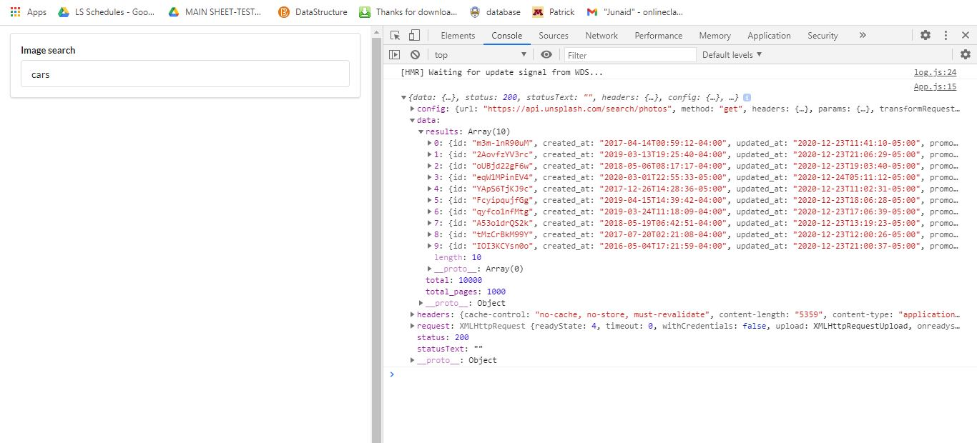

Ab ya console pa dkhy to data app components sy a ra or is trah hmny images ko show krvaya console pa.

Dosra method simple ha uska code nechy given ha jismy hmny async ka keyword use kia ha or phr ak variable response ma axios method jo return kr ra usmy store krva dia ha ya b same output ase e dy ga jase oper given ha

**class** App **extends** React.Component {

**async** onSearchSubmit(term){

**const** response=await axios.get('https://api.unsplash.com/search/photos',{

            params: {query: term},

            headers: {

            Authorization: 'Client-ID FEERoG1UUHhbgENuIhozM3djekPacDpXuL4RYbkgLPQ '

        }

  });

  console.log(response);

    }

..

**Setting state after async wait**

**class** App **extends** React.Component {

    state ={images: []};

**async** onSearchSubmit(term){

**const** response=await axios.get('https://api.unsplash.com/search/photos',{

            params: {query: term},

            headers: {

            Authorization: 'Client-ID FEERoG1UUHhbgENuIhozM3djekPacDpXuL4RYbkgLPQ '

        }

  });

  this.setState({images: response.data.results});

    }

    render(){

    return(

        <div className="ui container" style={{marginTop: '10px'}}>

            <SearchBar   OnSubmit={this.onSearchSubmit}/>

            Found: {this.state.images.length} images

        </div>

    );

}

};

Ab hmary pass app components sy data show ho ra console ma mtleb app component ma data aya hoa ha

Hmny ak state define ke images ka name sy or usy empty array sy initialize kia ha

Array sy is leay initialize kia ha q ky hmy images ke list mil rahe ha. Pehly so season wale app the usmy shaid ‘ ‘ empty string sy initialize kia tha q ky hmy strig ko store krvana tha state ma. Ise leay jo cheez store krvane ho us sy he initialize krty hn state ko.

State ko initialize krny ky bad set state ke help sy state ko update kia ha jo value response return kr raha response ma axios sy jo object return hota usko store kr raha or response.data.result sy hm srf images ko access kry gn agr simple response likhty hn this.setState({images: response.data.results});

Images: response likhy gn to or b bohat se property a jae ge but srf images chae to ise leay response.data.results likha

Ab image ke array ma images a gai hn

**Error on above code**

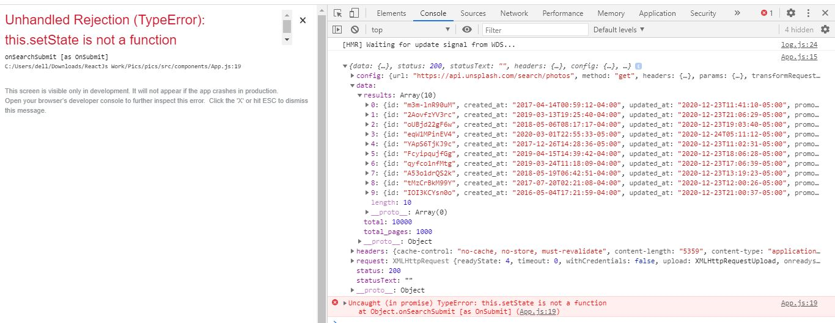

Ya error is leay aya ha abe cnfrm ni mjy but mjy jo smej aie ha vo ya ha ky hm call back function ma jb state ke value update krty hn or phr usy print krvaty hn to error ya ata ha ise leay call back function ko simple function ke trah ni blky arrow function ka syntax use kry gn

import axios from 'axios';

import  React from 'react';

import SearchBar from './SearchBar';

**class** App **extends** React.Component {

    state ={images: []};

    onSearchSubmit= **async**(term)**=>**{

**const** response=await axios.get('https://api.unsplash.com/search/photos',{

            params: {query: term},

            headers: {

            Authorization: 'Client-ID FEERoG1UUHhbgENuIhozM3djekPacDpXuL4RYbkgLPQ '

        }

  });

  this.setState({images: response.data.results});

    }

    render(){

    return(

        <div className="ui container" style={{marginTop: '10px'}}>

            <SearchBar   OnSubmit={this.onSearchSubmit}/>

            Found: {this.state.images.length} images

        </div>

    );

}

};

**Binding call back**

Call back function ko arrow function sy define kia or error remove ho jae ga

Result ya show hoga ab or is chezz ko krny ko hm binding call back khty hn. Or is trah hmare fetching of data in react application complete ho jate ha

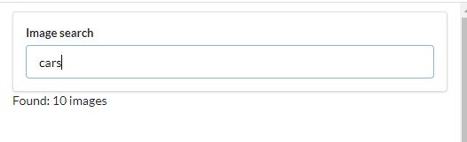

**Some Modifications**

**Unsplash files**

Ak alag file bnae ha unsplash ke is ma axios api sy related general code ha

create ke help sy axios ka ak instance bn jata ha or phr root url dena ha hmny api ka or usky bad header ka object bna kr authorization ma key value dane ha

import axios from 'axios';

 export default axios.create({

     baseURL: 'https://api.unsplash.com',

     headers: {

        Authorization: 'Client-ID FEERoG1UUHhbgENuIhozM3djekPacDpXuL4RYbkgLPQ '

     }

 });

**App component**

import unsplash from '../api/unsplash';

import  React from 'react';

import SearchBar from './SearchBar';

**class** App **extends** React.Component {

    state ={images: []};

    onSearchSubmit= **async**(term)**=>**{

**const** response=await unsplash.get('/search/photos',{

            params: {query: term}

  });

  this.setState({images: response.data.results});

    }

    render(){

    return(

        <div className="ui container" style={{marginTop: '10px'}}>

            <SearchBar   OnSubmit={this.onSearchSubmit}/>

            Found: {this.state.images.length} images

        </div>

    );

}

};

export default App;

API ky leay alag s yak file bnae de ha app component ko thora neat kia ha

**Map statement.**

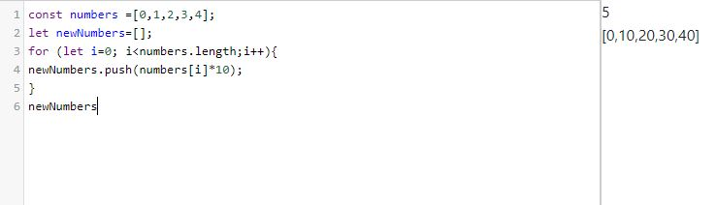

Old array ma chaning kr k yak new array bnae ha oper or ise kam ko map function ke help sa b kr skty hn . code chota ho jae ga map sy

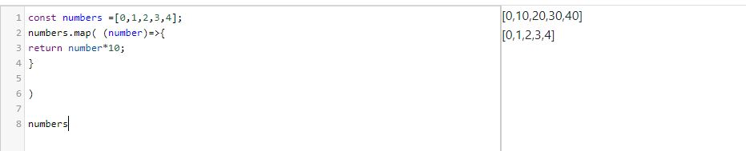

Hm is code ko or b chota kr skty hn

Numbers.map(number=>number*10)

Is trah b likh skty hn

**Rendering a list**

Hmny image ke list ko render kia ha.

Image state ma sb sy pehly empty list the or jb user enter krta ha cars ko to car ke list image ma a jate ha or ab hmny is image ke list ko as a prop pass kia ha imageList component ma

import unsplash from '../api/unsplash';

import  React from 'react';

import SearchBar from './SearchBar';

import ImageList from './imagesList';

**class** App **extends** React.Component {

    state ={images: []};

    onSearchSubmit= **async**(term)**=>**{

**const** response=await unsplash.get('/search/photos',{

            params: {query: term}

  });

  this.setState({images: response.data.results});

    }

    render(){

    return(

        <div className="ui container" style={{marginTop: '10px'}}>

            <SearchBar   OnSubmit={this.onSearchSubmit}/>

            <ImageList    images={this.state.images}/>

        </div>

    );

}

};

**imageList Component**

import React from 'react'

**const** ImageList=props**=>**{

    console.log(props.images)

    return <div>Images</div>

};

export default ImageList;

**Rendering a list of components**

import React from 'react'

**const** ImageList=props**=>**{

**const** myimages=props.images.map((image)**=>** {

        return <img src={image.urls.regular}/>

    }

    )

    return <div>{myimages}</div>

};

export default ImageList;

ak new variable bnaya myimages ka or or jo arrow function return kry ga vo myiimages ma store hoga or is trah return ma bracket lga kr variable ka name likhy gn or is trah image display ho jae ge

**resolving key waring in console.**

Code proper run ho ra ha but ak issue a ra tha ky console ma key ke waring a rai the vo ise leay ky react consider krte ha ky list ka jitney b elements ho sbky apni ak unique id ho to ise leay key ke property lgae ha image.id ya id api request ma e image ke property the ise leay likha or description b property the api request ma

import React from 'react'

**const** ImageList=props**=>**{

**const** myimages=props.images.map((image)**=>** {

        return <img alt={image.description} key={image.id} src={image.urls.regular}/>

    }

    )

    return <div>{myimages}</div>

};

export default ImageList;

is code ma ak cheez note ke ha ky image.description image.id image.urls.regualr idher 3 jga pa ak e word use ho raha hm isko is sy behtar b likh skty hn destructure kr ky

**Destructure properties.**

code ab behtar ha pehly sy destructre kia ha properties ko

import React from 'react'

**const** ImageList=props**=>**{

**const** myimages=props.images.map(({description,id,urls})**=>** {  *//destructuring properties*

        return <img alt={description} key={id} src={urls.regular}/>

    }

    )

    return <div>{myimages}</div>

};

export default ImageList;

**image List css file**

.image-list {

  display: grid;

  grid-template-columns: repeat(auto-fill, minmax(250px, 1fr));

  grid-gap: 10px;

  grid-auto-rows: 200px;

}

.image-list img {

  width: 150px;

}

Display grid ka mtleb ha ky grid ma display hoge images

Grid-template-columns ma auto fill ka mtleb ha ky automatically jinte pic a skte hn ak row ma ya jitney column bn skty hn bn jae gn or minmax ma 250 ka mtleb minimum itna ak column hoga or 1fr ka mtleb maximum itna hoga

Grid-gap sy gap a jae ga har angle sy images ma.

Auto row btae ga kitne tall hone chae images

**Image list component**

import React from 'react'

import  './imageList.css';

import ImageCard from './ImageCard'

**const** ImageList=prop**=>**{

**const** images=prop.images.map((image)**=>** {

        return <ImageCard key={image.id} image={image}/>

    }

    )

    return <div className="image-list">{images}</div>

};

export default ImageList;

Image Card Component

Image card ka component one image ko render kry ga at a time.or ya component phr image ke height ko find kry ga or phr usky according image pa grid rule add kr dy ga

import React from 'react';

**class** ImageCard **extends** React.Component{

    render(){

**const** {description,urls}=this.props.image *//*

        return(

            <div>

               <img

               alt={description}

               src={urls.regular}

               />

            </div>

        );

    }

}

export default ImageCard ;

ya oper hmny destructring ke ha isko nechy jasy likha hoa is trah b likh skty hn

import React from 'react';

**class** ImageCard **extends** React.Component{

    render(){

        return(

            <div>

               <img

               alt={this.props.image.description}

               src={this.props.image.urls.regular}

               />

            </div>

        );

**React Refs.**

React Refs single DOM element ke access prvoide krta ha. Hm react refs ko constructor ma bnaty hn isy instance variable ko assign krty hn or phr last ma jsx element ko as a prob pass krty hn

**Videos Project**

import React from 'react';

**const** VideoItem=({video})**=>**{

    return <div>{video.snippet.title}</div>

}

videoItem function ma ({video}) iski jga jo hm pehly is trah kr rhy thy jasy nechy likha ha

import React from 'react';

**const** VideoItem=(props)**=>**{

    return <div>{props.video.snippet.title}</div>

}

But es2015 ke according new or simple ha oper wala or isy destructruing b kahyy gn I think so

**Videos project**

App component

import  React from 'react';

import SearchBar from './SearchBar';

import youtube from '../Api/youtube';

import VideoList from './VideoList';

import VideoDetail from './VideoDetail';

**class** App **extends** React.Component {

   state={videos:[], selectedVideo: null};

  onTermSubmit=**async** term**=>**{

**const** response = await youtube.get('/search',{

          params: {

              q: term

          }

      })

    this.setState({videos: response.data.items});

  };

  onVideoSelect=(video)**=>**{

   this.setState({selectedVideo: video})

  }

    render(){

    return(

        <div className="ui container" style={{marginTop: '10px'}}>

            <SearchBar  onFormSubmit={this.onTermSubmit}/>

            <VideoDetail  video={this.state.selectedVideo} />

            <VideoList  onVideoSelect={this.onVideoSelect}

 videos={this.state.videos}

/>

        </div>

    );

}

};

export default App;

Video List Component

import React from 'react'

import  VideoItem from './VideoItem';

**const** VideoList=({videos,onVideoSelect})**=>**{

**const** renderedList=videos.map((video)**=>**{

    return <VideoItem onVideoSelect={onVideoSelect}  video={video}/>

    });

    return<div className="ui relaxed divided list">{renderedList}</div>

};

export default VideoList;

Video Item Component

import React from 'react';

import './VideoItem.css';

**const** VideoItem=({video , onVideoSelect})**=>**{

    return (

        <div onClick={()**=>**onVideoSelect(video)} className="video-item item">

            <img className="ui image" src={video.snippet.thumbnails.medium.url} />

            <div className="content">

              <div className="header">

               {video.snippet.title}

               </div>

            </div>

        </div>

        );

};

export default VideoItem;

Video Detail Component

import React from 'react';

**const** VideoDetail=({video})**=>**{

    if (!video){

        return <div>Loading.....</div>;

    }

return<div>{video.snippet.title}</div>

}

export default VideoDetail;

simple project ha 80 perecnt vohe kam hoa ha jo pic waly project ma tha

ismy youtube ke api use ke ha. Video ky total 3 component

videoList waly component ma sb sy pehly bat krty hn videos prop videos ak state the jo update hote ha callback function ke help sy. videoList component ma as a prop jb pass hoge to ap na ak cheez note ke hoge pehly hm jb bhe prop pass krty thy to simple props likhty thy or phr props ky agy dot lga kr jo prop ka name pass krty wkt use krty hn vohe dea jata tha but ab hmny direct vohe name use kia ha

pehly asy hota tha prop likhty thy or phr jidher use krna hota tha props.videos is trah likhty thy

**const** VideoList=(props)**=>**{

**const** renderedList=props.videos.map((video)**=>**{

    return <VideoItem  video={video}/>

    });

Jo ab new method sy kia ha isy destructring khy gn or ya zeada acha ha or es2015 ky mutabik ha

**const** VideoList=({videos })**=>**{

**const** renderedList=videos.map((video)**=>**{

    return <VideoItem  video={video}/>

    });

    return<div className="ui relaxed divided list">{renderedList}</div>

};

Videos ke list videoList component ko mil gai ha ab map function ke help sy single video at a time pass ho rai VideoItem component ko

**Video Item Component**

import React from 'react';

import './VideoItem.css';

**const** VideoItem=({video})**=>**{

    return (

        <div  className="video-item item">

            <img className="ui image" src={video.snippet.thumbnails.medium.url} />

            <div className="content">

              <div className="header">

               {video.snippet.title}

               </div>

            </div>

        </div>

Video item component ma ab video ko display krva dea ha uski 2 properties ky sth jo api ma pehly sa e the snippet.title or or dosre video ka thumbnail

Ya jo class wagera extra ha video-item etc ya sb css style ha iska abe itna concept ni ha

Yaha tk kam ho gea

Ab jo videos display ho rai us ma sa ak video ko select krna ha jis trah yotube pa videos show hote or kise ak video pa click krty hn to vo video play hony lg jate or uski screen bre nazer ate is kam ky leay hm VideoItem ma onCLick ke property ka use kry gn

import React from 'react';

import './VideoItem.css';

**const** VideoItem=({video , onVideoSelect})**=>**{

    return (

        <div onClick={()**=>**onVideoSelect(video)} className="video-item item">

            <img className="ui image" src={video.snippet.thumbnails.medium.url} />

            <div className="content">

              <div className="header">

               {video.snippet.title}

               </div>

            </div>

        </div>

        );

};

export default VideoItem;

ab ya onClick property ma arrow function use hoa ha arrow function ma jo onVideoSelect ha vo call back function ha hmny child sy information dane ha parent ma ka knse video pa click hoa ha.

onVideoSelect callback function ha jo App component ma bnaya ha or jasy ka janty hn child sy parent ma information dane ho to hm callback function ke help sy dy skty hn

App component ma onVideoSelect function bnaya or isko pehly as a prob VideoList function ma pass kia or phr VideoList ma as a prob VideoITem ma pass kia or phr videoItem pa video ky sth callback function ko invoke kia onClick property ke help sy jb bhe user click kry ga kise bhe video pa to onVideoSelect callback function invoke hoga

**App component**

import  React from 'react';

import SearchBar from './SearchBar';

import youtube from '../Api/youtube';

import VideoList from './VideoList';

import VideoDetail from './VideoDetail';

**class** App **extends** React.Component {

   state={videos:[], selectedVideo: null};

  onTermSubmit=**async** term**=>**{

**const** response = await youtube.get('/search',{

          params: {

              q: term

          }

      })

    this.setState({videos: response.data.items});

  };

  onVideoSelect=(video)**=>**{

   this.setState({selectedVideo: video})

  }

    render(){

    return(

        <div className="ui container" style={{marginTop: '10px'}}>

            <SearchBar  onFormSubmit={this.onTermSubmit}/>

            <VideoDetail  video={this.state.selectedVideo} />

            <VideoList  onVideoSelect={this.onVideoSelect}  videos={this.state.videos}/>

        </div>

    );

}

};

export default App;

selectedVideo ak state bnae ha or usy null assign kia ha isy empty list ise leay assign ni kia q ky user at a time ak e video pa click kr skta or iska mtleb onClick property s yak e video at a time aie ge ab us video or onVideoSelect function sy state update hoge or selectedVideo ma click ke gai video a jae ge or phr isko VideoDetail Component ma as a prob pas kia ha

**Video Detail Component**

Video detail component ma not equal to ise leay lgaya ha ky ager hm

    if (!video){

        return <div>Loading.....</div>;

    }

Ya oper wala code na likhy to error aie ga vo ise leay ky hmny app component ma VideoDetail component ko use kia ha or agr user click kry ga tbhe to selectedVideo state update hoge wrna to null e rhy ga or hm video.snippet.title kr rhy video koi hoge e ni ise leay error show hoga

Ise waja sy ise waja sy if (!video) likha ky ager user click e na kry to bs loading show hota jae

import React from 'react';

**const** VideoDetail=({video})**=>**{

    if (!video){

        return <div>Loading.....</div>;

    }

return<div>{video.snippet.title}</div>

}

export default VideoDetail;