The Islamia University of Bahawalpur
Department of Information Technology



SOFTWARE REQUIREMENTS SPECIFICATION
(SRS DOCUMENT)
for

Advanced Weather App

Version 1.0

By
Muhammad Junaid
Roll No
F22BINFT1M01005

Supervisor
Muhammad Asadullah

Bachelor in Information Technology

Table of Contents
Version 1.0 1
Revision History 1
Application Evaluation History 2
Introduction 3
Purpose 3
Scope 3
Overall description 3
Product perspective 3
Operating environment 3
Design and implementation constraints 3
Requirement identifying technique 4
Use case diagram 4
Use case description 4
Functional Requirements 6
Non-Functional Requirements 8
Performance 8
References 9

Revision History

Name | Date | Reason for changes | Version
Muhammad Junaid | 2025-12-02 | Initial draft SRS based on provided project data | 0.1.0

Application Evaluation History

Comments (by committee)  *include the ones given at scope time both in doc and presentation | Action Taken

Supervised by
Muhammad Asadullah

Signature

Introduction
The primary goal of this document is to detail the functional and non-functional requirements for the Weather App. It is intended to serve as a technical foundation for all stakeholders, including developers, designers, and testers.

Purpose

The main goal is to create a complete and clear blueprint (specification) for the Weather App. This ensures that critical aspects like the system's behavior, the type of inputs it accepts, the outputs it produces, and its overall performance are clearly and unambiguously defined. This document will serve as the guiding map for the development team.

Scope

The application is a dynamic, responsive web-based app. Its key function is to fetch and display real-time weather information for any city the user searches for. The data displayed includes temperature, humidity, wind speed, and the current weather conditions. Beyond just data, it also includes visual elements like weather icons, animated backgrounds, motivational quotes, and a voice-based weather description feature.

Overall description

Product perspective
The Weather App is an independent, standalone web application. It doesn't rely on any other internal system or database. Its only external interactions are with the WeatherAPI (for data) and the browser's SpeechSynthesis engine (for voice).
- Operations: This details the step-by-step process when a user searches for weather:
  - User inputs a city name.
  - The system sends an external request (query) to the WeatherAPI.
  - The API sends back the weather data in JSON format, which the system then reads (parses).
  - The User Interface (UI) is updated with the new information (temperature, icon, wind, humidity).
  - The background visuals change dynamically according to the weather condition (e.g., sunny, rain).
  - A motivational quote is displayed.
  - The weather information is narrated using the voice output feature.

Product Functions
These are the main capabilities the application must provide:
- Searching for real-time weather by city.
- Dynamic Presentation: Detecting the weather condition (like "Clear," "Cloudy") and rendering the correct icon and animated background.
- Displaying motivational quotes.
- Narrating the weather using text-to-speech.
- Handling user errors gracefully (e.g., if an invalid city is entered or if the network fails).

General Constraints
These are the major limitations or restrictions the system must operate under:
- The application's reliability depends entirely on the WeatherAPI's uptime and functionality (if the API is down, the app won't work).
- It requires a stable internet connection to fetch data.
- It must be compatible with different web browsers.
- It must be optimized to load quickly (fast loading is critical).

Requirement identifying technique
The requirements for this project were identified through multiple reliable sources to ensure completeness and accuracy. They are based on the detailed project JSON you provided, as well as standard academic guidelines and common web-application patterns. These inputs together form a solid foundation for defining both functional and non-functional requirements.
- Provided project JSON (stakeholders, tech stack, current features, future features)
- University SRS template structure
- Common web-app use cases (home view, admin management, detail pages)

External Interface Requirements
This describes how the app connects and communicates with the outside world.
- System Interfaces: The app uses the HTTPS protocol to make secure, outward requests to the WeatherAPI. The data received is always in JSON format.
- Software Interfaces: The system relies on three main software components:
  - The external WeatherAPI (for data).
  - The browser's SpeechSynthesis API (for voice).
  - The browser's HTML5/CSS3/JavaScript runtime engine (to run the application itself).

Functional Requirements
These are the core activities the software must perform.
- Feature #1 – Weather Search:
  - The system must accept a City name as input.
  - It must perform three steps: Validate the input, send the API request, and then Parse the response.
  - The output must be the current temperature, weather icons, and detailed conditions.
- Feature #2 – Voice Output:
  - The system must read the complete weather description aloud using the browser's SpeechSynthesis capability.
  - If the user's browser does not support this API, the voice option must be automatically disabled.

Ref | Function Name | Detailed Requirement
FR 3.2.3 | Data Display | The system MUST display the real-time values for temperature, humidity, and wind speed retrieved from the parsed JSON data
FR 3.2.4 | Icon Rendering | The system MUST identify the weather condition (e.g., 'Sunny', 'Rain') and render the corresponding weather icon on the UI
FR 3.2.5 | Dynamic Background | The system MUST update the background visuals/animations of the app to adapt dynamically based on the current weather condition
FR 3.2.6 | Quote Display | The system MUST display a motivational quote in the UI after a successful weather search
FR 3.2.7 | Invalid City Error | The system MUST display a clear error message to the user if the input city name is invalid or not found by the WeatherAPI
FR 3.2.8 | API Failure Handling | The system MUST handle API connection failure by displaying an appropriate network or API error message
FR 3.2.9 | Responsive Layout | The system MUST automatically adjust the layout and presentation to remain usable and optimized across various screen sizes (Responsive UI behavior)

Non-Functional Requirements
These requirements define the quality, performance, and design characteristics of the system, rather than what the system does.

Requirement | Detailed Expectation
Performance | The app must load in under 2 seconds.
Reliability | There must be high availability for the external API.
Security | HTTPS encryption is mandatory for all communications.
Maintainability | The code base must be modular (easy to update and fix).
Portability | The application must function correctly across different web browsers.

Use case diagram

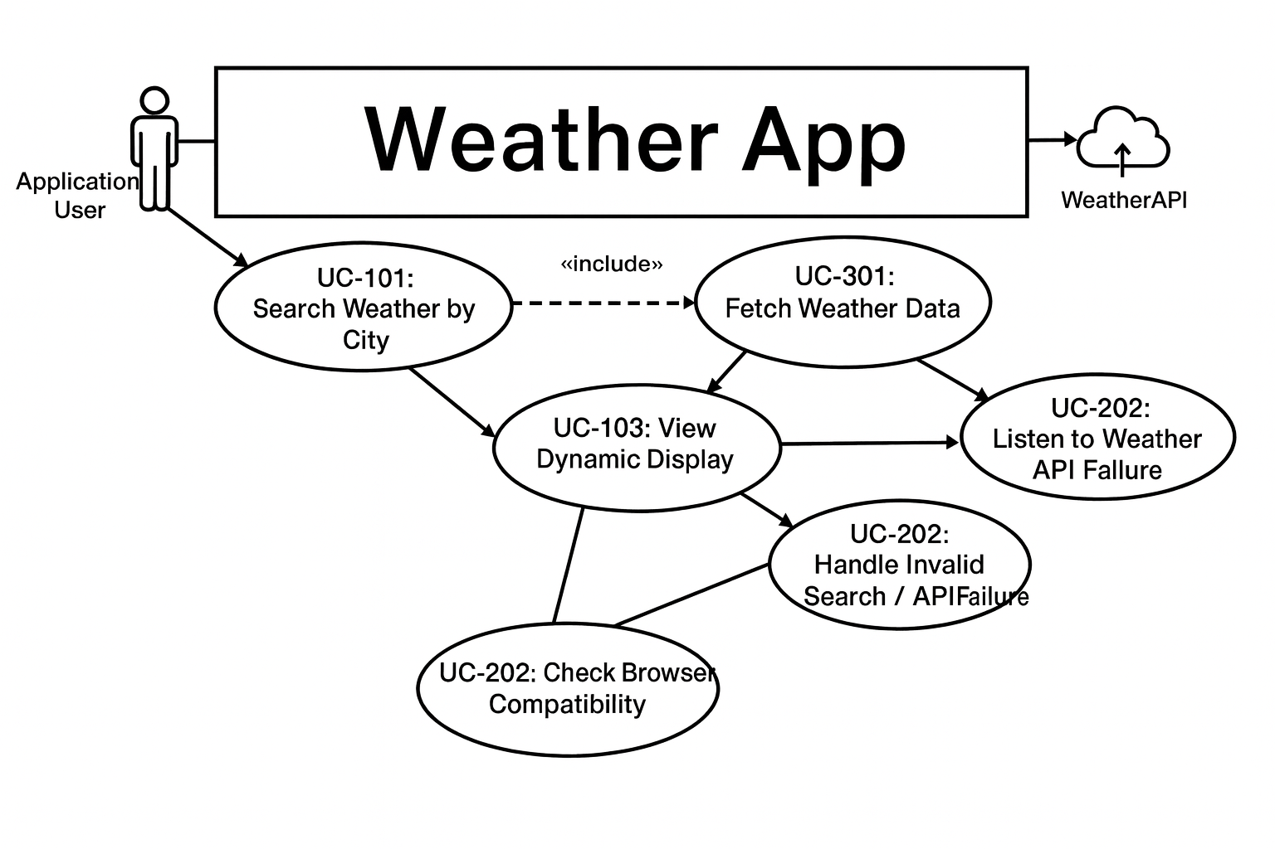

Use case description

The Weather App's functionality is driven by several key Use Cases. The core user interaction is UC-101: Search Weather by City, where the Application User seeks real-time weather information. This process mandatorily «includes» the system-side UC-301: Fetch Weather Data, which involves securely requesting JSON data from the external WeatherAPI.

- Primary Actor: Application User

Use Case ID | Use Case Name | Goal Achieved | Trigger
UC-101 | Search Weather by City | To successfully retrieve and display real-time weather information for a specified location. | User inputs a city name and presses the search button.
UC-102 | Listen to Weather Narration | To get an audible description of the current weather conditions. | User clicks the "Voice Output" button.
UC-103 | View Dynamic Display | To view weather information presented with appropriate icons and a dynamic background. | System successfully retrieves and processes weather data (usually follows UC-101).

Secondary Actor: Application User (Error/Constraint Handling)

Use Case ID | Use Case Name | Goal Achieved | Trigger
UC-201 | Handle Invalid Search | To gracefully notify the user when the entered city cannot be found. | User submits an invalid or unknown city name.
UC-202 | Handle API Failure | To notify the user when the external weather data service is unreachable. | The system attempts to connect to the WeatherAPI and fails (network or server down).
UC-203 | Check Browser Compatibility | To inform the user if the voice output feature is unavailable. | System detects that the browser does not support the SpeechSynthesis API.

External Actor: WeatherAPI (System Interface)

Use Case ID | Use Case Name | Goal Achieved | Trigger
UC-301 | Fetch Weather Data | To successfully request and receive raw weather data in JSON format from the external service. | System sends an HTTPS GET request to the WeatherAPI.

References
University SRS Template (Provided Document): Department of Information Technology, The Islamia University of Bahawalpur. “Software Requirements Specification (SRS) Template.”

