Big Data Assignment
Hadoop-Like Distributed System Simulation
Using Docker Containers & MapReduce (Vibe Coding)

Field | Details
Subject | Big Data
Assignment Type | Vibe Coding (AI-Assisted Development)
Technology Used | Docker, Python, Flask, MapReduce
Dataset | COVID-19 Global Dataset (CSV)
Semester | 7th Semester

1. Objective
The goal of this assignment is to simulate a Hadoop-like distributed computing system using Docker containers and Python. The system implements the MapReduce programming model where a Master node distributes data chunks to Worker nodes, which process them in parallel and return results for final aggregation.

2. System Architecture

2.1 System Architecture Diagram

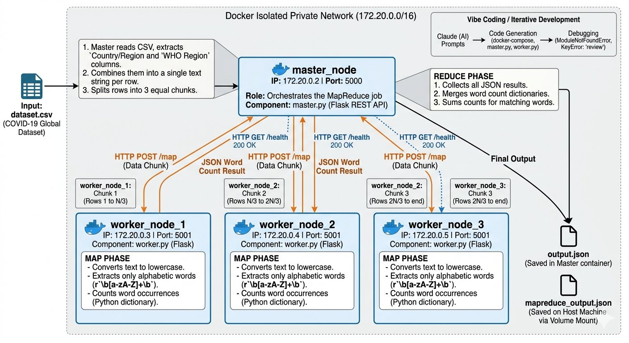
Figure 1: Hadoop-Like Distributed System Architecture

2.2 Container Setup
The system uses Docker and docker-compose to create an isolated private network (172.20.0.0/16) with four containers:

Container | IP Address | Port | Role
master_node | 172.20.0.2 | 5000 | Orchestrates the MapReduce job
worker_node_1 | 172.20.0.3 | 5001 | Processes data chunk #1 (MAP)
worker_node_2 | 172.20.0.4 | 5001 | Processes data chunk #2 (MAP)
worker_node_3 | 172.20.0.5 | 5001 | Processes data chunk #3 (MAP)

2.3 Communication
All containers communicate over HTTP using Flask REST APIs. The Master sends POST requests to each worker's /map endpoint with a data chunk. Workers return JSON word count results. This simulates the network communication in a real Hadoop cluster.

2.4 MapReduce Flow
- Master reads dataset.csv and extracts the Country/Region and WHO Region columns
- Master splits rows into 3 equal chunks (one per worker)
- Master checks worker health via GET /health before dispatching
- Master sends each chunk to a worker via POST /map
- Each worker runs word count on its chunk (MAP phase)
- Master receives all results and merges them (REDUCE phase)
- Final sorted word count is returned as JSON and saved to output.json

3. Data Chunking
The dataset used is a COVID-19 global statistics CSV file with columns: Province/State, Country/Region, Lat, Long, Date, Confirmed, Deaths, Recovered, Active, WHO Region.

The Master node reads the Country/Region and WHO Region text columns and combines them into a single text string per row. It then splits all rows evenly across the 3 available workers using Python's list slicing:

Worker | Rows Assigned | Data
worker_node_1 | Rows 1 to N/3 | Country/Region + WHO Region text
worker_node_2 | Rows N/3 to 2N/3 | Country/Region + WHO Region text
worker_node_3 | Rows 2N/3 to end | Country/Region + WHO Region text (remainder)

4. Map Phase (Worker Nodes)
Each worker runs worker.py which is a Flask application listening on port 5001. When a chunk arrives at the /map endpoint, the worker:
- Converts all text to lowercase
- Extracts only alphabetic words using regex: r'\b[a-zA-Z]+\b'
- Counts occurrences of each word in a Python dictionary
- Returns the word count dictionary as JSON to the Master

Example MAP output from one worker:

Word | Count
europe | 5013
western | 3509
pacific | 3446
africa | 3071
eastern | 1379

5. Reduce Phase (Master Node)
After all workers return their MAP results, the Master node performs the REDUCE phase. It merges all three word count dictionaries by summing counts for matching words:

Final REDUCE output (Top 20 words from actual run):

Rank | Word | Total Count
1 | western | 10528
2 | pacific | 10340
3 | africa | 9212
4 | americas | 8648
5 | china | 6204
6 | eastern | 4136
7 | mediterranean | 4136
8 | asia | 1880
9 | australia | 1504
10 | and | 1316

Total unique words found: 226 | Workers used: 3 | Time taken: 1.3 seconds

6. Results & Output
The system successfully completed the MapReduce job with the following outcomes:
- 226 unique words identified across the entire COVID-19 dataset
- 3 worker nodes processed data in parallel simultaneously
- Job completed in 1.3 seconds demonstrating distributed efficiency
- Full results saved to output.json inside the master container
- Local results saved to mapreduce_output.json on the host machine

7. Vibe Coding — Prompt Log
The following prompts were used with AI (Claude) during development. They show how the system was designed and debugged through iterative AI-assisted development:

# | Prompt Used | Purpose | Outcome
1 | Create a Hadoop-like distributed system using Docker with 1 master and 3 worker containers | Initial system design | Generated docker-compose.yml with static IPs and private network
2 | Write a Flask worker node that receives a text chunk and does word count (MAP phase) | Worker implementation | Created worker.py with /map and /health endpoints
3 | Write a master node that reads a CSV, splits rows across workers, collects results and reduces them | Master implementation | Created master.py with full MapReduce pipeline
4 | My CSV has columns: Province/State, Country/Region, Lat, Long, Date, Confirmed, Deaths, Recovered, Active, WHO Region — fix the master to use correct columns | Bug fix | Fixed KeyError by using Country/Region and WHO Region columns
5 | Flask is not installing in Docker — ModuleNotFoundError: No module named flask | Debugging | Fixed by removing requirements.txt and using RUN pip install directly in Dockerfile
6 | Create app.py to test the system locally and display results nicely | Testing client | Created app.py with health check, job trigger, and formatted output

8. Debugging Report
The following errors were encountered during development and resolved using AI assistance:

Error | Cause | AI-Assisted Fix
ModuleNotFoundError: No module named flask | requirements.txt was not being copied before pip install in Docker | Removed requirements.txt and added RUN pip install flask directly in Dockerfile
FileNotFoundError: /data/dataset.csv | Volume mount in docker-compose was missing the version key causing parse issues | Removed obsolete 'version' field from docker-compose.yml, verified volume mount
KeyError: 'review' | Master was reading a column 'review' but CSV had different column names | Updated master.py to use row.get('Country/Region') and row.get('WHO Region')
Connection refused on localhost:5000 | Running app.py before docker-compose up | Always start containers first with docker-compose up, then run app.py

9. Conclusion
This assignment successfully demonstrated a working distributed computing system that simulates Hadoop's core MapReduce paradigm. Key concepts implemented include:
- Distributed data processing across multiple containerized nodes
- IP-based HTTP communication between Master and Worker nodes
- Parallel MAP phase execution on independent data chunks
- Centralized REDUCE phase combining distributed results
- Container orchestration using Docker and docker-compose

The vibe coding approach using AI assistance significantly accelerated development. AI helped with initial architecture design, debugging Docker issues, and fixing data pipeline errors. The final system processed a real-world COVID-19 dataset and produced meaningful word frequency analysis across 226 unique terms in 1.3 seconds using 3 parallel workers.

