Junaid Qadir
Biography (400 words)
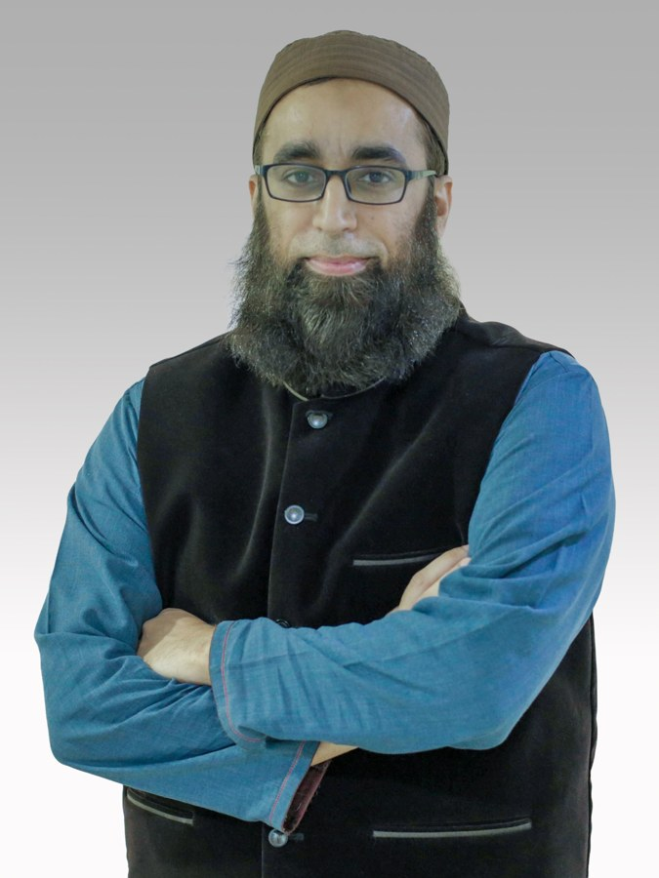
Junaid Qadir is a Professor of Computer Engineering at Qatar University in Doha, Qatar, where he directs the IHSAN Research Lab. His research spans AI ethics and governance, AI safety, human-AI interaction, and applied AI in education and healthcare. Across these areas he asks how AI can be made safe and accountable, and how it shapes the human intelligence, agency and flourishing it is meant to serve. He approaches these questions through multiplexity, a systemic both-and framework that pairs integrative and analytical methods to bring many disciplines, models, perspectives, sources of knowledge and levels of reality into one living whole in which higher purposes guide lower means.
He has published more than 300 peer-reviewed articles: in artificial intelligence venues such as IEEE Transactions on Pattern Analysis and Machine Intelligence, IEEE Transactions on Artificial Intelligence and the Journal of Artificial Intelligence Research; in health and ethics venues such as npj Digital Medicine and Bioethics; and in computing venues such as ACM Computing Surveys and IEEE Communications Surveys and Tutorials. His work has been cited more than 27,500 times, and he has been included every year since 2019 in the Stanford–Elsevier list of the top 2% of scientists worldwide. His research has been funded by the Qatar Research, Development and Innovation Council, the Qatar National Research Fund, Facebook Research and the British Embassy Doha.
His awards include the IEEE Engineering in Medicine and Biology Prize Paper Award (2023), the Emerald Literati Outstanding Paper Award (2023) and the IEEE EDUCON 2025 Most Cited Paper award in London. At Qatar University he received the Outstanding Faculty Service Award (2025–26), given each year to one member of its 2,000-strong faculty, and the College of Engineering Dean's Awards for Excellence in Research (2024), Service (2025) and Teaching (2026). He also received Pakistan's highest national teaching honor, the Higher Education Commission's Best University Teacher Award (2012–13).
He chairs the AI for Teaching and Learning subgroup of the IEEE P3722 standards working group on responsible AI in higher education. He is an ACM Distinguished Speaker (2020–2026) and an IEEE Education Society Distinguished Lecturer (2025–2026), and a Senior Member of IEEE and ACM. Before joining Qatar University in 2021, he taught at the National University of Sciences and Technology and chaired the Department of Electrical Engineering at the Information Technology University, Lahore. He holds a PhD in Computer Science and Engineering from the University of New South Wales, Australia.
junaidqadir.github.io · jqadir@qu.edu.qa · orcid.org/0000-0001-9466-2475

