**Muhammad Junaid Riaz-23110164**

**Dashboard**

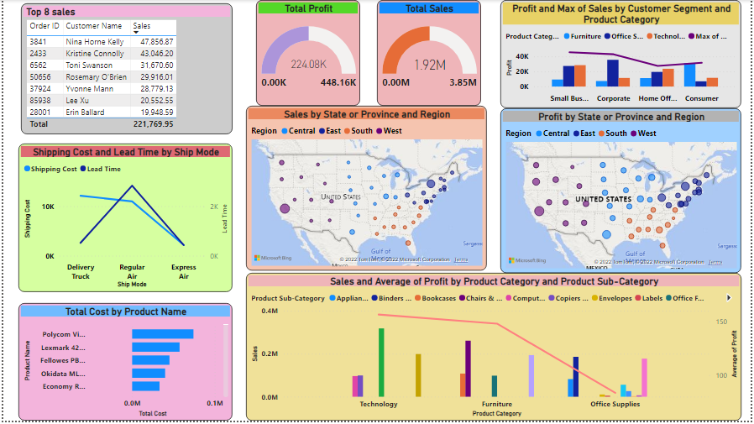

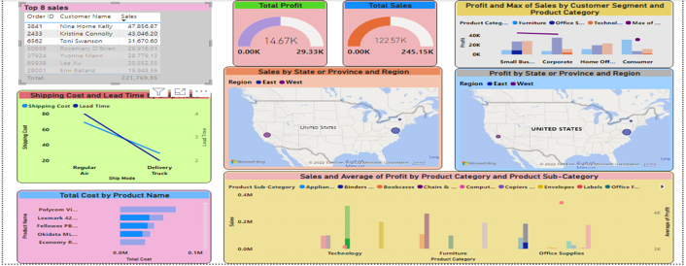This dashboard is created to analyze sales, profits and costs of different areas of United States. We found the total sales to be $1.92 Million while profits turned out to be $224.08K. This was complimented by the representation of top 7 customers’ sales. Sales’ relation was also found against product category and maximu7m sales was in Technology’s office machines with the value of $318,170. Average profit was also maximum for the same category, $156.56. We found a new variable namely lead time (Shipping date – Order time) and we got maximum lead time for “Regular Air”, while maximum shipping cost was for “Delivery Truck” method. Moreover, we got the data of sales and profits depending on State/Province and Region. In both cases, New York and California were the most beneficial areas for business. Another relation was of Profit against customer segment and corporate was found to have maximum profit. Same graph showed maximum of “max sales” was in small business segment.

Top three sales’ customers were selected who gave $14.67K of Profit and $122.57K of sales. This was mainly in Small business and corporate segment, while sales coming from new York and California. Main three products were Lexmark, Fellowes and Okidata.

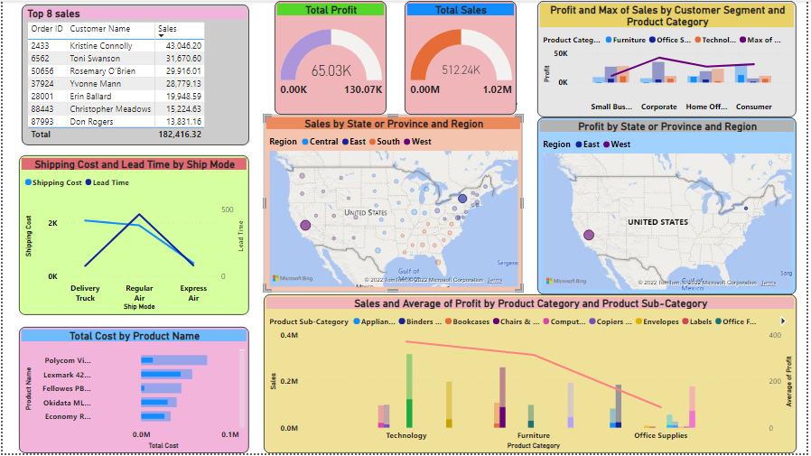

In this dashboard, New York and California was selected and results yielded were the profit of $65.03K and sales of $512.24K. Corporate segment gave maximum of “max sales” and maximum profit. Maximum total cost was of Lexmark, while sales and average profit were maximum for product category of technology.

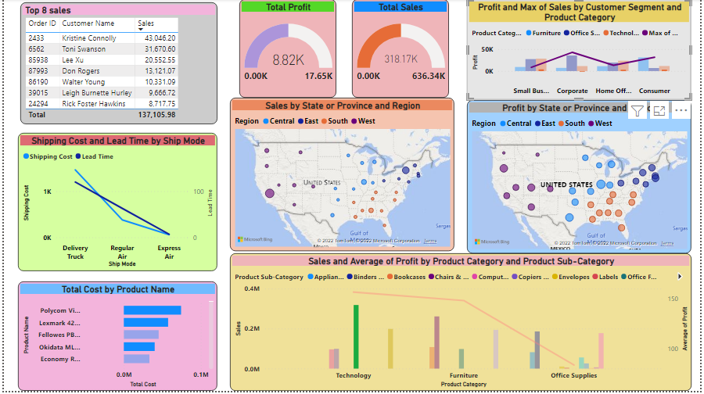

We selected maximum sales data of technology. It showed maximum profit and “max sales” in corporate segment, maximum average profit was in technology category. Maximum data was from Southern region and delivery truck had maximum shipping cost and lead time.

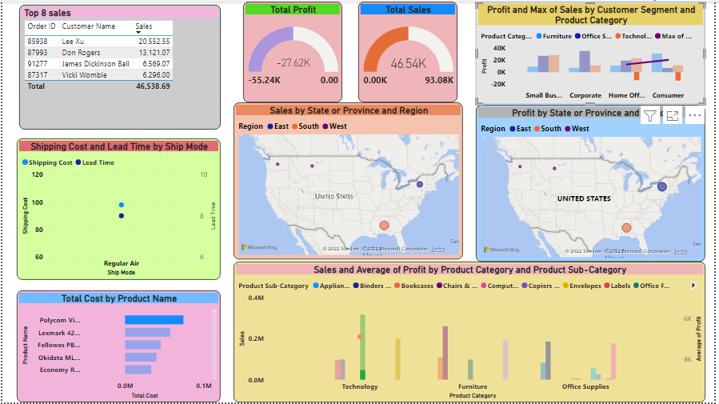

This data was a representative of maximum total cost that was calculated by us (Total sales - profit). It resulted in loss of $27.62K. Loss came from Home office and consumer segment.

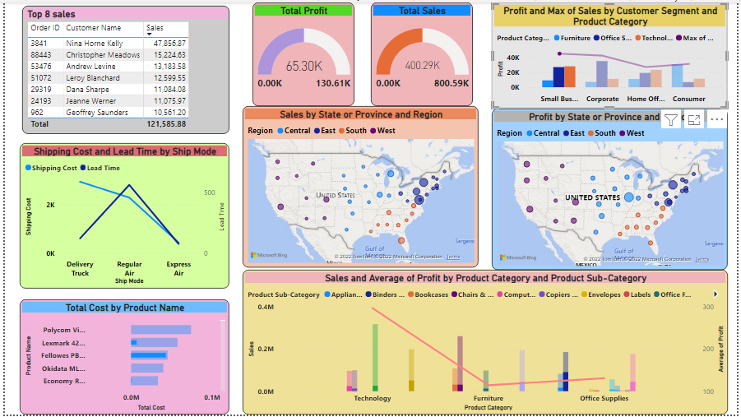

Maximum of sales against consumer segment was selected and it gave us the profit of $65.3K and total sales of $400.29K. Average profit was maximum in technology sector and maximum sale was in office supplies

All these showed that Technology was major source of income and this was mainly from New York and California. Also, corporate segment gave most of the profit while maximum cost was incurred by product, Polycom.

(**Note:** if pages are excluded, it becomes one pager)