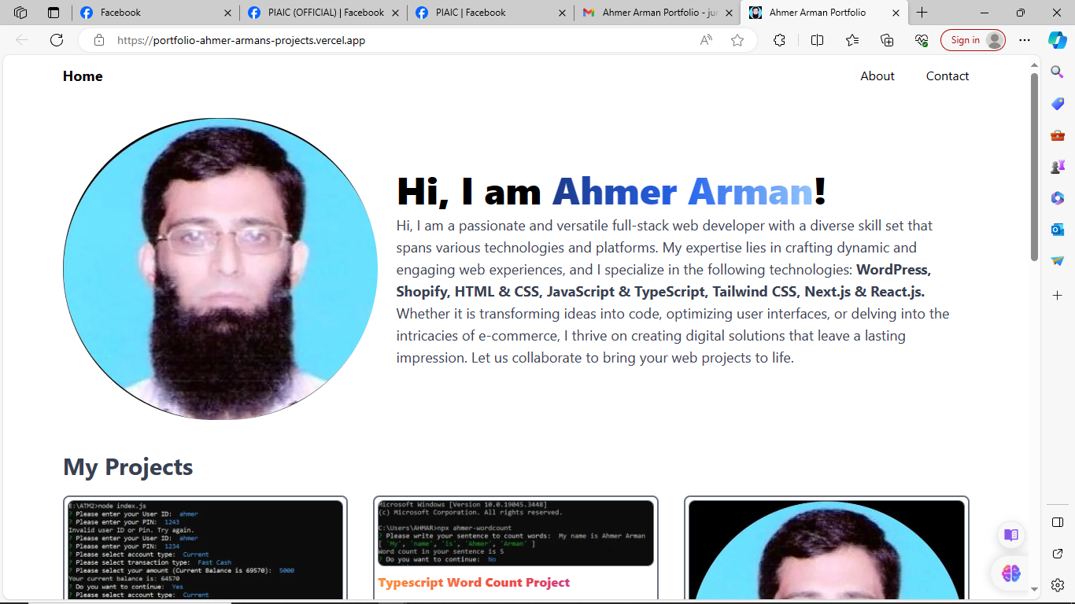
https://portfolio-ahmer-armans-projects.vercel.app/https://portfolio-ahmer-armans-projects.vercel.app/https://portfolio-ahmer-armans-projects.vercel.app/https://portfolio-ahmer-armans-projects.vercel.app/https://portfolio-ahmer-armans-projects.vercel.app/https://portfolio-ahmer-armans-projects.vercel.app/https://portfolio-ahmer-armans-projects.vercel.app/https://portfolio-ahmer-armans-projects.vercel.app/https://portfolio-ahmer-armans-projects.vercel.app/https://portfolio-ahmer-armans-projects.vercel.app/https://portfolio-ahmer-armans-projects.vercel.app/https://portfolio-ahmer-armans-projects.vercel.app/https://portfolio-ahmer-armans-projects.vercel.app/https://portfolio-ahmer-armans-projects.vercel.app/https://portfolio-ahmer-armans-projects.vercel.app/https://portfolio-ahmer-armans-projects.vercel.app/https://portfolio-ahmer-armans-projects.vercel.app/https://portfolio-ahmer-armans-projects.vercel.app/https://portfolio-ahmer-armans-projects.vercel.app/https://portfolio-ahmer-armans-projects.vercel.app/https://portfolio-ahmer-armans-projects.vercel.app/https://portfolio-ahmer-armans-projects.vercel.app/https://portfolio-ahmer-armans-projects.vercel.app/https://portfolio-ahmer-armans-projects.vercel.app/https://portfolio-ahmer-armans-projects.vercel.app/https://portfolio-ahmer-armans-projects.vercel.app/https://portfolio-ahmer-armans-projects.vercel.app/https://portfolio-ahmer-armans-projects.vercel.app/https://portfolio-ahmer-armans-projects.vercel.app/https://portfolio-ahmer-armans-projects.vercel.app/https://portfolio-ahmer-armans-projects.vercel.app/
