Software Requirements Specification (SRS)

C++ Command-Line Chatbot System

1. Introduction

1.1 Purpose
This document describes the requirements for a C++ chatbot application that demonstrates operating system concepts including process management, multithreading, file I/O, and inter-process communication using tmux.

1.2 Scope
The chatbot is a command-line application that: - Answers pre-defined questions about operating systems and C++ - Manages conversation history with automatic saving - Uses tmux for split-panel answer display - Demonstrates OS concepts like fork, exec, pipes, threads, and file operations

1.3 Target Users
- Students learning operating system concepts
- Developers understanding C++ system programming
- Anyone interested in command-line chatbot applications

2. System Overview

2.1 Description
A terminal-based chatbot that runs inside tmux sessions, displays answers in a side panel, and automatically saves conversations. Built using C++ with system calls and threading.

2.2 Key Features
- Question answering system with 13+ pre-defined topics
- Automatic conversation saving every second
- Tmux integration for split-screen display
- Conversation management (save, load, continue)
- Multiple command support (help, list, load, save, new, clear, close, exit)

3. Functional Requirements

3.1 Tmux Session Management
- FR-1: System must check if running inside a tmux session
- FR-2: If not in tmux, automatically create a new session and restart the program
- FR-3: Kill existing sessions before creating new ones to avoid conflicts

3.2 Question Answering
- FR-4: Support questions about: C++, tmux, processes, fork, multithreading, pipes, FIFO pipes, shared resources, exec, file operations, semaphores, and process management
- FR-5: Display answers in a split tmux panel on the right side
- FR-6: Allow loading questions by number using “load question N” command

3.3 Conversation Management
- FR-7: Automatically save conversations every 1 second with default name “autosave_timestamp”
- FR-8: Save conversations manually with custom titles
- FR-9: Load previous conversations and continue them
- FR-10: List all saved conversations with numbers
- FR-11: Start new conversations (with option to save current one)
- FR-12: Clear conversation history

3.4 User Interface
- FR-13: Display ASCII welcome banner on startup
- FR-14: Show “You:” prompt for user input
- FR-15: Provide help command listing all available commands
- FR-16: Support clear command to refresh screen

3.5 Panel Management
- FR-17: Open tmux panel to display answers
- FR-18: Update existing panel if already open
- FR-19: Close panel on demand with “close” command
- FR-20: Kill panel when exiting program

4. Non-Functional Requirements

4.1 Performance
- NFR-1: Auto-save must complete within 100ms to avoid UI blocking
- NFR-2: Command response time should be under 200ms
- NFR-3: Program startup time should be under 2 seconds

4.2 Reliability
- NFR-4: Thread-safe conversation access using mutex locks
- NFR-5: No data loss during auto-save operations
- NFR-6: Graceful cleanup on exit (join threads, kill tmux session)

4.3 Usability
- NFR-7: Simple command syntax (single words or “action object” format)
- NFR-8: Clear error messages for invalid inputs
- NFR-9: Case-insensitive command matching

4.4 Maintainability
- NFR-10: Modular design with separate header files for each component
- NFR-11: No namespace pollution in header files
- NFR-12: Clean code structure with meaningful function names

5. System Architecture

5.1 Components

5.1.1 Main Program (main.cpp)
- Entry point
- Event loop handling
- Thread management
- Command routing

5.1.2 Chatbot Module (chatbot.hpp)
- Question bank storage
- Answer matching logic
- Command validation
- Help system

5.1.3 Tmux Manager (tmux_manager.hpp)
- Session creation/destruction
- Panel operations (open, update, close)
- Process forking for tmux commands
- Uses fork + exec for system calls

5.1.4 Conversation Manager (conversation.hpp)
- Message storage
- File I/O operations
- Auto-save functionality
- Thread synchronization
- Load/save conversations

5.1.5 Utilities (utils.hpp)
- String manipulation (toLower, trim)
- Helper functions

5.2 Threading Model
- Main Thread: Handles user input and UI
- Auto-Save Thread: Runs in background, saves every 1 second

5.3 Data Flow
User Input → Command Parser → Action Handler → Response Display
↓
Conversation Storage
↓
Auto-Save Thread → File System

6. System Requirements

6.1 Software Requirements
- Operating System: Linux (Ubuntu/Debian recommended)
- Compiler: g++ with C++11 support or later
- Dependencies: tmux terminal multiplexer
- Standard Libraries: iostream, string, thread, mutex, atomic, fstream

6.2 Hardware Requirements
- RAM: Minimum 512 MB
- Storage: 10 MB for program and conversation files
- Processor: Any modern CPU

7. Technologies and Concepts Used

7.1 Operating System Concepts
- Process Management: fork(), exec(), waitpid(), exit()
- File Operations: open(), read(), write(), close(), remove()
- Directory Operations: mkdir(), opendir(), readdir(), closedir(), stat()
- Multithreading: std::thread, std::mutex, std::atomic
- Inter-Process Communication: System calls via system() and execl()

7.2 C++ Features
- Object-Oriented Programming (classes, encapsulation)
- STL Containers (vector, map, string)
- File Streams (ifstream, ofstream)
- Threading Library (thread, mutex, atomic, lock_guard)
- RAII (Resource Acquisition Is Initialization)

7.3 System Calls
- fork() - Create child process
- execl() - Execute tmux commands
- waitpid() - Wait for child process completion
- readlink() - Get executable path
- time(), localtime(), strftime() - Timestamp generation
- mkdir() - Create directories
- stat() - Check file/directory existence
- remove() - Delete files
- opendir(), readdir(), closedir() - Directory traversal

8. System Flowchart
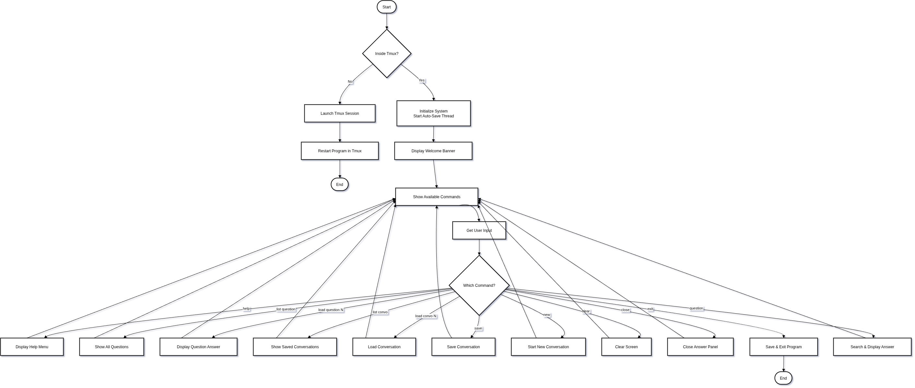
The flowchart shows the main program flow: 1. Start - Program initialization 2. Tmux Check - Verify if running in tmux, launch if not 3. Initialize - Create objects, start auto-save thread 4. Display Welcome - Show banner and available commands 5. Command Loop - Process user commands 6. Command Execution - Execute specific actions (help, save, load, etc.) 7. Exit - Save conversation and cleanup

9. User Commands
Command | Description | Example
help | Display all available commands | help
list question | Show all questions with numbers | list question
load question <N> | Load and display question N | load question 5
list convo | Show saved conversations | list convo
load convo <N> | Load conversation N | load convo 2
save | Save current conversation | save
new | Start new conversation | new
clear | Clear screen | clear
close | Close answer panel | close
exit | Save and exit program | exit
Any question | Search and display answer | what is fork

10. File Structure
chatbot-cpp/
├── main.cpp # Main program entry point
├── include/
│ ├── chatbot.hpp # Question answering logic
│ ├── tmux_manager.hpp # Tmux operations
│ ├── conversation.hpp # Conversation storage
│ └── utils.hpp # Utility functions
├── conversations/ # Saved conversation files
│ ├── autosave_*.txt # Auto-saved conversations
│ └── *.txt # User-named conversations
├── bin/
│ └── chatbot # Compiled executable
├── run.sh # Build and run script
└── SRS.md # This document

11. Conversation File Format
Title: conversation_name
Date: 2024-02-04 10:30:45
=====================================
[2024-02-04 10:30:50] user: what is fork
[2024-02-04 10:30:50] bot: fork() is a system call that creates a new process...
[2024-02-04 10:31:20] user: what is multithreading
[2024-02-04 10:31:20] bot: Multithreading is the ability of a CPU...

12. Build and Run

Compilation and Execution
./run.sh
The script automatically compiles and runs the program inside tmux.

13. Known Limitations
- Only works on Linux systems with tmux installed
- Pre-defined questions only (no AI/dynamic learning)
- Requires terminal with sufficient width for split panels
- Exit delay up to 1 second (waiting for auto-save thread)
- File-based storage (no database)

14. Future Enhancements
- Add dynamic question learning
- Implement search functionality in conversations
- Export conversations to PDF/HTML
- Add conversation analytics (word count, question frequency)
- Support for multiple simultaneous conversations
- Integration with external APIs for real-time answers
- Voice input/output support
- Web interface for remote access

15. Testing Requirements

15.1 Unit Testing
- Test each command individually
- Verify file I/O operations
- Test thread synchronization

15.2 Integration Testing
- Test tmux integration
- Verify auto-save functionality
- Test conversation loading

15.3 System Testing
- End-to-end user workflows
- Performance testing (auto-save speed)
- Stress testing (large conversations)

16. Conclusion
This chatbot system successfully demonstrates core operating system concepts through practical implementation. It combines process management, multithreading, file operations, and inter-process communication in a user-friendly command-line interface. The project serves as both an educational tool and a functional application.

Document Version: 1.0
Last Updated: February 4, 2026
Author: Chatbot-CPP Development Team

