**Junaid Ur Rehman**

[junaidurrehman001@gmail.com](mailto:junaidurrehman001@gmail.com)

# Evaluation Task

## Environment

**Operating System:** Window 7

**Compilers:** **1-** Microsoft Visual C++ (Version 2010)

**2-** Dev C++ (Version 5.4.1)

Section : 1

## Approach using Dev C++

* **Brief Overview**

I started new project as an Empty Project, The requirements of the code are to implement basic Arithmetic function including Addition, Subtraction, Multiplication & Division. I took an approach of using separate functions for each arithmetic function.

The user would be asked to select any single operation, e.g The user’s requirement is to simply carry out addition operation on any numbers, the user can select from the Four given options and then the program requires the input from the user, required to carry out the operation.

* **Creating New Project**

File > New > Project > Empty Project

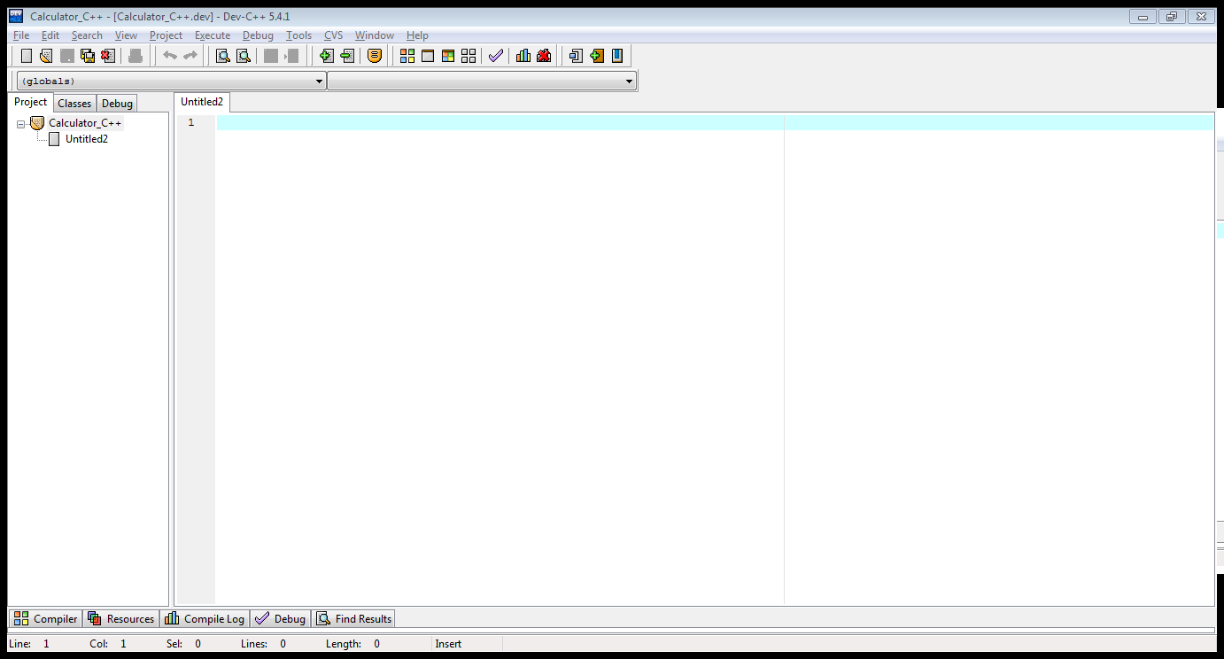

* **Main Function Approach**

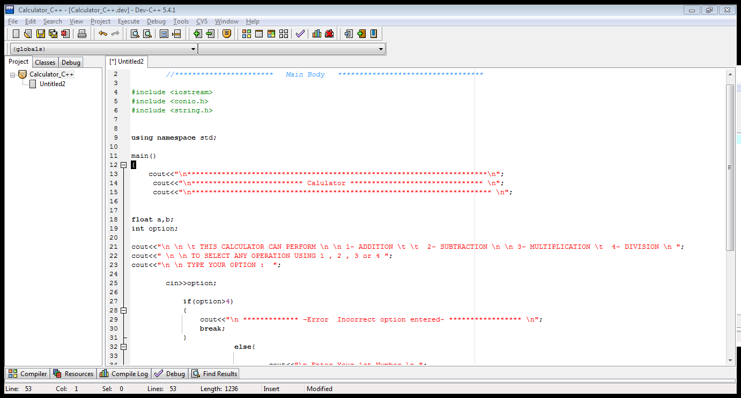

* **Creating a Header File named as FUNCT**

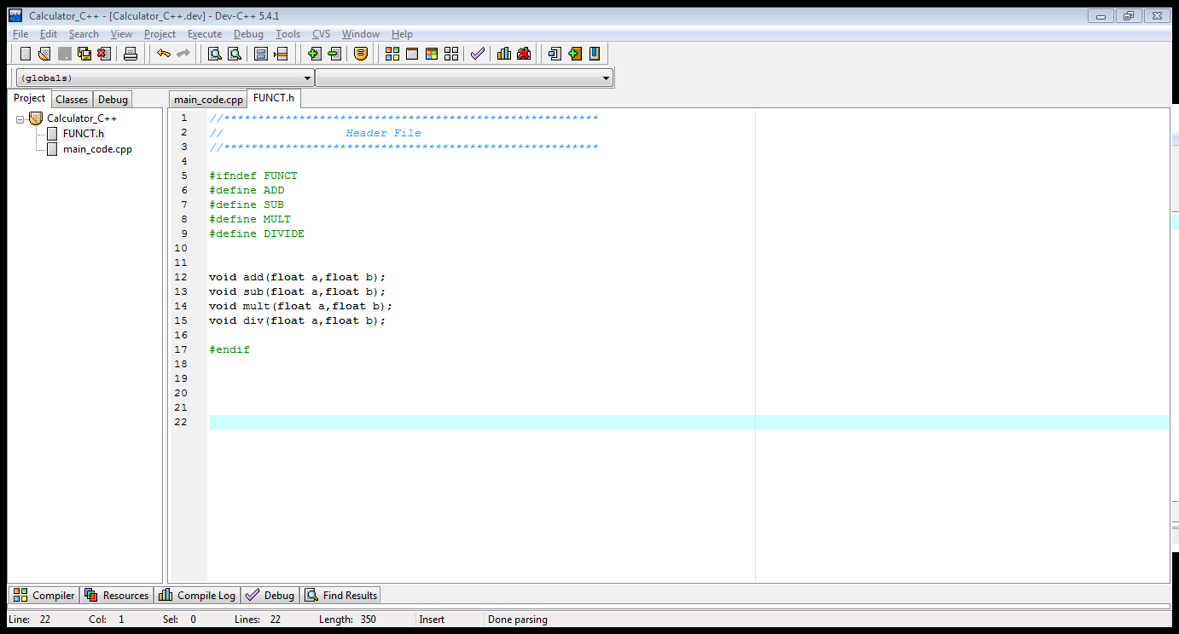

* **Arithmetic Operation:** Addition, Subtraction, Multiplication & Division

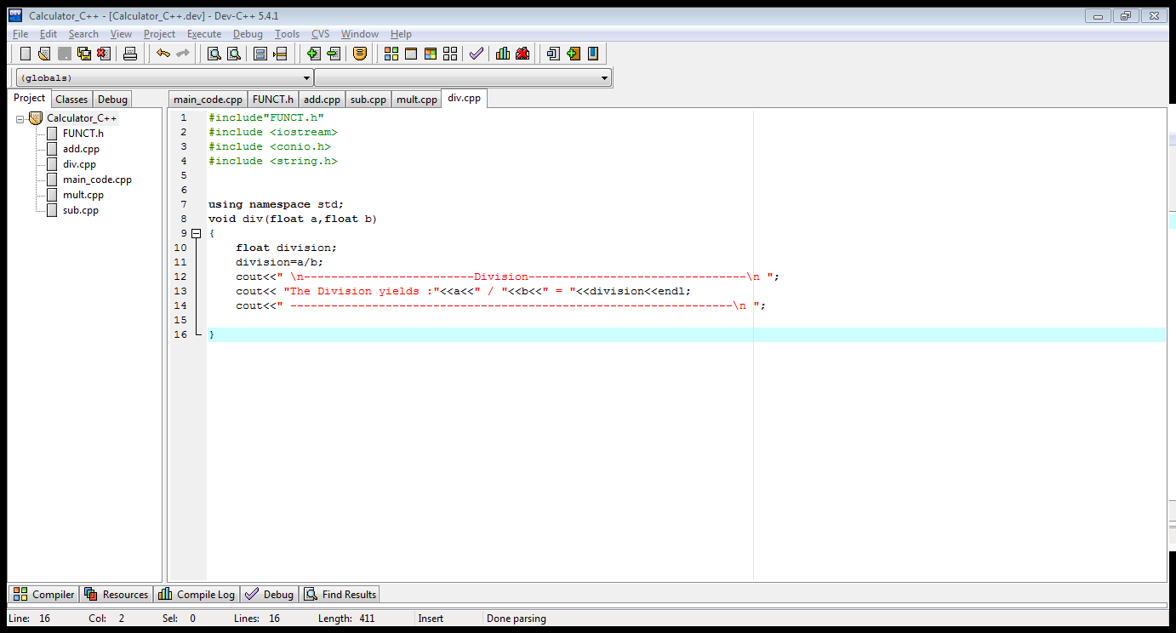

## Results

**Compiling & Running:**

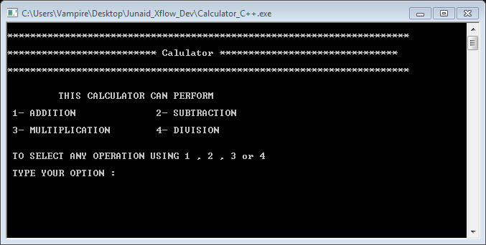

* **Example -1: Subtraction of Two Numbers**

For Subtraction, User select’s Option 2 and then enters the numbers as shown in the window below.

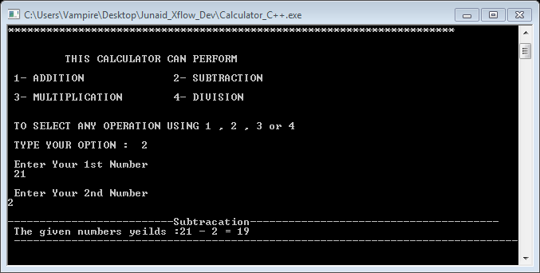

**Example -2: Incorrect Option > “Error Message “**

Incase the user inserts the incorrect option the program detects it and displays an Error message.

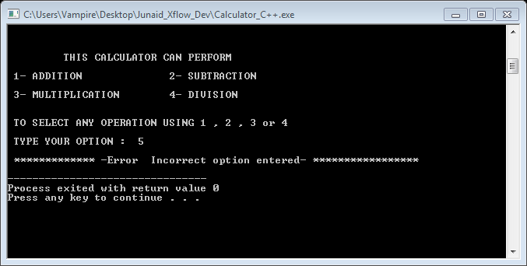

# B-Graphical Approach using Microsoft Visual Studio – 2010

* **Brief Overview**

I am using Microsoft Visual Studio compiler to implement the given Arithmetic Operations using graphical approach. This calculator design is inspired by Windows-7 default Calculator; it can perform the basic Addition, Subtraction, Multiplication and Division.

* In this compiler I am initiating with **Windows Forms Application** type project.

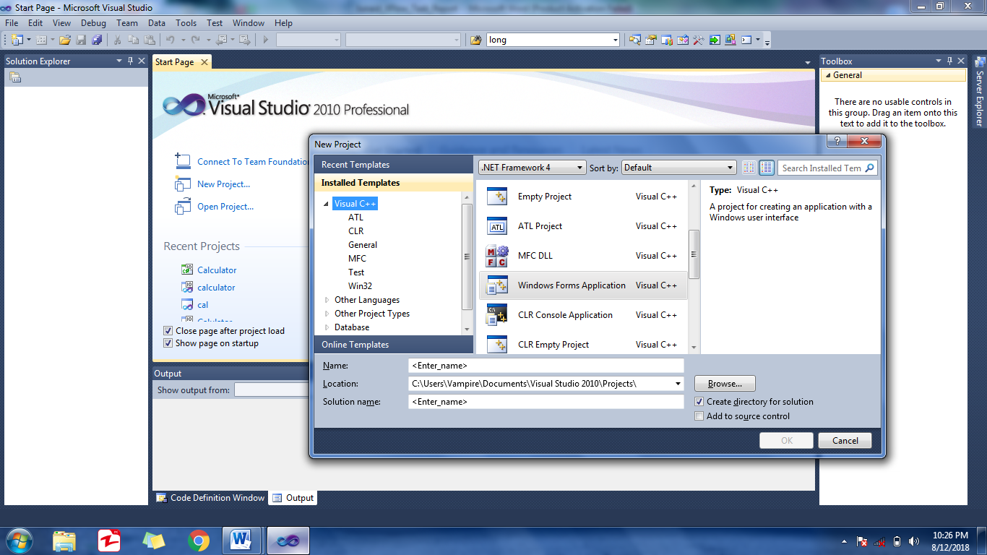

* Default empty template appears when the project is initiated.

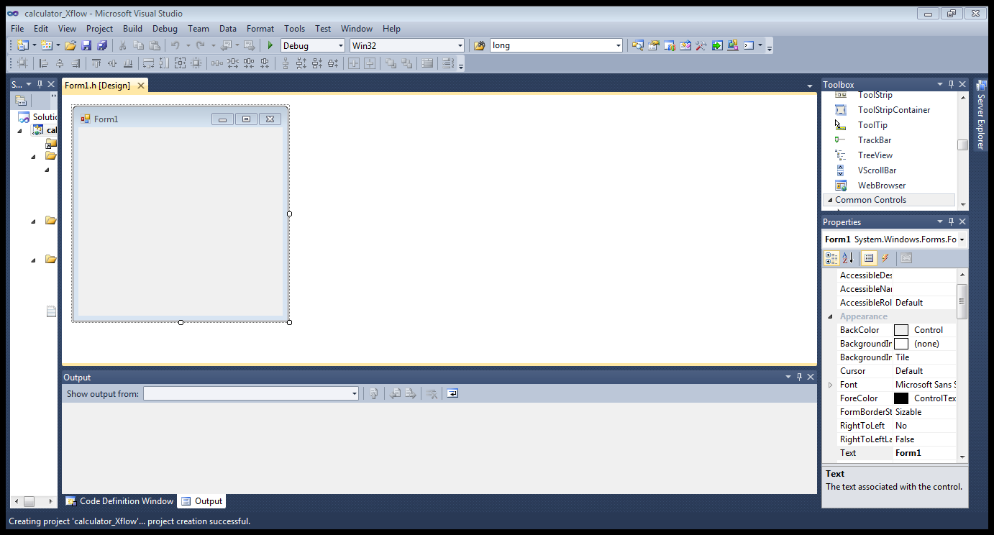

* Adding Buttons for numerical inputs, Operators and a Display Box (Label).

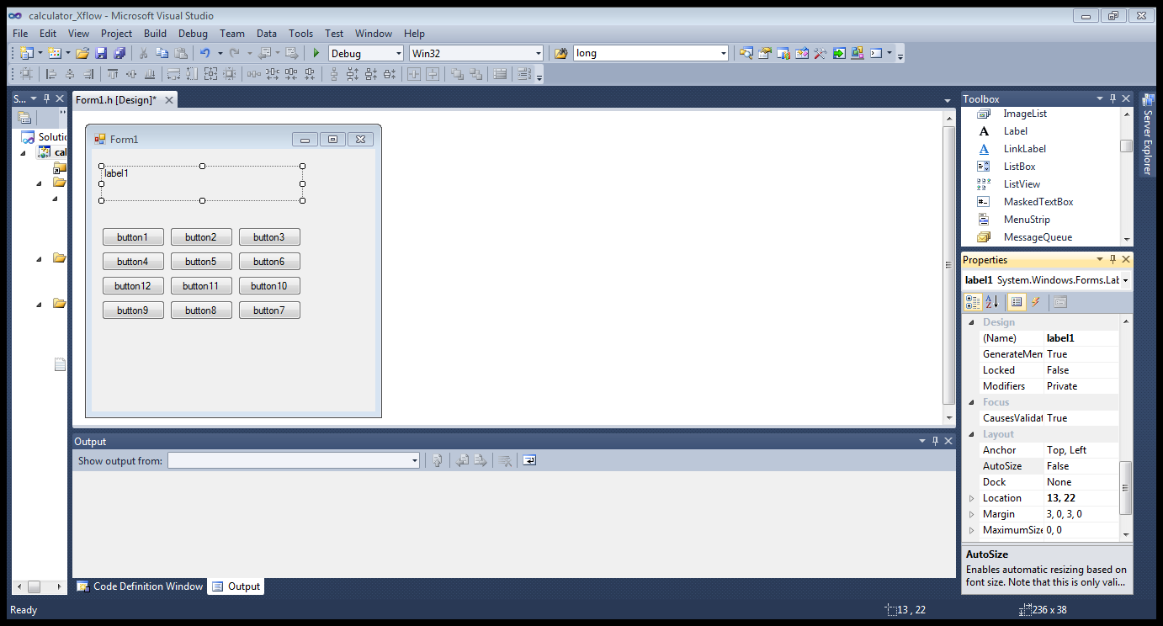

* The final Design is shown in the following figure.

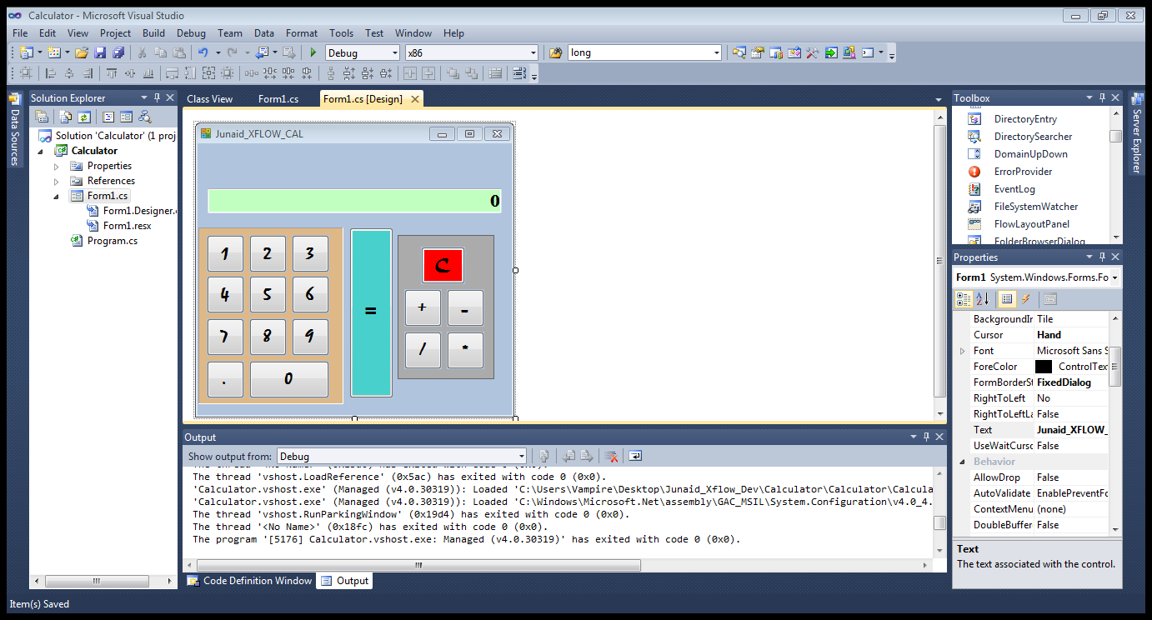

**Properties & Events**

* All the button properties , sizes , fonts etc are set to specifications and assigned click events

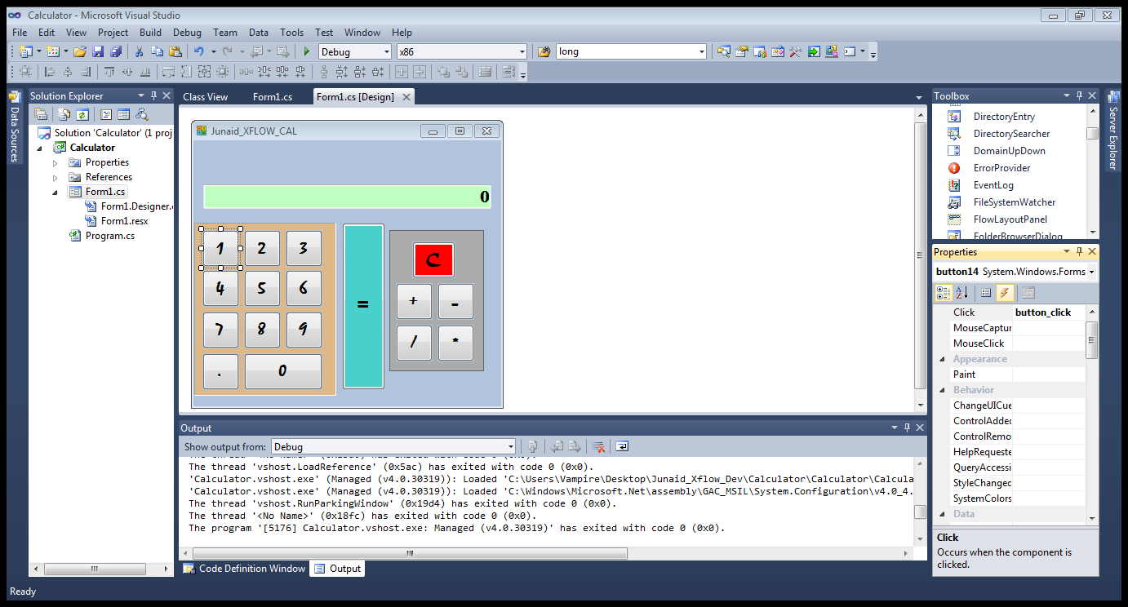

* Linking Button Events to the Label Window Box(Display).

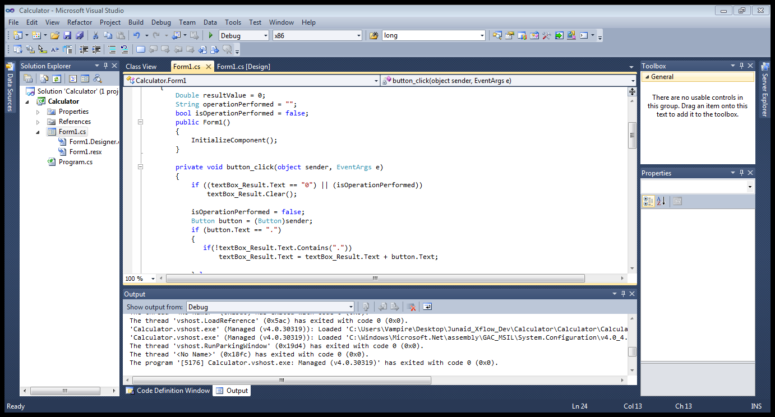

# Result:

* Building & Running the project.

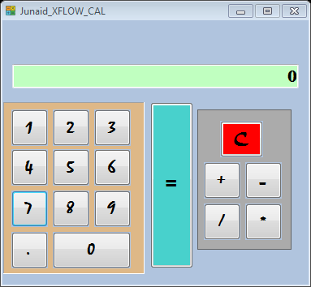

* In the following Figures the user adds two Numbers.

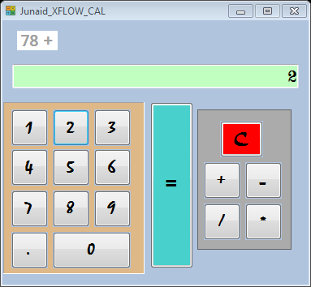 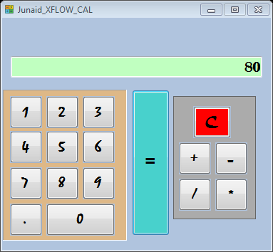

# References

1. <http://scholar.cu.edu.eg/?q=mhafez/files/windows_forms_using_c.pdf>
2. <https://cs-cit.wpunj.edu/dotAsset/308705.pdf>
3. <http://www.instructables.com/id/Creating-a-Calculator-Visual-Studio-C/>
4. <https://www.youtube.com/watch?v=Oxg6ciIcO3U>
5. <https://www.youtube.com/watch?v=zn1Cl5Kh4as>
6. <https://www.youtube.com/watch?v=Y9L85OBo1c4>