The **Blueprint for Change**

Resource

**Partnering to implement**

**Patient Blood Management**

**Module 4: Business module**

Implementation of patient blood management can improve patient safety and outcomes and enhance the hospital’s reputation as one of excellence in standard of care.

Patient Blood Management Toolkit

4 – Business Module

Table of Contents

Introduction 3

Global Health Care Crisis 3

Health Care Expenditures from Selected Countries 3

Blood Transfusions and Associated Complications 4

Preoperative Anemia: An Independent Risk Factor for Blood Transfusions 6

Burden of Cost of Blood Transfusions in Preoperative Anemia Management 6

Patient Blood Management and its Vision 8

Global Development of Patient Blood Management Program 9

Successful PBM Implementation Programs 9

Key Performance Indicators for Successful PBM Programs 10

Important Elements to Optimize Patient Blood Management 11

Cost-effectiveness of PBM Implementation in Clinical Settings 11

Models for PBM Implementation 12

Donabedian Model: Identifying Gaps and Ensuring PBM 12

WHO Europe’s Scheme of Essential Public Health Operations 13

Health Economic Models for PBM Implementation: A Cost-benefit Analysis 14

Building a Business Case for Implementing a Successful PBM Program 15

Introduction 16

Mission Statement/Business Purpose 16

Objectives/Benefits 16

Preferred Approach and Alternate Solutions 16

Performance and Progress Measures 17

Risks Involved and Mitigation 17

Operational Plan and Timelines 17

Financial analysis and Funding Sources 18

Transfusion Economics 19

Implementation Plan of a Blood Conservation Program 19

Practical Development of a Hospital Level Blood-Management Program 20

Development of PBM Reimbursement Schemes 21

Conclusion 22

References 23

# Introduction

## Global Health Care Crisis

Medical advances and economic growth have increased massively in the last 60 years, but health disparities persist in almost all the areas. The economic crisis indicates towards unjustified or excessive consumption of resources that are depleting. Health is a basic endowment that is every individual’s right and opportunity to lead a satisfying life (Benatar, Gill, & Bakker, 2011).

### Health Care Expenditures from Selected Countries

Figure 1 illustrates the healthcare expenditures of countries from 2015 to 2019 (OECD, 2020).

**Figure 1**: Healthcare expenditures and financing of some countries (Accessed: March 02, 2021 from OECD.Stat)

Major economies have reported financial decline and overall decrease in healthcare expenses due to the pandemic coronavirus-2019 (COVID-2019) emergency. Figure 2 represents the data of healthcare finances for some economies and world for 2020-2021 (The Economist Intelligence Unit, 2020).

.

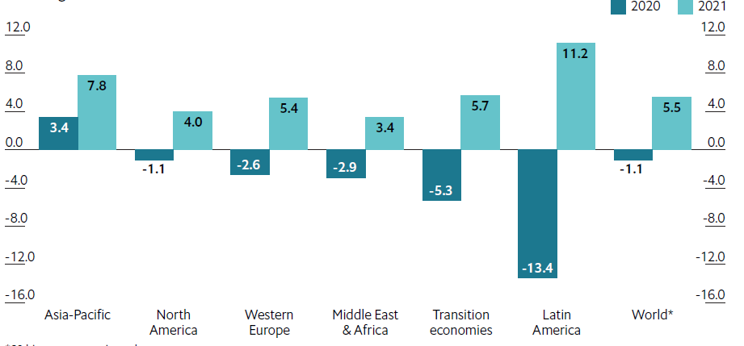

**Figure 2**: Health care spending (% change in US Dollars billion)

*60 biggest economies only

*Source*: The Economist Intelligence Unit. Accessed March 15, 2021.

In the coming decades, the acceleration and advancement of biomedical discoveries will bring upon an era where the economic resources for health care will gradually decrease and come to an end. The aim of future medicine will be efficient use of resources in order to prevent diseases, with an objective of delivering the best care to patient who needs treatment (Kohane, Drazen, & Campion, 2012).

## Blood Transfusions and Associated Complications

Blood transfusions have proven to be life-saving procedure and made complicated surgical treatment possible. It has been widely used since the early 20th century to treat anemia and hemorrhage. Transfusion has been overused and continues to be excessively used in the face of limited availability of blood and serious adverse events involved. (Yaddanapudi & Yaddanapudi, 2014) Blood transfusion are associated with complications such as increased risk of infections, myocardial infarction, transfusion-associated circulatory overload (TACO) and transfusion-related acute lung injury (TRALI), postoperative morbidity, increased early and late mortality (Bernard, Davenport, Chang, Vaughan, & Zwischenberger, 2009; Gombotz, 2012; G. J. Murphy et al., 2007). Hence, the decision-making for administration of blood depends on analyzing risks and potential benefits of blood transfusion against those for anemia.

Figure 3 demonstrates the risk factors associated with blood transfusions performed in anemic and iron-deficient patients. Table 1 enlists the transfusion related complications reported by Food and Drug Administration (FDA) for the financial year 2014 –2018 (Food and Drug Administration, 2018).

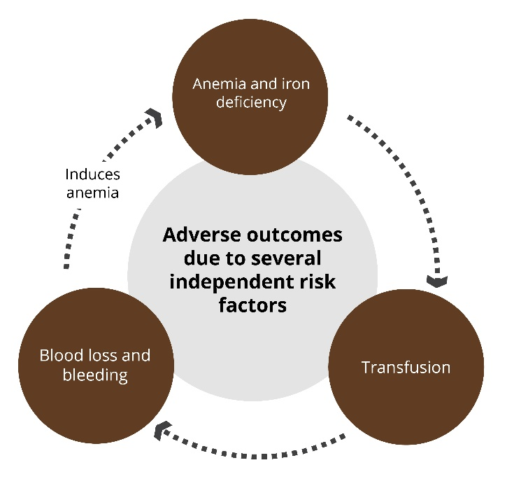

**Figure 3**: Risk factors associated with blood transfusions performed in anemic and iron-deficient patients

*Adapted from*: Farmer SL, Towler SC, Leahy MF, Hofmann A. Drivers for change: Western Australia Patient Blood Management Program (WA PBMP), World Health Assembly (WHA) and Advisory Committee on Blood Safety and Availability (ACBSA). *Best Pract Res Clin Anaesthesiol*. 2013 Mar;27(1):43-58. doi: 10.1016/j.bpa.2012.12.007. PMID: 23590915.

**Table 1**: Transfusion-associated fatalities by complication

|  |  |  |
| --- | --- | --- |
| **Complication** | **Total No.** | **Total %** |
| Anaphylaxis | 14 | 8% |
| Contamination | 25 | 14% |
| HTR (ABO) | 13 | 7% |
| HTR (non- ABO) | 19 | 11% |
| Hypotensive Reaction | 3 | 2% |
| TACO | 58 | 32% |
| TRALI | 46 | 26% |

*Abbreviations*: HTR: Hemolytic transfusion reactions; TACO: Transfusion-associated circulatory overload; TRALI: Transfusion-related acute lung injury.

## Preoperative Anemia: An Independent Risk Factor for Blood Transfusions

The use of allogenic blood products because of preoperative anemia may lead to higher mortality and morbidity in various patient groups (Butcher & Richards, 2018; Marik & Corwin, 2008). Preoperative anemia was independently associated with an increased risk of 30-day morbidity and mortality in patients undergoing major non-cardiac surgery in a study by Musallam et al. (odds ratio [OR] 1.42, 95% CI 1.31-1.54) (Musallam et al., 2011). In another study, 30-day mortality was higher in patients with preoperative anemia (3.2%) than those without preoperative anemia (1.6%, OR unadjusted 1.98, 95% CI: 1.56–2.51, *P*<0.001). Also, preoperatively anemic patients were 21% more likely to develop major morbidity within 30 days than those without preoperative anemia (OR adjusted 1.21, 95% CI: 1.09–1.33) (Tohme, Varley, Landsittel, Chidi, & Tsung, 2016). Thus, allogenic blood transfusion (ABT) is itself considered to be an independent risk factor for poor clinical conditions.

A detailed account of preoperative anemia, bleeding risks and transfusions and resulting complications has been covered in the Clinician Module of this Patient Blood Management Toolkit.

### Burden of Cost of Blood Transfusions in Preoperative Anemia Management

Another huge disadvantage associated with ABTs is the associated high costs. The processing, screening, conservation and distribution costs and administration costs are high. The adverse outcomes, prolonged length of hospital stays, and increased blood transfusion frequency ultimately leads to increased direct and indirect healthcare costs (Baron et al., 2014; Burton et al., 2018). In one study, 945 cardiac surgery patients, the length of ICU stay and total days of hospitalization from surgery to discharge were higher in patients receiving RBC is the first 24 hours postoperatively (Mohnle et al., 2011).

A systematic review estimated the cost of a two-unit packed RBC transfusion in western Europe is around Euros (€) 877.69 (Abraham & Sun, 2012). An estimated blood administration annual cost in United Kingdom National Health Service was found to be exceeding 120 million Pounds (£), excluding the blood products (Stokes et al., 2018).Shander et al. (2010) estimated cost of packed unit of RBCs at four hospitals in United States using activity-based model (ABC) constructed by the Cost of Blood Consensus Conference (COBCON). The total cost per unit was $760.82 ± $293.74 (mean ± standard deviation [SD]), which varied depending on the hospitals participating. Total RBC unit costs were 3.2 to 4.8-folds greater than the cost of blood product acquisition. The acquisition costs only 21-32% of transfusion-related expenditures. Figure 4 shows the total ABC model cost and acquisition cost at each of the four hospitals. This study confirmed that the cost per unit of RBC vary across healthcare settings and geographies (Shander et al., 2010).

**Figure 4**: Mean acquisition costs and total ABC model costs per unit of RBC

*Abbreviations*: EHMC: Englewood Hospital Medical Center; RIH: Rhode Island Hospital; CHUV: Centre Hospitalier Universities Vaudois; AKH: General Hospital Linz.

Another study by Purvis et al analyzed the economics of liberal transfusion (intraoperative hemoglobin [Hb] level: ≥10 g/dL and postoperative Hb level: ≥8 g/dL) in spine surgery patients. The total costs of packed RBC transfusion were estimated to be between $2,268,079 and $7,835,182 in approximately 6.6 years. The overall cost associated with liberal transfusion was between $1,330,439 and $4,596,062 (Purvis et al., 2017).

Blood transfusions constitute the major proportion of expenses in the healthcare system. Improved financing and judicious use of blood components and services is a mandate (Oge, Kilic, & Kilic, 2014). The concept of patient blood management (PBM) was introduced to address the increased incidence of preoperative anemia associated with adverse outcomes, higher occurrence of infections, prolonged hospital stays, increased frequency of blood transfusions, and higher healthcare costs (Baron et al., 2020; Shander et al., 2020). PBM is a new standard of care to significantly improve outcomes and reduce costs.

## Patient Blood Management and its Vision

PBM is a holistic, patient-focused, evidence-based, systematic approach to optimize the management of patients and transfusion of blood in surgical and non-surgical settings (Gombotz, 2012; WHO, 2011b).

The World Health Organization (WHO) defines PBM as an “evidence-based, patient-focused, systematic approach to optimize patient management, transfusion of blood, reduce perioperative blood losses and increase tolerance of physiological anemia” (WHO, 2011a). PBM focuses on a three-pillar strategy (Figure 5) and includes measures to avoid unnecessary blood transfusion (anemia management, cell salvage, anti-fibrinolytic drugs) and ensures that the patients receive optimal treatment and rationalize the judicious use of blood products (M. Murphy & Goodnough, 2015).

**Figure 5**: Three principal foundations or pillars for PBM approach

Thus, contrary to the traditional product-focused approach of Optimal Blood Use program, PBM is a patient-focused approach (Hofmann A et al., 2017). The aim of PBM programs is to promote transfusion guidelines, optimize patient’s Hb and iron levels, and enhance education and awareness regarding restrictive RBC transfusion policy (Revel-Vilk & Naamad, 2018).

## Global Development of Patient Blood Management Program

PBM initiatives across the globe have contributed to good practices to treat anemia, minimize blood loss, and avoid unnecessary transfusions while improving patient outcomes (Desai, Schofield, & Richards, 2018; Leahy et al., 2017)

### Successful PBM Implementation Programs

|  |
| --- |
| * European Union (EU) Optimal Blood Use (EU, 2015) * National project by Italian National Blood Centre and Italian Society of Transfusion Medicine, 2013 (Guerra, Velati, Liumbruno, & Grazzini, 2016) * PBM Guidelines Module 2: Perioperative by Australian National Blood Authority (NBA) (NBA, 2012) * The World Health Organization’s (WHO) global forum for blood safety: March 2011 (WHO, 2011b) * The Ontario Nurse Transfusion Coordinators (ONTraC) blood conservation program (2002-2011) (Freedman, 2014) * Western Australia Department of Health Project - Western Australia Patient Blood Management Program (WA PBMP) in 2008 (Leahy et al., 2017) * Better Blood Transfusion in Scotland * PBM by NHS Blood and Transplant (NHSBT) in England (JPAC) |

### ***Key Performance Indicators*** for ***Successful PBM Programs***

For ensuring a successful implementation and functioning of PBM, monitoring and surveying of evaluation tools or key performance indicators (KPIs) is recommended. EU Optimum Blood Use has included quality (internal and external), structural, process and outcome indicators to evaluate the transfusion practices (EU, 2015). Scotland’s Better Blood Transfusion guidelines performance was assessed based on measures such as staff training, amount of blood transfused and number of transfusions. Later, they employed new methods to evaluate performance based on a matrix scoring system which included training, transfusion incidents and blood wastage (Dalrymple & Watson, 2014).

WA PBMP assessed the impact of PBM program implementation on key outcome measures in four metropolitan tertiary hospitals. They elected 5 primary key program-performance indicators and 4 primary hospital-wide patient outcome measures. Performance indicators selected included:

* Mean RBC, fresh frozen plasma (FFP), and platelet units transfused per patient discharge
* Mean Hb before transfusion
* Number of single-unit RBC transfused
* Proportion of preoperative anemia patients (Hb levels: Males: <13.0 g/dL; Females: <12.0 g/dL)
* Acquisition cost of blood products

The key hospital-wide patient outcome measures were:

* In-hospital mortality
* Length of stay
* All-cause, 28-day readmissions
* Hospital-acquired infections

WA PBMP implementation in four adult public tertiary hospitals was found to be associated with significant reductions in mortality, length of stays, transfusion of RBC, FFP, and platelet, considerable product-acquisition and estimated activity-based transfusion cost savings, and an increase in all-cause emergency readmissions (Leahy et al., 2017).

## Important Elements to Optimize Patient Blood Management

The key components for a well-functioning health system are: (WHO, 2010)

* + - Improving health status at individual, family, and community level
    - Protecting the people against health threatening issues
    - Safeguarding people against the economic consequences of ill-condition
    - Providing unbiased access to people-centric care

## Cost-effectiveness of PBM Implementation in Clinical Settings

PBM implementation has successfully shown to reduce transfusions while maintaining or even improving patient outcomes in surgical as well as non-surgical settings (Franchini et al., 2019). In an orthopedic unit of a private metropolitan hospital, PBM resulted in improved preoperative assessment, increased administration of iron infusions for severely iron deficient anemia (IDA) patients and decreased unnecessary blood transfusions (pre-implementation: 9.2%, and post-implementation: 2.3%, P<0.001) (Morgan et al., 2018).

Blood transfusions can influence hospital costs and are independently associated with higher or additional charges. These costs are dose dependent (each unit is associated with higher hospital costs). Studies and reports imply that implementing PBM strategy can result into substantial reduction in transfusions and related costs (Althoff et al., 2019; Kaserer et al., 2019; Shander et al., 2010; Trentino et al., 2015). The PBM monitoring and feedback program at the University Hospital of Zurich, Switzerland showed successful reduction in the transfusion of allogeneic blood products and transfusion-related costs, without compromising the patient outcomes (Mehra et al., 2015).

# Models for PBM Implementation

## Donabedian Model: Identifying Gaps and Ensuring PBM

Donabedian quality framework is a quality improvement model used in public healthcare settings, and is based on three approaches namely, structure, process, and outcome (Figure 6). Donabedian model refers outcomes as ‘ultimate validators’ as they determine the effectiveness and quality of healthcare, and process as measures of quality (NHS). For a patient-centric health system, the quality of outcome should define the quality of structure and process (Hofmann A et al., 2017).

**Figure 6**: The Donabedian model for quality of care

Application of the Donabedian framework can help identify gaps and areas of improvement that may limit the establishment of PBM as standard of care. These may include lack of awareness and/or education in the stakeholders, professionals or patients, lack of information about the risks involved with anemia, bleeding disorders, etc., lack of prioritizing the PBM implementation, uncoordinated patient care, lack of a proper PBM benchmarking, analytics, and reporting system, and so on. Figure 7 gives the essentials of a quality framework (Hofmann A et al., 2017).

**Figure 7**: Quality framework for PBM implementation process

## WHO Europe’s Scheme of Essential Public Health Operations

The WHO Europe’s Scheme of Essential Public Health (EPHO) is a structural framework for disseminating and implementing PBM initiated by WHO Regional Committee for Europe to strengthen the Public Health Capacities and Services and its accompanying resolutions (WHO, 2012). It includes 10 essential operations that intends to assist European Member States in strengthening their public health capacities and services and propagating and implementing PBM in Europe (Figure 8). These operations are majorly based on three areas: health protection, disease prevention, and health promotion (WHO).

.

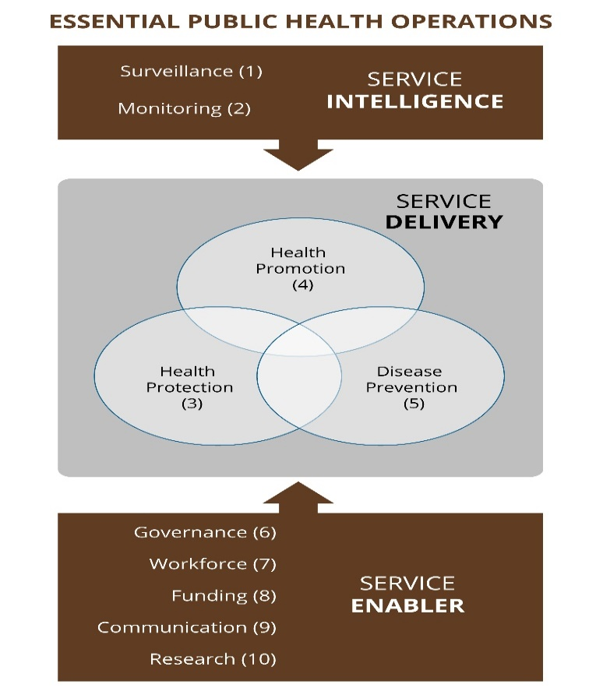

**Figure 8**: Ten essential and core public health operations as observed by the WHO

*Adapted from*: Joanna N. The European Action Plan for Strengthening Public Health, WHO Regional Office for Europe - Health Promoting Networks 2012, Available from: <http://slideplayer.com/slide/2520311/>.

# Health Economic Models for PBM Implementation: A Cost-benefit Analysis

Health economic models are being developed and used to evaluate the cost-effectiveness of PBM. In a recent systemic review and meta-analysis, PBM implementation was reported to be associated with reduced RBC use and length of stay. Mean cost for transfusion per patient reduced from € 68.62 (Pre-PBM) to €32.41 (Post-PBM) (savings: €36.21). Overall savings accounted to €150.64 per patient. The Monte Carlo simulation (repeated random sampling for calculation) demonstrated distribution of cost-savings from € -253.01 to € -31.46 and a mean value of € -150.63 (95% CI: -200.75; -100.45). In this simulation, the total cost savings were € 1,878,000 in 100,000 simulated patients (Meybohm et al., 2020).

Kleinerüschkamp et al. performed a cost-analysis to assess the clinical and economic impact of PBM implementation. In the simulation model comprising of 10,000 patients, PBM, including restrictive transfusion strategy, was related to reduced total complication rate and deaths in both non-cardiac (17.68% and 4.11% deaths, respectively) and cardiac surgery (12.45% and 3.04%, respectively) patients. Cost-savings per avoided complication were € 16,318.79 for non-cardiac and €14,139.04 for cardiac surgery patients (Kleineruschkamp, Meybohm, Straub, Zacharowski, & Choorapoikayil, 2019). In other study by Munoz et al., a cost-analysis in 182 patients with total lower limb arthroplasty revealed reduced transfusion and no incremental costs (Munoz et al., 2014). Tranexamic acid administration was associated with reduced blood transfusions in 198 patients undergoing arthroplasty interventions and reduced costs (mean savings: €138 per patient).

PBM program introduction in Western Australia reported 41% reduction in blood products utilization and decrease in in-hospital mortality (28%; P <0.001), mean length of stay (15%; P <0.001). Product-acquisition cost savings accounted to Australian Dollar, AUD 18.5 million (Leahy et al., 2017).

# Building a Business Case for Implementing a Successful PBM Program ([Derderian, 2004](#_ENREF_9" \o "Derderian, 2004 #1), AABB, 2015)

A business model or case is a tool to design a plan that enlists limitations and important operational parameters for a business plan. A well-crafted business plan is a fundamental step to build an interdepartmental consensus around the goals of a program, for clinical staff to advocate improved transfusion-related quality of care and patient safety, and to evaluate potential financial benefits.

A business case focuses on five key requirements:

* Introduction to PBM
* Rationale for PBM
* Need of education (key stakeholders)
* Actions required
* Associated costs and benefits

A business plan should be a written proposal including an introduction, purpose, objectives or benefits, approach and alternatives, performance measures, a risk-benefit profiling an operations plan, and financial analysis.

## Introduction

An introduction in the preliminary proposal includes the history of blood transfusion and its efficacy and discussion on current trends.

## Mission Statement/Business Purpose

A program statement is directly tied to the issues, needs and opportunities. PBM is defined both for in-hospital blood conservation as well as a marketing tool for the public. A model introduction should define blood conservation from patient’s care perspectives and needs. It addresses the basic requirements of the program including capital and noncapital expenses, educational needs, and administrative support.

## Objectives/Benefits

The objectives of any plan should define detailed, quantifiable goals for the program. It should include the baseline data, current gaps and situation, targets, medical records and review, benchmarking data (internal and external), inventories, billing and budgeting, morbidity and mortality data and statements from key stakeholders.

## Preferred Approach and Alternate Solutions

This part of the business model should include the predefined best suitable solution and approaches to meet the objectives. Alternative approaches along with discussion on why the selected solution is preferred can also be defined to bring in reasonable objections from their analysis and assessments.

## Performance and Progress Measures

Certain measurable improvements and their evaluation in the model stage can disclose PBM shortcomings and identify prospects for savings. Thus, metrics to measure the program performance should be defined under this section. Important PBM metrics may include:

* + - Overall transfusion rate compared to that of other hospitals
    - Transfusion rates in specific cases/surgeries compared to data from literature
    - Record of transfusions outside of hospital or professional transfusion recommendations
    - Transfusion administration compliance
    - Transfusion adverse reaction rates
    - Budget (inventory, supply costs, etc.)

## Risks Involved and Mitigation

Risk and benefits analysis evaluate risks and potential challenges in the implementation of the program. Programs like PBM yield a net positive effect on the cost returns as well as improved patient outcomes but may have few risks associated with them. This can include alienation of members of staff involved, non or underperformance of key stakeholders or other failures. SWOT analysis (Strengths, Weaknesses, Opportunities and Threats) can identify implementation risks involved and help develop reasonable mechanisms to mitigate the challenges with support from internal stakeholders.

## Operational Plan and Timelines

A formal program plan should enlist major activities, required staff resources and an estimated timeline with important milestones for the deliverables stated. The timelines are the expected time needed to implement a PBM program and can be represented using Gantt charts (bar charts). Additionally, this process will require a quality staff who are experts in project management, know the design and can help in identifying required data for a successful business case.

The other crucial step involves defining roles and laying out the starting and the endpoints for the program. Table 2 illustrates the layout of a formal operation plan for a hospital’s PBM program.

**Table 2**: Operations plan for a hospital blood conservation program

|  |
| --- |
| **Program Development:**   * Development of policies and procedure for nursing and medical staff * Delineation of treatment protocols and QA assessment * Determination of physician participation   + Meeting with key interested members of the staff to establish the program (buy in)   + Develop a staff work group   + Develop program structure with staff assistance   + Evaluation of compliance * Evaluate blood utilization data   **Development of educational strategies:**   * Introduce the concept of the program to the staff and trainees * Introduce the concept to the nursing and ancillary staff * Use advanced educational strategies to enhance the function of the program |

## Financial analysis and Funding Sources

Financial analysis or a detailed program budget is a fundamental aspect of a formal business case that involves defining the cost estimates and funding sources. It should identify budget that comprises of initial project costs (salaries, equipment needs and any resources) and ongoing project costs. Essentially, this is performed by a finance expertise or internal finance support team.

PBM-related cost savings should be estimated and can be categorized as hard or soft. The preference is to use historical trends in blood utilization, cost of purchase of blood and blood products, and costs required to prepare blood products for transfusion. Capital and noncapital costs can then be used to extrapolate different scenarios.

Finding resources to fund the program is challenging due to limited hospital and healthcare resources. Alternative funding sources should be considered to initiate a program. PBM program may result into cost savings but starting one needs an initial small investment. Return on investment (ROI), a calculator to evaluate efficiency of an investment, is used in order to evaluate the program’s efficiency.

The ROI thresholds are used by hospitals for evaluating program investments and returns.

## Transfusion Economics

Transfusion-associated costs include the cost of labor, processing and supplies for storage, testing, administering, and monitoring blood products. These are the direct variable costs which can be quantified.

The bulk of transfusion economics other than analysis of all direct and indirect overhead costs of blood transfusions includes adverse event costs that cover hospital-acquired infections, increased length of stay, and transfusion-related acute lung injury (TRALI). Cost of adverse events can increase drastically but can be avoided by practicing safer transfusion.

# Implementation Plan of a Blood Conservation Program

After the discussion and decision to implement a program, a detailed implementation plan needs to be structured. This encompasses significant endpoints such as decrease in transfusion rates, adherence to recognized guidelines, total number of participants, etc. An implementation plan is represented in form of goals— short, medium, and long-term (Figure 9).

**Figure 9**: Short-, medium-, and long-term goals for PBM implementation

# Practical Development of a Hospital Level Blood-Management Program

Figure 10 presents the practical simulation algorithm for the implementation of an in-hospital PBM program with all the dimensions and teams involved.



**Figure 10**: In-hospital structure for blood conservation management

Source: Tokin, C., Almeda, J., Jain, S., Kim, J., Henderson, R., Nadim, M., Selby, R. R. (2009). Blood-management programs: a clinical and administrative model with program implementation strategies. *Perm J, 13*(1), 18-28. doi:10.7812/tpp/08-029 (Tokin et al., 2009)

## Development of PBM Reimbursement Schemes

The PBM treatment approach is generally for the hospitalized patients and the related costs are covered or reimbursed by the public health insurance system. Some PBM modalities may pose certain restrictions around adequate reimbursements in some health systems. For instance, management of preoperative anemia is planned several days prior to the intended elective surgery. However, any treatment or measure performed prior to several days before actual hospitalization may not be covered under the reimbursement plan by the public health insurance. Thus, to overcome this disparity, all PBM services should be integrated with appropriate reimbursement schemes. the responsibility of planning and managing these financial requirements is carried out by the task force under the guidance and supervision of PBM Steering Committee including clinical experts, hospital administrators and public health insurance party (Hofmann A et al., 2017; Shander et al., 2012).

# Conclusion

Blood transfusions have been extensively used but limited availability of blood, associated complications such as increased morbidity, mortality, length of hospital stay, and high costs are the major concerns. Health-system-wide PBM implementation is considered to be a new holistic tool for improved standard of care to significantly contribute to improved clinical outcomes and reduced expenses. Several global health systems have implied successful PBM programs to shift the focus of transfusion medicine from blood products to patients.

This Business Module summarizes the key elements and models crucial for implementation and performance of PBM programs. It entails the requirements of a successful business case proposal and implementation plans.

PBM success is subject to continuous evolution and further randomized controlled trials are required to optimize and support the PBM approach in both surgical and non-surgical patients.

# References

Abraham, I., & Sun, D. (2012). The cost of blood transfusion in Western Europe as estimated from six studies. *Transfusion, 52*(9), 1983-1988. doi:10.1111/j.1537-2995.2011.03532.x

Althoff, F. C., Neb, H., Herrmann, E., Trentino, K. M., Vernich, L., Fullenbach, C., . . . Choorapoikayil, S. (2019). Multimodal Patient Blood Management Program Based on a Three-pillar Strategy: A Systematic Review and Meta-analysis. *Ann Surg, 269*(5), 794-804. doi:10.1097/SLA.0000000000003095

Baron, D. M., Franchini, M., Goobie, S. M., Javidroozi, M., Klein, A. A., Lasocki, S., . . . Meybohm, P. (2020). Patient blood management during the COVID-19 pandemic: a narrative review. *Anaesthesia*. doi:10.1111/anae.15095

Baron, D. M., Hochrieser, H., Posch, M., Metnitz, B., Rhodes, A., Moreno, R. P., . . . European Society of, A. (2014). Preoperative anaemia is associated with poor clinical outcome in non-cardiac surgery patients. *Br J Anaesth, 113*(3), 416-423. doi:10.1093/bja/aeu098

Benatar, S. R., Gill, S., & Bakker, I. (2011). Global health and the global economic crisis. *Am J Public Health, 101*(4), 646-653. doi:10.2105/AJPH.2009.188458

Bernard, A. C., Davenport, D. L., Chang, P. K., Vaughan, T. B., & Zwischenberger, J. B. (2009). Intraoperative transfusion of 1 U to 2 U packed red blood cells is associated with increased 30-day mortality, surgical-site infection, pneumonia, and sepsis in general surgery patients. *J Am Coll Surg, 208*(5), 931-937, 937 e931-932; discussion 938-939. doi:10.1016/j.jamcollsurg.2008.11.019

Burton, B. N., Alison, M., Brovman, E. Y., Scott, M. J., Urman, R. D., & Gabriel, R. A. (2018). Optimizing Preoperative Anemia to Improve Patient Outcomes. *Anesthesiology clinics, 36*(4), 701-713.

Butcher, A., & Richards, T. (2018). Cornerstones of patient blood management in surgery. *Transfus Med, 28*(2), 150-157. doi:10.1111/tme.12476

Dalrymple, K., & Watson, D. (2014). Ten years of transfusion practitioners and better blood transfusion in Scotland. *Nurs Manag (Harrow), 20*(10), 27-30. doi:10.7748/nm2014.02.20.10.27.e1147

Desai, N., Schofield, N., & Richards, T. (2018). Perioperative Patient Blood Management to Improve Outcomes. *Anesth Analg, 127*(5), 1211-1220. doi:10.1213/ANE.0000000000002549

EU. (2015). Optimal Blood Use Promoting and sharing best practice across the EU. Retrieved from <http://www.optimalblooduse.eu/> [Accessed on March 04, 2020]

Food and Drug Administration. (2018). Fatalities Reported to FDA Following Blood Collection and Transfusion, 2018 Annual Summary. Retrieved from <https://www.fda.gov/media/136907/download>. Accessed February 09, 2021

Franchini, M., Marano, G., Veropalumbo, E., Masiello, F., Pati, I., Candura, F., . . . Liumbruno, G. M. (2019). Patient Blood Management: a revolutionary approach to transfusion medicine. *Blood Transfus, 17*(3), 191-195. doi:10.2450/2019.0109-19

Freedman, J. (2014). The ONTraC Ontario program in blood conservation. *Transfus Apher Sci, 50*(1), 32-36. doi:10.1016/j.transci.2013.12.010

Gombotz, H. (2012). Patient Blood Management: A Patient-Orientated Approach to Blood Replacement with the Goal of Reducing Anemia, Blood Loss and the Need for Blood Transfusion in Elective Surgery. *Transfus Med Hemother, 39*(2), 67-72. doi:10.1159/000337183

Guerra, R., Velati, C., Liumbruno, G. M., & Grazzini, G. (2016). Patient Blood Management in Italy. *Blood Transfus, 14*(1), 1-2. doi:10.2450/2015.0171-15

Hofmann A, Nørgaard A, Kurz J, Choorapoikayil S, Meybohm P, Zacharowski K, . . . Gombotz H. (2017). *Building national programmes of Patient Blood Management (PBM) in the EU. A Guide for Health Authorities*. European Commission Retrieved from <https://op.europa.eu/en/publication-detail/-/publication/5ec54745-1a8c-11e7-808e-01aa75ed71a1/language-en>

JPAC. Patient Blood Management. Retrieved from <https://www.transfusionguidelines.org/uk-transfusion-committees/national-blood-transfusion-committee/patient-blood-management> [Accessed on March 04, 2020]

Kaserer, A., Rossler, J., Braun, J., Farokhzad, F., Pape, H. C., Dutkowski, P., . . . Spahn, D. R. (2019). Impact of a Patient Blood Management monitoring and feedback programme on allogeneic blood transfusions and related costs. *Anaesthesia, 74*(12), 1534-1541. doi:10.1111/anae.14816

Kleineruschkamp, A., Meybohm, P., Straub, N., Zacharowski, K., & Choorapoikayil, S. (2019). A model-based cost-effectiveness analysis of Patient Blood Management. *Blood Transfus, 17*(1), 16-26. doi:10.2450/2018.0213-17

Kohane, I. S., Drazen, J. M., & Campion, E. W. (2012). A glimpse of the next 100 years in medicine. *N Engl J Med, 367*(26), 2538-2539. doi:10.1056/NEJMe1213371

Leahy, M. F., Hofmann, A., Towler, S., Trentino, K. M., Burrows, S. A., Swain, S. G., . . . Farmer, S. L. (2017). Improved outcomes and reduced costs associated with a health-system-wide patient blood management program: a retrospective observational study in four major adult tertiary-care hospitals. *Transfusion, 57*(6), 1347-1358. doi:10.1111/trf.14006

Marik, P. E., & Corwin, H. L. (2008). Efficacy of red blood cell transfusion in the critically ill: a systematic review of the literature. *Crit Care Med, 36*(9), 2667-2674. doi:10.1097/CCM.0b013e3181844677

Mehra, T., Seifert, B., Bravo-Reiter, S., Wanner, G., Dutkowski, P., Holubec, T., . . . Spahn, D. R. (2015). Implementation of a patient blood management monitoring and feedback program significantly reduces transfusions and costs. *Transfusion, 55*(12), 2807-2815. doi:10.1111/trf.13260

Meybohm, P., Straub, N., Fullenbach, C., Judd, L., Kleineruschkamp, A., Taeuber, I., . . . Choorapoikayil, S. (2020). Health economics of Patient Blood Management: a cost-benefit analysis based on a meta-analysis. *Vox Sang, 115*(2), 182-188. doi:10.1111/vox.12873

Mohnle, P., Snyder-Ramos, S. A., Miao, Y., Kulier, A., Bottiger, B. W., Levin, J., . . . Multicenter Study of Perioperative Ischemia Research, G. (2011). Postoperative red blood cell transfusion and morbid outcome in uncomplicated cardiac surgery patients. *Intensive Care Med, 37*(1), 97-109. doi:10.1007/s00134-010-2017-z

Morgan, P. N., Coleman, P. L., Martinez-Garduno, C. M., Gunaratne, A. W., McInnes, E., & Middleton, S. (2018). Implementation of a patient blood management program in an Australian private hospital orthopedic unit. *J Blood Med, 9*, 83-90. doi:10.2147/JBM.S157571

Munoz, M., Gomez-Ramirez, S., Martin-Montanez, E., Naveira, E., Seara, J., & Pavia, J. (2014). Cost of post-operative intravenous iron therapy in total lower limb arthroplasty: a retrospective, matched cohort study. *Blood Transfus, 12*(1), 40-49. doi:10.2450/2013.0088-13

Murphy, G. J., Reeves, B. C., Rogers, C. A., Rizvi, S. I., Culliford, L., & Angelini, G. D. (2007). Increased mortality, postoperative morbidity, and cost after red blood cell transfusion in patients having cardiac surgery. *Circulation, 116*(22), 2544-2552. doi:10.1161/CIRCULATIONAHA.107.698977

Murphy, M., & Goodnough, L. (2015). The scientific basis for patient blood management. *Transfus Clin Biol, 22*(3), 90-96. doi:10.1016/j.tracli.2015.04.001

Musallam, K. M., Tamim, H. M., Richards, T., Spahn, D. R., Rosendaal, F. R., Habbal, A., . . . Jamali, F. R. (2011). Preoperative anaemia and postoperative outcomes in non-cardiac surgery: a retrospective cohort study. *Lancet, 378*(9800), 1396-1407. doi:10.1016/S0140-6736(11)61381-0

NBA. (2012). Patient blood management guidelines: module 2: perioperative. *Canberra, Australia: National Blood Authority (NBA)*. Retrieved from <https://www.blood.gov.au/system/files/documents/pbm-module-2.pdf> [Accessed on March 03. 2020]

NHS. *Quality, Service Improvement and Redesign Tools: A model for measuring quality care*. Retrieved from <https://improvement.nhs.uk/documents/2135/measuring-quality-care-model.pdf>. Accessed February 11, 2021.

OECD. (2020). Health expenditure and financing. Retrieved from <https://stats.oecd.org/Index.aspx?DataSetCode=SHA>. Accessed February 09, 2021.

Oge, T., Kilic, C. H., & Kilic, G. S. (2014). Economic impact of blood transfusions: balancing cost and benefits. *Eurasian J Med, 46*(1), 47-49. doi:10.5152/eajm.2014.08

Purvis, T. E., Goodwin, C. R., De la Garza-Ramos, R., Ahmed, A. K., Lafage, V., Neuman, B. J., . . . Sciubba, D. M. (2017). Effect of liberal blood transfusion on clinical outcomes and cost in spine surgery patients. *Spine J, 17*(9), 1255-1263. doi:10.1016/j.spinee.2017.04.028

Revel-Vilk, S., & Naamad, M. (2018). Patient blood management programs: how to spread the word? *Isr J Health Policy Res, 7*(1), 8. doi:10.1186/s13584-018-0204-5

Shander, A., Goobie, S. M., Warner, M. A., Aapro, M., Bisbe, E., Perez-Calatayud, A. A., . . . Society for the Advancement of Blood Management Work, G. (2020). Essential Role of Patient Blood Management in a Pandemic: A Call for Action. *Anesth Analg, 131*(1), 74-85. doi:10.1213/ANE.0000000000004844

Shander, A., Hofmann, A., Ozawa, S., Theusinger, O. M., Gombotz, H., & Spahn, D. R. (2010). Activity-based costs of blood transfusions in surgical patients at four hospitals. *Transfusion, 50*(4), 753-765. doi:10.1111/j.1537-2995.2009.02518.x

Shander, A., Van Aken, H., Colomina, M. J., Gombotz, H., Hofmann, A., Krauspe, R., . . . Spahn, D. R. (2012). Patient blood management in Europe. *Br J Anaesth, 109*(1), 55-68. doi:10.1093/bja/aes139

Stokes, E. A., Wordsworth, S., Staves, J., Mundy, N., Skelly, J., Radford, K., & Stanworth, S. J. (2018). Accurate costs of blood transfusion: a microcosting of administering blood products in the United Kingdom National Health Service. *Transfusion, 58*(4), 846-853. doi:10.1111/trf.14493

The Economist Intelligence Unit. (2020). *Covid-19: the impact on healthcare expenditure*. Retrieved from <https://www.eiu.com/n/campaigns/covid-19-the-impact-on-healthcare-expenditure/>. Accessed March 15, 2021.

Tohme, S., Varley, P. R., Landsittel, D. P., Chidi, A. P., & Tsung, A. (2016). Preoperative anemia and postoperative outcomes after hepatectomy. *HPB (Oxford), 18*(3), 255-261. doi:10.1016/j.hpb.2015.09.002

Tokin, C., Almeda, J., Jain, S., Kim, J., Henderson, R., Nadim, M., . . . Selby, R. R. (2009). Blood-management programs: a clinical and administrative model with program implementation strategies. *Perm J, 13*(1), 18-28. doi:10.7812/tpp/08-029

Trentino, K. M., Farmer, S. L., Swain, S. G., Burrows, S. A., Hofmann, A., Ienco, R., . . . Leahy, M. F. (2015). Increased hospital costs associated with red blood cell transfusion. *Transfusion, 55*(5), 1082-1089. doi:10.1111/trf.12958

WHO. The 10 Essential Public Health Operations. Retrieved from <https://www.euro.who.int/en/health-topics/Health-systems/public-health-services/policy/the-10-essential-public-health-operations>. Accessed March 01, 2021.

WHO. (2010). *Key components of a well functioning health system*. Retrieved from <https://www.who.int/healthsystems/EN_HSSkeycomponents.pdf?ua=1>. Accessed February 11, 2021.

WHO. (2011a). WHO Global Forum for Blood Safety: patient blood management. . Retrieved from <https://www.who.int/11bloodsafety/events/gfbs_01_pbm/en/> [Accessed on February 22, 2021]

WHO. (2011b). World Health Organization- Global Forum for Blood Safety: patient Blood Management- Concept paper. Retrieved from <http://www.who.int/bloodsafety/events/gfbs_01_pbm_concept_paper.pdf> [Accessed on February 28, 2020]

WHO. ( 2012). *EUR/RC62/R4 Health 2020 – The European policy framework for health and well-being, WHO Regional Office for Europe*. Retrieved from <https://www.euro.who.int/en/about-us/governance/regional-committee-for-europe/past-sessions/sixty-second-session/documentation/resolutions-and-decisions/eurrc62r4-health-2020-the-european-policy-framework-for-health-and-well-being>. Accessed March 01, 2020.

Yaddanapudi, S., & Yaddanapudi, L. (2014). Indications for blood and blood product transfusion. *Indian J Anaesth, 58*(5), 538-542. doi:10.4103/0019-5049.144648

*©2021*

*Zuellig Pharma*

**The Blueprint for Change Resource**

The Blueprint for Change Resource is a series of modules for developing a keen understanding of Patient Blood Management (PBM) needed for its implementation. Speaking to the multidisciplinary nature of PBM, modules for Clinicians, Operations, Business and Patients are developed based on extensive literature research and successful programs implemented globally. The Blueprint for Change resource seeks to strengthen the link between understanding the clinical evidence and implementation, highlight sustainable successes, and explore challenges ahead and ways to improve.

GET IN TOUCH

**Dr Nicholas Lim**

Regional Medical Manager (Asia)

ZP Therapeutics, a division of Zuellig Pharma

[nlimry@zuelligpharma.com](mailto:nlimry@zuelligpharma.com)