The **Blueprint for Change**

Resource



**Partnering to implement**

**Patient Blood Management**

**Module 3: Patient module**

Implementation of patient blood management can improve patient safety and outcomes and enhance the hospital’s reputation as one of excellence in standard of care.

**Patient Blood Management Toolkit**

**Patient-specific Module**

Table of Contents

1. Introduction 2

2. What is PBM? Why PBM? 2

3. How do PBM programs conserve blood? 4

3.1 Adopting restrictive transfusion strategy 4

3.2 Avoiding unnecessary transfusions 6

3.3 Promoting awareness of other alternatives 7

4. Action plan of PBM to enhance red blood cell production and minimize blood loss 9

4.1 Prime role of blood in our body 9

4.2 Strategies to increase red blood cell production 10

5. Role of patients in PBM 13

5.1 An ideal PBM team 14

5.2 Current and future roles of patients and patient organizations in PBM 15

6. Hospital accreditation to enhance patient safety 18

6.1 AABB-Joint Commission International (JCI) PBM certification 18

6.2 Society for the Advancement of Blood Management (SABM) PBM accreditation 19

6.3 Advantages of accrediting hospitals 19

7. Strategies for blood management plan 20

8. PBM education and awareness 22

8.1 Initiatives to promote PBM awareness 23

8.2 Creating awareness on: 24

9. Take-away points! 26

10. References: 27

# Introduction

The Patient Module is one of the four modules of the Patient Blood Management (PBM) Toolkit. This module is patient-specific and discusses the following: 1) What is PBM and how it exemplifies the patient-centered clinical decision-making process, 2) how transfusion-associated risks can be circumvented to improve a patient’s safety and well-being, and 3) the role of a patient as part of a hospital PBM implementation program m. At the end of this module, patients and their caregivers would know if and when transfusion is required for their treatment and how to approach for the PBM program.

# What is PBM? Why PBM?

A PBM program is a team-based, patient-centric approach that can assess blood management needs by detecting patients at risk of transfusion and providing them with an alternative to reduce or eliminate the need for transfusion (A. Thomson, 2009; Bolcato, Russo, Rodriguez, & Aprile, 2020; "A Patient's Guide to Patient Blood Management," 2019).

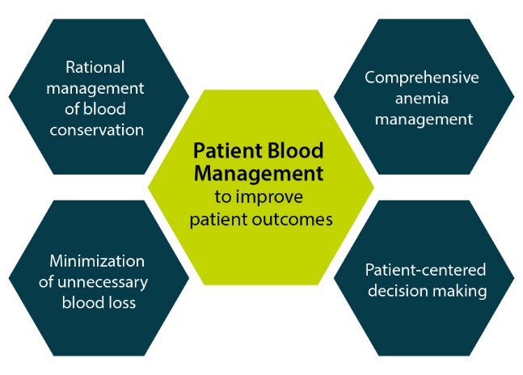

**Figure 1: Improved patient outcomes using PBM**

According to the Society for the Advancement of Blood Management (SABM), PBM adopts evidence-based medical and surgical techniques to improve patient outcomes by minimizing anemia, decrease bleeding and avoiding the need for unnecessary transfusions (Figure 1, Figure 2) (Bolcato et al., 2020; "SABM Adminstrative and Clinical Standards for Patient Blood Management Programs,").

**Figure 2: Main pillars of PBM**

Advantages of PBM

PBM programs are exceptional in improving patient’s clinical outcomes (Franchini et al., 2019). PBM can

* Improve patient safety by minimizing exposure to blood ("A Patient's Guide to Patient Blood Management," 2019)
* Minimize risk of exposure to viruses and other blood-borne diseases ("A Patient's Guide to Patient Blood Management," 2019)
* Decrease the risk of hospital-acquired complications and infections (Moskowitz et al., 2010; "A Patient's Guide to Patient Blood Management," 2019; Shander, Isbister, & Gombotz, 2016)
* Decreased the rate of death occurrence (Althoff et al., 2019; Farmer L.S, 2015)
* Reduce length of hospital stay (Althoff et al., 2019; Farmer L.S, 2015; "A Patient's Guide to Patient Blood Management," 2019)
* Reduce cost compared to transfusion (Althoff et al., 2019; Basora, Pereira, Coca, Tio, & Lozano, 2018; Farmer L.S, 2015; Mehra et al., 2015)
* Promote improved outcomes ("A Patient's Guide to Patient Blood Management," 2019)
* Enhance quality of life and well-being ("A Patient's Guide to Patient Blood Management," 2019)

# How do PBM programs conserve blood?

Blood transfusions are quite common and were ranked by the Joint Commission (in 2012) as one of the top-five overused procedures, with well-published concerns regarding its high cost and risks involved (A. Thomson, 2009; "Joint Commission T, American Medical Association-Convened Physician Consortium for Performance Improvement:Proceedings from the National Summit on Overuse: September 24, 2012.,"). Early blood conservation programs focused in limiting the use and need for blood transfusions in all at-risk patients. Later, PBM programs evolved this concept from just “conservation” to better “management of patient blood”(Shander et al., 2016).

## Adopting restrictive transfusion strategy

Blood transfusion can be classified into liberal transfusion and restrictive transfusion (Figure 3) (Jeffrey L Carson et al., 2015).

**Figure 3: Types of blood transfusion**

One of the prime objectives of a PBM program is to preserve the patient’s red blood cell (RBC) mass so as to allow for a restrictive transfusion strategy (Franchini et al., 2019). Several studies have shown that there is little or no benefit of a liberal transfusion strategy over restrictive transfusion strategy. In fact, some studies have shown that restrictive transfusion can lead to similar or improved outcomes when compared to liberal transfusion strategy (Table 1, see also section 2.2.3.3. of clinician module) (J. L. Carson, Stanworth, et al., 2016; Hirano, Miyoshi, Kondo, Okamoto, & Tanaka, 2019; Kashani et al., 2020; Palmieri et al., 2019; Rohde et al., 2014; Salpeter, Buckley, & Chatterjee, 2014).

**Table 1: Summary of the list of outcomes observed in various studies comparing restrictive with liberal transfusion strategy**

|  |
| --- |
| Reduced exposure to unnecessary blood transfusions and associated harmful effects |
| Low rates of re-bleeding events |
| Decrease in number of hospitalization days, hence reducing cost |
| Reduced risk of in-hospital and total deaths |

(For a detailed information on liberal vs restrictive transfusion, please refer the section 2.2.3.3 in the clinician module.)

### Guidelines for blood transfusion

Restrictive transfusion strategy is recommended in hemodynamically stable critically ill patients with absence of comorbidities such as acute myocardial infarction or myocardial ischemia that might affect the decision otherwise (Shander, Javidroozi, & Lobel, 2017).

**Table 2: Summary of some of the blood transfusion guidelines**

|  |  |
| --- | --- |
| International organization/ association | Recommendations |
| American Society of Hematology (ASH) | * For non-cardiac patients (in whom transfusion is necessary), transfusion should be limited to minimum number of units until the anemia symptoms are resolved or the hemoglobin level reaches 7-8 gm/dl (Hicks et al., 2013). |
| American Association of Blood Banks (AABB) | * For hospitalized adult patients who are hemodynamically stable, including critically ill patients, transfusion is not recommended until the hemoglobin concentration is 7 g/dL (J. L. Carson, Guyatt, et al., 2016) * For patients undergoing orthopedic surgery, cardiac surgery, and those with pre-existing cardiovascular disease, a restrictive transfusion threshold of 8 g/dL is recommended. (J. L. Carson, Guyatt, et al., 2016) |
| UK National Clinical Guideline Centre guidelines | * For chronic anemic patients in need of regular transfusions, set individual thresholds and hemoglobin concentration targets ("National Institute for Clinical Excellence guidelines - Blood Transfusion,"). |

## Avoiding unnecessary transfusions

PBM programs provide clinical decision support and aim to avoid unnecessary transfusions. An initiative of PBM - “Why Give 2 When 1 Will Do?” campaign promotes single-unit blood cell transfusions in stable patients (Figure 4). 

**Figure 4: Motto of a PBM initiated campaign**

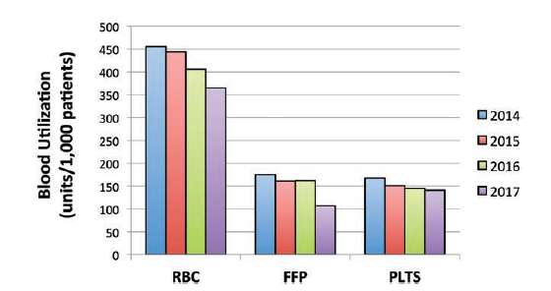A PBM program at the John Hopkins Hospital, USA was launched in January 2012. The study utilized the health system-wide PBM across the five hospitals under the John Hopkins Health System with a “clinical community” objective. By April 2015, this health system-wide PBM program introduced the “Why Give Two When One Will Do?” campaign aimed to minimize the multiple-unit packed red blood cell (RBC) transfusion orders within the five hospitals examined. A dip in the number of transfusion units per 1000 patients for RBC (by 19.8%), plasma (by 38.9%), and platelet (by15.6%) were observed between 2014-2017 (Figure 5) . Additionally, the PBM approach rewarded an annualized cost savings for 2017 (worth $2,120,273/year) compared to 2014 (Frank et al., 2017).

**Figure 5: Transfusion unit utilization trends (per 1,000 patients) during 2014-2017**

## Promoting awareness of other alternatives

This includes educating the public on concepts of PBM so that patients can make effective treatment choice by seeking treatment options without transfusion (Gombotz, Hofmann, Norgaard, & Kastner, 2017; "A Patient's Guide to Patient Blood Management," 2019).The PBM guiding materials can be physician oriented (Fischer et al., 2015). A study launched PBM in a hospital for the first-time by adopting techniques such as (Yang, Thakkar, Gehrie, Chen, & Frank, 2017)

* Articles related to PBM launch were circulated in health system newsletters.
* Screen-saver messages on hospital workstation computers promoting the use of single-transfusion policy for non-bleeding individuals who are hemodynamically stable.
* Sharing “report cards” with all physicians every quarter which records the rate of single unit or multiple units of RBC orders and the frequency of orders in patients with an earlier Hb levels of less than 8 g/dl.
* Pop-up alert while administering RBC transfusion in case the previous Hb concentration was ≥ 7 g/dl to ensure safety practice.

In addition, PBM programs must include educating the patients with ample information on advantages/disadvantages of blood transfusion (Pourfathollah, Karimi, Namini, Darestani, & Dehshal, 2019), and other alternatives and explanation of restrictive policy (Meybohm et al., 2017) so that patients can make an informed decision.

Involving patients in shared decision making regarding their own treatment choices often results in better patient satisfaction and health outcomes. Shared decision making for transfusion is an addition to an ‘informed consent’ concept (Figure 6). As shared decision making can help to recognize and acknowledge about a necessary choice after a thorough evidence-based understanding, while integrating patient’s values into the decision (Friedman, Bizargity, Gilmore, & Friedman, 2015; Toledo, 2014; Vetter, Adhami, Porterfield, & Marques, 2014).

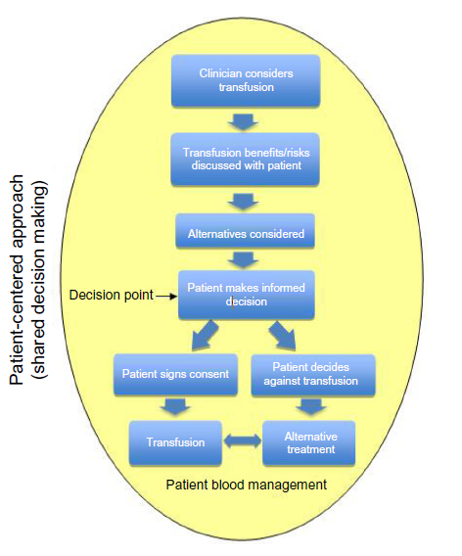

**Figure 6: Joint physician-patient shared decision making (patient- centered model)**

# Action plan of PBM to enhance red blood cell production and minimize blood loss

## Prime role of blood in our body

Blood cells bring oxygen to organs and tissues. Oxygen is carried and released by hemoglobin (Hgb), a protein present in red blood cells (Figure 7). A lower-than-normal hemoglobin level is called anemia and should not be left untreated. If anemia is severe or allowed to progress for a long period of time, it can result in complications to such as other disease conditions, more number of days at hospital, costs, and mortality (Baron et al., 2014; Friedman et al., 2015; Kassebaum et al., 2014; Shander et al., 2012).

**Figure 7: What does blood do in our body**

## Strategies to increase red blood cell production

PBM involves three main strategies to fulfil its objectives: optimizing the RBC count of patients, reduce loss of blood, and harness and optimize their body tolerance of anemia (Shander et al., 2012). A combination of the following PBM-related strategies may be used to enhance blood production (Table 3) (Shander et al., 2012) ("A Patient's Guide to Patient Blood Management," 2019).

**Table 3: PBM-based strategies to increase blood production**

|  |  |  |
| --- | --- | --- |
| Before hospital visit | During procedure | Additional strategies |
| Test tubes with solid fillSynthetic Erythropoietin – A hormone that stimulates production of red blood cells in your bone marrow*  Needle with solid fill  Medicine outlineIron (Oral and Intravenous) – A mineral essential for the formation of red blood cells*  Medicine outlineVitamin B12, Folic acid, Vitamin C – Vitamins necessary for red blood cell production* | Transfusion free icon**Intraoperative Blood Cell Recovery and Reinfusion** – The process of collecting blood lost during surgery and returning it to the patient.  Intravenous saline drip free icon  **Volume Expanders** – Intravenous fluids made with water, salts, sugars, or starches that help to maintain the correct amount of fluid in the blood vessels.  Pills premium icon**Hemostatic Drug Therapy** – Medications that assist with the clotting functions of blood.  Blood transfusion premium icon**Acute Normovolemic Hemodilution** – Removal of a specific amount of blood during surgery, replaced with intravenous (IV) fluids and returned during or after surgery.  Surgery free icon**Meticulous Surgical Approach** – Using surgical techniques and instruments that prevent or minimize blood loss.  Robotic surgery premium icon**Advanced/Minimally Invasive Surgical Techniques and Devices** – e.g., robotic and laparoscopic surgeries.  **Advanced Cauterization** – Devices that use heat, electricity, vibration, or light to stop bleedingtissue.  **Thrombin and Adhesives** – Human-derived or synthetic products that can be used in surgery to support the body’s ability to clot and reduce bleeding. | Test tube free icon**Reduced Blood for Testing** – Reducing either the number of times blood is drawn and/or the amount of blood used for testing, thus reducing the risk of anemia.  Transfusion free icon**Postoperative Blood Cell Recovery and Reinfusion** – Collecting blood lost after surgery and returning it to the patient after it is appropriately processed. |

*\*May also be used during or after hospitalization. It is recommended that you discuss these strategies with your physician.*

These strategies should be customized for each patient according to his/her condition and can be communicated effectively to the patient to demonstrate that due consideration for blood management has been undertaken to improve his/her chances of a safe and effective procedure (Shander et al., 2012).

PBM encourages elaborate evaluation of risk of bleeding and anemia prior to surgery thereby allowing full evaluation and correction of anemia (L. T. Goodnough et al., 2011; Shander et al., 2012). Implementing initiatives such as to screen and detect anemia and subsequently allow diagnosis of the causes of anemia (iron deficiency anemia, Vitamin B12/folate deficiency, inflammation associated anemia). Extended diagnostic testing support and referring to a specialist in conditions where exact etiology of anemia cannot be detected (L. T. Goodnough et al., 2011; Meybohm et al., 2017). Since anemia is a serious and treatable condition it plays an vital role while scheduling operation/surgeries (L. T. Goodnough et al., 2011).

.

Also, patients must inform their physician if on any of the following: ("A Patient's Guide to Patient Blood Management," 2019):

* Herbal medications
* Vitamin E
* Non-steroidal anti-inflammatory drugs (e.g., ibuprofen, naproxen)
* Medications that affect blood clotting (e.g., warfarin, dabigatran, aspirin, clopidogrel)

It is important to mention it to the healthcare provider as these may increase the risk of bleeding during procedures.

# Role of patients in PBM

Patients played an upper hand in declining blood transfusions for their personal reasons (Gombotz et al., 2017) (cultural or religious beliefs ex. Jehovah’s Witnesses, backgrounds, education levels, values (Friedman et al., 2015)) , (Lawrence T Goodnough, Shander, & Spence, 2003) when it was first introduced. Physicians around the world favored in a options other than blood transfusion (Gombotz et al., 2017) due to objections from certain patient groups, limited blood supply, or lack of availability of safe blood (Lawrence T Goodnough et al., 2003). These small groups further developed to becoming the first blood conservation centers and later into internationally recognized PBM centers such as The Institute for Patient Blood Management and Bloodless Medicine and Surgery at Englewood Hospital (Center, 2015), The National Patient Blood Management (PBM) Collaborative (Care, 2015), The Center for Bloodless Medicine and Surgery (Medicine, 2015), etc

## An ideal PBM team

To minimize and avoid exposing patients to allogenic transfusion requires an interdisciplinary team approach (Lawrence T Goodnough et al., 2003). The European Union (EU) PBM program utilizes a well-coordinated and a multi-disciplinary approach comprising of patients, physicians, hospital administrators,nurses, perfusionists, clinical pharmacists, networkers, and quality managers (Figure 8) (Gombotz et al., 2017).

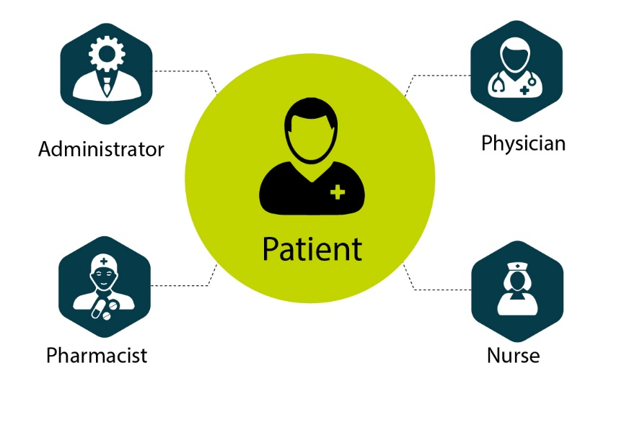

**Figure 8: Ideal PBM team**

A PBM stakeholder is a person or group affected or involved by setting PBM as a new example in medicine field. The key PBM stakeholders in the EU commission team comprises of clinical department heads, blood services, hospital blood bank heads/transfusion medicine departments, and patient organizations. Roles and responsibilities of the clinical department heads and transfusion medicine departments include:

1. Implementation of PBM as part of standard of care in the hospital
2. Providing PBM education to other members
3. Promoting awareness on PBM
4. Recruitment of volunteers
5. Establishing a network among primary stakeholders
6. Ensuring continuity and sustainability of PBM
7. Reconstituting the hospital blood bank to adhere to transfusion needs.
8. Expansion from transfusion consultation to PBM consultation with appropriate training.

The patient organizations aim to provide opportunity for patients to voice-out their opinion on blood transfusion and to formulate the use of PBM for better patient safety and outcome (Gombotz et al., 2017).

Furthermore, the Society for the Advancement of Blood Management (SABM), an international organization was launched in 2001 to advance the science of blood conservation. The SABM has developed a mentorship program in bloodless medicine (Lawrence T Goodnough et al., 2003).

A review study reported that PBM programs were associated with certain advantages such as decreased RBC and platelet transfusions, no increase in transfusion-associated risks, and reduced costs related to transfusion (Sullivan & Roback, 2019).

Ideal patient groups for PBM include bleeding patients, anemic patients, iron deficient patients, patients at a high risk of major blood loss and patients with bleeding disorders. These patients receive most RBCs, platelets, and fresh frozen plasma. PBM focusses on allowing these patients to think and talk about medical tests and procedures that can be avoided and thereby act as key determinants in selecting their treatment plan (Gombotz et al., 2017).

## Current and future roles of patients and patient organizations in PBM

To make PBM the new standard of care, it is essential to promote the advantages of PBM so that a large group of patients can become primary PBM stakeholders and pro-actively discuss their PBM options and treatment plan with their general practitioner and clinicians (Gombotz et al., 2017). The roles and responsibilities of patient organizations include (Figure 9 and Figure 10) the following :

**Figure 9: Roles and responsibilities of patient organizations**

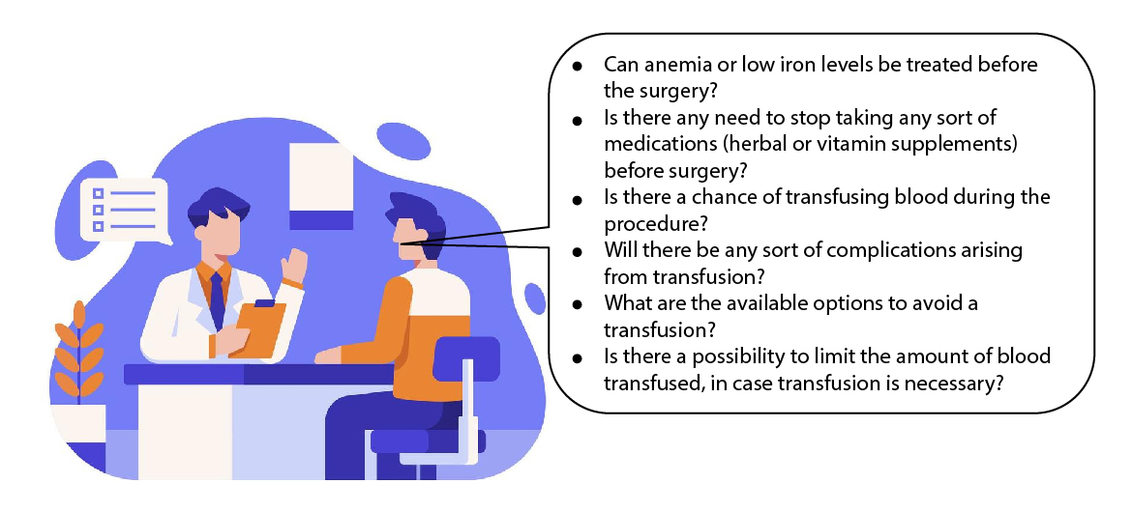

**Figure 10: List of some relevant questions patients can ask their clinicians**

### Informed consent for transfusions

An informed consent is a permission granted in full knowledge of the possible consequences, typically which is given by a patient to a doctor for treatment with knowledge of the possible risks and benefits of, and the alternatives to, transfusion. Despite the elective nature of surgery, most blood transfusions are being given to this group of patients despite time being available for discussion of alternatives for effective anaemia management ("NHS Consent for Blood Transfusion and Patient Information,"). It is ideal to discuss with the physician prior to surgery ("A Patient's Guide to Patient Blood Management," 2019).

It is anticipated that a full information and consent form outlining the risks and benefits of transfusion requiring signatures from patient and consenting clinician will reduce inappropriate transfusions through doctor and patient education and engagement (Leahy et al., 2014). The need for informed consent form based on patient’s choice, public welfare and moral values are described below (Figure 11).

#### What is the need for informed consent form?

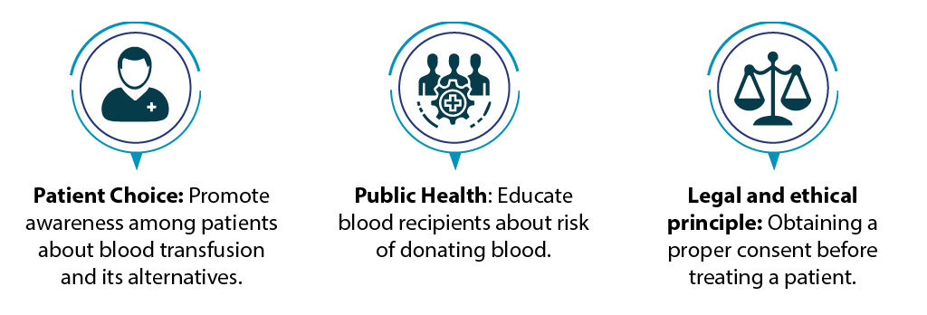

**Figure 11: Objectives of informed consent**

#### Essential criteria of an informed consent form

* The patient’s records contain evidence that the reason for transfusion of blood or blood components has been explained and discussed with the patient. This includes discussion of valid alternatives to transfusion and the option to refuse ("NHS Consent for Blood Transfusion and Patient Information,").
* Leaflets explaining the risks and benefits of, and alternatives to, transfusion are readily available to patients who may require to be or have been transfused ("NHS Consent for Blood Transfusion and Patient Information,").
* Where pre-transfusion discussion is not possible (e.g. in an emergency) there is a system, compatible with the patient’s clinical needs, to investigate and act in accordance with the treatment preferences. This includes compliance with an advance decision document ("NHS Consent for Blood Transfusion and Patient Information,").
* When pre-transfusion discussion has not taken place, the reason for transfusion (based on risks and benefits) are discussed with the patient and written information offered retrospectively ("NHS Consent for Blood Transfusion and Patient Information,").

# Hospital accreditation to enhance patient safety

Evaluating the effectiveness of a PBM program is an important tool for improving patient outcomes ("SABM Adminstrative and Clinical Standards for Patient Blood Management Programs,").

There is a process for evaluating the effectiveness of the PBM program. This evaluation is integrated into appropriate quality review activities within each institution. The information is used to improve anemia management, minimize blood loss, and improve transfusion practice. This evaluation is based on metrics defined by the hospital("SABM Adminstrative and Clinical Standards for Patient Blood Management Programs,").

## AABB-Joint Commission International (JCI) PBM certification

The AABB-JCI PBM Certification promotes patient safety and quality and will help hospitals realize the maximum benefit of establishing a comprehensive PBM program. This voluntary hospital certification is based on the AABB Standards for a PBM Program ("Patient Blood Management Certification Review Process Guide 2020," 2020).

## Society for the Advancement of Blood Management (SABM) PBM accreditation

Blood and blood component transfusions are evaluated using metrics defined by the hospital that allow comparison of blood utilization and transfusion practices with other institutions and the published literature. Quality measures defined by the hospital are used to assess the clinical efficacy and cost effectiveness of PBM clinical strategies in reducing blood utilization, minimizing bleeding and blood loss, and managing anemia ("SABM Adminstrative and Clinical Standards for Patient Blood Management Programs,").

## Advantages of accrediting hospitals

Patients can expect the following from certified organizations ("Patient Blood Management Certification Review Process Guide 2020," 2020):

* Risk reduction in fewer adverse events and incidents
* Improved patient outcomes
* Reduced hospital stays, readmissions, and lengths of stay
* Ensuring blood availability for those most in need
* Optimized care for those who may need transfusion
* Fostering collaboration throughout the hospital
* Providing a competitive edge in the marketplace
* Enhanced staff recruitment and development
* Cost savings

# Strategies for blood management plan

A fully functioning PBM would include several benchmarking and reporting systems to ensure sustainability where the transfusion data are routinely linked with other patient-related domain that provide data such as demographic and patient outcomes. The multimodal PBM committee would regularly monitor the data generated in these systems (Gombotz et al., 2017).

### Strategy 1 – Total Blood Management Plan

Hospitals are in the process of utilizing technological resources which would provide clinician education and monitor transfusion practice. For example, an alert screen pops up in the computer when a prescriber tries to order blood cells or plasma for a patient possessing high Hb values as per the transfusion guidelines (Figure 9) (Yazer & Waters, 2012).



**Figure 12: Model of an alert screen in the total blood management plan**

### Strategy 2 – Collecting patient-level data on anemia and its treatment

As we know, one of the prime objectives of PBM is to manage anemia. It is important to monitor the incidence and treatment of anemia prior to surgery, especially patients who require high risk procedures (Gombotz et al., 2017)

Mild anemia can be an independent predictor of adverse outcomes. This strategy helps to analyze the following (Gombotz et al., 2017):

* Hemoglobin concentration at the patient’s first visit of the pre-op anemia clinic
* Pre-operative hemoglobin concentration (after anemia correction)
* Post-operative hemoglobin concentration, preferably between post-op days 3, 4 or 5.

And for transfused patients (Gombotz et al., 2017):

* Pre-transfusion hemoglobin concentration
* Post-transfusion hemoglobin concentration

### Strategy 3 – Collecting patient-level data on calculated perioperative blood loss

Blood loss is also an important predictor for adverse outcome and therefore it is important to monitor the incidence and volume of perioperative blood loss (Gombotz et al., 2017).

### Step 4 – Measurement of comparing outcome data on transfusion and PBM patients

The following parameters are recommended to measure patient outcomes (Gombotz et al., 2017):

* 30-day mortality
* 90-day mortality
* 5-year mortality
* Average Length of Stay (ALOS)
* Composite morbidity
* Cost
* Hospital mortality
* Hospital acquired anemia rate
* Infection rate
* Pulmonary complication rate
* Readmission rate
* Reoperations

Factors such as standardized and electronic reporting, internal auditing, and frequent reviewing of transfusions and PBM results aid the primary stakeholders can help in changing the management process (Gombotz et al., 2017).

# PBM education and awareness

As mentioned earlier, there should be emphasis on the PBM-related education strategies to reform the existing hospital culture and practice. Patients and other key stakeholders need to participate effectively in continuous educational programs focusing on PBM to stay updated with the latest evidence on the impact of anemia, blood loss, bleeding, and transfusion (Hofmann et al., 2017).

Patient education is aimed at keeping patients well-informed about the most prevalent conditions, the available therapeutic options, and measures that are necessary to prevent or control the disease by health-care professionals in a formal or informal way. It helps in building a better understanding for the patients (Hofmann et al., 2017).

Diseases that require frequent blood and tissue-based tests can be taxing for the patients with a surge in the cost of contemporary hematology/oncology treatments (Hicks et al., 2013). SABM Choosing Wisely lists out five relevant questions physicians and patients should consider before their tests/procedures or treatments (Table 4) ("SABM. Five Things Physicians and Patients Should Question. ,").

**Table 4: Five things physicians and patients should question before blood management**

|  |
| --- |
| Do not proceed with elective surgery in patients with properly diagnosed and correctable anemia until the anemia has been appropriately treated. |
| Do not perform laboratory blood testing unless clinically indicated or necessary for diagnosis or management in order to avoid iatrogenic anemia. |
| Do not transfuse plasma in the absence of active bleeding or significant laboratory evidence of coagulopathy |
| Avoid transfusion when antifibrinolytic drugs are available to minimize surgical bleeding. |
| Avoid transfusion, outside of emergencies, when alternative strategies are available as part of informed consent; make discussion of alternatives part of the informed consent process. |

## Initiatives to promote PBM awareness

* Including an active marketing strategy to emphasize on the transition from using a blood transfusion to successful implementation of PBM. For example, creating reminders using portal, screen saver, tweets, social media, and posters (Gombotz et al., 2017).
* The vision of PBM implementation is to improve patient safety and achieve optimal clinical outcomes. Some ideal vision statements in favor of PBM such as ‘We prevent and treat anemia to improve outcome and save lives!”, “PBM is the gold standard to improve patient safety and outcome” promotes public to use PBM (Gombotz et al., 2017).

Widespread awareness about PBM educates patients and their caregivers about the risks and benefits of blood transfusion, adjuvant options, thus empowering them in the shared decision making (Hofmann et al., 2017).

## Creating awareness on:

### Iron deficiency day

Iron deficiency day is celebrated every year on the 26th of November to raise awareness of the impact of iron deficiency on health in general population and at-risk population ("Iron Deficiency Day,").

This day strives to increase awareness in the public and amongst health professionals to draw attention to anemia with its associated risks, social determinants, consequences, and its avoidance, integrate anemia in the pathways of health promotion (Hofmann et al., 2017).

Online Source:

<https://www.google.com/url?sa=i&url=http%3A%2F%2Fidday.icon-test.com%2F&psig=AOvVaw2jcc4w04h5TobZ6t394lfO&ust=1615646403877000&source=images&cd=vfe&ved=0CAkQjhxqFwoTCMDgvNz9qu8CFQAAAAAdAAAAABAD>

Additionally, numerous organizations such as World Health Organization (WHO), United Nations World Food Program etc. have been involved in promoting health awareness, educating population about iron deficiency anemia, and identifying its symptoms and consequences (Hofmann et al., 2017)

Online Source: <https://www.google.com/url?sa=i&url=https%3A%2F%2Fgutscharity.org.uk%2F2019%2F11%2Firon-deficiency-day-2019%2F&psig=AOvVaw1rfbNJsn0OcgmD1i5V8Prf&ust=1615646215816000&source=images&cd=vfe&ved=0CAkQjhxqFwoTCKDb7oP9qu8CFQAAAAAdAAAAABAD>

### PBM awareness week

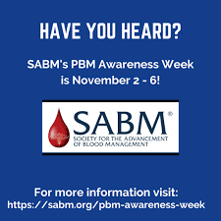The SABM will celebrate its 14th Annual PBM awareness week® from November 2nd - 6th 2020 ("SABM Patient Blood Management Awareness Week®,").

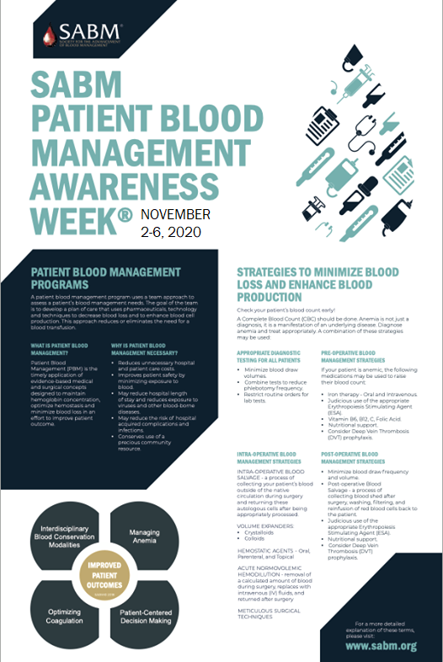SABM invites healthcare organizations worldwide to participate in this week dedicated to educating patients and healthcare professionals about patient blood management and transfusion overuse ("SABM Patient Blood Management Awareness Week®,").

The focus is to train healthcare professionals, equip the healthcare centers with proper diagnosing tools, promote the importance of PBM and conserve blood stores, avoid unnecessary transfusions, and help physicians and surgeons in guiding their patients with proper decision-making before, during and after the surgical procedure (Hofmann et al., 2017).

# Take-away points!

* PBM is the scientific use of safe and effective medical and surgical techniques designed to prevent anemia and decrease bleeding to improve patient outcome.
* PBM can improve patient safety by minimizing exposure to blood, minimize risk of exposure to viruses and other blood-borne diseases, minimize unnecessary sources of blood loss, decrease the risk of hospital acquired complications and infections, reduce length of hospital stay, reduce cost compared to transfusion, inform patients and encourage their participation in transfusion decisions, promote improved outcomes, enhance quality of life and well-being.
* PBM adopts techniques such as restrictive transfusion, clinical decision support, and educational efforts to reduce blood use effectively.
* A PBM utilizes a well-coordinated and a multi-disciplinary approach comprising of patients, physicians, hospital administrators, nurses, perfusionists and clinical pharmacists.
* Widespread awareness about PBM educates patients and their caregivers about the risks and benefits of blood transfusion and adjuvant options, thus empowering them in the shared decision making.

# References:

A. Thomson, S. F., 2 A. Hofmann,3 J. Isbister4 & A. Shander5. (2009). Patient blood management – a new paradigm for transfusion

medicine? *ISBT Science Series, 4*, 423-435.

Althoff, F. C., Neb, H., Herrmann, E., Trentino, K. M., Vernich, L., Fullenbach, C., . . . Choorapoikayil, S. (2019). Multimodal Patient Blood Management Program Based on a Three-pillar Strategy: A Systematic Review and Meta-analysis. *Ann Surg, 269*(5), 794-804. doi:10.1097/SLA.0000000000003095

Baron, D. M., Hochrieser, H., Posch, M., Metnitz, B., Rhodes, A., Moreno, R. P., . . . Metnitz, P. (2014). Preoperative anaemia is associated with poor clinical outcome in non-cardiac surgery patients. *Br J Anaesth, 113*(3), 416-423. doi:10.1093/bja/aeu098

Basora, M., Pereira, A., Coca, M., Tio, M., & Lozano, L. (2018). Cost-effectiveness analysis of ferric carboxymaltose in pre-operative haemoglobin optimisation in patients undergoing primary knee arthroplasty. *Blood Transfus, 16*(5), 438-442. doi:10.2450/2018.0031-18

Bolcato, M., Russo, M., Rodriguez, D., & Aprile, A. (2020). Patient blood management implementation in light of new Italian laws on patient's safety. *Transfus Apher Sci, 59*(4), 102811. doi:10.1016/j.transci.2020.102811

Care, A. C. o. S. a. Q. i. H. (2015). The National Patient Blood Management (PBM) Collaborative. Retrieved from <https://www.safetyandquality.gov.au/national-priorities/pbm-collaborative>

Carson, J. L., Guyatt, G., Heddle, N. M., Grossman, B. J., Cohn, C. S., Fung, M. K., . . . Tobian, A. A. (2016). Clinical Practice Guidelines From the AABB: Red Blood Cell Transfusion Thresholds and Storage. *JAMA, 316*(19), 2025-2035. doi:10.1001/jama.2016.9185

Carson, J. L., Sieber, F., Cook, D. R., Hoover, D. R., Noveck, H., Chaitman, B. R., . . . Rhoads, G. G. (2015). Liberal versus restrictive blood transfusion strategy: 3-year survival and cause of death results from the FOCUS randomised controlled trial. *The Lancet, 385*(9974), 1183-1189.

Carson, J. L., Stanworth, S. J., Roubinian, N., Fergusson, D. A., Triulzi, D., Doree, C., & Hebert, P. C. (2016). Transfusion thresholds and other strategies for guiding allogeneic red blood cell transfusion. *Cochrane Database Syst Rev, 10*, CD002042. doi:10.1002/14651858.CD002042.pub4

Center, E. H. a. M. (2015). The Institute for Patient Blood Management and Bloodless Medicine and Surgery at Englewood Hospital. Retrieved from <https://www.englewoodhealth.org/service/bloodless-medicine-and-surgery>

Farmer L.S, T. K., Hofmann A, et al. (2015). A Programmatic Approach to Patient Blood Management – Reducing Transfusions and Improving Patient Outcome. *The Open Anesthesiology Journal 9*, 6-16.

Fischer, D. P., Zacharowski, K. D., Müller, M. M., Geisen, C., Seifried, E., Müller, H., & Meybohm, P. (2015). Patient blood management implementation strategies and their effect on physicians' risk perception, clinical knowledge and perioperative practice - the frankfurt experience. *Transfusion medicine and hemotherapy : offizielles Organ der Deutschen Gesellschaft fur Transfusionsmedizin und Immunhamatologie, 42*(2), 91-97. doi:10.1159/000380868

Franchini, M., Marano, G., Veropalumbo, E., Masiello, F., Pati, I., Candura, F., . . . Liumbruno, G. M. (2019). Patient Blood Management: a revolutionary approach to transfusion medicine. *Blood Transfus, 17*(3), 191-195. doi:10.2450/2019.0109-19

Frank, S. M., Thakkar, R. N., Podlasek, S. J., Ken Lee, K., Wintermeyer, T. L., Yang, W. W., . . . Wachter, P. A. (2017). Implementing a health system–wide patient blood management program with a clinical community approach. *Anesthesiology, 127*(5), 754-764.

Friedman, M. T., Bizargity, P., Gilmore, S., & Friedman, A. (2015). Patient inclusion in transfusion medicine: current perspectives. *International Journal of Clinical Transfusion Medicine, 3*, 7-16.

Gombotz, H., Hofmann, A., Norgaard, A., & Kastner, P. (2017). *Supporting Patient Blood Management (PBM) in the EU - A Practical Implementation Guide for Hospitals*.

Goodnough, L. T., Maniatis, A., Earnshaw, P., Benoni, G., Beris, P., Bisbe, E., . . . Szpalski, M. (2011). Detection, evaluation, and management of preoperative anaemia in the elective orthopaedic surgical patient: NATA guidelines. *Br J Anaesth, 106*(1), 13-22. doi:10.1093/bja/aeq361

Goodnough, L. T., Shander, A., & Spence, R. (2003). Bloodless medicine: clinical care without allogeneic blood transfusion. *Transfusion, 43*(5), 668-676.

Hicks, L. K., Bering, H., Carson, K. R., Kleinerman, J., Kukreti, V., Ma, A., . . . Crowther, M. A. (2013). The ASH Choosing Wisely(R) campaign: five hematologic tests and treatments to question. *Blood, 122*(24), 3879-3883. doi:10.1182/blood-2013-07-518423

Hirano, Y., Miyoshi, Y., Kondo, Y., Okamoto, K., & Tanaka, H. (2019). Liberal versus restrictive red blood cell transfusion strategy in sepsis or septic shock: a systematic review and meta-analysis of randomized trials. *Crit Care, 23*(1), 262. doi:10.1186/s13054-019-2543-1

Hofmann, A., Norgaard, A., Kurz, J., Choorapoikayil, S., Meybohm, P., Zacharowski, K., . . . Gombotz, H. (2017). *Building national programmes of Patient Blood Management (PBM) in the EU - A Guide for Health Authorities*.

Iron Deficiency Day. Retrieved from <https://irondeficiencyday.com/>

Joint Commission T, American Medical Association-Convened Physician Consortium for Performance Improvement:Proceedings from the National Summit on Overuse: September 24, 2012. Retrieved from <https://www.jointcommission.org/assets/1/6/National_Summit_Overuse.pdf>.

Kashani, H. H., Lodewyks, C., Kavosh, M. S., Jeyaraman, M. M., Neilson, C., Okoli, G., . . . Grocott, H. P. (2020). The effect of restrictive versus liberal transfusion strategies on longer-term outcomes after cardiac surgery: a systematic review and meta-analysis with trial sequential analysis. *Can J Anaesth, 67*(5), 577-587. doi:10.1007/s12630-020-01592-w

Kassebaum, N. J., Jasrasaria, R., Naghavi, M., Wulf, S. K., Johns, N., Lozano, R., . . . Murray, C. J. L. (2014). A systematic analysis of global anemia burden from 1990 to 2010. *Blood, 123*(5), 615-624. doi:<https://doi.org/10.1182/blood-2013-06-508325>

Leahy, M. F., Roberts, H., Mukhtar, S. A., Farmer, S., Tovey, J., Jewlachow, V., . . . Western Australian Patient Blood Management, P. (2014). A pragmatic approach to embedding patient blood management in a tertiary hospital. *Transfusion, 54*(4), 1133-1145. doi:10.1111/trf.12362

Medicine, J. H. (2015). The Center for Bloodless Medicine and Surgery. Retrieved from <https://www.hopkinsmedicine.org/bloodless_medicine_surgery/>

Mehra, T., Seifert, B., Bravo-Reiter, S., Wanner, G., Dutkowski, P., Holubec, T., . . . Spahn, D. R. (2015). Implementation of a patient blood management monitoring and feedback program significantly reduces transfusions and costs. *Transfusion, 55*(12), 2807-2815. doi:10.1111/trf.13260

Meybohm, P., Richards, T., Isbister, J., Hofmann, A., Shander, A., Goodnough, L. T., . . . Zacharowski, K. (2017). Patient Blood Management Bundles to Facilitate Implementation. *Transfus Med Rev, 31*(1), 62-71. doi:10.1016/j.tmrv.2016.05.012

Moskowitz, D. M., McCullough, J. N., Shander, A., Klein, J. J., Bodian, C. A., Goldweit, R. S., & Ergin, M. A. (2010). The impact of blood conservation on outcomes in cardiac surgery: is it safe and effective? *Ann Thorac Surg, 90*(2), 451-458. doi:10.1016/j.athoracsur.2010.04.089

National Institute for Clinical Excellence guidelines - Blood Transfusion. Retrieved from <https://www.nice.org.uk/guidance/ng24/resources/blood-transfusion-1837331897029>

NHS Consent for Blood Transfusion and Patient Information. Retrieved from <https://www.unchealthcare.org/app/files/public/701/pdf-mclendon-labs-transfusion-informedconsentfaq.pdf>. Retrieved 12-Mar-2021 <https://www.unchealthcare.org/app/files/public/701/pdf-mclendon-labs-transfusion-informedconsentfaq.pdf>

Palmieri, T. L., Holmes, J. H., Arnoldo, B., Peck, M., Cochran, A., King, B. T., . . . Pollock, B. H. (2019). Restrictive Transfusion Strategy Is More Effective in Massive Burns: Results of the TRIBE Multicenter Prospective Randomized Trial. *Mil Med, 184*(Suppl 1), 11-15. doi:10.1093/milmed/usy279

A Patient's Guide to Patient Blood Management. (2019). Retrieved from <https://sabm.org/wp-content/uploads/2019/02/A-Patients-Guide-to-PBM-2019.pdf>. <https://sabm.org/wp-content/uploads/2019/02/A-Patients-Guide-to-PBM-2019.pdf>

Patient Blood Management Certification Review Process Guide 2020. (2020). Retrieved from <https://www.jointcommission.org/-/media/tjc/documents/accred-and-cert/survey-process-and-survey-activity-guide/2020-patient-blood-mgmt-organization-rpg.pdf>

Pourfathollah, A., Karimi, G., Namini, M., Darestani, S., & Dehshal, M. (2019). Patient's involvement and the improvement of patient blood management. *Global Journal of Transfusion Medicine, 4*(1), 65-68. doi:10.4103/gjtm.Gjtm_20_19

Rohde, J. M., Dimcheff, D. E., Blumberg, N., Saint, S., Langa, K. M., Kuhn, L., . . . Rogers, M. A. (2014). Health care-associated infection after red blood cell transfusion: a systematic review and meta-analysis. *JAMA, 311*(13), 1317-1326. doi:10.1001/jama.2014.2726

SABM Adminstrative and Clinical Standards for Patient Blood Management Programs. Retrieved from <https://www.sabm.org/wp-content/uploads/SABM-Standards-2019.pdf>

SABM Patient Blood Management Awareness Week®. Retrieved from <https://sabm.org/wp-content/uploads/SABM-PBMAW-2020-Poster.pdf>. <https://sabm.org/wp-content/uploads/SABM-PBMAW-2020-Poster.pdf>

SABM. Five Things Physicians and Patients Should Question. . Retrieved from <https://www.sabm.org/wp-content/uploads/2018/08/SABM-Choosing-Wisely-List.pdf>. <https://www.sabm.org/wp-content/uploads/2018/08/SABM-Choosing-Wisely-List.pdf>

Salpeter, S. R., Buckley, J. S., & Chatterjee, S. (2014). Impact of more restrictive blood transfusion strategies on clinical outcomes: a meta-analysis and systematic review. *Am J Med, 127*(2), 124-131 e123. doi:10.1016/j.amjmed.2013.09.017

Shander, A., Isbister, J., & Gombotz, H. (2016). Patient blood management: the global view. *Transfusion, 56 Suppl 1*, S94-102. doi:10.1111/trf.13529

Shander, A., Javidroozi, M., & Lobel, G. (2017). Patient Blood Management in the Intensive Care Unit. *Transfus Med Rev, 31*(4), 264-271. doi:10.1016/j.tmrv.2017.07.007

Shander, A., Van Aken, H., Colomina, M. J., Gombotz, H., Hofmann, A., Krauspe, R., . . . Spahn, D. R. (2012). Patient blood management in Europe. *Br J Anaesth, 109*(1), 55-68. doi:10.1093/bja/aes139

Sullivan, H. C., & Roback, J. D. (2019). The pillars of patient blood management: key to successful implementation (Article, p. 2840). *Transfusion, 59*(9), 2763-2767. doi:10.1111/trf.15464

Supporting Patient Blood Management in the EU

A Practical Implementation Guide for Hospitals. (2017). Retrieved from <https://www.researchgate.net/publication/317179242_Supporting_Patient_Blood_Management_PBM_in_the_EU_-_A_Practical_Implementation_Guide_for_Hospitals>. <https://www.researchgate.net/publication/317179242_Supporting_Patient_Blood_Management_PBM_in_the_EU_-_A_Practical_Implementation_Guide_for_Hospitals>

Toledo, P. (2014). Shared Decision-Making and Blood Transfusions: Is It Time to Share More? *Anesthesia & Analgesia, 118*(6), 1151-1153. doi:10.1213/ane.0000000000000299

Vetter, T. R., Adhami, L. F., Porterfield, J. R. J., & Marques, M. B. (2014). Perceptions About Blood Transfusion: A Survey of Surgical Patients and Their Anesthesiologists and Surgeons. *Anesthesia & Analgesia, 118*(6), 1301-1308. doi:10.1213/ane.0000000000000131

Yang, W. W., Thakkar, R. N., Gehrie, E. A., Chen, W., & Frank, S. M. (2017). Single-unit transfusions and hemoglobin trigger: relative impact on red cell utilization. *Transfusion, 57*(5), 1163-1170. doi:10.1111/trf.14000

Yazer, M. H., & Waters, J. H. (2012). How do I implement a hospital-based blood management program? *Transfusion, 52*(8), 1640-1645. doi:10.1111/j.1537-2995.2011.03451.x

GET IN TOUCH

**Dr Nicholas Lim**

Regional Medical Manager (Asia)

ZP Therapeutics, a division of Zuellig Pharma

[nlimry@zuelligpharma.com](mailto:nlimry@zuelligpharma.com)

*©2021*

*Zuellig Pharma*

**The Blueprint for Change Resource**

The Blueprint for Change Resource is a series of modules for developing a keen understanding of Patient Blood Management (PBM) needed for its implementation. Speaking to the multidisciplinary nature of PBM, modules for Clinicians, Operations, Business and Patients are developed based on extensive literature research and successful programs implemented globally. The Blueprint for Change resource seeks to strengthen the link between understanding the clinical evidence and implementation, highlight sustainable successes, and explore challenges ahead and ways to improve.