Name: Mark Andrie D. Datus | Yr. & Sec: BSIT 4A
Company: LHOOPA INC. | Position: Web Developer

NARRATIVE REPORT

- Duties and Responsibilities Assigned to the Trainee

Before starting my On-the-Job Training (OJT) at Lhoopa, the Human Resources team asked me to choose between becoming a Quality Assurance intern or a Web Developer intern. That question stuck in my mind for a while, it kept me awake every night, it felt like I’m choosing between comfort and growth, while choosing the QA felt like a light task that seemed more secure and easier, it can hinder my dream of becoming a Full-stack Web Developer, on the other hand the Web developer role feels like I’m going into a battle without knowing what I’m up against. But I want to be a good developer someday so I told myself, if not now, When? when will I conquer my fear, when will I stand on my own, I’m not a kid anymore who needs to be carried so I chose the Web Developer role, as it aligns with the career path I wanted to pursue after graduating from college. This decision placed me under the Information Technology (IT) department, specifically within the team responsible for managing the company’s main web application, referred to as the “Platform.”

As a Web Developer intern, my initial expectation was that I would be assigned to handle simple tasks such as modifying user interface elements or fixing minor bugs in their live system. However, we were not allowed to directly interact with the company’s system since it was too risky for interns, but instead we undergo a structured training phase. Our main responsibility during this period was to strengthen our foundational knowledge in web development, particularly in Web development. This included studying topics ranging from basic concepts such as variables and control structures to more advanced principles like Object-Oriented Programming (OOP).
I thought that the training would be easy since I already practicing during Christmas break and believe that my knowledge on HTML, CSS and JAVASCRIPT is quite advanced. However, I soon realized that the expectations extended far beyond front-end development. The activities required me to analyze and develop my logical thinking, understand server-side processes, and manage data effectively. Through consistent practice and hands-on experience, I was able to enhance my skills significantly.
Moreover, this experience helped me overcome my fear of failing, because in this training it didn’t serve a subject that I needed to complete to graduate it shaped me, helped me gain knowledge, help me exceed limitations and help me to understand how back-end of a system really works from getting the data to the users to passing it to store in the database.

Skills Acquired and Improved

Working as a Web Developer Intern at Lhoopa allowed me to improve my technical and analytical skills to next level. One of the most noticeable improvements was in my logical thinking, since I’m coding for approximately six to nine hours every day I became more comfortable building small CRUD (Create, Read, Update, Delete) applications. This was something I did not expect, especially since I had no interest in back-end development back when I was studying in university.

On the front-end I had a good background in HTML and CSS, but I improved my JavaScript skills. In particular I got more confident in handling and manipulating DOM (Document Object Model) elements and adding interactive features to my projects. This enabled me to build more dynamic and user-friendly interfaces.
Overall back-end development is where I saw the most improvement. I was a little scared to start learning back-end technologies, but I ended up working with PHP as a full back-end language and built small systems with JavaScript.
This internship helped me improve my problem solving and logical thinking skills as well as my front end and back end skills making me a more of a full-stack developer rather than a front-end web developer.

Management Techniques Observed

While working with Lhoopa and finishing my OJT hours, I noticed that the company holds regular meetings, usually every Friday, and their agenda is system usability, How do they make their system more user-friendly because their customers always access their website or web application The main thing I want to highlight and the most noticeable part or technique they use is that they have a system, they work systematically. In the IT department they have a ticketing system that handles all the work needed to be done for that specific day if QA finds some bug in the system, they create a ticket so the workflow is fast and developers quickly debug and deploy updates to production.

Lesson Learned

During my On-the-Job Training (OJT), I was able to gain valuable knowledge and hands-on experience in front-end and back-end web development. This training gave me the chance to apply the concepts I learned in university to real-world situations, as well as exposure to new tools, frameworks, and development practices used in a professional environment. Regular exercises, activities conducted by the instructor, and developing
hands-on projects helped me deepen my understanding of basic programming principles and learn how web applications are created and maintained in a systematic way.

Although I work with both the frontend and the backend, backend logic and client-side interactivity take up a large amount of my attention. I spent a lot of time studying JavaScript on the front end, with a particular emphasis on manipulating the DOM (Document Object Model) to produce interactive user experiences. From choosing individual elements by ID to effectively capturing several elements at once, I learnt a variety of element targeting approaches. Additionally, I used event listeners and regular expressions (regex) to successfully construct a real-time password validator.
However, I also encountered complex challenges, particularly with client-server communication. Understanding how data flows and is packaging data and sending it using JSON has been a hard task for me. I have decided to set this aside temporarily to focus on my immediate deadlines, but I plan to thoroughly study this data flow once my final output is complete.
Currently, my primary goal is finishing that final system. To achieve this, I am dedicating time to mastering core PHP and Object-Oriented Programming (OOP). Because I prefer to understand how things work from scratch, grasping these foundational concepts is one of the keys for me to understand and implement the MVC (Model-View-Controller)

architecture. Learning how the Model, View, and Controller interact will allow me to build systems in a highly organized, scalable, and systematic way.

Classroom Theories Employed

During my OJT, I have realized the real value of applying the fundamental knowledge I have learn to solve complex problems. At school I learned the basics of how to structure pages using HTML, how to style them with CSS and how to add some simple interactivity with a bit of JavaScript, such as creating responsive layouts and implementing event listeners for user interactions. I also learned how to design database schemas to properly organize and relate information. During the training, I got to use these same concepts on a much bigger, more dynamic scale.
The fundamentals of HTML and CSS gave me a advantage for the more complex DOM manipulation I was learning, such creating the real-time password validator, and helped me grasp how to modify things in JavaScript. Additionally, it was quite simple for me to see how a backend system links to its data because I had academic expertise with database structures. I can now comfortably manage PHP and the MVC architecture to handle data effectively for my ultimate output because of this fundamental knowledge.

Conclusion

Completing my Memorable 486-hour On-the-Job Training at Lhoopa Inc. has been a very rewarding and transformative experience for which I am deeply grateful. When I first stepped into the company, my primary focus and comfort zone lay strictly in front-end design, but this internship has significantly accelerated my overall growth, bridging the crucial gap between my academic studies and my ultimate career goal of becoming a versatile, full-stack web developer.

I will always remember and cherish the invaluable lessons our senior developers taught us. They went above and beyond simply assigning tasks they took the time to expose me to various real-world scenarios, illustrating exactly what it takes to survive and thrive in a fast-paced world of technology. They showed me the defining traits of a truly good developer such as patience during debugging, the importance of writing clean and maintainable code, the value of continuous learning, and the necessity of thoroughly understanding business logic before writing a single line of syntax.
Most importantly, I am so grateful that Lhoopa did not treat us as just temporary students or simple observers, but with the same respect, high expectations, and inclusion as their regular employees. We were embedded in their real workflow, in discussions with them and learning their professional practices. This inclusive environment greatly enhanced my technical abilities, but also instilled in me a sense of professional maturity, responsibility, and confidence that will carry over to my future career in the tech industry.

Recommendations

I highly recommend Lhoopa Inc. to future interns because this company truly values your fundamentals and actively strengthens them to prepare you for the real world. You will quickly realize that the basic knowledge you gained in school like HTML structuring, CSS design, and JavaScript scripting is the exact foundation you need to survive and thrive as a Web Developer. Lhoopa also pushes you to learn back-end business logic. They give you PHP tutorials and expect you to study independently, but the senior developers are always ready to support you when you get stuck. I love the way they handle mentorship They do not

spoon-feed you or just hand over the source code. Instead, they give you the right tips and let you solve your own logic problems, which builds your confidence immensely.

Because of this setup, I strongly advise future interns to study their fundamentals thoroughly before starting. If you know your basics, you will have a clearer idea of what is going on and can formulate great questions to ask the senior developers. On the other hand, my one recommendation for Lhoopa’s training program is to add AI integration into the intern study roadmap. The current roadmap they give is pretty solid for building core skills, but updating it to include how to integrate AI in your workflow, AI prompting changes the game plan or how to use AI tools would perfectly meet the needs of a modern IT company in today's landscape.

Pictures with Captions (Documentation)

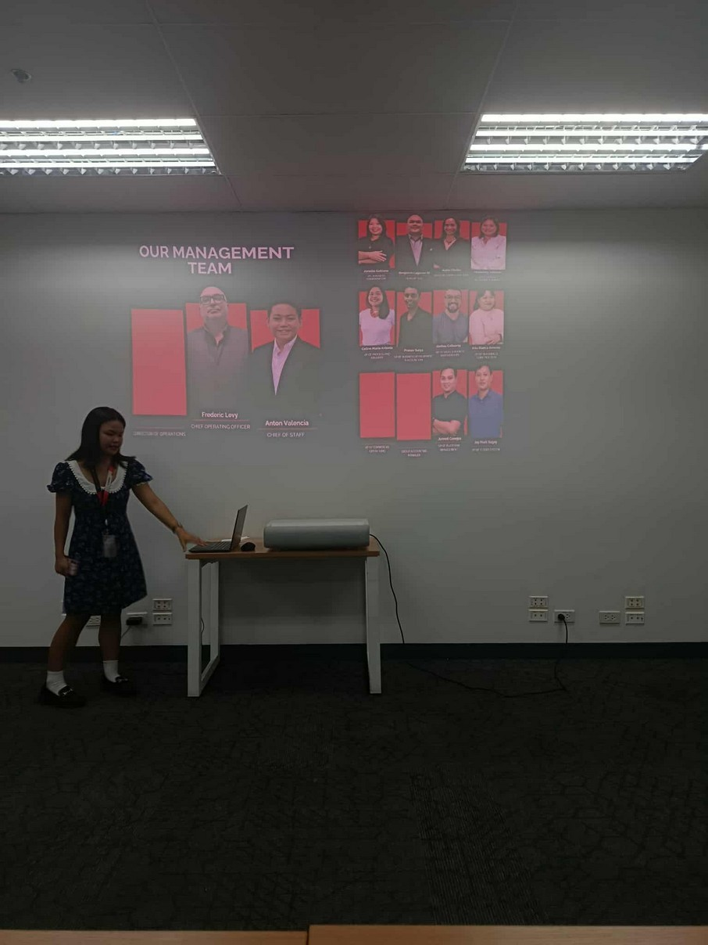

Orientation on the company’s organizational structure, including department heads and hierarchy, during the first day of work

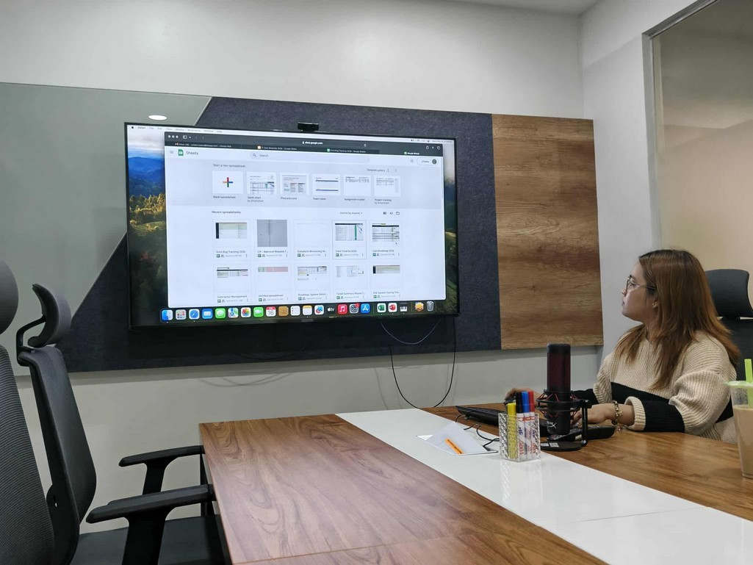

A guided walkthrough of the Cornerstone system used by Lhoopa
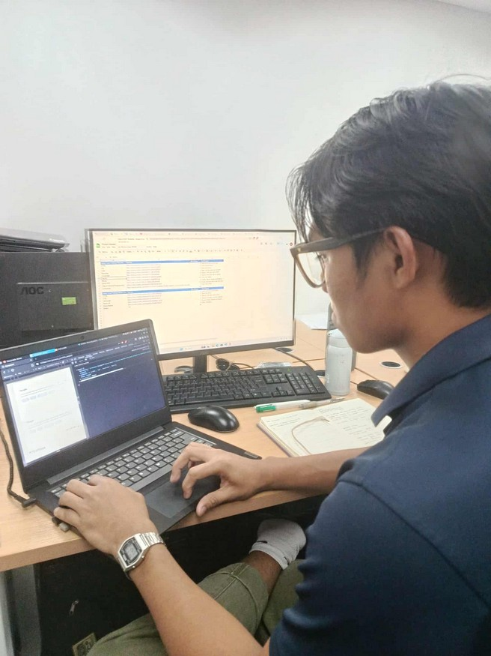
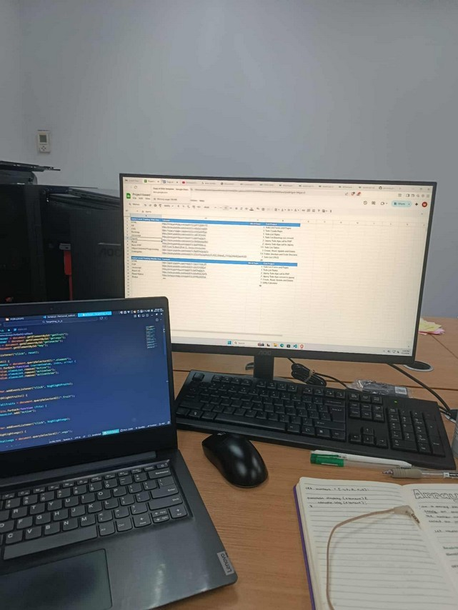

Setting up development environment (IDE) and initiation of the first activity on styling and positioning elements using Bootstrap CSS.
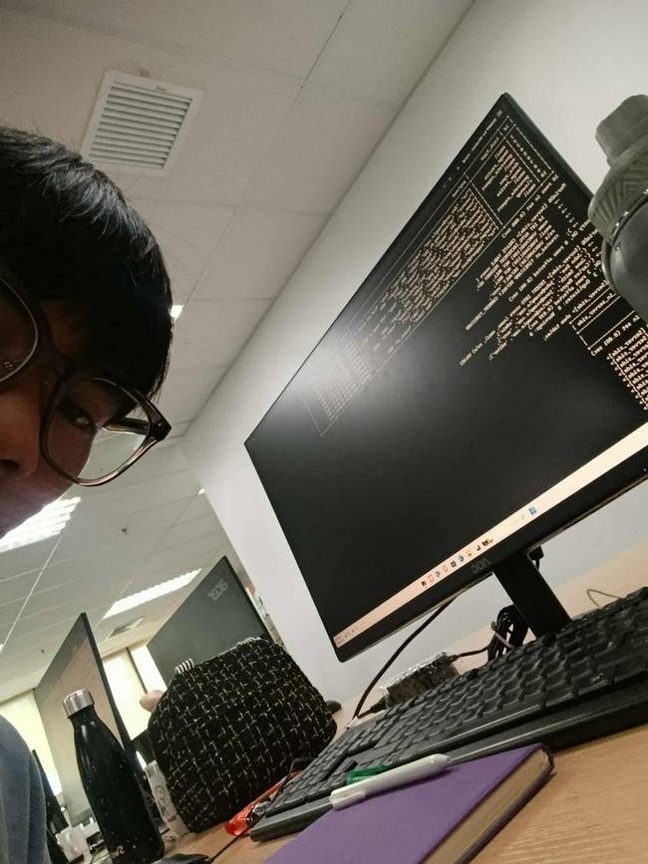
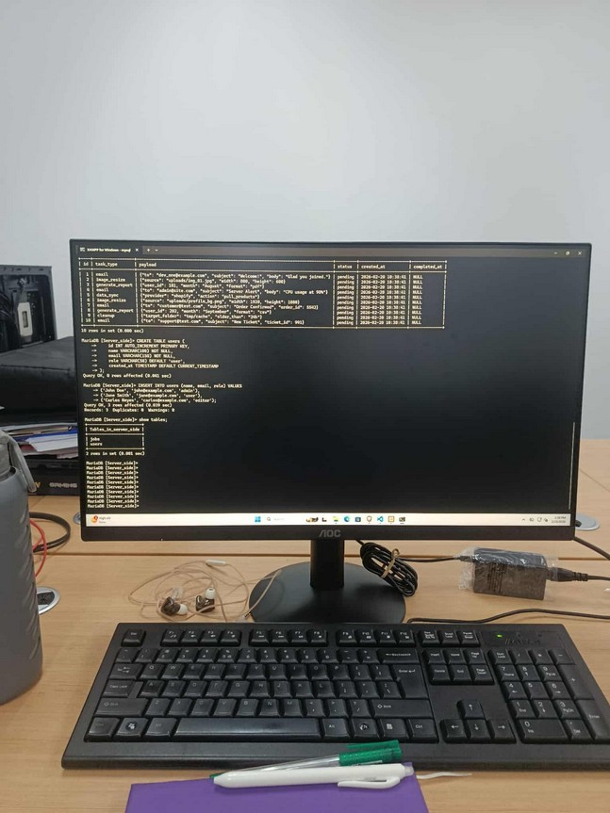

Hands-on practice of database queries, including table joins and CRUD operations (Create, Read, Update, Delete) using the MySQL terminal environment.

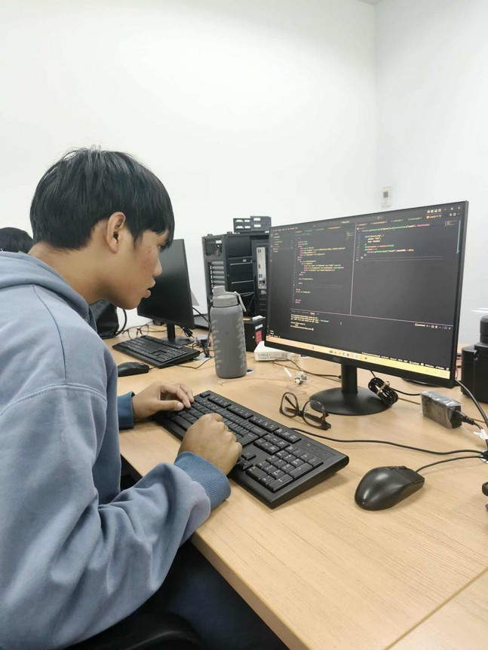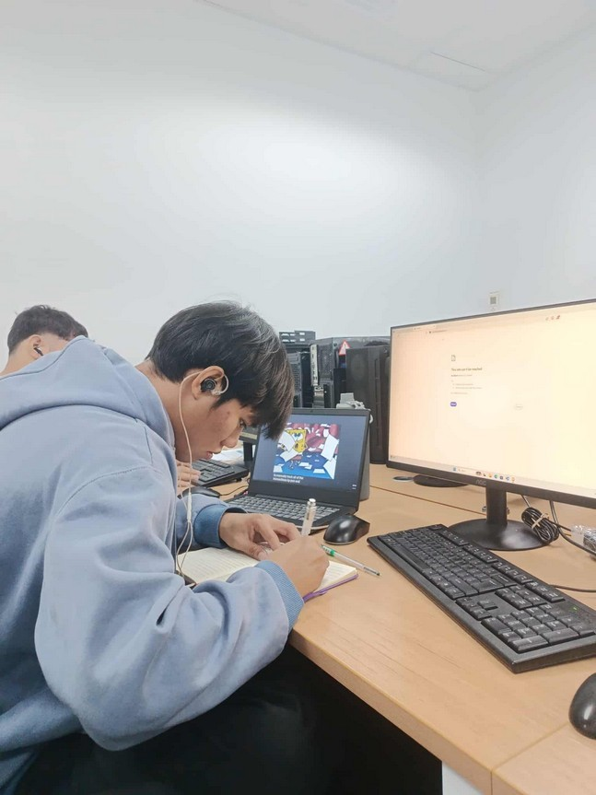

Familiarization with Object-Oriented Programming (OOP) concepts and terminologies, including classes, methods, setters, getters, and inheritance.
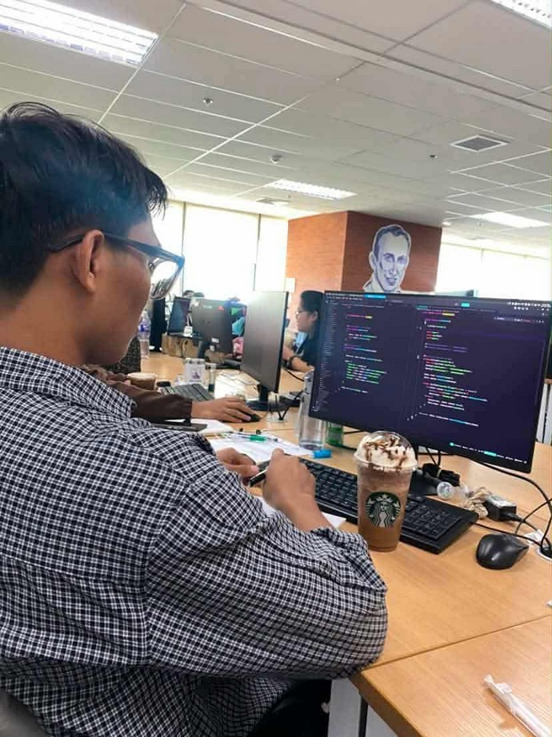
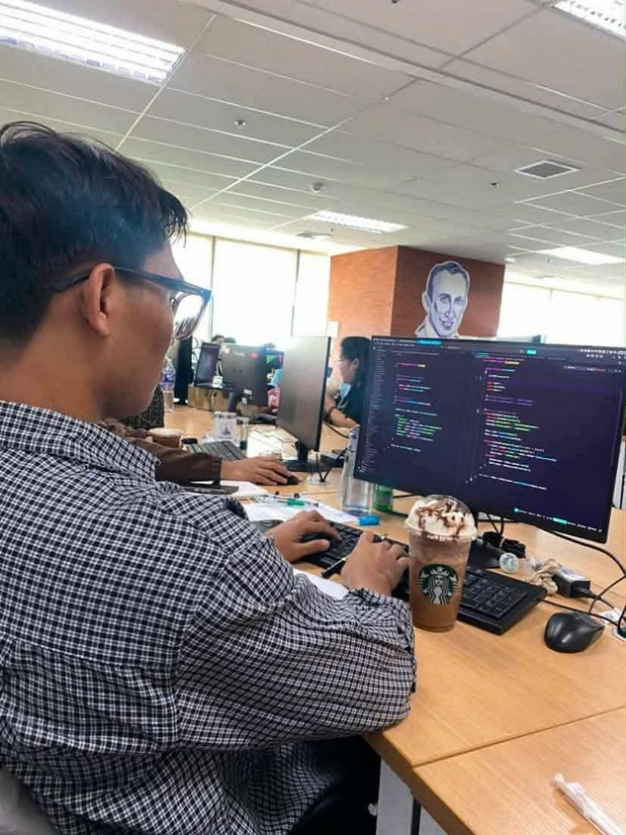

Conducted research on Model-View-Controller (MVC) architecture prior to starting a PHP framework project using CodeIgniter.

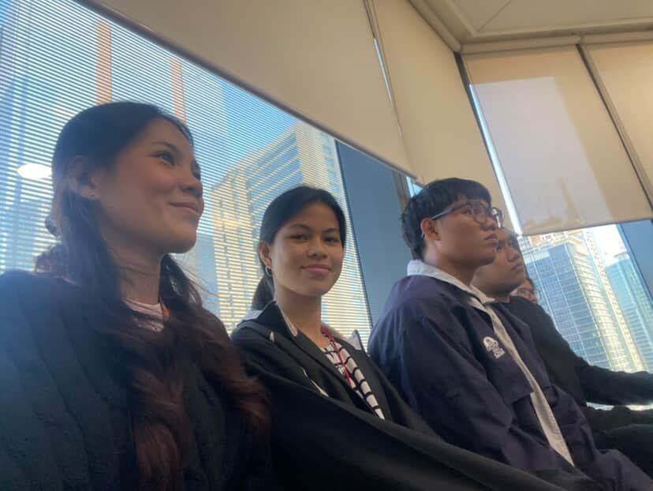
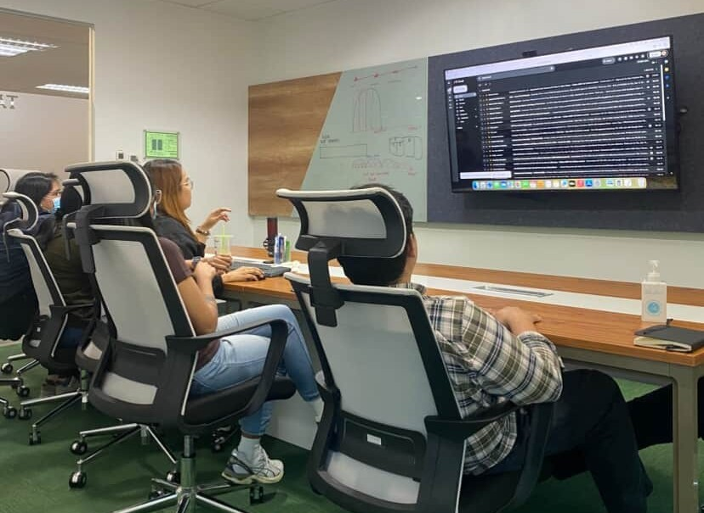
KPI (Key Performance Indicator) meeting and subsequent updates made to the system.

