컴퓨터학부 20142385 엄재식

1. 과제 개요

Multi-level Feedback Queue 스케줄링 구현, 0~2 level의 큐로 구성되있다.

스케줄링을 할 때 1번 큐를 우선으로 프로세스를 찾고 1번 큐에 없다면 2번 큐에서 프로세스를 찾는다. Time quantum을 모두 소비하면 0번 큐에서 0번 프로세스로 이동해 schedule 함수를 호출해 스케줄링을 한다.

1. 0번큐

0번 프로세스를 위한 큐, 0번 프로세스는 idle 프로세스로 schedule 함수만 호출하도록 구현

1. 1번큐

0번큐를 제외한 프로세스 생성시 1번큐로 이동, i/o를 마친 프로세스도 1번큐로 이동 (FIFO)

1번큐에서 스케줄링 된 프로세스는 40tick의 time quantum을 할당함

1. 2번큐

1번큐에서 스케줄링을 마친 프로세스가 2번큐로 이동 (Round Robin)

1. 상세설계
2. sched.c

sched_find_que 함수에서 list_empty함수를 사용해 검색할 큐를 찾은 다음 get_next_proc함수를 사용해 스케줄링할 프로세스를 검색하도록 코드를 추가함.

get_next_proc 함수에서 큐에서 프로세스를 건내 줄 때 list_remove 함수를 사용해 큐에서 pop해주는 코드를 추가함.

schedule

1. 호출한 프로세스가 0번 프로세스가 아닐 경우 0번 프로세스로 바꿔주는 코드를 추가함
2. 스케줄링 할 때마다 latest를 갱신하여 이전에 스케줄링 된 프로세스가 무엇인지 알게함, lastest의 큐 레벨을 보고 1이면 큐 레벨을 낮추어 2번 큐로 push할 수 있게 만들고 2이면 다시 2번 큐로 push하도록 코드를 추가함
3. sched_find_que 함수를 이용해 다음 프로세스 찾은 switch_process 함수를 이용해 context switching을 한다.

proc_que_levelup 함수에서 프로세스 큐의 레벨을 1로 바꿔주고 1번 큐에 push하도록 코드를 추가함

proc_que_leveldown 함수에서 프로세스 큐의 레벨을 2로 바꿔주고 2번 큐에 push하도록 코드를 추가함

1. proc.c

proc_create 함수에서 프로세스를 생성하고 1번 큐로 push하도록 코드를 추가함

proc_end 와 proc_sleep 함수가 시작할 때 intr_disable을 추가해 종료나 i/o 할 동안에 time quantum이 끝나지 않도록 함

proc_wake 함수에서 i/o가 끝난 함수가 1번큐로 이동하도록 proc_que_levelup 함수를 호출함

1. interrupt.c

timer_handler 함수에서 time_slice를 먼저 검사한 뒤 time_used와 time_slice를 증가시키도록 수정하여 i/o 시작 시간과 스케줄 시간이 겹칠 때 i/o 먼저하고 time quantum을 끝내도록 만듬

1. 시뮬레이션

|  |  |  |  |  |
| --- | --- | --- | --- | --- |
| **PID**  **(순서)** | **시작시각**  **(tick)** | **종료시각**  **(tick)** | **I/O 제외**  **총 수행시간**  **(tick)** | **I/O 시작 시각**  **(tick)** |
| **1** | **0** | **1210** | **200** | **640** |
| **2** | **40** | **830** | **120** | **70** |
| **3** | **70** | **2180** | **300** | **700** |
| **4** | **110** | **3010** | **300** | **140, 990** |
| **5** | **140** | **3350** | **400** | **160, 1110** |
| **6** | **160** | **2590** | **200** | **170. 340, 980, 1900,** |
| **7** | **170** | **3630** | **500** | **190, 360, 1130** |
| **8** | **190** | **3850** | **600** | **210** |
| **9** | **210** | **3950** | **750** | **240** |
| **10** | **240** | **4030** | **800** | **1450** |

1. 실행결과

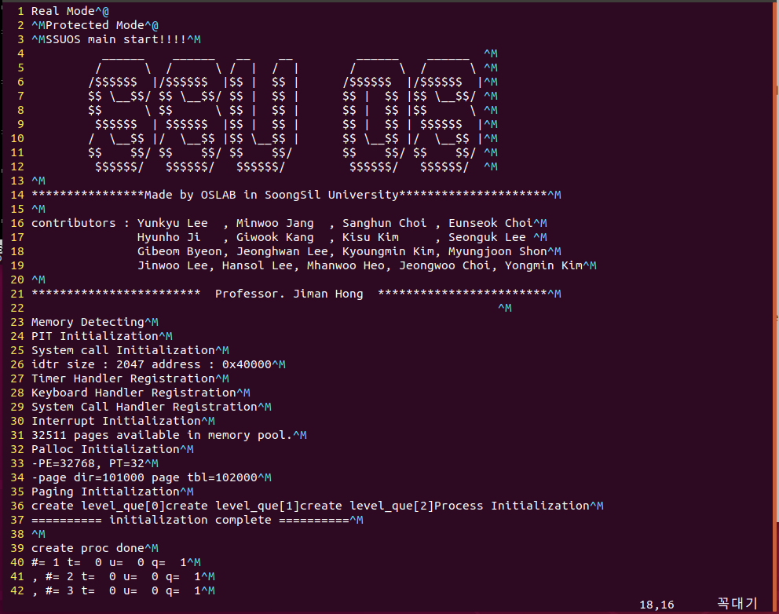

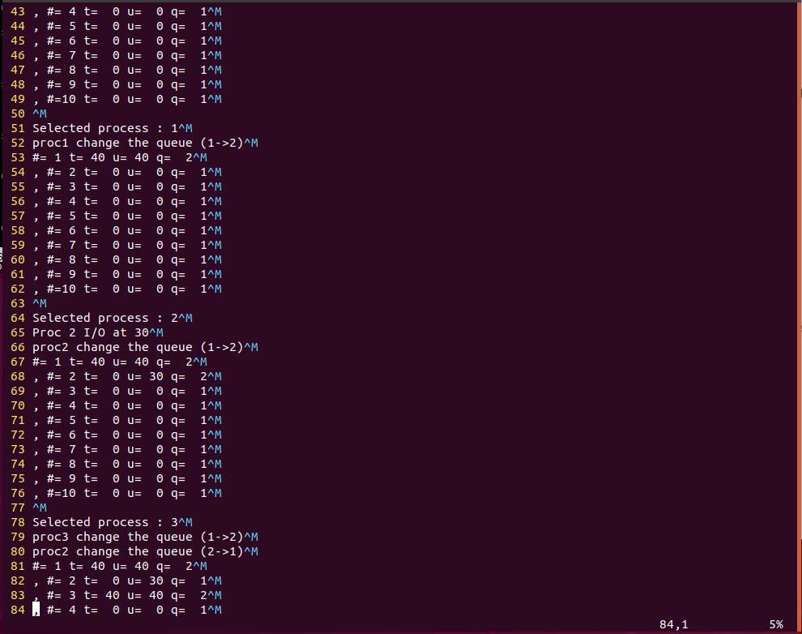

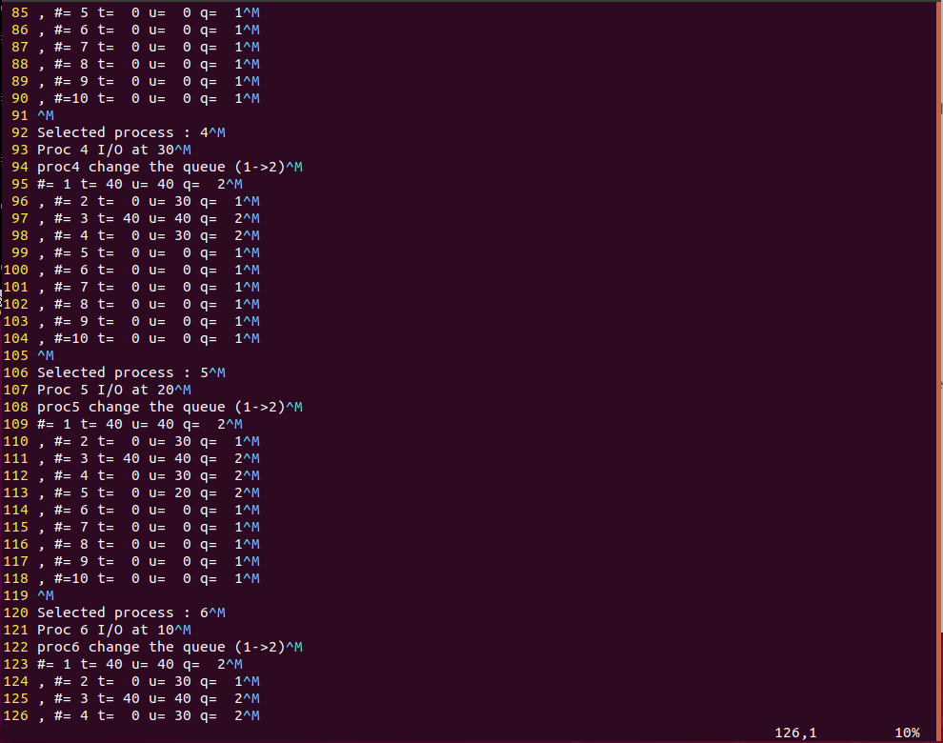

중간생략…

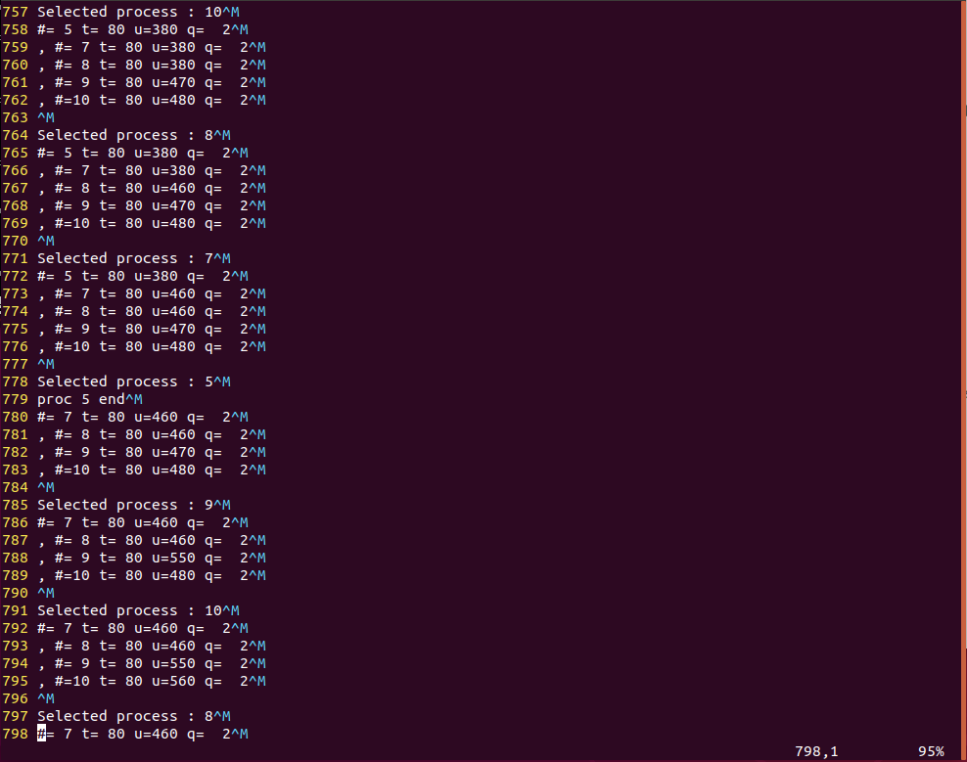

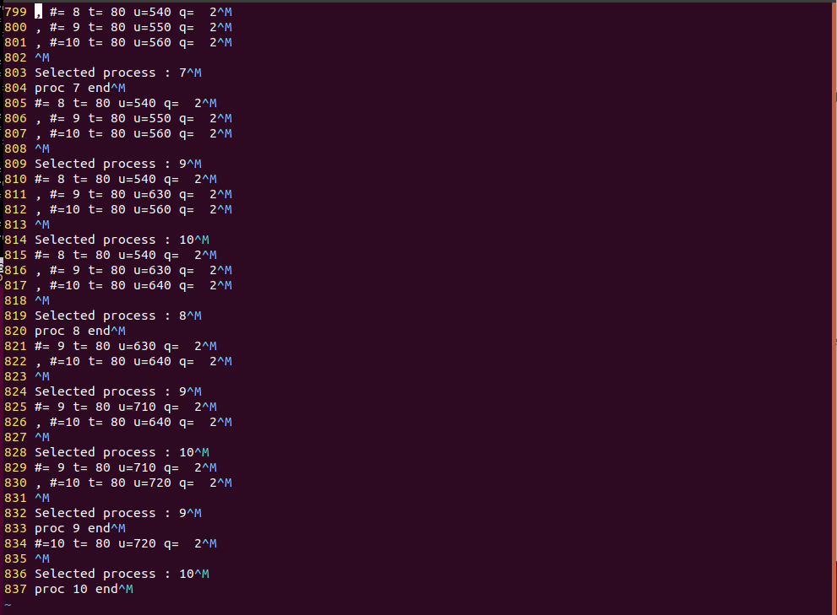

1. 소스코드

sched.c

#include <list.h>  
#include <proc/sched.h>  
#include <mem/malloc.h>  
#include <proc/proc.h>  
#include <proc/switch.h>  
#include <interrupt.h>  
#include <device/console.h>  
  
extern struct list level_que[QUE_LV_MAX];  
extern struct list plist;  
extern struct list slist;  
extern struct process procs[PROC_NUM_MAX];  
extern struct process *idle_process;  
  
struct process *latest;  
  
struct process* get_next_proc(struct list *rlist_target);  
void proc_que_levelup(struct process *cur);  
void proc_que_leveldown(struct process *cur);  
struct process* sched_find_que(void);  
  
int scheduling;  
  
/*  
    linux multilevelfeedback queue scheduler  
    level 1 que policy is FCFS(First Come, First Served)  
    level 2 que policy is RR(Round Robin).  
*/  
  
//sched_find_que find the next process from the highest queue that has proccesses.  
struct process* sched_find_que(void) {  
    int i,j;  
    struct process * result = NULL;  
       
    proc_wake();  
  
        /*TODO :check the queue whether it is empty or not    
         and find each queue for the next process.  
        */  
    while(result == NULL){  
        if(!list_empty(&level_que[1]))//1번 큐 찾기  
            result = get_next_proc(&level_que[1]);  
        else if(!list_empty(&level_que[2]))//2번 큐 찾기  
            result = get_next_proc(&level_que[2]);      
    }  
    return result;  
}  
  
struct process* get_next_proc(struct list *rlist_target) {  
    struct list_elem *e;  
  
    for(e = list_begin (rlist_target); e != list_end (rlist_target);  
        e = list_next (e))  
    {  
        struct process* p = list_entry(e, struct process, elem_stat);  
          
        if(p->state == PROC_RUN)  
        {  
            list_remove(e);//리스트에서 뺌  
            return p;  
        }  
    }  
    return NULL;  
}  
  
void schedule(void)  
{  
    struct process *cur;  
    struct process *next;  
    struct process *tmp;  
    struct list_elem *ele;  
    int i = 0, printed = 0;  
  
    scheduling = 1;      
    cur = cur_process;  
    /*TODO : if current process is idle_process(pid 0), schedule() choose the next process (not pid 0).  
    when context switching, you can use switch_process().    
    if current process is not idle_process, schedule() choose the idle process(pid 0).  
    complete the schedule() code below.  
    */  
  
    if ((cur -> pid) != 0) {  
        //0번 프로세스가 아니면 0번 프로세스로 바꿈  
        ele = list_begin(&level_que[0]);  
        next = list_entry(ele, struct process, elem_stat);  
        cur_process = next;  
        switch_process(cur, next);  
        return;  
    }  
          
        switch (latest -> que_level){  
            case 1:  
                //이전 프로세스가 1번큐였으면 2번큐로 바꿈  
                proc_que_leveldown(latest);  
                break;  
            case 2:  
                //이전 프로세스가 2번큐였으면 2번큐로 다시 푸쉬  
                if(latest->state!=PROC_ZOMBIE&&latest->state!=PROC_STOP)  
                    list_push_back(&level_que[2], &latest->elem_stat);  
                break;  
        }  
    proc_wake(); //wake up the processes   
      
    //print the info of all 10 proc.  
    for (ele = list_begin(&plist); ele != list_end(&plist); ele = list_next(ele)) {  
        tmp = list_entry (ele, struct process, elem_all);  
        if ((tmp -> state == PROC_ZOMBIE) ||   
            //(tmp -> state == PROC_BLOCK) ||   
            //    (tmp -> state == PROC_STOP) ||  
                    (tmp -> pid == 0))     continue;  
            if (!printed) {      
                printk("#=%2d t=%3d u=%3d ", tmp -> pid, tmp -> time_slice, tmp -> time_used);  
                printk("q=%3d\n", tmp->que_level);  
                printed = 1;              
            }  
            else {  
                printk(", #=%2d t=%3d u=%3d ", tmp -> pid, tmp -> time_slice, tmp->time_used);  
                printk("q=%3d\n", tmp->que_level);  
                }  
              
    }  
    //printk("que 1 size %d\n", list_size(&level_que[1]));  
    //printk("que 2 size %d\n", list_size(&level_que[2]));  
    if (printed)  
        printk("\n");  
    if ((next = sched_find_que()) != NULL) {  
        printk("Selected process : %d\n", next -> pid);      
        //프로세스를 next 프로세스로 바꿈          
        intr_enable();      
        next->time_slice = 0;  
        latest = next;  
        scheduling = 0;  
        cur_process = next;  
        switch_process(cur, next);  
        //프로세스를 0번 프로세스로 바꿈  
        ele = list_begin(&level_que[0]);  
        next = list_entry(ele, struct process, elem_stat);  
        cur_process = next;  
        switch_process(cur, next);  
        intr_disable();  
        return;  
    }  
    return;  
}  
  
void proc_que_levelup(struct process *cur)  
{  
    /*TODO : change the queue lv2 to queue lv1.*/  
    //큐레벨을 1로 바꿔준 다음 1번큐에 푸쉬  
    printk("proc%d ", cur->pid);  
    printk("change the queue (2->1)\n");  
    cur->que_level = 1;  
    list_push_back(&level_que[1], &cur->elem_stat);  
}  
  
void proc_que_leveldown(struct process *cur)  
{  
    /*TODO : change the queue lv1 to queue lv2.*/  
    //큐레벨을 2로 바꿔준 다음 2번큐에 푸쉬      
    printk("proc%d ", cur->pid);  
    printk("change the queue (1->2)\n");  
    cur->que_level = 2;  
    if(cur->state!=PROC_ZOMBIE&&cur->state!=PROC_STOP)  
        list_push_back(&level_que[2], &cur->elem_stat);  
}

proc.c

#include <list.h>  
#include <proc/sched.h>  
#include <mem/malloc.h>  
#include <proc/proc.h>  
#include <ssulib.h>  
#include <interrupt.h>  
#include <proc/sched.h>  
#include <syscall.h>  
#include <mem/palloc.h>  
#include <device/console.h>  
  
  
#define STACK_SIZE 512  
  
struct list plist;                  
struct list level_que[QUE_LV_MAX];  
struct list slist;                  
struct list dlist;                  
struct process procs[PROC_NUM_MAX];   
struct process *cur_process;  
struct process *idle_process;   
int pid_num_max;  
uint32_t process_stack_ofs;   
static int lock_pid_simple;   
static int lately_pid;   
  
bool more_prio(const struct list_elem *a, const struct list_elem *b, void *aux);  
bool less_time_sleep(const struct list_elem *a, const struct list_elem *b, void *aux);  
pid_t getValidPid(int *idx);  
void proc_start(void);  
void proc_end(void);  
  
  
void kernel1_proc(void *aux);  
void kernel2_proc(void *aux);  
void kernel3_proc(void *aux);  
void kernel4_proc(void *aux);  
void kernel5_proc(void *aux);  
void kernel6_proc(void *aux);  
void kernel7_proc(void *aux);  
void kernel8_proc(void *aux);  
void kernel9_proc(void *aux);  
void kernel10_proc(void *aux);  
  
extern int scheduling;  
  
void init_proc()  
{  
    int i, j;  
    process_stack_ofs = offsetof (struct process, stack);   
  
    lock_pid_simple = 0;  
    lately_pid = -1;  
  
    list_init(&plist);  
  
    for (i = 0; i < 3 ; i++) {  
            list_init(&level_que[i]);  
            printk("create level_que[%d]", i);  
    }  
  
    list_init(&slist);  
    list_init(&dlist);  
  
    for (i = 0; i < PROC_NUM_MAX; i++)  
    {  
        procs[i].pid = i;  
        procs[i].state = PROC_UNUSED;  
        procs[i].parent = NULL;  
    }  
  
    pid_t pid = getValidPid(&i);  
    cur_process = &procs[0];  
    idle_process = &procs[0]; //procs 0 is always idle  
  
    cur_process->pid = pid;  
    cur_process->parent = NULL;  
    cur_process->state = PROC_RUN;  
  
    cur_process -> nice = 0;  
    cur_process -> rt_priority = 0;  
    cur_process -> priority = cur_process -> nice + cur_process -> rt_priority;  
  
    cur_process->stack = 0;  
    cur_process->pd = (void*)read_cr3();  
    cur_process -> elem_all.prev = NULL;  
    cur_process -> elem_all.next = NULL;  
    cur_process -> elem_stat.prev = NULL;  
    cur_process -> elem_stat.next = NULL;  
  
    cur_process->que_level = 0 ;  
    list_push_back(&plist, &cur_process->elem_all);  
    list_push_back(&level_que[0], &cur_process->elem_stat);  
  
}  
  
pid_t getValidPid(int *idx) {  
    pid_t pid = -1;  
    int i;  
  
    while(lock_pid_simple);  
  
    lock_pid_simple++;  
  
    for(i = 0; i < PROC_NUM_MAX; i++)  
    {  
        int tmp = i + lately_pid + 1;  
        if(procs[tmp % PROC_NUM_MAX].state == PROC_UNUSED) {   
            pid = lately_pid + 1;  
            *idx = tmp % PROC_NUM_MAX;  
            break;  
        }  
    }  
  
    if(pid != -1)  
        lately_pid = pid;      
  
    lock_pid_simple = 0;  
  
    return pid;  
}  
  
pid_t proc_create(proc_func func, struct proc_option *opt, void* aux)  
{  
    struct process *p;  
    int idx;  
    int i,j;  
  
    enum intr_level old_level = intr_disable();  
  
    pid_t pid = getValidPid(&idx);  
    p = &procs[pid];  
    p->pid = pid;  
    p->state = PROC_RUN;  
  
    if(opt != NULL) {  
        p -> nice = opt -> nice; // not use.  
        p -> rt_priority = opt -> rt_priority;   //not use.  
    }  
    else {  
        p -> nice = 20;  
        p -> rt_priority = (unsigned char)45;  
    }  
  
    p -> priority = p -> nice + p -> rt_priority; //not use.  
    p -> que_level = 1;   
    p -> old_proc = 0;  
    p->time_used = 0;  
    p->time_slice = 0;  
    p->parent = cur_process;  
    p->simple_lock = 0;  
    p->child_pid = -1;  
    p->pd = pd_create(p->pid);  
  
    //init stack  
    int *top = (int*)palloc_get_page();  
    int stack = (int)top;  
    top = (int*)stack + STACK_SIZE - 1;  
  
    *(--top) = (int)aux;        //argument for func  
    *(--top) = (int)proc_end;    //return address from func  
    *(--top) = (int)func;        //return address from proc_start  
    *(--top) = (int)proc_start; //return address from switch_process  
  
    //process call stack :   
    //switch_process > proc_start > func(aux) > proc_end  
  
    *(--top) = (int)((int*)stack + STACK_SIZE - 1); //ebp  
    *(--top) = 1; //eax  
    *(--top) = 2; //ebx  
    *(--top) = 3; //ecx  
    *(--top) = 4; //edx  
    *(--top) = 5; //esi  
    *(--top) = 6; //edi  
  
    p -> stack = top;  
    p -> elem_all.prev = NULL;  
    p -> elem_all.next = NULL;  
    p -> elem_stat.prev = NULL;  
    p -> elem_stat.next = NULL;  
  
    list_push_back(&plist, &p->elem_all);  
    //큐레벨에 프로세스 푸쉬  
    list_push_back(&level_que[p->que_level], &p->elem_stat);  
     //TODO : when create first , input the level 1 queue  
  
    intr_set_level (old_level);  
    return p->pid;  
}  
  
void* getEIP()  
{  
    return __builtin_return_address(0);  
}  
  
void  proc_start(void)  
{  
    intr_enable ();  
    return;  
}  
  
void proc_free(void)  
{  
    uint32_t pt = *(uint32_t*)cur_process->pd;  
    cur_process->parent->child_pid = cur_process->pid;  
    cur_process->parent->simple_lock = 0;  
  
    cur_process->state = PROC_ZOMBIE;  
    list_push_back(&dlist, &cur_process->elem_stat);   
  
    palloc_free_page(cur_process->stack);   
    palloc_free_page((void*)pt);  
    palloc_free_page(cur_process->pd);  
  
    list_remove(&cur_process->elem_stat);  
    list_remove(&cur_process->elem_all);  
}  
  
void proc_end(void)  
{  
    intr_disable();//종료할거니까 멈춰라  
    proc_free();  
    printk("proc %d end\n", cur_process->pid);  
    schedule();  
    return;  
}  
  
void proc_wake(void)  
{  
    struct process* p;  
    int que_level;  
    int old_level;  
    unsigned long long t = get_ticks();  
    struct list_elem *e;  
        for(e = list_begin (&slist); e != list_end (&slist);  
        e = list_next (e))  
    {  
        struct process* p = list_entry(e, struct process, elem_stat);  
    }  
       while(!list_empty(&slist))  
    {  
            p = list_entry(list_front(&slist), struct process, elem_stat); //pop the sleep list of sleeping proc  
        if(p->time_sleep > t)  
            break;  
  
        list_remove(&p->elem_stat);      
        //i/o가 끝나면 1번큐로 바꿈          
        proc_que_levelup(p);  
        p->state = PROC_RUN;  
    }  
      
}  
  
void proc_sleep(unsigned ticks)  
{  
    intr_disable();//i/o 할거니까 멈춰라  
    unsigned long cur_ticks = get_ticks();  
    //프로세스 번호와 i/o 출력      
    scheduling = 1;  
    printk("Proc %d ",cur_process->pid);  
    printk("I/O at %d\n", cur_process->time_used);  
    scheduling = 0;  
    cur_process->time_sleep =  ticks + cur_ticks;  
    cur_process->state = PROC_STOP;  
    cur_process->time_slice = 0;  
    struct list_elem *e;  
      
    list_remove(&cur_process->elem_stat); //remove queue list  
  
    list_insert_ordered(&slist, &cur_process->elem_stat,  
            less_time_sleep, NULL); //order by less time sleep   
  
    list_sort (&slist,less_time_sleep, NULL);  
    schedule();  
}  
  
void proc_block(void) //io   
{  
    cur_process->state = PROC_BLOCK;  
    schedule();      
}  
  
void proc_unblock(struct process* proc)  
{  
    enum intr_level old_level;  
    list_push_back(&level_que[proc->que_level],&proc->elem_stat);  
    proc->state = PROC_RUN;  
}       
  
bool less_time_sleep(const struct list_elem *a, const struct list_elem *b,void *aux)  
{  
    struct process *p1 = list_entry(a, struct process, elem_stat);  
    struct process *p2 = list_entry(b, struct process, elem_stat);  
  
    return p1->time_sleep < p2->time_sleep;  
}  
  
bool more_prio(const struct list_elem *a, const struct list_elem *b,void *aux)  
{  
    struct process *p1 = list_entry(a, struct process, elem_stat);  
    struct process *p2 = list_entry(b, struct process, elem_stat);  
      
    return p1->priority > p2->priority;  
}  
  
void kernel1_proc(void* aux)  
{  
    int passed = 0;  
    while(1)  
    {  
        if ((cur_process -> time_used >= 80) && (!passed)) {  
          
            proc_sleep(60);  
            passed = 1;  
              
        }  
        if (cur_process -> time_used >= 200)  
            proc_end();      
    }  
}  
  
void kernel2_proc(void* aux)  
{  
    int passed = 0;  
    while(1)  
    {  
        if ((cur_process -> time_used >= 30) && (!passed)) {  
            proc_sleep(30);  
            passed = 1;  
              
        }  
  
        if (cur_process -> time_used >= 120) {  
            proc_end();  
        }  
    }  
}  
  
void kernel3_proc(void* aux)  
{  
    int passed = 0;  
  
  
    while(1)  
    {  
        if ((cur_process -> time_used >= 100) && (!passed)) {  
            proc_sleep(200);  
            passed = 1;  
          
        }  
  
        if (cur_process -> time_used >= 300) {  
            proc_end();  
        }  
    }  
}  
  
void kernel4_proc(void* aux)  
{  
    int passed1=0, passed2 = 0 ;  
  
    while(1)  
    {  
        if ((cur_process -> time_used >= 30) && (!passed1)){  
            proc_sleep(250);  
            passed1 = 1 ;  
          
        }  
          
        if ((cur_process -> time_used >= 80) && (!passed2)){  
            proc_sleep(300);  
            passed2 =1;  
              
        }  
  
        if (cur_process -> time_used >=300){  
            proc_end();  
        }  
    }  
   
}  
void kernel5_proc(void* aux)  
{  
    int passed1=0, passed2 = 0 ;  
    while(1)  
    {  
        if ((cur_process -> time_used >= 20) && (!passed1)){  
            proc_sleep(350);  
            passed1 = 1;  
              
        }  
        if ((cur_process -> time_used >= 100) && (!passed2)){  
            proc_sleep(50);  
            passed2 = 1;  
          
        }  
        if (cur_process -> time_used >=400)  
            proc_end();  
    }  
}  
  
void kernel6_proc(void* aux)  
{  
    int passed1=0, passed2 = 0, passed3 = 0, passed4 = 0;  
    while(1)  
    {  
        if ((cur_process -> time_used >= 10) && (!passed1)){  
            proc_sleep(10);  
            passed1 = 1;  
              
        }  
        if ((cur_process -> time_used >= 30) && (!passed2)){  
            proc_sleep(20);  
            passed2 = 1;  
              
        }  
        if ((cur_process -> time_used >= 100) && (!passed3)){  
            proc_sleep(200);  
            passed3 = 1;  
          
        }  
        if ((cur_process -> time_used >= 150) && (!passed4)){  
            proc_sleep(10);  
            passed4 = 1;  
              
        }  
  
        if (cur_process -> time_used >=200)  
            proc_end();  
    }  
}  
  
void kernel7_proc(void* aux)  
{  
    int passed1=0, passed2 = 0, passed3 = 0;  
    while(1)  
    {  
        if ((cur_process -> time_used >= 20) && (!passed1)){  
            proc_sleep(20);  
            passed1 = 1;  
              
        }  
        if ((cur_process -> time_used >= 40) && (!passed2)){  
            proc_sleep(200);  
            passed2 = 1;  
              
        }  
        if ((cur_process -> time_used >= 100) && (!passed3)){  
            proc_sleep(10);  
            passed3 = 1;  
              
        }  
        if (cur_process -> time_used >=500)  
            proc_end();  
    }  
}  
  
void kernel8_proc(void* aux)  
{  
    int passed = 0;  
    while(1)  
    {  
        if ((cur_process -> time_used >= 20) && (!passed)){  
            proc_sleep(200);  
            passed = 1;  
              
        }  
  
        if (cur_process -> time_used >=600)  
            proc_end();  
    }  
}  
  
void kernel9_proc(void* aux)  
{  
    int passed = 0;  
    while(1)  
    {  
        if ((cur_process -> time_used >= 30) && (!passed)){  
            proc_sleep(20);  
            passed = 1;  
              
        }  
  
        if (cur_process -> time_used >=750)  
            proc_end();  
    }  
}  
  
void kernel10_proc(void* aux)  
{  
    int passed = 0;  
    while(1)  
    {  
        if ((cur_process -> time_used >= 200) && (!passed)){  
            proc_sleep(100);  
            passed = 1;  
              
        }  
  
        if (cur_process -> time_used >=800)  
            proc_end();  
    }  
}  
  
void idle(void* aux)  
{  
    proc_create(kernel1_proc, NULL, NULL);  
    proc_create(kernel2_proc, NULL, NULL);  
    proc_create(kernel3_proc, NULL, NULL);  
    proc_create(kernel4_proc, NULL, NULL);  
    proc_create(kernel5_proc, NULL, NULL);  
    proc_create(kernel6_proc, NULL, NULL);  
    proc_create(kernel7_proc, NULL, NULL);  
    proc_create(kernel8_proc, NULL, NULL);  
    proc_create(kernel9_proc, NULL, NULL);  
    proc_create(kernel10_proc, NULL, NULL);  
    printk("create proc done\n");  
    struct list_elem *ele;  
    while(1) {    
        schedule();      
    }  
}  
  
  
  
void proc_print_data()  
{  
    int a, b, c, d, bp, si, di, sp;  
  
    //eax ebx ecx edx  
    __asm__ __volatile("mov %%eax ,%0": "=m"(a));  
  
    __asm__ __volatile("mov %ebx ,%eax");  
    __asm__ __volatile("mov %%eax ,%0": "=m"(b));  
      
    __asm__ __volatile("mov %ecx ,%eax");  
    __asm__ __volatile("mov %%eax ,%0": "=m"(c));  
      
    __asm__ __volatile("mov %edx ,%eax");  
    __asm__ __volatile("mov %%eax ,%0": "=m"(d));  
      
    //ebp esi edi esp  
    __asm__ __volatile("mov %ebp ,%eax");  
    __asm__ __volatile("mov %%eax ,%0": "=m"(bp));  
  
    __asm__ __volatile("mov %esi ,%eax");  
    __asm__ __volatile("mov %%eax ,%0": "=m"(si));  
  
    __asm__ __volatile("mov %edi ,%eax");  
    __asm__ __volatile("mov %%eax ,%0": "=m"(di));  
  
    __asm__ __volatile("mov %esp ,%eax");  
    __asm__ __volatile("mov %%eax ,%0": "=m"(sp));  
  
    printk(    "\neax %o ebx %o ecx %o edx %o"\  
            "\nebp %o esi %o edi %o esp %o\n"\  
            , a, b, c, d, bp, si, di, sp);  
}  
  
void hexDump (void *addr, int len) {  
    int i;  
    unsigned char buff[17];  
    unsigned char *pc = (unsigned char*)addr;  
  
    if (len == 0) {  
        printk("  ZERO LENGTH\n");  
        return;  
    }  
    if (len < 0) {  
        printk("  NEGATIVE LENGTH: %i\n",len);  
        return;  
    }  
  
    for (i = 0; i < len; i++) {  
        if ((i % 16) == 0) {  
            if (i != 0)  
                printk ("  %s\n", buff);  
  
            printk ("  %04x ", i);  
        }  
  
        printk (" %02x", pc[i]);  
  
        if ((pc[i] < 0x20) || (pc[i] > 0x7e))  
            buff[i % 16] = '.';  
        else  
            buff[i % 16] = pc[i];  
        buff[(i % 16) + 1] = '\0';  
    }  
  
    while ((i % 16) != 0) {  
        printk ("   ");  
        i++;  
    }  
  
    printk ("  %s\n", buff);  
}

interrupt.c

#include <interrupt.h>  
#include <device/console.h>  
#include <type.h>  
#include <device/pit.h>  
#include <proc/sched.h>  
#include <device/io.h>  
#include <device/kbd.h>  
#include <proc/proc.h>  
#include <ssulib.h>  
#include <proc/switch.h>  
#include <syscall.h>  
  
#pragma pack(push, 1)  
  
typedef struct _ID  
{  
    unsigned short LowOffset;  
    unsigned short CodeSelector;  
    unsigned short Type;  
    unsigned short HighOffset;  
} _ID;  
  
typedef struct _IDTR  
{  
    unsigned short Size;  
    unsigned long Address;  
} _IDTR;  
#pragma pack(pop)  
  
#ifndef ASSERT  
#define ASSERT(CONDITION) ( (void*) 0)  
#endif  
  
static unsigned long ticks;  
intr_handler_func *handlers[INTR_MAX];  
bool sched_on_return;  
static bool in_external_intr;    
_ID     *idt;  
extern int scheduling;  
unsigned long proc_ticks;  
extern struct list level_que[QUE_LV_MAX];  
  
typedef void intr_stub_func (void);  
void default_handler(struct intr_frame *iframe);  
void timer_handler(struct intr_frame *iframe);  
void syscall_handler(struct intr_frame *iframe);  
void intr_exit (void);  
extern intr_stub_func *intr_stubs[INTR_MAX];  
  
int init_intr(void)  
{  
    int i;  
    _IDTR   IDTR;  
    ticks = 0;  
    in_external_intr = false;  
    sched_on_return = false;  
    enum intr_level old_level = intr_disable();  
  
    __asm__ __volatile("sidt %0"::"m" (IDTR));  
    printk("idtr size : %d address : 0x%x\n", IDTR.Size, IDTR.Address);  
    idt = (_ID *)IDTR.Address;  
  
    for(i = 0; i < INTR_MAX; i++)  
    {  
        idt[i].LowOffset = (unsigned short)((unsigned long)intr_stubs[i] & 0xffff);  
        idt[i].CodeSelector = (unsigned short)CODE_SEGMENT;  
        idt[i].Type = (unsigned short)0x8e00;       
        idt[i].HighOffset = (unsigned short)(((unsigned long)intr_stubs[i] >> 16) & 0xffff);  
  
        handlers[i] = default_handler;  
    }  
  
    reg_handler(32, timer_handler);  
    printk("%s", "Timer Handler Registration\n");  
    printk("%s", "Keyboard Handler Registration\n");  
  
    reg_handler(0x30, syscall_handler);  
    printk("%s", "System Call Handler Registration\n");  
  
    intr_set_level (old_level);  
    return 1;  
}  
  
void intr_common(struct intr_frame *iframe)  
{  
    in_external_intr = iframe->vec_no >= 0x20 && iframe->vec_no < 0x30;  
  
    if(in_external_intr)  
    {  
        ASSERT (intr_get_level () == INTR_OFF);  
        sched_on_return = false;  
    }  
  
    if(handlers[iframe->vec_no] != NULL)  
        handlers[iframe->vec_no](iframe);  
    else  
        default_handler(iframe);  
  
    if(in_external_intr)  
    {  
        ASSERT (iframe->vec_no >= 0x20 && iframe->vec_no < 0x30);  
        in_external_intr = false;  
        outb(0x20, 0x20);  
  
        if(iframe->vec_no >= 0x28)  
            outb(0xa0, 0x20);  
  
        if(sched_on_return)  
            schedule();  
    }  
}  
  
void do_sched_on_return(void)  
{  
    ASSERT (intr_context ());  
    sched_on_return = true;  
}  
  
void reg_handler(unsigned short idx, intr_handler_func *handler)   
{  
    enum intr_level old_level = intr_disable();  
    handlers[idx] = handler;  
  
    intr_set_level (old_level);  
    return;  
}  
  
#define FLAG_MBS  0x00000002  
#define FLAG_IF   0x00000200  
  
enum intr_level intr_get_level (void)   
{  
    uint32_t flags;  
    asm volatile ("pushfl; popl %0" : "=g" (flags));  
    return flags & FLAG_IF ? INTR_ON : INTR_OFF;  
}  
  
enum intr_level intr_set_level (enum intr_level level)   
{  
    return level == INTR_ON ? intr_enable () : intr_disable ();  
}  
  
enum intr_level intr_enable (void)   
{  
    enum intr_level old_level = intr_get_level ();  
    ASSERT (!intr_context ());  
  
    asm volatile ("sti");  
  
    return old_level;  
}  
  
enum intr_level intr_disable (void)   
{  
    enum intr_level old_level = intr_get_level ();  
  
    asm volatile ("cli" : : : "memory");  
  
    return old_level;  
}  
  
bool intr_context (void)  
{  
    return in_external_intr;  
}  
  
unsigned long get_ticks(void)  
{  
    return ticks;  
}  
  
void default_handler(struct intr_frame *iframe)  
{  
    printk("\n\nint intr %d\n\n", iframe->vec_no);  
}  
  
void timer_handler(struct intr_frame *iframe)  
{  
    ticks++;  
    if ((cur_process -> pid != 0) && (!scheduling) && (cur_process->state == PROC_RUN)) {          
        //i/o시작 시간과 스케줄 시간이 겹치는 것을 고려해 구조 바꿈      
        if(cur_process->time_slice >= TIMER_MAX*cur_process->que_level)  
            do_sched_on_return();  
        else  
        {  
            cur_process->time_used++;      
            cur_process->time_slice++;  
        }  
    }  
  
#ifdef SCREEN_SCROLL  
    static unsigned long refresh_ticks = 0;  
    if(++refresh_ticks >= (PIT_FRQ_HZ/REFRESH_FPS)) {  
        refresh_ticks = 0;  
        refreshScreen();  
    }  
#endif  
}  
  
void syscall_handler(struct intr_frame *iframe)  
{  
    long sys_num, arg_num, ret;  
    int *pt;  
    int i;  
  
#define SYSCALL_ARG_MAX 3  
    long arg[SYSCALL_ARG_MAX];  
  
    pt = (int*) (((int)&iframe->ss) - 4);  
    sys_num = *pt++;  
    arg_num = syscall_tbl[sys_num][1];  
  
    for(i = 0; i<arg_num; i++)  
        arg[i] = *pt++;  
  
    switch(arg_num)  
    {  
        case 0:  
            ret = ((int(*)(void))syscall_tbl[sys_num][0])();  
            break;  
        case 1:  
            ret = ((int(*)(int))syscall_tbl[sys_num][0])(arg[0]);  
            break;  
        case 2:  
            ret = ((int(*)(int, int))syscall_tbl[sys_num][0])(arg[0], arg[1]);  
            break;  
        case 3:  
            ret = ((int(*)(int, int, int))syscall_tbl[sys_num][0]) (arg[0], arg[1], arg[2]);  
            break;  
    }  
      
    *(pt + 3) = ret;          
}