Beyond technical potential: an optimization-based assessment of profitability, robustness, and sustainability in Colombia's palm oil biomass-to-power routes
Complete draft for co-author review, prepared ahead of journal submission (Journal of Cleaner Production)
Juan Camilo Barrera-Hernandez, Electo Eduardo Silva Lora, Alexis Sagastume Gutierrez, Jesús Alberto García-Nuñez
NEST, Excellence Group in Thermal Power and Distributed Generation, Institute of Mechanical Engineering, Federal University of Itajubá, Av. BPS 1303, Itajubá, MG, CEP: 37500-903, Brazil
Department of Civil Engineering, Faculty of Distance Studies, Nueva Granada Military University, Cajicá 250247, CU, Colombia
Colombian Oil Palm Research Centre, Cenipalma, Calle 98 N° 70 - 91 Piso 14, Bogotá, Colombia

Abstract
Colombia's palm oil residual biomass has long been recognized as a technically viable energy source and an energy-transition candidate, yet that recognition has not translated into deployment, raising the question of whether the gap is financial rather than technical. This study assesses profitability, robustness, and sustainability trade-offs across two mature biomass-to-power routes, both pairing a steam turbine with biogas from palm oil mill effluent: Scenario 1 emphasizes the turbine, Scenario 2 emphasizes biogas, adding co-digested effluent and pretreated empty fruit bunches. A mixed integer optimization model covers six extraction plants in the Magdalena department, assessing economic, environmental, and social outcomes jointly.
Each scenario is profitable at its own economic optimum but diverges sharply beyond it: Scenario 2 stays profitable across its entire range, while Scenario 1 turns negative almost immediately past its optimum, since turbine losses far exceed biogas losses and its surplus is capped into the lowest-value spot market once retail-linked tiers fill. At full deployment, no mill remains profitable under Scenario 1, against four of six under Scenario 2; what separates viable mills from unviable ones is less the technology chosen than annual operating hours, a pattern invisible at the departmental scale. Both scenarios already cover the department's entire rural residential demand at their own economic optimum; beyond that, Scenario 1 avoids more emissions given its larger potential, but closing the gap costs USD 294 per additional tonne of CO2 for Scenario 1 against USD 599 for Scenario 2, both above Colombia's carbon tax. Neither route dominates outright.
Keywords: palm oil mill effluent; empty fruit bunch; multi-objective optimization; feed-in tariff; carbon abatement cost; plant-level heterogeneity

Nomenclature
Sets and indices
Symbol | Description
i ∈ I | Plant index, I = {A, B, C, D, E, F}
j ∈ J_{i} | Turbine catalog option available to plant i
b ∈ B | Biomass fraction, B = {fiber, shell, EFB}
k = 0,…,10 | Interval index of the epsilon-constraint sweep
Decision variables
Symbol | Description | Unit
y_{i,j} | 1 if turbine option j is selected for plant i, 0 otherwise | binary
n_{i} | Number of 1,000 kW biogas engine modules installed at plant i | integer
u^{turb}_{i}, u^{bio}_{i} | Utilization factor of the turbine and biogas routes at plant i | [0,1]
E^{auto}_{i}, E^{permuta}_{i}, E^{bolsa}_{i} | Annual energy allocated to the self-consumption, energy-credit, and spot-market tiers at plant i | kWh/yr
Parameters
Symbol | Description | Unit
S_{i}, S_{ref} | Installed capacity of plant i's equipment; reference capacity for cost scaling | kW or t FFB/h
C_{ref} | Reference equipment cost at Sref | USD
CEPCI_{y} | Chemical Engineering Plant Cost Index in year y | –
PVAF | Present value annuity factor | –
r, N | Discount rate (10%), project lifetime (20 yr) | %, yr
α | Operating and maintenance rate (2.5% of capital cost) | %/yr
p^{retail}_{i} | Plant i's own weighted retail electricity price | USD/kWh
p^{spot} | Wholesale spot market price | USD/kWh
h_{i} | Annual operating hours of plant i | h/yr
η^{net}_{turb}, η^{net}_{bio} | Net conversion factors, turbine and biogas routes | –
D_{i} | Plant i's own electricity demand | kWh/yr
OC^{bio}_{i}, OC^{EFB}_{i} | Opportunity cost of fiber/shell (PKS/MF value) and of EFB (Net Fertilizer Replacement Value) diverted from their current use at plant i | USD/yr
u^{EFB}_{i} | Utilization variable scaling the EFB opportunity cost; equals uturbi under Scenario 1, ubioi under Scenario 2 | [0,1]
EF_{biomass}, EF_{biogas}, EF_{diesel}, EF_{grid} | Emission factors for biomass, biogas, diesel, and grid displacement | kg CO2eq/unit
c_{HH} | Average annual rural household electricity consumption (346) | kWh/hh/yr
N^{rural} | Total rural households in the department | households
C_{i} | Equipment CAPEX (before annualization) | USD
C^{bio}_{i} | Modular biogas generator CAPEX | USD
C_{unit} | Cost per 1,000 kW biogas module | USD
C^{ann}_{i} | Annualized CAPEX | USD/yr
C^{total}_{i} | Total CAPEX (fixed + variable) | USD
OM_{i} | Operating and maintenance cost | USD/yr
P^{turb}_{i}, P^{bio}_{i} | Rated capacity of selected turbine and biogas modules | kW
R_{i} | Annual revenue from the three-tier tariff structure | USD/yr
f₁ | Objective 1: annual net benefit (maximized) | USD/yr
f₂ | Objective 2: annual net electricity generation (maximized) | kWh/yr
ε_{k} | Floor on f2 at sweep interval k | kWh/yr
LCOE_{i} | Levelized cost of electricity (export basis) | USD/kWh
ΔGHG_{i} | Net avoided greenhouse gas balance | kg CO2eq/yr
m^{biomass}_{i} | Mass of solid biomass combusted | t/yr
V^{biogas}_{i} | Volume of biogas combusted | m3/yr
E^{diesel}_{i} | Backup diesel electricity generated | kWh/yr
HH_{i} | Rural household-equivalent coverage | households
Abbreviations: CAPEX, capital expenditure; O&M, operation and maintenance; LCOE, levelized cost of electricity; MILP, mixed-integer linear programming; FFB, fresh fruit bunches; EFB, empty fruit bunches; POME, palm oil mill effluent; HHV, higher heating value; BMP, biochemical methane potential.

1. Introduction
Colombia's oil palm agroindustry generates large volumes of residual biomass, EFB, fiber, shell, and POME, whose energy potential has been documented for nearly two decades. Arrieta et al. (2007) first analyzed cogeneration potential across three Colombian POMs through case studies, already pointing to operating hours and capacity utilization as central to viability. That potential has since been quantified repeatedly and consistently upward: 61,078 GWh across agriculture, agroindustry, livestock, and slaughterhouse waste nationally (Sagastume Gutierrez et al., 2020), narrowed to 61 to 227 MW of electricity capacity for the palm sector specifically (Barrera Hernandez et al., 2024), 2,762 kilotonnes of available palm biomass waste for 2023 across 45 companies (Alean et al., 2025), and a projected rise from 840 PJ in 2010 to 1,400 PJ by 2030 (Gonzalez-Salazar et al., 2014). Economic assessments remain aggregate by comparison: Ramirez-Contreras et al. (2020), Boom-Cárcamo et al. (2025), and Martinez et al. (2025) evaluate national, cluster-level, and regional scenarios, none disaggregated to individual POMs; Montoya et al. (2020) come closest, simulating the same two turbine technologies examined in this study for a single representative POM, but reporting levelized cost rather than a multi-POM comparison. Despite two decades of documentation, deployment remains marginal. What, then, is the actual constraint: technical, financial, or something else entirely?
Answering that question requires more than another estimate of potential; it requires a tool suited to compare investment decisions under competing objectives. Mathematical optimization offers exactly that. MILP has supported palm biomass supply-chain design in Sumatra and multiperiod scheduling of a combined biomass, biogas, and solar system in Malaysia (Harahap et al., 2019; Ho et al., 2015). Multi-objective formulations solved via the epsilon-constraint method, the same approach adopted in this study, have compared pyrolysis technologies and evaluated waste-to-energy deployment under a carbon tax (Teh et al., 2023; Aprilianto and Rau, 2025), while other MILP models have optimized feed-in tariff participation and compared carbon tax against cap-and-trade (Nair et al., 2022; Memari et al., 2018). Closer to home, mathematical programming has been applied to Colombian palm and biodiesel supply chains, from facility siting and bioenergy generation (Peña González et al., 2021) to trade-offs among cost, food security, and emissions (Orjuela-Castro et al., 2019), but always as one design decision embedded in a broader supply-chain problem, at a national rather than a POM-specific scale. A critical gap therefore remains in POM-level MILP modeling to assess profitability against infrastructure constraints and energy policy in Colombia; nor has the epsilon-constraint method been applied to derive Pareto fronts for mature cogeneration technologies in this sector, a gap this study closes by revealing why technical potential rarely coincides with the economic optimum under real tariff schemes.
This tension between the economic optimum and what is technically and environmentally optimal has received limited attention in the palm biomass valorization literature. The same gap holds outside Colombia: assessments elsewhere (e.g., Sodri and Septriana, 2022, in Indonesia) are similarly confined to a single mill or a national aggregate. Two practically important questions therefore remain unanswered: does profitability hold uniformly across POMs of different sizes and operating conditions, or is it concentrated in a subset, with implications for whether policy support should be broad or targeted; and how large is the gap between what a private investor would rationally choose to deploy and the full technical potential, and how much profit would a POM have to give up to close it?
Converting technical potential into installed capacity is not automatic. Bioenergy generation is a discretionary investment outside a POM's core business, exposed to electricity prices, self-generation regulation, and technology costs that are irrelevant to producing crude palm oil. The relevant question for an investor is therefore not whether it is technically feasible or environmentally desirable, both well established, but whether it is profitable enough to justify entering an unfamiliar line of business — whether the deployment level that maximizes a POM's own profit falls short of what is technically achievable. From a system perspective, however, more renewable generation is unambiguously beneficial: it strengthens grid robustness and supports decarbonization and rural electrification targets Colombia has struggled to meet despite ample unused potential (Cabello Eras et al., 2018; Martinez et al., 2025), regardless of whether the private return reflects that value. This value is codified in Colombia's energy-transition law, which frames non-conventional renewable deployment as a compliance mechanism for its Nationally Determined Contribution under the Paris Agreement, most recently updated to a 2035 ceiling of 155–161 million tonnes CO2-equivalent en route to carbon neutrality by 2050 (Congreso de la República de Colombia, 2021; Ministerio de Ambiente y Desarrollo Sostenible, 2025).
The resource itself is what makes this comparison possible in the first place. Colombia's palm oil residues are relatively abundant, carry a real opportunity cost given competing uses such as soil amendment, and differ enough in physicochemical characteristics, moisture content, calorific value, digestibility, across fractions, fiber, shell, EFB, effluent, that POMs can plausibly route them toward more than one valorization pathway. Of the available pathways, electricity generation is the most technologically mature: steam cycles have reached high technology readiness levels in prior comparative assessments (Dovichi Filho et al., 2021), and POME-based biogas power generation is likewise commercially proven (Sodri and Septriana, 2022), unlike lower-TRL alternatives such as gasification or pyrolysis.
This study examines two such routes, both aimed at electricity but each built around a different use of the same swing fraction, EFB: an extraction condensation steam turbine that maximizes cogeneration, burning EFB alongside fiber and shell, and a backpressure turbine that maximizes anaerobic digestion instead, co-digesting EFB with POME rather than combusting it. The two scenarios span the extremes of how a POM could route this swing fraction, combustion or digestion, rather than an intermediate blend, building on an established line of Colombian palm-to-biorefinery research (Garcia-Nunez et al., 2016). A mixed integer optimization model is developed for six POMs in the Magdalena department, jointly assessing economic, environmental, and social outcomes. The central claim of this study is that technical potential and the economic optimum are not the same thing, and the gap between them, not the existence of the resource, is what should guide policy. The analysis quantifies that gap for each technology route, evaluates POM-level profitability and its robustness to electricity price fluctuations, and estimates the cost, in forgone profitability, of closing it. In doing so, this study reframes the relevant policy question from whether this transition needs to be subsidized to which technological route policy should favor, and for which POMs targeted intervention may be warranted.

2. Materials and Methods
This study builds on the gap identified above: whether the economic optimum falls short of the technical potential because biomass availability limits it, because market and regulatory conditions make full deployment unprofitable, or because the technological route selected shapes what a POM can profitably capture. A multi-objective mixed-integer linear programming (MILP) model was built in Python 3 using the Pyomo algebraic modelling library and solved with the GLPK solver, a formulation chosen because the problem combines discrete equipment choices, turbine size, digester count, with continuous flows of biomass, steam, and electricity, and requires the full trade-off frontier between competing objectives rather than a single weighted solution (justified further in Section 2.2.3). The model was parameterized with primary operational data from six palm oil mills and used to generate Pareto fronts of profitability against biomass deployment; the levelized cost of electricity (LCOE), the greenhouse gas balance, and rural electricity coverage were subsequently evaluated at every point of each front. All data cleaning, modeling, and post-processing steps are implemented in openly available Jupyter notebooks (see Data availability).
The original spreadsheets, laid out with one column per plant for ease of reading, were restructured into a tidy long format query able by the optimization model, normalizing eleven processing stages across the six mills, from reception through the boiler house. Data quality was audited rather than assumed: reported values were cross-checked against physical and stoichiometric first principles rather than taken at face value, and the resulting corrections were treated as model outputs subject to validation, not as fixed inputs.

2.1 Study area and data collection

2.1.1 Plant characterization and biomass availability
This study covers six palm oil mills, POMs (Plants A to F) located in the Magdalena department, on the Caribbean coast of Colombia. Primary data were collected in the field in 2022 and comprise process flows, steam and electricity consumption by processing stage, biomass yields, fuel use, and equipment inventories. Nominal processing capacities range from 20 to 40 tonnes of fresh fruit bunches per hour, and actual annual throughput ranges from 38,620 to 206,200 tonnes, reflecting substantial heterogeneity in scale and utilization across the sample (Table 1). Annual operating hours also vary widely, from 1,931 hours per year at Plant F to 5,920 hours per year at Plant C; this difference turns out to matter a great deal for profitability, as Section 4.2 shows.
Biomass composition data used to compute the higher heating value of each fraction (fiber, shell, empty fruit bunches) are consistent with those used in the author's preceding potential-quantification study of this same sector (Barrera Hernandez et al., 2024), while effluent characterization came from each POM's own process-control laboratory. Table 1 shows the resulting biomass fractions per tonne of fresh fruit bunches processed, consistent with typical ranges reported for the sector: empty fruit bunches at 21 to 24%, fiber at 12 to 13%, shell at 6 to 7%, and palm oil mill effluent at 0.55 to 0.65 m3 per tonne. The organic load of the effluent, expressed as chemical oxygen demand, ranges from 74,496 to 122,973 mg/L across the six plants, the basis for the biogas yield calculation described in Section 2.2.3.
Table 1 — Plant characterization and annual biomass availability
Plant | Capacity (t FFB/h) | Hours (h/yr) | FFB processed (t/yr) | Shell (t/yr) | Fiber (t/yr) | EFB (t/yr) | POME (m3/yr)
A | 30 | 5,105 | 153,150 | 9,189 | 18,837 | 37,215 | 91,890
B | 40 | 5,155 | 206,200 | 8,496 | 25,775 | 46,395 | 123,720
C | 30 | 5,920 | 177,600 | 7,992 | 22,555 | 40,670 | 106,560
D | 24 | 5,496 | 131,904 | 7,519 | 16,356 | 24,534 | 79,142
E | 30 | 3,147 | 94,410 | 3,444 | 12,368 | 22,979 | 56,646
F | 20 | 1,931 | 38,620 | 2,703 | 4,905 | 8,245 | 23,172
Sanity check passed: POME/FFB ratio ≈ 0.6 m3/t (Plant A), within the typical literature range of 0.5 to 0.7 m3/t FFB.

2.1.2 Current energy configuration
At present, two of the six POMs already operate on-site power generation: Plant A meets 79.1% of its electricity demand through existing steam cogeneration, and Plant D meets 70.0% of its demand through an existing biogas system; the remaining four POMs rely entirely on grid supply for electricity (Table 2). Process thermal demand, in contrast, is met entirely from each POM's own boiler in all six cases; there is no grid substitute for process steam. It is 13.5 to 26.4 times larger than electricity demand, which is typical for a process this steam intensive. This existing infrastructure is treated as a baseline condition rather than as a modeled investment in either scenario, and its implications for the marginal investment case of Plants A and D are examined separately in Section 3.4.
Table 2 — Current (baseline) energy configuration
Plant | Electricity consumption (MWh/yr) | Self-generation (%) | Self-generation source | Thermal demand (kWth) | Thermal demand (MWh_th/yr)
A | 3,083.7 | 79.1 | Steam cogeneration (existing) | 11,627.4 | 59,357.9
B | 5,398.1 | 0.0 | Grid only | 14,954.1 | 77,088.2
C | 2,740.9 | 0.0 | Grid only | 12,199.8 | 72,222.8
D | 3,746.2 | 70.0 | Biogas (existing) | 9,180.4 | 50,455.2
E | 2,281.7 | 0.0 | Grid only | 10,323.7 | 32,488.7
F | 702.9 | 0.0 | Grid only | 7,436.5 | 14,360.0
Sanity check passed: thermal-to-electric demand ratio ranges from 13.5x (Plant D) to 26.4x (Plant C), consistent with the steam-intensive profile typical of palm oil extraction.

2.2 Model formulation

2.2.1 Modeling workflow overview
A single flow diagram summarizes the two-phase modeling process described throughout this section: data inputs feed technical sizing per POM, which determines CAPEX and O&M, followed by MILP optimization, the resulting Pareto front, the sustainability indicators computed at every point of that front, and finally the sensitivity analyses of Section 2.6. The full formal notation for each step, introduced as it is used, follows in the remainder of this section.
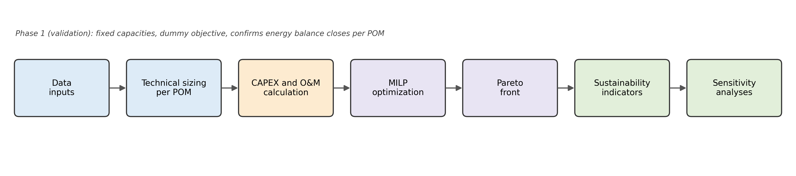
Figure 1 — Modeling workflow overview.

2.2.2 System boundary and scenario definitions
This is an incremental analysis: the system boundary is drawn at the POM gate, and only the additional investment and operating costs of energy valorization (boilers, turbines, flue gas treatment, digesters, biogas engines, and related process substitutions) are considered. The existing extraction process is assumed identical across all cases, so its own costs and revenues are excluded from both sides of the comparison. Combustion of biogenic carbon is treated as climate neutral following IPCC convention; only CH4 and N2O from combustion, together with fossil diesel use, are accounted as emissions.
Three configurations are compared. The baseline reproduces the POMs' measured current operation, in which low pressure boilers supply process steam and electricity is drawn from up to three sources: on site biomass cogeneration where it exists, the national grid, and back up diesel generation. The baseline is not a design case but a validation case, used to confirm that the model reproduces the POMs' measured energy balances before either scenario is evaluated (Section 2.2.3).
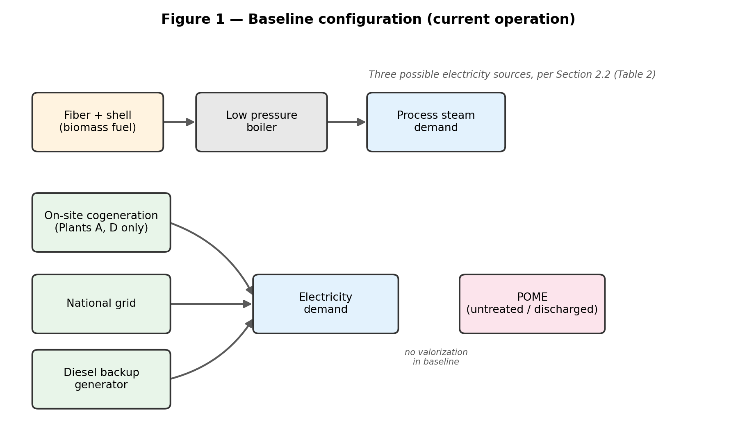
Figure 2 — Baseline configuration: current operation, as measured across the six mills (Section 2.1.2).
Scenario 1 (extraction condensation route with POME digestion) combusts all solid residues, fiber, shell, and EFB, in a high-pressure boiler; all EFB generated by the POM is routed to combustion under this scenario, none of it diverted to digestion or soil application. Before combustion, EFB is mechanically pretreated in a rotary dryer using residual heat from the boiler's own flue gases, reducing its moisture from 50% to 15% (Ocampo Batlle et al., 2020). Burning EFB directly, rather than diverting it elsewhere, has become an increasingly common practice despite EFB's comparatively high alkali index, driven mainly by its potassium content, which promotes ash clinkering and fouling in the boiler and raises operating and maintenance costs if the fuel is not properly pretreated (Alaw and Sulaiman, 2019). An extraction condensation steam turbine bleeds steam to satisfy process heat demand and expands the remainder to condensing conditions to maximize electricity output. POME is anaerobically digested, and the resulting biogas fuels a gas engine; EFB is not part of this digestion stream. Continuous sterilization, operating at 1 bar and 120°C, replaces the conventional batch process in this scenario; the additional steam it requires is drawn from the same high-pressure boiler already sized for EFB combustion.
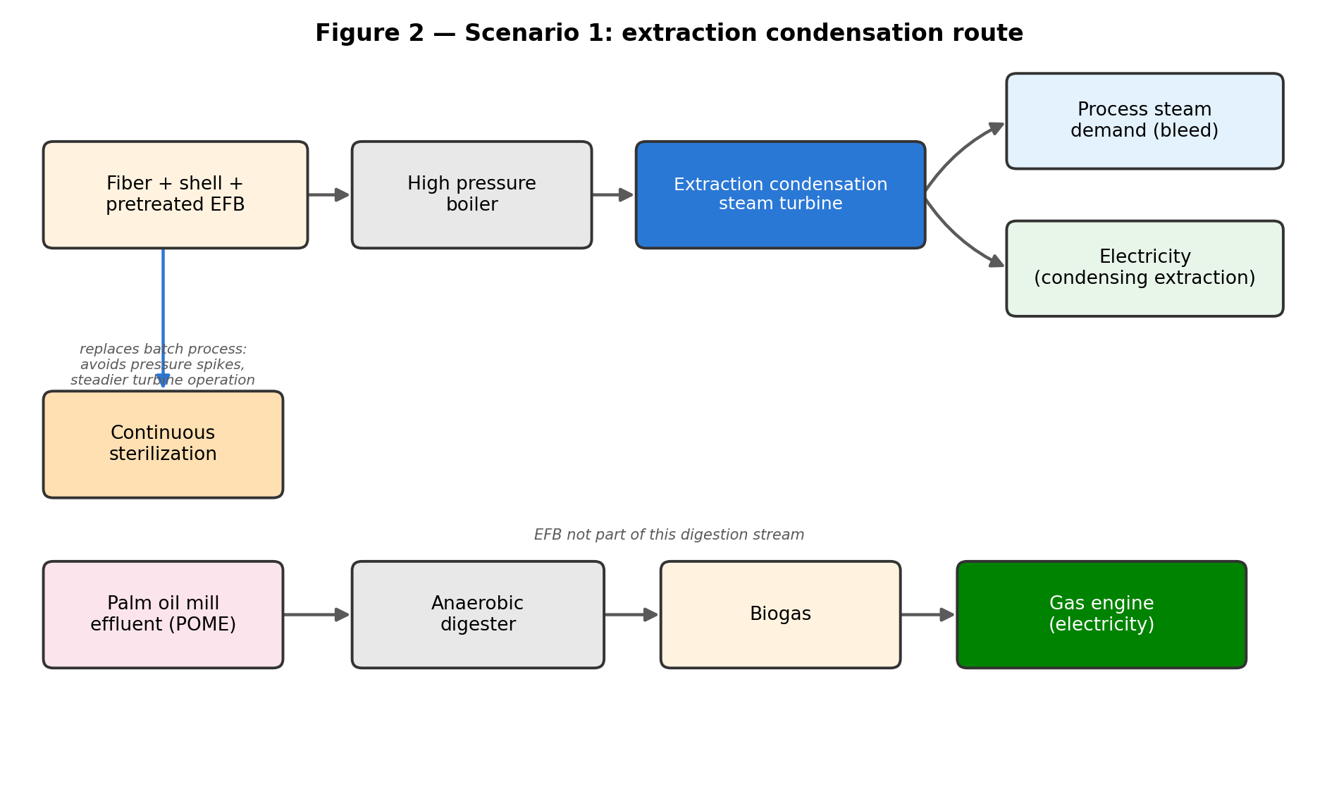
Figure 3 — Scenario 1: extraction condensation route. The turbine and biogas routes are independent generation paths sharing only the plant's overall revenue and cost accounting.
Scenario 2 (backpressure route with co-digestion) combusts only fiber and shell, in a lower pressure boiler feeding a backpressure turbine whose exhaust steam supplies the entire process heat demand; all EFB generated by the POM is withdrawn from the combustion train under this scenario, none of it burned. Instead, EFB is thermally pretreated by steam explosion, at 16 bar and consuming 0.3 tonnes of steam per tonne of biomass, with 50% of that steam recovered internally and roughly 1 kWh of electricity consumed per tonne of EFB processed (Voogt et al., 2021), to raise its biodegradability before co-digestion with palm oil mill effluent, so that the anaerobic route carries a substantially larger organic load than in Scenario 1. Continuous sterilization is not implemented in this scenario: the additional steam demand it requires could not be met by the energy available from the reduced solid biomass stream (fiber and shell only), so the conventional batch process is retained. Dynamic clarification, which does not add steam demand, replaces the conventional stage in both scenarios.
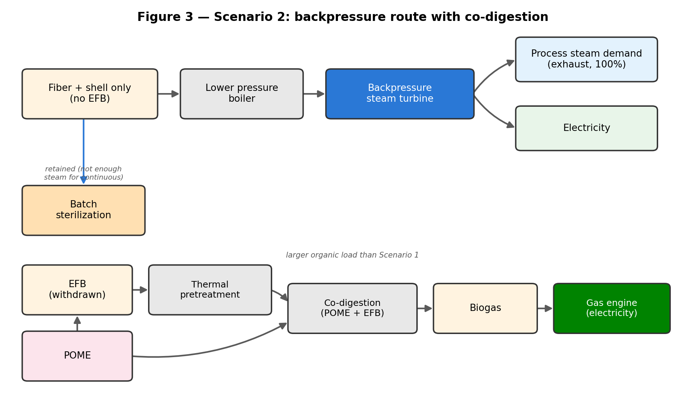
Figure 4 — Scenario 2: backpressure route with co-digestion. Note the larger anaerobic organic load compared with Figure 3, since EFB is routed to digestion rather than combustion.
Boiler and turbine design parameters follow operating conditions reported for comparable installations (Booneimsri et al., 2018, for the Scenario 2 turbine); EFB biochemical methane potential follows Thomsen et al. (2014), and organic load removal, biogas yield, and CH4 content follow Voogt et al. (2021).

2.2.3 Optimization model
The model was developed in two phases. Phase 1 (validation) formulates each configuration with fixed capacities and no degrees of freedom, using a dummy objective; its purpose is to confirm that the thermal balance and the electricity balance close simultaneously for each mill before any decision variable is introduced. All three configurations returned optimal status for the six mills, confirming the internal consistency of the cleaned dataset.
Phase 2 (superstructure) releases equipment capacity as a decision variable. Two generation routes are represented independently for each mill: a steam turbine selected from a discrete commercial catalogue by binary variables, and a modular biogas engine sized as an integer number of 1,000 kW units (Equation 1), a modularity consistent with units reported for POME-to-biogas installations.
$C_{i}^{bio} = n_{i} × C_{unit}, n_{i} ∈ Z_{≥0}$ (1)
Each route carries its own continuous utilization factor, bounded between zero and one. Biomass availability is the binding physical constraint: no route may generate more energy than its substrate allows.
Surplus electricity is remunerated through three tiers, in descending order of value. Self-consumption and an energy-credit tier both pay the POM's own weighted retail electricity price (0.114 to 0.259 USD/kWh, computed from each POM's measured supply mix), since both displace a retail purchase rather than reaching the spot market; because they pay the same price, only their combined volume matters, and it is capped jointly at the POM's own metered demand. Any generation beyond that joint cap is sold at the spot price (0.0703 USD/kWh, the eleven-month average of the wholesale market, adopted to smooth out its high short-term volatility). Because the two retail-linked tiers are priced identically, how the solver splits volume between them is immaterial to profitability; only the joint cap against metered demand affects the result (Equation 2).
$R_{i} = p_{i}^{retail}\left(E_{i}^{auto} + E_{i}^{permuta}\right) + p^{spot} E_{i}^{bolsa}, s.t. E_{i}^{auto} + E_{i}^{permuta} ≤ D_{i}$ (2)

2.3 Model parameters

2.3.1 Regulatory framework represented in the model
Three families of instruments govern the economics of distributed bioenergy in Colombia, and the model represents them asymmetrically, a choice made explicit here because it conditions the interpretation of the results.
CREG Resolution 174 of 2021 governs remuneration of surplus electricity from small-scale self-generators (up to 1 MW) and is the only instrument embedded in the optimization itself: exported energy is first netted against the POM's own grid import within the billing period as an energy credit, valued at the retail rate minus a commercialization charge; any surplus beyond that import is instead settled at the hourly wholesale spot price. Because it sets the marginal revenue of each additional kWh, this tiered structure directly shapes the sizing decision and is described formally in Section 2.2.3.
Capital-side tax incentives for non-conventional renewable sources (Law 1715 of 2014, as amended by Law 2099 of 2021), income tax deduction, VAT exclusion, and accelerated depreciation that together can reduce effective capital cost by up to 30%, are deliberately not represented in the base case; the economic results reported in Section 3 are therefore conservative by construction, and the magnitude of this omission is quantified separately in the sensitivity analysis of Section 2.6.
The current carbon tax (Decree 926 of 2017, currently USD 8.70/tCO2 under DIAN Resolution 000003 of 2026) is likewise treated as context rather than embedded in the optimization, and is assessed against the model's avoided-emissions outputs in Section 4.3.

2.3.2 Techno-economic parameters
Capital costs for the boiler and steam turbine are derived from seven independent supplier quotations obtained in August 2022: four for the boiler, from three suppliers (Boilermech and Mackenzie Industries, Malaysia; TECNINTEGRAL, Colombia), and three for the turbine, from two suppliers (PRIME and PMT Industries/SHINKO, both Malaysia). All quotations are equipment-only (EXW or FOB), excluding installation, transport, and civil works, which are costed separately. Because reference capacities varied across quotations (8,000 to 15,000 kg/h steam for boilers, 200 to 600 kW for turbines), costs were scaled to each POM's own capacity using the six-tenths rule (Equation 3) and escalated to 2026 USD using the Chemical Engineering Plant Cost Index. No comparable market quotation was obtained for anaerobic digestion or biogas generation equipment; capital costs for that route are instead based on actual investment costs reported for a real operating biogas cogeneration project (Entrepalmas S.A.S.; Silva-Imbachi, 2019), with organic loading and biogas yield parameters drawn from Rahayu et al. (2015).
$C_{i} = C_{ref}{\left(\frac{S_{i}}{S_{ref}}\right)}^{0.6} × \frac{{CEPCI}_{2026}}{{CEPCI}_{2019}}, {CEPCI}_{2019} = 607.5, {CEPCI}_{2026} ≈ 873.8$ (3)
This replaces an earlier, invalid linear CAPEX assumption in which boiler cost was inadvertently double counted with turbine cost. Investments are annualized with a present value annuity factor of 8.5136, corresponding to a 10% discount rate over a 20-year lifetime.
$PVAF = \frac{{\left(1 + r\right)}^{N} - 1}{r{\left(1 + r\right)}^{N}}, r = 10\%, N = 20 yr$ (4)
Operating and maintenance costs are taken as 2.5% of capital cost per year, applied to both fixed and variable CAPEX.
${OM}_{i} = α × C_{i}^{total}, α = 0.025$ (5)
A distinction is made between capital costs that respond to the sizing decision, turbine and biogas engine, and those that do not (boiler, flue gas treatment, digester lagoons, process substitutions), dimensioned instead by throughput. Only the former enters the solver's objective, since the latter cannot alter the optimal solution; both are included in the reported net benefit, so profitability reflects the full incremental investment.
Diverting solid biomass toward energy generation also carries an opportunity cost: fiber and shell are priced at existing PKS/MF market rates, and EFB, valued as a soil amendment, is estimated through a Net Fertilizer Replacement Value (NFRV): empty fruit bunches release plant available nutrients (N, P, K, Mg) as they decompose in the field, at rates of 7.7, 2.3, 21.7, and 3.3 kg of equivalent synthetic fertilizer per tons of fresh EFB respectively (Caliman et al., 2001), priced at Colombian market rates for urea, diammonium phosphate, potassium chloride, and a Mg source (Fedepalma/DANE-Sipsa, Q1 2025), and converted to USD at the prevailing exchange rate. Because EFB decomposition is a microbially mediated process constrained by its high C/N ratio, unlike the immediate solubility of synthetic fertilizer, only a fraction of this theoretical nutrient value is realized within the first year; a mineralization efficiency of 70%, within the 60 to 80% range reported for field-scale EFB decomposition (Caliman et al., 2001; Salètes et al., 2004; agronomic parameters for oil palm from Ramírez Contreras et al., 2011), is applied to the gross replacement value to obtain the net opportunity cost used in the model. This cost enters the objective scaled by the same utilization variable that governs solid biomass combustion in Scenario 1, and by the biogas utilization variable in Scenario 2, since EFB is co-digested rather than combusted in that configuration.

2.4 Sustainability indicators
Three indicators, one per pillar of sustainability, economic (levelized cost of electricity), environmental (greenhouse gas balance), and social (rural electricity coverage), are computed at every point of the Pareto front rather than at a single design point, so that sustainability performance can be read directly off the same trade-off frontier that already reports profitability and robustness.
The LCOE is calculated as annualized capital cost plus annual operating and maintenance cost, divided by the annual electricity exported rather than generated.
${LCOE}_{i} = \frac{C_{i}^{ann} + {OM}_{i}}{E_{i}^{permuta} + E_{i}^{bolsa}}$ (6)
Exported surplus, the electricity that actually leaves the POM and is remunerated or credited under the tariff structure of Section 2.2.3, is the economically and physically meaningful quantity for this indicator; self-consumption, which is fixed by each mill's own demand and does not respond to the sizing decision, is excluded from the denominator to keep the indicator comparable across plants of different demand.
The greenhouse gas balance draws on that same exported surplus. It applies IPCC default emission factors for CH4 and N2O from solid biomass and biogas combustion, an emission factor of 74,100 kg CO2/TJ for backup diesel, and a credit for the displacement of grid electricity by the exported surplus.
${ΔGHG}_{i} = {EF}_{biomass} m_{i}^{biomass} + {EF}_{biogas} V_{i}^{biogas} + {EF}_{diesel} E_{i}^{diesel} - {EF}_{grid}\left(E_{i}^{permuta} + E_{i}^{bolsa}\right), {EF}_{grid} = 163.4 g CO2/kWh$ (7)
The palm plantation itself also sequesters carbon, at a rate of approximately 644 kg CO2 per tonne of fresh fruit bunches processed, based on the aboveground carbon stock reported for Colombian oil palm plantations (Ramirez-Contreras et al., 2020); this credit is common to both scenarios, since it depends only on the volume of fruit processed and not on which cogeneration route is chosen, and including it in the main comparison would dominate the technology-specific differences this study is designed to isolate. It is therefore excluded from the avoided emissions figures reported throughout Results, which credit grid displacement only and are meant to compare technology routes on a like-for-like basis.
Rural electricity coverage expresses the same surplus as an equivalent number of rural households, using the departmental average rural consumption (346 kWh per household per year, derived from Cabello Eras et al. 2022) and 3.7 persons per household (DANE, CNPV 2018).
${HH}_{i} = min\left[\frac{E_{i}^{permuta} + E_{i}^{bolsa}}{c_{HH}} , N^{rural}\right]$ (8)
Because a single POM can exceed the aggregate rural residential demand of the entire department, the indicator is capped at 100% coverage for reporting, and a second, non-saturating indicator, the surplus as a share of total departmental electricity demand, is reported alongside it.

2.5 Multi-objective solution method
A preliminary structural analysis showed that the environmental and social objectives are nearly collinear with electricity generation in this system: avoided emissions scale approximately linearly with exported electricity, and rural coverage scales linearly with the surplus. The only genuine conflict is therefore between economic performance and biomass deployment, and the problem is formulated in two dimensions: f1, maximize annual net benefit, and f2, maximize annual electricity generated from biomass, a joint proxy for the environmental and social pillars.
$f_{1} = \sum_{i}{\left[R_{i} - C_{i}^{ann} - {OM}_{i} - u_{i}^{turb} {OC}_{i}^{bio} - u_{i}^{EFB} {OC}_{i}^{EFB}\right]}$ (9)
$f_{2} = \sum_{i}{\left[η_{turb}^{net} P_{i}^{turb} u_{i}^{turb} + η_{bio}^{net} P_{i}^{bio} u_{i}^{bio}\right]} h_{i}$ (10)
The Pareto front is obtained with the two-step epsilon constraint method.
$max f_{1}\left(x\right) s.t. f_{2}\left(x\right) ≥ ε_{k}, ε_{k} = f_{2}^{min} + \frac{k}{10}\left(f_{2}^{max} - f_{2}^{min}\right), k = 0, …, 10$ (11)
A lexicographic payoff table first establishes the extremes of each objective, rather than a naive one: multiple solutions can tie on f1 alone, and an arbitrarily selected tie among them need not be Pareto efficient in f2; the lexicographic step resolves this by maximizing f2 as a secondary criterion among f1-optimal solutions, anchoring the front at genuinely efficient extremes rather than weakly efficient ones. f1 is then maximized subject to a progressively increasing floor on f2, with the floor varied over 10 intervals between those extremes, following the epsilon-constraint implementation of Mavrotas (2009). The epsilon constraint method (Haimes et al., 1971) was preferred over weighted sum aggregation for three reasons: it controls the number of efficient solutions directly, rather than through arbitrarily chosen weights, which would require assigning a qualitative preference between economic and environmental-social performance that this study does not presume to make; it does not skip non-convex regions of the front, which weighted sums can miss entirely; and it avoids arbitrary normalization of objectives expressed in different units. The resulting front also serves a further purpose beyond identifying efficient solutions: because each point corresponds to a specific, interpretable deployment level, the front itself visualizes how sensitively profitability responds to marginal increases in deployment, information a single weighted-sum solution would not reveal.

2.6 Policy instrument analysis
Two further analyses were performed on the converged model, to assess the two families of policy instruments available to Colombian policy using their actual, legally defined parameter ranges rather than generic or arbitrary ones. Both re-solve the full optimization rather than post-processing its outputs, keeping the sizing decision free to respond.
- Capital side instruments: a generic effective reduction of capital cost (0%, 10%, 19%, and 30%) is applied to both fixed and variable CAPEX, reflecting the combined tax deduction, VAT exclusion, and accelerated depreciation benefits available to non-conventional renewable energy projects under Colombian law (Congreso de la República de Colombia, 2021), and the epsilon constraint procedure is re-run in full at each level; the 0% case reproduces the base results exactly and serves as a verification of the procedure.
- Price side instruments: the spot market tier price is swept from 0.07 to 0.25 USD/kWh in one cent steps, a sensitivity range set with deliberate additional margin around the order of magnitude of Colombia's renewable energy auction prices (UPME, 2019) and its wholesale spot market (bolsa) prices (XM S.A. E.S.P., 2021), wide enough to locate the deployment threshold of the technical potential rather than to reproduce either market's historical bounds exactly; at each price, both the unconstrained economic optimum and the forced full deployment case are solved. Only the spot market tier price is varied; retail priced tiers, which reflect each plant's own avoided purchases, are held at their measured values. Results are reported in Section 3.7.

3. Results

3.1 Deployment relative to the baseline
The scale of the change from current operation is substantial at every plant, whichever route is followed (Table 4; Figure 5). Under the baseline, four mills draw their electricity entirely from the grid and two already partially self-generate (Table 2); under either scenario, all six become net electricity producers at the economic optimum, generating between three and eleven times their current consumption.
Scenario 1's multiples at the economic optimum are notably uniform across plants (3.2 to 5.2 times baseline), a direct consequence of the conversion loss mechanism established in Section 2.3.2 to 2.4: every plant selects the smallest available turbine and relies almost entirely on POME biogas, so plant-to-plant differences in turbine sizing no longer apply. Scenario 2 retains a wider range at its own optimum (6.4 to 10.9 times), closer to the pattern of underlying biomass availability. Plant A illustrates the shift most clearly: its multiple is smaller under Scenario 1 (3.3 times) than under Scenario 2 (7.9 times) at the optimum.
Forcing deployment to its technical maximum re-introduces the variation the economic optimum suppresses in Scenario 1: multiples widen to a 9.5 to 16.4 range, as every plant is pushed toward a much larger turbine regardless of profitability, as Section 3.3 shows in aggregate terms. Scenario 2 changes far less between its own optimum and full deployment (6.4 to 11.7 at full deployment), consistent with the narrow gap Section 3.3 establishes between those two points.
Table 4 — Generation relative to baseline electricity consumption, at the economic optimum and at full deployment
Plant | Baseline (MWh/yr) | Sc.1 optimum | Sc.1 full deployment | Sc.2 optimum | Sc.2 full deployment
A | 3,083.7 | 10,205.6 (3.3x) | 39,635.5 (12.9x) | 24,452.7 (7.9x) | 26,861.6 (8.7x)
B | 5,398.1 | 17,108.4 (3.2x) | 52,696.2 (9.8x) | 34,435.0 (6.4x) | 37,834.4 (7.0x)
C | 2,740.9 | 14,222.6 (5.2x) | 44,940.4 (16.4x) | 29,915.0 (10.9x) | 32,186.3 (11.7x)
D | 3,746.2 | 14,087.4 (3.8x) | 35,433.8 (9.5x) | 24,021.5 (6.4x) | 25,653.1 (6.8x)
E | 2,281.7 | 7,989.1 (3.5x) | 25,004.2 (11.0x) | 16,722.0 (7.3x) | 17,845.3 (7.8x)
F | 702.9 | 3,350.1 (4.8x) | 10,506.5 (14.9x) | 6,619.1 (9.4x) | 7,152.5 (10.2x)
Values are net electricity generated, corrected for conversion losses (Section 2.3.2 to 2.4). At the economic optimum, every plant selects the smallest turbine in the Scenario 1 catalog (300 kW) and relies almost entirely on biogas, explaining the narrow range of multiples in that column relative to full deployment or to Scenario 2.
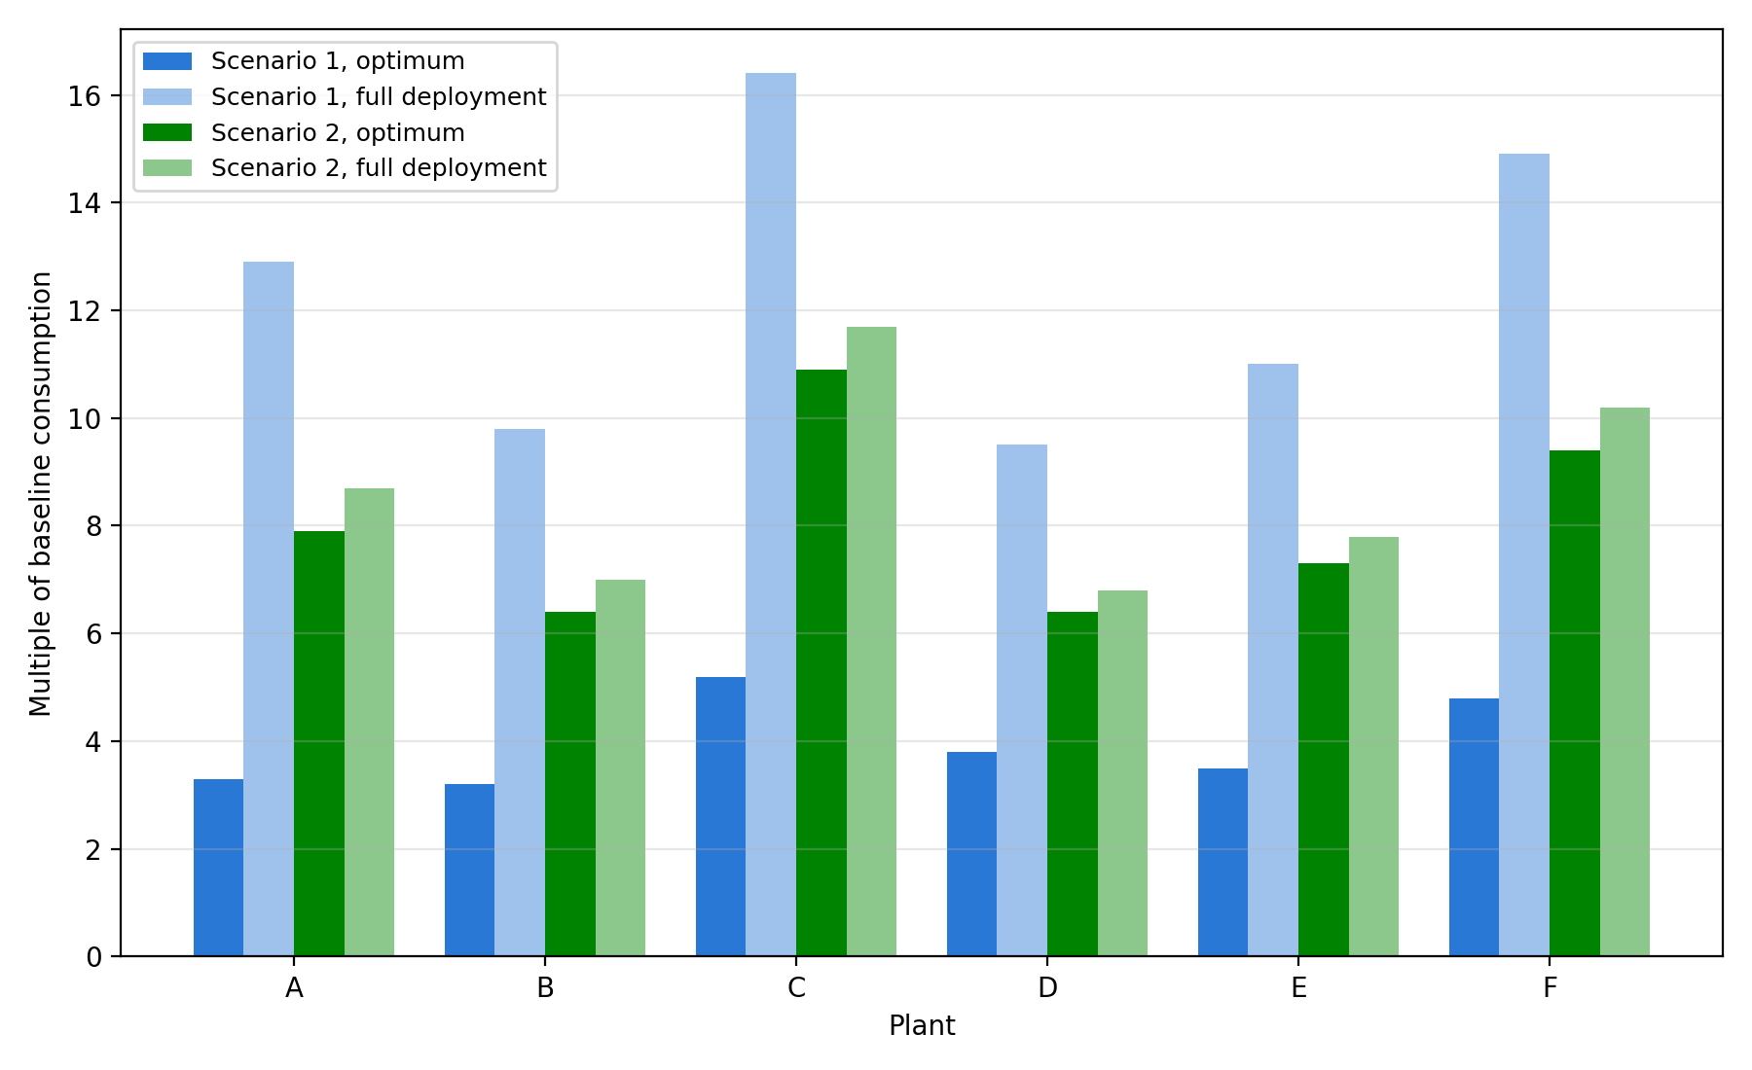
Figure 5 — Generation as a multiple of baseline consumption, by plant
Grouped bar chart complementing Table 4; makes the uniformity at the Scenario 1 economic optimum, and its reversal at full deployment, visually immediate.

3.2 Energy flow through conversion routes
Figures 5 and 6 trace how generation moves from primary biomass sources, through conversion losses, to the three revenue tiers of Section 2.2.3, at the economic optimum and at full deployment, for each scenario. In Scenario 1, generation at the economic optimum relies almost entirely on POME biogas (64.2 GWh/yr), with only a small turbine contribution (8.0 GWh/yr); full deployment reverses this balance, driven by a turbine expansion to 184.9 GWh/yr while biogas remains capped at its POME-derived ceiling. This follows directly from the asymmetry in conversion losses established in Section 2.3.2 to 2.4: turbine losses (about 20%) substantially exceed biogas losses (about 6%), so losses grow from 5.3 to 40.9 GWh/yr in Scenario 1 as the lossier turbine route expands, a much steeper rise than the 11.3 to 14.1 GWh/yr range in Scenario 2, where biogas remains dominant throughout (127.4 to 127.9 GWh/yr) and the turbine grows only modestly (20.1 to 33.7 GWh/yr). Revenue routing follows a parallel divergence: in Scenario 1, the joint self-consumption/energy-credit cap is filled entirely by self-consumption, so all exported surplus routes to the spot market at both points checked; Scenario 2, by contrast, keeps accessing both the self-consumption and energy-credit tiers (16.8 GWh/yr each, unchanged) even at full deployment, with only the remainder routed to the spot market.
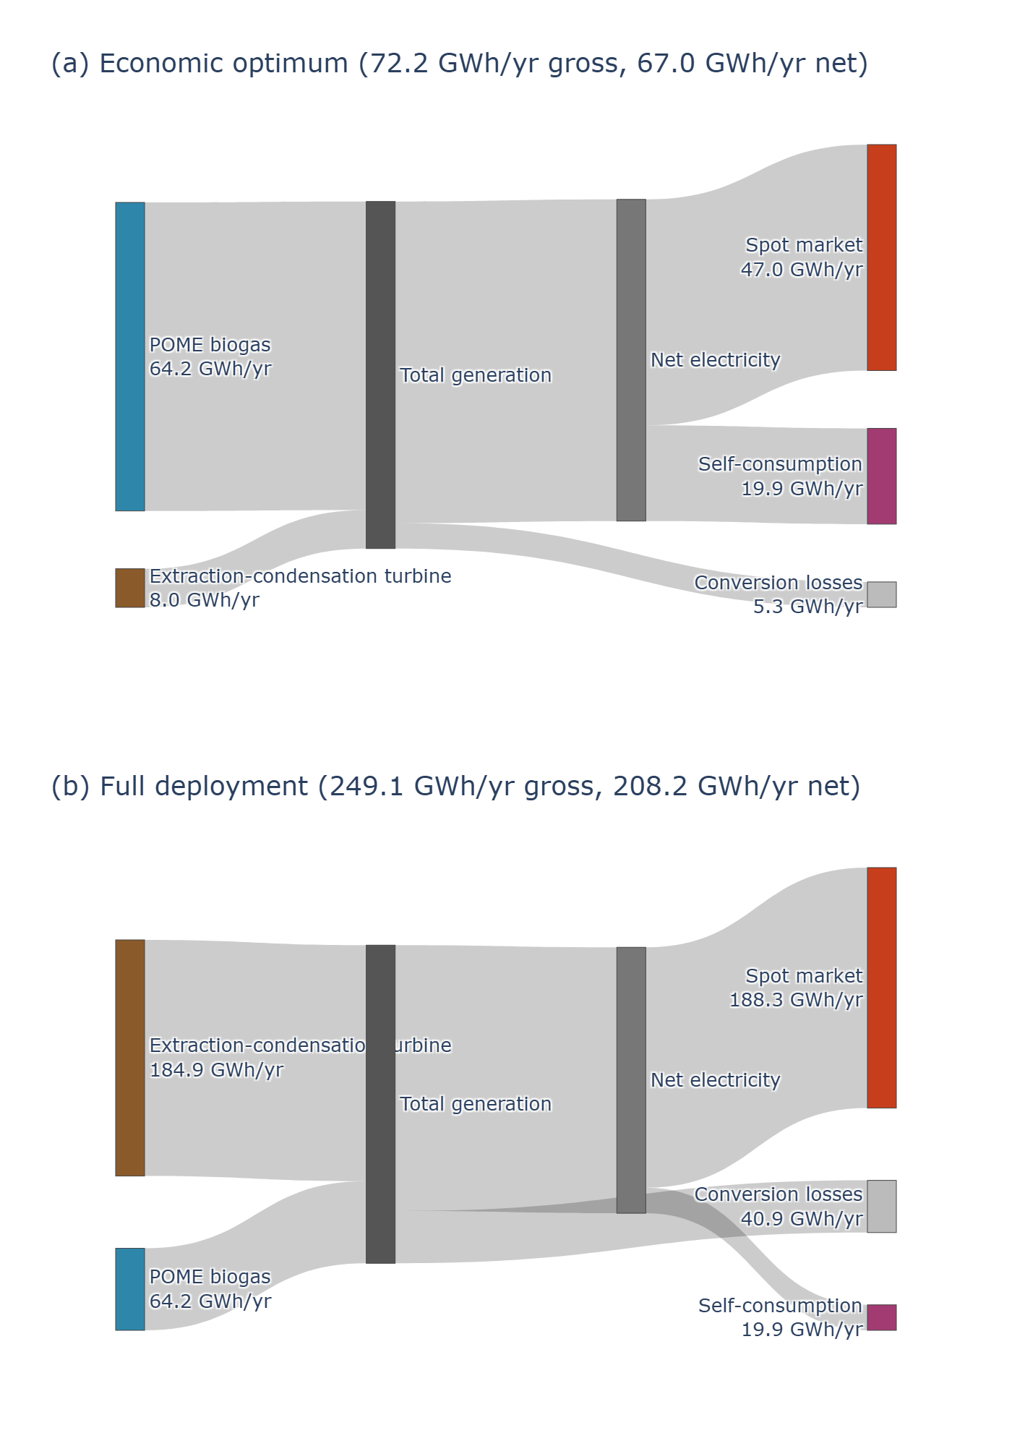
Figure 6 — Scenario 1: energy flow from primary sources to revenue tiers
Sankey diagram of Scenario 1 electricity generation, from primary sources through conversion losses to the three revenue tiers of Section 2.2.3, at (a) the economic optimum (72.2 GWh/yr gross, 67.0 GWh/yr net) and (b) full deployment (249.1 GWh/yr gross, 208.2 GWh/yr net). Node values are annual energy flows, in GWh per year.
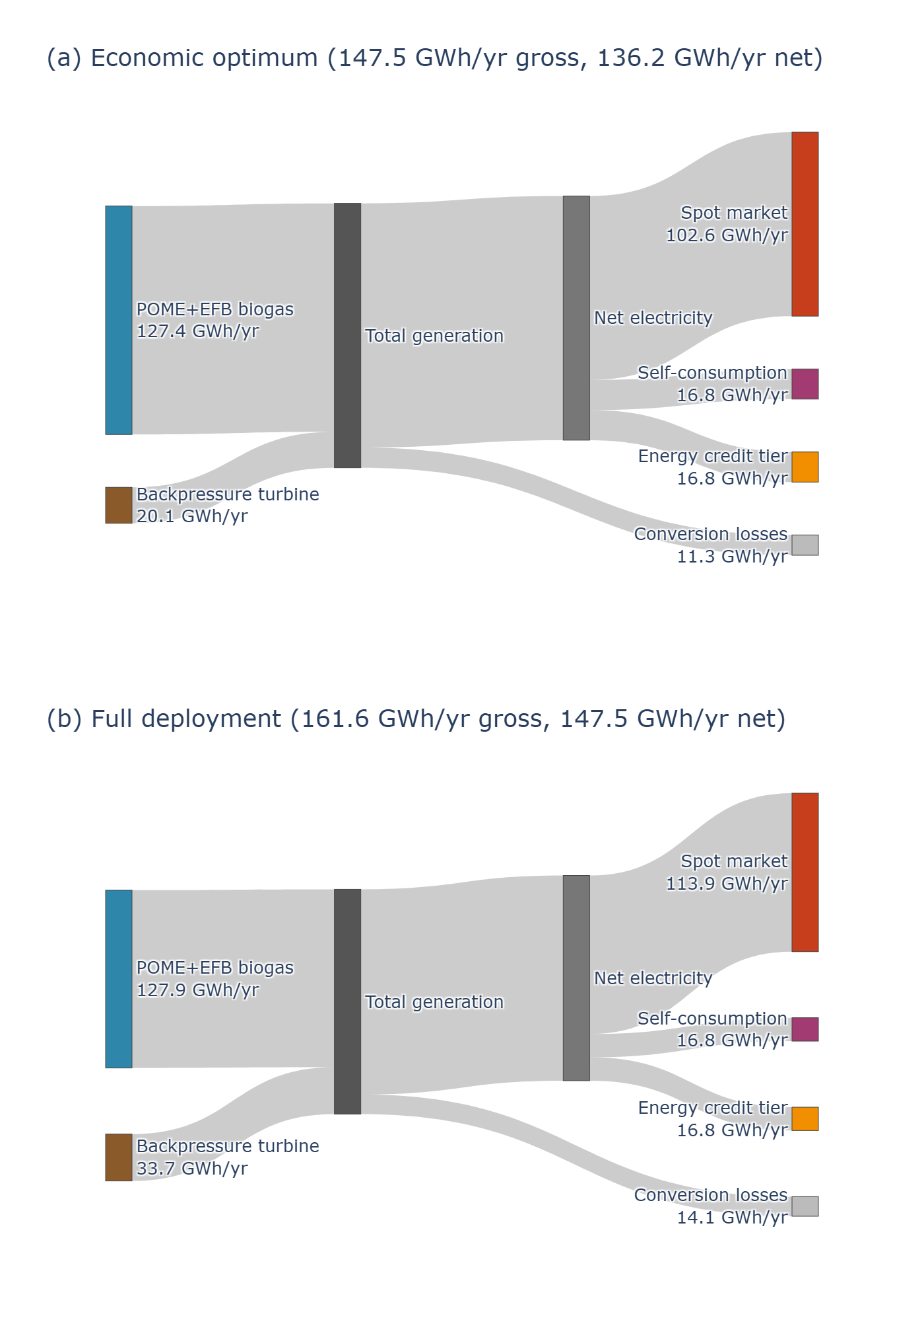
Figure 7 — Scenario 2: energy flow from primary sources to revenue tiers
Sankey diagram of Scenario 2 electricity generation, from primary sources through conversion losses to the three revenue tiers of Section 2.2.3, at (a) the economic optimum (147.5 GWh/yr gross, 136.2 GWh/yr net) and (b) full deployment (161.6 GWh/yr gross, 147.5 GWh/yr net). Node values are annual energy flows, in GWh per year.

3.3 Economic, environmental, and social performance across the deployment front
Both scenarios are profitable at their own economic optimum, with net benefits of USD 258,705 (Scenario 1, at 32.2% of potential) and USD 3,427,932 (Scenario 2, at 92.3% of potential) per year. That resemblance does not survive full deployment: Scenario 2 remains profitable throughout (USD 2,315,672 per year at 100%), while Scenario 1 turns negative at USD −6,531,746 per year at full deployment, a divergence examined further in Section 3.4. The mechanism, the turbine route's larger conversion losses and its confinement to the lowest-value revenue tier, was established in Section 3.2: Scenario 1's profitable window closes almost as soon as it opens (Figure 8a).
LCOE, on an exported energy basis (Section 2.4), captures the same asymmetry from a cost perspective, but tells a subtler story. Scenario 1's LCOE is genuinely U-shaped across the front (Figure 8b): it falls from 0.1488 USD/kWh at its own economic optimum to a minimum of about 0.0940 USD/kWh near 87% of potential, then rises again to 0.1033 USD/kWh at full deployment. Profitability does not track this shape: net benefit is negative exactly where LCOE is lowest, since Scenario 1 is profitable only very close to its own economic optimum (Figure 8a). Scenario 2 shows no such tension: its LCOE-minimizing point coincides exactly with its economic optimum (92.3% of potential, 0.0576 USD/kWh), so for Scenario 2, the cheapest point on the curve and the economic optimum coincide (Figure 8a, b).
Neither profitability nor cost, therefore, capture what deployment is worth to the system beyond the mill gate: avoided emissions and rural electricity coverage keep growing with deployment regardless of profitability (Figure 8c). The implicit cost of the last increment of deployment, from the economic optimum to full technical deployment, is USD 294 per tonne of CO2 for Scenario 1 and USD 599 per tonne for Scenario 2. Rural electricity coverage exceeds the department's aggregate rural residential demand from the economic optimum onward in both scenarios, a consequence of Magdalena's unusually low rural electricity consumption (Cabello Eras et al., 2022) rather than an implausibly large surplus; the indicator is therefore capped at 100% of departmental rural demand, alongside the non-saturating share of total departmental electricity demand (Section 2.4) — both grow linearly with exported surplus in Figure 8c, since they depend only on how much electricity leaves the mill gate, not on its profitability.
Figure 8 brings these three pillars together across the full Pareto front of each scenario, normalized to its own technical potential. Net benefit (a) and LCOE (b) both place Scenario 1 in unfavorable territory across nearly its entire range, while avoided emissions and departmental demand share (c) continue to grow regardless of profitability. This separates the two questions this study set out to ask: how much of the technical potential is worth capturing privately, and how much exists physically and matters to the system either way. For Scenario 2 alone, they converge on the same answer.
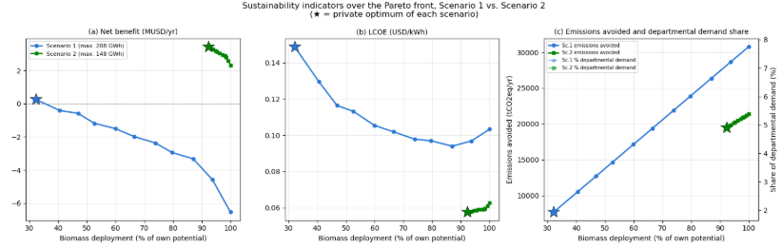
Figure 8 — Net benefit (a), LCOE (b), and avoided emissions paired with departmental demand share (c) across the full Pareto front of each scenario, as a share of each scenario's own technical potential. Stars mark the economic optimum of each scenario.

3.4 Plant-level profitability analysis
Aggregate profitability conceals substantial variation across mills, sharpest not at the endpoints but in the crossing itself: four of six mills are profitable at their own economic optimum under Scenario 1, yet all six turn negative by full deployment (Figure 9). Plants B, C, and D cross from profitable to unprofitable somewhere along the front, while Plant A and Plant E start negative and fall further; only Plant F is unprofitable under Scenario 1 at every point checked. Scenario 2 shows the opposite pattern: four of six mills (B, C, D, E) remain profitable across the full range from their own optimum to full deployment, and only Plant A crosses from positive to negative, a reversal examined further in Section 3.5. Plant F is the one mill unviable under either route at either point, consistent with its low operating hours limiting the surplus available to cover fixed costs regardless of conversion route.
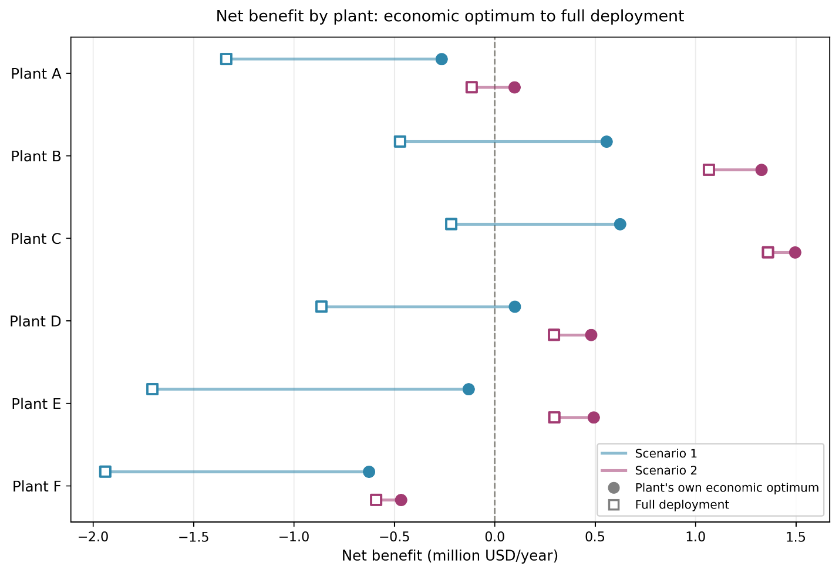
Figure 9 — Net benefit by plant, from each plant's own economic optimum to full deployment. Circles mark each plant's own economic optimum; open squares mark full deployment. Lines connect the two points for each plant and scenario.
Plants A and D are the two mills that already partially self-generate (steam cogeneration and biogas, respectively), and it would seem their head start should ease the case for expanding it. The model shows the opposite: because new investment is priced against each mill's own avoided cost, cheaper existing infrastructure narrows rather than widens the marginal case for expansion, since there is less low-cost headroom left to capture.
This depends on a genuinely uncertain input, though: no single reliable estimate exists for the value of either mill's existing infrastructure. Figure 10 tests the finding across the full cost range reported by Cenipalma's 2024 sector-wide benchmarking study of Colombian palm oil mills (21 to 543.3 COP/kWh for steam cogeneration, sample of 6 mills; 180 to 465.1 COP/kWh for biogas, sample of 7 mills), for both plants, both scenarios, and both the economic optimum and full deployment.
The picture holds, and for Plant A it hardens under Scenario 1: unprofitable across the entire observed cost range at both deployment levels. Plant D fares only marginally better under Scenario 1, also unprofitable throughout. Under Scenario 2 the picture is more mixed: Plant D remains profitable across the entire range, but Plant A is profitable only from roughly the average reported cost upward, turning negative at the low end, so the crossing already noted above is not an isolated result but part of a broader pattern across much of Plant A's plausible cost range. A study using a single reference grid price for all mills, rather than each mill's own measured energy matrix, would not surface this — and it is a caution against treating existing self-generation as a straightforward advantage, since for the marginal investment decision modeled here it can just as easily cut the other way.
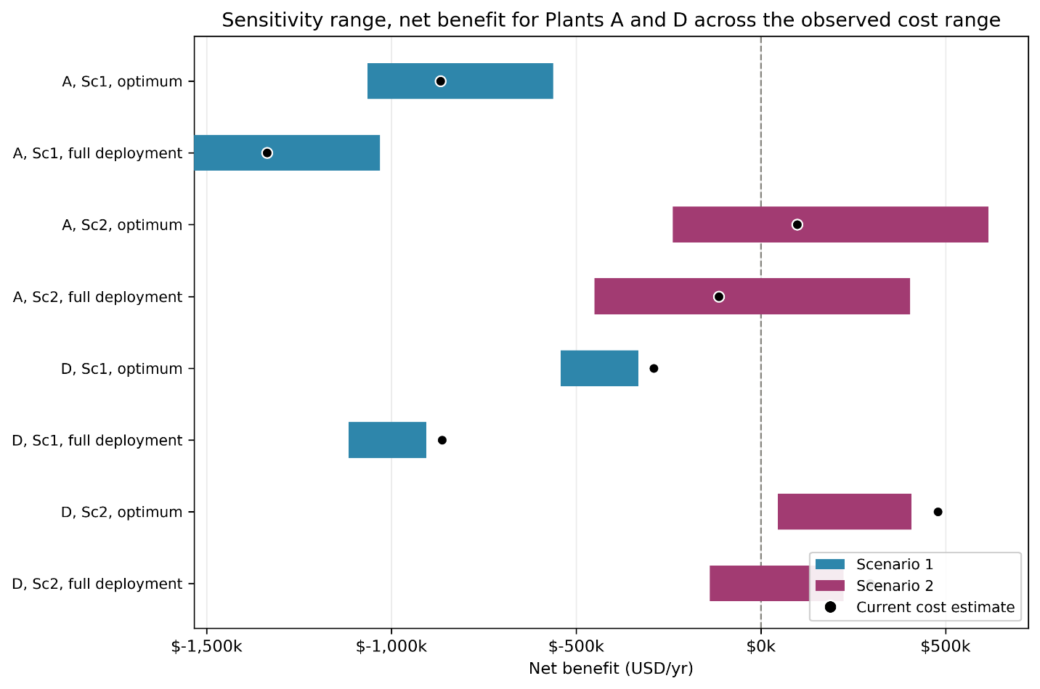
Figure 10 — Sensitivity range, net benefit for Plants A and D across the observed cost range.
Horizontal bars span the empirically observed cost range for each plant's existing infrastructure (Mosquera-Montoya et al., 2025); black markers show net benefit at each plant's own currently measured cost. Note that Plant D's current cost estimate falls slightly above the benchmarking sample's maximum, reflecting that its own installation is costlier than the seven other mills in that sample, not a plotting error.

3.5 Robustness to the spot market price
Profitability at full deployment for either scenario depends on the wholesale spot price staying above some minimum: fall below it, and full deployment stops paying for itself. That minimum differs sharply between scenarios and across plants (Figure 11). At the aggregate level, Scenario 1 needs the spot price at or above 0.1050 USD/kWh, about 49% above the current price, while Scenario 2 remains profitable down to 0.0500 USD/kWh, a 29% drop from the current price (Figure 11a). Both thresholds rose substantially once the EFB opportunity cost was properly included (Scenario 1 from 0.0757 to 0.1050, Scenario 2 from 0.0234 to 0.0500), narrowing the robustness gap between the two routes without closing it. The same asymmetry holds plant by plant (Figure 11b): Plant F is least robust under either scenario, requiring 0.2697 USD/kWh under Scenario 1 and still 0.1703 USD/kWh under Scenario 2, nearly four times the current price, while Plant C is most robust, needing only 0.0148 USD/kWh under Scenario 2 to stay profitable at full deployment.
It would be easy to assume Scenario 2's robustness comes from depending less on the volatile spot market. The opposite is true: a majority of its exported surplus is sold there rather than at the fixed retail-linked tiers (Section 2.2.3). The real reason is volume: Scenario 2's spot-exposed surplus at full deployment is large enough that even a moderate price generates enough revenue to close what would otherwise be a substantial shortfall. Scenario 1 needs a higher price for the same mechanism to work, because its cost structure, dominated by a larger turbine investment and the EFB opportunity cost, leaves a bigger gap to close per unit of spot-exposed volume. Robustness, in other words, comes from having a lot of low-priced surplus to sell, not from needing the spot market less. This is not unique to this study's context: in an independent optimization of palm oil waste-to-energy scenarios in Indonesia, Aprilianto and Rau (2025) similarly find POME-based processing infeasible below the government-set electricity price, a structurally similar breakeven mechanism to the one identified here.
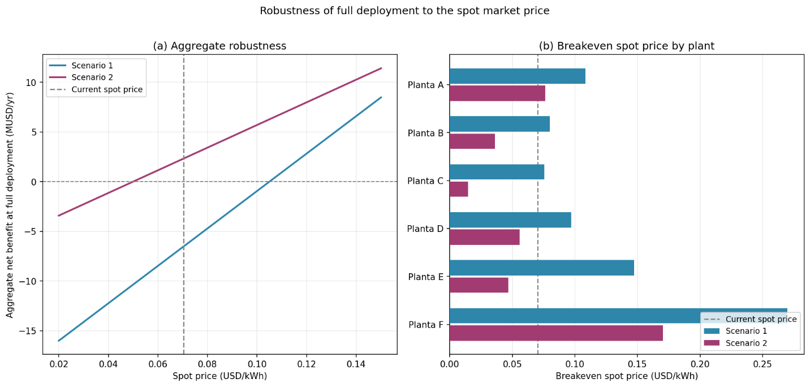
Figure 11 — Robustness of full deployment to the spot market price. (a) Aggregate net benefit at full deployment as a function of the spot market price, for Scenario 1 and Scenario 2; the vertical line marks the current spot price (0.0703 USD/kWh). (b) Breakeven spot price by plant, at which full deployment stops being profitable, for each scenario; the vertical line marks the same current price.

4. Discussion

4.1 Policy instrument sensitivity and implications
At first glance, this looks like a solved problem: both biomass-to-power routes are profitable at their own economic optimum, and the obvious next question for policy would seem to be how to subsidize the jump to full deployment. But that framing does not survive contact with the results. Neither scenario's economic optimum reaches full technical deployment at current prices (32.2% for Scenario 1, 92.3% for Scenario 2), and for Scenario 1 the shortfall is not a modest final stretch: profitability turns negative almost immediately past its own optimum, so closing the gap means overturning what a rational investor would otherwise choose. Doing so costs USD 294 per additional tonne of CO2 avoided for Scenario 1 and USD 599 for Scenario 2 (Section 3.3).
If this is simply a subsidy gap, Colombia already has two policy levers built for exactly this purpose, and neither one closes it. On the capital side, even a 30% reduction in capital cost, the upper end of what current tax incentives make available (Congreso de la República de Colombia, 2021), leaves full deployment of Scenario 1 unprofitable (Figure 12a). What the incentive buys is reach, not resolution: the deployment level Scenario 1 can sustain without losing money grows from 35.4% of potential with no incentive to 96.4% at the maximum incentive tested, but even the most generous capital support available falls just short of the finish line (Figure 12b). On the price side, the story repeats with a different instrument: Figure 13 traces how each scenario's freely chosen deployment responds as the spot price rises, and Scenario 1's curve plateaus at 96.1% of potential once the price triples; no feed-in tariff level makes the mill choose full deployment on its own. Scenario 2, meanwhile, needs neither lever, already close to its technical ceiling at the current price and profitable at every incentive level tested.
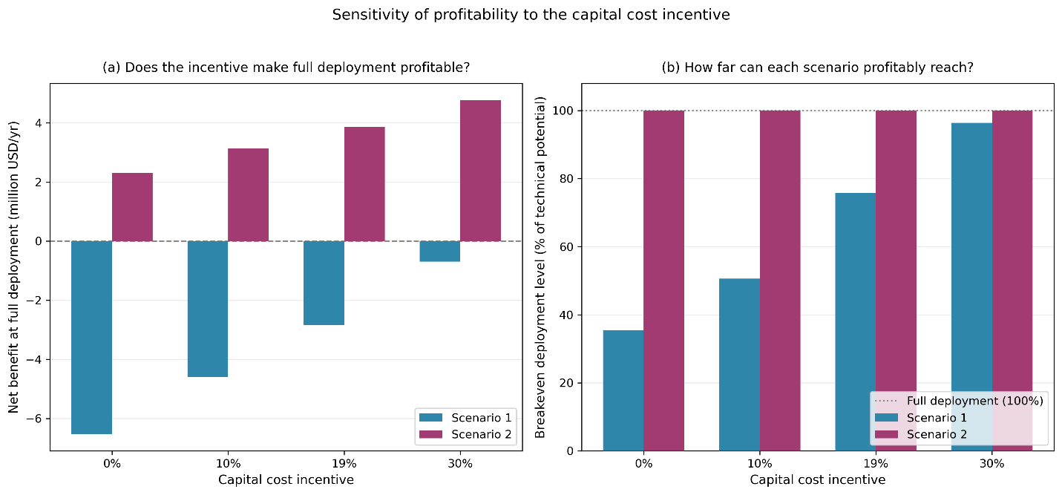
Figure 12 — Sensitivity of profitability to the capital cost incentive
(a) Net benefit at full deployment as a function of the capital cost incentive, for Scenario 1 and Scenario 2. (b) Breakeven deployment level, the furthest point along each scenario's own Pareto front that remains profitable, as a function of the same incentive. The dotted line marks full deployment (100% of technical potential).
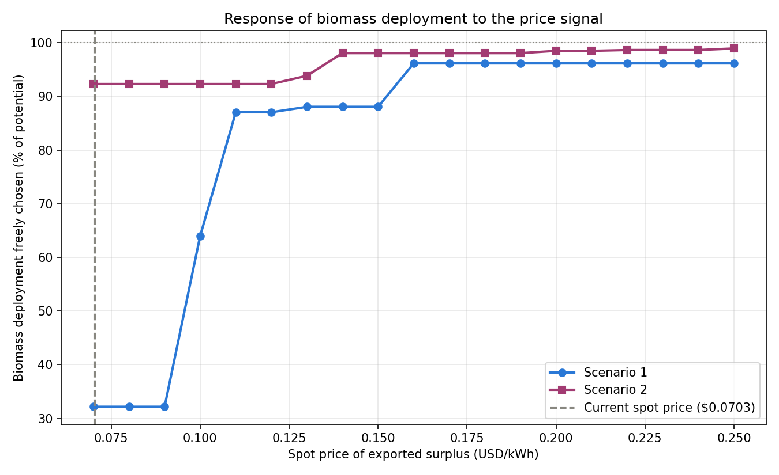
Figure 13 — Response of biomass deployment to the price signal
Deployment level each scenario would freely choose, as a share of its own technical potential, as a function of the spot price of exported surplus. The vertical dashed line marks the current spot price (0.0703 USD/kWh).
Two policy instruments, tested across their full plausible range, both fail to close the same gap for the same reason: Scenario 1's shortfall is not a pricing problem at the margin, it is structural, rooted in the turbine route's conversion losses and its confinement to the lowest-value revenue tier (Section 3.2). No incentive sized within what current Colombian law and market prices allow changes that. The practical question this study set out to answer, then, is not whether biomass valorization needs a subsidy, since it demonstrably does and no available instrument fully supplies it, but which of the two routes policy should back, and for whom. Neither dominates outright: Scenario 2 is more profitable, more robust to a falling spot price, and viable at more mills; Scenario 1 avoids substantially more emissions in absolute terms, since its technical potential is larger. That trade-off, not the search for the right subsidy level, is the more useful frame for policy attention, sharper still once profitability is examined mill by mill (Section 3.4).

4.2 Effect of operating hours and plant scale on profitability
Section 3.4 already showed that aggregate profitability hides a sharper story at the plant level: four of six mills profitable at their own optimum under Scenario 1, none surviving to full deployment. But the disparity runs deeper than that crossing alone, and it does not track technology choice the way one might expect. The two largest, highest-utilization mills, B and C, come closest to breaking even under Scenario 1 and would be the natural first candidates for any partial or phased deployment strategy, yet even they are negative at full deployment once the full set of opportunity costs is priced correctly. Scenario 2 is far more broadly viable, with four of six mills profitable at full deployment; only Plant F is unviable under either route, and Plant A, despite already partially self-generating, turns negative under Scenario 2 specifically at full deployment, a reversal examined further in Section 3.4.
What actually separates the mills that survive from the ones that do not is not which technology they adopt, but how many hours a year they run (Figure 14): a POM operating under 2,000 hours annually, like Plant F, cannot generate enough surplus to cover the fixed costs of either pathway, regardless of turbine or biogas configuration. This pattern is invisible in departmental-aggregate assessments, which report only the sector-wide total, and is one of this study's central contributions.
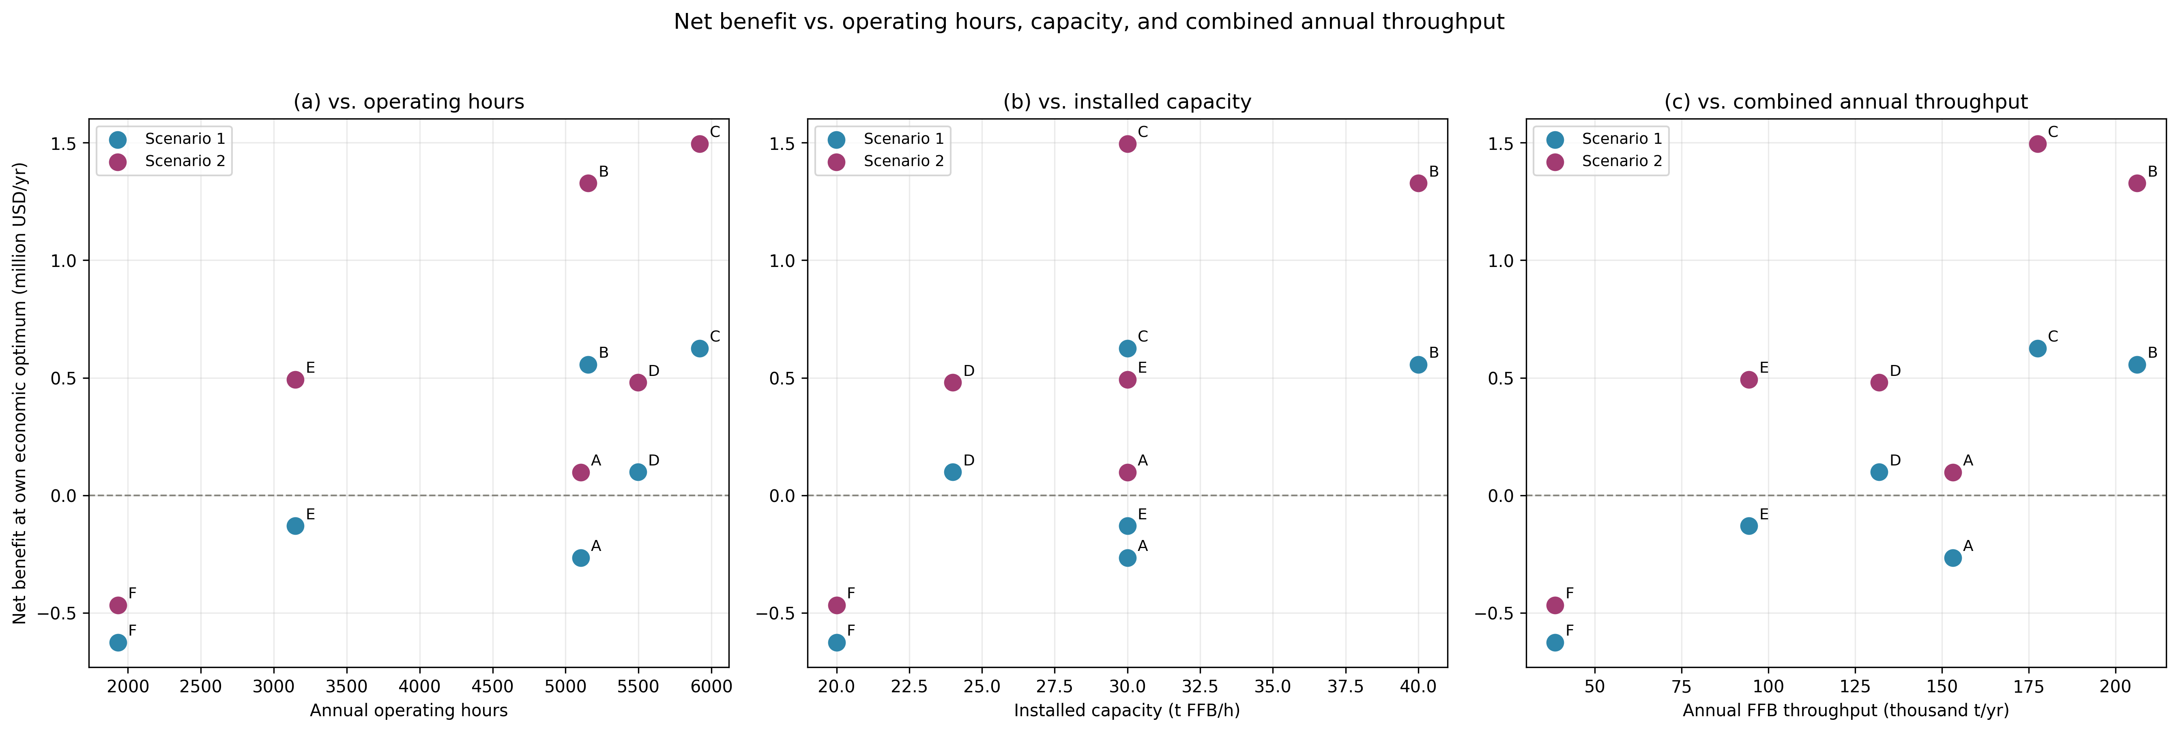
Figure 14 — Net benefit at the economic optimum against operating hours (a), installed capacity (b), and combined annual throughput (c), by plant and scenario.

The policy implication follows directly and is sharper than an aggregate view suggests. A uniform subsidy or feed-in tariff, sized to the sector average, would understate what Scenario 1 actually needs to become viable at any mill, and would overcompensate the mills already profitable under Scenario 2. Plant F, specifically, is not a pricing problem that a higher tariff would solve; it is a scale problem, better addressed through the kind of centralized, shared infrastructure discussed under future work, than through instruments that treat all six mills as interchangeable.

4.3 Adequacy of the carbon tax as a policy instrument
Colombia already prices carbon, and at first glance that tax looks like the natural instrument to close the remaining gap between private and full deployment: if biomass valorization avoids emissions and Colombia taxes emissions, the tax should push mills toward full deployment on its own. But at its currently verified rate of USD 8.70 per tonne of CO2 (DIAN Resolution 000003 of 2026), the tax covers only a small fraction of what closing that gap actually costs, about one thirty-fourth of it for Scenario 1 and one sixty-ninth for Scenario 2. Figure 15 makes the shortfall visible: the cost of closing the gap between the economic optimum and full deployment (a), and what that cost implies per tonne of CO2 avoided (b), both plotted against the current tax. Scenario 1's gap costs less in absolute terms, USD 6.79 million per year against USD 1.11 million for Scenario 2, but Scenario 1 already deploys a smaller share of its own potential at the optimum, so that same absolute gap represents 2,625% of its own optimal net benefit, against just 32% for Scenario 2. Per tonne of CO2 the ordering reverses: Scenario 1's marginal abatement is actually cheaper (USD 294/tCO2) than Scenario 2's (USD 599/tCO2), since Scenario 1 has more low-hanging technical potential left to capture. Either way the tax sits far below both figures, and this is not an artifact of an early, uncorrected model: the gap widened, not narrowed, once fully validated, with Scenario 1's implicit abatement cost rising from USD 169 to USD 294 per tonne. On the tax rate alone, there is little reason to expect it to move deployment meaningfully beyond the economic optimum.
A second, unmodeled channel may matter more than the rate itself. Colombian regulation allows entities liable for the carbon tax to offset up to half of it by purchasing and retiring carbon credits from verified domestic emission-reduction projects, a mechanism that creates demand for credits independent of the tax rate. A biomass valorization project that displaces grid electricity could generate credits sellable into that market, an income stream this study's model does not represent, since it credits avoided emissions physically rather than monetarily. Quantifying it would require assumptions about credit pricing and market access beyond this study's scope, but it is flagged here as a more promising avenue than the tax rate for closing Scenario 1's marginal gap, and as unexplored policy space rather than a modeled result.
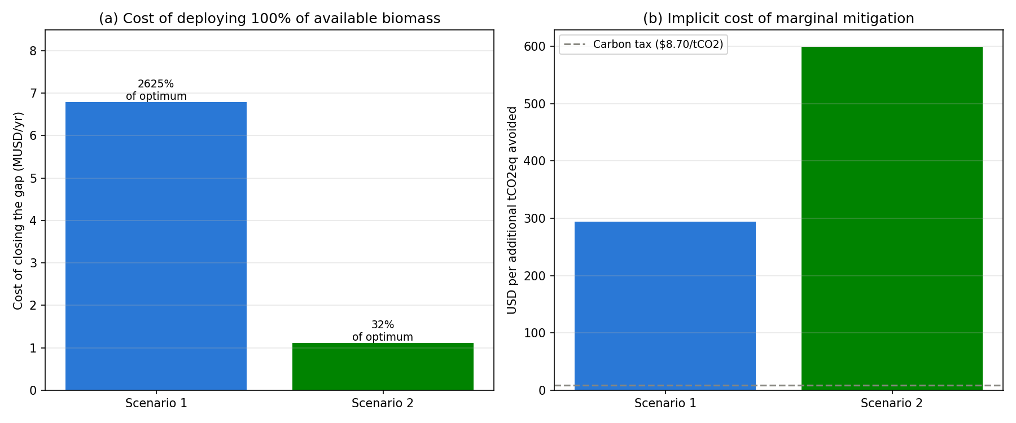
Figure 15 — Cost of closing the gap between the economic optimum and full deployment
Cost of deploying the full technical potential beyond each scenario's economic optimum (a), and the implicit cost per additional tonne of CO2 avoided by doing so (b), compared against Colombia's current carbon tax (DIAN Resolution 000003 of 2026, COP 29,070.49/tCO2eq).

4.4 Limitations
Every result here rests on standard techno-economic assumptions and published references rather than site measurement at each of the six mills, and some of those assumptions matter more than others. Turbine and biogas efficiencies (about 20% and 6% losses, respectively) were central to this study's main finding once properly applied (Section 3.2), so a plant whose real equipment performs differently would see its own profitability shift accordingly, particularly under Scenario 1, where the turbine's larger loss makes it the more sensitive route; biomass composition itself, known to vary with fruit ripeness, season, and milling practice (Marrugo et al., 2016), adds further variation the fixed reference values cannot represent. The EFB opportunity cost (Section 2.3.2) is the more consequential simplification: it rests on literature-based nutrient equivalence factors (Caliman et al., 2001) and a 70% mineralization efficiency drawn from a 60 to 80% range reported elsewhere (Salètes et al., 2004), rather than local soil and application data, and this cost was found to materially affect plant-level profitability (Section 3.4). Operating costs, fixed at 2.5% of capital cost across all equipment, and the biogas co-digestion parameters, drawn from a conceptual design reference (Voogt et al., 2021) rather than plant-level performance since none of the six mills operates that configuration yet, add smaller but real uncertainty of the same kind. The avoided emissions indicator (Figure 8c) credits only grid displacement and likely overstates avoided emissions by roughly 10 to 21%, growing with deployment under Scenario 1.
None of these changes the direction of the central finding: Scenario 2's advantage over Scenario 1 is large enough to survive plausible variation in any single assumption on its own. Overturning the comparison itself would take several of these adjustments moving together, not one alone, such as a measured turbine efficiency substantially below catalog values combined with a materially lower EFB opportunity cost. Short of that combination, what these assumptions change is precision at the individual mill level, particularly for the mills already closest to the breakeven line (Section 3.4), not the direction of the comparison between the two routes.

5. Conclusions
Both mature biomass-to-power routes examined here are profitable at their own economic optimum. But profitability alone turns out to be an incomplete basis for choosing between them, or for assuming either one will reach its full technical potential on its own. Scenario 2, a backpressure turbine paired with biogas from co-digested effluent and empty fruit bunches, remains profitable across its entire technical range and needs no external support to reach full deployment. Scenario 1, an extraction condensation turbine paired with POME biogas, is profitable only in a narrow window close to its own optimum, at 32.2% of its technical potential; profitability turns negative almost immediately beyond that point, and neither of Colombia's two available policy levers, a 30% capital cost incentive or a spot price three times the current level, is enough to close the remaining gap.
This divergence reframes the policy question. Rather than asking how much subsidy either route requires, given that Scenario 2 requires none, the more useful question is which route to favor, and the answer depends on what is weighed most heavily: Scenario 2 is more profitable, more robust to a falling electricity price, and viable at more mills, while Scenario 1 avoids substantially more emissions in absolute terms because its technical potential is larger. Neither route dominates the other outright. This distinction matters more once bioenergy generation is recognized as a discretionary line of business, separate from a mill's core activity of producing crude palm oil: an investor entering it can tolerate a bad year less than one expanding a business it already knows, which makes Scenario 2's robustness, not only its profitability, the more relevant number for an actual investment decision.
Plant-level results sharpen this picture further, and in one respect complicate it: at full deployment, none of the six mills remain profitable under Scenario 1, against four of six under Scenario 2, and even mills that already partially self-generate are not spared, turning negative under one or both scenarios once the full set of opportunity costs, including the value of empty fruit bunches as a soil amendment, is properly priced. What separates the mills that remain viable from the ones that do not is less a matter of which technology they adopt than of how many hours a year they operate, a pattern invisible to any assessment conducted at the departmental or national scale. Colombia's current carbon tax, meanwhile, covers only a small fraction of the cost of closing the gap between the economic optimum and full deployment for either scenario, about one thirty-fourth for Scenario 1 and one sixty-ninth for Scenario 2, indicating that carbon pricing alone is unlikely to move deployment meaningfully beyond what mills would choose on their own.

Future work
Two extensions follow directly from these findings, one regulatory and one methodological. On the regulatory side, CREG Resolution 101-99 of 2026 now allows a centralized biomass processing hub to serve several extraction plants under common ownership, a possibility worth testing for the smallest, lowest utilization mills this study identifies as facing a scale problem rather than a pricing one.
On the methodological side, this study's optimization framework could extend beyond electricity export to the multi-product biorefinery pathways outlined conceptually elsewhere (Garcia-Nunez et al., 2016; Rincón et al., 2014). Applying the same mixed-integer, multi-objective approach to that broader set of pathways would turn those conceptual boundaries into testable limits, situated against both Colombia's regulatory context and the international optimization literature reviewed in the Introduction, none of which has yet reached biorefinery scale.

References
Alaw, F.A., Sulaiman, N.S., 2019. A review of boiler operational risks in empty fruit bunch fired biopower plant. Journal of Chemical Engineering and Industrial Biotechnology, 5(5), 29-35. https://doi.org/10.15282/jceib.v5i2.3624
Alean, J., Bastidas, M., Boom-Carcamo, E., Maya, J.C., Chejne, F., Ramirez, S., Nieto, D., Ceballos, C., Saurith, A., Cordoba-Ramirez, M., 2025. Design of a technical decision-making strategy to collect biomass waste from the palm oil industry as a renewable energy source: case study in Colombia. Environments, 12(5), 165. https://doi.org/10.3390/environments12050165
Aprilianto, H.C., Rau, H., 2025. A multi-objective optimization approach for generating energy from palm oil wastes. Energies, 18(11), 2947. https://doi.org/10.3390/en18112947
Orjuela-Castro, J.A., Aranda-Pinilla, J.A., Moreno-Mantilla, C.E., 2019. Identifying trade-offs between sustainability dimensions in the supply chain of biodiesel in Colombia. Computers and Electronics in Agriculture, 154, 253-264. https://doi.org/10.1016/j.compag.2018.03.009
Peña González, D., Cortés Borda, D., Mele, F.D., Barrios Sarmiento, A., Domínguez Santiago, M., 2021. An optimization approach for the design and planning of the oil palm supply chain in Colombia. Computers & Chemical Engineering, 146, 107208. https://doi.org/10.1016/j.compchemeng.2020.107208
Rahayu, A.S., Karsiwulan, D., Yuwono, H., Trisnawati, I., Mulyasri, S., Rahardjo, S., Hokermin, S., Paramita, V., 2015. Konversi POME Menjadi Biogas: Panduan Untuk Konversi Gas Rumah Kaca Metode Perhitungan Menggunakan IPCC Tier 2. Winrock International.
Barrera Hernandez, J.C., Sagastume Gutierrez, A., Ramirez-Contreras, N.E., Cabello Eras, J.J., Garcia-Nunez, J.A., Barrera Agudelo, O.R., Silva Lora, E.E., 2024. Biomass-based energy potential from the oil palm agroindustry in Colombia: a path to low carbon energy transition. Journal of Cleaner Production, 449, 141808. https://doi.org/10.1016/j.jclepro.2024.141808
Boom-Carcamo, E., Penabaena-Niebles, R., Alean, J., 2025. Scenario analysis of the use of oil palm residual biomass for bioenergy generation: a comparison with fossil fuels. Energy, 335, 137933. https://doi.org/10.1016/j.energy.2025.137933
Booneimsri, P., Kubaha, K., Chullabodhi, C., 2018. Increasing power generation with enhanced cogeneration using waste energy in palm oil mills. Energy Science & Engineering, 6(3), 154-173. https://doi.org/10.1002/ese3.196
Cabello Eras, J.J., Balbis Morejon, M., Sagastume Gutierrez, A., Pardo Garcia, A., Cabello Ulloa, M., Rey Martinez, F.J., Rueda-Bayona, J.G., 2018. A look to the electricity generation from non-conventional renewable energy sources in Colombia. International Journal of Energy Economics and Policy, 9(1), 15-25. https://doi.org/10.32479/ijeep.7108
Cabello Eras, J.J., et al., 2022. [Rural electricity demand baseline for Magdalena department; full citation to be verified before submission]
Briceño, I., Valencia, J., Posso, M., 2015. Potencial de generación de energía de la agroindustria de la palma de aceite en Colombia. Palmas, 36(3), 43-53.
Calderón Prieto, C., Bautista, K., Chávez Duarte, N., Cala Amaya, S., Benavides Aponte, E., 2025. Referenciación de esterilización en plantas de beneficio de palma de aceite: eficiencia, calidad y optimización del proceso. El Palmicultor, Fedepalma/Cenipalma, 29 de diciembre de 2025.
Caliman, J.P., et al., 2001. [Nutrient equivalence factors for EFB as fertilizer replacement; primary source to be independently verified before submission, see Methods 2.6]
Congreso de la República de Colombia, 2021. Ley 2099 de 2021, por medio de la cual se dictan disposiciones para la transición energética, la dinamización del mercado energético, la reactivación económica del país y se dictan otras disposiciones. Diario Oficial No. 51.756, Bogotá, Colombia.
Dovichi Filho, F.B., Castillo Santiago, Y., Silva Lora, E.E., Escobar Palacio, J.C., Almazan del Olmo, O.A., 2021. Evaluation of the maturity level of biomass electricity generation technologies using the technology readiness level criteria. Journal of Cleaner Production, 295, 126426. https://doi.org/10.1016/j.jclepro.2021.126426
Garcia-Nunez, J.A., Rodriguez, D.T., Fontanilla, C.A., Ramirez, N.E., Silva Lora, E.E., Frear, C.S., Stockle, C., Amonette, J., Garcia-Perez, M., 2016. Evaluation of alternatives for the evolution of palm oil mills into biorefineries. Biomass and Bioenergy, 95, 310-329. https://doi.org/10.1016/j.biombioe.2016.05.020
Gonzalez-Salazar, M.A., Venturini, M., Poganietz, W.R., Finkenrath, M., Leal, M.R.L.V., 2014. Methodology for biomass energy potential estimation: Projections of future potential in Colombia. Renewable Energy, 66, 736-747. https://doi.org/10.1016/j.renene.2013.12.020
Haimes, Y.Y., Lasdon, L.S., Wismer, D.A., 1971. On a bicriterion formulation of the problems of integrated system identification and system optimization. IEEE Transactions on Systems, Man, and Cybernetics, 1(3), 296-297.
Harahap, F., Leduc, S., Mesfun, S., Khatiwada, D., Kraxner, F., Silveira, S., 2019. Opportunities to optimize the palm oil supply chain in Sumatra, Indonesia. Energies, 12(3), 420. https://doi.org/10.3390/en12030420
Ho, W.S., Khor, C.S., Hashim, H., Lim, J.S., Ashina, S., Herran, D.S., 2015. Optimal operation of a distributed energy generation system for a sustainable palm oil-based eco-community. Clean Technologies and Environmental Policy, 17, 1597-1617. https://doi.org/10.1007/s10098-014-0893-6
Marrugo, G., Valdés, C.F., Chejne, F. (2016). Characterization of Colombian agroindustrial biomass residues as energy resources. Energy & Fuels, 30(10), 8386-8398. https://doi.org/10.1021/acs.energyfuels.6b01596
Martinez, G.L., Buritica Arboleda, C.I., Silva Lora, E.E., Castillo Santiago, Y., Almazan del Olmo, O.A., 2025. Techno-economic evaluation of converting biomass to electricity in isolated areas of Colombia. Biofuels, Bioproducts and Biorefining, 19(4), 1059-1074. https://doi.org/10.1002/bbb.2768
Mavrotas, G., 2009. Effective implementation of the ε-constraint method in Multi-Objective Mathematical Programming problems. Applied Mathematics and Computation, 213(2), 455-465. https://doi.org/10.1016/j.amc.2009.03.037
Memari, A., Ahmad, R., Abdul Rahim, A.R., et al., 2018. An optimization study of a palm oil-based regional bio-energy supply chain under carbon pricing and trading policies. Clean Technologies and Environmental Policy, 20, 113-125. https://doi.org/10.1007/s10098-017-1461-7
Ministerio de Ambiente y Desarrollo Sostenible, 2025. Contribución Determinada a Nivel Nacional de Colombia (NDC 3.0): Transformaciones para la Vida. Gobierno de Colombia, Bogotá.
Montoya, J., Valdés, C., Chaquea, H., Pecha, M.B., Chejne, F., 2020. Surplus electricity production and LCOE estimation in Colombian palm oil mills using empty fresh bunches (EFB) as fuel. Energy, 202, 117713. https://doi.org/10.1016/j.energy.2020.117713
Mosquera-Montoya, M., Ruiz-Alvarez, E., Munevar-Martinez, D.E., Estupinan, M., Guerrero, A.E., Cala, S., 2022. Estudio de costos de produccion 2021 para empresas benchmark del sector de la palma de aceite de Colombia. Palmas, 43(4), 26-39. https://doi.org/10.56866/01212923.13911
Mosquera-Montoya, M., Ruiz-Alvarez, E., Munevar-Martinez, D.E., Ardila Badillo, C., Cala Amaya, S.L., Benavides Aponte, E.D., Chavez Duarte, N., 2025. Costos de produccion 2024 en la palmicultura colombiana: un analisis de empresas benchmark. Palmas, 46(1), 41-54. https://doi.org/10.56866/01212923.14473 [Note: cost-range figures used in Table 7 need final confirmation against this specific edition]
Nair, P.N.S.B., Andiappan, V., Foo, D.C.Y., Chemmangattuvalappil, N.G., 2022. Disjunctive fuzzy optimisation of electricity generation by biomass power producers in a feed-in tariff programme. Asia-Pacific Journal of Chemical Engineering, 17(6), e2830. https://doi.org/10.1002/apj.2830
Ocampo Batlle, E.A., Castillo Santiago, Y., Venturini, O.J., Escobar Palacio, J.C., Silva Lora, E.E., Yepes Maya, D.M., Albis Arrieta, A.R., 2020. Thermodynamic and environmental assessment of different scenarios for the insertion of pyrolysis technology in palm oil biorefineries. Journal of Cleaner Production, 250, 119544. https://doi.org/10.1016/j.jclepro.2019.119544
Ramirez-Contreras, N.E., Munar-Florez, D.A., Garcia-Nuñez, J.A., Mosquera-Montoya, M., Faaij, A.P.C., 2020. The GHG emissions and economic performance of the Colombian palm oil sector; current status and long-term perspectives. Journal of Cleaner Production, 258, 120757. https://doi.org/10.1016/j.jclepro.2020.120757
Ramírez Contreras, N.E., Silva Ramírez, A.S., Garzón González, E.M., Yáñez Angarita, E.E., 2011. Caracterización y manejo de subproductos del beneficio del fruto de palma de aceite. Boletín Técnico No. 30. Cenipalma, Bogotá.
Rocha-Meneses, L., Luna-delRisco, M., Gonzalez, C.A., Villegas Moncada, S., Moreno, A., Sierra-Del Rio, J., Castillo-Meza, L.E., 2023. An overview of the socio-economic, technological, and environmental opportunities and challenges for renewable energy generation from residual biomass: a case study of biogas production in Colombia. Energies, 16(16), 5901. https://doi.org/10.3390/en16165901
Sagastume Gutierrez, A., Cabello Eras, J.J., Hens, L., Vandecasteele, C., 2020. The energy potential of agriculture, agroindustrial, livestock, and slaughterhouse biomass wastes through direct combustion and anaerobic digestion. The case of Colombia. Journal of Cleaner Production, 269, 122317. https://doi.org/10.1016/j.jclepro.2020.122317
Salètes, S., Caliman, J.P., Raham, D., 2004. Study of mineral nutrient losses from oil palm empty fruit bunches during temporary storage. Journal of Oil Palm Research, 16(1), 11-21.
Silva-Imbachi, W.A., 2019. Efecto de la cogeneración en la huella de carbono. Palmas, 40(4), 114-125.
Sodri, A., Septriana, F.E., 2022. Biogas power generation from palm oil mill effluent (POME): techno-economic and environmental impact evaluation. Energies, 15(19), 7265. https://doi.org/10.3390/en15197265
Teh, K.C., Tan, J., Chew, I.M.L., 2023. Multiple biogenic waste valorization via pyrolysis technologies in palm oil industry: economic and environmental multi-objective optimization for sustainable energy system. Process Integration and Optimization for Sustainability, 7(4), 847-860. https://doi.org/10.1007/s41660-023-00327-w
Thomsen, S.T., Spliid, H., Ostergard, H., 2014. Statistical prediction of biomethane potentials based on the composition of lignocellulosic biomass. Bioresource Technology, 154, 80-86. https://doi.org/10.1016/j.biortech.2013.12.029
Unidad de Planeación Minero Energética (UPME), 2019. Resultados de la subasta de contratos de largo plazo para el suministro de energía eléctrica a partir de fuentes no convencionales de energía renovable. UPME, Bogotá.
Voogt, J., et al., 2021. [Conceptual design assumptions for co-digestion of POME and pretreated EFB; primary source not located this session, see Methods 2.3 note]
XM S.A. E.S.P., 2021. Informe de gestión: precio de bolsa nacional. XM, Medellín.

