# **SEED Software Release Guide**

# **Version 1.6.1**

## **Introduction**

This documentation is for SEED version 1.6.1.

## **Prerequisites**

1. bitbucket.org account
2. git

## **Tools and terms**

1. WinISO

## **SEED Doc**

**Introduction**

The repository is hosted at https://bitbucket.org/jcisoft/seed-doc.git

**Branches**

The central repo holds two main branches with an infinite lifetime:

master: https://bitbucket.org/jcisoft/seed-doc/branch/master

develop: https://bitbucket.org/jcisoft/seed-doc/branch/develop

The master to be the main branch where the source code of HEAD always reflects a production-ready state.

The develop to be the main branch where the source code of HEAD always reflects a state with the latest delivered development changes for the next release.

**Tags**

When the source code in the develop branch reaches a stable point and is ready to be released, all of the changes should be merged back into master somehow and then tagged with a release number.

https://bitbucket.org/jcisoft/seed-doc/commits/tag/version-1-6-1

**Downloads**

https://bitbucket.org/jcisoft/seed-doc/get/version-1-6-1.zip

## **SEED API**

**Introduction**

The repository is hosted at https://bitbucket.org/jcisoft/seed-api.git

**Branches**

The central repo holds two main branches with an infinite lifetime:

master: https://bitbucket.org/jcisoft/seed-api/branch/master

develop: https://bitbucket.org/jcisoft/seed-api/branch/develop

The master to be the main branch where the source code of HEAD always reflects a production-ready state.

The develop to be the main branch where the source code of HEAD always reflects a state with the latest delivered development changes for the next release.

**Tags**

When the source code in the develop branch reaches a stable point and is ready to be released, all of the changes should be merged back into master somehow and then tagged with a release number.

https://bitbucket.org/jcisoft/seed-api/commits/tag/version-1-6-0

**Downloads**

https://bitbucket.org/jcisoft/seed-api/get/version-1-6-0.zip

## **SEED Windows**

**Introduction**

The repository is hosted at https://bitbucket.org/jcisoft/seed-windows.git

**Branches**

The central repo holds two main branches with an infinite lifetime:

master: https://bitbucket.org/jcisoft/seed-windows/branch/master

develop: https://bitbucket.org/jcisoft/seed-windows/branch/develop

The master to be the main branch where the source code of HEAD always reflects a production-ready state.

The develop to be the main branch where the source code of HEAD always reflects a state with the latest delivered development changes for the next release.

**Tags**

When the source code in the develop branch reaches a stable point and is ready to be released, all of the changes should be merged back into master somehow and then tagged with a release number.

https://bitbucket.org/jcisoft/seed-windows/commits/tag/version-1-6-1

**Downloads**

https://bitbucket.org/jcisoft/seed-windows/get/version-1-6-1.zip

## **ADS SEED Gateway**

**Introduction**

The repository is hosted at https://bitbucket.org/jcisoft/ads-seed-gateway.git

**Branches**

The central repo holds two main branches with an infinite lifetime:

master: https://bitbucket.org/jcisoft/ads-seed-gateway/branch/master

develop: https://bitbucket.org/jcisoft/ads-seed-gateway/branch/develop

The master to be the main branch where the source code of HEAD always reflects a production-ready state.

The develop to be the main branch where the source code of HEAD always reflects a state with the latest delivered development changes for the next release.

**Tags**

When the source code in the develop branch reaches a stable point and is ready to be released, all of the changes should be merged back into master somehow and then tagged with a release number.

https://bitbucket.org/jcisoft/ads-seed-gateway/commits/tag/version-1-6-0

**Downloads**

https://bitbucket.org/jcisoft/ads-seed-gateway/get/version-1-6-0.zip

## **BACnet SEED Gateway**

**Introduction**

The repository is hosted at https://bitbucket.org/jcisoft/bacnet-seed-gateway.git

**Branches**

The central repo holds two main branches with an infinite lifetime:

master: https://bitbucket.org/jcisoft/bacnet-seed-gateway/branch/master

develop: https://bitbucket.org/jcisoft/bacnet-seed-gateway/branch/develop

The master to be the main branch where the source code of HEAD always reflects a production-ready state.

The develop to be the main branch where the source code of HEAD always reflects a state with the latest delivered development changes for the next release.

**Tags**

When the source code in the develop branch reaches a stable point and is ready to be released, all of the changes should be merged back into master somehow and then tagged with a release number.

https://bitbucket.org/jcisoft/bacnet-seed-gateway/commits/tag/version-1-6-0

**Downloads**

https://bitbucket.org/jcisoft/bacnet-seed-gateway/get/version-1-6-0.zip

## **OPC SEED Gateway**

**Introduction**

The repository is hosted at https://bitbucket.org/jcisoft/opc-seed-gateway.git

**Branches**

The central repo holds two main branches with an infinite lifetime:

master: https://bitbucket.org/jcisoft/opc-seed-gateway/branch/master

develop: https://bitbucket.org/jcisoft/opc-seed-gateway/branch/develop

The master to be the main branch where the source code of HEAD always reflects a production-ready state.

The develop to be the main branch where the source code of HEAD always reflects a state with the latest delivered development changes for the next release.

**Tags**

When the source code in the develop branch reaches a stable point and is ready to be released, all of the changes should be merged back into master somehow and then tagged with a release number.

https://bitbucket.org/jcisoft/opc-seed-gateway/commits/tag/version-1-6-0

**Downloads**

https://bitbucket.org/jcisoft/bacnet-seed-gateway/get/version-1-6-0.zip

## **SEED Web APP**

**Introduction**

The repository is hosted at https://bitbucket.org/jcisoft/seed-web-app.git

**Branches**

The central repo holds two main branches with an infinite lifetime:

master: https://bitbucket.org/jcisoft/seed-web-app/branch/master

develop: https://bitbucket.org/jcisoft/seed-web-app/branch/develop

The master to be the main branch where the source code of HEAD always reflects a production-ready state.

The develop to be the main branch where the source code of HEAD always reflects a state with the latest delivered development changes for the next release.

**Tags**

When the source code in the develop branch reaches a stable point and is ready to be released, all of the changes should be merged back into master somehow and then tagged with a release number.

https://bitbucket.org/jcisoft/seed-web-app/commits/tag/version-1-6-0

**Downloads**

https://bitbucket.org/jcisoft/seed-web-app/get/version-1-6-0.zip

## **SEED Report**

**Introduction**

The repository is hosted at https://bitbucket.org/jcisoft/seed-report.git

**Branches**

The central repo holds two main branches with an infinite lifetime:

master: https://bitbucket.org/jcisoft/seed-report/branch/master

develop: https://bitbucket.org/jcisoft/seed-report/branch/develop

The master to be the main branch where the source code of HEAD always reflects a production-ready state.

The develop to be the main branch where the source code of HEAD always reflects a state with the latest delivered development changes for the next release.

**Tags**

When the source code in the develop branch reaches a stable point and is ready to be released, all of the changes should be merged back into master somehow and then tagged with a release number.

https://bitbucket.org/jcisoft/seed-report/commits/tag/version-1-6-0

**Downloads**

https://bitbucket.org/jcisoft/seed-report/get/version-1-6-0.zip

## **SEED Database**

**Introduction**

The repository is hosted at https://bitbucket.org/jcisoft/seed-database.git

**Branches**

The central repo holds two main branches with an infinite lifetime:

master: https://bitbucket.org/jcisoft/seed-database/branch/master

develop: https://bitbucket.org/jcisoft/seed-database/branch/develop

The master to be the main branch where the source code of HEAD always reflects a production-ready state.

The develop to be the main branch where the source code of HEAD always reflects a state with the latest delivered development changes for the next release.

**Tags**

When the source code in the develop branch reaches a stable point and is ready to be released, all of the changes should be merged back into master somehow and then tagged with a release number.

https://bitbucket.org/jcisoft/seed-database/commits/tag/version-1-6-0

**Downloads**

https://bitbucket.org/jcisoft/seed-database/get/version-1-6-0.zip

## **SEED Report Publish**

**Introduction**

The repository is hosted at https://bitbucket.org/jcisoft/seed-report-publish.git

**Branches**

The central repo holds two main branches with an infinite lifetime:

master: https://bitbucket.org/jcisoft/seed-report-publish/branch/master

The master to be the main branch where the source code of HEAD always reflects a production-ready state.

The develop to be the main branch where the source code of HEAD always reflects a state with the latest delivered development changes for the next release.

**Tags**

When the source code in the develop branch reaches a stable point and is ready to be released, all of the changes should be merged back into master somehow and then tagged with a release number.

https://bitbucket.org/jcisoft/seed-report/commits/tag/version-1-6-0

**Downloads**

https://bitbucket.org/jcisoft/seed-report-publish/commits/tag/version-1-6-0.zip

## **SEED Infrastructure**

**Introduction**

The repository is hosted at https://bitbucket.org/jcisoft/seed-infrastructure.git

**Branches**

The central repo holds two main branches with an infinite lifetime:

master: https://bitbucket.org/jcisoft/seed-infrastructure/branch/master

develop: https://bitbucket.org/jcisoft/seed-infrastructure/branch/develop

The master to be the main branch where the source code of HEAD always reflects a production-ready state.

The develop to be the main branch where the source code of HEAD always reflects a state with the latest delivered development changes for the next release.

**Tags**

When the source code in the develop branch reaches a stable point and is ready to be released, all of the changes should be merged back into master somehow and then tagged with a release number.

https://bitbucket.org/jcisoft/seed-infrastructure/commits/tag/version-1-6-0

**Downloads**

https://bitbucket.org/jcisoft/seed-infrastructure/get/version-1-6-0.zip

## **SEED InstallShield**

**Introduction**

The repository is hosted at https://bitbucket.org/jcisoft/seed-installshield.git

**Branches**

The central repo holds two main branches with an infinite lifetime:

master: https://bitbucket.org/jcisoft/seed-installshield/branch/master

develop: https://bitbucket.org/jcisoft/seed-installshield/branch/develop

The master to be the main branch where the source code of HEAD always reflects a production-ready state.

The develop to be the main branch where the source code of HEAD always reflects a state with the latest delivered development changes for the next release.

**Tags**

When the source code in the develop branch reaches a stable point and is ready to be released, all of the changes should be merged back into master somehow and then tagged with a release number.

https://bitbucket.org/jcisoft/seed-installshield/commits/tag/version-1-6-0

**Downloads**

https://bitbucket.org/jcisoft/seed-installshield/get/version-1-6-0.zip

## **Checking prior to release**

All bugs and issues are fixed.

## **Preparing Product Package**

1. Create a new folder C:\seed-1-6-1;
2. Download the below file and extract to a temporary folder,

https://bitbucket.org/jcisoft/seed-doc/get/version-1-6-1.zip

Copy the below files to C:\seed-1-6-1\documents\,

SEED用户手册1.6精简版.pdf

建筑设施能耗分析系统SEED用户手册1.6.pdf

建筑设施能耗管理系统安装手册1.6.pdf

1. Download the below file and extract to a temporary folder,

https://bitbucket.org/jcisoft/seed-api/get/version-1-6-0.zip

Copy the seed-api.zip to C:\seed-1-6-1\,

1. Download the below file and extract to a temporary folder,

https://bitbucket.org/jcisoft/seed-web-app/get/version-1-6-0.zip

Copy the below folders and files to C:\seed-1-6-1\seed-web-app\,

css

font

images

img

js

templates

api.js

help.pdf

humans.txt

robots.txt

index.html

1. Download the below file and extract to a temporary folder,

https://bitbucket.org/jcisoft/seed-report-publish/commits/tag/version-1-6-0.zip

Copy the below folders and files to C:\seed-1-6-1\seed-web-app\

bin

CommonReport

Dll

ReportImg

Scripts

Views

Global.asax

packages.config

Web.config

1. Download the below file and extract to a temporary folder,

https://bitbucket.org/jcisoft/seed-windows/get/version-1-6-1.zip

Open the SEEDWindows.sln with Virtual Studio 2013, and Build Solution

Protect files in \bin\Release as below with .NET reactor,

SEEDManager.exe, SEEDCommon.dll, SEEDDBUtilty.dll, SEEDModel.dll, SEEDMySQLBLL.dll, SEEDMySQLDAL.dll, and SEEDSpiderService.exe

Replace old files with protected files in \bin\Release

Open seed-windows.ismin seed-installshield with Install Shield 2015. Check if the PATH_TO_RELEASE_FILES is up to date and Build.

Copy the setup.exe under [seed-installshield\seed-windows\PROJECT_ASSISTANT\SINGLE_EXE_IMAGE\DiskImages\DISK1 to C:\seed-1-6-1\ and rename to SEEDManagerSetup.1.6.1.exe

1. Download the below file and extract to a temporary folder,

https://bitbucket.org/jcisoft/ads-seed-gateway/get/version-1-6-0.zip

Open the SEEDWindows.sln with Virtual Studio 2013, and Build Solution

Protect files in \bin\Release as below with .NET reactor,

ADSSEEDGateway.exe, ADSSEEDGatewayService.exe, SEEDGatewayBLL.dll, SEDGatewayCommon.dll, SEEDGatewayDAL.dll, SEEDGatewayDBUtility.dll, SEEDGatewayModel.dll

Replace old files with protected files in \bin\Release

Open ads-seed-gateway.ismin seed-installshield with Install Shield 2015. Check if the PATH_TO_RELEASE_FILES is up to date and Build.

Copy the setup.exe under [seed-installshield\ads-seed-gateway\PROJECT_ASSISTANT\SINGLE_EXE_IMAGE\DiskImages\DISK1 to C:\seed-1-6-1\ and rename to ADSSEEDGatewaySetup.1.6.0.exe

1. Download the below file and extract to a temporary folder,

https://bitbucket.org/jcisoft/opc-seed-gateway/get/version-1-6-0.zip

Open the SEEDWindows.sln with Virtual Studio 2013, and Build Solution

Protect files in \bin\Release as below with .NET reactor,

OPCSEEDGateway.exe, OPCSEEDGatewayService.exe, SEEDGatewayBLL.dll, SEDGatewayCommon.dll, SEEDGatewayDAL.dll, SEEDGatewayDBUtility.dll, SEEDGatewayModel.dll

Replace old files with protected files in \bin\Release

Open opc-seed-gateway.ismin seed-installshield with Install Shield 2015. Check if the PATH_TO_RELEASE_FILES is up to date and Build.

Copy the setup.exe under [seed-installshield\opc-seed-gateway\PROJECT_ASSISTANT\SINGLE_EXE_IMAGE\DiskImages\DISK1 to C:\seed-1-6-1\ and rename to OPCSEEDGatewaySetup.1.6.0.exe

1. Download the below file and extract to a temporary folder,

https://bitbucket.org/jcisoft/bacnet-seed-gateway/get/version-1-6-0.zip

Open the SEEDWindows.sln with Virtual Studio 2013, and Build Solution

Protect files in \bin\Release as below with .NET reactor,

BACnetSEEDGateway.exe, BACnetSEEDGatewayService.exe, SEEDGatewayBLL.dll, SEDGatewayCommon.dll, SEEDGatewayDAL.dll, SEEDGatewayDBUtility.dll, SEEDGatewayModel.dll

Replace old files with protected files in \bin\Release

Open bacnet-seed-gateway.ismin seed-installshield with Install Shield 2015. Check if the PATH_TO_RELEASE_FILES is up to date and Build.

Copy the setup.exe under [seed-installshield\bacnet-seed-gateway\PROJECT_ASSISTANT\SINGLE_EXE_IMAGE\DiskImages\DISK1 to C:\seed-1-6-1\ and rename to BACnetSEEDGatewaySetup.1.6.0.exe

1. Download the below file and extract to a temporary folder,

https://bitbucket.org/jcisoft/seed-database/get/version-1-6-0.zip

Copy the below files to C:\seed-1-6-1\database\,

my-ini-config-5.7.txt

seed_billing_db.sql

seed_building_db.sql

seed_energy_db.sql

seed_historian_db.sql

seed_user_db.sql

1. Download the below file and extract to a temporary folder,

https://bitbucket.org/jcisoft/seed-infrastructure/get/version-1-6-0.zip

Copy the below folders to C:\seed-1-6-1\,

additional-tools

prerequisites

## **Burning Product Disc**

Open WinISO 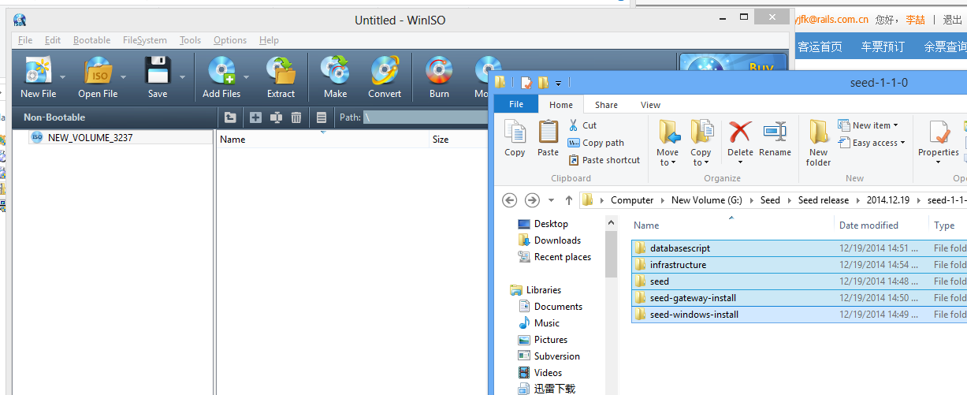

Click Add Files and select all folders and files in C:\seed-1-6-1\ to WinISO

Click Save, enter the File name SEED-1-6-1.iso and save to C:\.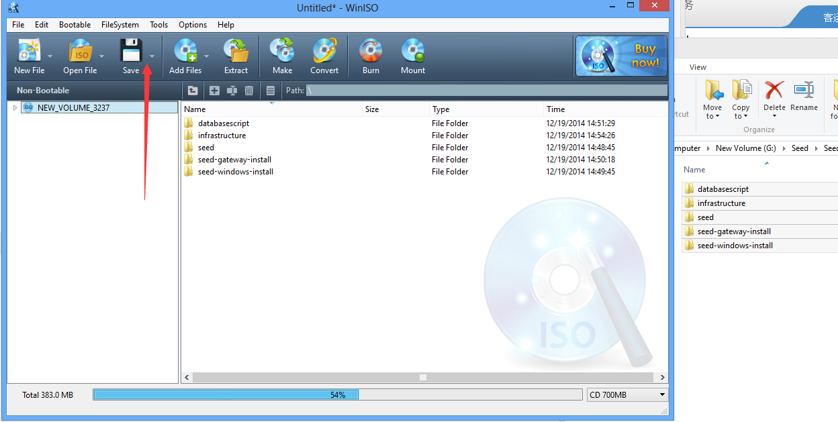

The SEED setup package has been successfully created!