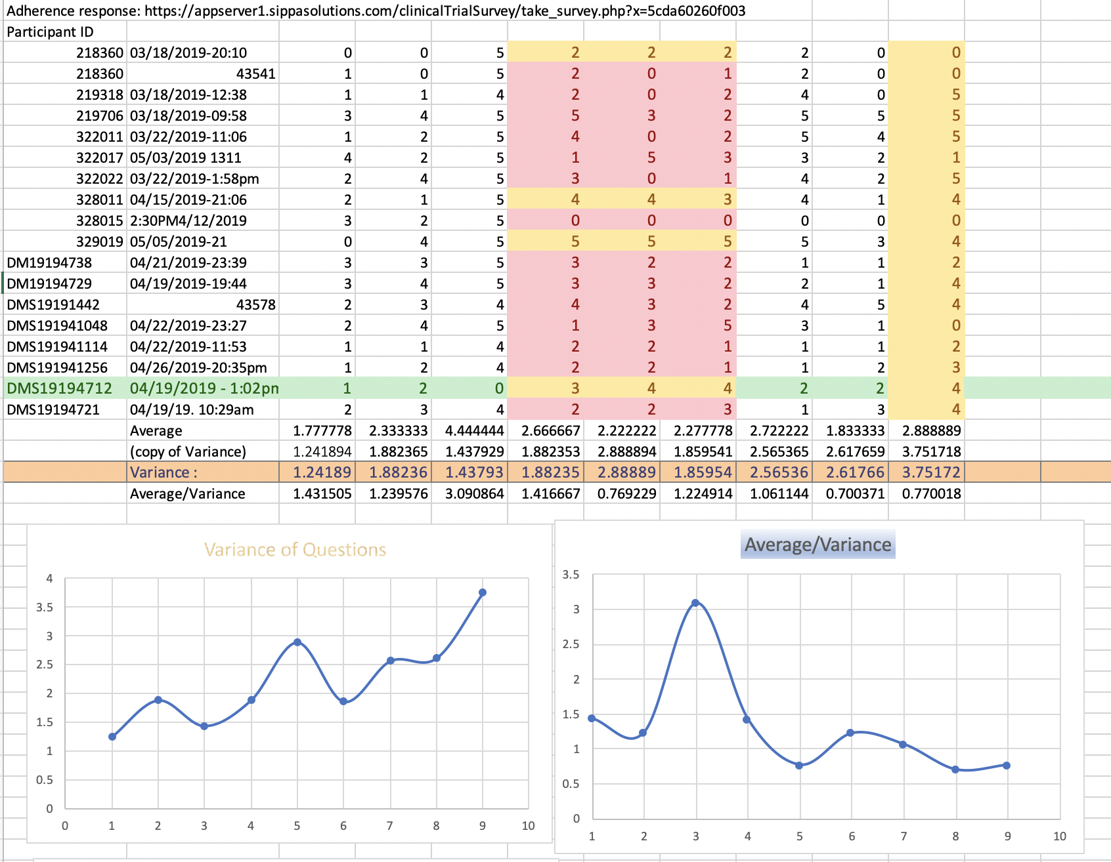

The picture above is the data set about Adherence response. What we did is calculate the average and variance on those questions, try to find the interesting things between those.

According the graph what we got on Average/Variances, It is easily to notice the question 4 higher than others. Then we pull out what the question is:

Question 4:

How often have you taken your prescribed medications?

High result on Average/Variances means to the answers they chose are highly the same(most of answers are >= 4 ).

The interesting thing is there is a person chose 0 on the question.



And base on the question we got, it is related how often take the prescribed medications, which means that person is healthy because he barely takes the medications. And others are unhealthy depend on the answer they chose (most of them take medication all the time).

Then we started to look the data in his row. We figure out that he may have good habits on health. The yellow cell are things what he did often. Such as:

1. Check the glucose level according to the doctor recommendation usually
2. Check the blood pressure level according to the doctor recommendation usually
3. Doing exercise usually

Those things are really helpful on health, and others who usually take medications are bad in those cells. Like this (2 out 3 cells <= 3):



It shows us 13 out 16 are doing bad on those things.

So in conclusion, if we need to develop a APP, we will chose target users on those bad habits people, and develop feature like send reminder to them for their health.(this is what I think roughly, if you get good idea on it , feel free to edit this part . )