LAPORAN RESMI
MEMBUAT BACKEND SOCIAL MEDIA DENGAN NODEJS DAN MONGODB



Disusun untuk Memenuhi Tugas
Mata Kuliah:
WORKSHOP APLIKASI BERBASIS WEB

Oleh:
JUNDIAH INDIRA MILKA TSAURI
3122521020

PROGRAM STUDI D3 TEKNIK INFORMATIKA
PSDKU LAMONGAN
POLITEKNIK ELEKTRONIKA NEGERI SURABAYA
2023
Langkah-langkah:
- Buat folder baru,
- Lalu buka visual studio code, klik terminal dan jalankan perintah npm init
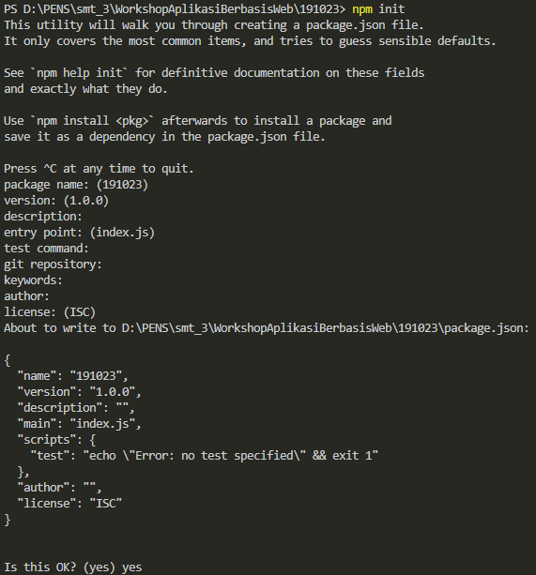
- Jalankan perintah npm install express mongoose dotenv helmet morgan nodemon
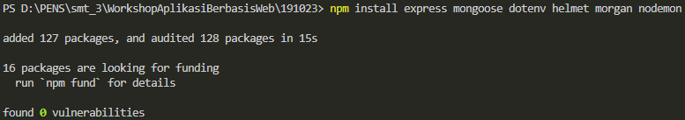
- Buat file baru dengan nama index.js
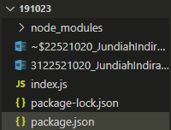
- Tambahkan “start” pada package.js
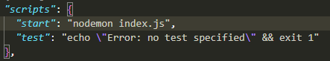
- Isi index.js dengan:
const express = require("express");
const app = express();
app.listen(8800, () => {
console.log("Backend server is running!");
});

Kemudian jalankan dengan perintah npm start
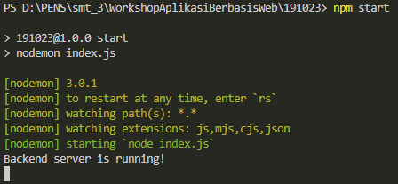
- Buka cloud.mongodb.com, login atau daftar akun jika belum punya akunnya lalu ikuti langkah gambar dibawah ini:
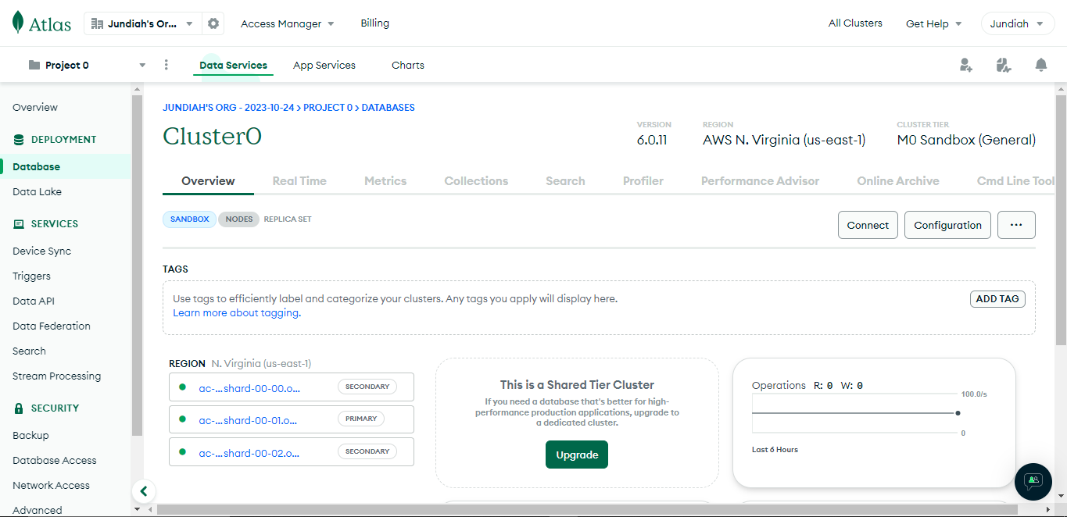
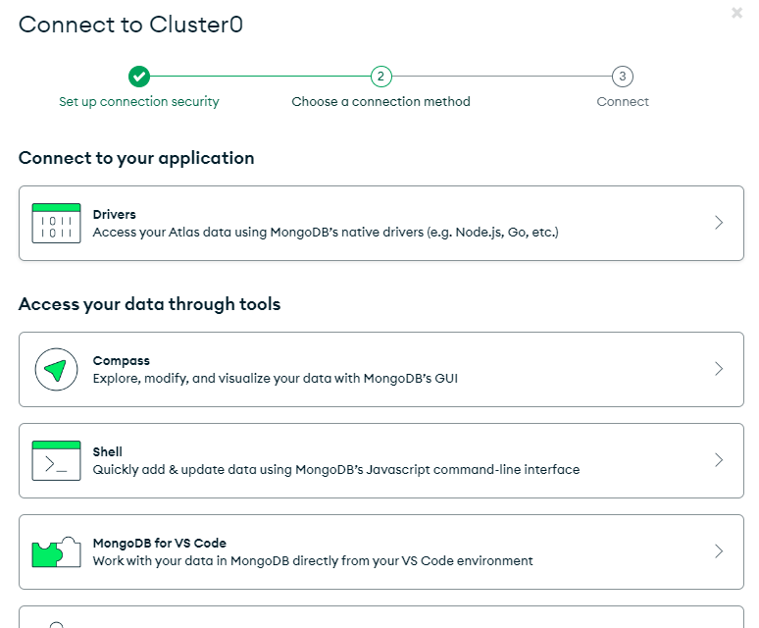
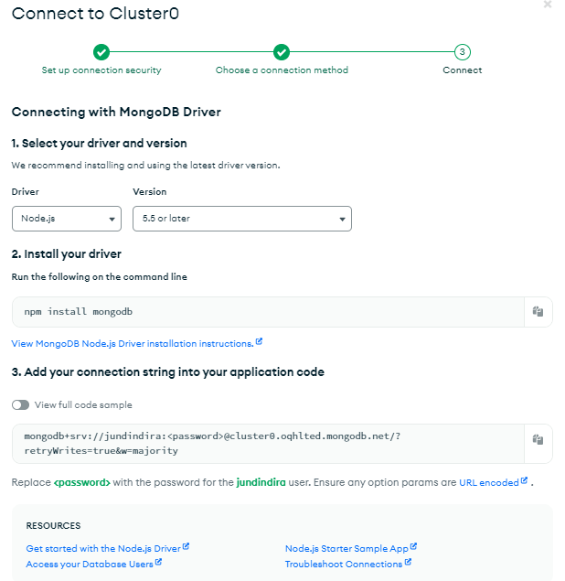

- Buat file baru dengan nama .env dan isi dengan code dari cluster0
Isi username dan password sesuai dengan ketika daftarnya.
- Buka index.js lalu tambahkan:
mongoose.connect(
process.env.MONGO_URL, {
useNewUrlParser: true, useUnifiedTopology: true },
)
.then (() => {
console.log("Connected to MongoDB");
})
.catch((error) => {
console.error("Error connecting to MongoDB:", error);
});
Ketik perintah npm start
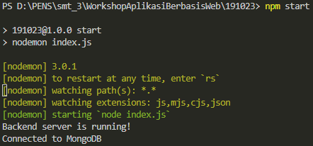
- Tambahkan koding
//middleware
app.use(express.json());
app.use(helmet());
app.use(morgan("common"));

app.get("/", (req,res)=>{
res.send("welcome to homepage")
})
Dalam terminal akan otomatis menuliskan “Backend server is running!”
Buka browser,
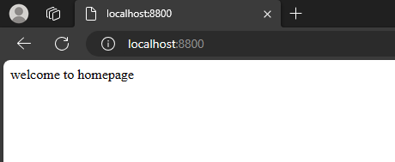
Jika ditambah koding:
app.get("/users", (req,res)=>{
res.send("welcome to user page")
})
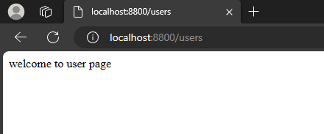
- Buat folder baru dengan nama routes
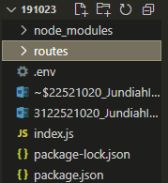
- Buat file baru dalam routes
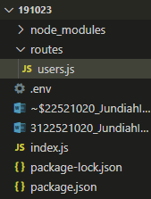
- Buka file index.js, tambahkan koding
const userRoute = require("./routes/users");
.
.
app.use("/api/users", userRoute);
users.js diisi:
const router = require("express").Router();

router.get("/", (req, res) => {
res.send("hey its user router")
});

module.exports = router;

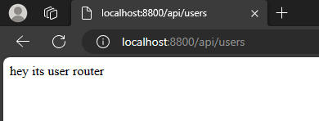
- Buat file baru dalam routes dengan nama auth.js
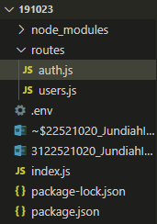
Isi dengan koding:
const router = require("express").Router();

router.get("/", (req, res) => {
res.send("hey its auth router")
});

module.exports = router;
buka index.js, lalu tambahkan koding:
const authRoute = require("./routes/auth");
.
.
app.use("/api/auth", authRoute);
buka browser
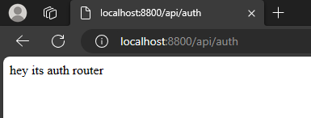
- Buat folder baru bernama models dan buat file bernama User.js
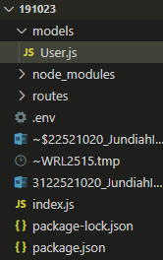
Isi dengan:
const mongoose = require("mongoose");

const UserSchema = new mongoose.Schema(
{
username: {
type: String,
require: true,
min: 3,
max: 20,
unique: true,
},
email: {
type: String,
required: true,
max: 50,
unique: true,
},
password: {
type: String,
required: true,
min: 6,
},
profilePicture: {
type: String,
default: "",
},
coverPicture: {
type: String,
default: "",
},
followers: {
type: Array,
default: [],
},
followings: {
type: Array,
default: [],
},
isAdmin: {
type: Boolean,
default: false,
},
});

module.exports = mongoose.model("User", UserSchema);
- Buka auth.js, tambah kodingan:
const User = require("../models/User");

//REGISTER
router.get("/register", async (req, res) => {
const user = await new User({
username: "John",
email: "john@gmail.com",
password: "123456"
})
await user.save();
res.send("ok")
});
Buka browser:
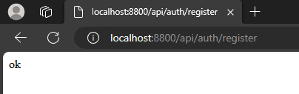
- Buka Postman buat Collections baru
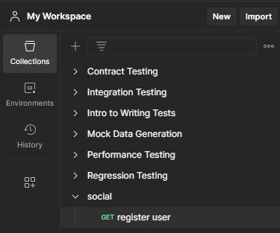
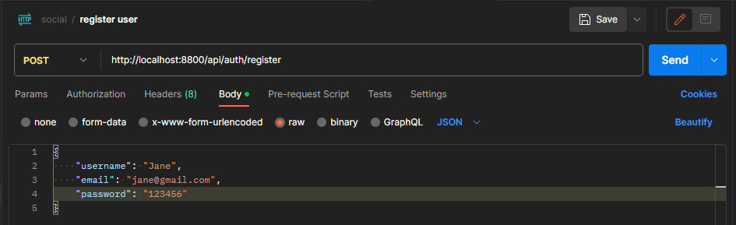
- Buka auth.js. ada beberapa koding yang diubah
//REGISTER
router.post("/register", async (req, res) => {
const newUser = new User({
username: req.body.username,
email: req.body.email,
password: req.body.username,
});
try {
const user = await newUser.save();
res.status(200).json(user);
} catch (err) {
console.log(err);
}
});
- Buka Postman lagi lalu klik Send
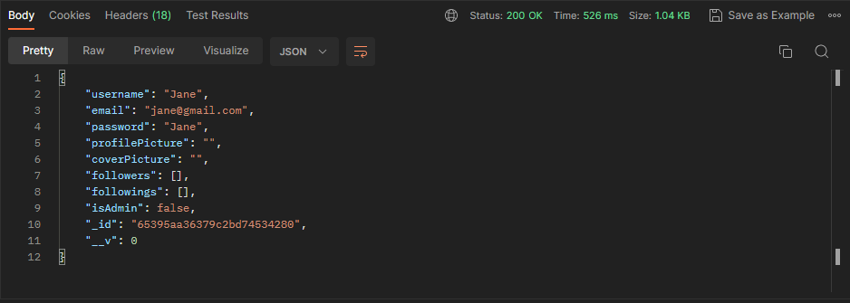
- Buka mongodb Atlas, klik Database lalu Collections, hasil Postman akan muncul disini
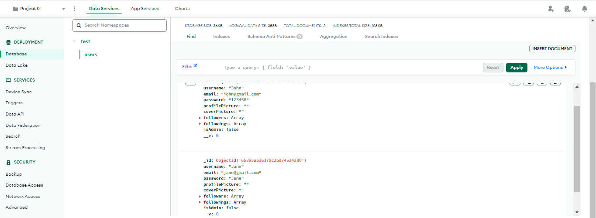
- Jalankan perintah npm install bcrypt
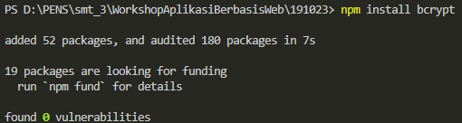
- Buka postman lagi untuk menambahkan data:
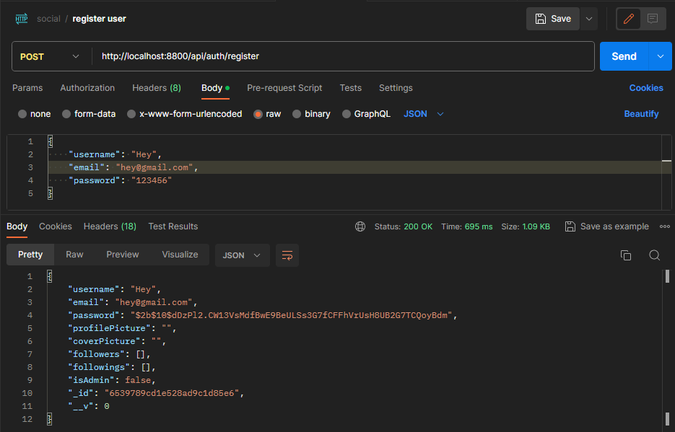
- Buka User.js, hasil semua kodingannya yaitu
const mongoose = require("mongoose");

const UserSchema = new mongoose.Schema(
{
username: {
type: String,
require: true,
min: 3,
max: 20,
unique: true,
},
email: {
type: String,
required: true,
max: 50,
unique: true,
},
password: {
type: String,
required: true,
min: 6,
},
profilePicture: {
type: String,
default: "",
},
coverPicture: {
type: String,
default: "",
},
followers: {
type: Array,
default: [],
},
followings: {
type: Array,
default: [],
},
isAdmin: {
type: Boolean,
default: false,
},
desc: {
type: String,
max: 50,
},
city: {
type: String,
max: 50,
},
from: {
type: String,
max: 50,
},
relationship: {
type: Number,
enum: [1, 2, 3],
},
},
{ timestamps: true }
);

module.exports = mongoose.model("User", UserSchema);

- Buka users.js dan tambahkan kodingan
//update user
router.put("/:id", async (req, res) => {
if (req.body.userId === req.params.id || req.body.isAdmin) {
if (req.body.password) {
try {
const salt = await bcrypt.genSalt(10);
req.body.password = await bcrypt.hash(req.body.password, salt);
} catch (err) {
return res.status(500).json(err);
}
}
try {
const user = await User.findByIdAndUpdate(req.params.id, {
$set: req.body,
});
res.status(200).json("Account has been updated");
} catch (err) {
return res.status(500).json(err);
}
} else {
return res.status(403).json("You can update only your account!");
}
});
Run kembali
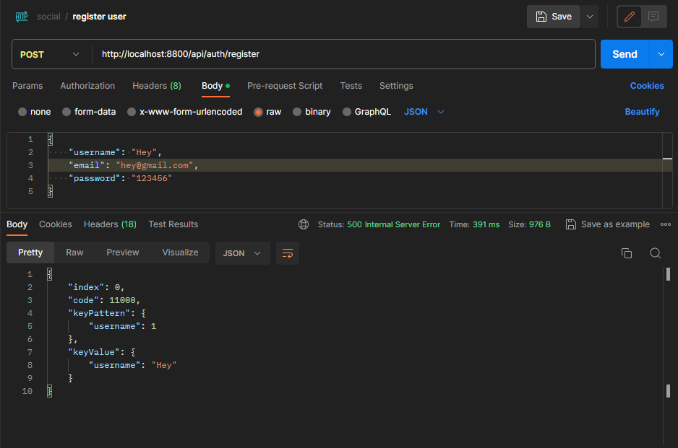
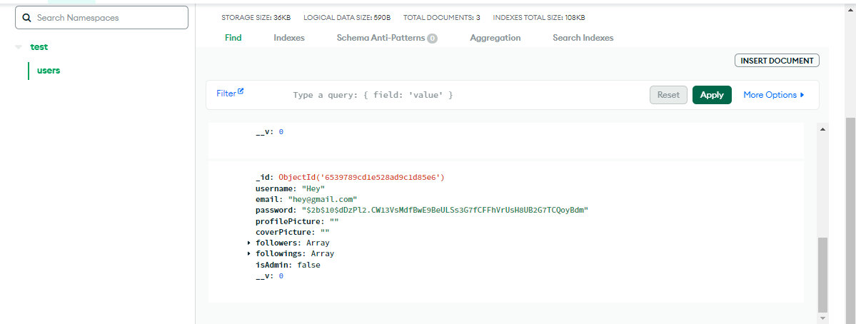
- Buka Postman, buat add request dengan nama update user
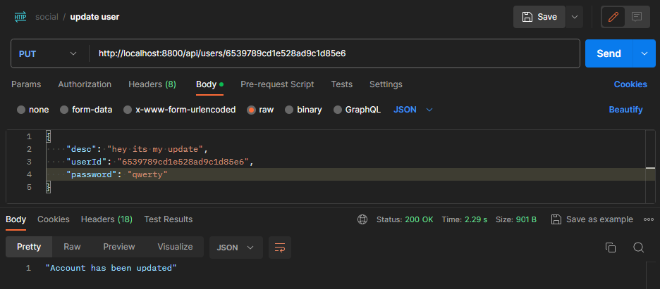
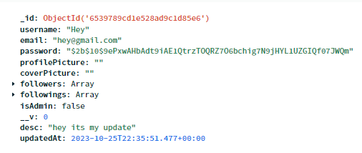
- Di user.js tambahkan koding
//delete user
router.delete("/:id", async (req, res) => {
if (req.body.userId === req.params.id || req.body.isAdmin) {
try {
await User.findByIdAndDelete(req.params.id);
res.status(200).json("Account has been deleted");
} catch (err) {
return res.status(500).json(err);
}
} else {
return res.status(403).json("You can delete only your account!");
}
});
- Buat request dengan nama delete user
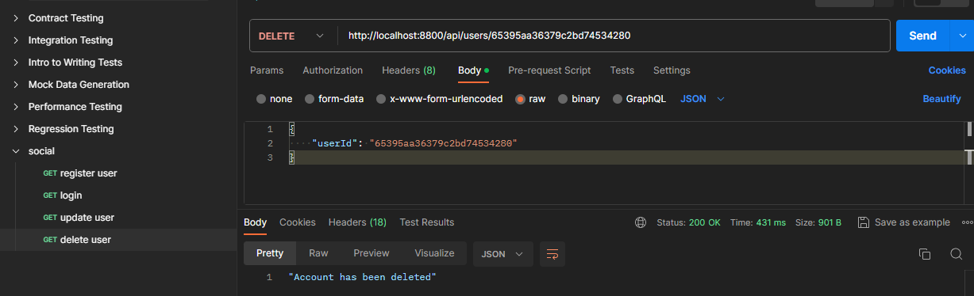
- Tambahkan user.js dengan kodingan
//get a user
router.get("/:id", async (req, res) => {
try {
const user = await User.findById(req.params.id);
const { password, updatedAt, ...other } = user._doc;
res.status(200).json(other);
} catch (err) {
res.status(500).json(err);
}
});
- Buat request baru di Postman
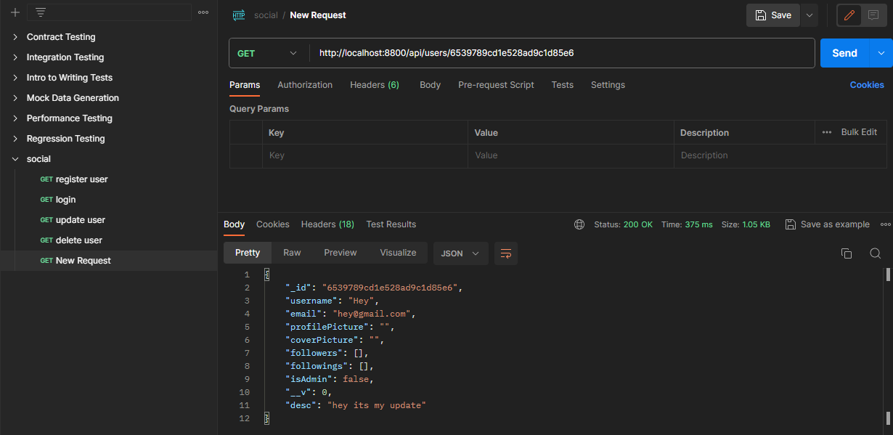
- User.js tambah kodingan:
//follow a user
router.put("/:id/follow", async (req, res) => {
if (req.body.userId !== req.params.id) {
try {
const user = await User.findById(req.params.id);
const currentUser = await User.findById(req.body.userId);
if (!user.followers.includes(req.body.userId)) {
await user.updateOne({ $push: { followers: req.body.userId } });
await currentUser.updateOne({ $push: { followings: req.params.id } });
res.status(200).json("user has been followed");
} else {
res.status(403).json("you allready follow this user");
}
} catch (err) {
res.status(500).json(err);
}
} else {
res.status(403).json("you cant follow yourself");
}
});
- Buat request baru
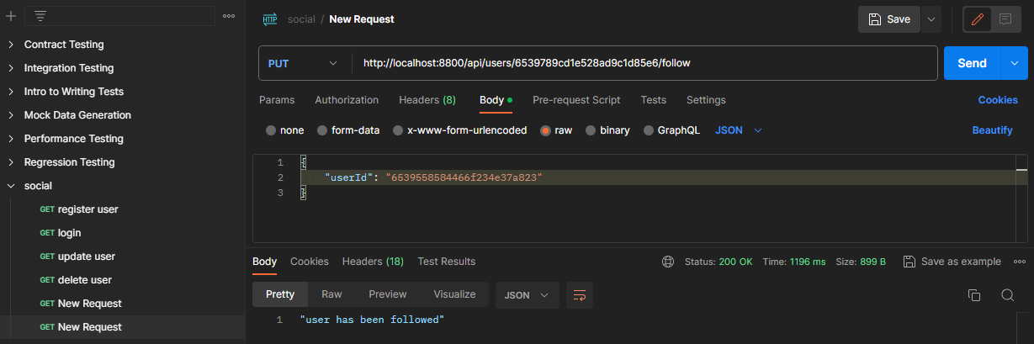
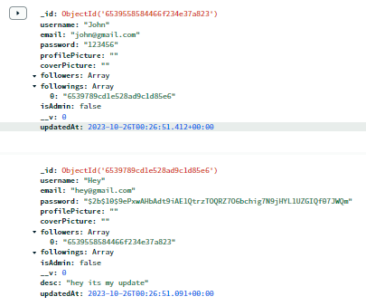
- Tambah kodingan di user.js
//unfollow a user
router.put("/:id/unfollow", async (req, res) => {
if (req.body.userId !== req.params.id) {
try {
const user = await User.findById(req.params.id);
const currentUser = await User.findById(req.body.userId);
if (user.followers.includes(req.body.userId)) {
await user.updateOne({ $pull: { followers: req.body.userId } });
await currentUser.updateOne({ $pull: { followings: req.params.id } });
res.status(200).json("user has been unfollowed");
} else {
res.status(403).json("you dont follow this user");
}
} catch (err) {
res.status(500).json(err);
}
} else {
res.status(403).json("you cant unfollow yourself");
}
});
- Buka Postman,
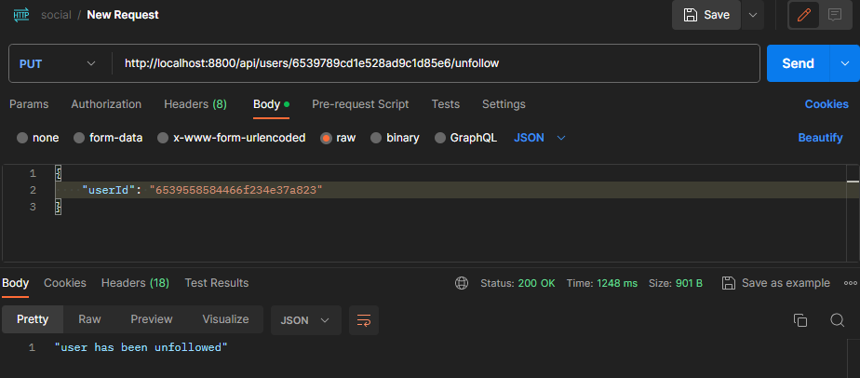
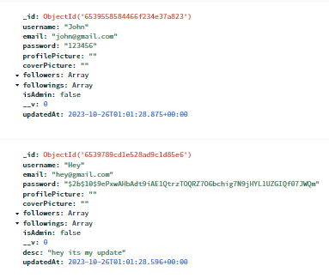
- Buat file baru di folder models dengan nama Post.js
const mongoose = require("mongoose");

const PostSchema = new mongoose.Schema(
{
userId: {
type: String,
required: true,
},
desc: {
type: String,
max: 500,
},
img: {
type: String,
},
likes: {
type: Array,
default: [],
},
},
{ timestamps: true }
);

module.exports = mongoose.model("Post", PostSchema);
- Buat file baru bernama posts.js di folder routes
const router = require("express").Router();
const Post = require("../models/Post");
const User = require("../models/User");

//create a post

router.post("/", async (req, res) => {
const newPost = new Post(req.body);
try {
const savedPost = await newPost.save();
res.status(200).json(savedPost);
} catch (err) {
res.status(500).json(err);
}
});
- Buat request baru bernama create post
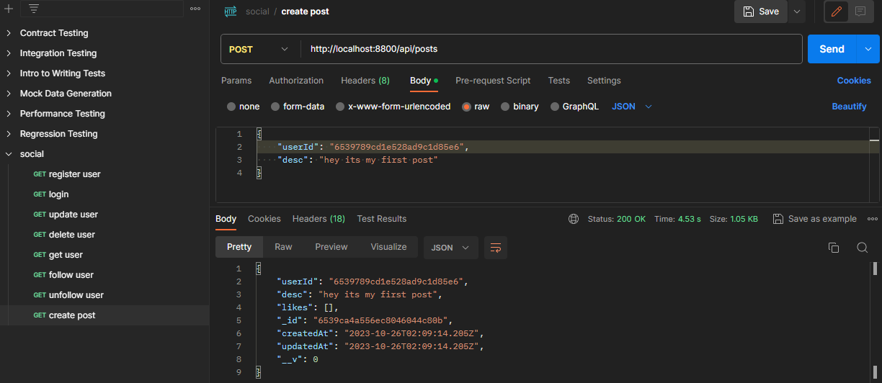
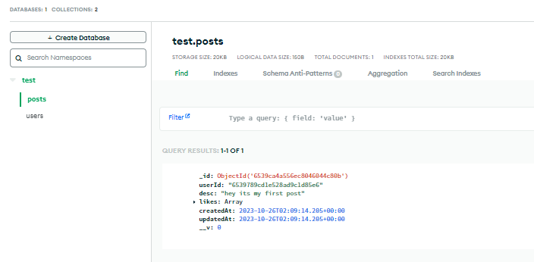
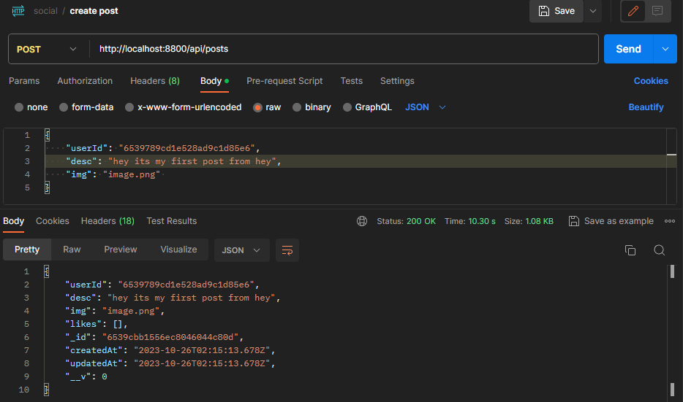
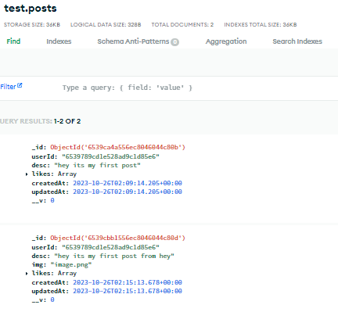
- Update post dalam posts.js
//update a post
router.put("/:id", async (req, res) => {
try {
const post = await Post.findById(req.params.id);
if (post.userId === req.body.userId) {
await post.updateOne({ $set: req.body });
res.status(200).json("the post has been updated");
} else {
res.status(403).json("you can update only your post");
}
} catch (err) {
res.status(500).json(err);
}
});
- Buat request update post
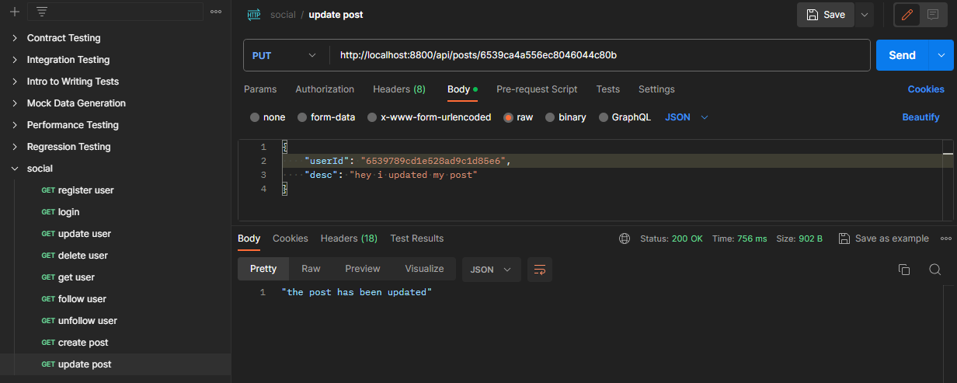
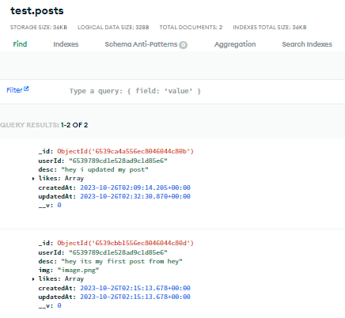
- Tambah kodingan user.js
//delete a post
router.delete("/:id", async (req, res) => {
try {
const post = await Post.findById(req.params.id);
if (post.userId === req.body.userId) {
await post.deleteOne();
res.status(200).json("the post has been deleted");
} else {
res.status(403).json("you can delete only your post");
}
} catch (err) {
res.status(500).json(err);
}
});
- Buat request delete post
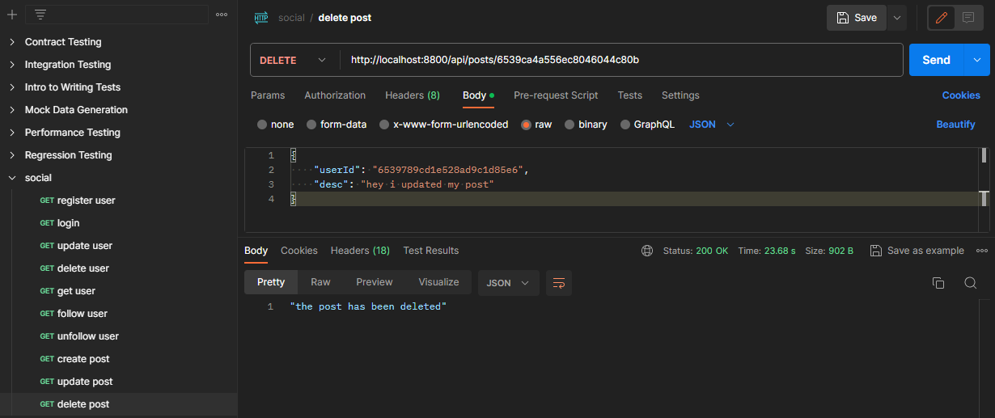
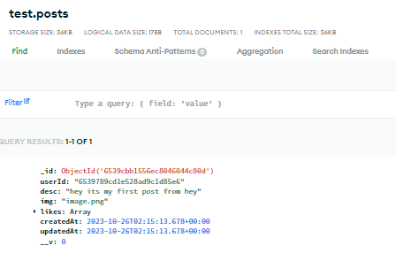
- Tambah koding untuk like atau dislike post
//like / dislike a post
router.put("/:id/like", async (req, res) => {
try {
const post = await Post.findById(req.params.id);
if (!post.likes.includes(req.body.userId)) {
await post.updateOne({ $push: { likes: req.body.userId } });
res.status(200).json("The post has been liked");
} else {
await post.updateOne({ $pull: { likes: req.body.userId } });
res.status(200).json("The post has been disliked");
}
} catch (err) {
res.status(500).json(err);
}
});
- Buat request like dislike post
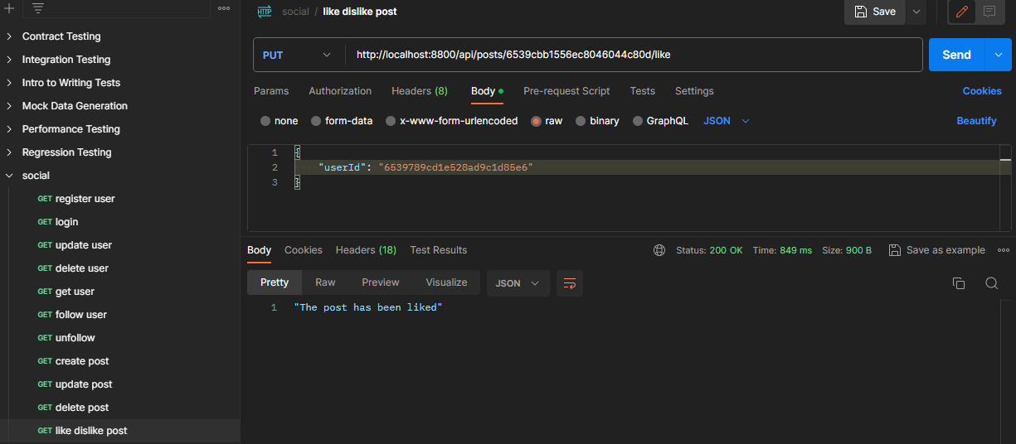
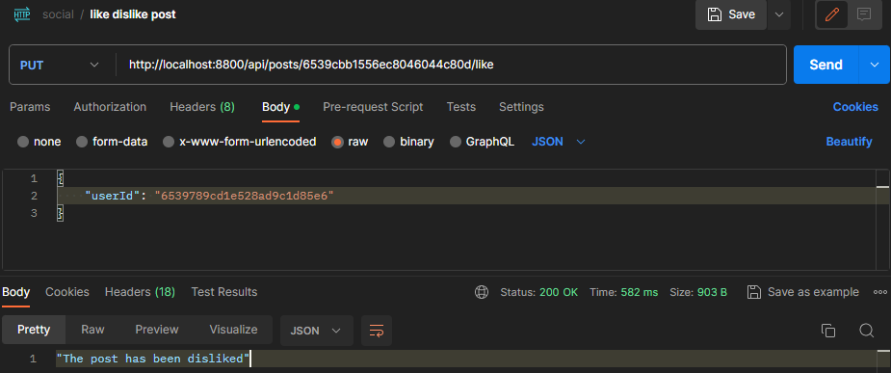
- Tambah kodingan user.js
//get a post
router.get("/:id", async (req, res) => {
try {
const post = await Post.findById(req.params.id);
res.status(200).json(post);
} catch (err) {
res.status(500).json(err);
}
});
- Buat request get a post di postman
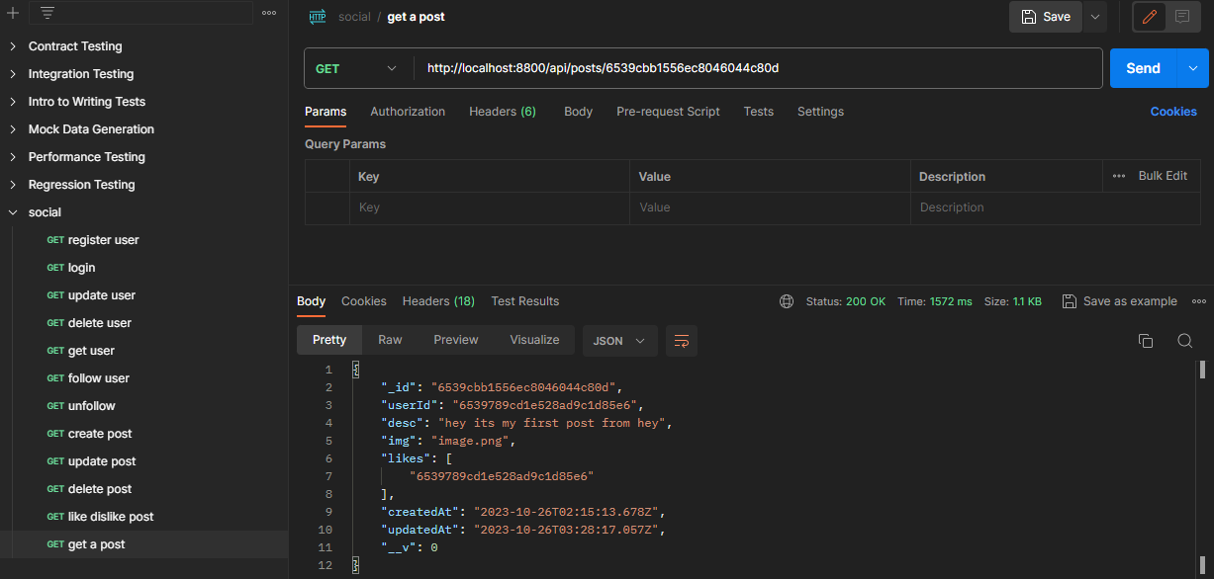
- Tambahkan kodingan untuk timeline post
//get timeline posts
router.get("/timeline/all", async (req, res) => {
try {
const currentUser = await User.findById(req.body.userId);
const userPosts = await Post.find({ userId: currentUser._id });
const friendPosts = await Promise.all(
currentUser.followings.map((friendId) => {
return Post.find({ userId: friendId });
})
);
res.json(userPosts.concat(...friendPosts))
} catch (err) {
res.status(500).json(err);
}
});
- Buat request di Postman
