LAPORAN RESMI
PRAKTEK PACKET DAN SIRCUIT SWITCHING



Disusun untuk Memenuhi Tugas
Mata Kuliah:
PRAKTEK KONSEP JARINGAN

Oleh:
JUNDIAH INDIRA MILKA TSAURI
3122521020

PROGRAM STUDI D3 TEKNIK INFORMATIKA
PSDKU LAMONGAN
POLITEKNIK ELEKTRONIKA NEGERI SURABAYA
2023
GAMBAR HASIL AKHIR PERCOBAAN:
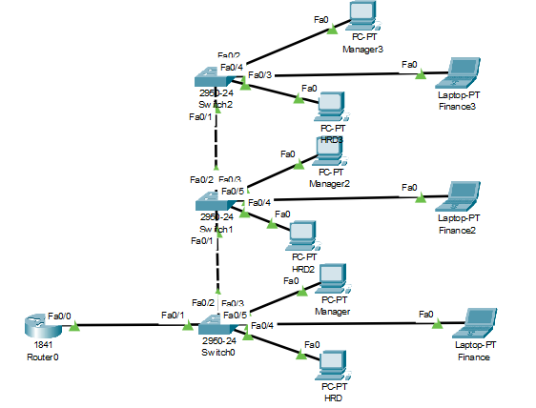

Langkah-langkah:
- Langkah pertama dari praktek ini, kita membuat desain jaringan di aplikasi Cisco Packet Tracer
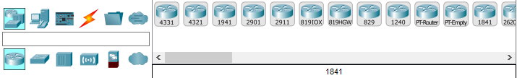
Router
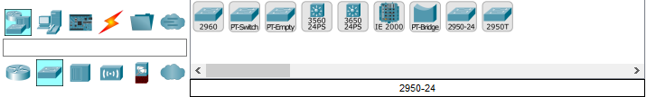
Switch
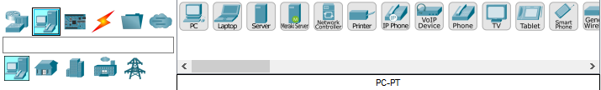
Device

- Menghubungkan komponen-komponen dengan kabel Copper
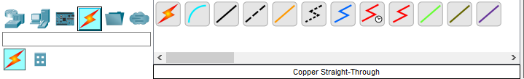
Kabel straight untuk menyambungkan router ke switch, dan switch ke device
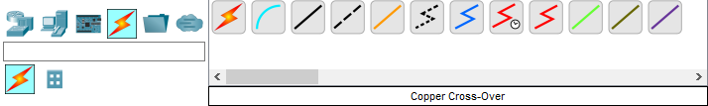
Kabel cross untuk menyambungkan switch ke switch

- Konfigurasi router
Router>enable
Router#configure terminal
Enter configuration commands, one per line. End with CNTL/Z.
Router(config)#interface fastEthernet 0/0
Router(config-if)#no shutdown

Router(config-if)#
%LINK-5-CHANGED: Interface FastEthernet0/0, changed state to up

%LINEPROTO-5-UPDOWN: Line protocol on Interface FastEthernet0/0, changed state to up

Router(config-if)#exit
Router(config)#interface fastEthernet 0/0.1
Router(config-subif)#
%LINK-5-CHANGED: Interface FastEthernet0/0.1, changed state to up

%LINEPROTO-5-UPDOWN: Line protocol on Interface FastEthernet0/0.1, changed state to up

Router(config-subif)#no shutdown
Router(config-subif)#encapsulation dot1Q 10
Router(config-subif)#ip address 192.168.0.1 255.255.255.240
Router(config-subif)#no shutdown
Router(config-subif)#exit
Router(config)#interface fastEthernet 0/0.2
Router(config-subif)#
%LINK-5-CHANGED: Interface FastEthernet0/0.2, changed state to up

%LINEPROTO-5-UPDOWN: Line protocol on Interface FastEthernet0/0.2, changed state to up

Router(config-subif)#encapsulation dot1Q 20
Router(config-subif)#ip address 192.168.1.1 255.255.255.224
Router(config-subif)#no shutdown
Router(config-subif)#exit
Router(config)#interface fastEthernet 0/0.3
Router(config-subif)#
%LINK-5-CHANGED: Interface FastEthernet0/0.3, changed state to up

%LINEPROTO-5-UPDOWN: Line protocol on Interface FastEthernet0/0.3, changed state to up

Router(config-subif)#encapsulation dot1Q 30
Router(config-subif)#ip address 192.168.2.1
% Incomplete command.
Router(config-subif)#ip address 192.168.2.1 255.255.255.128
Router(config-subif)#no shutdown
Router(config-subif)#exit
Router(config)#ip dhcp pool vlan10
Router(dhcp-config)#default-router 192.168.0.1
Router(dhcp-config)#network 192.168.0.0 255.255.255.240
Router(dhcp-config)#exit
Router(config)#ip dhcp pool vlan20
Router(dhcp-config)#default-router 192.168.1.1
Router(dhcp-config)#network 192.168.1.0 255.255.255.224
Router(dhcp-config)#exit
Router(config)#ip dhcp pool vlan30
Router(dhcp-config)#default-router 192.168.2.1
Router(dhcp-config)#network 192.168.2.0 255.255.255.128
Router(dhcp-config)#exit
Router(config)#ip dhcp excluded-address 192.168.0.1 192.168.0.2
Router(config)#ip dhcp excluded-address 192.168.1.1 192.168.1.5
Router(config)#ip dhcp excluded-address 192.168.2.1 192.168.2.10
Router(config)#
Hasil konfigurasi dapat dilihat ketika kursor mengarah ke router:
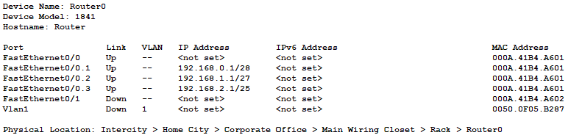

- Konfigurasi switch0
Switch>enable
Switch#ls
Translating "ls"...domain server (255.255.255.255)
% Unknown command or computer name, or unable to find computer address

Switch#configure terminal
Enter configuration commands, one per line. End with CNTL/Z.
Switch(config)#vlan 10
Switch(config-vlan)#vlan 20
Switch(config-vlan)#vlan 30
Switch(config-vlan)#exit
Switch(config)#exit
Switch#
%SYS-5-CONFIG_I: Configured from console by console

Switch#configure terminal
Enter configuration commands, one per line. End with CNTL/Z.
Switch(config)#vlan 10
Switch(config-vlan)#name HRD
Switch(config-vlan)#exit
Switch(config)#vlan 20
Switch(config-vlan)#name Manager
Switch(config-vlan)#exit
Switch(config)#vlan 30
Switch(config-vlan)#
Switch(config-vlan)#name Finance
Switch(config-vlan)#exit
Switch(config)#exit
Switch#
%SYS-5-CONFIG_I: Configured from console by console

Switch#configure terminal
Enter configuration commands, one per line. End with CNTL/Z.
Switch(config)#interface fastEthernet 0/2
Switch(config-if)#switchport mode trunk
Switch(config-if)#switchport trunk allowed vlan 10-30
Switch(config-if)#exit
Switch(config)#interface fastEthernet 0/4
Switch(config-if)#switchport mode access
Switch(config-if)#switchport access vlan 10
Switch(config-if)#exit
Switch(config)#interface fastEthernet 0/3
Switch(config-if)#switchport mode access
Switch(config-if)#switchport access vlan 10
Switch(config-if)#exit
Switch(config)#interface fastEthernet 0/3
Switch(config-if)#switchport mode access
Switch(config-if)#switchport access vlan 20
Switch(config-if)#exit
Switch(config)#interface fastEthernet 0/5
Switch(config-if)#switchport mode access
Switch(config-if)#switchport access vlan 30
Switch(config-if)#exit
Hasil konfigurasi dapat dilihat ketika kursor mengarah ke Switch0:

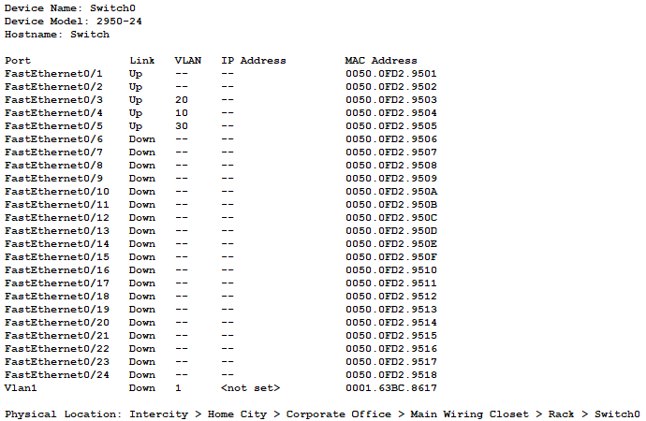

- Konfigurasi switch1
Switch>enable
Switch#configure terminal
Enter configuration commands, one per line. End with CNTL/Z.
Switch(config)#vlan 10
Switch(config-vlan)#vlan 20
Switch(config-vlan)#vlan 30
Switch(config-vlan)#exit
Switch(config)#vlan
% Incomplete command.
Switch(config)#vlan 10
Switch(config-vlan)#name HRD2
Switch(config-vlan)#exit
Switch(config)#vlan 20
Switch(config-vlan)#name Manager2
Switch(config-vlan)#exit
Switch(config)#vlan 30
Switch(config-vlan)#name Finance2
Switch(config-vlan)#exit
Switch(config)#interface fastEthernet 0/1
Switch(config-if)#switchport mode trunk
Switch(config-if)#switchport trunk allowed vlan 10-30
Switch(config-if)#exit
Switch(config)#interface fastEthernet 0/4
Switch(config-if)#switchport mode access
Switch(config-if)#switchport access vlan 10
Switch(config-if)#exit
Switch(config)#interface fastEthernet 0/3
Switch(config-if)#switchport mode access
Switch(config-if)#switchport access vlan 20
Switch(config-if)#exit
Switch(config)#interface fastEthernet 0/5
Switch(config-if)#swicthport mode access
^
% Invalid input detected at '^' marker.

Switch(config-if)#switchport mode access
Switch(config-if)#switchport access vlan 30
Switch(config-if)#exit
Switch(config)#interface fastEthernet 0/2
Switch(config-if)#switchport mode trunk
Switch(config-if)#switchport trunk allowed vlan 10-30
Switch(config-if)#exit
Hasil konfigurasi dapat dilihat ketika kursor mengarah ke Switch1:
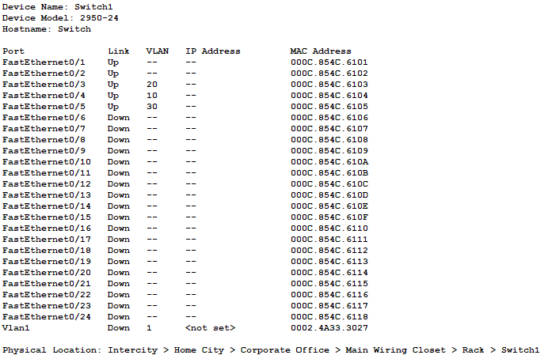

- Konfigurasi switch2
Switch>enable
Switch#configure terminal
Enter configuration commands, one per line. End with CNTL/Z.
Switch(config)#vlan 10
Switch(config-vlan)#vlan 20
Switch(config-vlan)#vlan 30
Switch(config-vlan)#exit
Switch(config)#vlan 10
Switch(config-vlan)#name HRD3
Switch(config-vlan)#exit
Switch(config)#vlan 20
Switch(config-vlan)#name Manager3
Switch(config-vlan)#exit
Switch(config)#vlan 30
Switch(config-vlan)#name Finance3
Switch(config-vlan)#exit
Switch(config)#interface fastEthernet 0/1
Switch(config-if)#switchport mode trunk
Switch(config-if)#switchport trunk allowed vlan 10-30
Switch(config-if)#exit
Switch(config)#interface fastEthernet 0/2
Switch(config-if)#switchport mode access
Switch(config-if)#switchport access vlan 20
Switch(config-if)#exit
Switch(config)#interface fastEthernet 0/3
Switch(config-if)#switchport mode access
Switch(config-if)#switchport access vlan 10
Switch(config-if)#exit
Switch(config)#interface fastEthernet 0/4
Switch(config-if)#switchport mode access
Switch(config-if)#switchport access vlan 30
Switch(config-if)#exit
Switch(config)#
Hasil konfigurasi dapat dilihat ketika kursor mengarah ke Switch2:
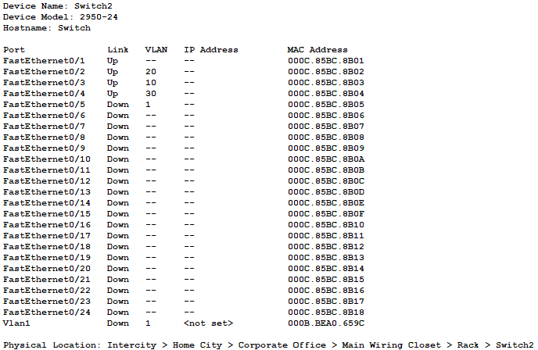

- Investigasi vlan dengan perintah show vlan
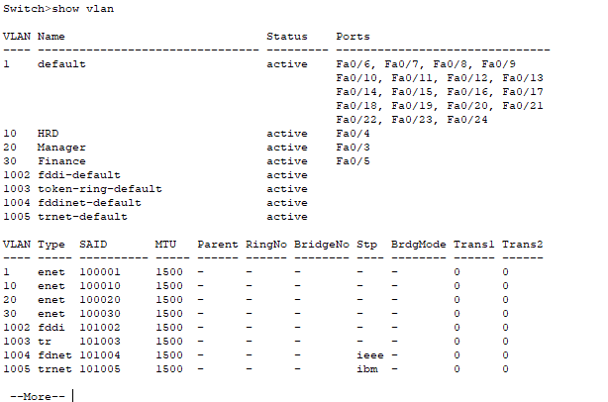

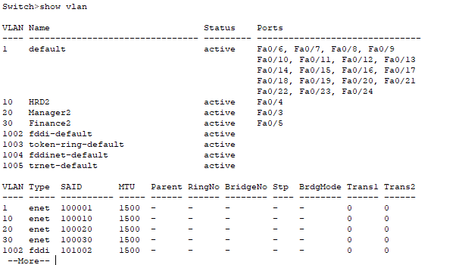
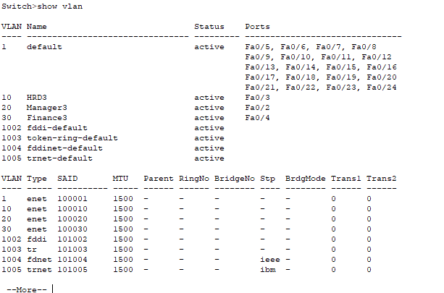

- Untuk mendapatkan IP Manager klik kursor ke arah PC Manager, kemudian pilih Desktop dan masuk ke IP Configuration

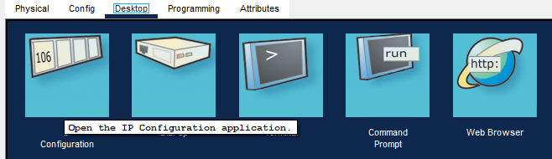

Pada halaman IP Configuration, ubah Static menjadi DHCP:
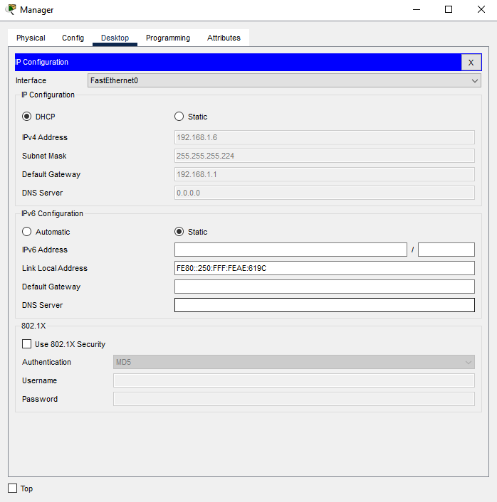

Begitu pula untuk mendapatkan IP HRD
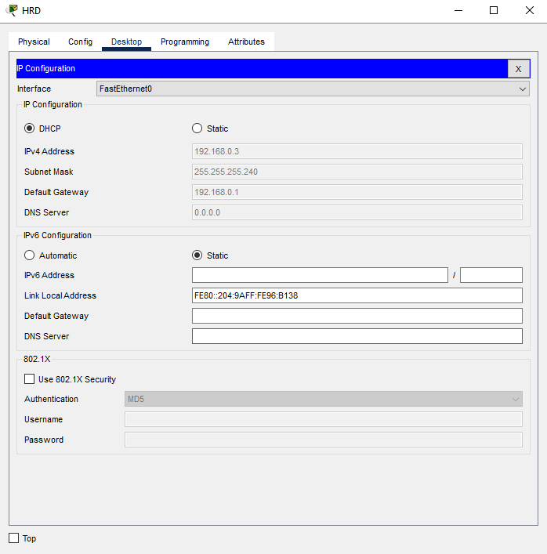

IP Finance
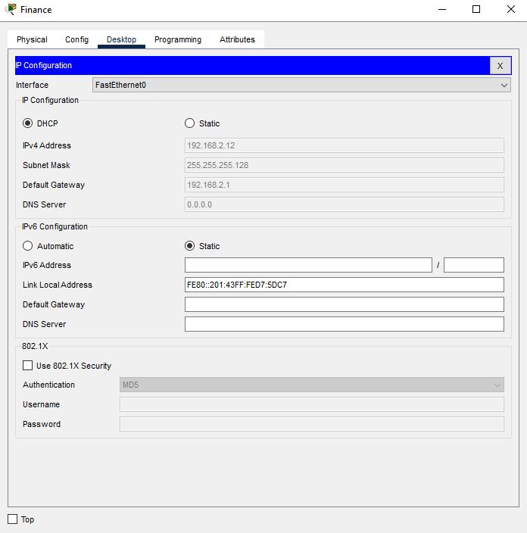

IP Manager2
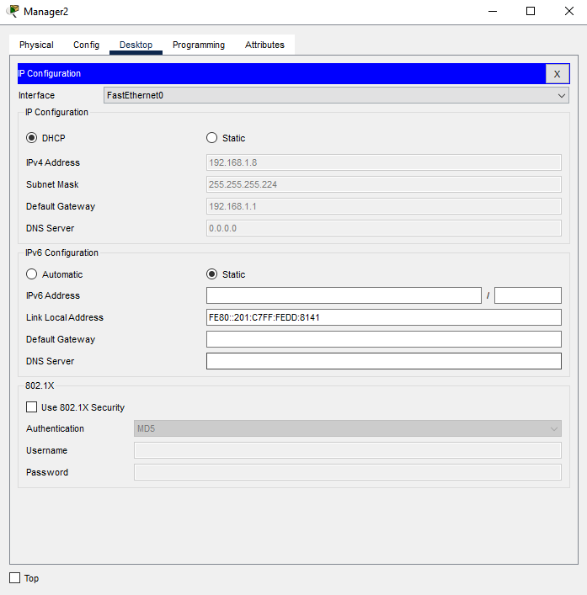

IP HRD2
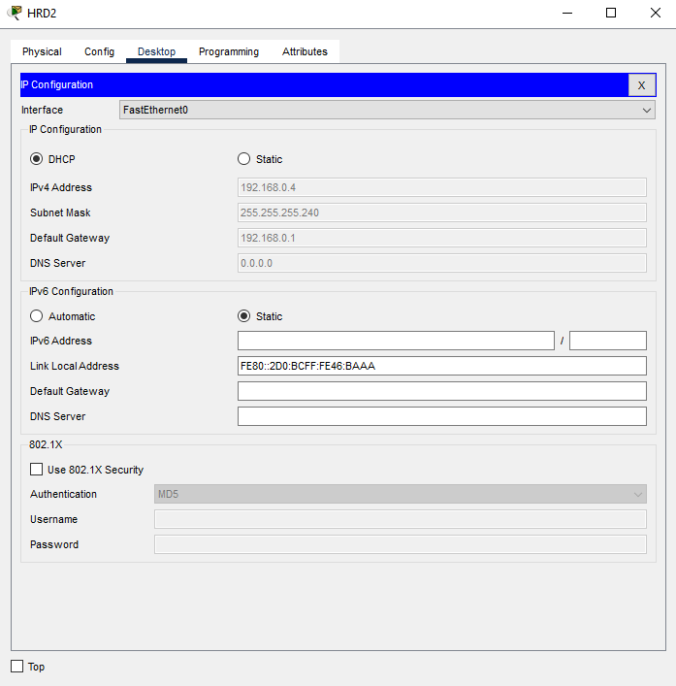

IP Finance2
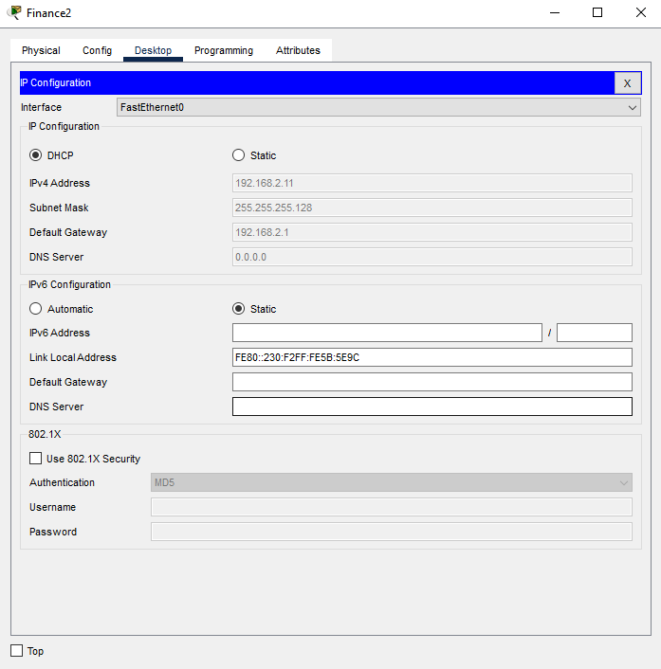

IP Manager3
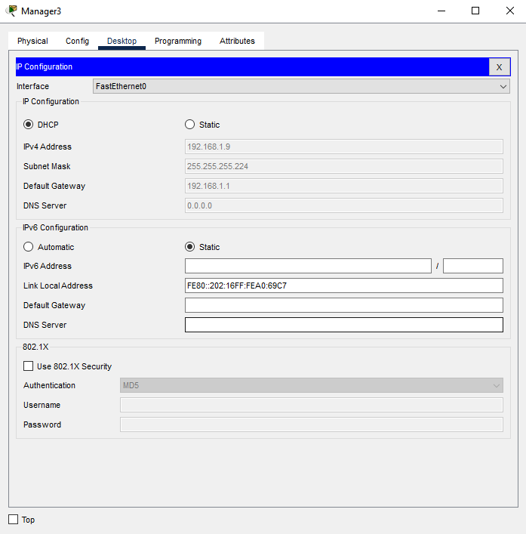

IP HRD3
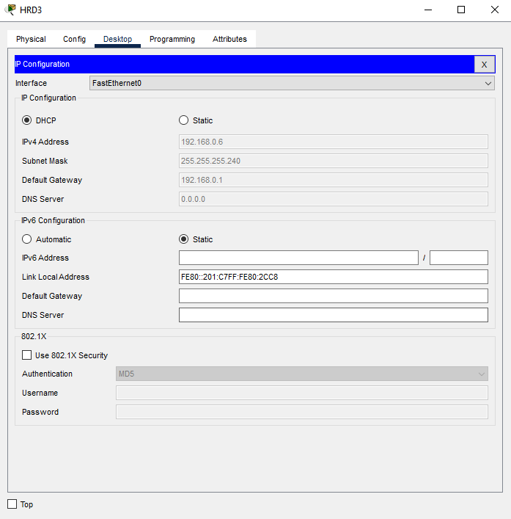

IP Finance3
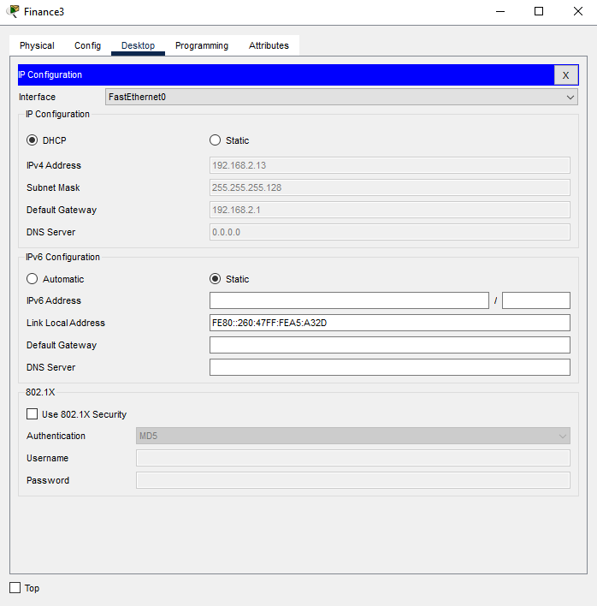

- Untuk mengecek koneksi HRD ke HRD2, masuk ke halaman Command Prompt
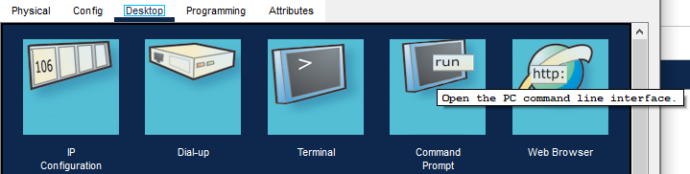

Dan ketik seperti pada gambar berikut:
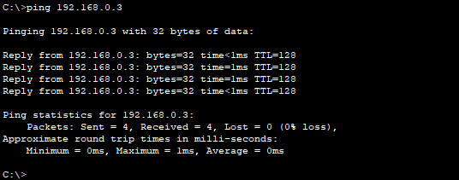

Cek juga koneksi Manager ke Manager2
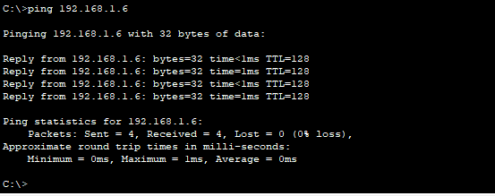

Cek koneksi Finance ke Finance2
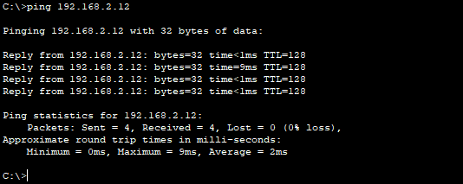

Cek koneksi HRD2 ke HRD3
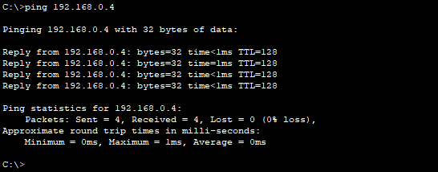

Cek koneksi Manager2 ke Manager3
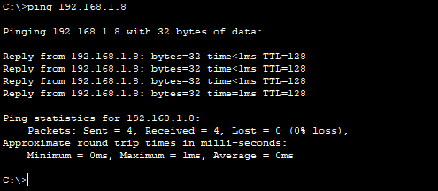

Cek koneksi Finance2 ke Finance3
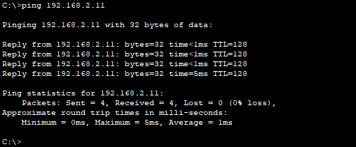
Jika hasil ping seperti pada gambar, maka artinya sudah berhasil terkoneksi.

