**M.Asjaun**

**1103210181**

**Uts**

**Link Video**

Informasi Dataset:

<class 'pandas.core.frame.DataFrame'>

RangeIndex: 4000 entries, 0 to 3999

Data columns (total 91 columns):

# Column Non-Null Count Dtype

--- ------ -------------- -----

0 Year 4000 non-null int64

1 x1 4000 non-null float64

2 x2 4000 non-null float64

3 x3 4000 non-null float64

4 x4 4000 non-null float64

5 x5 4000 non-null float64

6 x6 4000 non-null float64

7 x7 4000 non-null float64

8 x8 4000 non-null float64

9 x9 4000 non-null float64

10 x10 4000 non-null float64

11 x11 4000 non-null float64

12 x12 4000 non-null float64

13 x13 4000 non-null float64

14 x14 4000 non-null float64

15 x15 4000 non-null float64

16 x16 4000 non-null float64

17 x17 4000 non-null float64

18 x18 4000 non-null float64

19 x19 4000 non-null float64

20 x20 4000 non-null float64

21 x21 4000 non-null float64

22 x22 4000 non-null float64

23 x23 4000 non-null float64

24 x24 4000 non-null float64

25 x25 4000 non-null float64

26 x26 4000 non-null float64

27 x27 4000 non-null float64

28 x28 4000 non-null float64

29 x29 4000 non-null float64

30 x30 4000 non-null float64

31 x31 4000 non-null float64

32 x32 4000 non-null float64

33 x33 4000 non-null float64

34 x34 4000 non-null float64

35 x35 4000 non-null float64

36 x36 4000 non-null float64

37 x37 4000 non-null float64

38 x38 4000 non-null float64

39 x39 4000 non-null float64

40 x40 4000 non-null float64

41 x41 4000 non-null float64

42 x42 4000 non-null float64

43 x43 4000 non-null float64

44 x44 4000 non-null float64

45 x45 4000 non-null float64

46 x46 4000 non-null float64

47 x47 4000 non-null float64

48 x48 4000 non-null float64

49 x49 4000 non-null float64

50 x50 4000 non-null float64

51 x51 4000 non-null float64

52 x52 4000 non-null float64

53 x53 4000 non-null float64

54 x54 4000 non-null float64

55 x55 4000 non-null float64

56 x56 4000 non-null float64

57 x57 4000 non-null float64

58 x58 4000 non-null float64

59 x59 4000 non-null float64

60 x60 4000 non-null float64

61 x61 4000 non-null float64

62 x62 4000 non-null float64

63 x63 4000 non-null float64

64 x64 4000 non-null float64

65 x65 4000 non-null float64

66 x66 4000 non-null float64

67 x67 4000 non-null float64

68 x68 4000 non-null float64

69 x69 4000 non-null float64

70 x70 4000 non-null float64

71 x71 4000 non-null float64

72 x72 4000 non-null float64

73 x73 4000 non-null float64

74 x74 4000 non-null float64

75 x75 4000 non-null float64

76 x76 4000 non-null float64

77 x77 4000 non-null float64

78 x78 4000 non-null float64

79 x79 4000 non-null float64

80 x80 4000 non-null float64

81 x81 4000 non-null float64

82 x82 4000 non-null float64

83 x83 4000 non-null float64

84 x84 4000 non-null float64

85 x85 4000 non-null float64

86 x86 4000 non-null float64

87 x87 4000 non-null float64

88 x88 4000 non-null float64

89 x89 4000 non-null float64

90 x90 4000 non-null float64

dtypes: float64(90), int64(1)

memory usage: 2.8 MB

None

Ringkasan Statistik:

Year x1 x2 x3 x4 \

count 4000.000000 4000.000000 4000.000000 4000.000000 4000.000000

mean 1998.435000 43.311786 1.012153 8.463853 0.733843

std 11.034773 6.203113 51.931772 34.550414 15.871093

min 1927.000000 4.836880 -287.287360 -181.649920 -92.331640

25% 1994.000000 39.850093 -27.499023 -11.580035 -8.685952

50% 2002.000000 44.244950 7.177550 10.800570 -0.780245

75% 2006.000000 47.776155 36.072565 28.977497 8.317600

max 2010.000000 56.111220 177.001290 153.307500 109.984410

x5 x6 x7 x8 x9 ... \

count 4000.000000 4000.000000 4000.000000 4000.000000 4000.000000 ...

mean -6.717566 -9.437315 -2.249602 -1.893381 3.815266 ...

std 22.870201 12.694786 14.559507 7.942464 10.587308 ...

min -102.797980 -70.450570 -66.829680 -39.386550 -74.424430 ...

25% -20.770273 -18.333112 -10.703190 -6.561155 -2.065132 ...

50% -6.277740 -11.006495 -1.860480 -1.821385 4.063490 ...

75% 7.200255 -2.281867 6.619840 2.520313 9.958815 ...

max 168.918870 57.099910 131.396350 52.576250 55.831130 ...

x81 x82 x83 x84 x85 \

count 4000.000000 4000.000000 4000.000000 4000.000000 4000.000000

mean 16.298369 -75.223614 39.250547 34.652395 0.662173

std 35.048044 176.846479 117.832238 95.055468 16.882065

min -196.289070 -1783.416650 -701.391740 -1147.976630 -200.135010

25% -1.470347 -147.562252 -23.325915 -5.634960 -6.246187

50% 9.131615 -50.506850 28.999400 32.555595 0.881840

75% 26.071280 13.461400 88.818755 76.210900 8.686333

max 644.414220 1404.511780 921.008720 530.860360 133.924920

x86 x87 x88 x89 x90

count 4000.000000 4000.000000 4000.000000 4000.000000 4000.000000

mean 18.797449 -26.717331 4.212853 20.868842 1.483193

std 117.535274 175.062616 13.861867 213.872855 24.067136

min -1308.055150 -2179.274330 -70.480920 -7458.378150 -119.192560

25% -30.921385 -102.911478 -2.739300 -57.671635 -8.756602

50% 15.873315 -19.234530 3.129655 11.952900 0.171950

75% 70.179970 57.769723 9.950910 84.542975 9.601770

max 748.164480 981.440830 243.004150 2042.531890 600.766240

[8 rows x 91 columns]

Pemeriksaan Nilai Null:

Year 0

x1 0

x2 0

x3 0

x4 0

..

x86 0

x87 0

x88 0

x89 0

x90 0

Length: 91, dtype: int64

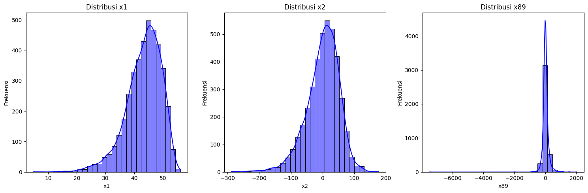

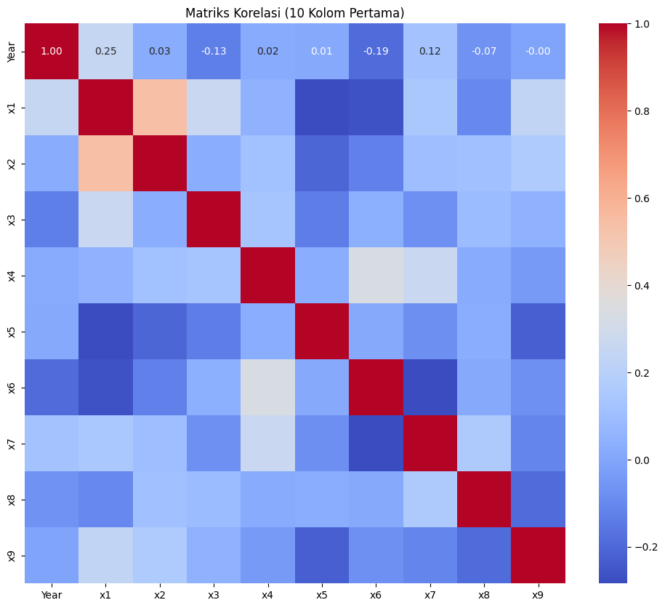

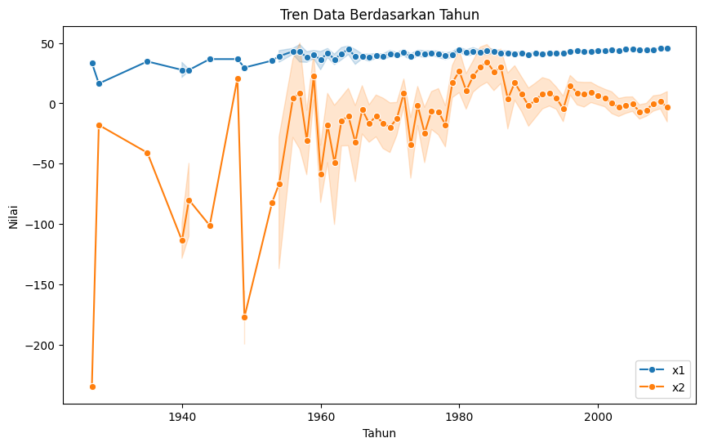

Hasil Evaluasi Model:

Model Best Parameters MSE \

0 LinearRegression {'poly__degree': 1} 95.419414

1 Ridge {'poly__degree': 1, 'regressor__alpha': 100} 94.735538

2 Lasso {'poly__degree': 1, 'regressor__alpha': 0.1} 94.464910

R2

0 0.195256

1 0.201023

2 0.203306

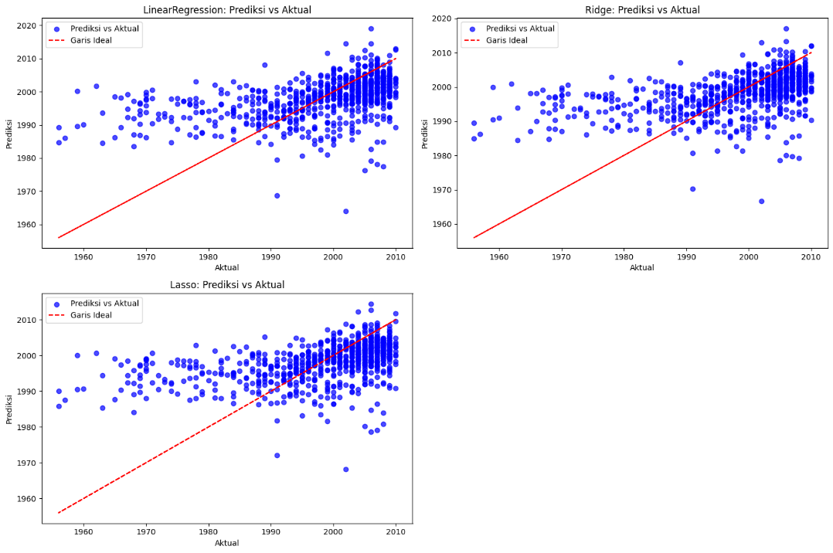

Laporan Evaluasi:

Best Parameters: {'regressor__max_depth': 5, 'regressor__min_samples_leaf': 2, 'regressor__min_samples_split': 10}

MSE: 128.81943893636526

R2: -0.08643207093942529

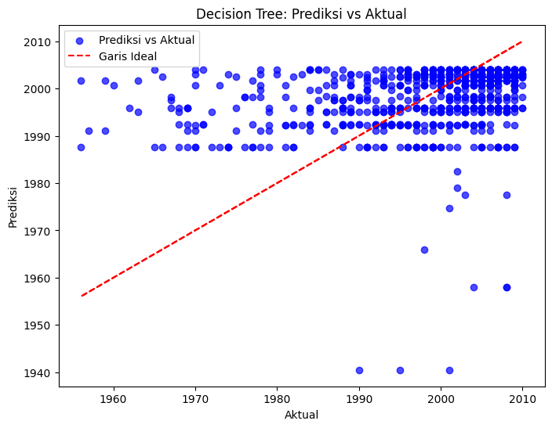

Laporan Evaluasi:

Best Parameters: {'regressor__n_neighbors': 9, 'regressor__p': 1, 'regressor__weights': 'distance'}

MSE: 104.07453402408778

R2: 0.12226048750530494

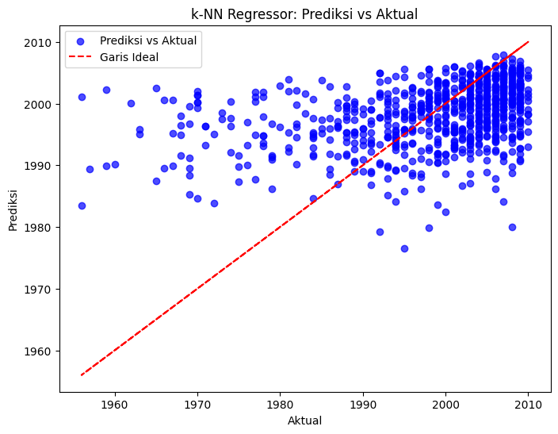

Laporan Evaluasi:

Best Parameters: {'regressor__colsample_bytree': 0.6, 'regressor__learning_rate': 0.1, 'regressor__max_depth': 3, 'regressor__n_estimators': 100, 'regressor__subsample': 1.0}

MSE: 91.07851157441735

R2: 0.2318658056199524

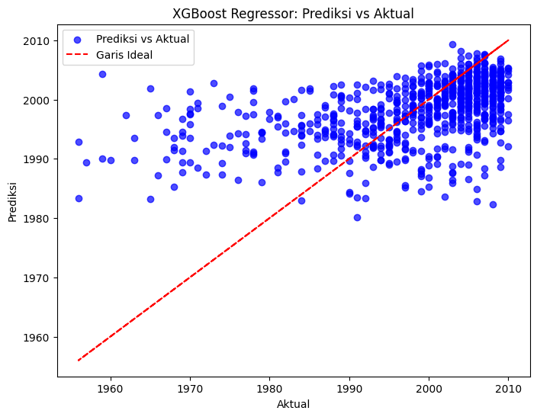

Lima baris pertama dataset:

Clump_thickness Uniformity_of_cell_size Uniformity_of_cell_shape \

0 5 1 1

1 5 4 4

2 3 1 1

3 6 8 8

4 4 1 1

Marginal_adhesion Single_epithelial_cell_size Bare_nuclei \

0 1 2 1.0

1 5 7 10.0

2 1 2 2.0

3 1 3 4.0

4 3 2 1.0

Bland_chromatin Normal_nucleoli Mitoses Class

0 3 1 1 2

1 3 2 1 2

2 3 1 1 2

3 3 7 1 2

4 3 1 1 2

Informasi dataset:

<class 'pandas.core.frame.DataFrame'>

RangeIndex: 699 entries, 0 to 698

Data columns (total 10 columns):

# Column Non-Null Count Dtype

--- ------ -------------- -----

0 Clump_thickness 699 non-null int64

1 Uniformity_of_cell_size 699 non-null int64

2 Uniformity_of_cell_shape 699 non-null int64

3 Marginal_adhesion 699 non-null int64

4 Single_epithelial_cell_size 699 non-null int64

5 Bare_nuclei 683 non-null float64

6 Bland_chromatin 699 non-null int64

7 Normal_nucleoli 699 non-null int64

8 Mitoses 699 non-null int64

9 Class 699 non-null int64

dtypes: float64(1), int64(9)

memory usage: 54.7 KB

None

Statistik deskriptif dataset:

Clump_thickness Uniformity_of_cell_size Uniformity_of_cell_shape \

count 699.000000 699.000000 699.000000

mean 4.417740 3.134478 3.207439

std 2.815741 3.051459 2.971913

min 1.000000 1.000000 1.000000

25% 2.000000 1.000000 1.000000

50% 4.000000 1.000000 1.000000

75% 6.000000 5.000000 5.000000

max 10.000000 10.000000 10.000000

Marginal_adhesion Single_epithelial_cell_size Bare_nuclei \

count 699.000000 699.000000 683.000000

mean 2.806867 3.216023 3.544656

std 2.855379 2.214300 3.643857

min 1.000000 1.000000 1.000000

25% 1.000000 2.000000 1.000000

50% 1.000000 2.000000 1.000000

75% 4.000000 4.000000 6.000000

max 10.000000 10.000000 10.000000

Bland_chromatin Normal_nucleoli Mitoses Class

count 699.000000 699.000000 699.000000 699.000000

mean 3.437768 2.866953 1.589413 2.689557

std 2.438364 3.053634 1.715078 0.951273

min 1.000000 1.000000 1.000000 2.000000

25% 2.000000 1.000000 1.000000 2.000000

50% 3.000000 1.000000 1.000000 2.000000

75% 5.000000 4.000000 1.000000 4.000000

max 10.000000 10.000000 10.000000 4.000000

Distribusi target:

Class

2 458

4 241

Name: count, dtype: int64

<ipython-input-2-1c45595c9e5d>:37: FutureWarning:

Passing `palette` without assigning `hue` is deprecated and will be removed in v0.14.0. Assign the `x` variable to `hue` and set `legend=False` for the same effect.

sns.countplot(x=target_column, data=data, palette="pastel")

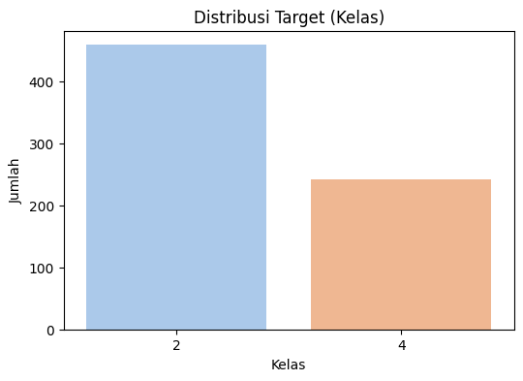

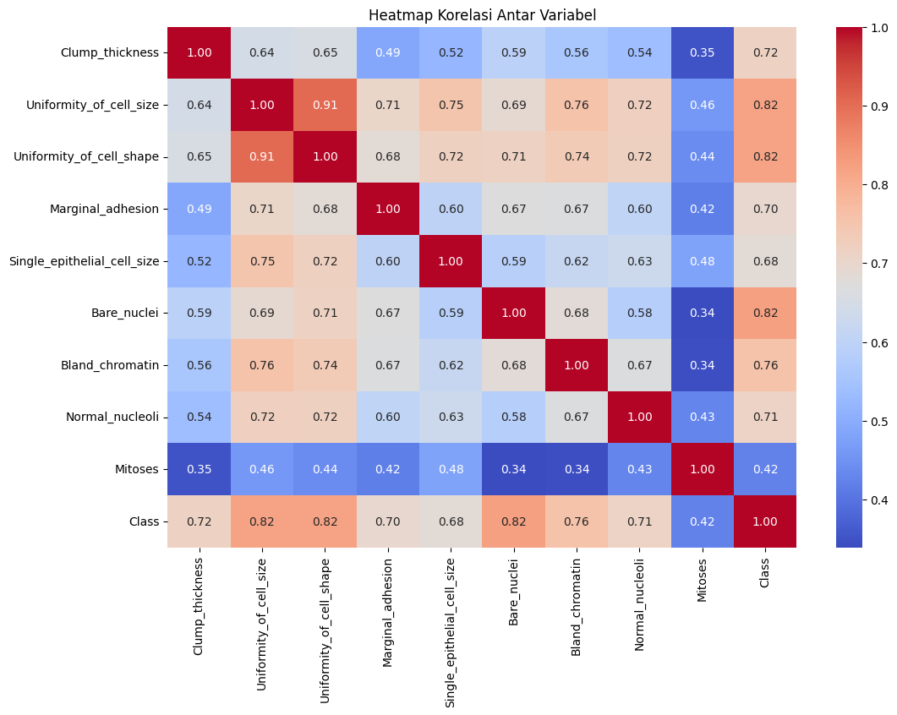

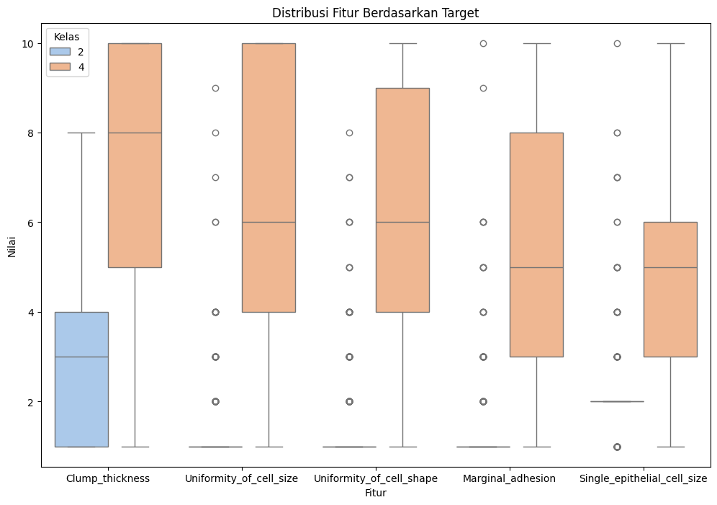

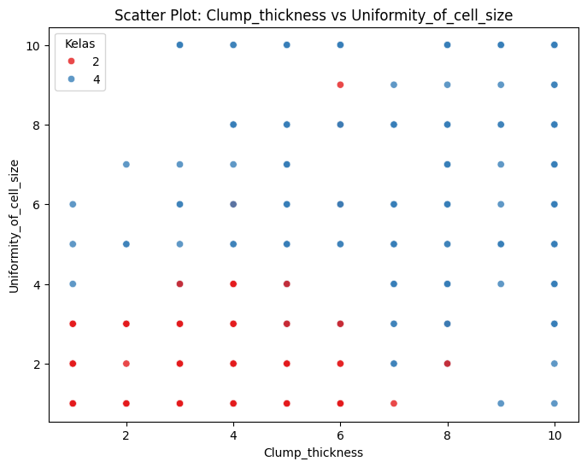

Laporan Evaluasi:

precision recall f1-score support

2 0.96 0.97 0.96 92

4 0.94 0.92 0.93 48

accuracy 0.95 140

macro avg 0.95 0.94 0.94 140

weighted avg 0.95 0.95 0.95 140

Parameter Terbaik:

{'classifier__C': 1, 'classifier__penalty': 'l1', 'classifier__solver': 'liblinear'}

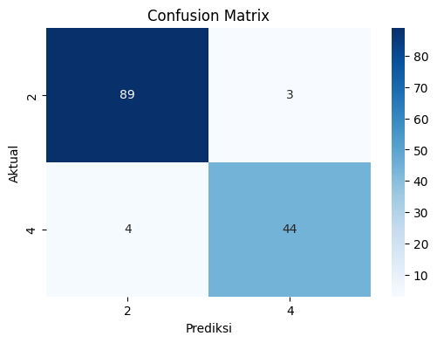

Laporan Evaluasi:

precision recall f1-score support

2 0.91 0.97 0.94 92

4 0.93 0.81 0.87 48

accuracy 0.91 140

macro avg 0.92 0.89 0.90 140

weighted avg 0.92 0.91 0.91 140

Parameter Terbaik:

{'classifier__criterion': 'entropy', 'classifier__max_depth': 5, 'classifier__max_features': None, 'classifier__min_samples_leaf': 1, 'classifier__min_samples_split': 5}

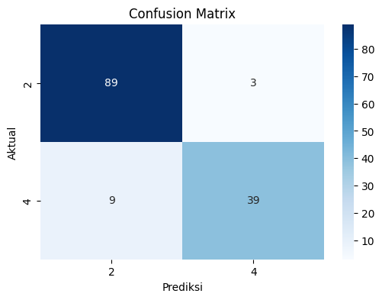

Laporan Evaluasi:

precision recall f1-score support

2 0.96 0.96 0.96 92

4 0.92 0.92 0.92 48

accuracy 0.94 140

macro avg 0.94 0.94 0.94 140

weighted avg 0.94 0.94 0.94 140

Parameter Terbaik:

{'classifier__metric': 'manhattan', 'classifier__n_neighbors': 3, 'classifier__p': 1, 'classifier__weights': 'distance'}

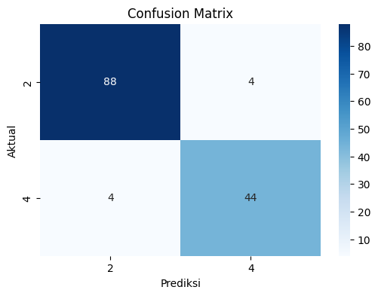

Laporan Evaluasi:

precision recall f1-score support

0 1.00 1.00 1.00 10

1 1.00 1.00 1.00 9

2 1.00 1.00 1.00 11

accuracy 1.00 30

macro avg 1.00 1.00 1.00 30

weighted avg 1.00 1.00 1.00 30

Parameter Terbaik:

{'classifier__colsample_bytree': 1.0, 'classifier__learning_rate': 0.01, 'classifier__max_depth': 3, 'classifier__n_estimators': 200, 'classifier__subsample': 1.0}

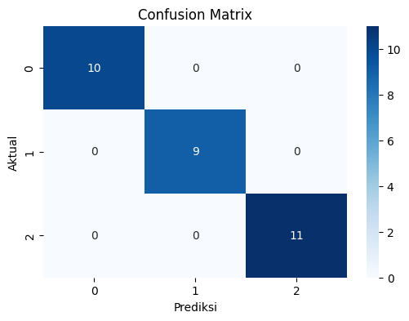

Laporan Evaluasi:

precision recall f1-score support

2 0.97 0.98 0.98 143

4 0.95 0.94 0.95 67

accuracy 0.97 210

macro avg 0.96 0.96 0.96 210

weighted avg 0.97 0.97 0.97 210

Parameter Terbaik:

{'xgb__learning_rate': 0.1, 'xgb__max_depth': 5, 'xgb__n_estimators': 100}

