**BUS MANAGEMENT SYSTEM**

**I. System Requirement**

**1. Requirement Elicitation**

In the initial phase of the project, we conducted a comprehensive requirement elicitation process to gather information from all relevant stakeholders. The goal was to understand their needs and expectations to create a robust and efficient Bus Management System. The key stakeholders identified for this project include Transport Operators, Passengers, Drivers, and Admins. Each stakeholder group has distinct needs and interactions with the system, which are outlined below.

**a. Stakeholder**

**-** Transport Operator: This user type can be considered as admin who is responsible for managing bus fleet.

- Passenger: This user type is the main customer of the business.

- Driver: This user type directly serves customer.

**b. User Story**

To further clarify the requirements, we developed user stories representing typical interactions with the system. These user stories help in understanding the specific needs and goals of different stakeholders.

Story 1: Passenger Books a Ticket

As a Passenger, I want to book a bus ticket for my desired route and date so that I can ensure my travel is planned and reserved in advance.

Story 2: Operator Manages Bus Schedules

As a Transport Operator, I want to create and update bus schedules, bus information, and driver information so that passengers have up-to-date information on bus timings and availability.

Story 3: Bus Driver Accesses Daily Schedule and Route Information

As a Bus Driver, I want to access my daily schedule and route information through the system so that I can efficiently manage my driving duties and ensure timely service for passengers.

**c. Persona**

To better understand the users, we created personas that represent different types of users interacting with the Bus Management System.

Persona 1: Morathi - The Daily Commuter

- Age: 29

- Occupation: Graphic Designer

- Experience with Technology: Moderate

- Goals: Morathi wants a reliable and efficient way to commute to her job in the city center. She values punctuality and prefers to plan her trips in advance to avoid delays.

- Challenges: Morathi often finds it difficult to get real-time updates on bus schedules, leading to missed buses or unnecessary waiting times.

- Interactions with the System: Morathi uses the system to book tickets, check bus schedules, and receive real-time updates on her bus's location.

Persona 2: Nehek - The Transport Operator

- Age: 37

- Occupation: Operations Manager at Succubus Bus Company

- Experience with Technology: High

- Goals: Nehek wants to simplify the operations of his bus fleet to ensure high efficiency and customer satisfaction. He looks to optimize routes, manage schedules effectively, and respond promptly to any service disruptions.

- Challenges: Nehek finds it challenging to gather and analyze operational data to make informed decisions. Communicating updates and changes efficiently to both drivers and passengers is also a concern.

- Interactions with the System: Nehek uses the system to manage bus schedules, monitor bus locations and operations in real-time, and generate reports on service performance.

Persona 3: Taurox - The Bus Driver

- Age: 45

- Occupation: 15 years as a bus driver

- Experience with Technology: Low to moderate

- Goals: Taurox aims to provide a safe and timely service to his passengers. He wants to easily access his daily schedules and any last-minute changes to his routes.

- Challenges: Taurox struggles with communicating delays or changes in the route to the transport operators and passengers. He also finds it hard to access his schedule in a convenient, digital format.

- Interactions with the System: Taurox uses the system to view his daily

schedules, report issues, and receive notifications about changes or emergencies.

**d. Scenario**

Scenario 1: Morathi Books a Ticket

On the previous evening, Morathi logs into the Bus Management System. She

She searches for a route from her home to the office for the next day at 8:00 AM. The system displays a bus that departs at 7:45 AM, arriving by 8:45 AM. Morathi selects the route and chooses a window seat near the front. She proceeds to payment, entering her credit card details. The payment is processed successfully. Morathi receives an email confirmation with her ticket details, including the seat number and bus schedule.

Scenario 2: Morathi Submits Feedback

After reaching her destination, Morathi decides to share her experience to help improve the service. She opens the Bus Management System app on her smartphone and taps on the "Feedback" section. The app presents Morathi with a simple form asking for ratings on various aspects of her journey, such as punctuality, cleanliness, and driver behavior. It also includes a free text field for additional comments. After reviewing her feedback to ensure it accurately reflects her experience, Morathi presses the "Submit" button. The app immediately displays a message thanking her for the feedback, assuring her that it is valuable in improving the service. The message also mentions that all feedback is reviewed by the transport operators.

**e. Use Case**

USE CASE DIAGRAM

**2. Requirement Analysis**

The requirement analysis phase involves translating the needs gathered during requirement elicitation into detailed functional and non-functional requirements. This ensures that the Bus Management System will meet the expectations of its stakeholders effectively.

**a. Functional Requirement**

The functional requirements detail the specific functions that the system must support. These functions are categorized based on the stakeholder roles:

- Transport operators can manage bus schedules by adding, removing, or modifying them as needed.

- Transport operators can access detailed information about bus schedules, buses, drivers, and routes.

- Transport operators can update information regarding buses (e.g., maintenance status) and drivers (e.g., availability, status updates).

- Passengers can purchase, cancel (with refund requests), and update (change time/routes) tickets.

- Passengers can look up bus routes and schedules to plan their trips effectively.

- Drivers can view their daily schedules and access bus routes, preferably integrated with Google Maps for navigation.

- Drivers can update route progress via transport operators, update their own information, request leave, and report any incidents on the road.

**b. Nonfunctional Requirement**

The non-functional requirements are specified to ensure the system's overall quality and user satisfaction:

- UI Design: The interface should be simple, intuitive, and user-friendly, with minimalistic design principles.

- Accessibility: Use large font sizes and a high-contrast color scheme (black and white) to enhance readability for all users.

- Simplicity: The interface should have a clean layout with minimal buttons to avoid overwhelming users.

- Real-Time Accessibility: The system must ensure real-time data access and updates, providing instantaneous information retrieval and communication.

**II. Architecture Design**

Microservice architecture is an architectural style that structures an application as a collection of loosely coupled services. Each service is self-contained, and implements a specific business capability. The advantages of using microservice architecture include: Scalability, Flexibility, Maintainability, and Resilience.

The Bus Management System leverages microservice architecture. This approach decomposes the system into six distinct services, each responsible for a specific set of functionalities. The services are as follows: Passenger Service, Operator Service, Payment Service, Notification Service, Driver Service, and Feedback Service.

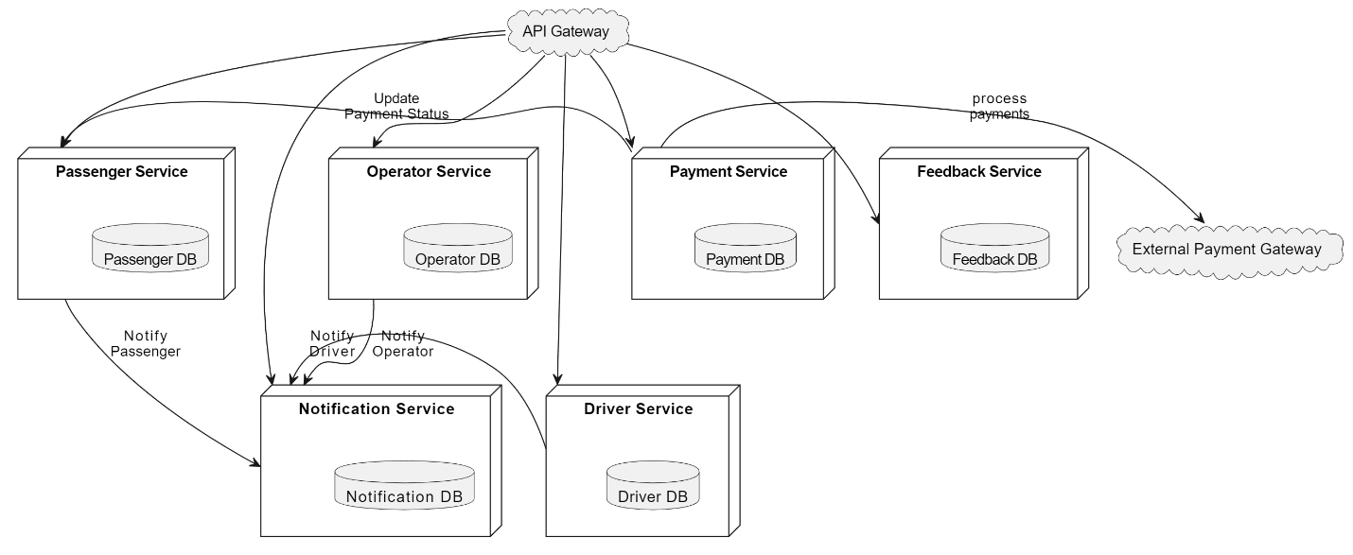

**a. Passenger Service**

- Manage passenger-related operations such as registration, login, ticket booking, ticket cancellation, and ticket updates.

- Provide interfaces for passengers to look up bus routes and schedules.

**b. Operator Service**

- Manage operations related to transport operators, including schedule creation, updates, and deletion.

- Provide interfaces for looking up bus schedules, bus information, driver details, and routes.

- Update bus and driver information.

**c. Payment Service**

- Handle all payment transactions, including ticket purchases and refunds.

- Interface with external payment gateways such as PayPal, Stripe, Momo, and Zalo Pay.

**d. Notification Service**

- Manage notifications and alerts for all users (passengers, drivers, and operators).

- Send real-time updates on ticket bookings, cancellations, schedule changes, and other important events.

**e. Driver Service**

- Manage driver-related operations, including schedule access, route updates, and personal information management.

- Allow drivers to report incidents, request leave, and update their progress on routes.

**d. Feedback Service**

- Collect and manage feedback from passengers regarding their journey experiences.

- Provide interfaces for operators to review and act on feedback to improve service quality.

**III. Module Design**

**1. Module: Passenger Service**

**2. Module: Operator Service**

**3. Module: Payment Service**

**4. Module: Notification Service**

**5. Module: Driver Service**

**IV. Component Design**

**V. Database Design**

**VI. System Implementation**

**1. Frontend**

**2. Backend**

**VII. Testing**

**VIII. Future Plan**

The development of the Bus Management System has been constrained by time, leading to a prioritization of core functionalities for passengers and transport operators. While these features form the backbone of the system, there are essential modules related to drivers that have yet to be implemented. Future development plans focus on expanding the system to include comprehensive driver-related features, ensuring a complete and robust bus management solution.

Planned features for Driver Module are as follows:

- Daily Schedule Access: Enable drivers to view their daily schedules, including assigned routes and timings.

- Real-Time Schedule Updates: Allow drivers to receive real-time updates and changes to their schedules directly through the system.

- Integrate Google Maps or a similar service to provide drivers with detailed route navigation and traffic updates.

- Implement route optimization features to suggest the most efficient routes based on current traffic conditions.

- Profile Management: Allow drivers to update their personal information, contact details, and availability status.

- Provide a feature for drivers to report incidents, accidents, or delays encountered during their routes.

- Integrated Messaging: Enhance the communication module to facilitate seamless and real-time messaging between drivers and transport operators.

- Emergency Alerts: Develop a feature for drivers to send emergency alerts to transport operators, ensuring immediate attention and assistance.