SKILLLINK SERVICE COOPERATIVE
“Connecting Skills, Building Futures”
STILL NOT HIGHLY RELEVANT TO THE THE ORG NAME Less 2
A Cooperative Study Proposal
Presented to the Faculty of Cainta Catholic College

In Partial Fulfillment of the Requirements for the Degree
Bachelor of Science in Business Administration
Major in Financial Management

ARLENE H. ABAY-ABAY
DENISE P. CHAN
PRINCES POLLYN L. GERONIMO
JEROME Q. MASANA
RECHELLE T. TARNATE
SHAWN DHENVER VIERNES

July 2026

Chapter 1
THE COOPERATIVE STUDY
Introduction
The rapid advancement of digital technology has significantly transformed the global economy by expanding opportunities for remote work, freelancing, and online business services. Digital platforms have become important channels for connecting skilled professionals with clients across different countries, making digital employment an essential contributor to economic growth and workforce development. According to the International Labour Organization (2021), digital labor platforms continue to create employment opportunities and promote participation in the global digital economy.
In the Philippines, the digital economy continues to expand due to improved internet connectivity, increasing digital adoption, and the growing demand for online services. More Filipinos, particularly students and young professionals, are developing digital skills and exploring freelance and remote work as alternative sources of income. The Department of Information and Communications Technology (2023) emphasized that digital transformation plays a vital role in creating jobs, strengthening innovation, and improving the country's competitiveness. Despite these developments, many skilled individuals still face challenges in obtaining stable clients, continuous training, and long-term career opportunities.
Although several online platforms connect freelancers with clients, most primarily focus on project matching and provide limited support for professional development, collaboration, and member welfare. As a result, many aspiring freelancers,
unemployed individuals, and underemployed workers continue to experience unstable income and limited access to resources that could improve their employability. This situation highlights the need for a more sustainable and member-centered approach to digital employment.
A service cooperative offers a practical solution by combining employment opportunities with cooperative values such as mutual assistance, shared resources, democratic participation, and continuous capacity building. Through a cooperative, members can access digital talent-matching services, skills development programs, networking opportunities, and business support that enhance both their professional growth and economic well-being. This approach supports not only individual success but also inclusive and sustainable community development.
In response to these trends and issues, this study proposes the establishment of the SkillLink Service Cooperative, a service cooperative that provides digital talent-matching and remote job outsourcing services. Specifically, this feasibility study aims to determine the market, technical, managerial, financial, and socio-economic viability of the proposed cooperative. The findings of this study are expected to provide a sustainable model for improving employment opportunities, strengthening digital workforce participation, and promoting inclusive economic development among cooperative members and the community.

Background of the Study
The issue of outsourcing has become a very important strategic element in many
businesses due to its capacity to cut down costs, increase efficiency, and enable companies to focus on their main operations. Developments in technology, along with the disruptive effect of the COVID-19 crisis, have greatly accelerated the need for outsourcing and remote working. Businesses now rely on outsourcing not just to save money but also to gain certain competences. ADD STATEMENT THAT URGE AND CONNECT THE REASON OF PROPONENTS TO COME UP THE STUDY Less 2
According to Remote Work (2024), the Philippines remains one of the world's leading outsourcing destinations, ranking 6th in the Tholons Services Globalization Index (2020). More than 780 BPO companies employ over 1.2 million Filipinos. With strong government support and investor-friendly policies, the industry continues to grow and remains a major driver of the Philippine economy. Outsourcing has also helped reduce unemployment by creating millions of jobs, particularly in call centers and information technology support. In 2022, the industry contributed billions to the country's Gross Domestic Product (GDP), highlighting its significant role in national economic growth.
As outsourcing continues to expand, the demand for skilled digital professionals has also increased. However, many qualified individuals still face challenges in accessing outsourcing opportunities because recruitment processes often prioritize communication skills and English proficiency over technical competence. This creates a gap between the growing need for specialized digital services and the available workforce with relevant skills. Recognizing this issue highlights the need for a more inclusive and competency-based employment model, which serves as the foundation for proposing the SkillLink Service Cooperative.
According to Holtgrewe and Wedderburn (2022), the pandemic reshaped organizations' approach to outsourcing by increasing reliance on digital collaboration and flexible work arrangements. While these changes created new opportunities, they also introduced challenges such as communication barriers, performance monitoring, and maintaining service quality. Likewise, the 2026 Remote Work & Outsourcing Statistics report highlights the continued global growth of outsourcing while identifying persistent issues involving productivity, coordination, and data security in remote work environments.
To address this gap, SkillLink Service Cooperative is proposed as a member-
owned organization that connects skilled individuals with businesses and clients seeking reliable digital services. Through talent matching, skills development, and cooperative support, SkillLink aims to create sustainable employment opportunities while promoting the economic and professional growth of its members. SkillLink Service Cooperative also aims to recognize members based on their actual competencies rather than solely on communication proficiency. The cooperative will connect skilled individuals with clients whose needs match their expertise while providing training, professional support, and development opportunities. Through this approach, SkillLink seeks to create more inclusive employment opportunities, help members maximize their talents, and promote sustainable livelihoods.

Significance of the Study
The results of this study are expected to benefit the following:
Skilled Individuals and Freelancers. SkillLink Service Cooperative will provide skilled workers with access to remote job opportunities that match their abilities, helping them improve their income and gain more work experience.
The Proponents. The study will help the proponents assess whether the business is worth pursuing. It will also serve as a guide in planning the operations, managing resources, and making sound business decisions.
Clients and Businesses. Clients can easily connect with qualified digital professionals, making it easier to complete projects efficiently and with quality results.
The Community. The propose cooperative can create more employment opportunities,
support digital entrepreneurship, and contribute to the local economy.
Service Cooperative. The findings of this study may serve as a reference for service cooperatives in improving their digital services, operations, and member support.
Future Proponents. This study may serve as a reference for future studies on digital talent matching, remote work, outsourcing services, and cooperative businesses.

Chapter 2
THE SUMMARY OF THE STUDY
Name of the Organization
The proposed cooperative is named SkillLink Service Cooperative. It was chosen to reflect the cooperative's mission of connecting skilled individuals with clients through digital talent matching and remote job outsourcing services. The name "SkillLink" represents the connection between talent and employment opportunities, while "Service Cooperative" identifies the organization as a member-owned cooperative that provides services for the benefit of its members. With the tagline “Connecting Skills, Building Futures” the cooperative expresses its commitment to creating sustainable employment opportunities, enhancing members' skills, and promoting collaboration, innovation, and shared success in the digital economy.

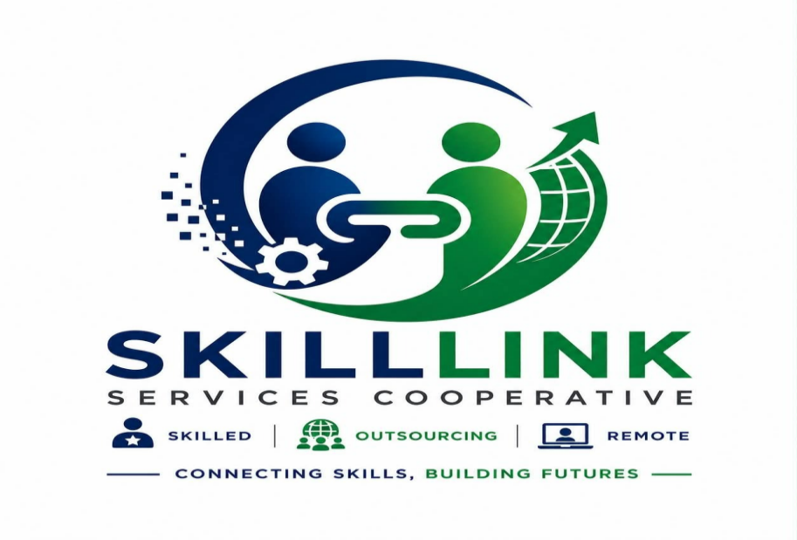
Logo

Figure 1. Logo of the Cooperative
REMOVE ARROW AND ICONS OF SKILLED, OUTSOURCED AND REMOTE.. INSTEAD ADD ICON OF COOP Less 2 Figure 1 illustrates the logo of the proposed SkillLink Service Cooperative. It represents the organization’s commitment to connecting skilled individuals with clients and employment opportunities through digital platforms and outsourcing services.
The two human figures symbolize the cooperative’s members, clients, and business partners, representing unity, collaboration, and mutual support. The link symbol positioned at the center signifies the connection between skilled professionals and potential employment opportunities. The gear represents the skills, competencies, and professional expertise of the cooperative’s members, while the globe and upward arrow signify digital connectivity, global outsourcing, growth, and professional advancement.
The circular design represents continuous development, cooperation, and the establishment of a strong network among members and clients. The blue color conveys trust, professionalism, and reliability, while the green color represents growth, opportunity, progress, and sustainability. The words “Skilled,” “Outsourcing,” and “Remote” emphasize the cooperative’s primary services and its focus on providing digital and remote work opportunities.
The tagline “Connecting Skills, Building Futures” reflects the cooperative’s mission of bridging skilled individuals with meaningful employment opportunities while promoting professional development, economic empowerment, and sustainable career growth.

Brief Description of the Study
This study focuses on the proposed establishment of SkillLink Service Cooperative, a service cooperative that provides digital talent-matching and remote outsourcing services. The cooperative aims to connect skilled individuals with businesses and clients seeking reliable digital services while supporting members through training, professional development, and cooperative assistance. Operating primarily through online platforms, SkillLink seeks to create sustainable employment opportunities, improve members' competencies, and contribute to their economic and professional growth. Through this business model, the cooperative promotes collaboration, quality service, and long-term benefits for both its members and clients. MAKE THE FORM OF ORG MORE SPECIFIC Less 1

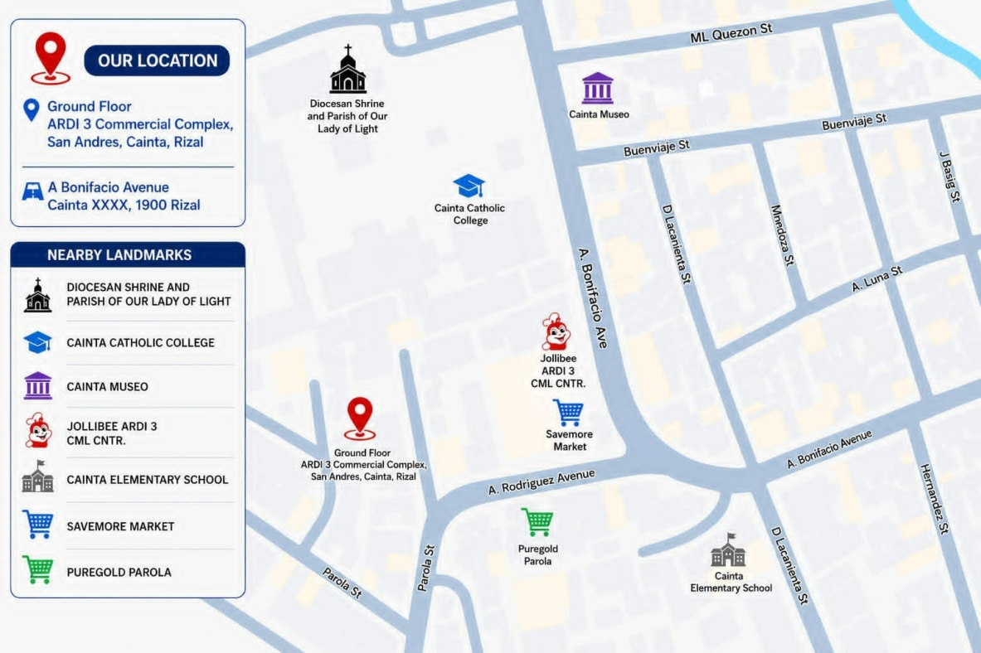
Location of the ORG..Firm

Initial Stage Location

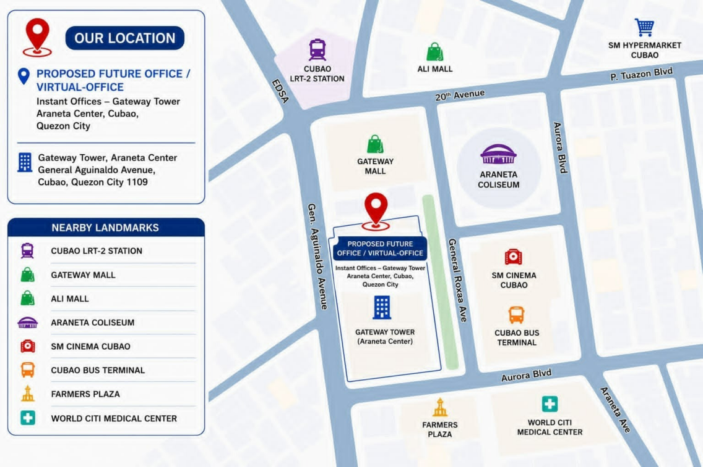

Proposed Virtual Office (Growth Phase)
Figure 2. Location
SkillLink Cooperative will primarily operate through an online business model because its main activities involve digital talent matching and remote outsourcing services. Client communication, member coordination, recruitment, project management, and service delivery will mainly be conducted through online platforms, allowing the cooperative to serve local and international clients while minimizing initial operating costs. USE ONE LOCATION ONLY… USE THE SAMPLE FORMAT AS STANDARD LOCATION MAP Less 4
During its initial stage, the cooperative will operate primarily online, with the proponents and members coordinating remotely. Cainta, Rizal will serve as the initial area of operation and administrative coordination because most of the proponents are
based in Cainta, making meetings and coordination more accessible during the
cooperative's startup stage.
As the cooperative grows, SkillLink Cooperative plans to establish a proposed future virtual office in Gateway Tower, Araneta Center, Cubao, Quezon City. This arrangement is suitable for the cooperative because its daily operations can remain primarily online while providing a professional business address and access to office-related facilities when needed. Cubao is also considered a strategic future location because of its accessibility through major transportation networks, making it convenient for members, clients, and business partners from different parts of the Philippines.
This phased location strategy allows SkillLink Cooperative to begin operations with lower costs while maintaining a practical plan for future expansion. The cooperative may initially operate primarily online and later adopt a virtual-office arrangement or establish a larger physical office as its membership, client base, and operational requirements increase.

Chapter 3
MANAGEMENT STUDY
MEMBER Proponents
The proponents of this cooperative study are Bachelor of Science in Business Administration students majoring in Financial Management from Cainta Catholic College. They are assigned to key positions based on their knowledge, skills, and competencies to ensure the effective management and operation of the proposed SkillLink Service Cooperative.
Mr. Shawn Dhenver Viernes is designated as the General Manager and is responsible for overseeing the cooperative's overall operations, coordinating departments, and ensuring that organizational goals are achieved. Ms. Arlene H. Abay-Abay serves as the Finance and Accounting Officer, responsible for managing the cooperative's financial resources, preparing financial reports, and monitoring expenditures. Ms. Denise P. Chan is assigned as the Service Coordination Officer, responsible for matching members with client service requests, coordinating service schedules, facilitating communication between clients and members, and monitoring the progress of assigned services. Mr. Jerome Q. Masana serves as the Marketing and Client Relations Officer, responsible for promoting the cooperative's services, building client partnerships, and strengthening its market presence. Ms. Princess Pollyn L. Geronimo is designated as the Operations Officer, responsible for overseeing the cooperative's daily operations, implementing operational policies, monitoring workflow efficiency, and ensuring that all activities are carried out smoothly. Ms. Rechelle T. Tarnate serves as the Members Services and
Development Officer, responsible for organizing member orientation and training programs, monitoring members' professional development, addressing member concerns, and promoting active participation in the cooperative's activities.

Management
The proposed SkillLink Service Cooperative adopts a democratic and member-centered management system guided by the principles of cooperation, accountability, transparency, and shared responsibility. Its management structure consists of Top-Level, Middle-Level, and Lower-Level Management, with each level performing specific functions to ensure the efficient operation of the cooperative and the effective delivery of services to its members and clients.
Top-Level Management consists of the General Assembly, Board of Directors, and General Manager. The General Assembly serves as the highest policy-making body of the cooperative, while the Board of Directors formulates policies and provides strategic direction. The General Manager oversees the implementation of these policies and manages the cooperative's overall operations to ensure that its goals and objectives are achieved.
Middle-Level Management is composed of the Finance and Accounting Officer, Service Coordination Officer, Marketing and Client Relations Officer, Operations Officer, and Member Services and Development Officer. These officers are responsible for implementing the policies approved by the Board of Directors, supervising their respective functional areas, coordinating member and client services, managing financial and operational activities, and supporting programs that promote member development and cooperative growth.
Lower-Level Management consists of the cooperative's members and qualified project-based service providers. They are responsible for performing the cooperative's daily operational activities, delivering services to clients, and carrying out assigned tasks efficiently while upholding the cooperative's policies, values, and quality standards.
To support its operations, the cooperative will primarily engage regular personnel to perform its administrative and operational functions. Depending on the needs of client projects, it may also engage project-based service providers from among its qualified members. This manpower sourcing approach enables the cooperative to efficiently meet service demands while providing members with equitable opportunities to participate in projects based on their skills, qualifications, and availability.

Vision/Mission and Objectives
Vision
SkillLink Service Cooperative envisions itself as a trusted and innovative service cooperative that empowers skilled individuals by connecting talents with opportunities and becoming one of the leading providers of reliable and quality services in the community. MAKE THIS BRIEF OF NOT MORE THAN 3 CORE STATEMENTS

Mission
SkillLink Service Cooperative commits itself to providing accessible, reliable, and technology-driven service opportunities that promote employment, skills development, and sustainable livelihoods for its members. It aims to uphold cooperative principles, deliver quality services to clients, strengthen community partnerships, and contribute to the economic and social development of its members through professionalism, integrity, and innovation. MISSION SHOULD BE ONE BRIEF PARAGRAPH THAT IS RELEVANT AND IN COMPLIANCE WITH THE VISION’S CORE STATEMENTS Less 4

Objectives
The following objectives guide the cooperative in achieving its mission and ensuring sustainable growth while serving the needs of both members and clients.
- To provide employment and income-generating opportunities for skilled individuals
- through cooperative-based services.
- To connect qualified service providers with clients using an efficient and reliable service platform.
- To provide continuous skills development, training, and professional growth for cooperative members.
- To deliver quality, affordable, and customer-oriented services while maintaining high standards of professionalism.
- To promote cooperative values, member participation, and sustainable community development. SHOULD BE IN MUNBERING. NOT MORE THAN 5 ITEMS IN COMPLIANCE WITH THE VM Less 2

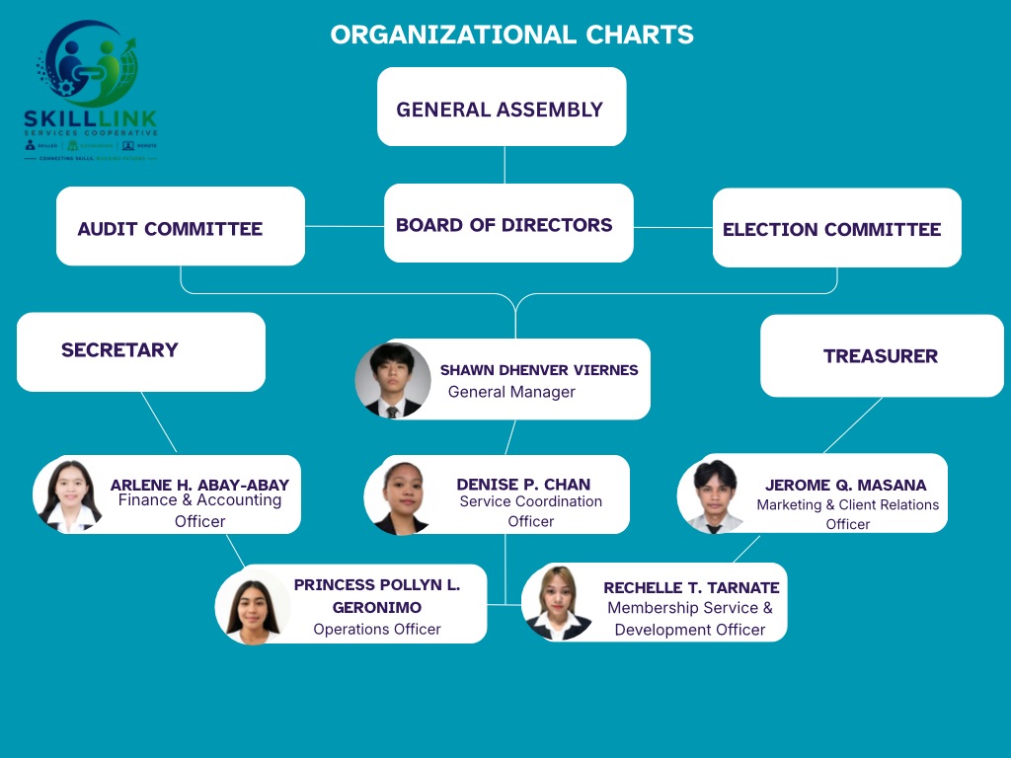
Organization Chart

Figure 3. Organizational Chart
USE FUNCTIONS THAT ARE RELEVANT TO THE TYPE OF ORG… LINES IN COMMITTEES, SECRETARY AND TREASURER ARE BROKEN LINES Less 3
The SkillLink Services Cooperative adopts a functional organizational structure to promote effective governance, accountability, and operational efficiency. This structure establishes a clear chain of authority, defines the roles and responsibilities of the General Assembly, Board of Directors, committees, management, and officers, and facilitates effective communication and coordination across all levels of the organization. By ensuring a systematic distribution of functions and responsibilities, the cooperative enhances transparency, teamwork, and timely decision-making in carrying out its operations. Furthermore, the organizational structure supports the cooperative’s mission of providing skilled manpower, outsourcing, and remote workforce solutions while creating sustainable employment opportunities, empowering its members through professional growth, and fostering strong, long-term partnerships with clients and stakeholders. Through this framework, the cooperative is well-positioned to achieve its strategic objectives and sustain its long-term growth and competitiveness.

Job Analysis (Personnel/Manpower)
The SkillLink Service Cooperative is established to provide its members with access to employment opportunities. It connects skilled individuals with clients and businesses through digital platforms and remote work services. The cooperative is composed of officers, management personnel, committees, and members. Each group is assigned specific duties and responsibilities that are essential to the effective operation of the organization. Each position requires competence, accountability, professionalism, and adherence to cooperative principles. These qualities ensure the efficient delivery of services and the achievement of the cooperative’s objectives.
General Assembly
The General Assembly is the highest decision maker of SkillLink Service Cooperative. It is composed of all qualified voting members. The General Assembly approves major policies, elects the Board of Trustees and decides on matters that affect the overall direction and sustainability of the cooperative. By exercising their right to vote and participate, members ensure that the cooperative remains accountable and transparent.
Board of Directors
The Board of Directors is elected by the members to oversee and guide the
cooperative on their behalf. The board provides strategic direction, ensures that the cooperative operates in accordance with its mission, and upholds legal and ethical standards.
Audit Committee
The Audit Committee is responsible for monitoring and reviewing the cooperative’s financial and operational records. It examines financial statements, verifies the accuracy of financial transactions, and ensures that proper internal controls and accounting procedures are followed. The committee also reports its findings and recommendations to the General Assembly to promote transparency, accountability, and responsible management of the cooperative’s resources.
Election Committee
The Election Committee is responsible for conducting and supervising the cooperative’s elections in a fair, orderly, and transparent manner. Its duties include preparing election procedures, verifying the qualifications of candidates and voters, overseeing the voting process, counting and validating votes, and announcing the election results. The committee ensures that elections are conducted in accordance with the cooperative’s bylaws and applicable rules and regulations.
Secretary
The Secretary is responsible for performing administrative and clerical functions within the cooperative. These duties include preparing and maintaining records, organizing documents, scheduling meetings, managing office supplies, and ensuring that official records are accurate and up to date.
Treasurer
The Treasurer oversees the cooperative's financial resources and ensures that funds are managed responsibly. Key responsibilities include preparing financial reports, monitoring budgets, maintaining financial records, advising the board on financial matters, and supporting the cooperative's financial planning and sustainability.

General Manager
The General Manager supervises the day-to-day operations of the SkillLink Service Cooperative and works to improve efficiency and organizational performance. This role includes overseeing employees, managing budgets, implementing business strategies, and developing initiatives that enhance services and support the cooperative's overall growth and success
Job Description
- Oversees the overall operations of the SkillLink Service Cooperative.
- Supervises daily business activities and employee performance.
- Develops and implements business strategies and operational plans.
- Monitors financial performance and organizational growth.
- Ensures compliance with cooperative policies and government regulations.
- Builds partnerships and promotes continuous improvement.
Job Qualification must have S to all
- Bachelor’s degree in Business Administration, Management, or related field
- At least 3–5 years of managerial experience
- Strong leadership, communication, and decision-making skills
- Knowledge of cooperative operations is an advantage

Finance and Accounting Officer
The Finance and Accounting Officer manages the SkillLink Service Cooperative daily financial records, budgeting, and accounting activities to ensure financial stability and compliance.
Job Description
- Maintains financial records and accounting books.
- Prepares budgets and financial reports.
- Processes payroll and monitors cash flow.
- Ensures compliance with accounting standards and tax regulations.
- Assists management in financial planning and decision-making.
Job Qualification
- Bachelor’s degree in Accountancy, Accounting Technology, or Finance
- Knowledge of accounting software
- Detail-oriented with strong analytical skills
- Experience in accounting is preferred

Service Coordination Officer
Service Coordination Officer Coordinates service delivery between members and clients to ensure projects are completed efficiently and meet quality standards.
Job Description
- Coordinates outsourcing projects between clients and cooperative members.
- Assigns projects based on members’ skills and availability.
- Monitors project progress and service quality.
- Ensures timely completion of projects.
- Resolves operational and client concerns.
Job Qualification
- Bachelor’s degree in Business Administration, Information Technology, or related field
- Good communication and organizational skills
- Experience in project coordination is an advantage
- Computer literate

Marketing and Client Relations Officer
Marketing Officer plans and implements marketing strategies to promote SkillLink Service Cooperative brand and services. They create campaigns, coordinate promotional activities, organize marketing events, and evaluate campaign performance to improve future marketing efforts.
Job Description
- Promotes the cooperative’s outsourcing services.
- Develops and implements marketing campaigns.
- Identifies and acquires new clients.
- Maintains strong relationships with existing clients.
- Manages the cooperative’s online presence and promotional activities.
Job Qualification
- Bachelor’s degree in Marketing, Business Administration, or Communications
- Excellent communication and negotiation skills
- Knowledge of digital marketing strategies

Operations Officer
Operations Officer oversees SkillLink Service Cooperative daily budgets, and
responsible for setting profit and sales goals to ensure efficient workflow and service delivery.
Job Description
- Oversees the cooperative’s daily operations.
- Monitors productivity and workflow efficiency.
- Prepares operational reports for management.
- Implements process improvements to enhance service delivery.
- Ensures operational goals and quality standards are achieved.
Job Qualification
- Bachelor’s degree in Business Administration, Operations Management, or related course
- Strong leadership and problem-solving skills
- Experience in operations management is preferred
Member Services and Development Officer
Member Services and Development Officer oversees member recruitment, training, engagement, and development to enhance member participation and professional growth.
Job Description
- Recruits and orients new cooperative members.
- Conducts training and development programs.
- Assists members with concerns and service-related inquiries.
- Monitors member participation and performance.
- Develops programs that improve member skills and engagement.
Job Qualification
- Bachelor’s degree in Human Resource Management, Psychology, Business Administration, or related field
- Excellent interpersonal and communication skills
- Experience in training or member development is an advantage

Organization and Management Policies
The Organization and Management Policies of SkillLink Service Cooperative play a vital role in ensuring the efficient, transparent, and accountable operation of the cooperative. These policies provide the framework for governance, management, membership, financial administration, and service delivery. They establish the responsibilities of officers, members, and employees while promoting democratic
participation, cooperation, and sustainable growth.
Pursuant to the provisions of Republic Act No. 9520, otherwise known as the Philippine Cooperative Code of 2008, its Implementing Rules and Regulations (IRR), and the guidelines issued by the Cooperative Development Authority (CDA), the proposed SkillLink Service Cooperative shall adopt the following Organization and Management Policies.
Section 1. Title. These policies shall be known as the Organization and Management Policies of Service Cooperative.
Section 2. Policy. It is the policy of the cooperative to promote democratic governance, transparency, accountability, and active member participation while providing quality digital talent-matching, remote job outsourcing, and other professional support services. The cooperative shall conduct all its operations in accordance with cooperative principles, applicable laws, and the rules and regulations of the Cooperative Development Authority (CDA).
Section 3. Purposes. These policies shall govern the orderly administration and management of SkillLink Service Cooperative in compliance with Republic Act No.
9520, its Implementing Rules and Regulations, the cooperative's Articles of Cooperation and By-laws, and other issuances of the Cooperative Development Authority.
Section 4. Coverage. These policies shall apply to all regular and associate members, elected officers, committee members, management personnel, employees, and project-based service providers of SkillLink Service Cooperative.

Section 5. Definition of Terms.
- Service Cooperative – A cooperative organized to provide services that improve the economic and professional welfare of its members through lawful business activities, including digital talent matching, remote job outsourcing, skills development, and other related services.
- Member – A person who has complied with the membership requirements of
the cooperative, subscribed to the required share capital, and enjoys the rights and
responsibilities provided under the Cooperative Code and the cooperative's By-laws.
c. General Assembly – The highest policy-making body of the cooperative composed of all members entitled to vote.
d. Board of Directors – The governing body elected by the General Assembly responsible for formulating policies, setting strategic directions, and supervising the affairs of the cooperative.
e. General Manager – The chief executive officer responsible for implementing the policies approved by the Board of Directors and managing the daily operations of the cooperative.
Section 6. Purposes and Objectives. The SkillLink Service Cooperative shall be
organized to achieve the following objectives:
- Employment and Income Generation – To provide members with opportunities for sustainable employment and income through digital talent-matching and remote job outsourcing services.
- Professional Development – To enhance the knowledge, technical skills, and
competencies of members through continuous education, training, and capacity-building programs.
c. Economic Sustainability – To strengthen the cooperative by expanding its services, increasing membership, and establishing partnerships that ensure long-term financial stability.
d. Community Development – To contribute to the economic and social development of communities by creating accessible employment opportunities and
promoting cooperative entrepreneurship.
Section 7. Cooperative Operations. The cooperative may engage in lawful service-oriented activities including, but not limited to:
- Digital talent matching;
- Remote job outsourcing;
- Administrative and virtual assistance services;
- Marketing and client support services;
- Skills training and professional development programs;
- Business process support services; and
- Other lawful service activities authorized by the Cooperative Development Authority.
Section 8. Administrative Regulations. The cooperative shall observe the following administrative regulations:
8.1 The cooperative shall maintain a permanent office with qualified management personnel and administrative staff.
8.2 The cooperative shall conduct at least one (1) General Assembly meeting every year.
8.3 Officers shall perform their duties in accordance with Republic Act No. 9520, the cooperative's By-laws, and CDA regulations.
8.4 Qualified applicants shall complete the required Cooperative Pre-Membership
Education Seminar (PMES) and satisfy all membership requirements before admission.
8.5 The cooperative shall maintain complete and accurate accounting records
using the Harmonized Standard Chart of Accounts (HSCA) prescribed by the CDA.
8.6 Financial statements and required reports shall be prepared and submitted to the Cooperative Development Authority and other government agencies within the prescribed periods.
8.7 Members shall receive continuing cooperative education, leadership development, and skills enhancement programs.
8.8 Net surplus shall be allocated in accordance with Republic Act No. 9520 and the cooperative's By-laws, including allocations for the Reserve Fund, Cooperative Education and Training Fund, Community Development Fund, Optional Fund, Interest on Share Capital, and Patronage Refund.
8.9 The cooperative shall maintain complete records of membership, financial transactions, contracts, and official proceedings.
8.10 All officers, employees, and members shall observe professionalism,
honesty, confidentiality, accountability, and ethical conduct in all cooperative activities.
Section 9. Monitoring and Compliance. The cooperative shall comply with all
regulations, reportorial requirements, inspections, and monitoring activities conducted by the Cooperative Development Authority and other government agencies. The Board of Directors and the General Manager shall ensure that all policies are properly implemented and periodically evaluated to improve the cooperative's operations.
Section 10. Settlement of Disputes. Any dispute involving members, officers, employees, or management shall first be resolved through mediation and conciliation in
accordance with the cooperative's By-laws and the provisions of Republic Act No. 9520
before resorting to other legal remedies.
Section 11. Amendments. These Organization and Management Policies may be amended upon approval of the Board of Directors and ratification by the General Assembly, provided that such amendments are consistent with Republic Act No. 9520, the Cooperative Development Authority's rules and regulations, and the cooperative's Articles of Cooperation and By-laws.

Membership Recruitment and Selection Process
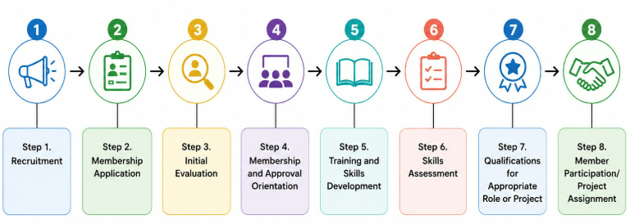
Figure 4. Membership Recruitment and Selection Process USE STANDARD FORMAT FOR MEMBERS RECRUITMENT ONLY Less 2
Step 1. Recruitment
We reach out to potential members through online platforms, referrals, schools, and other channels.
Step 2. Membership Application
Interested individuals submit their application and basic information.
Step 3. Initial Evaluation
We evaluate the applicant's willingness, background, skills (if any), and
alignment with our cooperative values.
Step 4. Membership and Approval Orientation
Qualified applicants are approved as members and attend orientation on policies
rights, and responsibilities.
Step 5. Training and Skills Development
Members who need to build or improve their skills join our training programs.
Step 6. Skills Assessment
We assess the member's skills through tests, interviews, portfolio review, or trial tasks.
Step 7. Qualifications for Appropriate Role or Project
Members who meet the requirements are qualified for roles or client projects based on their skills.
Step 8. Member Participation/Project Assignment
Qualified members are matched with suitable client projects or assigned roles (e.g., service provider, client acquisition).

References
Department of Information and Communications Technology. (2023). Philippine digital transformation strategy. Department of Information and Communications Technology.
Holtgrewe, U., & Wedderburn, L. (2022). How the past of outsourcing and offshoring is the future of post-pandemic remote work: A typology, a model and a review. The International Journal of Human Resource Management.
International Cooperative Alliance. (2023). What is a cooperative? International Cooperative Alliance.
International Labour Organization. (2021). World employment and social outlook 2021: The role of digital labour platforms in transforming the world of work. International Labour Organization.
Remote Work & Outsourcing Statistics (2026). Remote work & outsourcing statistics.
Remote Work (2024), Is Outsourcing Good For The Philippines? (Pros & Cons)
World Bank. (2022). Philippines digital economy report 2022. World Bank Group.

