L. D. College of Engineering, Ahmedabad
Gujarat Technological University (GTU)
DATA SCIENCE PROJECT REPORT
Customer Churn Prediction
Predicting Telecom Customer Attrition using Machine Learning
Item | Details
Student Name | Juned Ansari
Enrolment Number | 240280116004
Branch / Programme | Information Technology
Subject | Data Science
Faculty / Guide | Prof. Jaimin Chavda
Submission Date | 7 October 2026

Contents
1. Project Overview
2. Dataset
3. Data Preparation
4. Exploratory Data Analysis
5. Proposed Data Science Approach
6. Implementation and Results So Far
7. Findings, Limitations and Future Work
References

1. Project Overview

1.1 Project Title
Customer Churn Prediction for a Telecommunications Company.

1.2 Problem Statement
Customer churn, the loss of subscribers to a competitor or to cancellation, is one of the most costly problems in the telecommunications industry, because acquiring a new customer is considerably more expensive than retaining an existing one. A telecom operator generally cannot tell in advance which customers are about to leave, and therefore retention offers are either untargeted (wasteful) or applied too late. The problem addressed in this project is: given a customer’s demographic profile, subscribed services, contract and billing details, can we predict whether the customer will churn, and which factors drive that decision?

1.3 Objectives
- To understand the structure, quality and composition of the Telco Customer Churn dataset.
- To clean and transform the data into a form suitable for machine learning.
- To identify, through exploratory analysis, the customer characteristics most strongly associated with churn.
- To build and compare several classification models that predict whether a customer will churn.
- To evaluate the models using metrics appropriate for an imbalanced problem (Recall, Precision, F1-score and ROC-AUC) rather than accuracy alone.
- To translate the findings into practical retention recommendations for the business.

1.4 Brief Description of the Proposed Work
This project treats churn prediction as a supervised binary classification task. The dataset of 7,043 telecom customers is cleaned, encoded and enriched with two engineered features. An exploratory analysis then establishes the main churn patterns. Four classifiers (Logistic Regression, Decision Tree, Random Forest and Gradient Boosting) are trained on a stratified 80/20 split, compared using both a hold-out test set and 5-fold cross-validation, and the best model is analysed for feature importance and decision-threshold trade-offs.

2. Dataset

2.1 Dataset Name and Source
The dataset used is the Telco Customer Churn dataset, a sample dataset originally published by IBM and made available on Kaggle by the user “BlastChar”. Each record describes one customer of a fictional telecommunications company that provides home phone and Internet services in California.
Link to the original dataset: https://www.kaggle.com/datasets/blastchar/telco-customer-churn/data

2.2 Why this Dataset Was Selected
- It represents a real and commercially important business problem (customer retention) with clear practical value.
- It is a well-structured tabular dataset that mixes numerical, binary and multi-category variables, which allows a full data science workflow (cleaning, encoding, EDA, modelling, evaluation) to be demonstrated.
- The target is imbalanced (about 27% churners), which makes the evaluation more meaningful than a balanced toy problem.
- It is widely used as a benchmark, so the results obtained here can be compared with published work.
- The features are easily interpretable, enabling business-oriented conclusions rather than only model scores.

2.3 Number of Records and Features
The raw dataset contains 7,043 records (one per customer) and 21 columns: 1 identifier (customerID), 19 descriptive features and 1 target variable (Churn). After preparation the model matrix has 25 predictor columns and the binary target.

2.4 Description of Important Variables
Table 1: Description of the main variables
Variable | Type | Description
customerID | Identifier | Unique customer code (dropped before modelling)
gender, SeniorCitizen, Partner, Dependents | Demographic | Gender, whether aged 65+, and whether the customer has a partner or dependents
tenure | Numeric | Number of months the customer has stayed with the company (0–72)
PhoneService, MultipleLines | Service | Whether the customer has phone service and multiple lines
InternetService | Service | DSL, Fiber optic or No Internet
OnlineSecurity, OnlineBackup, DeviceProtection, TechSupport, StreamingTV, StreamingMovies | Service | Add-on services (Yes / No / No internet service)
Contract | Account | Month-to-month, One year or Two year
PaperlessBilling, PaymentMethod | Account | Billing preferences and payment method
MonthlyCharges, TotalCharges | Numeric | Amount charged per month and in total to date
Churn | Target | Yes if the customer left within the last month, otherwise No

3. Data Preparation

3.1 Missing Values
Initial inspection showed no null values (0 NaN cells). However, the TotalCharges column was stored as text because 11 records contained a blank string instead of a number. All 11 of these customers have a tenure of 0 months, i.e. they had just joined and had not yet been billed. The blanks were therefore converted to numeric and imputed with 0, which is the logically correct value, rather than being dropped or filled with a mean. The column was then converted to a floating-point type.

3.2 Duplicate Records
The dataset was checked for fully duplicated rows (0 found) and for repeated customer identifiers (0 found). No duplicate records exist, so no rows were removed.

3.3 Outliers
Outliers in the three numeric variables were examined with the 1.5×IQR rule. The number of outliers detected was 0 for tenure, 0 for MonthlyCharges and 0 for TotalCharges. As the data contains no statistical outliers (box plots in Section 4 confirm this), no capping or removal was needed.

3.4 Transformation, Encoding and Scaling
- Service columns: the labels “No phone service” and “No internet service” carry the same meaning as “No” for the respective add-on and were merged into “No” to avoid redundant categories.
- Binary encoding: Yes/No columns (Partner, Dependents, PhoneService, PaperlessBilling, MultipleLines and the six add-on services) were mapped to 1/0; gender was mapped to Male = 1, Female = 0; the target Churn was mapped to Yes = 1, No = 0.
- One-hot encoding: InternetService, Contract and PaymentMethod were one-hot encoded with the first category dropped to avoid multicollinearity.
- Scaling: tenure, MonthlyCharges, TotalCharges, AvgChargePerMonth and NumServices were standardised (zero mean, unit variance). The scaler was fitted on the training set only to prevent data leakage, and it was applied only for Logistic Regression; tree-based models are scale-invariant and use the raw values.

3.5 Features Removed or Created
- Removed: customerID, because it is a unique label with no predictive value.
- Created – AvgChargePerMonth: TotalCharges divided by tenure (MonthlyCharges is used where tenure is 0), capturing the customer’s historical average spend.
- Created – NumServices: count (0–6) of add-on services the customer subscribes to, representing how deeply a customer is embedded in the company’s ecosystem.
The final modelling table contains 7,043 rows and 25 predictors plus the target.

4. Exploratory Data Analysis

4.1 Target Distribution
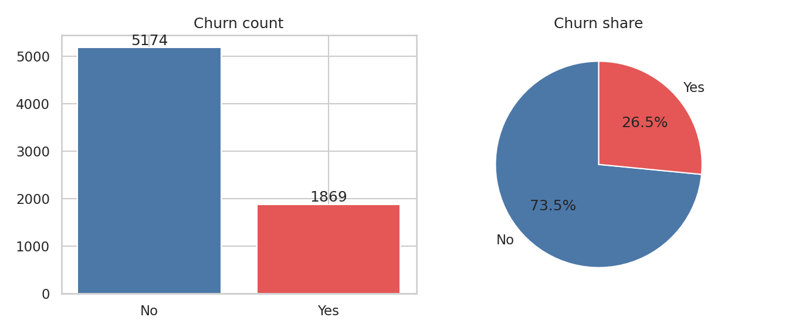
Figure 1: Distribution of the target variable (Churn)
Observation: Of the 7,043 customers, 1,869 (26.5%) churned and 5,174 (73.5%) stayed. The classes are moderately imbalanced (about 2.8 : 1), so accuracy alone would be misleading; a model predicting “no churn” for everyone would already score about 73.5%. Stratified splitting, class weighting and recall-oriented metrics are therefore used.

4.2 Numeric Variables
Table 2: Summary statistics of numeric variables
Statistic | tenure (months) | MonthlyCharges | TotalCharges
mean | 32.37 | 64.76 | 2279.73
std | 24.56 | 30.09 | 2266.79
min | 0 | 18.25 | 0
median | 29 | 70.35 | 1394.55
max | 72 | 118.75 | 8684.8
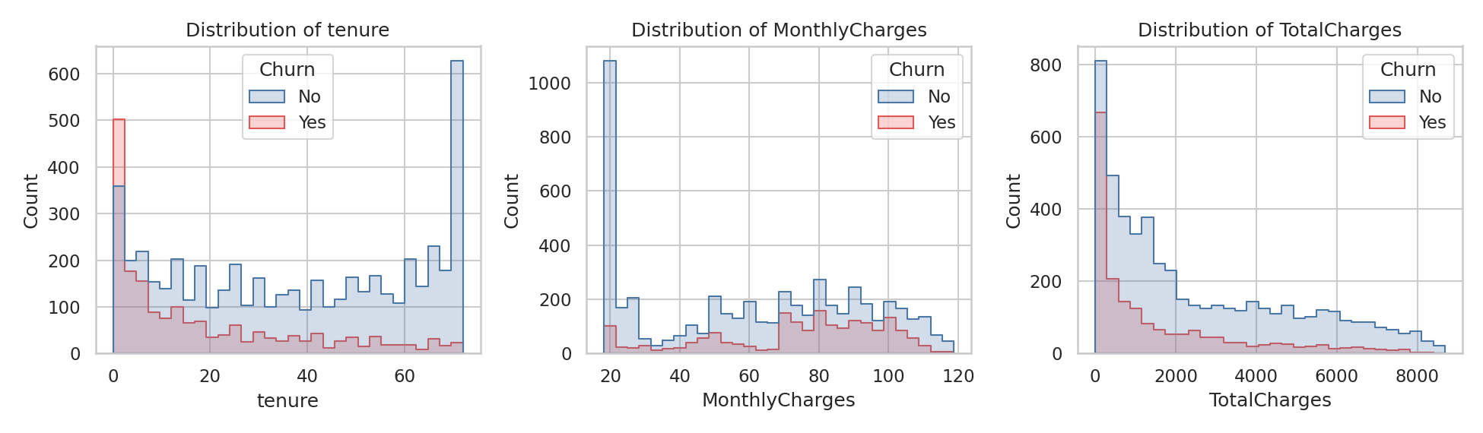
Figure 2: Distributions of tenure, MonthlyCharges and TotalCharges split by Churn
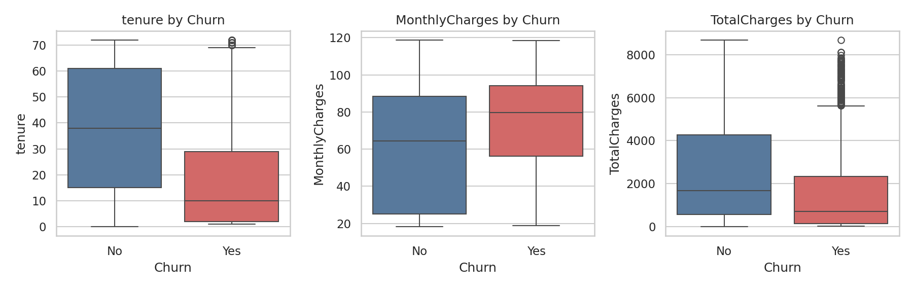
Figure 3: Box plots of numeric variables by Churn
Observations: Churners have a much shorter relationship with the company: mean tenure is 17.98 months for churners against 37.57 for non-churners (medians 10 vs 38). Churners also pay more per month (mean 74.44 vs 61.27) while having a lower accumulated TotalCharges (1,531.8 vs 2,549.91), which is a direct consequence of their short tenure. Tenure is strongly bimodal: many customers are either brand new or long-standing loyal customers. The box plots show no extreme outliers.

4.3 Churn by Tenure Group
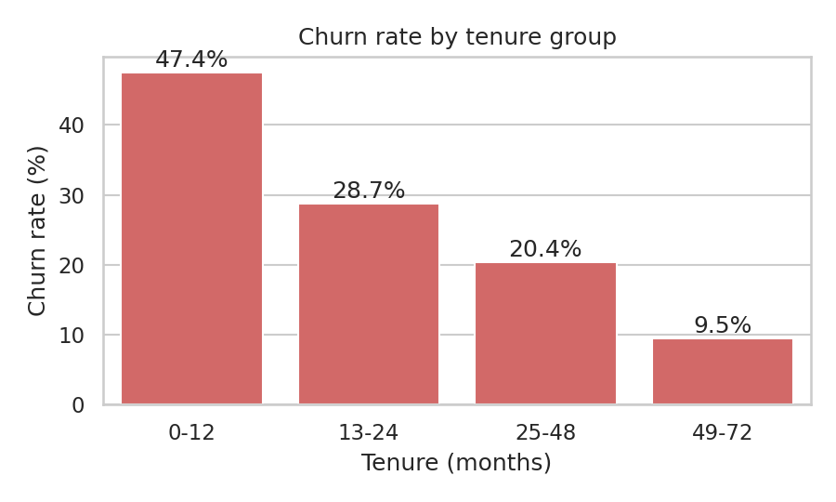
Figure 4: Churn rate by tenure group
Observation: Churn falls steadily with tenure, from 47.4% in the first year to 9.5% for customers with more than four years. The first 12 months are therefore the critical retention window.

4.4 Categorical Variables
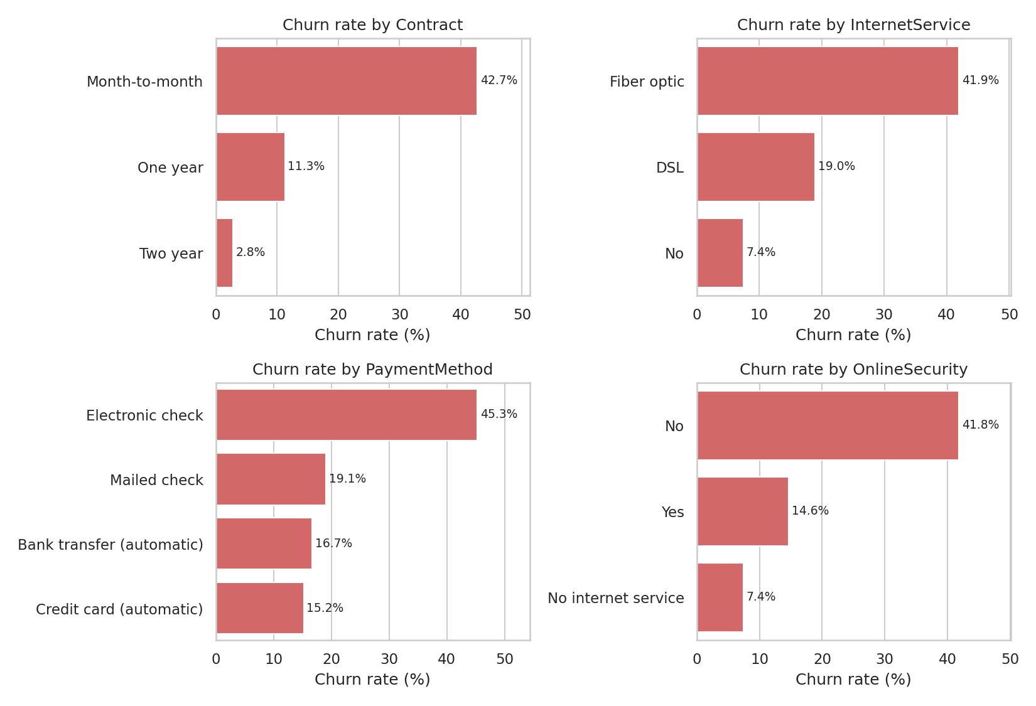
Figure 5: Churn rate by Contract, InternetService, PaymentMethod and OnlineSecurity
Observations:
- Contract: month-to-month customers churn at 42.7%, compared with 11.3% (one-year) and only 2.8% (two-year). Contract length is the single strongest business lever.
- Internet service: Fiber optic customers churn at 41.9%, far above DSL (19.0%) and customers with no Internet service (7.4%). This suggests pricing, reliability or competition issues in the fiber segment.
- Payment method: electronic-check users churn at 45.3%, about three times the rate of customers on automatic bank transfer (16.7%) or credit card (15.2%).
- Support services: customers without OnlineSecurity churn at 41.8% versus 14.6% for those with it; TechSupport shows an almost identical gap (41.6% vs 15.2%).
- Demographics: senior citizens churn at 41.7% against 23.6% for others; customers without a partner (33.0%) or dependents (31.3%) churn more than those with them (19.7% and 15.4%). Gender has no effect (Female 26.9%, Male 26.2%), and PhoneService is also uninformative.
- Billing: paperless-billing customers churn more (33.6%) than those on paper bills (16.3%).

4.5 Correlation Analysis
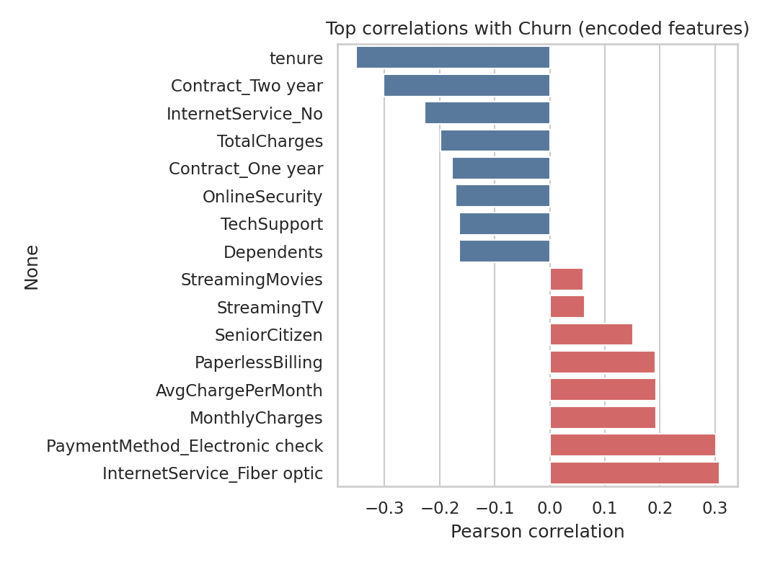
Figure 6: Strongest correlations between encoded features and Churn
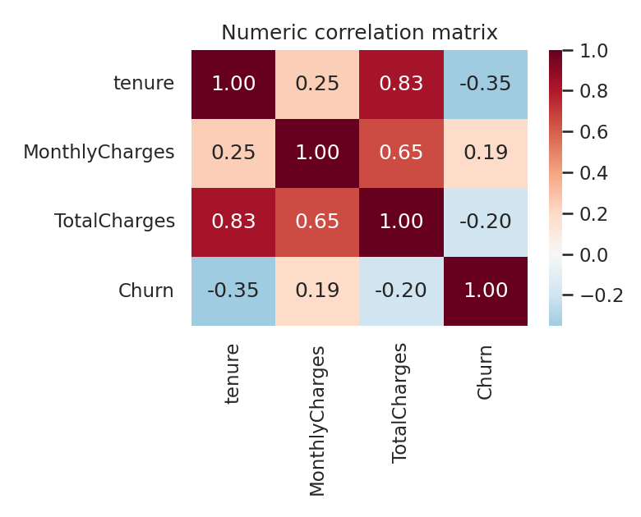
Figure 7: Correlation matrix of numeric variables and Churn
Observations: The strongest negative correlates of churn are tenure (-0.352), a two-year contract (-0.302) and having no Internet service (-0.228); the strongest positive correlates are Fiber optic service (0.308), electronic-check payment (0.302) and higher monthly charges (0.193). TotalCharges is highly correlated with tenure (0.826) and moderately with MonthlyCharges (0.651), which is expected because it is essentially their product; this redundancy is harmless for tree-based models but is handled by regularisation in Logistic Regression. All correlations with the target are moderate (|r| ≤ 0.35), indicating that churn is driven by a combination of factors rather than any single one.

4.6 Key Patterns Summary
- The typical churner is a recent, month-to-month, Fiber optic customer paying by electronic check, with no online security or tech support and relatively high monthly bills.
- The typical loyal customer has a one- or two-year contract, long tenure, automatic payments and several add-on services.
- Gender and phone service do not discriminate between churners and non-churners.

5. Proposed Data Science Approach

5.1 What is Being Predicted
The task is binary classification: for each customer, predict whether Churn = Yes (class 1, the positive class) or No (class 0). In addition to the prediction, the project analyses which features contribute most to the prediction so that the results can be used for targeted retention.

5.2 Algorithms Used
Table 3: Models used and the reason for including each
Model | Role in the study | Key settings
Logistic Regression | Interpretable baseline; coefficients show direction of each factor | class_weight = balanced; scaled inputs; max_iter = 2000
Decision Tree | Simple rule-based benchmark | max_depth = 5; class_weight = balanced
Random Forest | Ensemble capturing non-linear interactions; provides feature importance | 300 trees; max_depth = 8; min_samples_leaf = 5; class_weight = balanced
Gradient Boosting | Boosted ensemble, usually the strongest on tabular data | 150 estimators; learning_rate = 0.05; max_depth = 3

5.3 Workflow
- Load the raw dataset and inspect types, nulls and duplicates.
- Clean data: fix TotalCharges, merge redundant categories, drop customerID.
- Engineer features (AvgChargePerMonth, NumServices) and encode categorical variables.
- Perform EDA to identify patterns and validate data quality.
- Split into 80% training and 20% test sets using stratification (random_state = 42).
- Scale numeric features (training-set statistics only) for Logistic Regression.
- Train the four models; assess them on the test set and with 5-fold stratified cross-validation (ROC-AUC).
- Compare models, analyse the confusion matrix and feature importance, and tune the decision threshold.
- Summarise findings and business recommendations.

6. Implementation and Results So Far

6.1 Experimental Setup
The project was implemented in Python using pandas, NumPy, scikit-learn, Matplotlib and Seaborn. The data was divided into 5,634 training and 1,409 test records; both subsets preserve the original churn ratio (1,495 and 374 churners respectively). Because churn is the minority class, Recall, Precision, F1-score and ROC-AUC are reported alongside Accuracy.

6.2 Model Comparison
Table 4: Performance of all models on the hold-out test set (threshold = 0.5)
Model | Accuracy | Precision | Recall | F1-score | ROC-AUC | CV ROC-AUC
Logistic Regression | 0.738 | 0.504 | 0.781 | 0.613 | 0.842 | 0.845
Decision Tree | 0.723 | 0.487 | 0.810 | 0.608 | 0.828 | 0.823
Random Forest | 0.764 | 0.539 | 0.778 | 0.637 | 0.846 | 0.847
Gradient Boosting | 0.798 | 0.656 | 0.500 | 0.568 | 0.844 | 0.848

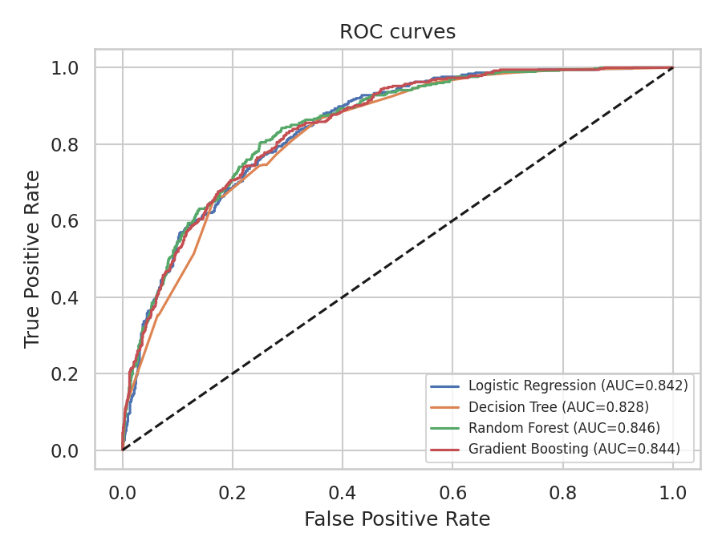
Figure 8: ROC curves of the four models on the test set
Observations: All four models perform within a narrow ROC-AUC band of 0.828 to 0.846, and the cross-validated scores confirm that the results are stable. Random Forest achieves the highest test ROC-AUC (0.846) and the highest F1-score (0.637), while Gradient Boosting has the highest accuracy (0.798) and precision (0.656) but the lowest recall (0.500), meaning that it misses half of the churners at the default threshold. The Decision Tree has the highest recall (0.810) but the weakest ROC-AUC. Logistic Regression, despite its simplicity, is competitive with the ensembles (ROC-AUC 0.842) and is fully interpretable.

6.3 Confusion Matrices
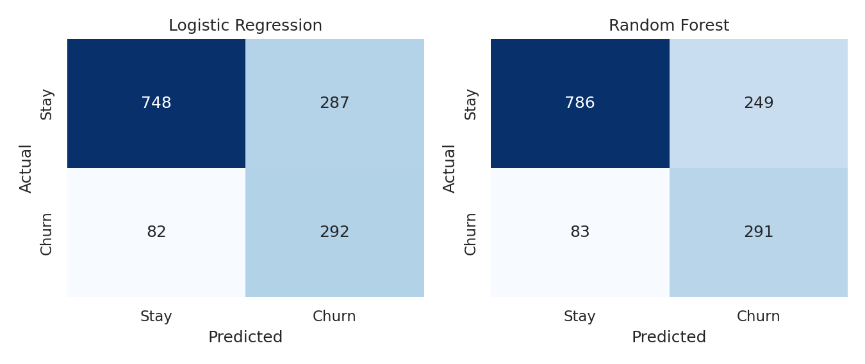
Figure 9: Confusion matrices for Logistic Regression and Random Forest
Random Forest correctly identifies 291 of the 374 actual churners (recall 0.778) at the cost of 249 false alarms, whereas Logistic Regression identifies 292 churners with 287 false alarms. In a retention setting a missed churner (lost revenue) is generally costlier than a wasted offer, so the recall-oriented behaviour of these two models is desirable.

6.4 Feature Importance
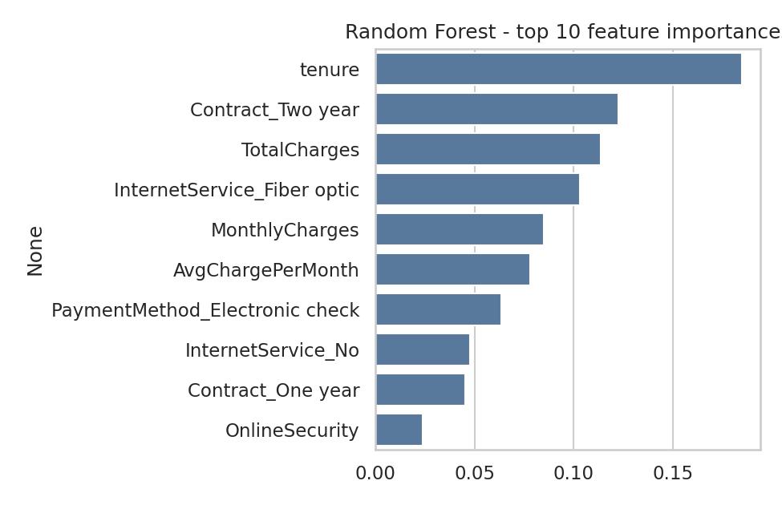
Figure 10: Top 10 features by Random Forest importance
The most important predictors are tenure (0.185), a two-year contract (0.122), TotalCharges (0.114) and Fiber optic internet (0.103). This agrees with the EDA and with the Logistic Regression coefficients, where a two-year contract (-1.415), tenure (-1.15) and no Internet service (-1.097) reduce churn risk most strongly, while Fiber optic service (+1.062), electronic-check payment (+0.4) and paperless billing (+0.337) increase it.

6.5 Decision-Threshold Analysis (Logistic Regression)
Table 5: Effect of changing the classification threshold
Threshold | Precision | Recall | F1-score | Accuracy
0.3 | 0.432 | 0.928 | 0.590 | 0.657
0.4 | 0.466 | 0.866 | 0.606 | 0.701
0.5 | 0.504 | 0.781 | 0.613 | 0.738
0.6 | 0.539 | 0.703 | 0.610 | 0.761

Lowering the threshold from 0.5 to 0.3 raises recall from 0.781 to 0.928, meaning that more than nine in ten churners are flagged, but precision falls to 0.432. The threshold can therefore be selected by the business according to the relative cost of a retention offer versus a lost customer.

6.6 Best Model
Taking ROC-AUC, F1-score and recall together, Random Forest is selected as the best-performing model in the current iteration (ROC-AUC 0.846, F1 0.637, recall 0.778), with Logistic Regression as a close and more interpretable alternative.

7. Findings, Limitations and Future Work

7.1 What Was Learned from the Data
- Churn is driven mainly by contract type, tenure and the type of internet service; demographic variables such as gender add no value.
- The first year is the most vulnerable period: nearly half of customers with tenure up to 12 months churn.
- Month-to-month, Fiber optic, electronic-check customers without security or support add-ons form the highest-risk segment.
- Customers who use automatic payments, hold longer contracts or subscribe to protection and support services are markedly more loyal.

7.2 Business Recommendations
- Offer discounts or incentives to move month-to-month customers onto one- or two-year contracts.
- Run an onboarding and early-engagement programme during the first 12 months.
- Investigate pricing and service quality in the Fiber optic segment.
- Encourage automatic payment methods and bundle online security and tech support into plans.
- Use the model’s churn probabilities to rank customers and target retention offers at the highest-risk group.

7.3 What Is Working / Not Working
Working: all models reach ROC-AUC above 0.82; cross-validated and test scores agree, indicating no overfitting; the model rankings are consistent with the EDA; the recall of about 0.78 for the best models means that most churners can be detected.
Not working as well: precision is only around 0.50–0.54 at the default threshold, so roughly half of the customers flagged would not actually have left; Gradient Boosting at the default threshold under-detects churners; and performance has plateaued across very different algorithms, which suggests the feature set rather than the algorithm is the limiting factor.

7.4 Current Limitations
- The data is a static snapshot with no time dimension, so churn cannot be modelled as a trend or survival process.
- The dataset is a relatively small (7,043 records), single-company sample and is partly synthetic; results may not generalise to other operators.
- Behavioural variables that strongly influence churn in practice (call-centre complaints, network quality, usage patterns, competitor offers) are not available.
- Hyper-parameters were set manually rather than through an exhaustive search, and the class imbalance was handled only through class weights and threshold analysis.
- The analysis shows association, not causation; for example, the high churn of Fiber optic customers does not prove that the technology itself causes churn.

7.5 What Remains to Be Completed
- Systematic hyper-parameter tuning (GridSearchCV / RandomizedSearchCV) for Random Forest and Gradient Boosting.
- Testing additional models such as XGBoost, LightGBM and a small neural network.
- Evaluating resampling techniques (SMOTE, under-sampling) and cost-sensitive learning.
- Model explainability with SHAP values for individual customer-level explanations.
- Customer segmentation (e.g. K-Means) to design segment-specific retention strategies.
- Packaging the best model into a simple web application (for example Streamlit or Flask) for demonstration.

References
- IBM Sample Data Sets: Telco Customer Churn. Published on Kaggle by BlastChar: https://www.kaggle.com/datasets/blastchar/telco-customer-churn/data
- Pedregosa, F. et al. (2011). Scikit-learn: Machine Learning in Python. Journal of Machine Learning Research, 12, 2825–2830.
- McKinney, W. (2010). Data Structures for Statistical Computing in Python. Proceedings of the 9th Python in Science Conference.

