1. Create account on [Cloudinary](https://cloudinary.com/)
2. Get your **Cloud name**

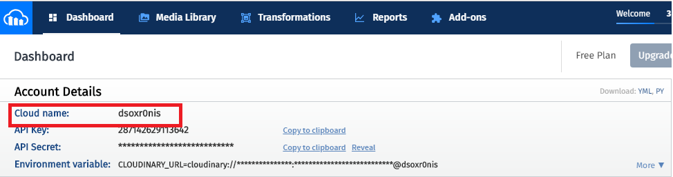

1. Go to **settings**



1. Go to **upload**

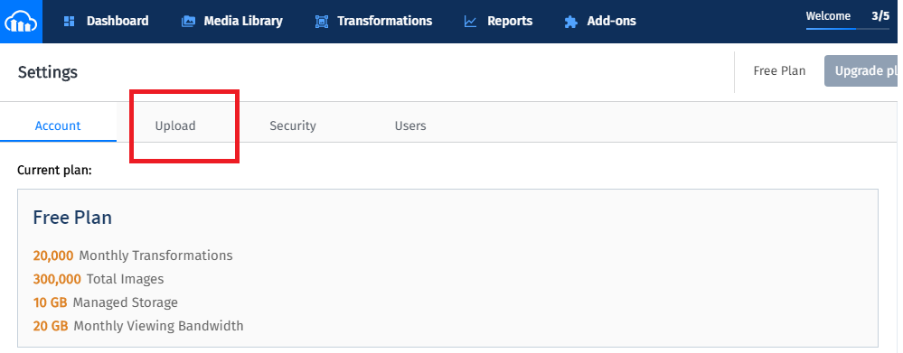

1. Enable upload presets and get **presets name**

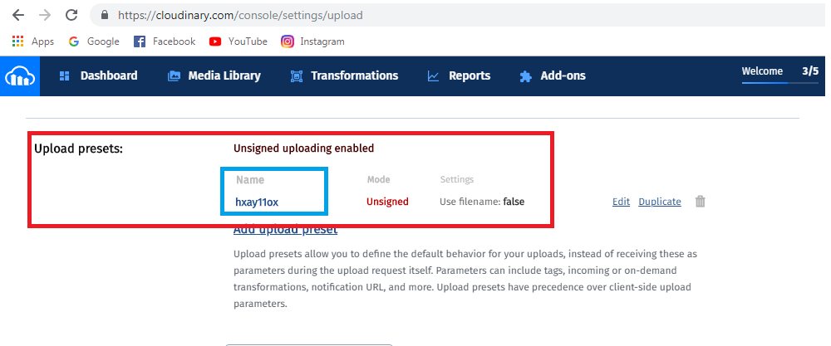

1. Replace this two value in code **index.js**

**const cloudName = 'your cloud name';**

**const unsignedUploadPreset = 'your preset name';**