MOHAMMAD JUNED

**Web Developer**

# Objective

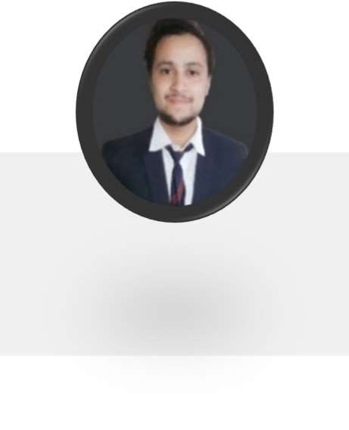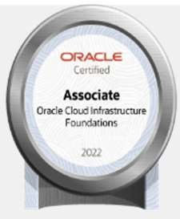

Team Player with clear and concise skills. Coming with excellent programming and bug resolution ability with two years of experience.

# Professional Experience

**Cognizant Pvt. Ltd., Hyderabad** – Java Developer

October 2022 - Present.

With more than a year of dedicated experience in web development, I've actively contributed to the successful deployment, rigorous testing, and seamless implementation of client-server and enterprise-wide applications. My proficiency extends to working with advanced technologies like Kubernetes and WebLogic.

In Kubernetes, I've played a pivotal role in efficiently managing and scaling containerized applications within cloud-based clusters, highlighting my adeptness in cloud storage solutions.

Strong Development Experience in Web applications using Spring boot framework, JavaScript, and React Js.

I also have experience in dynamic cloud application development and testing.

**Self-Employee, Bhopal** - Buzzart Software Pvt. Ltd.,

January 2021 – April 2021

Experienced in desktop-based Application development, deployment, testing & implementation as a Web front-end developer.

# Training

**Organization- Trainity Institute**

Duration: - (24 Sep 2021 to 04 Dec 2021)

**Exposure to-**

Implementation of front-end and back-end technology using advance Java concepts i.e., servlets and JSP in J2EE.

Also gained knowledge of Data Analytics & DB tools such as SQL, PL/SQL.

**Organization- Cisco Networking Academy**.

Duration: - (July 2021 to Sept 2021)

**Exposure to-**

Industrial Knowledge of IOT, Web Microservices and Introduction to networks.

# Projects

From October 2022 to Present – KeyBank (Retail & banking)

## ORACLE BANKING PLATFORM

This application is designed to help streamline the investment process, Qualis platform allows wealth managers to research and select advisers and their private funds, assist them with investment allocation& provide them with ongoing reporting and support. This application has the facility of all types sells and account calculators related to the bank domain.

**Technologies-** Java 8, Oracle 10g, Kubernetes, Jenkins & Spring boot framework, Linux OS.

**Responsibilities**- Analyze the design & developed different Modules & micro-services with MVC architecture. Responsible for developing and working with Java & cloud-based applications.  
  
Collaborated with four peers to construct the web application’s architecture and developed client and server modules compatible with containerized Kubernetes applications.

# Technical Skills

### Technology & Language:

Java, J2EE, Spring boot, Servlets, JSP with Soap &  
Rest-API, Linux & Shell scripting, Kubernetes.

### Front-end Technology:

React.js, JavaScript, HTML, CSS & TypeScript,

### Database:

Oracle 10g & MySQL, SQL & PL/SQ.

**IDE:**

VS Code, STS4, NetBeans, Eclipse, MySQL Workspace.

### Other Tools:

Jenkins, Jira, Dynatrace, Service Now, Postman, SOAP UI, Git source and MS office.

# Personal Projects

**Technologies-** Advance JAVA & J2EE, JavaScript, Spring, Oracle 10g.

#### Ginzy Food.

Ginzy Food is a restaurant based dynamic front-end application which is both mobile and desktop compatible. especially to facilitate the customer in remote areas.

* **Airport Management System**

A Full working dynamic web application made with Servlets and JSP based on Java EE specifications. In this user can book a hanger or register plan and pilot. This application also takes new registration of users based on their role as admin and manager and they can perform their relevant task.

## Claims Assigning APP.

A full working web application in which the front end is made of JSP, and backend is made with the help of spring. A user can register, check, and claim with the accurate matched details they possess.

## Volume Workout (plot your Exercise)

It is a mobile and desktop compatible application designed with JavaScript, and it is the paradigm of plotting day to day workout app.

# Additional Workshops.

* Cloud Solutions with Amazon Web Service.
* Google Cloud platform.
* **CISCO**: IOT & NETWORKING with packet tracer.

# Certificates

#### Oracle:

* Oracle cloud Infrastructure &  
  Oracle cloud data management.
* Oracle Cloud Infrastructure 2023 Architect Associate.
* Oracle Cloud Infrastructure 2023 Application Integration.

#### Udemy:

JAVA & Spring Boot, JAVASCRIPT, React Js, Oracle 10g.

#### Microsoft Certified:

Azure Developer Associate.

#### CISCO:

IOT & CCNAv7 (Introduction to Networks).

#### Trainity Edu. Inst:

Certificate of Data Analyst

* **Mecaps & A.P.J Abdul kalam** AWARD for outstanding performance in HSC & SSC school.

# Education

**Bachelor of Technology in Mechanical**  Aug 2018-

**Engineering**  July 2022

Rajiv Gandhi Proudyogiki Vishwavidyalaya University. Oriental Institute of Science and Technology,  Bhopal, MP

***Graduated with Honors Degree.***

**XII Senior Secondary**   June 2017-

MPBSE March 2018

St. George Co-Ed School  Bhopal, MP

**79.4%**

**X Secondary**   June 2015-

MPBSE March 2016

St. George Co-Ed School  Bhopal, MP

**86.33%**



Karond, Bhopal (MP) India, 462038.

+91 8109912102.

<http://www.linkedin.com/in/mohammad-juned-342b6a202> https://github.com/junedmohammadmjb   
 [Mjb.juned@Gmail.com](mailto:Mjb.juned@Gmail.com)