**Case Study for Data Mining and Analytics**

**[CA923]**

**On**

**“IS The Current Education System Create Geniuses?”**

**Developed By:**

**MUSTUFA Y. MAHETAR [16MCAL041]**

**AFZAL A.SHEKHADA [16MCAL106]**

**JAYDIP B. VAGHASIYA [16MCAL121]**

**Submitted On: 05 Th October 2018**

**IS The Current Education System Create Geniuses?**

**Data of .arff**

@relation education

@attribute STUDID{16MCA001,16MCA002,16MCA003,16MCA005,16MCA006,16MCA007,16MCA008,16MCA009,16MCA010,16MCA012,16MCA013,16MCA014,16MCA015,17MCAL002,17MCAL003,17MCAL004,17MCAL005,17MCAL009,17MCAL010,17MCAL011,17MCAL012,17MCAL013,17MCAL015}

@attribute FirstName{BHATT KAUSHAL VIKRAMBHAI,BHAVSAR JAY JAGDISHCHANDRA,DARJI KATHANKUMAR MINESHKUMAR,GOHEL PRAPTI RAMANBHAI,MALEK MANSURMIYA ILYASMIYA,PANCHAL HIMANIBEN PANKAJBHAI,PARMAR MANINI ANILKUMAR,PATEL AKSHAYKUMAR RAMESHBHAI,PATEL DIVYABEN PIYUSHBHAI,PATEL MEET JITENDRAKUMAR,PATEL NIKULKUMAR MITESHBHAI,

PATHAN SHARUKHKHAN,RANA HARDIK BHADRESHKUMAR,AMIN VRUNDA SUNILKUMAR, BABARIA FAZALMAHMMAD FARUKBHAI,BAMROLIYA MANSI HARESHKUMAR, BHATT JIGNABEN YOGESHBHAI,CONTRACTOR MAYUR UMESHKUMAR, DABHI ASHVINI THOMASBHAI,DARJI ABHISHEK SATISHBHAI, DESAI DEVALBEN PIYUSHBHAI, DESAI KOSHA AMITBHAI,GANDHI CHINTAN VIJAYKUMAR}

@attribute branch{MCA,MCALl}

@attribute gender{Male,Female}

@attribute SSC_PER{87.38,47,69.9,83,56.46,66.62,64.31,66.31,52.15,49.07,72.46,68,83.6,66.8,51.4,69,76,67.2,72,79.53,74.15,63.13,67.6}

@attribute SSC_year{2006,2007,2008,2009,2010,2011,2012}

@attribute HSC_PER{76.4,37,67,78,49.53,62.57,58.33,74,51.85,54,64.28,80,56.24,53.73,46.85,69.28,72,49.83,69.6,71.86,70.8,75.6,66.57}

@attribute GRAD_DEGREE{B.COM,BCA,B.Tech,B.SC,B.com}

@attribute GRAD_PER{6.63,62,67,76,59.97,5.65,6.71,5.91,6.18,66,56.7,70.2,77.6,70.7,72,73,58.2,55,57.3,82.7,71.86,72.08,74.6}

@attribute GRAD_YEAR{2011,2012,2013,2014,2015,2016}

@data

16MCA001,BHATT KAUSHAL VIKRAMBHAI,MCA,Male,87.38,2009,76.4,B.COM,6.63,2014,9.5

16MCA002,BHAVSAR JAY JAGDISHCHANDRA,MCA,Male,47,2006,37,B.com,62,2013,7.21

16MCA003,DARJI KATHANKUMAR MINESHKUMAR,MCA,Male,83,2009,78,B.COM,76,2014,9.86

16MCA005,GOHEL PRAPTI RAMANBHAI,MCA,Female,56.46,2009,49.53,BCA,59.97,2015,8.4

17MCAL002,AMIN VRUNDA SUNILKUMAR,MCAL,Female,83.6,2011,56.24,BCA,70.2,2016,7.02

17MCAL003,BABARIA FAZALMAHMMAD FARUKBHAI,MCAL,Male,51.4,2011,46.85,BCA,70.7,2016,7.07

17MCAL004,BAMROLIYA MANSI HARESHKUMAR,MCAL,Male,69,2011,69.28,BCA,72,2016,7.92

17MCAL005,BHATT JIGNABEN YOGESHBHAI,MCAL,Female,76,2011,72,BCA,73,2016,9.18

17MCAL009,CONTRACTOR MAYUR UMESHKUMAR,MCAL,Female,67.2,2011,49.83,B.SC,58.2,2016,8.5

17MCAL010,DABHI ASHVINI THOMASBHAI,MCAL,Male,79.53,2011,0.3796,B.SC,57.3,2016,5.73

17MCAL011,DARJI ABHISHEK SATISHBHAI,MCAL,Female,74.15,2010,69.6,BCA,82.7,2015,9.5

17MCAL012,DESAI DEVALBEN PIYUSHBHAI,MCAL,Male,63.13,2011,71.86,BCA,71.86,2016,9.63

**Associate**

* **Run Information:**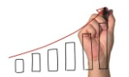
* === Run information ===
* Scheme: weka.associations.Apriori -N 10 -T 0 -C 0.9 -D 0.05 -U 1.0 -M 0.1 -S -1.0 -c -1
* Relation: dofa_jb
* Instances: 75
* Attributes: 11
* STUDID
* FirstName
* LastName
* branch
* gender
* SSC_PER
* SCC_year
* HSC_PER
* GRAD_DEGREE
* GRAD_PER
* GRAD_YEAR
* === Associator model (full training set) ===
* Apriori
* =======
* Minimum support: 0.5 (37 instances)
* Minimum metric <confidence>: 0.9
* Number of cycles performed: 10
* Generated sets of large itemsets:
* Size of set of large itemsets L(1): 5
* Size of set of large itemsets L(2): 9
* Size of set of large itemsets L(3): 4
* Size of set of large itemsets L(4): 1
* Best rules found:
* 1. SCC_year=2011 49 ==> GRAD_YEAR=2016 48 <conf:(0.98)> lift:(1.34) lev:(0.16) [12] conv:(6.53)
* 2. SCC_year=2011 GRAD_DEGREE=BCA 43 ==> GRAD_YEAR=2016 42 <conf:(0.98)> lift:(1.33) lev:(0.14) [10] conv:(5.73)
* 3. branch=MCALateralateral SCC_year=2011 42 ==> GRAD_YEAR=2016 41 <conf:(0.98)> lift:(1.33) lev:(0.14) [10] conv:(5.6)
* 4. branch=MCALateralateral SCC_year=2011 GRAD_DEGREE=BCA 39 ==> GRAD_YEAR=2016 38 <conf:(0.97)> lift:(1.33) lev:(0.13) [9] conv:(5.2)
* 5. branch=MCALateralateral GRAD_YEAR=2016 44 ==> SCC_year=2011 41 <conf:(0.93)> lift:(1.43) lev:(0.16) [12] conv:(3.81)
* 6. branch=MCALateralateral GRAD_YEAR=2016 44 ==> GRAD_DEGREE=BCA 41 <conf:(0.93)> lift:(1.15) lev:(0.07) [5] conv:(2.05)
* 7. branch=MCALateralateral SCC_year=2011 42 ==> GRAD_DEGREE=BCA 39 <conf:(0.93)> lift:(1.14) lev:(0.06) [4] conv:(1.96)
* 8. branch=MCALateralateral GRAD_DEGREE=BCA GRAD_YEAR=2016 41 ==> SCC_year=2011 38 <conf:(0.93)> lift:(1.42) lev:(0.15) [11] conv:(3.55)
* 9. branch=MCALateralateral SCC_year=2011 GRAD_YEAR=2016 41 ==> GRAD_DEGREE=BCA 38 <conf:(0.93)> lift:(1.14) lev:(0.06) [4] conv:(1.91)
* 10. SCC_year=2011 GRAD_DEGREE=BCA 43 ==> branch=MCALateralateral 39 <conf:(0.91)> lift:(1.31) lev:(0.12) [9] conv:(2.64)
* **Screenshot**

**Settings:**

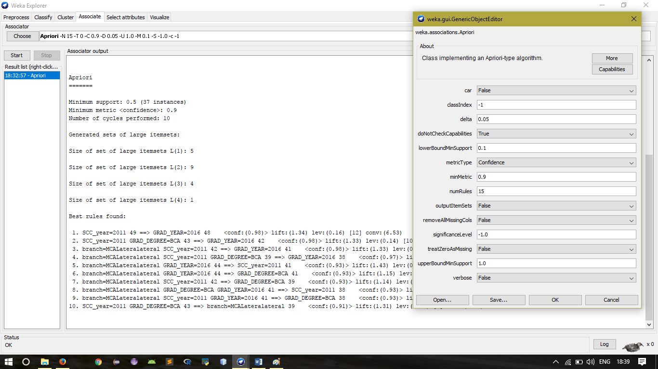

**Result:**

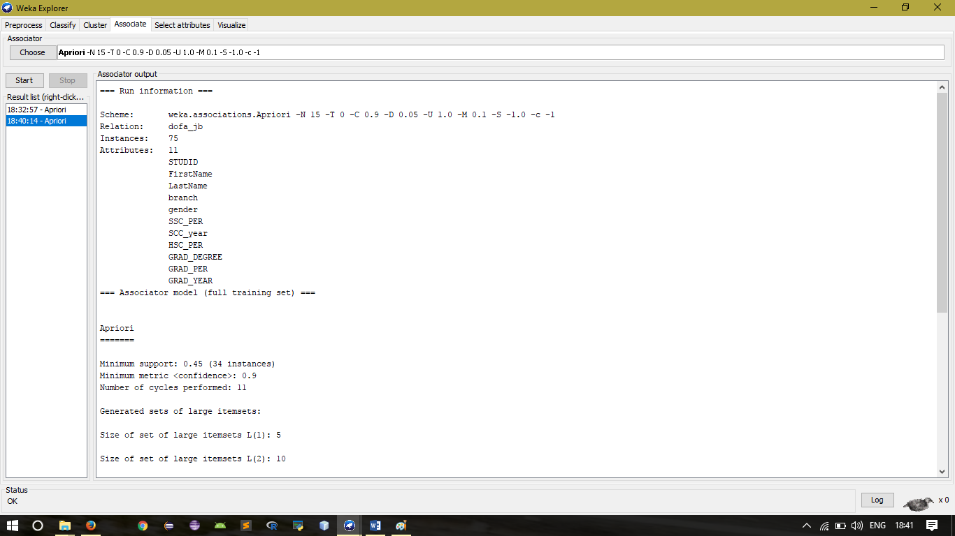

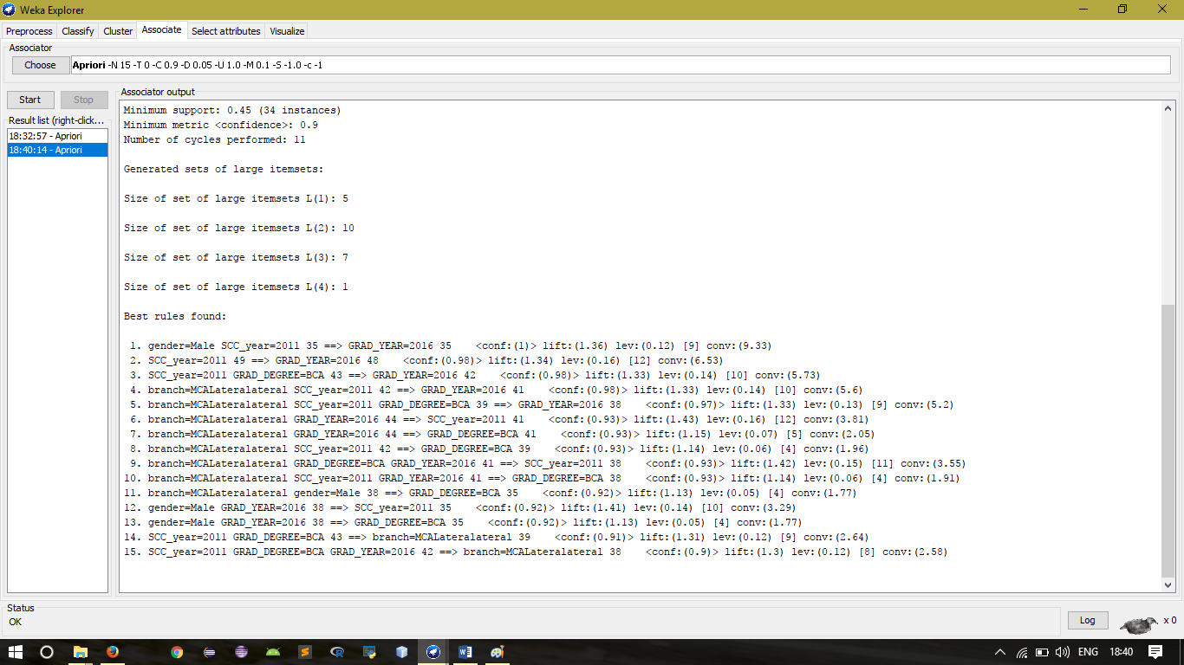

Classification

=== Run information ===

Scheme: weka.classifiers.rules.ZeroR

Relation: dofa_jb

Instances: 75

Attributes: 10

STUDID

Name

branch

gender

SSC_PER

SCC_year

HSC_PER

GRAD_DEGREE

GRAD_PER

GRAD_YEAR

Test mode: 10-fold cross-validation

=== Classifier model (full training set) ===

ZeroR predicts class value: 2016

Time taken to build model: 0 seconds

=== Stratified cross-validation ===

=== Summary ===

Correctly Classified Instances 55 73.3333 %

Incorrectly Classified Instances 20 26.6667 %

Kappa statistic 0

Mean absolute error 0.1539

Root mean squared error 0.2684

Relative absolute error 100 %

Root relative squared error 100 %

Coverage of cases (0.95 level) 98.6667 %

Mean rel. region size (0.95 level) 64.8889 %

Total Number of Instances 75

=== Confusion Matrix ===

a b c d e f <-- classified as

0 0 0 0 0 0 | a = 2011

0 0 0 0 0 0 | b = 2012

0 0 0 0 0 1 | c = 2013

0 0 0 0 0 7 | d = 2014

0 0 0 0 0 12 | e = 2015

0 0 0 0 0 55 | f = 2016

Visual Analysis

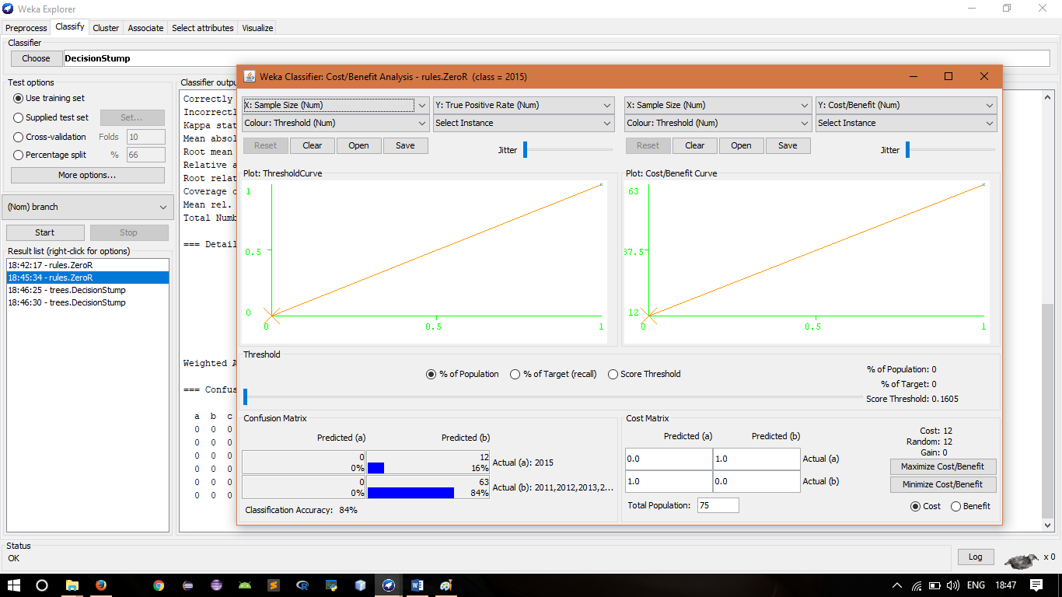

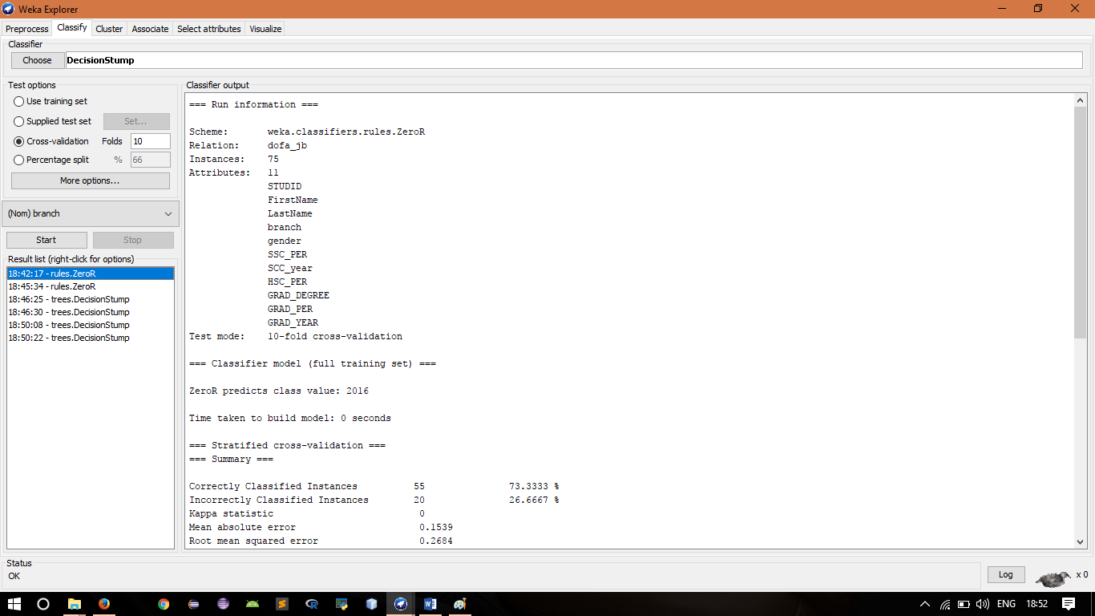

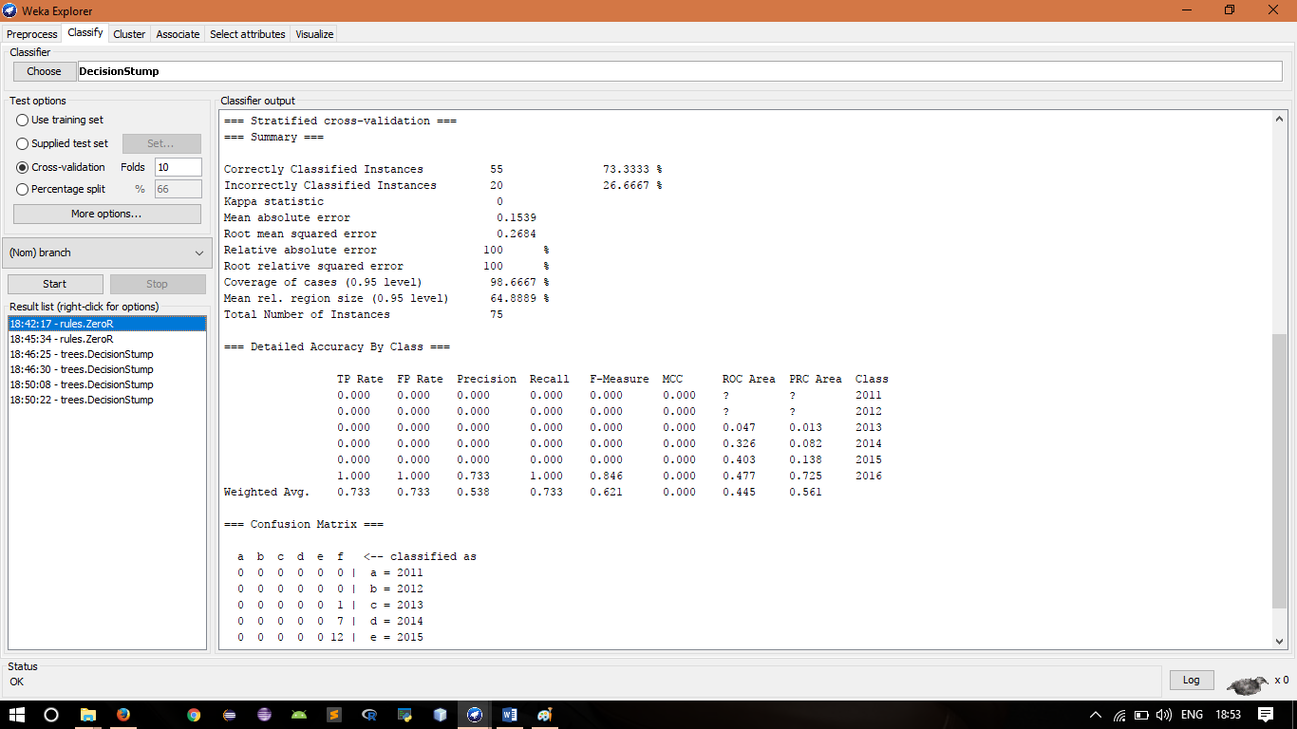

**Conclusion:**

On the basis of this Data Mining Process we can conclude that for today`s generation student, parents as well as teacher have to set such kind of environment through that student can do not only study but he/she can extra activities which can help the student to grow up and make a student to be a geniuses.

We first considered an efficient formulation for frequent itemset generation that could be applied to all algorithms based on Apriori. This saving in time-consuming I/O helped improve the performance significantly. Experiments with a number of datasets showed its scalability and performance improvement of about 15% in comparison to Optimization of Association Rules in Data Mining. Since the optimization performed targets at reduction of time spent in scans, it can be combined with other improvements or modifications to the basic Apriori algorithms.

Apriori is the simplest algorithm which is used for mining of frequent patterns from the transaction database. We have tried to implement the Apriori algorithm for sufficient research work and also we have utilized WEKA for referring the process of association rule mining.