Pattern Recognition ECE 7720

Junyoung Shin

Miniproject 2

* Plotting probability functions / posterior probability / decision boundaries of different classes

1. Generic function of computing Mahalanobis distance for 2 feature data :

Splitting 2 different cases where the mean and covariance is given / not given

1. Computing discriminant function with the given Mahalanobis distance:

Discriminant function is used as an aid in discriminating samples of different classes. Using the Mahalanobis distance from above, values from discriminant function is obtained as a comparison to determine which class the sample belongs to.



1. Generate dataset from a Gaussian distribution N(0,1) -> dewhiten-> computing pdf

Case1 : Sigma 1 = Sigma 2 = [[4.1, 0],[0, 2.8]] with priors [0.8, 0.2] respectively

For a given set of Mu / Covariance/ Prior, each datapoint generates a likelihood (probability density). Class 2(Class 1 on left graph) has a prior that is 4 times higher than that of class 1(Class 0 on left graph), resulting in probability density values corresponding to that.

1. Plotting Decision boundary on 2D

In terms of a 2 feature dataset, we can generate the decision boundary based on what the covariance matrix looks like. Since Case1 has the same covariance for all class, the decision boundary is a linear function, with the location of the line biased towards the class with a lower probability.

1. Plotting posterior probabilities

Posterior probability, derived from the Bayesian theorem is given as :

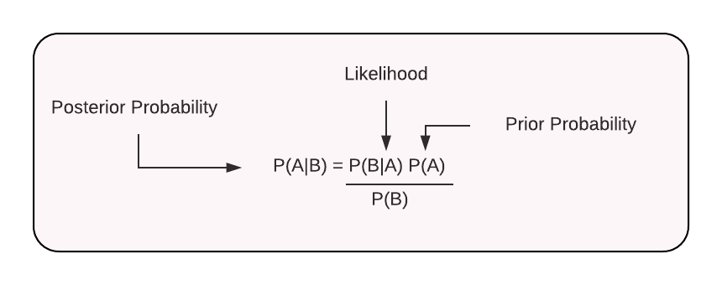 From Total theorem, Evidence (denominator) is the sum of (Likelihood)x(Prior) among all classes.

1. Case 2 : Sigma1= Sigma2 = [[4.1,1.4],[1.4,2.8]] with priors [0.8, 0.2] respectively

Unlike Case 1, Case2 have a covariance that are uncorrelated. Compared to the first set of data in Case 1, Case 2 shows data points that has an upper right orientation.

1. Case 3 : Sigma 1= [[2.1,1.5],[1.5,3.8]], Sigma 2=[[4.1, 0.4],[0.4, 2.8]] with priors [0.8, 0.4] respectively

Case 3 have 2 different covariance for each class, which gives a curve for the decision boundary. Green line (right left) indicates the decision boundary for the first class whereas the blue line indicates the decision boundary for the other. Changing the priors from [0.8, 0.2] to [0.8,0.4] leads to different results for the posterior probabilities and probability densities.

1. Case 4 : Sigma 1= [[2.1,1.5],[1.5,3.8]], Sigma 2=[[4.1, 0.4],[0.4, 2.8]] with priors [0.5, 0.5] respectively

Comparing the results from Case 3, having the priors equally brings a shift of the boundary decision towards the second class.

+) YAML file for configurations

