1分析数据位于 ycamera 模块下

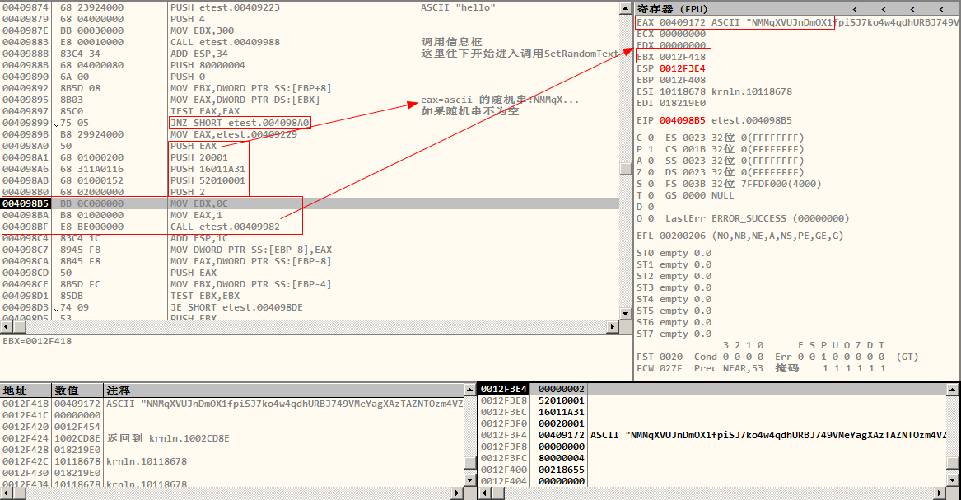
68D71550
68D71688
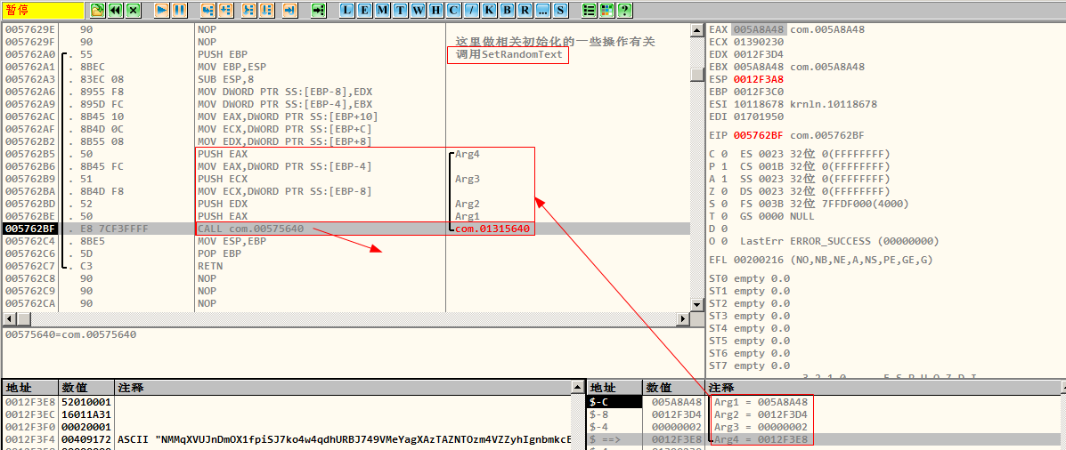

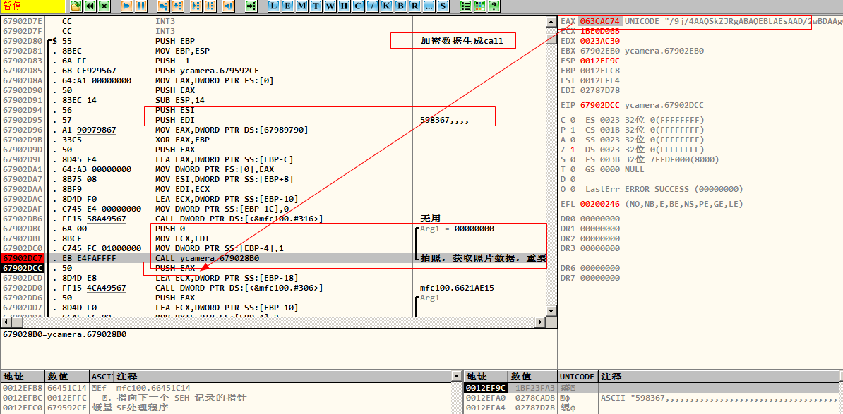

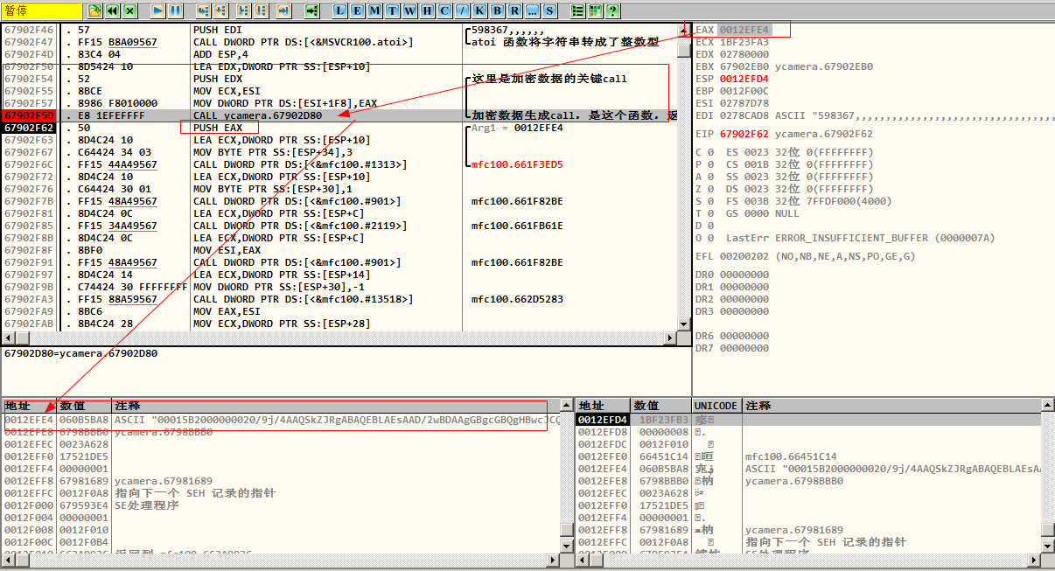
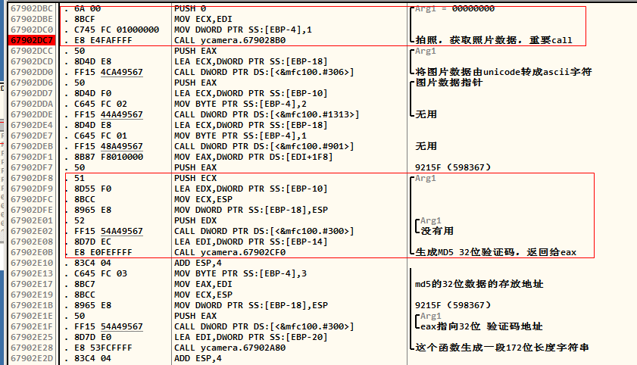
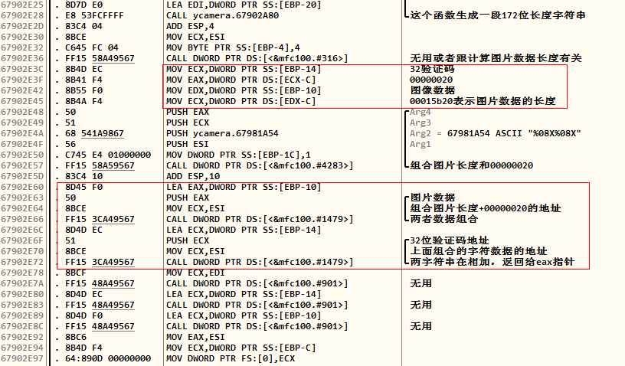

67902F4D |. 83C4 04 ADD ESP,4
67902F50 |. 8D5424 10 LEA EDX,DWORD PTR SS:[ESP+10]
67902F54 |. 52 PUSH EDX ; /这里是加密数据的关键call
67902F55 |. 8BCE MOV ECX,ESI ; |
67902F57 |. 8986 F8010000 MOV DWORD PTR DS:[ESI+1F8],EAX ; |
67902F5D |. E8 1EFEFFFF CALL ycamera.67902D80 ; \加密数据生成call，是这个函数，返回给eax

特征码：83 C4 04 8D 54 24 10 52 8B CE 89 86 F8 01 00 00 E8 1E FE FF FF

一个重要值的计算：
67902EFF |. 8B45 08 MOV EAX,DWORD PTR SS:[EBP+8]
67902F02 |. 51 PUSH ECX
67902F03 |. C64424 34 01 MOV BYTE PTR SS:[ESP+34],1
67902F08 |. 8BCC MOV ECX,ESP
67902F0A |. 896424 14 MOV DWORD PTR SS:[ESP+14],ESP
67902F0E |. 50 PUSH EAX
67902F0F |. FF15 50A49567 CALL DWORD PTR DS:[<&mfc100.#310>] ; 不是
67902F15 |. 8D4C24 14 LEA ECX,DWORD PTR SS:[ESP+14] ; |
67902F19 |. 51 PUSH ECX ; |Arg1
67902F1A |. E8 31FDFFFF CALL ycamera.67902C50 ; \一个重要因子的生成函数:598367,,,,
67902F1F |. 50 PUSH EAX ; /Arg1
67902F20 |. 8D8E 14020000 LEA ECX,DWORD PTR DS:[ESI+214] ; |
67902F26 |. C64424 34 02 MOV BYTE PTR SS:[ESP+34],2 ; |
特征码：8B 45 08 51 C6 44 24 34 01 8B CC 89 64 24 14 50

加密函数详情：
67902D80 /$ 55 PUSH EBP ; 加密数据生成call
67902D81 |. 8BEC MOV EBP,ESP
67902D83 |. 6A FF PUSH -1
67902D85 |. 68 CE929567 PUSH ycamera.679592CE
67902D8A |. 64:A1 00000000 MOV EAX,DWORD PTR FS:[0]
67902D90 |. 50 PUSH EAX
67902D91 |. 83EC 14 SUB ESP,14
67902D94 |. 56 PUSH ESI
67902D95 |. 57 PUSH EDI ; 598367,,,,
67902D96 |. A1 90979867 MOV EAX,DWORD PTR DS:[67989790]
67902D9B |. 33C5 XOR EAX,EBP
67902D9D |. 50 PUSH EAX
67902D9E |. 8D45 F4 LEA EAX,DWORD PTR SS:[EBP-C]
67902DA1 |. 64:A3 00000000 MOV DWORD PTR FS:[0],EAX
67902DA7 |. 8B75 08 MOV ESI,DWORD PTR SS:[EBP+8]
67902DAA |. 8BF9 MOV EDI,ECX
67902DAC |. 8D4D F0 LEA ECX,DWORD PTR SS:[EBP-10]
67902DAF |. C745 E4 00000000 MOV DWORD PTR SS:[EBP-1C],0
67902DB6 |. FF15 58A49567 CALL DWORD PTR DS:[<&mfc100.#316>] ; 无用
67902DBC |. 6A 00 PUSH 0 ; /Arg1 = 00000000
67902DBE |. 8BCF MOV ECX,EDI ; |
67902DC0 |. C745 FC 01000000 MOV DWORD PTR SS:[EBP-4],1 ; |
67902DC7 >|. E8 E4FAFFFF CALL ycamera.679028B0 ; \拍照，获取照片数据，重要call
67902DCC |. 50 PUSH EAX ; /Arg1
67902DCD |. 8D4D E8 LEA ECX,DWORD PTR SS:[EBP-18] ; |
67902DD0 |. FF15 4CA49567 CALL DWORD PTR DS:[<&mfc100.#306>] ; \将图片数据由unicode转成ascii字符
67902DD6 |. 50 PUSH EAX ; /图片数据指针
67902DD7 |. 8D4D F0 LEA ECX,DWORD PTR SS:[EBP-10] ; |
67902DDA |. C645 FC 02 MOV BYTE PTR SS:[EBP-4],2 ; |
67902DDE |. FF15 44A49567 CALL DWORD PTR DS:[<&mfc100.#1313>] ; \无用
67902DE4 |. 8D4D E8 LEA ECX,DWORD PTR SS:[EBP-18]
67902DE7 |. C645 FC 01 MOV BYTE PTR SS:[EBP-4],1
67902DEB |. FF15 48A49567 CALL DWORD PTR DS:[<&mfc100.#901>] ; 无用
67902DF1 |. 8B87 F8010000 MOV EAX,DWORD PTR DS:[EDI+1F8]
67902DF7 |. 50 PUSH EAX ; 9215F（598367）
67902DF8 |. 51 PUSH ECX ; /Arg1
67902DF9 |. 8D55 F0 LEA EDX,DWORD PTR SS:[EBP-10] ; |
67902DFC |. 8BCC MOV ECX,ESP ; |
67902DFE |. 8965 E8 MOV DWORD PTR SS:[EBP-18],ESP ; |
67902E01 |. 52 PUSH EDX ; |/Arg1
67902E02 |. FF15 54A49567 CALL DWORD PTR DS:[<&mfc100.#300>] ; |\没有用
67902E08 |. 8D7D EC LEA EDI,DWORD PTR SS:[EBP-14] ; |
67902E0B >|. E8 E0FEFFFF CALL ycamera.67902CF0 ; \生成MD5 32位验证码，返回给eax
67902E10 |. 83C4 04 ADD ESP,4
67902E13 |. C645 FC 03 MOV BYTE PTR SS:[EBP-4],3 ; |
67902E17 |. 8BC7 MOV EAX,EDI ; |md5的32位数据的存放地址
67902E19 |. 8BCC MOV ECX,ESP ; |
67902E1B |. 8965 E8 MOV DWORD PTR SS:[EBP-18],ESP ; |9215F（598367）
67902E1E |. 50 PUSH EAX ; |/Arg1
67902E1F |. FF15 54A49567 CALL DWORD PTR DS:[<&mfc100.#300>] ; |\eax指向32位 验证码地址
67902E25 |. 8D7D E0 LEA EDI,DWORD PTR SS:[EBP-20] ; |
67902E28 |. E8 53FCFFFF CALL ycamera.67902A80 ; \这个函数生成一段172位长度字符串
67902E2D |. 83C4 04 ADD ESP,4
67902E30 |. 8BCE MOV ECX,ESI
67902E32 |. C645 FC 04 MOV BYTE PTR SS:[EBP-4],4
67902E36 |. FF15 58A49567 CALL DWORD PTR DS:[<&mfc100.#316>] ; 无用或者跟计算图片数据长度有关
67902E3C |. 8B4D EC MOV ECX,DWORD PTR SS:[EBP-14] ; 32验证码
67902E3F |. 8B41 F4 MOV EAX,DWORD PTR DS:[ECX-C] ; 00000020
67902E42 |. 8B55 F0 MOV EDX,DWORD PTR SS:[EBP-10] ; 图像数据
67902E45 |. 8B4A F4 MOV ECX,DWORD PTR DS:[EDX-C] ; 00015b20表示图片数据的长度
67902E48 |. 50 PUSH EAX ; /Arg4
67902E49 |. 51 PUSH ECX ; |Arg3
67902E4A |. 68 541A9867 PUSH ycamera.67981A54 ; |Arg2 = 67981A54 ASCII "%08X%08X"
67902E4F |. 56 PUSH ESI ; |Arg1
67902E50 |. C745 E4 01000000 MOV DWORD PTR SS:[EBP-1C],1 ; |
67902E57 |. FF15 58A59567 CALL DWORD PTR DS:[<&mfc100.#4283>] ; \组合图片长度和00000020
67902E5D |. 83C4 10 ADD ESP,10
67902E60 |. 8D45 F0 LEA EAX,DWORD PTR SS:[EBP-10]
67902E63 |. 50 PUSH EAX ; /图片数据
67902E64 |. 8BCE MOV ECX,ESI ; |组合图片长度+00000020的地址
67902E66 >|. FF15 3CA49567 CALL DWORD PTR DS:[<&mfc100.#1479>] ; \两者数据组合
67902E6C |. 8D4D EC LEA ECX,DWORD PTR SS:[EBP-14]
67902E6F |. 51 PUSH ECX ; /32位验证码地址
67902E70 |. 8BCE MOV ECX,ESI ; |上面组合的字符数据的地址
67902E72 |. FF15 3CA49567 CALL DWORD PTR DS:[<&mfc100.#1479>] ; \两字符串在相加，返回给eax指针
67902E78 |. 8BCF MOV ECX,EDI
67902E7A |. FF15 48A49567 CALL DWORD PTR DS:[<&mfc100.#901>] ; 无用
67902E80 |. 8D4D EC LEA ECX,DWORD PTR SS:[EBP-14]
67902E83 |. FF15 48A49567 CALL DWORD PTR DS:[<&mfc100.#901>] ; 无用
67902E89 |. 8D4D F0 LEA ECX,DWORD PTR SS:[EBP-10]
67902E8C |. FF15 48A49567 CALL DWORD PTR DS:[<&mfc100.#901>] ; 无用
67902E92 |. 8BC6 MOV EAX,ESI
67902E94 |. 8B4D F4 MOV ECX,DWORD PTR SS:[EBP-C]
67902E97 |. 64:890D 00000000 MOV DWORD PTR FS:[0],ECX
67902E9E |. 59 POP ECX
67902E9F |. 5F POP EDI
67902EA0 |. 5E POP ESI
67902EA1 |. 8BE5 MOV ESP,EBP
67902EA3 |. 5D POP EBP
67902EA4 \. C2 0400 RETN 4

特征码：33 C5 50 8D 45 F4 64 A3 00 00 00 00 8B 75 08 8B F9 8D 4D F0 C7 45 E4 00 00 00 00

2 代码分析

2.1 SetRandomText,生成加密数据
-----------------------------------------------------------------------------------
补充：
FS寄存器指向当前活动线程的TEB结构（线程结构）
偏移 说明
000 指向SEH链指针 SEH结构---结构化异常处理
004 线程堆栈顶部
008 线程堆栈底部
00C SubSystemTib
010 FiberData
014 ArbitraryUserPointer
018 FS段寄存器在内存中的镜像地址
020 进程PID
024 线程ID
02C 指向线程局部存储指针
030 PEB结构地址（进程结构）
034 上个错误号
得到KERNEL32.DLL基址的方法
assume fs:nothing ;打开FS寄存器
mov eax,fs:[30h] ;得到PEB结构地址
mov eax,[eax + 0ch] ;得到PEB_LDR_DATA结构地址
mov esi,[eax + 1ch] ;InInitializationOrderModuleList
lodsd ;得到KERNEL32.DLL所在LDR_MODULE结构的InInitializationOrderModuleList地址
mov edx,[eax + 8h] ;得到BaseAddress，既Kernel32.dll基址
-------------------------------------------------------------

6AAF2EB0 /. 55 PUSH EBP ; SetRandomText,生成加密数据
6AAF2EB1 |. 8BEC MOV EBP,ESP ; 此函数需要一个172位随机码的参数
6AAF2EB3 |. 83E4 F8 AND ESP,FFFFFFF8
6AAF2EB6 |. 6A FF PUSH -1
6AAF2EB8 |. 68 E493B46A PUSH ycamera.6AB493E4
6AAF2EBD |. 64:A1 00000000 MOV EAX,DWORD PTR FS:[0]
6AAF2EC3 |. 50 PUSH EAX
6AAF2EC4 |. 83EC 1C SUB ESP,1C
6AAF2EC7 |. 56 PUSH ESI
6AAF2EC8 |. 57 PUSH EDI
6AAF2EC9 |. A1 9097B76A MOV EAX,DWORD PTR DS:[6AB79790]
6AAF2ECE |. 33C4 XOR EAX,ESP
6AAF2ED0 |. 50 PUSH EAX
6AAF2ED1 |. 8D4424 28 LEA EAX,DWORD PTR SS:[ESP+28]
6AAF2ED5 |. 64:A3 00000000 MOV DWORD PTR FS:[0],EAX
6AAF2EDB |. 8BF1 MOV ESI,ECX
6AAF2EDD |. E8 4F4C0500 CALL ycamera.6AB47B31 ; 没有用
6AAF2EE2 |. 50 PUSH EAX ; /Arg1
6AAF2EE3 |. 8D4C24 18 LEA ECX,DWORD PTR SS:[ESP+18] ; |
6AAF2EE7 |. FF15 84A5B46A CALL DWORD PTR DS:[<&mfc100.#322>] ; \无用
6AAF2EED |. 8D4C24 0C LEA ECX,DWORD PTR SS:[ESP+C]
6AAF2EF1 |. C74424 30 0000>MOV DWORD PTR SS:[ESP+30],0
6AAF2EF9 |. FF15 58A4B46A CALL DWORD PTR DS:[<&mfc100.#316>] ; mfc100.5FBB7561
6AAF2EFF |. 8B45 08 MOV EAX,DWORD PTR SS:[EBP+8]
6AAF2F02 |. 51 PUSH ECX ; /Arg2 172位随机码
6AAF2F03 |. C64424 34 01 MOV BYTE PTR SS:[ESP+34],1 ; |
6AAF2F08 |. 8BCC MOV ECX,ESP ; |
6AAF2F0A |. 896424 14 MOV DWORD PTR SS:[ESP+14],ESP ; |
6AAF2F0E |. 50 PUSH EAX ; |/Arg1 172随机码
6AAF2F0F |. FF15 50A4B46A CALL DWORD PTR DS:[<&mfc100.#310>] ;大概是平衡172因子
6AAF2F15 |. 8D4C24 14 LEA ECX,DWORD PTR SS:[ESP+14] ; |
6AAF2F19 |. 51 PUSH ECX ; |Arg1 172随机码地址指针的指针
6AAF2F1A |. E8 31FDFFFF CALL ycamera.6AAF2C50; \一个重要因子的生成函数:598367,,
6AAF2F1F |. 50 PUSH EAX ; /Arg1
6AAF2F20 |. 8D8E 14020000 LEA ECX,DWORD PTR DS:[ESI+214] ; |
6AAF2F26 |. C64424 34 02 MOV BYTE PTR SS:[ESP+34],2 ; |
6AAF2F2B |. FF15 44A4B46A CALL DWORD PTR DS:[<&mfc100.#1313>] ; \不是
6AAF2F31 |. 8D4C24 10 LEA ECX,DWORD PTR SS:[ESP+10]
6AAF2F35 |. C64424 30 01 MOV BYTE PTR SS:[ESP+30],1
6AAF2F3A |. FF15 48A4B46A CALL DWORD PTR DS:[<&mfc100.#901>] ; 不是
6AAF2F40 |. 8BBE 14020000 MOV EDI,DWORD PTR DS:[ESI+214]
6AAF2F46 |. 57 PUSH EDI ; /598367,,,,,,
6AAF2F47 |. FF15 B8A0B46A CALL DWORD PTR DS:[<&MSVCR100.atoi>] ; \函数将字符串转成了整数型
6AAF2F4D |. 83C4 04 ADD ESP,4
6AAF2F50 |. 8D5424 10 LEA EDX,DWORD PTR SS:[ESP+10]
6AAF2F54 |. 52 PUSH EDX ; /这里是加密数据的关键call
6AAF2F55 |. 8BCE MOV ECX,ESI ; |
6AAF2F57 |. 8986 F8010000 MOV DWORD PTR DS:[ESI+1F8],EAX ; |
6AAF2F5D |. E8 1EFEFFFF CALL ycamera.6AAF2D80 ; \加密数据生成call，是这个函数，返回给eax
6AAF2F62 |. 50 PUSH EAX ; /Arg1
6AAF2F63 |. 8D4C24 10 LEA ECX,DWORD PTR SS:[ESP+10] ; |
6AAF2F67 |. C64424 34 03 MOV BYTE PTR SS:[ESP+34],3 ; |
6AAF2F6C |. FF15 44A4B46A CALL DWORD PTR DS:[<&mfc100.#1313>]; \mfc100.5FB63ED5
6AAF2F72 |. 8D4C24 10 LEA ECX,DWORD PTR SS:[ESP+10]
6AAF2F76 |. C64424 30 01 MOV BYTE PTR SS:[ESP+30],1
6AAF2F7B |. FF15 48A4B46A CALL DWORD PTR DS:[<&mfc100.#901>]; mfc100.5FB682BE
6AAF2F81 |. 8D4C24 0C LEA ECX,DWORD PTR SS:[ESP+C]
6AAF2F85 |. FF15 34A4B46A CALL DWORD PTR DS:[<&mfc100.#2119>]; mfc100.5FB6B61E
6AAF2F8B |. 8D4C24 0C LEA ECX,DWORD PTR SS:[ESP+C]
6AAF2F8F |. 8BF0 MOV ESI,EAX
6AAF2F91 |. FF15 48A4B46A CALL DWORD PTR DS:[<&mfc100.#901>] ; mfc100.5FB682BE
6AAF2F97 |. 8D4C24 14 LEA ECX,DWORD PTR SS:[ESP+14]
6AAF2F9B |. C74424 30 FFFF>MOV DWORD PTR SS:[ESP+30],-1
6AAF2FA3 |. FF15 88A5B46A CALL DWORD PTR DS:[<&mfc100.#13518>]; mfc100.5FC45283
6AAF2FA9 |. 8BC6 MOV EAX,ESI
6AAF2FAB |. 8B4C24 28 MOV ECX,DWORD PTR SS:[ESP+28]
6AAF2FAF |. 64:890D 000000>MOV DWORD PTR FS:[0],ECX
6AAF2FB6 |. 59 POP ECX
6AAF2FB7 |. 5F POP EDI
6AAF2FB8 |. 5E POP ESI
6AAF2FB9 |. 8BE5 MOV ESP,EBP
6AAF2FBB |. 5D POP EBP
6AAF2FBC \. C2 0400 RETN 4
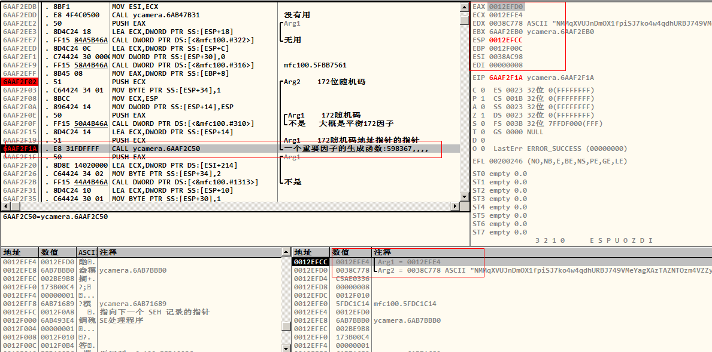
6AAF2C50函数调用

2.2 一个重要的参数数据的生成函数
6AAF2C50 /$ 55 PUSH EBP ; 一个重要的参数数据的生成函数
6AAF2C51 |. 8BEC MOV EBP,ESP
6AAF2C53 |. 6A FF PUSH -1
6AAF2C55 |. 68 2C92B46A PUSH ycamera.6AB4922C
6AAF2C5A |. 64:A1 00000000 MOV EAX,DWORD PTR FS:[0]
6AAF2C60 |. 50 PUSH EAX
6AAF2C61 |. 83EC 08 SUB ESP,8
6AAF2C64 |. 56 PUSH ESI
6AAF2C65 |. A1 9097B76A MOV EAX,DWORD PTR DS:[6AB79790]
6AAF2C6A |. 33C5 XOR EAX,EBP
6AAF2C6C |. 50 PUSH EAX
6AAF2C6D |. 8D45 F4 LEA EAX,DWORD PTR SS:[EBP-C]
6AAF2C70 |. 64:A3 00000000 MOV DWORD PTR FS:[0],EAX
6AAF2C76 |. 8B75 08 MOV ESI,DWORD PTR SS:[EBP+8]
6AAF2C79 |. C745 F0 000000>MOV DWORD PTR SS:[EBP-10],0
6AAF2C80 |. 8BCE MOV ECX,ESI
6AAF2C82 |. C745 FC 010000>MOV DWORD PTR SS:[EBP-4],1
6AAF2C89 |. FF15 58A4B46A CALL DWORD PTR DS:[<&mfc100.#316>] ; mfc100.5FBB7561
6AAF2C8F |. 51 PUSH ECX ; /Arg1 172位随机码数据
6AAF2C90 |. 8D45 0C LEA EAX,DWORD PTR SS:[EBP+C] ; |
6AAF2C93 |. 8BCC MOV ECX,ESP ; |
6AAF2C95 |. 8965 EC MOV DWORD PTR SS:[EBP-14],ESP ; |
6AAF2C98 |. 50 PUSH EAX ; |/Arg1
6AAF2C99 |. C745 F0 010000>MOV DWORD PTR SS:[EBP-10],1 ; ||
6AAF2CA0 |. FF15 54A4B46A CALL DWORD PTR DS:[<&mfc100.#300>]; |\mfc100.5FB6B5F6
6AAF2CA6 |. 8D4D EC LEA ECX,DWORD PTR SS:[EBP-14]; |Arg2 172随机码地址指针的指针
6AAF2CA9 |. E8 A2FEFFFF CALL ycamera.6AAF2B50 ; \这个是主生成函数
6AAF2CAE |. 83C4 04 ADD ESP,4 ; 返回给eax
6AAF2CB1 |. 50 PUSH EAX ; /agr1 ASCII 598367,,,,,, 128位长度
6AAF2CB2 |. 8BCE MOV ECX,ESI ; |
6AAF2CB4 |. C645 FC 02 MOV BYTE PTR SS:[EBP-4],2 ; |
6AAF2CB8 |. FF15 44A4B46A CALL DWORD PTR DS:[<&mfc100.#1313>] ; \mfc100.5FB63ED5
6AAF2CBE |. 8D4D EC LEA ECX,DWORD PTR SS:[EBP-14]
6AAF2CC1 |. FF15 48A4B46A CALL DWORD PTR DS:[<&mfc100.#901>] ; mfc100.5FB682BE
6AAF2CC7 |. 8D4D 0C LEA ECX,DWORD PTR SS:[EBP+C]
6AAF2CCA |. FF15 48A4B46A CALL DWORD PTR DS:[<&mfc100.#901>] ; mfc100.5FB682BE
6AAF2CD0 |. 8BC6 MOV EAX,ESI
6AAF2CD2 |. 8B4D F4 MOV ECX,DWORD PTR SS:[EBP-C]
6AAF2CD5 |. 64:890D 000000>MOV DWORD PTR FS:[0],ECX
6AAF2CDC |. 59 POP ECX
6AAF2CDD |. 5E POP ESI
6AAF2CDE |. 8BE5 MOV ESP,EBP
6AAF2CE0 |. 5D POP EBP
6AAF2CE1 \. C2 0800 RETN 8
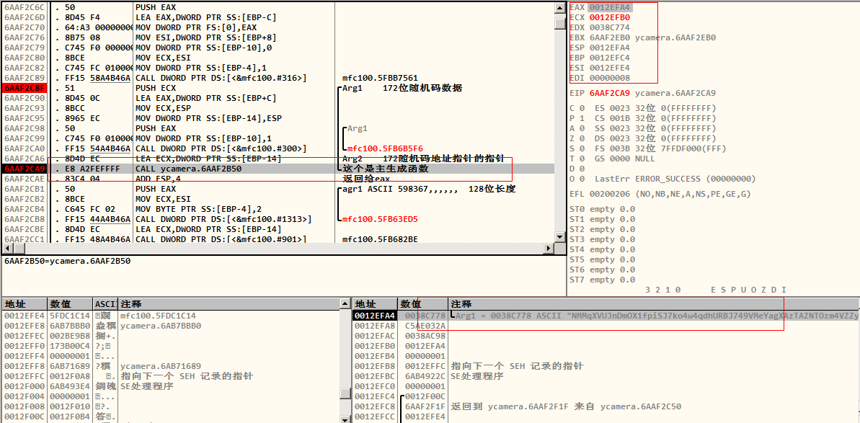
函数6AAF2B50

2.3 加密数据生成call
6AAF2D80 /$ 55 PUSH EBP ; 加密数据生成call
6AAF2D81 |. 8BEC MOV EBP,ESP
6AAF2D83 |. 6A FF PUSH -1
6AAF2D85 |. 68 CE92B46A PUSH ycamera.6AB492CE
6AAF2D8A |. 64:A1 00000000 MOV EAX,DWORD PTR FS:[0]
6AAF2D90 |. 50 PUSH EAX
6AAF2D91 |. 83EC 14 SUB ESP,14
6AAF2D94 |. 56 PUSH ESI
6AAF2D95 |. 57 PUSH EDI ; 598367,,,,
6AAF2D96 |. A1 9097B76A MOV EAX,DWORD PTR DS:[6AB79790]
6AAF2D9B |. 33C5 XOR EAX,EBP
6AAF2D9D |. 50 PUSH EAX
6AAF2D9E |. 8D45 F4 LEA EAX,DWORD PTR SS:[EBP-C]
6AAF2DA1 |. 64:A3 00000000 MOV DWORD PTR FS:[0],EAX
6AAF2DA7 |. 8B75 08 MOV ESI,DWORD PTR SS:[EBP+8]
6AAF2DAA |. 8BF9 MOV EDI,ECX
6AAF2DAC |. 8D4D F0 LEA ECX,DWORD PTR SS:[EBP-10]
6AAF2DAF |. C745 E4 000000>MOV DWORD PTR SS:[EBP-1C],0
6AAF2DB6 |. FF15 58A4B46A CALL DWORD PTR DS:[<&mfc100.#316>] ; 无用
6AAF2DBC |. 6A 00 PUSH 0 ; /Arg1 = 00000000
6AAF2DBE |. 8BCF MOV ECX,EDI ; |
6AAF2DC0 |. C745 FC 010000>MOV DWORD PTR SS:[EBP-4],1 ; |
6AAF2DC7 >|. E8 E4FAFFFF CALL ycamera.6AAF28B0 ; \拍照，获取照片数据，重要call
6AAF2DCC |. 50 PUSH EAX ; /Arg1
6AAF2DCD |. 8D4D E8 LEA ECX,DWORD PTR SS:[EBP-18] ; |
6AAF2DD0 |. FF15 4CA4B46A CALL DWORD PTR DS:[<&mfc100.#306>]; \将图片数据由unicode转成ascii字符
6AAF2DD6 |. 50 PUSH EAX ; /图片数据指针
6AAF2DD7 |. 8D4D F0 LEA ECX,DWORD PTR SS:[EBP-10] ; |
6AAF2DDA |. C645 FC 02 MOV BYTE PTR SS:[EBP-4],2 ; |
6AAF2DDE |. FF15 44A4B46A CALL DWORD PTR DS:[<&mfc100.#1313>] ; \无用
6AAF2DE4 |. 8D4D E8 LEA ECX,DWORD PTR SS:[EBP-18]
6AAF2DE7 |. C645 FC 01 MOV BYTE PTR SS:[EBP-4],1
6AAF2DEB |. FF15 48A4B46A CALL DWORD PTR DS:[<&mfc100.#901>] ; 无用
6AAF2DF1 |. 8B87 F8010000 MOV EAX,DWORD PTR DS:[EDI+1F8]
6AAF2DF7 |. 50 PUSH EAX ; 9215F（598367）
6AAF2DF8 |. 51 PUSH ECX ; /Arg1
6AAF2DF9 |. 8D55 F0 LEA EDX,DWORD PTR SS:[EBP-10] ; |
6AAF2DFC |. 8BCC MOV ECX,ESP ; |
6AAF2DFE |. 8965 E8 MOV DWORD PTR SS:[EBP-18],ESP ; |
6AAF2E01 |. 52 PUSH EDX ; |/Arg1
6AAF2E02 |. FF15 54A4B46A CALL DWORD PTR DS:[<&mfc100.#300>] ; |\没有用
6AAF2E08 |. 8D7D EC LEA EDI,DWORD PTR SS:[EBP-14] ; |
6AAF2E0B >|. E8 E0FEFFFF CALL ycamera.6AAF2CF0 ; \生成MD5 32位验证码，返回给eax
6AAF2E10 |. 83C4 04 ADD ESP,4
6AAF2E13 |. C645 FC 03 MOV BYTE PTR SS:[EBP-4],3 ; |
6AAF2E17 |. 8BC7 MOV EAX,EDI ; |md5的32位数据的存放地址
6AAF2E19 |. 8BCC MOV ECX,ESP ; |
6AAF2E1B |. 8965 E8 MOV DWORD PTR SS:[EBP-18],ESP ; |9215F（598367）
6AAF2E1E |. 50 PUSH EAX ; |/Arg1
6AAF2E1F |. FF15 54A4B46A CALL DWORD PTR DS:[<&mfc100.#300>] ; |\eax指向32位 验证码地址
6AAF2E25 |. 8D7D E0 LEA EDI,DWORD PTR SS:[EBP-20] ; |
6AAF2E28 |. E8 53FCFFFF CALL ycamera.6AAF2A80; \生成一段172位长度字符串
6AAF2E2D |. 83C4 04 ADD ESP,4
6AAF2E30 |. 8BCE MOV ECX,ESI
6AAF2E32 |. C645 FC 04 MOV BYTE PTR SS:[EBP-4],4
6AAF2E36 |. FF15 58A4B46A CALL DWORD PTR DS:[<&mfc100.#316>] ; 无用或者跟计算图片数据长度有关
6AAF2E3C |. 8B4D EC MOV ECX,DWORD PTR SS:[EBP-14] ; 32验证码
6AAF2E3F |. 8B41 F4 MOV EAX,DWORD PTR DS:[ECX-C] ; 00000020
6AAF2E42 |. 8B55 F0 MOV EDX,DWORD PTR SS:[EBP-10] ; 图像数据
6AAF2E45 |. 8B4A F4 MOV ECX,DWORD PTR DS:[EDX-C] ; 00015b20表示图片数据的长度
6AAF2E48 |. 50 PUSH EAX ; /Arg4
6AAF2E49 |. 51 PUSH ECX ; |Arg3
6AAF2E4A |. 68 541AB76A PUSH ycamera.6AB71A54 ;|Arg2 = 6AB71A54 ASCII "%08X%08X"
6AAF2E4F |. 56 PUSH ESI ; |Arg1
6AAF2E50 |. C745 E4 010000>MOV DWORD PTR SS:[EBP-1C],1 ; |
6AAF2E57 |. FF15 58A5B46A CALL DWORD PTR DS:[<&mfc100.#4283>] ; \组合图片长度和00000020
6AAF2E5D |. 83C4 10 ADD ESP,10
6AAF2E60 |. 8D45 F0 LEA EAX,DWORD PTR SS:[EBP-10]
6AAF2E63 |. 50 PUSH EAX ; /图片数据
6AAF2E64 |. 8BCE MOV ECX,ESI ; |组合图片长度+00000020的地址
6AAF2E66 >|. FF15 3CA4B46A CALL DWORD PTR DS:[<&mfc100.#1479>] ; \两者数据组合
6AAF2E6C |. 8D4D EC LEA ECX,DWORD PTR SS:[EBP-14]
6AAF2E6F |. 51 PUSH ECX ; /32位验证码地址
6AAF2E70 |. 8BCE MOV ECX,ESI ; |上面组合的字符数据的地址
6AAF2E72 |. FF15 3CA4B46A CALL DWORD PTR DS:[<&mfc100.#1479>] ; \两字符串在相加，返回给eax指针
6AAF2E78 |. 8BCF MOV ECX,EDI
6AAF2E7A |. FF15 48A4B46A CALL DWORD PTR DS:[<&mfc100.#901>] ; 无用
6AAF2E80 |. 8D4D EC LEA ECX,DWORD PTR SS:[EBP-14]
6AAF2E83 |. FF15 48A4B46A CALL DWORD PTR DS:[<&mfc100.#901>] ; 无用
6AAF2E89 |. 8D4D F0 LEA ECX,DWORD PTR SS:[EBP-10]
6AAF2E8C |. FF15 48A4B46A CALL DWORD PTR DS:[<&mfc100.#901>] ; 无用
6AAF2E92 |. 8BC6 MOV EAX,ESI
6AAF2E94 |. 8B4D F4 MOV ECX,DWORD PTR SS:[EBP-C]
6AAF2E97 |. 64:890D 000000>MOV DWORD PTR FS:[0],ECX
6AAF2E9E |. 59 POP ECX
6AAF2E9F |. 5F POP EDI
6AAF2EA0 |. 5E POP ESI
6AAF2EA1 |. 8BE5 MOV ESP,EBP
6AAF2EA3 |. 5D POP EBP
6AAF2EA4 \. C2 0400 RETN 4

2.4 计算重要随机码函数
6AAF2B50 /$ 55 PUSH EBP ; 计算重要随机码函数
6AAF2B51 |. 8BEC MOV EBP,ESP
6AAF2B53 |. 6A FF PUSH -1
6AAF2B55 |. 68 6C8FB46A PUSH ycamera.6AB48F6C
6AAF2B5A |. 64:A1 00000000 MOV EAX,DWORD PTR FS:[0]
6AAF2B60 |. 50 PUSH EAX
6AAF2B61 |. B8 0C400000 MOV EAX,400C
6AAF2B66 |. E8 05570500 CALL ycamera.6AB48270 ; 计算随机码 不是
6AAF2B6B |. A1 9097B76A MOV EAX,DWORD PTR DS:[6AB79790]
6AAF2B70 |. 33C5 XOR EAX,EBP
6AAF2B72 |. 8945 F0 MOV DWORD PTR SS:[EBP-10],EAX
6AAF2B75 |. 53 PUSH EBX
6AAF2B76 |. 56 PUSH ESI
6AAF2B77 |. 57 PUSH EDI
6AAF2B78 |. 50 PUSH EAX
6AAF2B79 |. 8D45 F4 LEA EAX,DWORD PTR SS:[EBP-C]
6AAF2B7C |. 64:A3 00000000 MOV DWORD PTR FS:[0],EAX
6AAF2B82 |. 8BD9 MOV EBX,ECX
6AAF2B84 |. 899D ECBFFFFF MOV DWORD PTR SS:[EBP+FFFFBFEC],EBX
6AAF2B8A |. C785 E8BFFFFF >MOV DWORD PTR SS:[EBP+FFFFBFE8],0
6AAF2B94 |. BE 01000000 MOV ESI,1
6AAF2B99 |. 8975 FC MOV DWORD PTR SS:[EBP-4],ESI
6AAF2B9C |. FF15 58A4B46A CALL DWORD PTR DS:[<&mfc100.#316>] ; mfc100.5FBB7561
6AAF2BA2 |. 68 00400000 PUSH 4000 ; |/n = 4000 (16384.)
6AAF2BA7 |. 8D85 F0BFFFFF LEA EAX,DWORD PTR SS:[EBP+FFFFBFF0] ; ||
6AAF2BAD |. 6A 00 PUSH 0 ; ||c = 00
6AAF2BAF |. 50 PUSH EAX ; ||s 从eax处向下4000（）处填充0
6AAF2BB0 |. 89B5 E8BFFFFF MOV DWORD PTR SS:[EBP+FFFFBFE8],ESI ; ||这个函数通常为新申请的内存做初始化工作， 其返回值为指向s的指针
6AAF2BB6 |. E8 01570500 CALL <JMP.&MSVCR100.memset> ; |\memset，作用是在一段内存块中填充某个给定的值
6AAF2BBB |. 8B55 08 MOV EDX,DWORD PTR SS:[EBP+8] ; |172随机码参数[ebp+8]
6AAF2BBE |. 8D8D F0BFFFFF LEA ECX,DWORD PTR SS:[EBP+FFFFBFF0] ; |
6AAF2BC4 |. 51 PUSH ECX ; |Arg2 上面开辟的4000长度的0空间首地址指针
6AAF2BC5 |. 52 PUSH EDX ; |Arg1 172码数据
6AAF2BC6 |. E8 25090000 CALL ycamera.6AAF34F0 ; \ycamera.6AAF34F0
6AAF2BCB |. 8B35 F4BFB76A MOV ESI,DWORD PTR DS:[6AB7BFF4]
6AAF2BD1 |. 83C4 14 ADD ESP,14
6AAF2BD4 |. 85F6 TEST ESI,ESI
6AAF2BD6 |. 74 3E JE SHORT ycamera.6AAF2C16
6AAF2BD8 |. 56 PUSH ESI
6AAF2BD9 |. E8 524C0000 CALL ycamera.6AAF7830
6AAF2BDE |. 8BD8 MOV EBX,EAX
6AAF2BE0 |. 8D43 01 LEA EAX,DWORD PTR DS:[EBX+1]
6AAF2BE3 |. 50 PUSH EAX ; /size
6AAF2BE4 |. FF15 B0A0B46A CALL DWORD PTR DS:[<&MSVCR100.malloc>] ; \malloc
6AAF2BEA |. 8BF8 MOV EDI,EAX
6AAF2BEC |. 8D43 01 LEA EAX,DWORD PTR DS:[EBX+1]
6AAF2BEF |. 50 PUSH EAX ; /n
6AAF2BF0 |. 6A 00 PUSH 0 ; |c = 00
6AAF2BF2 |. 57 PUSH EDI ; |s
6AAF2BF3 |. E8 C4560500 CALL <JMP.&MSVCR100.memset> ; \memset
6AAF2BF8 |. 6A 03 PUSH 3
6AAF2BFA |. 56 PUSH ESI
6AAF2BFB |. 57 PUSH EDI
6AAF2BFC |. 8D85 F0BFFFFF LEA EAX,DWORD PTR SS:[EBP+FFFFBFF0]
6AAF2C02 |. 50 PUSH EAX
6AAF2C03 |. 53 PUSH EBX
6AAF2C04 |. E8 774C0000 CALL ycamera.6AAF7880 ; 这里生成码6位码
6AAF2C09 |. 8B9D ECBFFFFF MOV EBX,DWORD PTR SS:[EBP+FFFFBFEC]
6AAF2C0F |. 83C4 28 ADD ESP,28
6AAF2C12 |. 85C0 TEST EAX,EAX
6AAF2C14 |. 79 05 JNS SHORT ycamera.6AAF2C1B
6AAF2C16 |> BF D316B76A MOV EDI,ycamera.6AB716D3
6AAF2C1B |> 57 PUSH EDI ; /Arg1
6AAF2C1C |. 8BCB MOV ECX,EBX ; |
6AAF2C1E |. FF15 40A4B46A CALL DWORD PTR DS:[<&mfc100.#1316>] ; \mfc100.5FB63ADE
6AAF2C24 |. 8D4D 08 LEA ECX,DWORD PTR SS:[EBP+8]
6AAF2C27 |. FF15 48A4B46A CALL DWORD PTR DS:[<&mfc100.#901>] ; mfc100.5FB682BE
6AAF2C2D |. 8BC3 MOV EAX,EBX
6AAF2C2F |. 8B4D F4 MOV ECX,DWORD PTR SS:[EBP-C]
6AAF2C32 |. 64:890D 000000>MOV DWORD PTR FS:[0],ECX
6AAF2C39 |. 59 POP ECX
6AAF2C3A |. 5F POP EDI
6AAF2C3B |. 5E POP ESI
6AAF2C3C |. 5B POP EBX
6AAF2C3D |. 8B4D F0 MOV ECX,DWORD PTR SS:[EBP-10]
6AAF2C40 |. 33CD XOR ECX,EBP
6AAF2C42 |. E8 46510500 CALL ycamera.6AB47D8D
6AAF2C47 |. 8BE5 MOV ESP,EBP
6AAF2C49 |. 5D POP EBP
6AAF2C4A \. C3 RETN
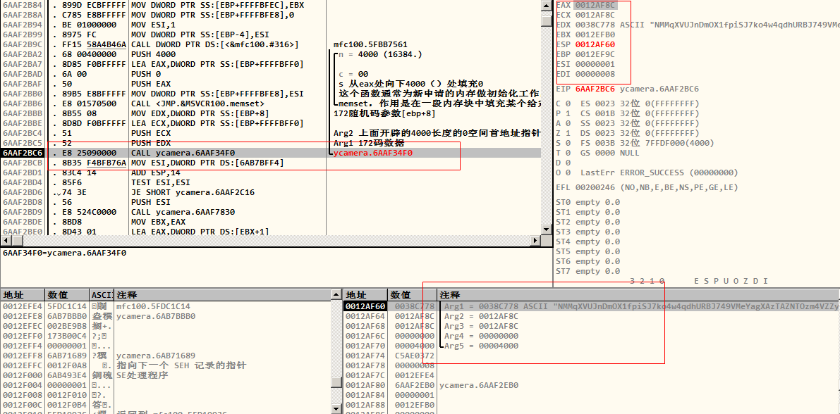
函数6AAF34F0
这里有个跳转：
6AAF787E . FFE1 JMP ECX
6AAF7880 $ 8B4424 10 MOV EAX,DWORD PTR SS:[ESP+10]
6AAF7884 . 8B48 08 MOV ECX,DWORD PTR DS:[EAX+8]
6AAF7887 . 894424 10 MOV DWORD PTR SS:[ESP+10],EAX
6AAF788B . 8B49 08 MOV ECX,DWORD PTR DS:[ECX+8]
6AAF788E . FFE1 JMP ECX ; ycamera.6AAFBA90
.........向下来到
6AAFBC66 . 83C4 0C ADD ESP,0C
6AAFBC69 . 85C0 TEST EAX,EAX
6AAFBC6B . 0F84 A6000000 JE ycamera.6AAFBD17
6AAFBC71 > 8B7C24 28 MOV EDI,DWORD PTR SS:[ESP+28]
6AAFBC75 . 57 PUSH EDI
6AAFBC76 . 53 PUSH EBX
6AAFBC77 . E8 641A0000 CALL ycamera.6AAFD6E0 ; 这里关键，先生成后5位
..........
6AAFBCCC > 56 PUSH ESI ; Case 1 of switch 6AAFBC83
6AAFBCCD . 50 PUSH EAX
6AAFBCCE . 8B4424 2C MOV EAX,DWORD PTR SS:[ESP+2C]
6AAFBCD2 . 57 PUSH EDI
6AAFBCD3 . 56 PUSH ESI
6AAFBCD4 . 50 PUSH EAX
6AAFBCD5 . E8 06BB0000 CALL ycamera.6AB077E0 ; 这里关键 成后6位

2.5 后5位数字生成函数
6AAFD6E0 /$ 53 PUSH EBX ; 后5位数字生成函数
6AAFD6E1 |. 8B5C24 08 MOV EBX,DWORD PTR SS:[ESP+8] ; 参数1传递给ebx
6AAFD6E5 |. 8B43 04 MOV EAX,DWORD PTR DS:[EBX+4] ; eax=32（20h）
6AAFD6E8 |. 55 PUSH EBP
6AAFD6E9 |. 56 PUSH ESI ; esi=128（80h）
6AAFD6EA |. 8D48 FF LEA ECX,DWORD PTR DS:[EAX-1]
6AAFD6ED |. 85C0 TEST EAX,EAX
6AAFD6EF |. 74 13 JE SHORT ycamera.6AAFD704
6AAFD6F1 |. 8B03 MOV EAX,DWORD PTR DS:[EBX]
6AAFD6F3 |. 8B1488 MOV EDX,DWORD PTR DS:[EAX+ECX*4]
6AAFD6F6 |. 52 PUSH EDX
6AAFD6F7 |. E8 F4FAFFFF CALL ycamera.6AAFD1F0
6AAFD6FC |. C1E1 05 SHL ECX,5
6AAFD6FF |. 83C4 04 ADD ESP,4
6AAFD702 |. 03C1 ADD EAX,ECX
6AAFD704 |> 83C0 07 ADD EAX,7
6AAFD707 |. 99 CDQ
6AAFD708 |. 83E2 07 AND EDX,7
6AAFD70B |. 03C2 ADD EAX,EDX
6AAFD70D |. 8BF0 MOV ESI,EAX
6AAFD70F |. C1FE 03 SAR ESI,3
6AAFD712 |. 8BEE MOV EBP,ESI
6AAFD714 |. 85F6 TEST ESI,ESI
6AAFD716 |. 74 39 JE SHORT ycamera.6AAFD751
6AAFD718 |. 57 PUSH EDI
6AAFD719 |. 8B7C24 18 MOV EDI,DWORD PTR SS:[ESP+18]
6AAFD71D |. 8D49 00 LEA ECX,DWORD PTR DS:[ECX]
6AAFD720 >|> 4E /DEC ESI ; 这里循环生成开始
6AAFD721 |. 8BC6 |MOV EAX,ESI
6AAFD723 |. 99 |CDQ
6AAFD724 |. 83E2 03 |AND EDX,3
6AAFD727 |. 03C2 |ADD EAX,EDX
6AAFD729 |. 8B13 |MOV EDX,DWORD PTR DS:[EBX]
6AAFD72B |. 8BCE |MOV ECX,ESI
6AAFD72D |. C1F8 02 |SAR EAX,2 ; 算术右移2位
6AAFD730 |. 81E1 03000080 |AND ECX,80000003
6AAFD736 |. 79 05 |JNS SHORT ycamera.6AAFD73D
6AAFD738 |. 49 |DEC ECX
6AAFD739 |. 83C9 FC |OR ECX,FFFFFFFC
6AAFD73C |. 41 |INC ECX
6AAFD73D |> 8B0482 |MOV EAX,DWORD PTR DS:[EDX+EAX*4]
6AAFD740 |. 03C9 |ADD ECX,ECX
6AAFD742 |. 03C9 |ADD ECX,ECX
6AAFD744 |. 03C9 |ADD ECX,ECX
6AAFD746 |. D3E8 |SHR EAX,CL
6AAFD748 |. 47 |INC EDI
6AAFD749 |. 8847 FF |MOV BYTE PTR DS:[EDI-1],AL
6AAFD74C |. 85F6 |TEST ESI,ESI
6AAFD74E |.^75 D0 \JNZ SHORT ycamera.6AAFD720 ; 循环结束
6AAFD750 |. 5F POP EDI
6AAFD751 |> 5E POP ESI
6AAFD752 |. 8BC5 MOV EAX,EBP
6AAFD754 |. 5D POP EBP
6AAFD755 |. 5B POP EBX
6AAFD756 \. C3 RETN

2.6 6AAF34F0函数的运算
6AAF34F0 /$ 55 PUSH EBP ; ebp=0012AF48
6AAF34F1 |. 8BEC MOV EBP,ESP ; esp=0012AF3C
6AAF34F3 |. 8B45 08 MOV EAX,DWORD PTR SS:[EBP+8] ; 172码数据 eax=025ABD28,此地址是变化的
6AAF34F6 |. 83EC 0C SUB ESP,0C ; 定义3个变量
6AAF34F9 |. 57 PUSH EDI ; edi=00000008
6AAF34FA |. 33FF XOR EDI,EDI ; edi=00000000
6AAF34FC |. 8038 00 CMP BYTE PTR DS:[EAX],0 ; 172每个字节跟0比较
6AAF34FF |. 0F84 F4000000 JE ycamera.6AAF35F9 ; 如果数据为空，就结束了
6AAF3505 |. BA FEFFFFFF MOV EDX,-2 ; edx=FFFFFFFE
6AAF350A |. 2BD0 SUB EDX,EAX ; edx=FDA542D6
6AAF350C |. 53 PUSH EBX ; ebx=0012EFA0
6AAF350D |. 8D48 02 LEA ECX,DWORD PTR DS:[EAX+2] ; 172码首码的后移一个字符的171码数据 ecx=025ABD2A,是随着eax而变化
6AAF3510 |. 8955 F4 MOV DWORD PTR SS:[EBP-C],EDX ; 将EDX=FDA542D6放到堆栈段[ebp-c]中存储，结束一轮循环会用到
6AAF3513 |. 56 PUSH ESI ; esi=1
6AAF3514 |> 8A51 FE /MOV DL,BYTE PTR DS:[ECX-2] ; 取第一个字符放到DL中，一个字符占用两个位
6AAF3517 |. C745 FC FFFFFF>|MOV DWORD PTR SS:[EBP-4],-1 ; 将堆栈段[ebp-4]置FFFFFFFF
6AAF351E |. 32C0 |XOR AL,AL ; 清空AL
6AAF3520 |. BE 6020B76A |MOV ESI,ycamera.6AB72060 ;ASCII "ABCDEFGHIJKLMNOPQRSTUVWXYZabcdefghijklmnopqrstuvwxyz0123456789+/"
6AAF3525 |> 3816 |/CMP BYTE PTR DS:[ESI],DL ; 第一次循环，从第一个字符开始挨个比较，总共比较64（40H）次
6AAF3527 |. 75 03 ||JNZ SHORT ycamera.6AAF352C ; 如果找到这个字符，执行下一条，如果没有找到继续向下执行循环
6AAF3529 |. 8845 FC ||MOV BYTE PTR SS:[EBP-4],AL ; 找到 取172随机串的第一个字符所在ABC...串中所在位置此时所比较的次数，将其填充到堆栈[ebp-4]
6AAF352C |> FEC0 ||INC AL ; 没找到直接跳到这里 例如字符N，所在ABC中的0D（13）位置[从0开始，0D表示第14个字母所在位置]
6AAF352E |. 46 ||INC ESI ; ABCDEFG...字串向后移动一位，继续比较，直到所有比较完成
6AAF352F |. 3C 40 ||CMP AL,40 ; AL跟64比较，也就是ABCDE，，串的长度
6AAF3531 |.^72 F2 |\JB SHORT ycamera.6AAF3525 ; 循环执行
6AAF3533 |. 8A51 FF |MOV DL,BYTE PTR DS:[ECX-1] ; 取172随机串的第二个字符
6AAF3536 |. 32C0 |XOR AL,AL ; 清空AL
6AAF3538 |. BE 6020B76A |MOV ESI,ycamera.6AB72060 ; ASCII "ABCDEFGHIJKLMNOPQRSTUVWXYZabcdefghijklmnopqrstuvwxyz0123456789+/"
6AAF353D |. 8D49 00 |LEA ECX,DWORD PTR DS:[ECX] ; 取数据段地址，ecx不会变化，ecx=025ABD2A
6AAF3540 |> 3816 |/CMP BYTE PTR DS:[ESI],DL ; 第二次循环，比较第二个字符
6AAF3542 |. 75 03 ||JNZ SHORT ycamera.6AAF3547
6AAF3544 |. 8845 FD ||MOV BYTE PTR SS:[EBP-3],AL ; 取第二个字符所在ABC串中的位置，所比较的次数,将其填充到[ebp-3]
6AAF3547 |> FEC0 ||INC AL ; 例如：字符M,所在ABC串的0C（12）位置
6AAF3549 |. 46 ||INC ESI
6AAF354A |. 3C 40 ||CMP AL,40
6AAF354C |.^72 F2 |\JB SHORT ycamera.6AAF3540
6AAF354E |. 8A11 |MOV DL,BYTE PTR DS:[ECX] ; 取数据段第三个字符给DL
6AAF3550 |. 32C0 |XOR AL,AL ; 清空AL
6AAF3552 |. BE 6020B76A |MOV ESI,ycamera.6AB72060 ; ASCII "ABCDEFGHIJKLMNOPQRSTUVWXYZabcdefghijklmnopqrstuvwxyz0123456789+/"
6AAF3557 |> 3816 |/CMP BYTE PTR DS:[ESI],DL ; 第三次循环 查找第三个字符所在位置比较次数
6AAF3559 |. 75 03 ||JNZ SHORT ycamera.6AAF355E
6AAF355B |. 8845 FE ||MOV BYTE PTR SS:[EBP-2],AL ; 取第三个字符所在ABC串中的位置，例如M在ABC串的0C位置，填充到堆栈[ebp-2]位置
6AAF355E |> FEC0 ||INC AL
6AAF3560 |. 46 ||INC ESI
6AAF3561 |. 3C 40 ||CMP AL,40
6AAF3563 |.^72 F2 |\JB SHORT ycamera.6AAF3557
6AAF3565 |. 8A59 01 |MOV BL,BYTE PTR DS:[ECX+1] ; 每4个一轮循环，每个循环的第四个字符[exc+1]，取第四个字符给了BL
6AAF3568 |. 8A45 FF |MOV AL,BYTE PTR SS:[EBP-1] ; 变量1的高2位 将堆栈[ebp-1]数据给了AL AL=FF
6AAF356B |. 32D2 |XOR DL,DL ; 清空DL
6AAF356D |. C745 F8 6020B7>|MOV DWORD PTR SS:[EBP-8],ycamera.6AB720>; ASCII "ABCDEFGHIJKLMNOPQRSTUVWXYZabcdefghijklmnopqrstuvwxyz0123456789+/"
6AAF3574 |> 8B75 F8 |/MOV ESI,DWORD PTR SS:[EBP-8] ; 第4次循环 将ABC...64码给了堆栈段[ebp-8],然后由给了esi=6AB72060
6AAF3577 |. 381E ||CMP BYTE PTR DS:[ESI],BL ; 比较第四个字符，如果找到就将比较次数给AL
6AAF3579 |. 75 02 ||JNZ SHORT ycamera.6AAF357D
6AAF357B |. 8AC2 ||MOV AL,DL ; 循环比较了第四个字符所在位置次数
6AAF357D |> FF45 F8 ||INC DWORD PTR SS:[EBP-8] ; 比如说字符q循环了2A（42）次，即第43次
6AAF3580 |. FEC2 ||INC DL
6AAF3582 |. 80FA 40 ||CMP DL,40
6AAF3585 |.^72 ED |\JB SHORT ycamera.6AAF3574 ; 第一轮4个循环完成有用的数据记录在AL和[ebp-2][ebp-3][ebp-4]
6AAF3587 |. 8A5D FD |MOV BL,BYTE PTR SS:[EBP-3] ; 第二个字母循环次数：0C
6AAF358A |. 8A55 FC |MOV DL,BYTE PTR SS:[EBP-4] ; 第一个字符循环比较次数：0D
6AAF358D |. 8B75 0C |MOV ESI,DWORD PTR SS:[EBP+C] ; edi=0 ESI=0012AF7C
6AAF3590 |. C0EB 04 |SHR BL,4 ; 将BL逻辑右移4位，高位置0 BL=00
6AAF3593 |. 02D2 |ADD DL,DL ; DL（0D）*2=1A DL=1A
6AAF3595 |. 80E3 03 |AND BL,3 ; 逻辑与运算 BL=00
6AAF3598 |. 02D2 |ADD DL,DL ; 1A+1A=34 DL=34
6AAF359A |. 0ADA |OR BL,DL ; 逻辑或运算 BL=34
6AAF359C |. 881C37 |MOV BYTE PTR DS:[EDI+ESI],BL ; 返回第一个，将34（字符‘4’）返回给数据段地址[0012AF7C]=00000034
6AAF359F |. 8039 3D |CMP BYTE PTR DS:[ECX],3D ; 取第三个字符跟3D（61['=']）比较，例如‘M’（4D[77]）
6AAF35A2 |. 74 4B |JE SHORT ycamera.6AAF35EF ; 如果相等就跳往 short 6AAF35EF，结束掉；否则，继续读取下一轮的四次循环
6AAF35A4 |. 8A5D FE |MOV BL,BYTE PTR SS:[EBP-2] ; 取第三个字符时候的比较次数 BL=0C EBX=0012EF0C
6AAF35A7 |. 8A55 FD |MOV DL,BYTE PTR SS:[EBP-3] ; 取第二个字符时候的比较次数 DL=0C EDX=FDA5420C
6AAF35AA |. C0EB 02 |SHR BL,2 ; 逻辑右移2位 BL=03
6AAF35AD |. C0E2 04 |SHL DL,4 ; 逻辑左移4位 DL=C0
6AAF35B0 |. 80E3 0F |AND BL,0F ; BL=03
6AAF35B3 |. 0ADA |OR BL,DL ; BL=C3
6AAF35B5 |. 8B55 F4 |MOV EDX,DWORD PTR SS:[EBP-C] ; 将上一次记录的变量[ebp-c]给edx，EDX=FDA542D6
6AAF35B8 |. 885C37 01 |MOV BYTE PTR DS:[EDI+ESI+1],BL ; 返回第二个，将算得的BL=C3给数据段的[0012AF7C+1]=C3
6AAF35BC |. 8B5D 08 |MOV EBX,DWORD PTR SS:[EBP+8] ; 把172串给ebx，EBX=025ABD28，这个地址是可变的
6AAF35BF |. 03D1 |ADD EDX,ECX ; EDX=00000000
6AAF35C1 |. 807C1A 03 3D |CMP BYTE PTR DS:[EDX+EBX+3],3D ; 172随机码的第四位跟3D（'='）相比
6AAF35C6 |. 74 38 |JE SHORT ycamera.6AAF3600 ; 如果相等，跳转到SHORT 6AAF3600
6AAF35C8 |. 8A55 FE |MOV DL,BYTE PTR SS:[EBP-2] ; DL=0C EDX=0000000C
6AAF35CB |. 24 3F |AND AL,3F ; 逻辑与 AL=2A EAX=025ABD2A
6AAF35CD |. C0E2 06 |SHL DL,6 ; DL=00 EDX=00000000
6AAF35D0 |. 0AC2 |OR AL,DL ; AL=2A EAX=025ABD2A
6AAF35D2 |. 884437 02 |MOV BYTE PTR DS:[EDI+ESI+2],AL ; 返回第三个 数据段[0012AF7E]=2A=[ESI+2] ESI=0012AF7C
6AAF35D6 |. 83C1 04 |ADD ECX,4 ; ECX=025ABD2E,向后移动四个字符
6AAF35D9 |. 83C7 03 |ADD EDI,3 ; EDI=00000003
6AAF35DC |. 8079 FE 00 |CMP BYTE PTR DS:[ECX-2],0 ; 下一轮循环的开始 取第5位（下一轮的第一字符）跟0比较
6AAF35E0 |.^0F85 2EFFFFFF \JNZ ycamera.6AAF3514 ; 判断是否为空0,如果是则向下结束，如果不是向上循环开始
6AAF35E6 |. 5E POP ESI ; 如果所有循环完成，到了0结束 ，弹出此时的esi
6AAF35E7 |. 5B POP EBX
6AAF35E8 |. 8BC7 MOV EAX,EDI
6AAF35EA |. 5F POP EDI
6AAF35EB |. 8BE5 MOV ESP,EBP
6AAF35ED |. 5D POP EBP
6AAF35EE |. C3 RETN
6AAF35EF |> 5E POP ESI ; 这里是判断与“=”字符相等跳转的地方
6AAF35F0 |. 5B POP EBX
6AAF35F1 |. 8D47 01 LEA EAX,DWORD PTR DS:[EDI+1]
6AAF35F4 |. 5F POP EDI
6AAF35F5 |. 8BE5 MOV ESP,EBP
6AAF35F7 |. 5D POP EBP
6AAF35F8 |. C3 RETN
6AAF35F9 |> 8BC7 MOV EAX,EDI ; 将eax置空00000000，结束掉
6AAF35FB |. 5F POP EDI
6AAF35FC |. 8BE5 MOV ESP,EBP
6AAF35FE |. 5D POP EBP
6AAF35FF |. C3 RETN
6AAF3600 |> 5E POP ESI ; 判断172码第4个字符是否与“=”相等，跳到这里结束
6AAF3601 |. 5B POP EBX
6AAF3602 |. 8D47 02 LEA EAX,DWORD PTR DS:[EDI+2]
6AAF3605 |. 5F POP EDI
6AAF3606 |. 8BE5 MOV ESP,EBP
6AAF3608 |. 5D POP EBP
6AAF3609 \. C3 RETN

2.7 数据签名，用到了MD5算法
6AAF5430 /$ 55 PUSH EBP ; 数据签名，用到了MD5算法
6AAF5431 |. 8BEC MOV EBP,ESP ; EBP=0012EF8C ESP=0012EF24
6AAF5433 |. 81EC 80000000 SUB ESP,80 ; ESP=0012EEA4
6AAF5439 |. A1 9097B76A MOV EAX,DWORD PTR DS:[6AB79790] ; 取数据段[6AB79790]的数据 EAX=C5BCECEE
6AAF543E |. 33C5 XOR EAX,EBP ; eax=C5AE03CA
6AAF5440 |. 8945 FC MOV DWORD PTR SS:[EBP-4],EAX ; 变量1 存储上面的eax的内容 SS:[0012EF20]=C5AE03CA
6AAF5443 |. 8B45 08 MOV EAX,DWORD PTR SS:[EBP+8] ; 将图片数据参数传给eax eax=0169EFE8 ascii‘/9j/4AA...’
6AAF5446 |. 53 PUSH EBX ; ebx=ycamera.6AAF2EB0
6AAF5447 |. 57 PUSH EDI ; edi=0012EFB4
6AAF5448 |. 8945 8C MOV DWORD PTR SS:[EBP-74],EAX
6AAF544B |. 894D 88 MOV DWORD PTR SS:[EBP-78],ECX ; 将图片数据给变量[ebp-74]
6AAF544E |. 8D50 01 LEA EDX,DWORD PTR DS:[EAX+1] ; 取数据段图片数据去掉第一个字符的地址给edx=0169EFE9
6AAF5451 >|> 8A08 /MOV CL,BYTE PTR DS:[EAX] ; 取图片数据第一个字符给CL 例如'/'(2F)给CL=2F;'='(3D)给CL=3D等等
6AAF5453 |. 40 |INC EAX ; 图片数据下移一个字符
6AAF5454 |. 84C9 |TEST CL,CL ; 判断CL是否为空，也就是判断图片数据是否读取完毕
6AAF5456 |.^75 F9 \JNZ SHORT ycamera.6AAF5451 ; 这个循环其实是在计算图像数据大小的
6AAF5458 |. 2BC2 SUB EAX,EDX ; EAX=00012F10(77584)表示图片的数据量是这么多
6AAF545A |. 68 0022B76A PUSH ycamera.6AB72200 ; /FileName = "advapi32.dll"
6AAF545F |. 8945 84 MOV DWORD PTR SS:[EBP-7C],EAX ; |变量[ebp-7C]存储图像数据大小 eax=00012F10
6AAF5462 |. FF15 28A0B46A CALL DWORD PTR DS:[<&KERNEL32.LoadLibrar>; \LoadLibraryA
6AAF5468 |. 8BD8 MOV EBX,EAX ; EBX=ADVAPI32.75DE0000 载入DLL库
6AAF546A |. 85DB TEST EBX,EBX
6AAF546C |. 74 54 JE SHORT ycamera.6AAF54C2 ; 如果么有advapi32.dll直接向下跳了
6AAF546E |. 8B3D 2CA0B46A MOV EDI,DWORD PTR DS:[<&KERNEL32.GetProc>; kernel32.GetProcAddress
6AAF5474 |. 68 1022B76A PUSH ycamera.6AB72210 ; /ProcNameOrOrdinal = "MD5Init"
6AAF5479 |. 53 PUSH EBX ; |hModule=ADVAPI32.75DE0000
6AAF547A |. FFD7 CALL EDI ; \edi=759533D3表示函数kernel32.GetProcAddress
6AAF547C |. 68 1822B76A PUSH ycamera.6AB72218 ; /ProcNameOrOrdinal = "MD5Update"
6AAF5481 |. 53 PUSH EBX ; |hModule=ADVAPI32.75DE0000
6AAF5482 |. 8946 04 MOV DWORD PTR DS:[ESI+4],EAX ; |将MD5Init给数据段 esi=0012EF40
6AAF5485 |. FFD7 CALL EDI ; \edi=759533D3表示函数GetProcAddress
6AAF5487 |. 68 2422B76A PUSH ycamera.6AB72224 ; /ProcNameOrOrdinal = "MD5Final"
6AAF548C |. 53 PUSH EBX ; |hModule=ADVAPI32.75DE0000
6AAF548D |. 8946 08 MOV DWORD PTR DS:[ESI+8],EAX ; |将MD5Update给数据段 esi=0012EF40
6AAF5490 |. FFD7 CALL EDI ; \edi=759533D3表示函数GetProcAddress
6AAF5492 |. 8D55 90 LEA EDX,DWORD PTR SS:[EBP-70] ; 取变量[ebp-70]的地址 edx=0012EEB4
6AAF5495 |. 8946 0C MOV DWORD PTR DS:[ESI+C],EAX
6AAF5498 |. 8B46 04 MOV EAX,DWORD PTR DS:[ESI+4] ; EAX=77129DD6 表示函数ntdll.MD5Init
6AAF549B |. 52 PUSH EDX ; EDX=0012EEB4
6AAF549C |. FFD0 CALL EAX ; MD5Init函数初始化，将数据段[0012EEB4][0012EEB8]清空
6AAF549E |. 8B45 0C MOV EAX,DWORD PTR SS:[EBP+C] ; 将6位码给eax=0009215F（598367）
6AAF54A1 |. 85C0 TEST EAX,EAX ; 如果这个eax参数不为空
6AAF54A3 |. 78 03 JS SHORT ycamera.6AAF54A8 ; 为空则跳转到SHORT 6AAF54A8
6AAF54A5 |. 8945 98 MOV DWORD PTR SS:[EBP-68],EAX ; 6位码赋值给变量[ebp-68]=0009215F
6AAF54A8 |> 8B4D 84 MOV ECX,DWORD PTR SS:[EBP-7C] ; 将图片数据大小00012F10（77584）给ecx=77584
6AAF54AB |. 8B55 8C MOV EDX,DWORD PTR SS:[EBP-74] ; EDX=0286EFE8，将图片数据地址指针给EDX
6AAF54AE |. 51 PUSH ECX ; 入栈图片大小数据0009215F
6AAF54AF |. 8B4E 08 MOV ECX,DWORD PTR DS:[ESI+8] ; ECX=77129E9E 表示函数ntdll.MD5Update
6AAF54B2 |. 52 PUSH EDX ; 入栈图片数据地址指针EDX=0286EFE8，这个地址是变化的
6AAF54B3 |. 8D45 90 LEA EAX,DWORD PTR SS:[EBP-70] ; 取变量[ebp-70]=0012EEB4的地址给eax=0012EEB4，这个数据段地址中数据内容已经被上面的MD5Init置0了
6AAF54B6 |. 50 PUSH EAX ; 入栈eax=0012EEB4
6AAF54B7 |. FFD1 CALL ECX ; 调用ecx=77129E9E ntdll.MD5Update函数 调用后变量[ebp-70]=[0012EEB4]=00097880 ecx=00000004
6AAF54B9 |. 8B46 0C MOV EAX,DWORD PTR DS:[ESI+C] ; EAX=77129E10 表示函数ntdll.MD5Final
6AAF54BC |. 8D55 90 LEA EDX,DWORD PTR SS:[EBP-70] ; EDX=0012EEB4,数据段对应内容是[0012EEB4]=00097880
6AAF54BF |. 52 PUSH EDX ; 入栈数据段地址
6AAF54C0 |. FFD0 CALL EAX ; EAX=77129E10 函数ntdll.MD5Final ecx=0，eax=0012EF0C
6AAF54C2 |> 8B7D 88 MOV EDI,DWORD PTR SS:[EBP-78] ; MD5Final函数后，变量[EBP-78]=0012EF54 EDI=0012EF54
6AAF54C5 |. 8D55 E8 LEA EDX,DWORD PTR SS:[EBP-18] ; 取变量[EBP-18]的地址给EDX=0012EF0C
6AAF54C8 |. E8 73FEFFFF CALL ycamera.6AAF5340 ; 这个函数生成了32位码
6AAF54CD |. 8B4D FC MOV ECX,DWORD PTR SS:[EBP-4]
6AAF54D0 |. 5F POP EDI
6AAF54D1 |. 33CD XOR ECX,EBP
6AAF54D3 |. 5B POP EBX
6AAF54D4 |. E8 B4280500 CALL ycamera.6AB47D8D ; 没有用
6AAF54D9 |. 8BE5 MOV ESP,EBP
6AAF54DB |. 5D POP EBP
6AAF54DC \. C2 0800 RETN 8

2.8 MD5生成函数
6AAF5340 /$ 33C9 XOR ECX,ECX ; MD5生成函数
6AAF5342 |> 0FB6040A /MOVZX EAX,BYTE PTR DS:[EDX+ECX]
6AAF5346 |. C1E8 04 |SHR EAX,4
6AAF5349 |. 0FB680 EC21B76A |MOVZX EAX,BYTE PTR DS:[EAX+6AB721EC]
6AAF5350 |. 88044D 60C1B76A |MOV BYTE PTR DS:[ECX*2+6AB7C160],AL
6AAF5357 |. 0FB6040A |MOVZX EAX,BYTE PTR DS:[EDX+ECX]
6AAF535B |. 83E0 0F |AND EAX,0F
6AAF535E |. 0FB680 EC21B76A |MOVZX EAX,BYTE PTR DS:[EAX+6AB721EC]
6AAF5365 |. 88044D 61C1B76A |MOV BYTE PTR DS:[ECX*2+6AB7C161],AL
6AAF536C |. 0FB6440A 01 |MOVZX EAX,BYTE PTR DS:[EDX+ECX+1]
6AAF5371 |. C1E8 04 |SHR EAX,4
6AAF5374 |. 0FB680 EC21B76A |MOVZX EAX,BYTE PTR DS:[EAX+6AB721EC]
6AAF537B |. 88044D 62C1B76A |MOV BYTE PTR DS:[ECX*2+6AB7C162],AL
6AAF5382 |. 0FB6440A 01 |MOVZX EAX,BYTE PTR DS:[EDX+ECX+1]
6AAF5387 |. 83E0 0F |AND EAX,0F
6AAF538A |. 0FB680 EC21B76A |MOVZX EAX,BYTE PTR DS:[EAX+6AB721EC]
6AAF5391 |. 88044D 63C1B76A |MOV BYTE PTR DS:[ECX*2+6AB7C163],AL
6AAF5398 |. 0FB6440A 02 |MOVZX EAX,BYTE PTR DS:[EDX+ECX+2]
6AAF539D |. C1E8 04 |SHR EAX,4
6AAF53A0 |. 0FB680 EC21B76A |MOVZX EAX,BYTE PTR DS:[EAX+6AB721EC]
6AAF53A7 |. 88044D 64C1B76A |MOV BYTE PTR DS:[ECX*2+6AB7C164],AL
6AAF53AE |. 0FB6440A 02 |MOVZX EAX,BYTE PTR DS:[EDX+ECX+2]
6AAF53B3 |. 83E0 0F |AND EAX,0F
6AAF53B6 |. 0FB680 EC21B76A |MOVZX EAX,BYTE PTR DS:[EAX+6AB721EC]
6AAF53BD |. 88044D 65C1B76A |MOV BYTE PTR DS:[ECX*2+6AB7C165],AL
6AAF53C4 |. 0FB6440A 03 |MOVZX EAX,BYTE PTR DS:[EDX+ECX+3]
6AAF53C9 |. C1E8 04 |SHR EAX,4
6AAF53CC |. 0FB680 EC21B76A |MOVZX EAX,BYTE PTR DS:[EAX+6AB721EC]
6AAF53D3 |. 88044D 66C1B76A |MOV BYTE PTR DS:[ECX*2+6AB7C166],AL
6AAF53DA |. 0FB6440A 03 |MOVZX EAX,BYTE PTR DS:[EDX+ECX+3]
6AAF53DF |. 83E0 0F |AND EAX,0F
6AAF53E2 |. 0FB680 EC21B76A |MOVZX EAX,BYTE PTR DS:[EAX+6AB721EC]
6AAF53E9 |. 88044D 67C1B76A |MOV BYTE PTR DS:[ECX*2+6AB7C167],AL
6AAF53F0 |. 83C1 04 |ADD ECX,4
6AAF53F3 |. 83F9 10 |CMP ECX,10
6AAF53F6 |.^0F8C 46FFFFFF \JL ycamera.6AAF5342
6AAF53FC |. C6044D 60C1B76A 00 MOV BYTE PTR DS:[ECX*2+6AB7C160],0
6AAF5404 |. 85FF TEST EDI,EDI
6AAF5406 |. 74 18 JE SHORT ycamera.6AAF5420
6AAF5408 |. 56 PUSH ESI
6AAF5409|.B9 60C1B76A MOV ECX,ycamera.6AB7C160 ;ASCII "341f1b2737fc25b664b86d5b8c466a7d"
6AAF540E |. 8BF7 MOV ESI,EDI
6AAF5410 |. 2BF1 SUB ESI,ECX
6AAF5412 |> 8A11 /MOV DL,BYTE PTR DS:[ECX]
6AAF5414 |. 88140E |MOV BYTE PTR DS:[ESI+ECX],DL
6AAF5417 |. 41 |INC ECX
6AAF5418 |. 84D2 |TEST DL,DL
6AAF541A |.^75 F6 \JNZ SHORT ycamera.6AAF5412
6AAF541C |. 8BC7 MOV EAX,EDI
6AAF541E |. 5E POP ESI
6AAF541F |. C3 RETN ; 走的这里
6AAF5420 |> B8 60C1B76A MOV EAX,ycamera.6AB7C160 ; ASCII "341f1b2737fc25b664b86d5b8c466a7d"
6AAF5425 \. C3 RETN

3 汇编代码整理

3.1 这里猜测是 Base64-encode加码函数
661833D0 /$ 55 PUSH EBP ; 这里猜测是 Base64-encode加码函数
661833D1 |. 8BEC MOV EBP,ESP
661833D3 |. 83EC 0C SUB ESP,0C
661833D6 |. 33C9 XOR ECX,ECX
661833D8 |. 33D2 XOR EDX,EDX
661833DA |. 57 PUSH EDI
661833DB |. 8B7D 08 MOV EDI,DWORD PTR SS:[EBP+8]
661833DE |. 394D 0C CMP DWORD PTR SS:[EBP+C],ECX
661833E1 |. 0F8E F6000000 JLE ycamera.661834DD
661833E7 |. 53 PUSH EBX
661833E8 |. BB 01000000 MOV EBX,1
661833ED |. 2BDF SUB EBX,EDI
661833EF |. B8 02000000 MOV EAX,2
661833F4 |. 2BC7 SUB EAX,EDI
661833F6 |. 895D FC MOV DWORD PTR SS:[EBP-4],EBX
661833F9 |. 8945 F8 MOV DWORD PTR SS:[EBP-8],EAX
661833FC |. EB 05 JMP SHORT ycamera.66183403
661833FE | 8BFF MOV EDI,EDI
66183400 |> 8B5D FC MOV EBX,DWORD PTR SS:[EBP-4]
66183403 |> 0FB60417 MOVZX EAX,BYTE PTR DS:[EDI+EDX]
66183407 |. 03FA ADD EDI,EDX
66183409 |. C1E8 02 SHR EAX,2
6618340C |. 0FB680 60202066 MOVZX EAX,BYTE PTR DS:[EAX+66202060]
66183413 |. 880431 MOV BYTE PTR DS:[ECX+ESI],AL
66183416 |. 8A07 MOV AL,BYTE PTR DS:[EDI]
66183418 |. 24 03 AND AL,3
6618341A |. 03DF ADD EBX,EDI
6618341C |. C0E0 04 SHL AL,4
6618341F |. 897D F4 MOV DWORD PTR SS:[EBP-C],EDI
66183422 |. 3B5D 0C CMP EBX,DWORD PTR SS:[EBP+C]
66183425 |. 7D 79 JGE SHORT ycamera.661834A0
66183427 |. 8B7D 08 MOV EDI,DWORD PTR SS:[EBP+8]
6618342A |. 0FB65C3A 01 MOVZX EBX,BYTE PTR DS:[EDX+EDI+1]
6618342F |. 0FB6C0 MOVZX EAX,AL
66183432 |. C1EB 04 SHR EBX,4
66183435 |. 0BD8 OR EBX,EAX
66183437 |. 0FB683 60202066 MOVZX EAX,BYTE PTR DS:[EBX+66202060]
6618343E |. 884431 01 MOV BYTE PTR DS:[ECX+ESI+1],AL
66183442 |. 8A443A 01 MOV AL,BYTE PTR DS:[EDX+EDI+1]
66183446 |. 8B7D F8 MOV EDI,DWORD PTR SS:[EBP-8]
66183449 |. 037D F4 ADD EDI,DWORD PTR SS:[EBP-C]
6618344C |. 24 0F AND AL,0F
6618344E |. 02C0 ADD AL,AL
66183450 |. 02C0 ADD AL,AL
66183452 |. 3B7D 0C CMP EDI,DWORD PTR SS:[EBP+C]
66183455 |. 7D 6A JGE SHORT ycamera.661834C1
66183457 |. 8B7D 08 MOV EDI,DWORD PTR SS:[EBP+8]
6618345A |. 0FB65C3A 02 MOVZX EBX,BYTE PTR DS:[EDX+EDI+2]
6618345F |. 0FB6C0 MOVZX EAX,AL
66183462 |. C1EB 06 SHR EBX,6
66183465 |. 0BD8 OR EBX,EAX
66183467 |. 0FB683 60202066 MOVZX EAX,BYTE PTR DS:[EBX+66202060]
6618346E |. 884431 02 MOV BYTE PTR DS:[ECX+ESI+2],AL
66183472 |. 0FB6443A 02 MOVZX EAX,BYTE PTR DS:[EDX+EDI+2]
66183477 |. 83E0 3F AND EAX,3F
6618347A |. 0FB680 60202066 MOVZX EAX,BYTE PTR DS:[EAX+66202060]
66183481 |. 884431 03 MOV BYTE PTR DS:[ECX+ESI+3],AL
66183485 |. 83C2 03 ADD EDX,3
66183488 |. 83C1 04 ADD ECX,4
6618348B |. 3B55 0C CMP EDX,DWORD PTR SS:[EBP+C]
6618348E |.^0F8C 6CFFFFFF JL ycamera.66183400
66183494 |. 5B POP EBX
66183495 |. C60431 00 MOV BYTE PTR DS:[ECX+ESI],0
66183499 |. 8BC6 MOV EAX,ESI
6618349B |. 5F POP EDI
6618349C |. 8BE5 MOV ESP,EBP
6618349E |. 5D POP EBP
6618349F |. C3 RETN
661834A0 |> 0FB6D0 MOVZX EDX,AL
661834A3 |. 8A82 60202066 MOV AL,BYTE PTR DS:[EDX+66202060]
661834A9 |. 884431 01 MOV BYTE PTR DS:[ECX+ESI+1],AL
661834AD |. 5B POP EBX
661834AE |. 66:C74431 02 3D3D MOV WORD PTR DS:[ECX+ESI+2],3D3D
661834B5 |. C64431 04 00 MOV BYTE PTR DS:[ECX+ESI+4],0
661834BA |. 8BC6 MOV EAX,ESI
661834BC |. 5F POP EDI
661834BD |. 8BE5 MOV ESP,EBP
661834BF |. 5D POP EBP
661834C0 |. C3 RETN
661834C1 |> 0FB6D0 MOVZX EDX,AL
661834C4 |. 8A82 60202066 MOV AL,BYTE PTR DS:[EDX+66202060]
661834CA |. 884431 02 MOV BYTE PTR DS:[ECX+ESI+2],AL
661834CE |. 5B POP EBX
661834CF |. 66:C74431 03 3D00 MOV WORD PTR DS:[ECX+ESI+3],3D
661834D6 |. 8BC6 MOV EAX,ESI
661834D8 |. 5F POP EDI
661834D9 |. 8BE5 MOV ESP,EBP
661834DB |. 5D POP EBP
661834DC |. C3 RETN
661834DD |> 880C31 MOV BYTE PTR DS:[ECX+ESI],CL
661834E0 |. 8BC6 MOV EAX,ESI
661834E2 |. 5F POP EDI
661834E3 |. 8BE5 MOV ESP,EBP
661834E5 |. 5D POP EBP
661834E6 \. C3 RETN

3.2 这里是一个典型的Base64-decode解码函数
以下用的172码，均是表示经过Base64-encode加码的数据

661834F0 /$ 55 PUSH EBP ; 这里是一个典型的Base64-decode解码函数 ebp=0012AF48
661834F1 |. 8BEC MOV EBP,ESP ; esp=0012AF3C
661834F3 |. 8B45 08 MOV EAX,DWORD PTR SS:[EBP+8] ; 172码数据 eax=025ABD28,此地址是变化的
661834F6 |. 83EC 0C SUB ESP,0C ; 定义3个变量
661834F9 |. 57 PUSH EDI ; edi=00000008
661834FA |. 33FF XOR EDI,EDI ; edi=00000000
661834FC |. 8038 00 CMP BYTE PTR DS:[EAX],0 ; 172每个字节跟0比较
661834FF |. 0F84 F4000000 JE ycamera.661835F9 ; 如果数据为空，就结束了
66183505 |. BA FEFFFFFF MOV EDX,-2 ; edx=FFFFFFFE
6618350A |. 2BD0 SUB EDX,EAX ; edx=FDA542D6
6618350C |. 53 PUSH EBX ; ebx=0012EFA0
6618350D |. 8D48 02 LEA ECX,DWORD PTR DS:[EAX+2] ; 172码首码的后移一个字符的171码数据 ecx=025ABD2A,是随着eax而变化
66183510 |. 8955 F4 MOV DWORD PTR SS:[EBP-C],EDX ; 将EDX=FDA542D6放到堆栈段[ebp-c]中存储，结束一轮循环会用到
66183513 |. 56 PUSH ESI ; esi=1
66183514 |> 8A51 FE /MOV DL,BYTE PTR DS:[ECX-2] ; 取第一个字符放到DL中，一个字符占用两个位
66183517 |. C745 FC FFFFFFFF |MOV DWORD PTR SS:[EBP-4],-1 ; 将堆栈段[ebp-4]置FFFFFFFF
6618351E |. 32C0 |XOR AL,AL ; 清空AL
66183520 |. BE 60202066 |MOV ESI,ycamera.66202060 ; ASCII "ABCDEFGHIJKLMNOPQRSTUVWXYZabcdefghijklmnopqrstuvwxyz0123456789+/"
66183525 |> 3816 |/CMP BYTE PTR DS:[ESI],DL ; 第一次循环，从第一个字符开始挨个比较，总共比较64（40H）次
66183527 |. 75 03 ||JNZ SHORT ycamera.6618352C ; 如果找到这个字符，执行下一条，如果没有找到继续向下执行循环
66183529 |. 8845 FC ||MOV BYTE PTR SS:[EBP-4],AL ; 找到 取172随机串的第一个字符所在ABC...串中所在位置此时所比较的次数，将其填充到堆栈[ebp-4]
6618352C |> FEC0 ||INC AL ; 没找到直接跳到这里 例如字符N，所在ABC中的0D（13）位置[从0开始，0D表示第14个字母所在位置]
6618352E |. 46 ||INC ESI ; ABCDEFG...字串向后移动一位，继续比较，直到所有比较完成
6618352F |. 3C 40 ||CMP AL,40 ; AL跟64比较，也就是ABCDE，，串的长度
66183531 |.^72 F2 |\JB SHORT ycamera.66183525 ; 循环执行
66183533 |. 8A51 FF |MOV DL,BYTE PTR DS:[ECX-1] ; 取172随机串的第二个字符
66183536 |. 32C0 |XOR AL,AL ; 清空AL
66183538 |. BE 60202066 |MOV ESI,ycamera.66202060 ; ASCII "ABCDEFGHIJKLMNOPQRSTUVWXYZabcdefghijklmnopqrstuvwxyz0123456789+/"
6618353D |. 8D49 00 |LEA ECX,DWORD PTR DS:[ECX] ; 取数据段地址，ecx不会变化，ecx=025ABD2A
66183540 |> 3816 |/CMP BYTE PTR DS:[ESI],DL ; 第二次循环，比较第二个字符
66183542 |. 75 03 ||JNZ SHORT ycamera.66183547
66183544 |. 8845 FD ||MOV BYTE PTR SS:[EBP-3],AL ; 取第二个字符所在ABC串中的位置，所比较的次数,将其填充到[ebp-3]
66183547 |> FEC0 ||INC AL ; 例如：字符M,所在ABC串的0C（12）位置
66183549 |. 46 ||INC ESI
6618354A |. 3C 40 ||CMP AL,40
6618354C |.^72 F2 |\JB SHORT ycamera.66183540
6618354E |. 8A11 |MOV DL,BYTE PTR DS:[ECX] ; 取数据段第三个字符给DL
66183550 |. 32C0 |XOR AL,AL ; 清空AL
66183552 |. BE 60202066 |MOV ESI,ycamera.66202060 ; ASCII "ABCDEFGHIJKLMNOPQRSTUVWXYZabcdefghijklmnopqrstuvwxyz0123456789+/"
66183557 |> 3816 |/CMP BYTE PTR DS:[ESI],DL ; 第三次循环 查找第三个字符所在位置比较次数
66183559 |. 75 03 ||JNZ SHORT ycamera.6618355E
6618355B |. 8845 FE ||MOV BYTE PTR SS:[EBP-2],AL ; 取第三个字符所在ABC串中的位置，例如M在ABC串的0C位置，填充到堆栈[ebp-2]位置
6618355E |> FEC0 ||INC AL
66183560 |. 46 ||INC ESI
66183561 |. 3C 40 ||CMP AL,40
66183563 |.^72 F2 |\JB SHORT ycamera.66183557
66183565 |. 8A59 01 |MOV BL,BYTE PTR DS:[ECX+1] ; 每4个一轮循环，每个循环的第四个字符[exc+1]，取第四个字符给了BL
66183568 |. 8A45 FF |MOV AL,BYTE PTR SS:[EBP-1] ; 变量1的高2位 将堆栈[ebp-1]数据给了AL AL=FF
6618356B |. 32D2 |XOR DL,DL ; 清空DL
6618356D |. C745 F8 60202066 |MOV DWORD PTR SS:[EBP-8],ycamera.662020>; ASCII "ABCDEFGHIJKLMNOPQRSTUVWXYZabcdefghijklmnopqrstuvwxyz0123456789+/"
66183574 |> 8B75 F8 |/MOV ESI,DWORD PTR SS:[EBP-8] ; 第4次循环 将ABC...64码给了堆栈段[ebp-8],然后由给了esi=6AB72060
66183577 |. 381E ||CMP BYTE PTR DS:[ESI],BL ; 比较第四个字符，如果找到就将比较次数给AL
66183579 |. 75 02 ||JNZ SHORT ycamera.6618357D
6618357B |. 8AC2 ||MOV AL,DL ; 循环比较了第四个字符所在位置次数
6618357D |> FF45 F8 ||INC DWORD PTR SS:[EBP-8] ; 比如说字符q循环了2A（42）次，即第43次
66183580 |. FEC2 ||INC DL
66183582 |. 80FA 40 ||CMP DL,40
66183585 |.^72 ED |\JB SHORT ycamera.66183574 ; 第一轮4个循环完成有用的数据记录在AL和[ebp-2][ebp-3][ebp-4]
66183587 |. 8A5D FD |MOV BL,BYTE PTR SS:[EBP-3] ; 第二个字母循环次数：0C
6618358A |. 8A55 FC |MOV DL,BYTE PTR SS:[EBP-4] ; 第一个字符循环比较次数：0D
6618358D |. 8B75 0C |MOV ESI,DWORD PTR SS:[EBP+C] ; edi=0 ESI=0012AF7C
66183590 |. C0EB 04 |SHR BL,4 ; 将BL逻辑右移4位，高位置0 BL=00
66183593 |. 02D2 |ADD DL,DL ; DL（0D）*2=1A DL=1A
66183595 |. 80E3 03 |AND BL,3 ; 逻辑与运算 BL=00
66183598 |. 02D2 |ADD DL,DL ; 1A+1A=34 DL=34
6618359A |. 0ADA |OR BL,DL ; 逻辑或运算 BL=34
6618359C |. 881C37 |MOV BYTE PTR DS:[EDI+ESI],BL ; 返回第一个，将34（字符‘4’）返回给数据段地址[0012AF7C]=00000034
6618359F |. 8039 3D |CMP BYTE PTR DS:[ECX],3D ; 取第三个字符跟3D（61['=']）比较，例如‘M’（4D[77]）
661835A2 |. 74 4B |JE SHORT ycamera.661835EF ; 如果相等就跳往 short 6AAF35EF，结束掉；否则，继续读取下一轮的四次循环
661835A4 |. 8A5D FE |MOV BL,BYTE PTR SS:[EBP-2] ; 取第三个字符时候的比较次数 BL=0C EBX=0012EF0C
661835A7 |. 8A55 FD |MOV DL,BYTE PTR SS:[EBP-3] ; 取第二个字符时候的比较次数 DL=0C EDX=FDA5420C
661835AA |. C0EB 02 |SHR BL,2 ; 逻辑右移2位 BL=03
661835AD |. C0E2 04 |SHL DL,4 ; 逻辑左移4位 DL=C0
661835B0 |. 80E3 0F |AND BL,0F ; BL=03
661835B3 |. 0ADA |OR BL,DL ; BL=C3
661835B5 |. 8B55 F4 |MOV EDX,DWORD PTR SS:[EBP-C] ; 将上一次记录的变量[ebp-c]给edx，EDX=FDA542D6
661835B8 |. 885C37 01 |MOV BYTE PTR DS:[EDI+ESI+1],BL ; 返回第二个，将算得的BL=C3给数据段的[0012AF7C+1]=C3
661835BC |. 8B5D 08 |MOV EBX,DWORD PTR SS:[EBP+8] ; 把172串给ebx，EBX=025ABD28，这个地址是可变的
661835BF |. 03D1 |ADD EDX,ECX ; EDX=00000000
661835C1 |. 807C1A 03 3D |CMP BYTE PTR DS:[EDX+EBX+3],3D ; 172随机码的第四位跟3D（'='）相比
661835C6 |. 74 38 |JE SHORT ycamera.66183600 ; 如果相等，跳转到SHORT 6AAF3600
661835C8 |. 8A55 FE |MOV DL,BYTE PTR SS:[EBP-2] ; DL=0C EDX=0000000C
661835CB |. 24 3F |AND AL,3F ; 逻辑与 AL=2A EAX=025ABD2A
661835CD |. C0E2 06 |SHL DL,6 ; DL=00 EDX=00000000
661835D0 |. 0AC2 |OR AL,DL ; AL=2A EAX=025ABD2A
661835D2 |. 884437 02 |MOV BYTE PTR DS:[EDI+ESI+2],AL ; 返回第三个 数据段[0012AF7E]=2A=[ESI+2] ESI=0012AF7C
661835D6 |. 83C1 04 |ADD ECX,4 ; ECX=025ABD2E,向后移动四个字符
661835D9 |. 83C7 03 |ADD EDI,3 ; EDI=00000003
661835DC |. 8079 FE 00 |CMP BYTE PTR DS:[ECX-2],0 ; 下一轮循环的开始 取第5位（下一轮的第一字符）跟0比较
661835E0 |.^0F85 2EFFFFFF \JNZ ycamera.66183514 ; 判断是否为空0,如果是则向下结束，如果不是向上循环开始
661835E6 |. 5E POP ESI ; 如果所有循环完成，到了0结束 ，弹出此时的esi
661835E7 |. 5B POP EBX
661835E8 |. 8BC7 MOV EAX,EDI
661835EA |. 5F POP EDI
661835EB |. 8BE5 MOV ESP,EBP
661835ED |. 5D POP EBP
661835EE |. C3 RETN
661835EF |> 5E POP ESI ; 这里是判断与“=”字符相等跳转的地方
661835F0 |. 5B POP EBX
661835F1 |. 8D47 01 LEA EAX,DWORD PTR DS:[EDI+1]
661835F4 |. 5F POP EDI
661835F5 |. 8BE5 MOV ESP,EBP
661835F7 |. 5D POP EBP
661835F8 |. C3 RETN
661835F9 |> 8BC7 MOV EAX,EDI ; 将eax置空00000000，结束掉
661835FB |. 5F POP EDI
661835FC |. 8BE5 MOV ESP,EBP
661835FE |. 5D POP EBP
661835FF |. C3 RETN
66183600 |> 5E POP ESI ; 判断172码第4个字符是否与“=”相等，跳到这里结束
66183601 |. 5B POP EBX
66183602 |. 8D47 02 LEA EAX,DWORD PTR DS:[EDI+2]
66183605 |. 5F POP EDI
66183606 |. 8BE5 MOV ESP,EBP
66183608 |. 5D POP EBP
66183609 \. C3 RETN

3.3 Base64编码、解码函数C语言实现
http://www.cnblogs.com/yejianfei/archive/2013/04/06/3002838.html
base64是一种基于64个可打印字符来表示二进制数据的表示方法。由于2⁶=64，所以每6位为一个单位，对应某个可打印字符。三个字节共24位，对应于4个base64单位，即3个字节需要用4个可打印字符来表示。它常用来作为电子邮件的传输编码。在base64中的可打印字符包括大写英文字母A-Z，小写英文字母a-z、阿拉伯数字0-9，这样共有62个字符，此外两个可打印符号在不同的系统中而不同，通常用加号（+）和正斜杠（/）。外加“补全符号”，通常用等号（=）。
完整的base64定义可见RFC 1421和RFC 2045。编码后的数据比原始数据略长，为原来的4/3。在电子邮件中，根据RFC 822的规定，每76个字符，还需要加上回车符和换行符。可以估算编码后数据长度大约为原长的135.1%。
base64编码的时候，将三个自己的数据，先后放入一个24位的缓冲区中，先来的自己占高位。数据不足3个字节的话，在缓冲区中剩下的位用0补足。然后，每次取出6（因为2⁶=64）位，按照其值选择ABCDEFGHIJKLMNOPQRSTUVWXYZabcdefghijklmnopqrstuvwxyz0123456789+/ 中的字符作为编码后的输出。不断进行，直到全部输入数据转换完成。如果最后剩下两个输入数据，在编码结果后加1个“=”；如果最后剩下一个输入数据，编码结果后加2个“=”；如果没有剩下任何数据，就什么都不要加。这样才可以保证资料还原的正确性。
/**
* base64编码、解码实现
* C语言源代码
*
* 注意：请使用gcc编译
*
* 使用说明：
* 命令行参数说明：若有“-d”参数，则为base64解码，否则为base64编码。
* 若有“-o”参数，后接文件名，则输出到标准输出文件。
* 输入来自标准输入stdin，输出为标准输出stdout。可重定向输入输出流。
*
* base64编码：输入任意二进制流，读取到文件读完了为止（键盘输入则遇到文件结尾符为止）。
* 输出纯文本的base64编码。
*
* base64解码：输入纯文本的base64编码，读取到文件读完了为止（键盘输入则遇到文件结尾符为止）。
* 输出原来的二进制流。
*
*/

#include <stdio.h>
#include <stdlib.h>
#include <string.h>
#include <unistd.h>
#include <io.h>
#include <fcntl.h>
#include <stdbool.h>

#ifndef MAX_PATH
#define MAX_PATH 256
#endif

const char * base64char = "ABCDEFGHIJKLMNOPQRSTUVWXYZabcdefghijklmnopqrstuvwxyz0123456789+/";

/**编码**/
char * base64_encode( const unsigned char * bindata, char * base64, int binlength )
{
int i, j;
unsigned char current;

for ( i = 0, j = 0 ; i < binlength ; i += 3 )
{
current = (bindata[i] >> 2) ;
current &= (unsigned char)0x3F;
base64[j++] = base64char[(int)current];

current = ( (unsigned char)(bindata[i] << 4 ) ) & ( (unsigned char)0x30 ) ;
if ( i + 1 >= binlength )
{
base64[j++] = base64char[(int)current];
base64[j++] = '=';
base64[j++] = '=';
break;
}
current |= ( (unsigned char)(bindata[i+1] >> 4) ) & ( (unsigned char) 0x0F );
base64[j++] = base64char[(int)current];

current = ( (unsigned char)(bindata[i+1] << 2) ) & ( (unsigned char)0x3C ) ;
if ( i + 2 >= binlength )
{
base64[j++] = base64char[(int)current];
base64[j++] = '=';
break;
}
current |= ( (unsigned char)(bindata[i+2] >> 6) ) & ( (unsigned char) 0x03 );
base64[j++] = base64char[(int)current];

current = ( (unsigned char)bindata[i+2] ) & ( (unsigned char)0x3F ) ;
base64[j++] = base64char[(int)current];
}
base64[j] = '\0';
return base64;
}

/**解码函数**/
int base64_decode( const char * base64, unsigned char * bindata )
{
int i, j;
unsigned char k;
unsigned char temp[4];
for ( i = 0, j = 0; base64[i] != '\0' ; i += 4 )
{
memset( temp, 0xFF, sizeof(temp) );
for ( k = 0 ; k < 64 ; k ++ )
{
if ( base64char[k] == base64[i] )
temp[0]= k;
}
for ( k = 0 ; k < 64 ; k ++ )
{
if ( base64char[k] == base64[i+1] )
temp[1]= k;
}
for ( k = 0 ; k < 64 ; k ++ )
{
if ( base64char[k] == base64[i+2] )
temp[2]= k;
}
for ( k = 0 ; k < 64 ; k ++ )
{
if ( base64char[k] == base64[i+3] )
temp[3]= k;
}

bindata[j++] = ((unsigned char)(((unsigned char)(temp[0] << 2))&0xFC)) |
((unsigned char)((unsigned char)(temp[1]>>4)&0x03));
if ( base64[i+2] == '=' )
break;

bindata[j++] = ((unsigned char)(((unsigned char)(temp[1] << 4))&0xF0)) |
((unsigned char)((unsigned char)(temp[2]>>2)&0x0F));
if ( base64[i+3] == '=' )
break;

bindata[j++] = ((unsigned char)(((unsigned char)(temp[2] << 6))&0xF0)) |
((unsigned char)(temp[3]&0x3F));
}
return j;
}
void encode(FILE * fp_in, FILE * fp_out)
{
unsigned char bindata[2050];
char base64[4096];
size_t bytes;
while ( !feof( fp_in ) )
{
bytes = fread( bindata, 1, 2049, fp_in );
base64_encode( bindata, base64, bytes );
fprintf( fp_out, "%s", base64 );
}
}
void decode(FILE * fp_in, FILE * fp_out)
{
int i;
unsigned char bindata[2050];
char base64[4096];
size_t bytes;
while ( !feof( fp_in ) )
{
for ( i = 0 ; i < 2048 ; i ++ )
{
base64[i] = fgetc(fp_in);
if ( base64[i] == EOF )
break;
else if ( base64[i] == '\n' || base64[i] == '\r' )
i --;
}
bytes = base64_decode( base64, bindata );
fwrite( bindata, bytes, 1, fp_out );
}
}
void help(const char * filepath)
{
fprintf( stderr, "Usage: %s [-d] [input_filename] [-o output_filepath]\n", filepath );
fprintf( stderr, "\t-d\tdecode data\n" );
fprintf( stderr, "\t-o\toutput filepath\n\n" );
}
int main(int argc, char * argv[])
{
FILE * fp_input = NULL;
FILE * fp_output = NULL;
bool isencode = true;
bool needHelp = false;
int opt = 0;
char input_filename[MAX_PATH] = "";
char output_filename[MAX_PATH] = "";

opterr = 0;
while ( (opt = getopt(argc, argv, "hdo:")) != -1 )
{
switch(opt)
{
case 'd':
isencode = false;
break;
case 'o':
strncpy(output_filename, optarg, sizeof(output_filename));
output_filename[sizeof(output_filename)-1] = '\0';
break;
case 'h':
needHelp = true;
break;
default:
fprintf(stderr, "%s: invalid option -- %c\n", argv[0], optopt);
needHelp = true;
break;
}
}
if ( optind < argc )
{
strncpy(input_filename, argv[optind], sizeof(input_filename));
input_filename[sizeof(input_filename)-1] = '\0';
}

if (needHelp)
{
help(argv[0]);
return EXIT_FAILURE;
}

if ( !strcmp(input_filename, "") )
{
fp_input = stdin;
if (isencode)
_setmode( _fileno(stdin), _O_BINARY );
}
else
{
if (isencode)
fp_input = fopen(input_filename, "rb");
else
fp_input = fopen(input_filename, "r");
}
if ( fp_input == NULL )
{
fprintf(stderr, "Input file open error\n");
return EXIT_FAILURE;
}

if ( !strcmp(output_filename, "") )
{
fp_output = stdout;
if (!isencode)
_setmode( _fileno(stdout), _O_BINARY );
}
else
{
if (isencode)
fp_output = fopen(output_filename, "w");
else
fp_output = fopen(output_filename, "wb");
}
if ( fp_output == NULL )
{
fclose(fp_input);
fp_input = NULL;
fprintf(stderr, "Output file open error\n");
return EXIT_FAILURE;
}

if (isencode)
encode(fp_input, fp_output);
else
decode(fp_input, fp_output);
fclose(fp_input);
fclose(fp_output);
fp_input = fp_output = NULL;
return EXIT_SUCCESS;
}

4 相关算法

4.1 AdvApi32.dll中的MD5算法
在Win2000/XP的AdvApi32.dll中实现了基本的Hash和RSA算法，但微软没有给出函数和数据的定义。
下面演示MD5算法的调用。
#include <windows.h>
/* Data structure for MD5 (Message-Digest) computation */
typedef struct {
ULONG i[2]; /* number of _bits_ handled mod 2^64 */
ULONG buf[4]; /* scratch buffer */
unsigned char in[64]; /* input buffer */
unsigned char digest[16]; /* actual digest after MD5Final call */
} MD5_CTX;
#define MD5DIGESTLEN 16
#define PROTO_LIST(list) list
/*
* MTS: Each of these assumes MD5_CTX is locked against simultaneous use.
*/
typedef void (WINAPI* PMD5Init) PROTO_LIST ((MD5_CTX *));
typedef void (WINAPI* PMD5Update) PROTO_LIST ((MD5_CTX *, const unsigned char *, unsigned int));
typedef void (WINAPI* PMD5Final )PROTO_LIST ((MD5_CTX *));
PMD5Init MD5Init = NULL;
PMD5Update MD5Update = NULL;
PMD5Final MD5Final = NULL;
const char *Hex2ASC(const BYTE *Hex, int Len)
{
static char ASC[4096 * 2];
int i;
for (i = 0; i < Len; i++)
{
ASC[i * 2] = "0123456789ABCDEF"[Hex[i] >> 4];
ASC[i * 2 + 1] = "0123456789ABCDEF"[Hex[i] & 0x0F];
}
ASC[i * 2] = '/0';
return ASC;
}
int main()
{
MD5_CTX ctx;
unsigned char buf[4] = "1233";
HINSTANCE hDLL;
if ( (hDLL = LoadLibrary("advapi32.dll")) > 0 )
{
MD5Init = (PMD5Init)GetProcAddress(hDLL,"MD5Init");
MD5Update = (PMD5Update)GetProcAddress(hDLL,"MD5Update");
MD5Final = (PMD5Final)GetProcAddress(hDLL,"MD5Final");
MD5Init(&ctx);
MD5Update(&ctx,buf,4);
MD5Final(&ctx);
printf(Hex2ASC(ctx.digest,16));
}
return 0;
}
是不是很简单呢。另外AdvApi32.Dll中还有其他的一些算法如RSA，
DSA，SHA等，
以上代码在WinXP SP1/vc6.0 下调试通过。

4.2 散列算法
1 概念
在信息安全技术中，经常需要验证消息的完整性，散列（Hash）函数提供了这一服务，它对不同长度的输入消息，产生固定长度的输出。这个固定长度的输出称 为原输入消息的“散列”或“消息摘要”（Message digest）。一个安全的哈希函数H必须具有以下属性：
l）H能够应用到大小不一的数据上。
2）H能够生成大小固定的输出。
3）对干任意给定的x，H（x）的计算相对简单。
4）对于任意给定的代码h，要发现满足H（x）＝h的x在计算上是不可厅的。
5) 对于任意给定的块x，要发现满足H（y）＝H（x）而y=x在计算上是不可行的。
6）要发现满足H（X）=H（y）的（X，y）对在计算上是不可行的。
2 MD2算法
MD2算法是Rivest在1989年开发出来的，在处理过程中首先对信息进行补位，使信息的长度是16的倍数，然后以一个16位的校验和追加到信息的末 尾，并根据这个新产生的信息生成128位的散列值。它针对8位的计算机进行过优化，但速度比后来的散列算法要慢。
3 MD4算法
Rivest在1990年又开发出MD4算法。MD4算法也需要信息的填充，它要求信息在填充后加上448能够被512整除。用64比特表示消息的长度，放在填充比特之后生成128位的散列值。
4 MD5算法
MD5（MessagC Digest Algorithm--5）算法是由 Rivest在1991年设计的，在RFC 1321中描述[16]。MD5按512位数据块为单位来处理输入，产生128位的消息摘要。
5 SHA/SHA-1算法
SHA（ Secure Hash Algorithm）算法由NIST开发，并在1993年作为联邦信息处理标准公布。在1995年公布了其改进版本SHA-1。SHA与MD5的设计原理 类似，同样也按刘二位数据块为单位来处理输入，但它产生160位的消息摘要，具有比MD5更强的安全性。
SHA1算法原理简介
安全哈希算法（Secure Hash Algorithm）主要适用于数字签名标准（Digital Signature Standard DSS）里面定义的数字签名算法（Digital Signature Algorithm DSA）。对于长度小于2^64位的消息，SHA1会产生一个160位的消息摘要。当接收到消息的时候，这个消息摘要可以用来验证数据的完整性。在传输的过程中，数据很可能会发生变化，那么这时候就会产生不同的消息摘要。
SHA1有如下特性：不可以从消息摘要中复原信息；两个不同的消息不会产生同样的消息摘要。
2 术语和概念
2.1位(Bit)，字节（Byte）和字（Word）
SHA1始终把消息当成一个位（bit）字符串来处理。本文中，一个“字”（Word）是32位，而一个“字节”（Byte）是8位。比如，字符串“abc”可以被转换成一个位字符串：01100001 01100010 01100011。它也可以被表示成16进制字符串: 0x616263.
2.2 运算符和符号
下面的逻辑运算符都被运用于“字”（Word）
X^Y = X， Y逻辑与
X \/ Y = X， Y逻辑或
X XOR Y= X， Y逻辑异或
~X = X逻辑取反
X+Y定义如下：
字 X 和 Y 代表两个整数 x 和y, 其中 0 <= x < 2^32 且 0 <= y < 2^32. 令整数z = (x + y) mod 2^32. 这时候 0 <= z < 2^32. 将z转换成字Z, 那么就是 Z = X + Y.
循环左移位操作符Sn(X)。X是一个字，n是一个整数，0<=n<=32。Sn(X) = (X<<n)OR(X>>32-n)
X<<n定义如下：抛弃最左边的n位数字，将各个位依次向左移动n位，然后用0填补右边的n位（最后结果还是32位）。X>>n是抛弃右边的n位，将各个位依次向右移动n位，然后在左边的n位填0。因此可以叫Sn(X)位循环移位运算
3 SHA1算法描述
在SHA1算法中，我们必须把原始消息（字符串，文件等）转换成位字符串。SHA1算法只接受位作为输入。假设我们对字符串“abc”产生消息摘要。首先，我们将它转换成位字符串如下：
01100001 01100010 01100011
―――――――――――――
‘a’=97 ‘b’=98 ‘c’=99
这个位字符串的长度为24。下面我们需要5个步骤来计算MD5。
3.1 补位
消息必须进行补位，以使其长度在对512取模以后的余数是448。也就是说，（补位后的消息长度）%512 = 448。即使长度已经满足对512取模后余数是448，补位也必须要进行。
补位是这样进行的：先补一个1，然后再补0，直到长度满足对512取模后余数是448。总而言之，补位是至少补一位，最多补512位。还是以前面的“abc”为例显示补位的过程。
原始信息： 01100001 01100010 01100011
补位第一步：01100001 01100010 01100011 1
首先补一个“1”
补位第二步：01100001 01100010 01100011 10…..0
然后补423个“0”
我们可以把最后补位完成后的数据用16进制写成下面的样子
61626380 00000000 00000000 00000000
00000000 00000000 00000000 00000000
00000000 00000000 00000000 00000000
00000000 00000000
现在，数据的长度是448了，我们可以进行下一步操作。
3.2 补长度
所谓的补长度是将原始数据的长度补到已经进行了补位操作的消息后面。通常用一个64位的数据来表示原始消息的长度。如果消息长度不大于2^64，那么第一个字就是0。在进行了补长度的操作以后，整个消息就变成下面这样了（16进制格式）
61626380 00000000 00000000 00000000
00000000 00000000 00000000 00000000
00000000 00000000 00000000 00000000
00000000 00000000 00000000 00000018
如果原始的消息长度超过了512，我们需要将它补成512的倍数。然后我们把整个消息分成一个一个512位的数据块，分别处理每一个数据块，从而得到消息摘要。
3.3 使用的常量
一系列的常量字K(0), K(1), ... , K(79)，如果以16进制给出。它们如下：
K_{t} = 0x5A827999 (0 <= t <= 19)
K_{t} = 0x6ED9EBA1 (20 <= t <= 39)
K_{t} = 0x8F1BBCDC (40 <= t <= 59)
K_{t} = 0xCA62C1D6 (60 <= t <= 79).
3.4 需要使用的函数
在SHA1中我们需要一系列的函数。每个函数f_{t} (0 <= t <= 79)都操作32位字B，C，D并且产生32位字作为输出。f_{t}(B,C,D)可以如下定义
f_{t}(B,C,D) = (B AND C) or ((NOT B) AND D) ( 0 <= t <= 19)
f_{t}(B,C,D) = B XOR C XOR D (20 <= t <= 39)
f_{t}(B,C,D) = (B AND C) or (B AND D) or (C AND D) (40 <= t <= 59)
f_{t}(B,C,D) = B XOR C XOR D (60 <= t <= 79).
3.5 计算消息摘要
必须使用进行了补位和补长度后的消息来计算消息摘要。计算需要两个缓冲区，每个都由5个32位的字组成，还需要一个80个32位字的缓冲区。第一个5个字的缓冲区被标识为A，B，C，D，E。第一个5个字的缓冲区被标识为H_{0,} H₁, H₂, H₃, H₄
。80个字的缓冲区被标识为W₀, W₁,..., W₇₉
另外还需要一个一个字的TEMP缓冲区。
为了产生消息摘要，在第4部分中定义的16个字的数据块M₁, M₂,..., M_{n}
会依次进行处理，处理每个数据块M_{i} 包含80个步骤。
在处理每个数据块之前，缓冲区{H_{i}} 被初始化为下面的值（16进制）
H₀ = 0x67452301
H₁ = 0xEFCDAB89
H₂ = 0x98BADCFE
H₃ = 0x10325476
H₄ = 0xC3D2E1F0.
现在开始处理M₁, M₂, ... , M_{n。}为了处理 M_{i},需要进行下面的步骤
(1). 将 M_{i} 分成 16 个字 W₀, W₁, ... , W₁₅, W₀ 是最左边的字
(2). 对于 t = 16 到 79 令 W_{t} = S¹(W_{t-3} XOR W_{t-8} XOR W_{t- 14} XOR W_{t-16}).
(3). 令 A = H₀, B = H₁, C = H₂, D = H₃, E = H₄.
(4) 对于 t = 0 到 79，执行下面的循环
TEMP = S⁵(A) + f_{t}(B,C,D) + E + W_{t} + K_{t};
E = D; D = C; C = S³⁰(B); B = A; A = TEMP;
(5). 令 H₀ = H₀ + A, H₁ = H₁ + B, H₂ = H₂ + C, H₃ = H₃ + D, H₄ = H₄ + E.
在处理完所有的 M_{n}, 后，消息摘要是一个160位的字符串，以下面的顺序标识
H₀ H₁ H₂ H₃ H₄.
对于SHA256,SHA384,SHA512。你也可以用相似的办法来计算消息摘要。对消息进行补位的算法完全是一样的。

4.3 实例 : VC中调用DLL实现数据加密---（DLL）

摘要 本文介绍了动态连接库这种模块复用方法及在VC中对它的调用，并给出了一个通过复用来实现数据加密的具体实例。
关键词 VC DLL 模块复用 数据加密
引言
模块化思想贯穿于软件工程各个发展阶段，模块复用是构建大系统的一种重要思想。模块复用方法有：函数，函数库，动态链接库，COM。其都是基于模块化的基本思想。函数是最简单的模块化思想，也是后面方法的基础，甚至是一个应用程序的基础。函数库是函数的组合，一般将一些功能相似的函数放在一起作为函数库。这种函数库叫静态库，其链接方法是静态的。COM即组件对象模型，使一种集成技术，可以使程序在运行时把各种不相干的软件程序混合在一起。而不必考虑这些软件是用什么语言编写的，它也是一种标准或者称为协议，负责将一个软件模块与另一个软件连接起来。动态链接库DLL（Dynamic Link Library）是一个可以被其他应用程序共享的程序模块，其中封装了一些可以被共享的例程和资源，其链接方式是动态的。动态链接库文件的扩展名一般都dll，也可能是fon,sys和dry,他们和可执行文件(.exe)非常相似，区别在于DLL中虽然包含了可执行代码却不能单独执行，而应该由windows应用程序直接或间接调用。Windows 操作系统中包含了大量的动态链接库，其中最主要的有：KERNEL 32.dll，//（Kernel）User32.DLL,GDI 32.dll.
DLL的调用
调用DLL，首先需要将DLL文件映像到用户进程的地址空间中，然后才能进行函数调用，这个函数和进程内部一般函数的调用方法相同。windows提供了两种将DLL映像到地址空间的方法：
1、隐式的加载时链接
这种方法需要DLL工程经编译产生LIB文件，此文件包含了DLL允许应用程序调用的所有函数的列表，当链接器发现应用程序调用了LIB文件列出的某个函数，就会在应用程序的可执行文件的文件映像中加入一些信息，这些信息指出了包含这个函数的DLL文件的名字。（当这个应用程序运行时，也就是它的可执行文件被操作系统产生映像文件时，系统会查看这个映像文件中关于DLL的信息，然后将这个DLL文件映像到进程的地址空间）
系统通过DLL文件的名称，试图加载这个文件到进程地址空间时，它寻找DLL 文件的路径按照先后顺序如下：
·程序运行时的目录，即可执行文件所在目录。
·当前程序工作目录。
·系统目录：对于Windows95/98来说，可以调用GetSystemDirectory函数来得到，对于WindowsNT/2000来说，指的是32位Windows的系统目录，也可以调用GetSystemDirectory函数来得到，得到的值为SYSTEM32。
·Windows 目录/
·列在PATH环境变量中的所有目录。
VC中加载DLL的LIB文件的方法有以下三种：
1） LIB文件直接加入到工程文件列表中
在VC中打开File View一页，选中工程名，单击鼠标右键，然后选中"Add Files to Project"菜单，在弹出的文件对话框中选中要加入DLL的LIB文件即可。
2）设置工程的Project Settings莱加载DLL的LIB文件
选中Link，然后再Object/Library modules下的文本框中输入DLL的LIB文件。
3） 通过程序代码的方式
加入预编译指令#pragma comment (lib,"*.lib")，这种方法优点是可以利用条件预编译指令链接不同版本的LIB文件。因为，在Debug方式下，产生的LIB文件是Debug版本，如Regd.lib；在Release方式下，产生的LIB文件是Release版本，如Regr.lib。
2、显式的运行时链接
当应用程序对DLL的LIB文件加载后，还需要把DLL对应的头文件（*.h）包含到其中，（在这个头文件中给出了DLL中定义的函数原型，然后声明）。隐式链接虽然实现简单，但除了必须的*.dll 文件外还需要DLL的*.h文件和*.lib文件。因此在那些只提供*.dll文件的场合就无法使用，而只能采用显示连接的方法。这种方式通过调用API函数完成对DLL的加载和卸载，其能更加有效的使用内存，（在编写大型应用程序时往往采用此种方法 。）这种方法编程具体实现步骤如下：
1）使用Windows API 函数Load Lirary 或者MFC提供的AfxLoadLibrary将DLL模块映像到进程的内存空间，对DLL模块进行动态加载。
2）使用GetProcAddress函数得到要调用DLL中的函数指针。
3）不用DLL时，用Free Library函数或者AfxFreeLibrary 函数从进程的地址空间显示卸载DLL。
VC中调用实例
数据加密时计算机安全领域的重要内容，其基本思想是通过变换信息的表现形式来保护敏感信息。常用的数据加密算法有：DES,IDEA,RSA,ECC,AES,MD5,SHA等。
《共享软件加密算法库》是一款针对个人、企业开发共享软件的加密工具，支持Windows平台下各类开发工具:VC、VB、Delphi、PB、VFP等，算法库集成的算法有：BloeFish,MD5,Secret16,AES,SHA,CRC32,RSA,DES，字符串加/解密，文件加/解密等多种功能强大的算法。其提供了DLL文件Reg.dll ,可以通过服用它来实现数据加密与解密。
1、隐式链接
其提供了Reg.h与Reg.lib两个隐式链接所必须的文件，所以可以采用此种方式。
1）在VC中打开File View一页，选中工程名，单击鼠标右键，然后选中"Add Files to Project"菜单，在弹出的文件对话框中选中要加入Reg.lib。
2）在VC中打开File View一页，选中Header files，单击鼠标右键，然后选中"Add Files to Folder"菜单，在弹出的文件对话框中选中要加入Reg.h，
然后再工程相应的头文件中加入#include "Reg.h".在其中给出了DLL中定义的函数原型及声明
如：加密函数原型及声明为extern "C" BOOL WINAPI File encrypt(LPCTSTR lpInputFileName, LPCTSTR lpOutputFileName, LPCTSTR lpKey, LPCTSTR lpRegisterCode);解密函数原型及声明为extern "C" BOOL WINAPI File Decrypt(LPCTSTR lpInputFileName, LPCTSTR lpOutputFileName, LPCTSTR lpKey, LPCTSTR lpRegisterCode)。其中对于WINAPI宏，把它加到函数原型定义前，系统会把它翻译成适当的调用方式，在Win32中，使把它翻译_stdcall调用方式
3）直接调用所需要的加密与解密函数，如调用File Encrypt()函数实现文本文件和二进制文件的加密，调用File Decrypt()函数实现文本文件和二进制文件的解密，调用时的参数要与函数定义参数相符合。
2、显式链接
如果只提供Reg.dll一个文件，那么须用此种方式。
1）加密模块：调用 File Encrypt（）函数实现文本文件和二进制文件的加密。
//装载加密/解密DLL
HINSTANCE hdll=::Load Library("Reg.dll");
//通过类型定义语句typedef来定义函数指针类型
Typedef BOOL (_stdcall *lpFileEncrypt)(LPCTSTR, LPCTSTR,LPCTSTR, LPCTSTR)
//函数声明
LpFileEncrypt FileEncrypt1;
//获取加密函数File Encrypt的函数指针
FileEncrypt1= (lpFileEncrypt)::GetProcAddress(hdll,"FileEncrypt");
//调用DLL中加密函数File Encrypt对文件加密，user-12345678为软件注册号
FileEncrypt1(加密源文件名,加密生成目标文件名,密码,"user-12345678");
//释放DLL模块
::AfxFreeLibrary(hdll);
2)解密模块：调用File Decrypt()函数实现文本文件和二进制文件的解密。
//装载加密/解密DLL
HINSTANCE hdll=::Load Library ("Reg.dll");
//通过类型定义语句typedef来定义函数指针类型
Typedef BOOL (_stdcall *lpFileDecrypt)(LPCTSTR, LPCTSTR, LPCTSTR, LPCTSTR);
//函数声明
LpFileDecrypt FileDecrypt2;
//获取解密函数File Decrypt的函数指针
FileDecrypt2=(lpFileDecrypt)::GetProcAddress(hdll,"FileDecrypt");
//调用DLL中解密函数FileDecrypt对文件加密，user-12345678为软件注册号
FileDecrypt2(解密源文件名,解密生成目标文件名,密码,"user-12345678");
//释放DLL模块
::AfxFreeLibrary(hdll);
结束语
利用DLL这种模块复用方法可以减少软件工程开发的工作量，增强代码的可移植性，降低模块测试的复杂性，从总体上提高软件工程的开发效率。

5 爆破思路

5.1 字符转换爆破
在拍照后生成的字节集数据，经过Base64编码后得到的是Unicode的字符数据，在程序中需要转换成Ascii字符的数据，这个函数可以作为一个突破口。函数是mfc100.5DC4AE1，参数是Unicode的字符串，返回eax是Ascii字符串；
考虑到多处可能用的此函数，需要充分预估计图片数据的大小后在根据情况做转换。

5.2 MD5算法处爆破
在调用MD5的MD5Update方法处，直接插入自己的图片Base64字符数据，其他条件不变可以生成正确的32位值。
可拦截的函数是ntdll.MD5Init、ntdll.MD5Update、ntdll.MD5Final

6 Win32环境下代码注入与API钩子的实现

本文详细的介绍了在Visual Studio（以下简称VS）下实现API钩子的编程方法，阅读本文需要基础：有操作系统的基本知识（进程管理，内存管理），会在VS下编写和调试Win32应用程序和动态链接库（以下简称DLL）。

API钩子是一种高级编程技巧，常常用来完成一些特别的功能，比如词典软件的屏幕取词，游戏修改软件的数据修改等。当然，此技术更多的是被黑客或是病毒用来攻击其它程序，截获需要的数据或改变目标程序的行为。本文不探讨此技术的应用，只讲实现。同时希望掌握此技术的人都能够合法的应用它，不要去做危险或违法的事情，害人害己。

6.1 原理
每一个程序在操作系统中运行，都必须调用操作系统提供的函数——也就是API（应用程序编程接口）——来实现程序的各种功能。在Windows操作系统下，API就是那几千个系统函数。在有些程序中并没直接调用API的代码，比如下面的程序：

#include <iostream>
using namespace std;
int main(void)
{
cout << "Hello World!" << endl;
return 0;
}

事实上，cout对象的内部处理函数已经替你调用API。就算你的main函数是空的，里面什么代码都不写，只要程序被操作系统启动，也会调用一些基本的API，比如LoadLibrary。这个函数是用来加载DLL的，也就是在进程运行的过程中，把DLL中的程序指令和数据读入当前进程并执行启动代码，我们后面会用到这个函数。

如果能够设法用自定义函数替换宿主进程调用的目标API函数，那么就可以截获宿主进程传入目标API的参数，并可以改变宿主进程的行为。但要想修改目标API函数必须先查找并打开宿主进程，并让自定义代码能在宿主进程中运行。
因此挂API钩子分为四步：
- 查找并打开宿主进程，
- 将注入体装入宿主进程中运行，
- 用伪装函数替换目标API，
- 执行伪装函数。
整个程序也分为两部分，一部分是负责查找并打开宿主进程和注入代码的应用程序，另一部分是包含修改代码和伪装函数的注入体。

6.2 查找指定的进程
查找指定的进程有很多方法，下面简单的介绍三种：

6.2.1找到鼠标所指窗体的进程句柄
DWORD GetProcIDFromCursor(void)
{
//Get current mouse cursor position
POINT ptCursor;
if (!GetCursorPos(&ptCursor))
{
cout << "GetCursorPos Error: " << GetLastError() << endl;
return 0;
}

//Get window handle from cursor postion
HWND hWnd = WindowFromPoint(&ptCursor);
if (NULL == hWnd)
{
cout << "No window exists at the given point!" << endl;
return 0;
}

//Get the process ID belong to the window.
DWORD dwProcId;
GetWindowThreadProcessId(hWnd, &dwProcId);

return dwProcId;
}

6.2.2 查找指定文件名的进程
#include <Psapi.h>
#pragma comment(lib, "Psapi.lib")
DWORD GetProcIDFromName(LPCTSTR lpName)
{
DWORD aProcId[1024], dwProcCnt, dwModCnt;
HMODULE hMod;
TCHAR szPath[MAX_PATH];

//枚举出所有进程ID
if (!EnumProcesses(aProcId, sizeof(aProcId), &dwProcCnt))
{
cout << "EnumProcesses error: " << GetLastError() << endl;
return 0;
}

//遍例所有进程
for (DWORD i = 0; i < dwProcCnt; ++i)
{
//打开进程，如果没有权限打开则跳过
HANDLE hProc = OpenProcess(PROCESS_ALL_ACCESS, FALSE, aProcId[i]);
if (NULL != hProc)
{
//打开进程的第1个Module，并检查其名称是否与目标相符
if (EnumProcessModules(hProc, &hMod, sizeof(hMod), &dwModCnt))
{
GetModuleBaseName(hProc, hMod, szPath, MAX_PATH);
if (0 == lstrcmpi(szPath, lpName))
{
CloseHandle(hProc);
return aProcId[i];
}
}
CloseHandle(hProc);
}
}
return 0;
}

6.2.3 查找其它指定信息的进程
通过CreateToolhelp32Snapshot枚举系统中正在运行的所有进程，并通过相关数据结构得到进程的信息，具体用法可以参见：
http://msdn.microsoft.com/en-us/library/windows/desktop/ms686701.aspx

6.3 代码注入
上面提到过LoadLibrary可以将指定的DLL代码注入当前进程，如果能让宿主进程来执行这个函数，并把我们自己的DLL的文件名传入，那么我们的代码就可以在宿主进程中运行了。
HMODULE WINAPI LoadLibrary(
__in LPCTSTR lpFileName
);
再看另一个函数：CreateRemoteThread，它可以让宿主进程新开一个线程，但是新线程的处理函数（LPTHREAD_START_ROUTINE）必须是宿主进程中的函数地址或系统API。
HANDLE WINAPI CreateRemoteThread(
__in HANDLE hProcess,
__in LPSECURITY_ATTRIBUTES lpThreadAttributes,
__in SIZE_T dwStackSize,
__in LPTHREAD_START_ROUTINE lpStartAddress,
__in LPVOID lpParameter,
__in DWORD dwCreationFlags,
__out LPDWORD lpThreadId
);

//其中LPTHREAD_START_ROUTINE的定义如下
typedef DWORD (WINAPI *PTHREAD_START_ROUTINE)(
LPVOID lpThreadParameter
);
如果可以用让宿主进程新开一个线程，执行LoadLibrary函数，而参数是注入体DLL的文件名，就大功告成了。不过要完成这些操作，我们先来分析一下可行性。
我们知道，所有系统API函数的调用方式都是__stdcall，即参数采用从右到左的压栈方式，自己在退出时清空堆栈。这一类函数的具体调用过程如下：在调用前先由调用者将所有参数以地址或数值的形式从右向左压入栈中，然后用call指令调用该函数；进入函数后，先从栈中取出这些参数再进行运算，并在函数返回前将之前压入的栈数据全部弹出以维持栈平衡，最后用eax寄存储传递返回值（地址或数值）给调用者。这也就是说在指令层面上讲，API函数的基本调用方式都相同，然而调用者必须在栈中压入确定数量的参数，若压入的参数数量不匹配，函数内的取栈和弹栈操作将会使得栈数据错乱，最终导致程序崩溃。
通过观察发现LoadLibrary的参数数量刚好与LPTHREAD_START_ROUTINE都只有一个参数，那么如果能够获取LoadLibrary函数在宿主进程中的地址，作为lpStartAddress传入CreateRemoteThread，并将我们的注入体DLL的文件名作为lpParameter传入，那么就可以让宿主进程执行注入体代码了。为了将DLL的文件名传入宿主进程，我们还需要以下四个API：VirtualAllocEx和VirtualFreeEx可以在宿主进程中分配和释放一段内存空间；ReadProcessMemory和WriteProcessMemory可以在宿主进程中的指定内存地址读出或写入数据。
在注入的代码执行完毕后，还要完成清理工作。首先是卸载刚刚载入的DLL，需要使用另一个系统API：FreeLibrary。过程与上面的代码注入一样，使用CreateRemoteThread，将FreeLibrary的地址作为lpStartAddress参数传入。注意到FreeLibrary的参数是一个HMODULE，该句柄其实是一个Module的全局ID，一般由LoadLibrary的返回值给出。因此可以调用GetExitCodeThread获取前面执行的LoadLibrary线程的返回值，再作为CreateRemoteThread的lpParameter参数传入，这样就完成了DLL的卸载。还要记得用VirtualFreeEx释放VirtualAllocEx申请到的内存，并关闭打开的所有句柄，完成最后的清理工作。
现在注入代码的步骤就比较清晰了：
- 调用OpenProcess获取宿主进程句柄；
- 调用GetProcAddress查找LoadLibrary函数在宿主进程中的地址；
- 调用VirtualAllocEx和WriteProcessMemory将DLL文件名字符串写入宿主进程的内存；
- 调用CreateRemoteThread执行LoadLibrary在宿主进程中运行DLL；
- 调用VirtualFreeEx释放刚申请的内存；
- 调用WaitForSingleObject等待注入线程结束；
- 调用GetExitCodeThread获取前面加载的DLL的句柄；
- 调用CreateRemoveThead执行FreeLibrary卸载DLL；
- 调用CloseHandle关闭打开的所有句柄。
代码注入的所有代码整理如下。（注意：这个程序需要在win32控制台模式下编译生成一个exe文件。在控制台下运行时需要两个参数：第1个参数为宿主进程的映象名称，可以在任务管理器中查看；第2个参数为注入体DLL的完整路径文件名。程序运行后就会将指定的DLL装入指定名称的宿主进程）
#include <tchar.h>
#include <Windows.h>
#include <atlstr.h>
#include <Psapi.h>
#pragma comment(lib, "Psapi.lib")

#include <iostream>
#include <string>
using namespace std;

DWORD FindProc(LPCSTR lpName)
{
DWORD aProcId[1024], dwProcCnt, dwModCnt;
char szPath[MAX_PATH];
HMODULE hMod;

//枚举出所有进程ID
if (!EnumProcesses(aProcId, sizeof(aProcId), &dwProcCnt))
{
//cout << "EnumProcesses error: " << GetLastError() << endl;
return 0;
}

//遍例所有进程
for (DWORD i = 0; i < dwProcCnt; ++i)
{
//打开进程，如果没有权限打开则跳过
HANDLE hProc = OpenProcess(PROCESS_ALL_ACCESS, FALSE, aProcId[i]);
if (NULL != hProc)
{
//打开进程的第1个Module，并检查其名称是否与目标相符
if (EnumProcessModules(hProc, &hMod, sizeof(hMod), &dwModCnt))
{
GetModuleBaseNameA(hProc, hMod, szPath, MAX_PATH);
if (0 == _stricmp(szPath, lpName))
{
CloseHandle(hProc);
return aProcId[i];
}
}
CloseHandle(hProc);
}
}
return 0;
}

//第一个参数为宿主进程的映象名称，可以任务管理器中查看
//第二个参数为需要注入的DLL的完整文件名
int main(int argc, char *argv[])
{
if (argc != 3)
{
cout << "Invalid parameters!" << endl;
return -1;
}
//查找目标进程，并打开句柄
DWORD dwProcID = FindProc(argv[1]);
if (dwProcID == 0)
{
cout << "Target process not found!" << endl;
return -1;
}
HANDLE hTarget = OpenProcess(PROCESS_ALL_ACCESS, FALSE, dwProcID);
if (NULL == hTarget)
{
cout << "Can't Open target process!" << endl;
return -1;
}

//获取LoadLibraryW和FreeLibrary在宿主进程中的入口点地址
HMODULE hKernel32 = GetModuleHandle(_T("Kernel32"));
LPTHREAD_START_ROUTINE pLoadLib = (LPTHREAD_START_ROUTINE)
GetProcAddress(hKernel32, "LoadLibraryW");
LPTHREAD_START_ROUTINE pFreeLib = (LPTHREAD_START_ROUTINE)
GetProcAddress(hKernel32, "FreeLibrary");
if (NULL == pLoadLib || NULL == pFreeLib)
{
cout << "Library procedure not found: " << GetLastError() << endl;
CloseHandle(hTarget);
return -1;
}

WCHAR szPath[MAX_PATH];
MultiByteToWideChar(CP_ACP, MB_PRECOMPOSED, argv[2], -1,
szPath, sizeof(szPath) / sizeof(szPath[0]));

//在宿主进程中为LoadLibraryW的参数分配空间，并将参数值写入
LPVOID lpMem = VirtualAllocEx(hTarget, NULL, sizeof(szPath),
MEM_COMMIT, PAGE_READWRITE);
if (NULL == lpMem)
{
cout << "Can't alloc memory block: " << GetLastError() << endl;
CloseHandle(hTarget);
return -1;
}

// 参数即为要注入的DLL的文件路径
if (!WriteProcessMemory(hTarget, lpMem, (void*)szPath, sizeof(szPath), NULL))
{
cout << "Can't write parameter to memory: " << GetLastError() << endl;
VirtualFreeEx(hTarget, lpMem, sizeof(szPath), MEM_RELEASE);
CloseHandle(hTarget);
return -1;
}

//创建信号量，DLL代码可以通过ReleaseSemaphore来通知主程序清理
HANDLE hSema = CreateSemaphore(NULL, 0, 1, _T("Global\\InjHack"));

//将DLL注入宿主进程
HANDLE hThread = CreateRemoteThread(hTarget, NULL, 0, pLoadLib, lpMem, 0, NULL);

//释放宿主进程内的参数内存
VirtualFreeEx(hTarget, lpMem, sizeof(szPath), MEM_RELEASE);

if (NULL == hThread)
{
cout << "Can't create remote thread: " << GetLastError() << endl;
CloseHandle(hTarget);
return -1;
}

//等待DLL信号量或宿主进程退出
WaitForSingleObject(hThread, INFINITE);
HANDLE hObj[2] = {hTarget, hSema};
if (WAIT_OBJECT_0 == WaitForMultipleObjects(2, hObj, FALSE, INFINITE))
{
cout << "Target process exit." << endl;
CloseHandle(hTarget);
return 0;
}
CloseHandle(hSema);

//根据线程退出代码获取DLL的Module ID
DWORD dwLibMod;
if (!GetExitCodeThread(hThread, &dwLibMod))
{
cout << "Can't get return code of LoadLibrary: " << GetLastError() << endl;
CloseHandle(hThread);
CloseHandle(hTarget);
return -1;
}

//关闭线程句柄
CloseHandle(hThread);

//再次注入FreeLibrary代码以释放宿主进程加载的注入体DLL
hThread = CreateRemoteThread(hTarget, NULL, 0, pFreeLib, (void*)dwLibMod, 0, NULL);
if (NULL == hThread)
{
cout << "Can't call FreeLibrary: " << GetLastError() << endl;
CloseHandle(hTarget);
return -1;
}
WaitForSingleObject(hThread, INFINITE);
CloseHandle(hThread);

CloseHandle(hTarget);
return 0;
}

6.4 挂钩
上面的程序已经可以将自编代码注入到宿主进程中了，下面就要进一步讨论如何来编写注入体（动态链接库）以实现对目标API进行拦截。这一部分的内容比上面要深一些，需要一点汇编基础知识。

6.4.1 在VS中进行汇编级调试
VS为用户提供了非常强大的调试功能，可以方便的查看注入代码与宿主代码的运行情况。现在需要另创建一个项目作为宿主进程，MFC简单对话框程序是一个不错的选择。下面就以GetTickCount作为目标API进行讲解。先响应对话框的鼠标左键按下事件，并添加GetTickCount代码：
void CMyTargetDlg::OnLButtonDown(UINT nFlags, CPoint point)
{
GetTickCount();
CDialog::OnLButtonDown(nFlags, point);
}
在GetTickCount前设置断点，运行程序后点左键让程序停在这里，然后打开反汇编（调试菜单->窗口），会看到下面的反汇编代码：
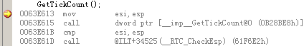
上图中有4行汇编指令，第1列是指令所在的内存地址，第2列是汇编指令，第3列是操作数。在不同的机器上编译结果也不同，所以内存地址会不一样，但后面的指令和操作数都大同小异。按一下F10（逐过程），运行到0063E615这一行，再按下F11（逐语句）就会进入到GetTickCount的代码中去，见下图：
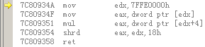
接下来要执行的指令是：
mov edx, 7FFE0000h
注意这一句代码所在的地址是7C80934A，下一句代码是7C80934F，说明这一行mov指令的长度为5。现在打开内存查看窗口（调试->窗口->内存），并在地址里输入0x7C80934A，显示如下：
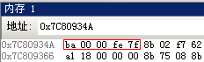
可知这条mov指令对应的机器码即是：ba 00 00 fe 7f。此时打开寄存器窗口（调试->窗口->寄存器），可以看到当前各寄存器的值。按下F10执行单步，还可以看到各寄存器的变化（变化的值用红色标出），如下图：
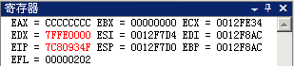

6.4.2 指令的格式
为了继续要了解x86架构下汇编码和机器码的对应关系，需要参考一部非常重要的文献“Intel® 64 and IA-32 Architectures Software Developer's Manual”（以下简称IA32SDM），这是Intel公司免费提供给开发者的，可以在下面的网址找到3卷合订本：
http://www.intel.com/content/www/us/en/processors/architectures-software-developer-manuals.html
在IA32SDM的Vol. 2B - 4.2（总第1257页）可以找到各种mov指令的说明：
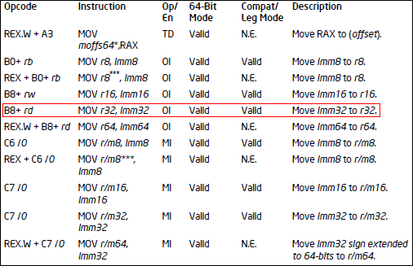
上表中每一行表示了一种mov指令，第一列是这种指令的操作码格式，第二列是指令格式，最后一列是描述信息。格令格式一列中r*是指位长为*的寄存 器，r/m*是指位长为*的内存地址，Imm*是指位长为*的立即数。上文中的mov指令“mov edx, 7FFE0000h”的操作数有两个：第一个是32位寄存器（r32）edx，第二个是一个32位立即数（Imm32）7FFE0000h。查上表可知该 mov指令就是用红框划出的那一种：“MOV r32, Imm32”，它对应的Opcode（操作码）是“B8+rd”，机器码编码格式为OI。在1258页可以看到各种mov指令的编码格式，第一列与上表中的第三列对应，后面四列是四个操作数。
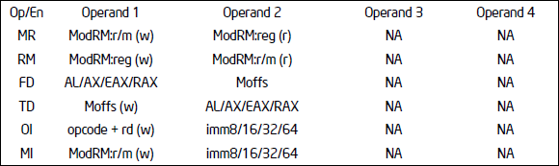
表中编码格式OI包含两个操作数，先是Opcode加寄存器代码，后面紧跟了一个立即数。而Opcode的编写格式参见IA32SDM的Vol. 2A - 3.1.1.1（总第606页），摘录如下：
The “Opcode” column in the table above shows the object code produced for each form of the instruction. When possible, codes are given as hexadecimal bytes in the same order in which they appear in memory. Definitions of entries other than hexadecimal bytes are as follows:
- REX.W — Indicates the use of a REX prefix that affects operand size or instruction semantics. The ordering of the REX prefix and other optional/mandatory instruction prefixes are discussed Chapter 2. Note that REX prefixes that promote legacy instructions to 64-bit behavior are not listed explicitly in the opcode column.
- /digit — A digit between 0 and 7 indicates that the ModR/M byte of the instruction uses only the r/m (register or memory) operand. The reg field contains the digit that provides an extension to the instruction's opcode.（翻译：这是一个0到7的数字，表示指令的ModR/M字节只使用r/m操作数。ModR/M的reg位就是该数，作为操作码的一个附加码）
- /r — Indicates that the ModR/M byte of the instruction contains a register operand and an r/m operand.
- cb, cw, cd, cp, co, ct — A 1-byte (cb), 2-byte (cw), 4-byte (cd), 6-byte (cp), 8-byte (co) or 10-byte (ct) value following the opcode. This value is used to specify a code offset and possibly a new value for the code segment register.
- ib, iw, id, io — A 1-byte (ib), 2-byte (iw), 4-byte (id) or 8-byte (io) immediate operand to the instruction that follows the opcode, ModR/M bytes or scaleindexing bytes. The opcode determines if the operand is a signed value. All words, doublewords and quadwords are given with the low-order byte first.
- +rb, +rw, +rd, +ro — A register code, from 0 through 7, added to the hexadecimal byte given at the left of the plus sign to form a single opcode byte. See Table 3-1 for the codes（翻译：这是一个寄存器代码，范围由0到7。与+号左边的16进制数代数相加构成一个完整的操作码字节。具体代码参见Table 3-1）. The +ro columns in the table are applicable only in 64-bit mode.
- +i — A number used in floating-point instructions when one of the operands is ST(i) from the FPU register stack. The number i (which can range from 0 to 7) is added to the hexadecimal byte given at the left of the plus sign to form a single opcode byte.
按照标记为红色的描述可知Opcode“B8+rd”中的B8是基础码值0xB8，rd表示32位寄存器EDX的代号。寄存器的代码表可参见IA32SDM的Vol. 2A - Table 3-1（总第607页），如下图：
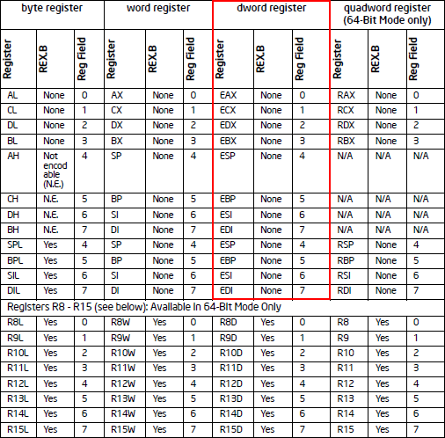
从上表中红色线框标出的部分中可以看出，EDX对应的附加码为2，因此这条mov指令的Opcode就是0xB8 + 0x02 = 0xBA。跟据编码格式OI，后面紧跟一个32位的立即数0x7FFE0000，由于Intel的CPU体系是Little Ending，所以字节序为逆序，故在内存查看器中立即数显示为“00 00 fe 7f”。综上所述，该mov指令的完整机器码为：“ba 00 00 fe 7f”，与内存查看器的结果吻合。

6.4.3 准备JMP
上面简单介绍了在VS进行汇编级调试的基本方法，并以mov指令为范例讲解了如何分析机器码。掌握了这些工具和资料，就可以清晰地了解我们下面要完成的代码在系统内部执行的细节。从上节可知，GetTickCount这个API执行的第一条指令是mov，如果能把mov的Opcode改为jmp，那就可以跳转到自定义的函数地址执行任意代码了。从IA32SDM（Vol. 2A - 3.2）中查出jmp指令的机器码：
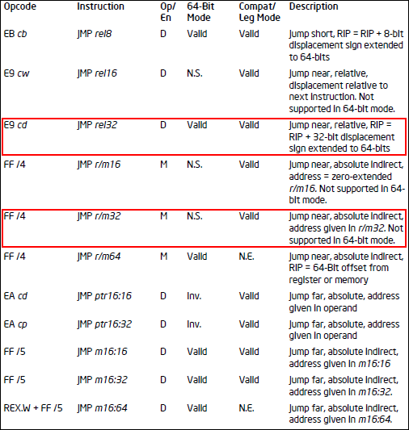
由于自定义的函数位置随机，且在win32操作系统的保护下，每个进程的段地址都是固定的，程序可以通过CS寄存器访问，但不能够改变。因此我们有两种选择，一是用JMP r/m32指令执行段内绝对跳转，二是用JMP rel32指令执行段内相对跳转。先讲解如何利用JMP r/m32执行绝对跳转。机器码的格式参见IA32SDM的Vol. 2A - 2.1，如下图：
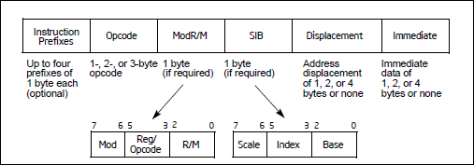
从上图可知，机器码由6大部分组成，而JMP r/m32指令对应的机器码为“FF /4”（其中/4的含义参见上文中Opcode说明里用蓝色标记的文字），用到了其中3个部分：1个字节的Opcode（即0xFF）、1个字节的ModR/M和4个字节的Displacement操作数。其中的ModR/M指定了CPU的寻址方式以及Opcode的附加码，它又分为三段：Mod、Reg/Opcode和R/M，具体构成可参见IA32SDM的Vol. 2A - 2.1.3和后面的Table 2-2，如下图：
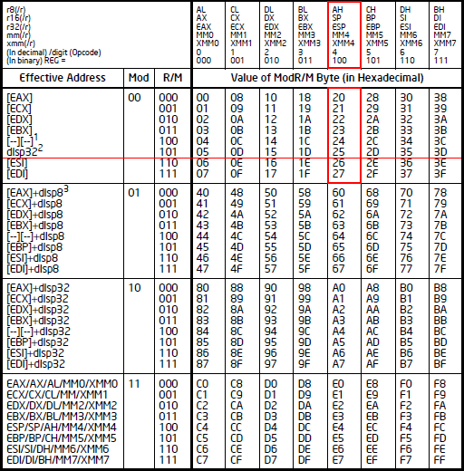
先看一下表头最左边一格，第6行“/digit (Opcode)”就是机器码“FF /4”中的4，所以看红框标记的那一列（4的二进制为100）就可以了。“Effective Address”指定了寻指方式，为了避免对寄存器进行操作，用1条指令就完成跳转，我们选择最简单的“disp32”这一行，它表示仅用指令机器码中的第3部分Displacement表示跳转的目标地址。这样就确定了使用的Mod位为00，Reg/Opcode位为100，R/M位为101。计算可得ModR/M字节为00 100 101（二进制） = 0x25。
Displacement指向一段4字节的内存，这段内存里存放的是最终的目标地址。因此需要先用VirtualAllocEx申请4个字节的空间，将自定义函数的地址存入，然后再将申请的地址填入Displacement。综上所述，完整的机器码应该是FF 25 XX XX XX XX，最后面的4个字节是一个存有目标函数入口地址的内存地址。
用JMP r/m32指令完成跳转是比较复杂的，不仅需要申请和释放内存，且整个机器指令有6个字节。更简单的方法就是利用JMP rel32指令执行相对跳转，而机器码只有5个字节。JMP rel32对应的机器码是E9 cd，其中cd就是相对地址，计算方法为：目标地址 - 当前指令地址 - 5。在准备好JMP指令的机器码后，就可以将其替换到目标API的入口地址处，欺骗宿主进程执行伪装函数。

6.4.4 修改入口点
看完上面的介绍，相信您已经迫不及待的想要尝试如何对目标API挂钩了。虽然还有很多问题没有解决，比如怎样返回，怎样执行原API功能，怎样全身而退等等，但这些问题可以先放一放，先来看看能否利用上面的方法成功挂钩。
首先需要建立一个DLL项目以生成注入体，自定义一个DllMain函数，如下：
#include <windows.h>

BOOL WINAPI DllMain(HINSTANCE hInstDll, DWORD fdwReason, LPVOID lpvReserved)
{
switch (fdwReason)
{
case DLL_PROCESS_ATTACH:
DisableThreadLibraryCalls(hInstDll);
InstallMonitor();
break;

case DLL_PROCESS_DETACH:
break;
}
return TRUE;
}
然后编写挂钩函数InstallMonitor：
void InstallMonitor(void)
{
HANDLE hProc = GetCurrentProcess();
BYTE aOpcode[5] = {0xE9}; //JMP Procudure
*(DWORD*)(&g_aOpcode[1]) = DWORD(MonFunc) - DWORD(GetTickCount) - 5;
WriteProcessMemory(hProc, LPVOID(GetTickCount), LPVOID(aOpcode), 5, NULL);
CloseHandle(hProc);
}
上面的代码很好理解，aOpcode就是根据前文介绍的方法构造的jmp指令，指定跳转到自定义的伪装函数MonFunc，然后用WriteProcessMemory将jmp指令填写入GetTickCount的代码处。伪装函数MonFunc函数很好写：
void WINAPI MonFunc(void)
{
MessageBox(NULL, _T("注入代码"), _T("示例"), 0);
}
至此，您就可以按上面的代码编译一个注入体DLL了，然后利用本文第三部分的注入程序就可以将此DLL注入到宿主进程执行。

6.5 完美欺骗
如果您按上文所述的方法执行出成功的结果，那么你很可能会发现在对话框确定后宿主进程崩溃了。原因有下面几条：
- 伪装函数没有正确的保持栈的平衡，导致返回时宿主清栈出错；
- 伪装函数没有按API执行方式执行出结果，宿主不能正常的调用系统API导致错误；
- 伪装函数不是线程安全的，导致宿主在并发调用时出错；
- 宿主有安全防护措施，检查到攻击后自动恢复或自我毁灭。
本文只讨论前3条原因的解决方案，不考虑第4条原因。下面逐条解释。

6.5.1 保持栈的平衡
大部分API都是有参数的，而参数是由宿主在call指令执行前压入堆栈。Win32API的调用约定是__stdcall，表示由API负责栈的清理，那么如果伪装函数在返回时没有适当的清栈必将导致出错。因此，伪装函数的参数表一定要与原API相同，才能保证编译器生成的代码能够正确返回到宿主代码。

6.5.2 执行原API的功能
为了能够执行原API的功能，必须在调用它之前恢复它原来的代码，否则就会陷入死循环。当然，应该在改写机器码时保留原先的机器码，这样就可以利用WriteProcessMemory将其恢复原状。ReadProcessMemory这个API函数与WriteProcessMemory的功能相反，可以读取指定位置的机器码。还要记得，在原API调用结束后还要修改它的入口点，否则下次就无法欺骗了。整个伪装函数的结构如下：
//Monitor Function
DWORD WINAPI MonFunc()
{
//Restore the original API before calling it
ReleaseBase();

//Calling the original API
DWORD dw = GetTickCount();

//Monitor the original API again
MonitorBase();

//You can do anything here

return dw;
}

6.5.3 线程安全
用EnterCriticalSection和LeaveCriticalSection是保证线程安全的最佳选择，将伪装函数用这对函数包起来就可以解决并发访问的问题。现在的代码应该看起来是这样：
//Monitor Function
DWORD WINAPI MonFunc()
{
//Thread safety
EnterCriticalSection(&g_cs);

//Restore the original API before calling it
ReleaseBase();
DWORD dw = GetTickCount();
MonitorBase();

//You can do anything here

//Thread safety
LeaveCriticalSection(&g_cs);
return dw;
}

6.5.4 完整实例
下面贴出注入体DLL的完整代码，供您参考。这个DLL对GetTickCount挂了钩子，您可以在伪装函数MonFunc中添加任意的自定义代码，并在退出的时候调用UninstallMonitor结束钩子程序。
#include <tchar.h>
#include <Windows.h>

//Handle of current process
HANDLE g_hProc;

//Backup of orignal code of target api
BYTE g_aBackup[6];
BYTE g_aOpcode[6];

//Critical section, prevent concurrency of calling the monitor
CRITICAL_SECTION g_cs;

//Base address of target API in DWORD
DWORD g_dwApiFunc = (DWORD)GetTickCount;

//Hook the target API
__inline BOOL MonitorBase(void)
{
// Modify the heading 6 bytes opcode in target API to jmp instruction,
// the jmp instruction will lead the EIP to our fake function
ReadProcessMemory(g_hProc, LPVOID(g_dwApiFunc), LPVOID(g_aBackup),<br> sizeof(g_aBackup)/ sizeof(g_aBackup[0]), NULL);<br> return WriteProcessMemory(g_hProc, LPVOID(g_dwApiFunc),
LPVOID(g_aOpcode), sizeof(g_aOpcode) / sizeof(g_aOpcode[0]), NULL);
}

//Unhook the target API
__inline BOOL ReleaseBase(void)
{
// Restore the heading 6 bytes opcode of target API.
return WriteProcessMemory(g_hProc, LPVOID(g_dwApiFunc),
LPVOID(g_aBackup), sizeof(g_aOpcode) / sizeof(g_aOpcode[0]), NULL);
}

//Pre-declare
BOOL UninstallMonitor(void);

//Monitor Function
DWORD WINAPI MonFunc()
{
//Thread safety
EnterCriticalSection(&g_cs);

//Restore the original API before calling it
ReleaseBase();
DWORD dw = GetTickCount();
MonitorBase();

//You can do anything here, and you can call the UninstallMonitor
//when you want to leave.

//Thread safety
LeaveCriticalSection(&g_cs);
return dw;
}

//Install Monitor
BOOL InstallMonitor(void)
{
//Get handle of current process
g_hProc = GetCurrentProcess();

g_aOpcode[0] = 0xE9; //JMP Procudure
*(DWORD*)(&g_aOpcode[1]) = (DWORD)MonFunc - g_dwApiFunc - 5;

InitializeCriticalSection(&g_cs);

//Start monitor
return MonitorBase();
}

BOOL UninstallMonitor(void)
{
//Release monitor
if (!ReleaseBase())
return FALSE;

DeleteCriticalSection(&g_cs);

CloseHandle(g_hProc);

//Synchronize to main application, release semaphore to free injector
HANDLE hSema = OpenSemaphore(EVENT_ALL_ACCESS, FALSE, _T("Global\\InjHack"));
if (hSema == NULL)
return FALSE;
return ReleaseSemaphore(hSema, 1, (LPLONG)g_hProc);
}

BOOL WINAPI DllMain(HINSTANCE hInstDll, DWORD fdwReason, LPVOID lpvReserved)
{
switch (fdwReason)
{
case DLL_PROCESS_ATTACH:
DisableThreadLibraryCalls(hInstDll);

InstallMonitor();
break;

case DLL_PROCESS_DETACH:
break;
}
return TRUE;
}

6.5.5 本文源地址
http://www.cnblogs.com/devymex/archive/2011/12/31/2308481.html

6.6 评论
#1楼 2012-01-02 16:52 leehark[未注册用户]
这个文章讲得很赞 。
我这里有几个问题：
1.用远程线程来进行注入操作，但这个种方法很容易被杀软干掉，有种方法是可以用消息钩子来注入DLL，但消息钩子只能用在有窗体的应用程序中，不知Console界面的应用程序中，有没有其他方法实现DLL的注入？
2.这里的挂钩API是更改某个API的前几个地址并JMP到DLL里的某个地址来实现的，用JMP覆盖时需要分析这个API的前几个汇编指令，微软提供了32位的detour来实现自动分析这个指令，但是开源的只有32位的，不知对64位的有没有相关开源库，来自动分析INTEL的地址（64位的detour是要收钱的）

#2楼 2012-01-03 16:48 乒乓球鸡蛋
专业，强人，崇拜
支持(0)反对(0)

#3楼[楼主] 2012-01-03 18:20 Devymex
@leehark
感谢捧场。
1. 对指定线程挂WH_GETMESSAGE消息钩子也可以将DLL注入宿主进程，但要求指定的线程必须包含窗体，然而很多Win32进程都没有窗体，或着窗体是动态创建的，因此这种方法相当大的局限性。
2. 用jmp覆盖代码时并不需要分析原指令，注意备份和恢复就可以了。
支持(0)反对(0)

#4楼 2012-01-04 09:36 技术拓荒者
mark强大
支持(0)反对(0)

#5楼 2013-01-11 14:06 Moon.Orm塑造Orm经典
楼主,写得很详细.
能否给一份代码
支持(0)反对(0)

#6楼 2014-01-26 10:45 Ace8793
酷毙了
支持(0)反对(0)

#7楼 2014-11-18 16:26 Xorono
最后完整示例中g_aBackup忘记赋值了, 如果调用同名函数会出现错误.
__inline BOOL MonitorBase(void)
{
// Modify the heading 6 bytes opcode in target API to jmp instruction,
// the jmp instruction will lead the EIP to our fake function
ReadProcessMemory(g_hProc, LPVOID(g_dwApiFunc), LPVOID(g_aBackup), sizeof(g_aBackup)/ sizeof(g_aBackup[0]), NULL);
return WriteProcessMemory(g_hProc, LPVOID(g_dwApiFunc),
LPVOID(g_aOpcode), sizeof(g_aOpcode) / sizeof(g_aOpcode[0]), NULL);
}
支持(1)反对(0)

#8楼 2015-06-30 10:11 pandeng
刚学apihook，学习到很多，在实现的时候出现了一个问题：我在MonFunc中添加了MessageBox(NULL, L"HOOKED",L"PZP",MB_OK);可以Hook成功但是宿主程序总是死掉。。。为什么
//You can do anything here, and you can call the UninstallMonitor
//when you want to leave.
MessageBox(NULL, L"HOOKED",L"PZP",MB_OK);
//Thread safety
支持(0)反对(0)

#9楼 2015-07-24 13:38 征__程
您好，您的思路很清晰，可是我有一个小疑问，GetTickCount()参数为空，可是MonFunc(DWORD dwErr)有一个形参，堆栈如何保持平衡？望解决我的疑惑
支持(0)反对(0)

#10楼[楼主] 2015-08-01 11:45 Devymex
@征__程
这是一个Bug，我已经去掉了那个参数。
请注意，文中提过：“伪装函数的参数表一定要与原API相同，才能保证编译器生成的代码能够正确返回到宿主代码。”
支持(0)反对(0)

#11楼[楼主] 2015-08-01 11:54 Devymex
@Xorono
谢谢，已经修正
支持(0)反对(0)

#12楼 2016-01-18 09:34 R.H.Zhang
多谢博主的文章。另外 WindowFromPoint 函数的参数是否有误呢？我改成 WindowFromPoint(ptCursor) 才能编译成功。我在 VS2015 中编译的
支持(0)反对(0

7 API钩取技术图表
方法 | 对象是什么 | 位置何处 | 技术如何 |  | API
静态 | 文件 | 1)IAT  2)代码  3)EAT | X |  | X
动态 | 进程  内存  00000000  ~  7FFFFFFF | 1)IAT  2)代码  3)EAT | A)调试(Interactive) |  | DebugActiveProcess  GetThreadContext  SetThreadContext
动态 | 进程  内存  00000000  ~  7FFFFFFF | 1)IAT  2)代码  3)EAT | B)注入  (standalone) | B-1)  Independant代码 | CreateRemoteThread
 |  |  |  | B-2)DLL文件 | Registry(AppInit_DLLs)  BHO(IE only)
SetWindowsHookEx
CreateRemoteThread

访问其他进程内存时也常常使用OpenProcess()、WriteProcessMemory()、ReadProcessMemory()等API。

