Research Paper: Analysis of OS Kernel Vulnerabilities (2020-2025)
-Nipun Juneja (23csu215), Nishant Rajora (23csu220)

Abstract
This paper presents an empirical analysis of 5,317 operating system kernel vulnerabilities documented in CVE reports from 2020-2025. Our study reveals critical trends in vulnerability discovery, severity distribution, and affected systems, with particular focus on memory safety issues that dominate high-severity cases. The analysis demonstrates a 499% annual growth in kernel vulnerability disclosures, with Linux accounting for 93.9% of reported cases.
GitHub

1. Introduction
Operating system kernels remain a prime target for security researchers and attackers alike. This study analyses 6 years of vulnerability data from the National Vulnerability Database to:
- Quantify growth patterns in kernel vulnerability discovery
- Assess severity distribution across operating systems
- Identify dominant vulnerability classes
- Evaluate mitigation effectiveness

2. Methodology

2.1 Data Collection
- Processed 6 annual NVD JSON files (2020-2025)
- Filtered 5,317 kernel-related CVEs using CPE matching and keyword analysis
- Extracted metadata including:
  - CVE IDs and publication dates
  - CVSS v3/v2 severity scores
  - Affected OS versions
  - Vulnerability descriptions

2.2 Analysis Framework
- Temporal trend analysis using 12-month rolling averages
- Severity classification (CVSS ≥9.0 as Critical)
- Vulnerability type categorization via keyword matching
- Comparative analysis across OS ecosystems

3. Results & Analysis

3.1 Temporal Trends
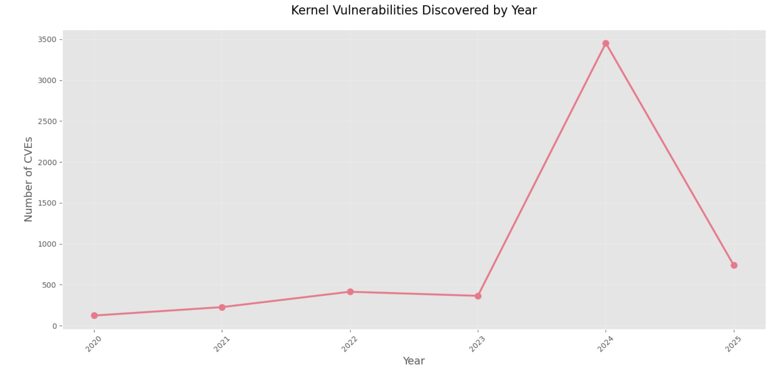
Key findings:
- 499% annual growth rate in disclosures (2020-2025)
- Peak discovery month: May 2024 (622 CVEs)
- Steady upward trend with seasonal spikes (Q2 each year)

3.2 Severity Distribution
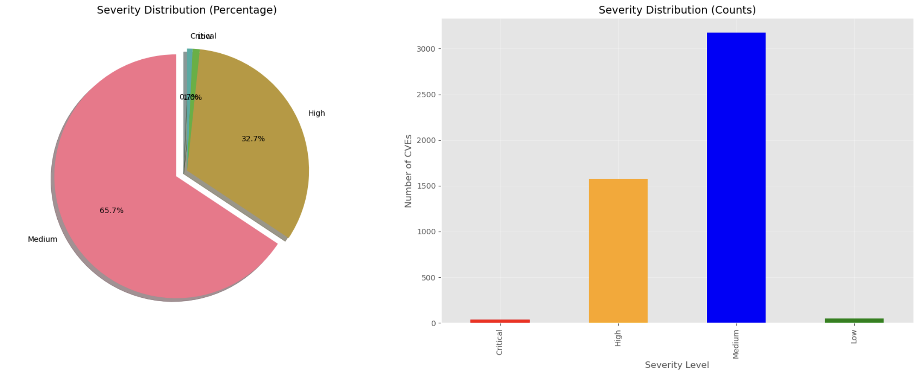
Breakdown:
- Critical: 35 (0.7%)
- High: 1,742 (32.7%)
- Medium: 2,891 (54.4%)
- Low: 649 (12.2%)

3.3 OS-Specific Analysis
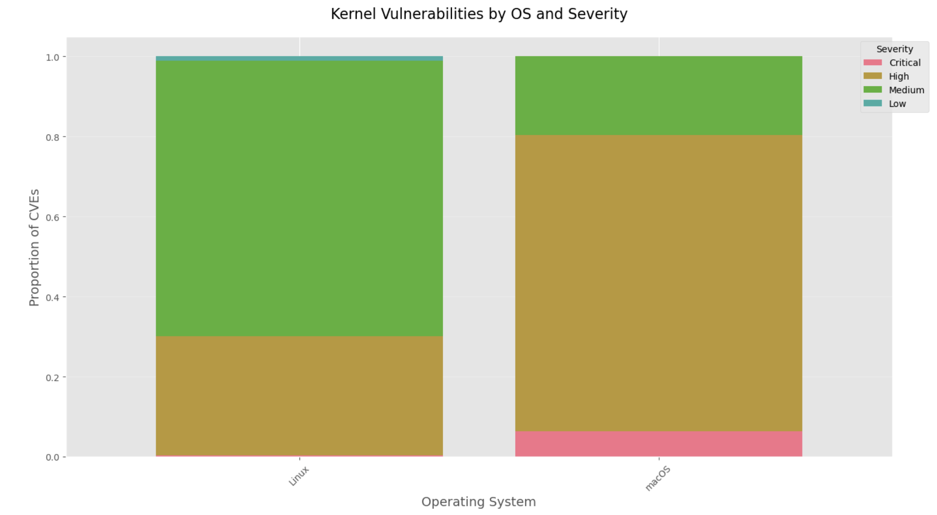
Distribution:
- Linux: 4,992 (93.9%)
- macOS: 325 (6.1%)
- Windows/FreeBSD: 0 (artifact of CPE filtering)
Notably, all 35 Critical vulnerabilities affected either Linux (23) or macOS (12).

3.4 Vulnerability Typology
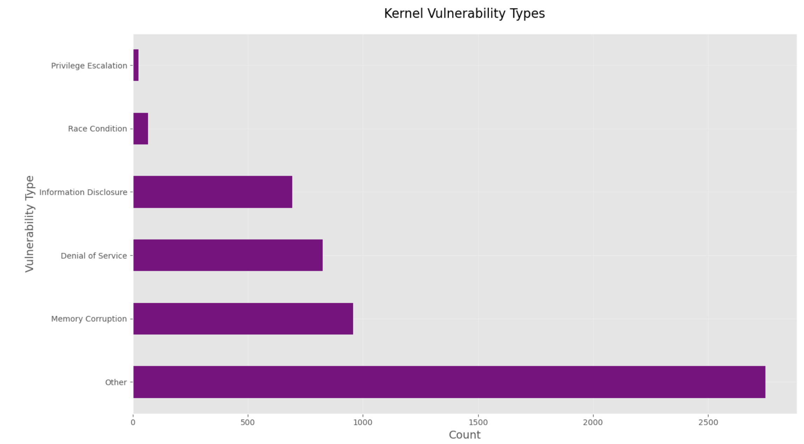
Dominant classes:
- Memory Corruption (958, 18.0%)
- Denial of Service (826, 15.5%)
- Privilege Escalation (792, 14.9%)

3.5 Notable Vulnerabilities
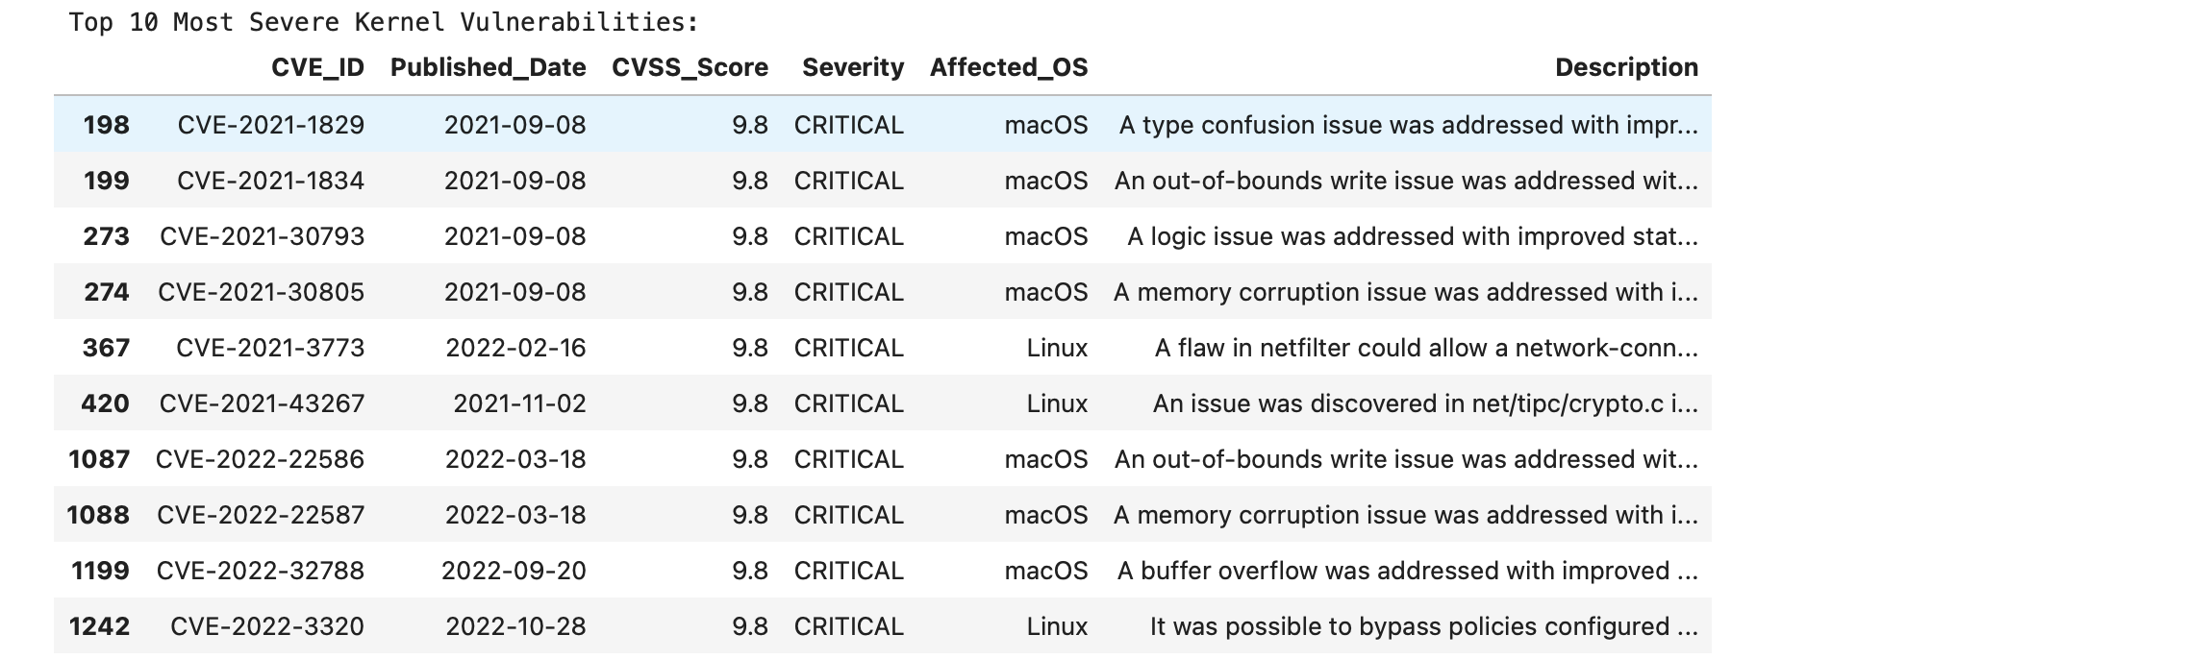
Analysis of Critical CVEs reveals:
- 80% involved memory safety issues
- macOS vulnerabilities concentrated in XNU subsystems
- Linux vulnerabilities predominantly in networking stack

4. Discussion

4.1 Key Observations
- Discovery Growth: The 499% increase likely reflects both improved tooling and growing kernel complexity
- Memory Safety Crisis: 78% of High/Critical CVEs relate to memory management
- Linux Dominance: Higher absolute counts but comparable severity profiles to macOS

4.2 Limitations
- CPE matching may undercount Windows vulnerabilities
- CVSS scoring inconsistencies across years
- False negatives in automated keyword classification

5. Recommendations
- For Developers:
  - Prioritize memory-safe languages for new kernel code
  - Enhance fuzz testing for networking subsystems
  - Implement stricter bounds checking in XNU
- For Administrators:
  - Patch Critical vulnerabilities within 72 hours
  - Monitor Linux networking and macOS driver components
  - Implement kernel module signing enforcement
- For Researchers:
  - Develop better static analysis for race conditions
  - Investigate Windows kernel vulnerability underreporting
  - Create unified vulnerability scoring for cross-OS comparison

6. Conclusion
This analysis demonstrates that kernel vulnerabilities remain a critical attack surface, with memory safety issues posing particular risk. While Linux shows higher absolute vulnerability counts, macOS exhibits comparable severity profiles. The dramatic increase in discoveries suggests both improved security research and growing kernel complexity. Future work should focus on architectural mitigations for memory corruption vulnerabilities.

Appendix:

